**Lord Dattatreya**

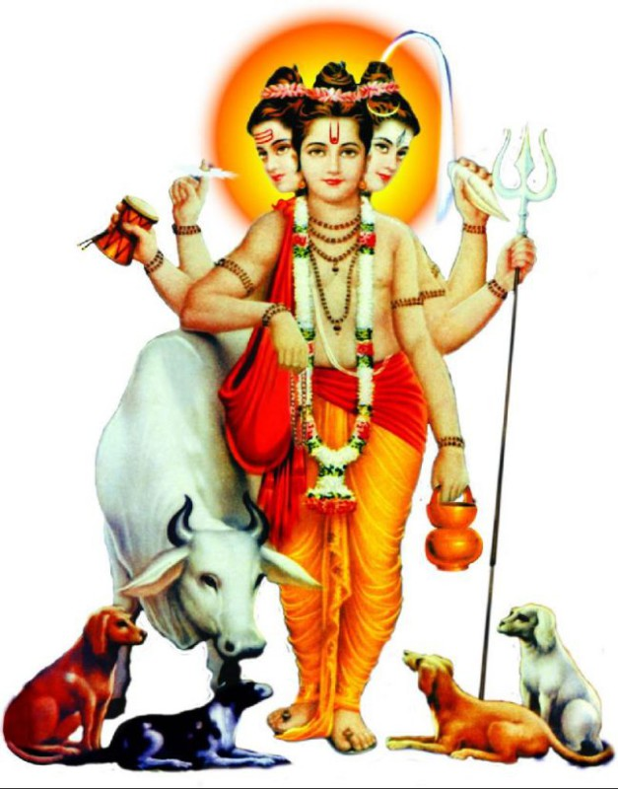

**Shri Dattatreya – Datta Guru**

**Lord Dattatreya:**

**Shri Dattatreya** is a very ancient incarnation and is highly venerated through the ages. Datta, means ‘given’ and Atreya, means son of Atri. He had descended on this earth to establish ‘**Satya**‘ (the Universal Truth), ‘Rta’ (the Cosmic Order), **Dharma**‘, (the perennial principles), in all its entirety. Dattatreya was the son of sage Atri and Anusuya. He is the manifestation of all three Primal Energies of **Brahma**, **Vishnu** and **Shiva**.

**Splendorous form of Dattatreya:**

Shri Dattatreya came to light the lamp of wisdom among the people. He has a splendorous form and his face radiates peace and divine charm and draws us away from the lures of the world. Though He is the Supreme Lord of this universe, He is a recluse. Though He moves from place to place, His favorite abode is the Holy Audambar tree (A type of fig type, Ficus glomerate). He has matted hair on His heads. His body is smeared with holy ashes. He always has a cow and four dogs with Him as His constant companions. He is always overflowing with compassion for all the beings and the entire creation. All the aspects of Godhead are fully manifest in Him.

**Significances:**

• **The Cow**, which is always with Him, represents the Mother Earth and Dharma. She is the wish fulfilling cow ‘**Kamadhenu**‘.  
• **The four dogs symbolise the four Vedas**.  
• The **Trident** indicates that He has transcended the **three gunas**, which constitute the illusory world: **Sattva- mode of pureness, Rajas- mode of passion and Tamas-mode of ignorance**.  
• The ‘**Sudharshana chakra**‘ , disc indicates that He is beyond the cycles of birth, death and time and His holding of ‘chakra’ means He is the controller of time.  
• The **Conch** represents the holy sound vibrations. The sound dispels all undesirable things.  
• He always carries a begging bowl so as to teach us the lesson that we should share our wealth and food with others.  
• The **Japa-mala**, rosary He wears reminds us that our primary duty is chanting the sacred name of the Lord and meditating on the feet of the Lord.

**Birth:**

Sage Atri had done penances for many years in order to obtain a son from Bramha, Shiva and Vishnu. Atri’s wife, Anusuya, was very famous for her devotion to her husband. She was the embodiment of chastity. Such was her spiritual power that, even hard earth turned soft and smooth for her as she walked about. Indra and the gods became worried that they may be put to shame due to this pious. Indra and the gods asked Bramha, Shiva and Vishnu to go and try find some fault in her chastity.

They transformed themselves into mendicants, approached the hermitage of sage Atri and begged for alms. At that time sage Atri was away at the river performing his daily oblations. Anusuya came out and offered food to them. They made a strange request; the food be prepared and served to them by Anusuya, without clothes. In the Brahman tradition any guest cannot be turned away, as they are considered to be an aspect of God. Hence she was placed in a dilemma. She smiled to herself and reflected: ‘I am totally purified by the long association with the holy sage Atri. What harm can the god of lust ever do to me? So I do fear nothing. As they have sought food from my hands, I look upon them as my own children and not as strangers and grown up men!’ Her thoughts instantly became reality; the elderly guests became babies!

Sage Atri on his return to the hermitage saw his wife Anusuya fondling three babies. Anusuya said “These children are the gift of God to us as we have been childless so far”. Sage Atri was overjoyed and named them **Datta**. At this, Brahma, Shiva and Vishnu reverted to their real forms and disclosed the truth. They extolled the power of chastity and purity of Anusuya. Sage Atri and Anusuya prayed that they should remain as their sons. They consented and the three Gods merged into one body.

**Other notable pastimes:**

Shri Dattatreya had left home at an early age to wander naked in search of the absolute truth. He spent most of his life wandering around.

The *Markandeya Purana* says that Dattatreya, to free himself of all attachments, spent a very long time in a lake in meditation.

**Shri Dattatreya**, in order to bless His devotees and the righteous ones, wanders about in the guise of a **random guest at lunch hour. That’s why it is said that a random guest has to be treated as the very embodiment of Lord Dattaterya**.

**Gurus:**

Shri Dattatreya had twenty four teachers from nature. They were the earth, ocean, water, wind, sky, fire, moon, sun, pigeon, hawk, python, serpent, deer, elephant, fish, spider, honeybee, moth, caterpillar, courtesan, arrow-maker, beekeeper, infant and maiden.

|  |  |  |  |
| --- | --- | --- | --- |
| The 24 teachers from mother nature | | | |
| [Serial Number](https://en.wikipedia.org/wiki/Number) | [Guru](https://en.wikipedia.org/wiki/Guru) | [Observation](https://en.wikipedia.org/wiki/Observation) | Dattatreya's Learning |
| 1. | [Earth](https://en.wikipedia.org/wiki/Earth) | Steadfastly productive, does its dharma, gets abused, heals and is steady in giving nourishment. | remain undisturbed even if oppressed, keep healing even if others injure you |
| 2. | [Wind](https://en.wikipedia.org/wiki/Wind) | Passes through everything and everyone, unchanged, unattached, like Truth; sometimes becomes a gale, disturbs and changes the world, like Truth. | be free like the wind, yet remain true to your self |
| 3. | [Sky](https://en.wikipedia.org/wiki/Sky) | the highest has no boundaries, no limits, is unaffected even if clouds and thunderstorms come and go | the highest within oneself, the Atman (self, soul) has no limits, let the clouds of materiality pass |
| 4. | [Water](https://en.wikipedia.org/wiki/Water) | serves all without pride, discrimination; is transparent to everyone; purifies and gives life to everyone it touches | a saint discriminates against no one and is never arrogant, lets other give him impurity, yet he always remains pure and cleanses others |
| 5. | [Fire](https://en.wikipedia.org/wiki/Fire) | purifies and reforms everything it comes in contact with, its energy shapes things | the heat of knowledge reforms everything it comes in contact with, to shape oneself one needs the energy of learning |
| 6. | [Moon](https://en.wikipedia.org/wiki/Moon) | waxes and wanes but its oneness doesn't change | birth, death, rebirth and the cycle of existence does not change the oneness of soul, |
| 7. | [Sun](https://en.wikipedia.org/wiki/Sun) | source of light and gives its gift to all creatures as a sense of duty; in rain puddles it reflects and seems like distinct in each puddle, yet it is the same one Sun | the soul may appear different in different bodies, yet everyone is connected and the soul is same in all; like Sun, one must share one's gifts as a sense of duty |
| 8. | [Pigeons](https://en.wikipedia.org/wiki/Pigeon) | they suffer losses in the hands of violent hunters, warn against obsessive attachments to anyone or to material things in this world | do not be obsessive, don't focus on transient things such as damage or personal loss, human life is a rare privilege to learn, discover one's soul and reach liberation |
| 9. | [Python](https://en.wikipedia.org/wiki/Python_(genus)) | eats whatever comes its way, makes the most from what it consumes | be content with what you have, make the most from life's gifts |
| 10. | [Honeybee](https://en.wikipedia.org/wiki/Bumblebee) | active, works hard to build and create its reserve by directly visiting the flowers, but is selective and uses discretion, harmonious with flowers and never kills or over consumes | be active, go directly to the sources of knowledge, seek wisdom from all sources but choose the nectar, be gentle, live harmoniously |
| 11. | [Beekeeper](https://en.wikipedia.org/wiki/Beekeeper) | profits from honeybees | don't crave for material pleasures or in piling up treasures, neither the body nor material wealth ever lasts |
| 12. | [Hawk](https://en.wikipedia.org/wiki/Hawk) | picks up a large chunk of food, but other birds harass him, when it drops its food other birds leave him alone | take what you need, not more |
| 13. | [Ocean](https://en.wikipedia.org/wiki/Ocean) | lucid at the surface, but deep and undisturbed within; receives numerous rivers yet remains the same | let rivers of sensory input not bother who you are deep inside, know your depths, seek self-knowledge, be unperturbed by life, equipoise |
| 14. | [Moth](https://en.wikipedia.org/wiki/Moth) | is deceived by its senses, it runs to the fire in misunderstanding which kills it | question your senses, question what others are telling you, question what you see, know senses can deceive, seek reason |
| 15. | [Elephant](https://en.wikipedia.org/wiki/Elephant) | is deceived by his lust, runs after the smell of a possible mate, and falls into a pit made by elephant tamers then captured and used | don't lust after something or someone, don't fall into traps of others or of sensory gratification |
| 16. | [Deer](https://en.wikipedia.org/wiki/Deer) | is deceived by his fear, by hunters who beat drums and scare him into a waiting net | fear not the noise, and do not succumb to pressure others design for you |
| 17. | [Fish](https://en.wikipedia.org/wiki/Fish) | is deceived by bait and so lured to its death | greed not the crumbs someone places before you, there are plenty of healthy opportunities everywhere |
| 18. | [Courtesan](https://en.wikipedia.org/wiki/Courtesan) | exchanges transient pleasure with body, but feels dejected with a meaningless life, ultimately moves on | many prostitute feel dejected with their career and circumstances, seek meaning and spirituality in life, move on to doing things you love to do |
| 19. | [Child](https://en.wikipedia.org/wiki/Child) | lives a life of innocent bliss | be a child, curious, innocent, blissful |
| 20. | [Maiden](https://en.wikipedia.org/wiki/Maiden) | she is poor yet tries her best to feed her family and guest, as she cooks she avoids attracting attention to her kitchen and poverty, by breaking all her bangles except one on each wrist | don't seek attention, a yogi accomplishes and shares more through solitude |
| 21. | [Snake](https://en.wikipedia.org/wiki/Snake) | lives in whatever hole that comes his way, willingly leaves bad skin and moults | a yogi can live in any place, must be ready to moult old ideas and body for rebirth of his spirit |
| 22. | [Arrow smith](https://en.wikipedia.org/wiki/Fletching) | the best arrow smith was so lost in his work that he failed to notice the king's procession that passed his way | concentrate on what you love to do, intense concentration is the way to self-realization |
| 23. | [Spider](https://en.wikipedia.org/wiki/Spider) | builds a beautiful web, destroys and abandons the web, then restarts again | don't get entangled by your own web, be ready to abandon it |
| 24. | [Caterpillar](https://en.wikipedia.org/wiki/Caterpillar) | starts out closed in a tiny nest but ultimately becomes a butterfly | long journeys start small, a disciple starts out as insignificant but ultimately becomes a spiritual master |