**Matsya, the Lord’s Fish Incarnation**

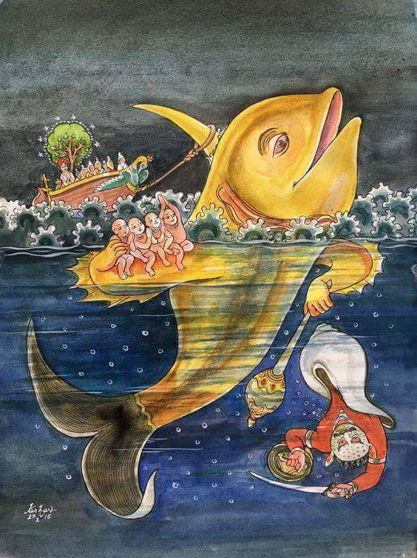

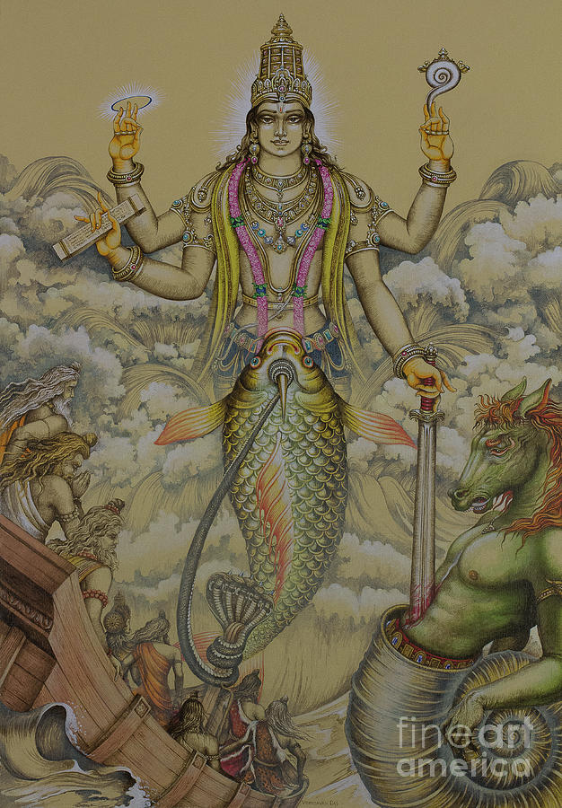

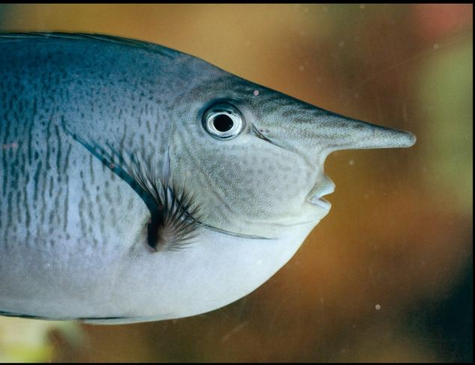**Unicorn fish**

**Narwhal**

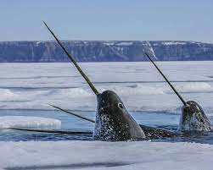

**Canto 8, chapter 24, Shrimad Bhagavatam:**

This chapter describes the Supreme Personality of Godhead’s incarnation as a fish, and it also describes the saving of Mahārāja Satyavrata from an inundation. There are two accounts of when the lord appeared as matsya avatar. The Supreme Personality of Godhead appears on this planet for the protection of the devotees, and for the destruction of the miscreants. At the beginning of a day of Bramha, the entire cosmos is generated, but at the end of the day, all the cosmos is destroyed or ends up in dissolution.

# First account:

Mahārāja Parīkṣit asked: What was the purpose for which the Supreme Personality of Godhead accepted the abominable form of a fish? The form of a fish is certainly condemned and full of terrible pain. What was the purpose of this incarnation?

Sūta Gosvāmī replied: O King, for the sake of protecting the cows, brāhmaṇas, demigods, devotees, the Vedic literature, religious principles, and principles to fulfil the purpose of life, the Supreme Personality of Godhead accepted the form of a fish. Once, at the end of the previous kalpa, when Brahmā felt sleepy and desired to lie down, the Vedas were emanating from his mouth, and the great demon named Hayagrīva (not the incarnation Hayagriva!) stole the Vedic knowledge.

When Lord Brahmā sleeps during the night, annihilation takes place, and the three worlds were covered by the water of the ocean. Understanding the acts of the great demon Hayagrīva, the Supreme Personality of Godhead, Hari, assumed the form of a fish (at the beginning of the period of Svāyambhuva Manu) and saved the Vedas by killing the demon.

Matsya delivered all the Vedic literatures to Lord Brahmā when Lord Brahmā awakened from sleeping the next morning.

# Second account:

During the reign of Cākṣuṣa Manu there was a king named Satyavrata, who was a great pious ruler. To save him, the Lord appeared as the fish incarnation for a second time.

To receive the favour of the Supreme Personality of Godhead, King Satyavrata engaged in the austerity of subsisting only by drinking water. Once, while performing this austerity on the bank of the Kṛtamālā River and offering oblations of water with the palm of his hand, he found a small fish. Satyavrata, the King of Draviḍadeśa, threw the fish into the water of the river along with the water in his palm, O King Parīkṣit, descendant of Bharata. The fish appealed to the King for protection, asking the King to keep Him in a safe place ,because there were other aquatics who could kill the fish. Although the King did not know that the small fish was the Supreme Personality of Godhead Himself, as a king he gave shelter to the fish and kept Him in a water jug and brought Him to his own residence. But in one night, the fish, being the Supreme Personality of Godhead, wanted to show His potency to King Satyavrata, and thus He immediately expanded His body in such a way that He could no longer be kept in the jug of water and asked the king to find him some other better reservoir of water where he could live comfortably. The King then put the fish in a big well. But within a moment the fish developed to the length of three cubits (1.4 m) and in a moment the well was too small. The fish asked for a more extensive reservoir. Then the King put the fish in a lake, but the lake was also unsuitable as the fish then assumed a gigantic form exceeding the extent of the water. The king then deposited the fish in the [Ganges](https://en.wikipedia.org/wiki/Ganges) river, but the fish even outgrew the river. Finally the King put the fish in the sea, but even the sea could not accommodate Him. While being thrown in the ocean, the fish said to King Satyavrata: ”O hero, in this water there are very powerful and dangerous sharks that will eat Me. Therefore you should not throw Me in this place.”

Thus the King understood that the fish was no one else but the Supreme Personality of Godhead, and he requested the Lord to describe His incarnation as a fish. The Personality of Godhead, being pleased with the King, informed him that within a week there would be an inundation throughout the universe and that he would protect the King. He instructed the king to take along with him, the seven ṛṣis, herbs, seeds and other living entities, in a boat, which would be attached to the fish’s horn. After saying this, the Lord disappeared. King Satyavrata offered respectful obeisance’s to the Supreme Lord and continued to meditate upon Him. Thereafter, gigantic clouds pouring incessant water swelled the ocean more and more. Thus the ocean began to overflow onto the land and inundate the entire world.

In due course of time, annihilation took place, and the King saw a boat coming near. After getting aboard with learned rsis and saintly persons, he offered prayers to worship the Supreme Personality of Godhead. Then King Satyavrata began to wait for that time of which the Lord had instructed. After spreading kuśa with its tips pointing east, the saintly King, himself facing the northeast, sat down on the grass and began to meditate upon the Supreme Personality of Godhead, Viṣṇu, who had assumed the form of a fish.

Then, while the King constantly meditated upon the Supreme Personality of Godhead, a large golden fish appeared in the ocean of inundation. The fish had one horn and was eight million miles long (approximately 1 million earths next to each other in length). Matsya instructed the king that as the boat is tossed about by the powerful winds, attach the vessel to My horn by means of the great serpent Vāsuki (King of all snakes), for I shall be present by your side. Pulling the boat, with you and all the ṛṣis in it, O King, I shall travel in the water of devastation until the night of Lord Brahmā’s slumber is over.

Following the instructions formerly given by the Supreme Personality of Godhead, the King anchored the boat to the fish’s horn, using the serpent Vāsuki as a rope. While moving in the water of inundation, Matsya explained to the king the Absolute Truth, who listened to the instructions of the Supreme Personality of Godhead in regard to self-realization. Matsya diligently dragged the boat through the flood for many a long year (our time, not Bramha’s time) and then he towed the vessel towards the highest peak of the [Himavat](https://en.wikipedia.org/wiki/Himavat) (Himalayas). The Himalayas are the highest point of the earth. Matsya then told those on the vessel to tie it to the peak of the Himavat. Thus the Manu (father of mankind) could populate the world again.

Anyone who hears it is delivered from the reactions of sinful life. One who narrates this description of the Matsya incarnation and King Satyavrata will certainly have all his ambitions fulfilled, and he will undoubtedly return home, back to Godhead.