Night of Destiny, 27th Ramadan: mathematical confirmation,
In the name of God, Most Gracious, Most Merciful
[97:1] We revealed it in the Night of Destiny.
[97:2] How awesome is the Night of Destiny!
[97:3] The Night of Destiny is better than a thousand months.
[97:4] The angels and the Spirit descend therein, by their Lord's leave, to carry out every command.
[97:5] Peaceful it is until the advent of the dawn.
Proof 1:
We know The Quran was placed into Muhammad's soul on the 27th night of Ramadan, 13 B.H. (Before Hijrah).
We have sent it down in a blessed night, for we are to warn. In it (the scripture), every matter of wisdom is clarified. (44:3-4)
Ramadan is the month during which the Quran was revealed, providing guidance for the people, clear teachings, and the statute book….. 2:185
Most glorified is the One who summoned His servant (Muhammad) during the night, from the Sacred Masjid (of Mecca) to the farthest place of prostration,* whose surroundings we have blessed, in order to show him some of our signs. He is the Hearer, the Seer. (17:1)
The Gematrical Value of the verses in the sura (97:1-5) : 6731
Gematrical value of Muhammad: 92
Month of Ramadan: 9
Night of Destiny: 27
you get: 6731 + 92 + 9 + 27 = 6859 = 19 x 19 x 19
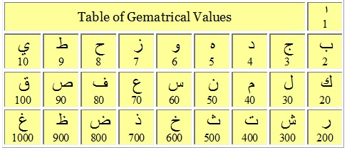
Praise be to God
Proof 2:

Sura 97 (Al-Qadr) contains 3 occurrences of the phrase "laylat al-qadr" (the night of destiny).
The Arabic phrase "laylat al-qadr" itself consists of 9 letters.
Therefore, within this sura, there are 27 (3 X 9) letters that participate in the proper name of this very special night.
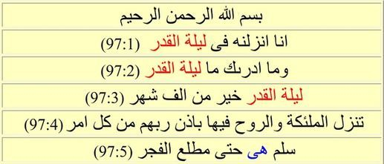
Proof 3:
"Peaceful it is until the advent of the dawn" [Quran 97:5]
(Arabic: salamun HIYA hatta mathlail fajr). The word IT (HIYA) refers to the night in question. It is interesting that the location of this word is 27th out of the 30 total words that comprise this sura.
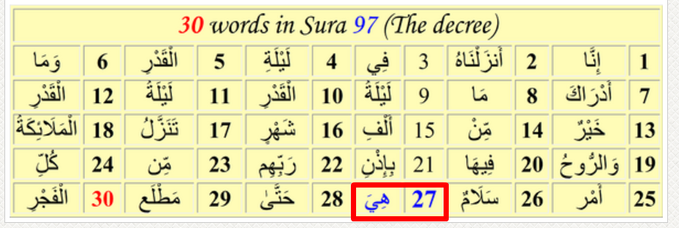
Proof 4:
The gematrical value of "Laylat Al Qadr" is 410 (see last two words in 97:1 for confirmation).
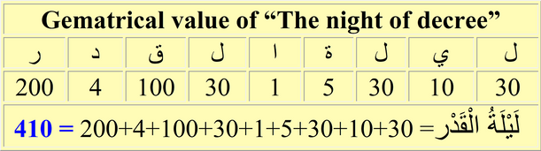
The nine Arabic letters that make up this phrase have the following values (letters shown in English equivalents): L=30, Y=10, L=30, T=5, A=1, L=30, Q=100, D=4, R=200.
If we add 410, the sum of the numbers shown above, plus the Sura number (97) and the verse numbers in which "Laylat Al Qadr" occurs (1, 2, 3),
we get: 410 + 97 + 1 + 2 + 3 = 513, or 19 x 27
and 27 is the number representing the specific night.
Proof 5:
Ramadan is the 9th month in the lunar calendar.
The Night of Destiny is the 27th night.
If you add: 97 + 9 + 27 = 133 (19 x 7)
Proof 6:
If you add the gematrical value of "Laylat Al Qadar" (410) and the Night of Destiny (27), you get: 410 + 27 = 437 (19 x 23).
Proof 7:
The phrase "laylat al-qadr" occurs in verses 97:1, 2 and 3. These verses have (see Table below) 20, 19 and 20 letters respectively, for a total of 59 letters.
Ramadan is the 9th month in the lunar calendar.
The Night of Destiny is the 27th night.
If you add 9 + 27 + 59 = 95 (19 x 5)
Sura 97, Structure of verses 1-3
Verse | Letters | Gematrical Value
1 | 20 | 695
2 | 19 | 733
3 | 20 | 1926
Total | 59 | 3354
Proof 8:
If you concatenate the Sura number (97) followed by, for each verse where Night of Destiny occurs the verse number, number of letters, gematrical value of the verse, followed by the month for Ramadan (9) and the day for Night of Destiny (27) you get:
97; 1, 20, 695; 2, 19, 733; 3, 20, 1926; 9, 27
= 19 x 51116155378807010627733
Proof 9:
Sura 97 has 5 verses. The phrase "laylat al-qadr" appears three times in the sura, each with a gematrical value of 410. If you sum up 410 three times, you get 410 + 410 + 410 = 1230. Ramadan is month 9 in the calendar and the night is the 27th night.
If you add: 97 + 5 + 1230 + 9 + 27 = 1368 (19 x 72)
Proof 10:
God tells us the Quran was revealed in the Night of Destiny.
The gematrical value of Al-Quran is 383. The gematrical value of Ramadan is 1091.
If we add: 383 (Al-Quran) + 1091 (Ramadan) + 27 (Night of Destiny) we get 1501 = 19 x 79.
Proof 11:
Adding the gematrical value of Ramadan (1091) + the gematrical value of "Laylat Al Qadr" (410) also gives us 1501 = 19 x 79.
Proof 12:
We can also take the sura number (97), add all the verse numbers (+1 +2 + 3 +4 +5) + 9 (Ramadan) + 27 (Night of destiny) + 410 (GV of Night of Destiny). This gives us: 1558 = 19 x 82
Proof 13:
The expression “Laylatul Qadr” (ليلة القدر = the Night of Destiny) occurs only in sura 97 in verses 1, 2 and 3:
97 + 1 + 2 + 3 = 103 = 27th prime number.
This is an allegorical sign that the sura and verse numbers point at the 27th night.
Proof 14:
In addition, the expression « laylatul Qadr » is mentioned for the last time in the Quran in verse 97:3. 97 is the 25th prime number and 3 is the second prime number:
25 + 2 = 27
Proof 15:
when you count forward : 27th word ‘IT’ (HIYA) reference to Night of destiny
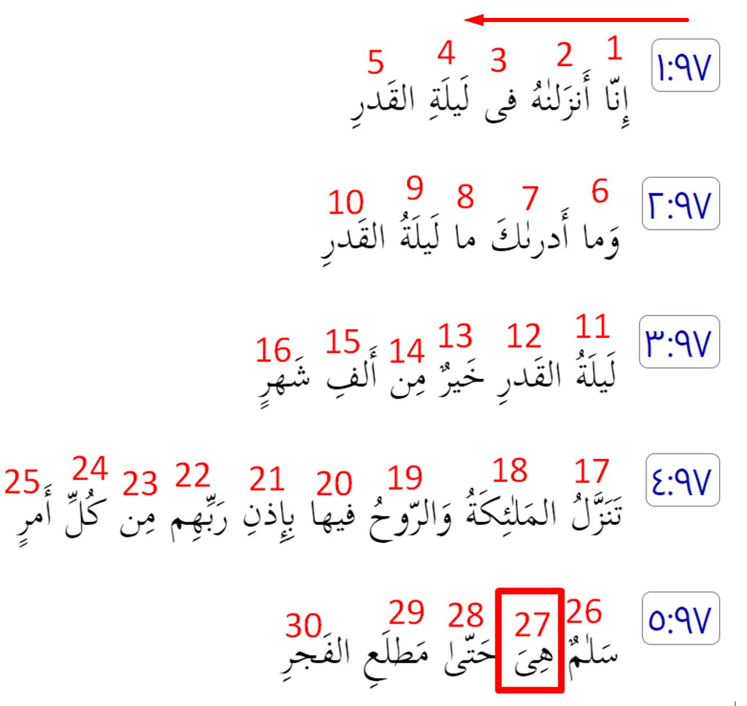
***
When you counting backward : 27th word ‘Night’ (LAYL) reference to Night of destiny.
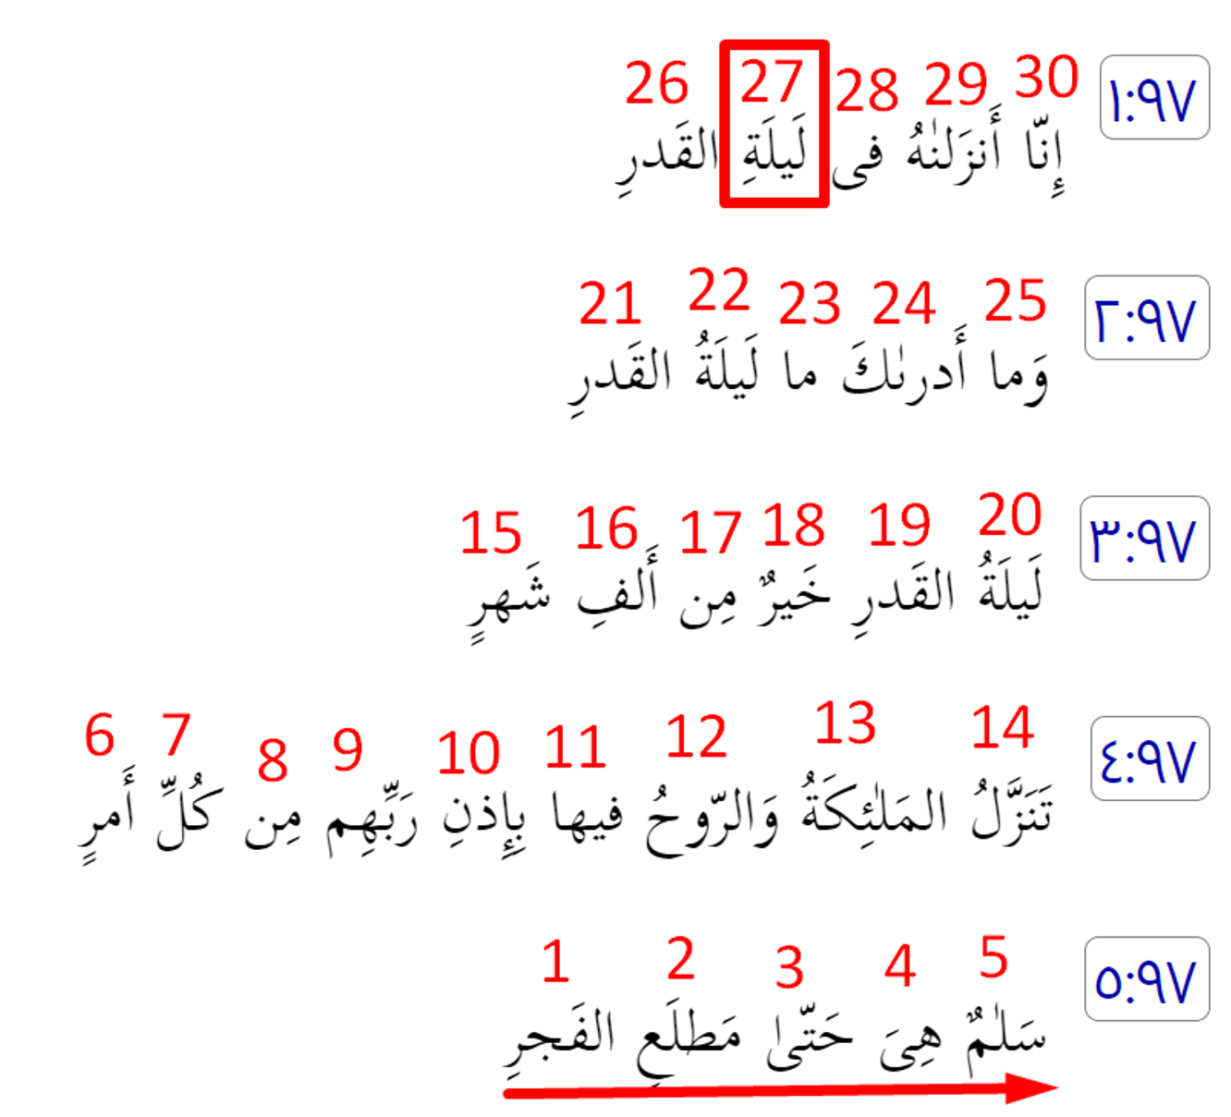
We will show them our proofs in the horizons, and within themselves, until they realize that this is the truth. Is your Lord not sufficient as a witness of all things? (41:53)
This is to ascertain that they have delivered their Lord's messages. He is fully aware of what they have. He has counted the numbers of all things. (72:28) 7 + 2 + 2 + 8 = 19.
Over it is nineteen. (74:30)
We appointed angels to be guardians of Hell, and we assigned their number (19)
(1) to disturb the disbelievers,
(2) to convince the Christians and Jews (that this is a divine scripture),
(3) to strengthen the faith of the faithful,
(4) to remove all traces of doubt from the hearts of Christians, Jews, as well as the believers, and
(5) to expose those who harbor doubt in their hearts, and the disbelievers; they will say, "What did God mean by this allegory?" God thus sends astray whomever He wills, and guides whomever He wills. None knows the soldiers of your Lord except He. This is a reminder for the people. (74:31)
Absolutely, (I swear) by the moon. (74:32)
And the night as it passes. (74:33)
And the morning as it shines. (74:34)
This is one of the great miracles. (74:35) 7 + 4 + 3 + 5 = 19.
Glory to God, Lord of the universe!

