SHAHAADAH
Meaning of Shahaadah?
Shahaadah meaning is “The proclamation of faith” / “Bearing witnesses”
What is Correct Shahaadah?
In Quran 3:18 God teach us Shahaadah is "La Elaaha Ella Allah" in English "There is no god except God,"
God bears witness that there is no god except He, and so do the angels and those who possess knowledge. Truthfully and equitably, He is the absolute god; there is no god but He, the Almighty, Most Wise.
The Shahada or Proclamation of Faith is the same first commandment given to Moses, and it has to be the same commandment given to all the prophets and messengers.
"I, the Lord, am your God who brought you out of the Land of Egypt, that place of slavery. You shall not have any other gods beside me. ....." Deuteronomy 5:6
Why need to declare Shahaadah?
To prove ourself and declare of faith / submission to GOD. By saying correct Shahaadah.
Can we add any other name in Shahaadah, even if it is true?
Never! no one rights to alter God’s word.
The TRUE believers KNOW that Muhammed was the messenger of God and bear witness that "La Elaaha Ella Allah" there is no god besides God.
4:36 You shall worship God alone - do not associate anything with Him.
22:31 You shall maintain your devotion absolutely to God alone. Anyone who sets up any idol beside God is like one who fell from the sky, then gets snatched up by vultures, or blown away by the wind into a deep ravine.
39:3 Absolutely, the religion shall be devoted to God alone. Those who set up idols beside Him say, "We idolize them only to bring us closer to God; for they are in a better position!" God will judge them regarding their disputes. God does not guide such liars, disbelievers.
39:45 When God ALONE is mentioned, the hearts of those who do not believe in the Hereafter shrink with aversion. But when others are mentioned beside Him, they become satisfied.
NOTE THE REASON
40:12 This is because when God ALONE was advocated, you disbelieved, but when others were mentioned beside Him, you believed. Therefore, God's judgment has been issued; He is the Most High, the Great.
The TRUE believers KNOW that Muhammed was the messenger of God and bear witness that "La Elaaha Ella Allah" there is no god besides God.

A Gross Blasphemy
Many Muslims insist on adding Muhammed's name to the shahada, defying God and the idea of keeping the religion absolutely to GOD ALONE. Nowhere in the Quran can we find Muhammed's name added to the name of God in the shahada. The statement, "Muhammed Rasoul Allah" is a statement of fact and should not be confused with the statement of shahada that we bear witness.

However, the Quran's great criterion in 39:45 stamps such are disbelievers: "When God ALONE is mentioned, the hearts of those who do disbelieve in the Hereafter shrink with aversion, but when others are mentioned with Him, they become satisfied."
Quran says in sura The Hypocrites (Al-Munaafeqoon)‎ verse 1:
When the hypocrites come to you they say, "We bear witness that you are the messenger of God." God knows that you are His messenger, and God bears witness that the hypocrites are liars.

There is an indication that mentioning of Muhammad’s name as a messenger of God next to God is the Shahadah of the hypocrites. Thus, those who recite Shahadah adding Muhammad as a messenger of God belong to the hypocrites. But it is unfortunate that the majority Muslims ignore this fact and insist on mentioning “Muhammad is a messenger of God” in the Shahadah precisely stated by God in the Quran as well as the previous scripture.
Since this is the religion of Abraham (2:130, 135; 3:95; 4:125; 6:161; 12:37-38; 16:123; 22:78) the ONLY creed must be "LAA ELAAHA ELLAA ALLAH (there is no god except the One God)". Muhammad did not exist on earth before Abraham.

No distinction among God's messengers
Additionally, it violates the major commandments in 2:136, 2:285, 3:84, & 4:150-152 prohibiting any distinction among God's messengers. By proclaiming that "Muhammad is a messenger of God,"

2:136 Say, "We believe in God, and in what was sent down to us, and in what was sent down to Abraham, Ismail, Isaac, Jacob, and the Patriarchs; and in what was given to Moses and Jesus, and all the prophets from their Lord. We make no distinction among any of them. To Him alone we are submitters."

2:285 The messenger has believed in what was sent down to him from his Lord, and so did the believers. They believe in God, His angels, His scripture, and His messengers: "We make no distinction among any of His messengers." They say, "We hear, and we obey.* Forgive us, our Lord. To You is the ultimate destiny."

3:84 Say, "We believe in God, and in what was sent down to us, and in what was sent down to Abraham, Ismail, Isaac, Jacob, and the Patriarchs, and in what was given to Moses, Jesus, and the prophets from their Lord. We make no distinction among any of them. To Him alone we are submitters."

4:150 Those who disbelieve in God and His messengers, and seek to make distinction among God and His messengers, and say, "We believe in some and reject some," and wish to follow a path in between;
4:151 these are the real disbelievers. We have prepared for the disbelievers a shameful retribution.
4:152 As for those who believe in God and His messengers, and make no distinction among them, He will grant them their recompense. God is Forgiver, Most Merciful.

Mathematical Confirmation :
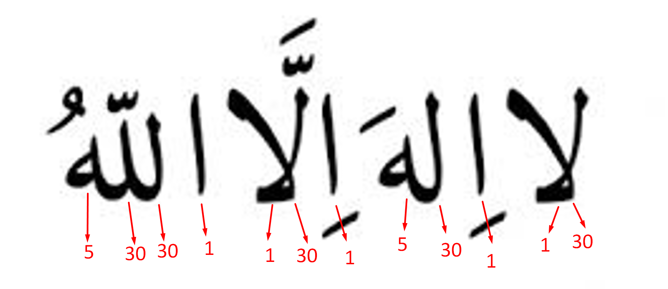
The gematrical (numerical) values of these letters associated with them are 30, 1, 1, 30, 5, 1, 30, 1, 1, 30, 30 and 5. Now if we write these numbers together, which is a multiple of 19
30113051301130305 = 19 x 1584897436901595.
This mathematical confirmation is a stamp of God on this statement clearly indicating to us that this is the correct statement, and this amazing stamp leaves no doubt about our shahadah.
-------------------
There are 5 instances of “wahdahu” (Alone) which refer to God are found in 4 suras of the Quran. If the relevant sura number and verse numbers are added, the sum is a multiple of 19 => 361= 19 x 19
SURA NO | VERSE NO | TOTAL
7 | 70 | 77
39 | 45 | 84
40 | 12,84 | 136
60 | 4 | 64
 |  | 361
 |  | 19 X 19

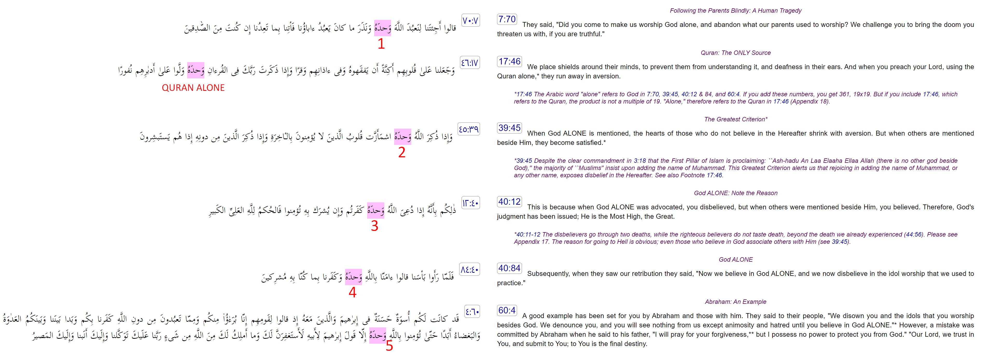
-------------------
This most important expression (LA ELAAHA ELLA HOO= there is no other god besides Him) occurs in 19 suras.
Sura No. 2, 3, 4, 6, 7, 9, 11, 13, 20, 23, 27, 28, 35, 39, 40, 44, 59, 64, 73 = 19 Suras
-------------------
Also, by adding the numbers of the 19 suras where LA ELAAHA ELLA HOO occurs, plus the verse numbers where this crucial expression is found, plus the total number of occurrences (29), the grand total comes to 2128, or 19X112.
SURA NO | VERSE NO | Total Occurrence
2 | 163 | 1
 | 255 | 1
3 | 2 | 1
 | 6 | 1
 | 18 | 2
4 | 87 | 1
6 | 102 | 1
 | 106 | 1
7 | 158 | 1
9 | 31 | 1
11 | 14 | 1
13 | 30 | 1
20 | 8 | 1
 | 98 | 1
23 | 116 | 1
27 | 26 | 1
28 | 70 | 1
 | 88 | 1
35 | 3 | 1
39 | 6 | 1
40 | 3 | 1
 | 62 | 1
 | 65 | 1
44 | 8 | 1
59 | 22 | 1
 | 23 | 1
64 | 13 | 1
73 | 9 | 1
507 | 1592 | 29
TOTAL 507+1592+29 = 2128 (19 X 112)
-------------------

The first occurrence is in 2:163 and the last occurrence is in 73:9. The total of sura numbers plus the number of verses between the first occurrence and the last occurrence, plus the sum of these verse numbers is 316502 = 19 X 16658.
Sura | Verses | Sum of Verses
2 | 123 | 27675
3 | 200 | 20100
4 | 176 | 15576
5 | 120 | 7260
6 | 165 | 13695
7 | 206 | 21321
8 | 75 | 2850
9 | 127 | 8128
10 | 109 | 5995
11 | 123 | 7626
12 | 111 | 6216
13 | 43 | 946
14 | 52 | 1378
15 | 99 | 4950
16 | 128 | 8256
17 | 111 | 6216
18 | 110 | 6105
19 | 98 | 4851
20 | 135 | 9180
21 | 112 | 6328
22 | 78 | 3081
23 | 118 | 7021
24 | 64 | 2080
25 | 77 | 3003
26 | 227 | 25878
27 | 93 | 4371
28 | 88 | 3916
29 | 69 | 2415
30 | 60 | 1830
31 | 34 | 595
32 | 30 | 465
33 | 73 | 2701
34 | 54 | 1485
35 | 45 | 1035
36 | 83 | 3486
37 | 182 | 16653
38 | 88 | 3916
39 | 75 | 2850
40 | 85 | 3655
41 | 54 | 1485
42 | 53 | 1431
43 | 89 | 4005
44 | 59 | 1770
45 | 37 | 703
46 | 35 | 630
47 | 38 | 741
48 | 29 | 435
49 | 18 | 171
50 | 45 | 1035
51 | 60 | 1830
52 | 49 | 1225
53 | 62 | 1953
54 | 55 | 1540
55 | 78 | 3081
56 | 96 | 4656
57 | 29 | 435
58 | 22 | 253
59 | 24 | 300
60 | 13 | 91
61 | 14 | 105
62 | 11 | 66
63 | 11 | 66
64 | 18 | 171
65 | 12 | 78
66 | 12 | 78
67 | 30 | 465
68 | 52 | 1378
69 | 52 | 1378
70 | 44 | 990
71 | 28 | 406
72 | 28 | 406
73 | 9 | 45
2700 | 5312 | 308490
2700 + 5312 + 308490 = 316502 ( 19 x 16658 )

This mathematical analysis of ‘God alone’ “allahu wahdahu” exactly tells us that the association of anything or anyone with God from His creation would be idolatry. Hence, there should not be any doubt in the hearts of the true believers that the correct statement of faith is “There is no god beside God” (in Arabic, laa-ilaaha Illaa allah).
PRAISE BE TO GOD ALONE.

