Directory Structure:

Src/main/java java source code

Src/main/webapp package of bootstrap and jquery as well as .jsp files

Src/main/java/ controller implementation of controller

Src/main/java/databaseconnection implementation of connection to database

Src/main/java/datasource implementation of mapper which generates SQL to database

Src/main/java/dto implementation of data transfer object

Src/main/java/facade implementation of facade object

Src/main/java/domainlogic implementation of “behavior conductor” which process requests from controller and interacts with database by unit of work class

Src/main/unitofwork implementation of unit of work class

Src/main/launch launching server for this system

Test Process:

Two users has been added into system by register function:

Which can be directly used for test:

User1:

Username:kevin zhang

Phone Number: 0416014222

Password: 12345

User Type: buyer

User2:

Username:Ana Wang

Phone Number: 0416014333

Password: 12345

User Type: seller

Index page:

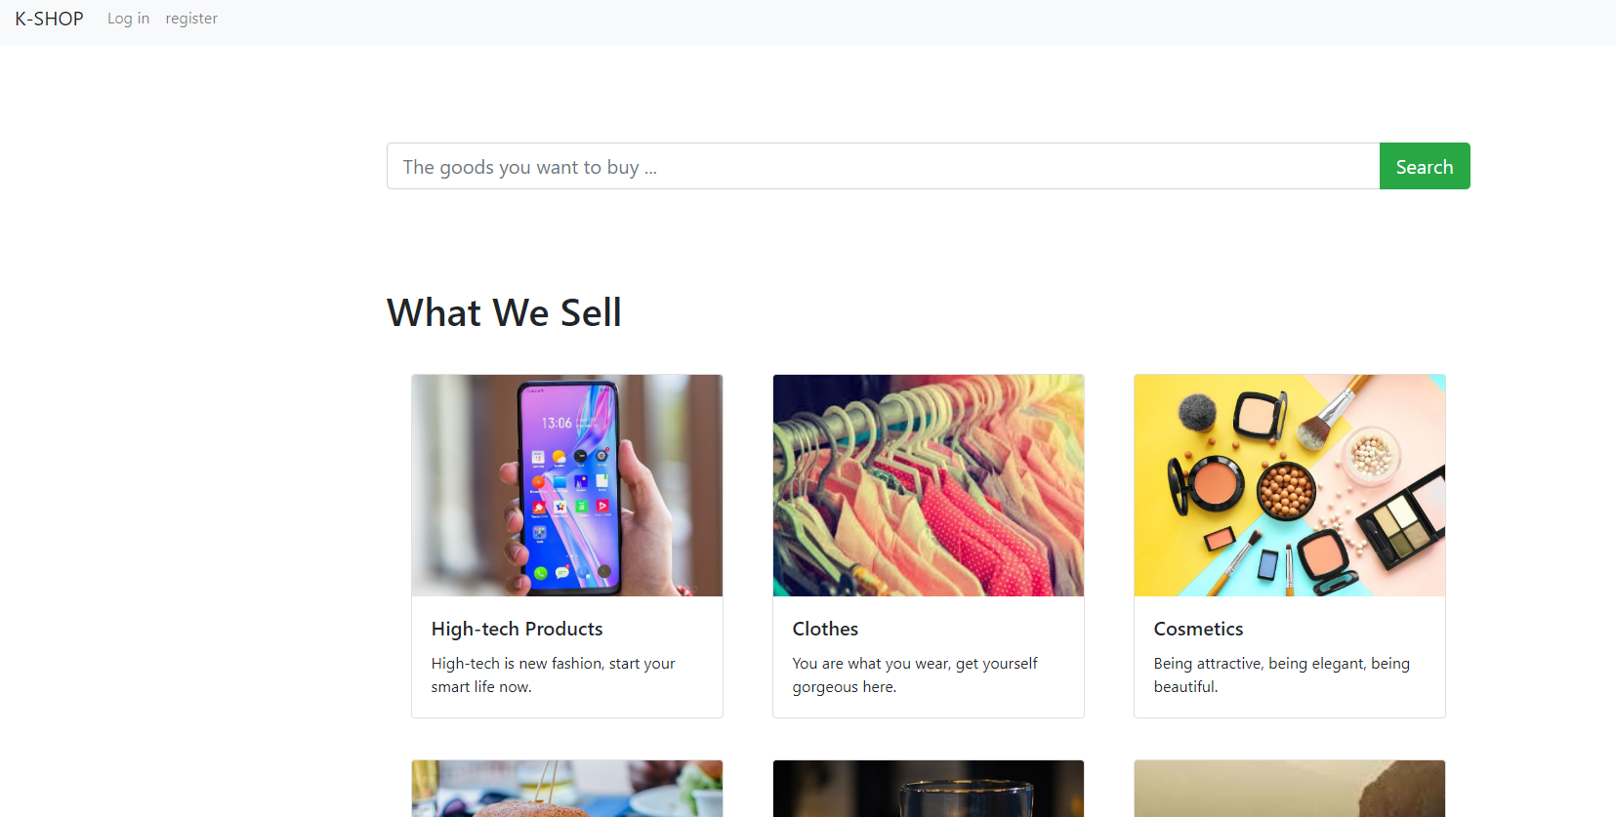

By click search, it can get all goods available in system:

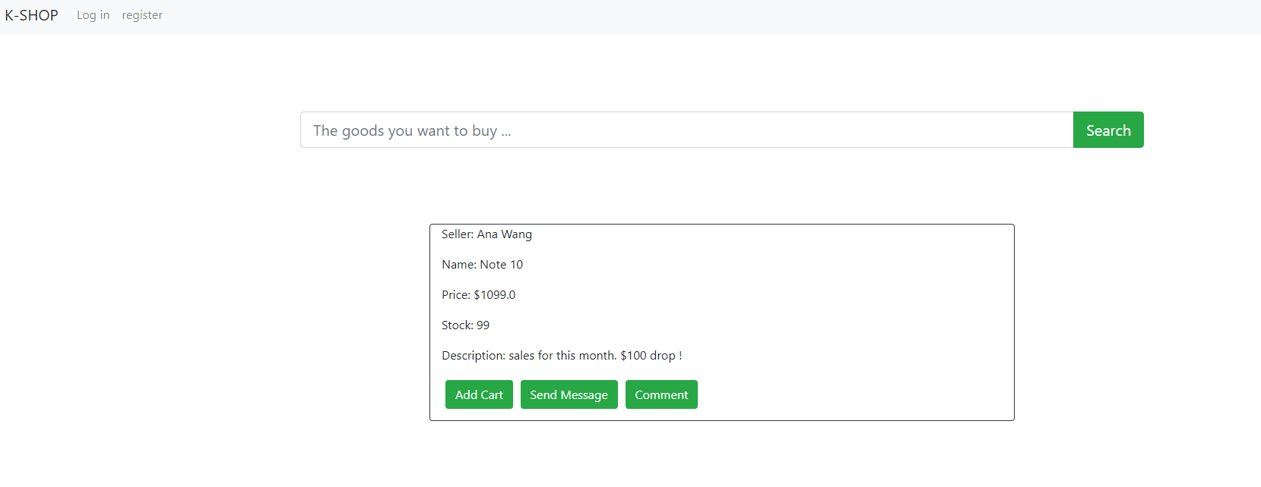

By click comment, it can see all comments for this good

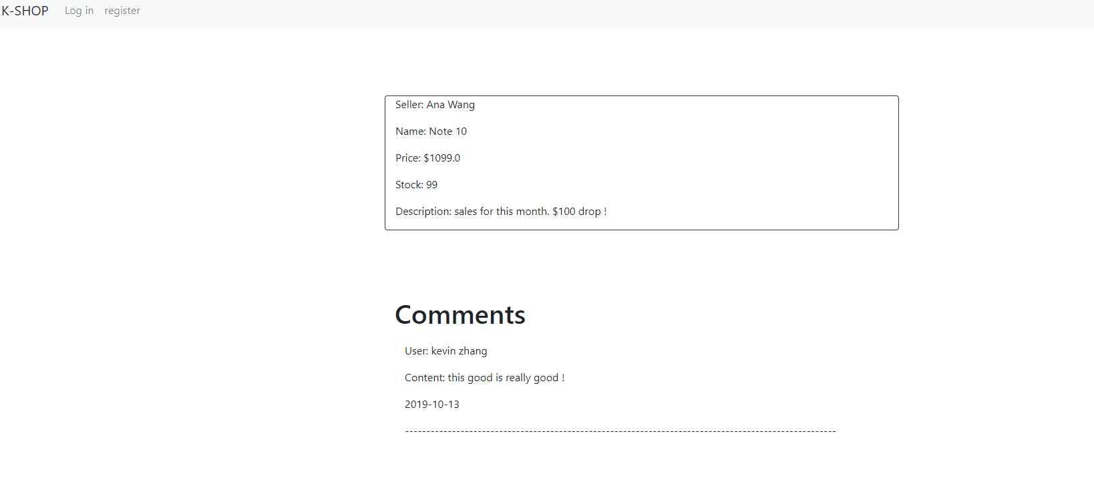When click add cart or send message, as it is not logged in, a alert will pump out to inform log in:

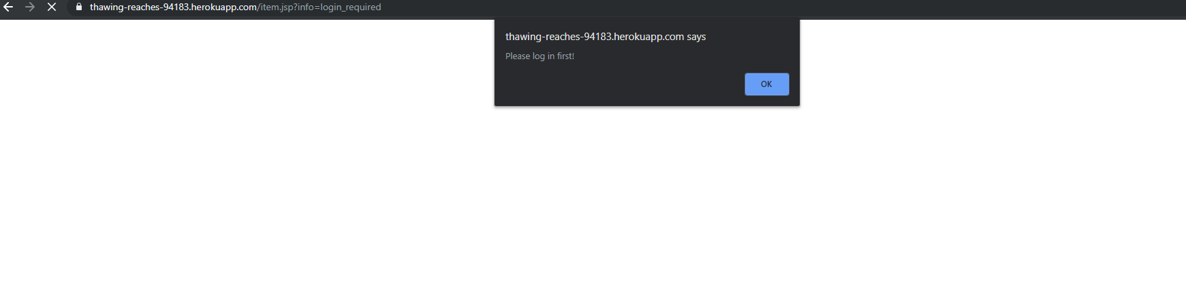

By click log in in navigation bar at top, it comes to log page:

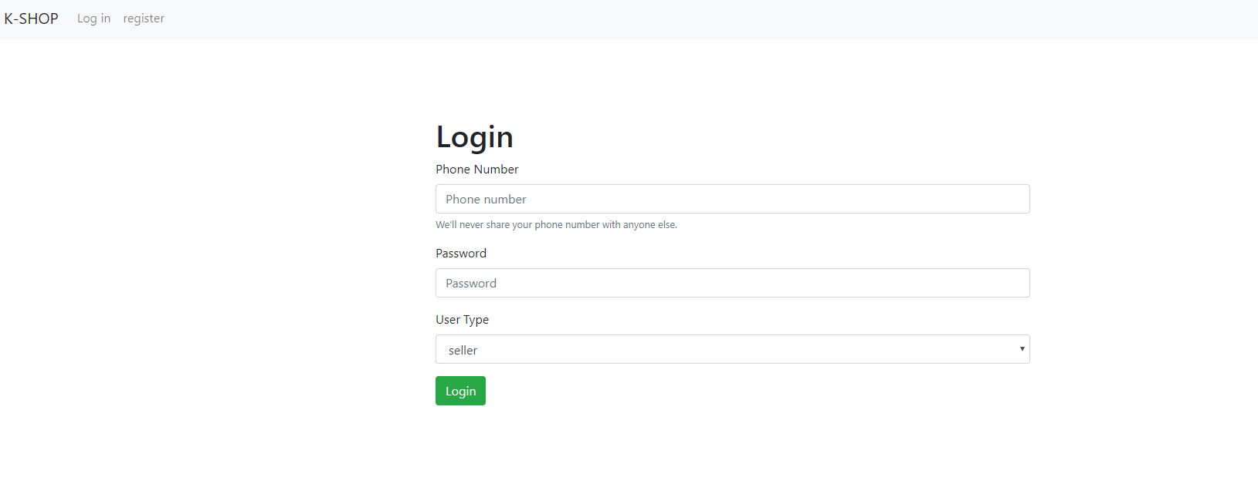

Let s log in by using information of buyer kevin zhang this time, please user phone number/password pair to log in and dont forget choose right user type, after successful log in, navigation bar becomes:

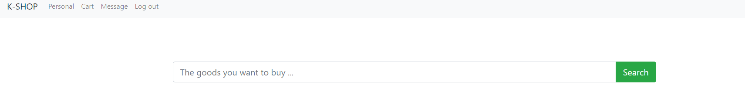

Let’s get into personal:

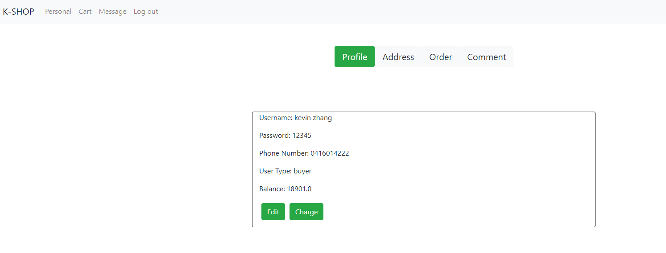

This is your profile, edit is used to edit your username, and charge is to add your balance, lets charge balance first:

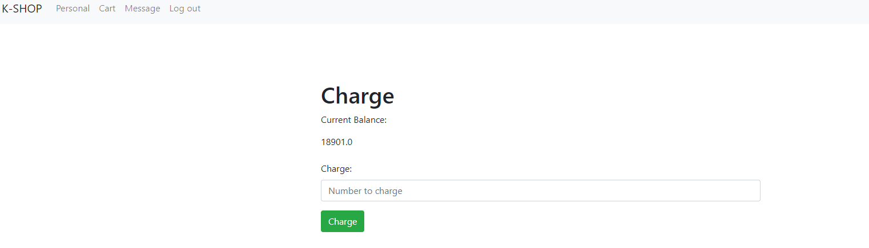

Lets add 5000 to balance

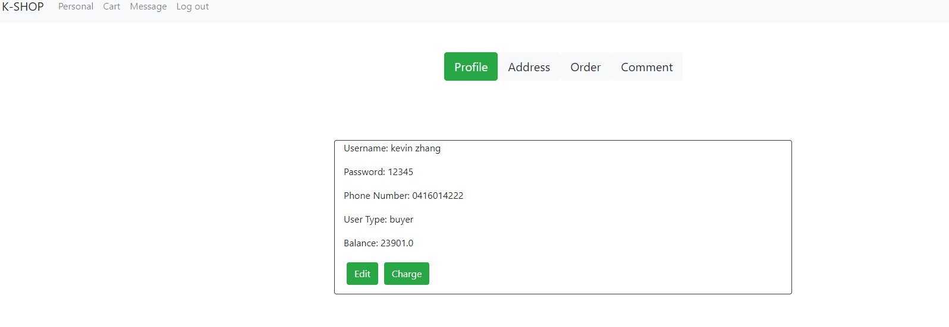

Then it becomes 23901, then lets try edit username by clicking edit:

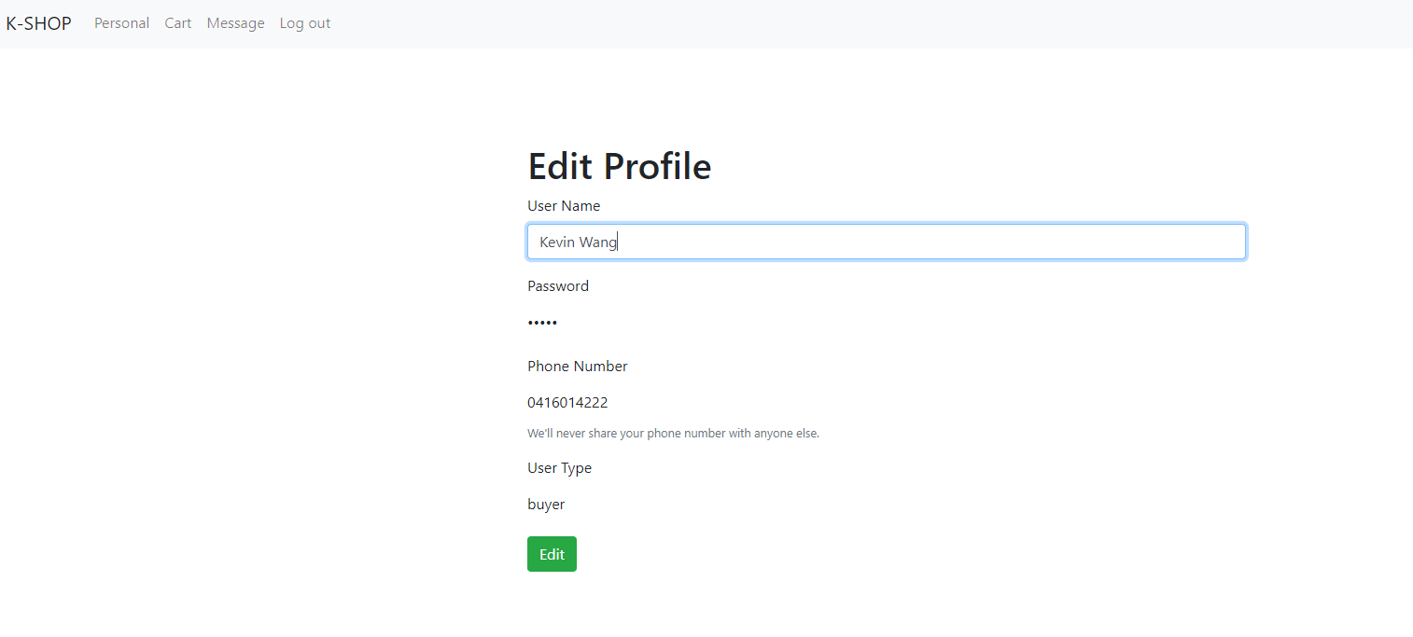

Let try change name to Kevin Wang and edit

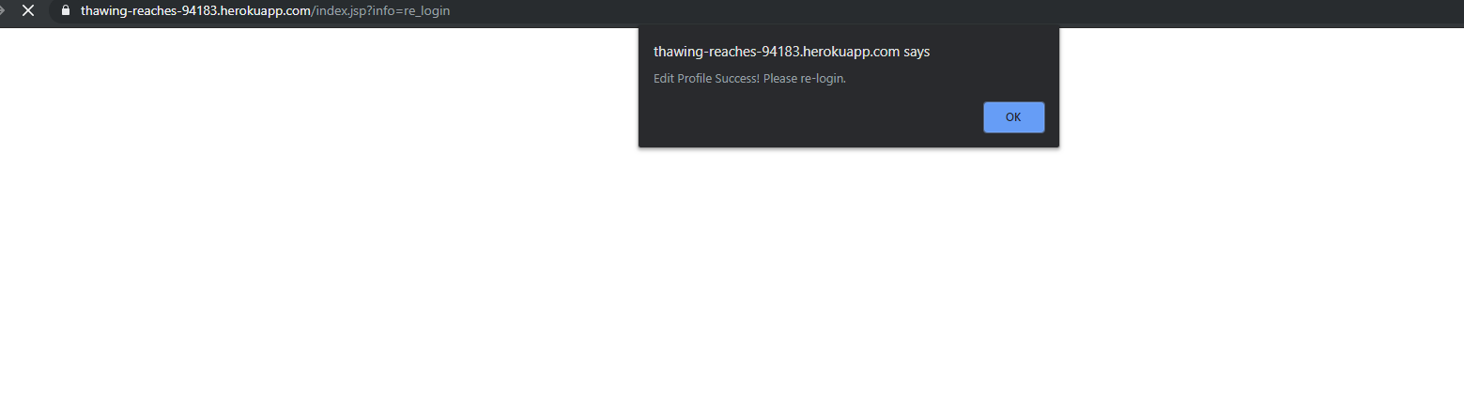

It success, but need re-login to make this session valid.

After re-login, lets try add item into cart. Back to item page we went through before:

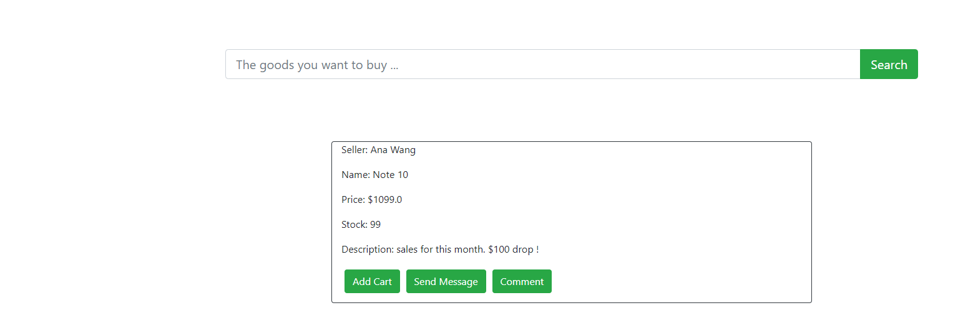

The click add cart:

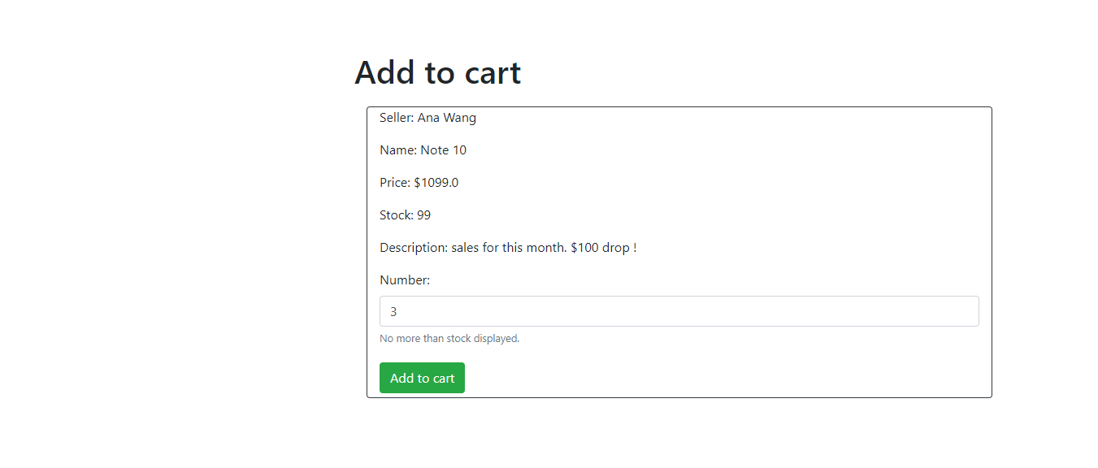

Choose the number you want to add to cart, lets say 3:

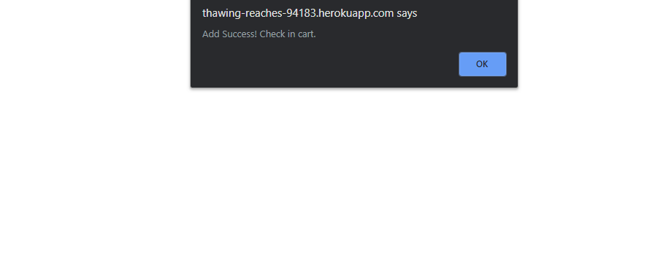

It successes, the lets go to cart by clicking cart in navigation bar:

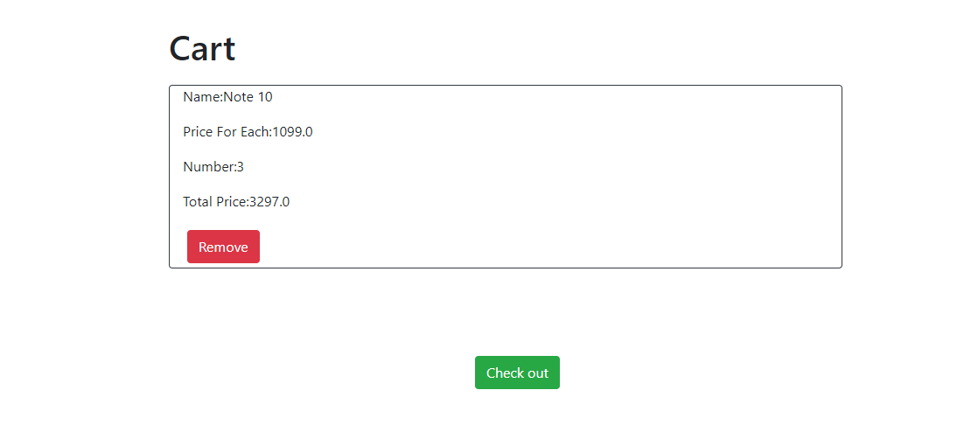

You can see this good already being added, lets check out:

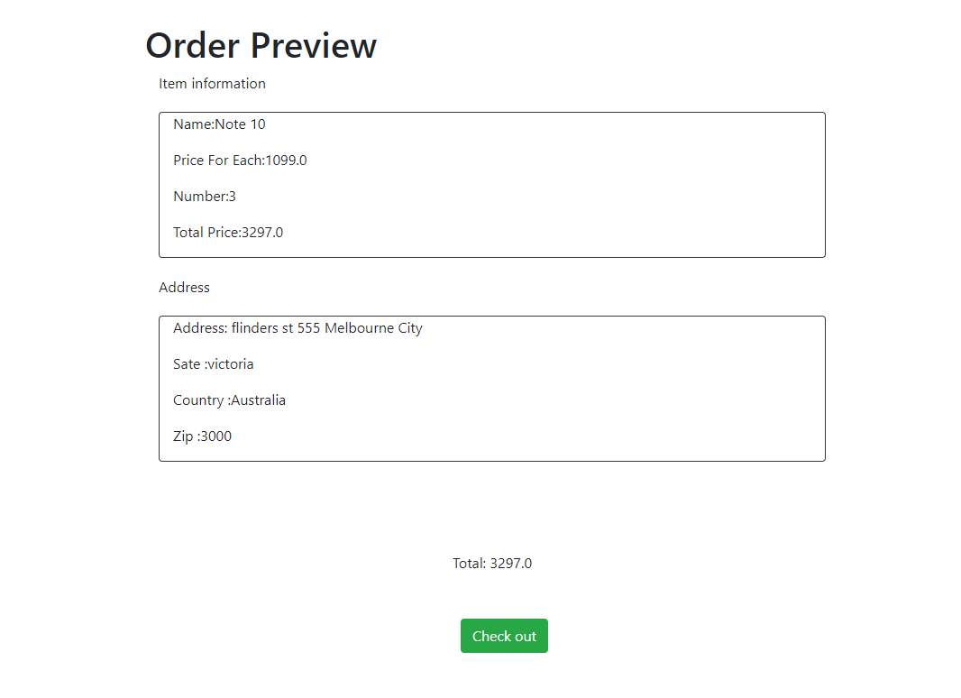

As an address is pre-added for this buyer, it can come to check out process, otherwise this system will ask you to add an address first. Lets check out:

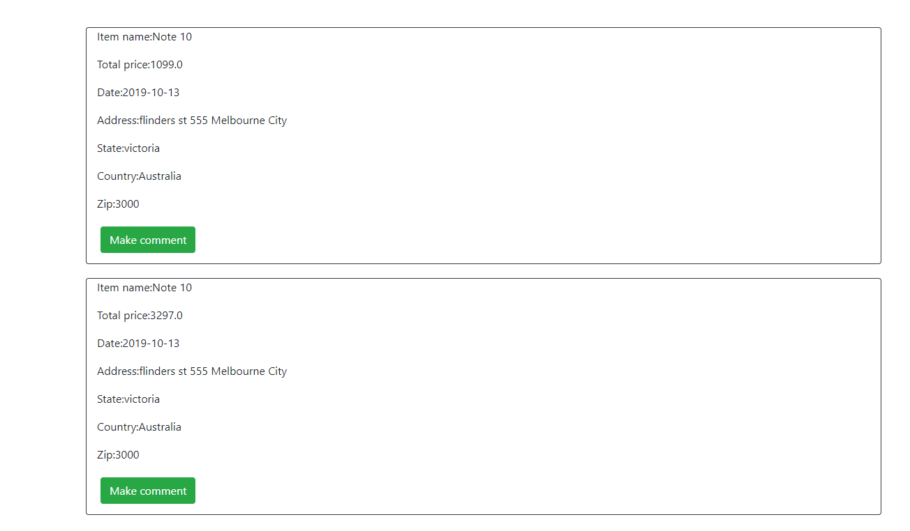

The order has been generated(the first one is something test before. At this time, we can make comments to this good we buy.

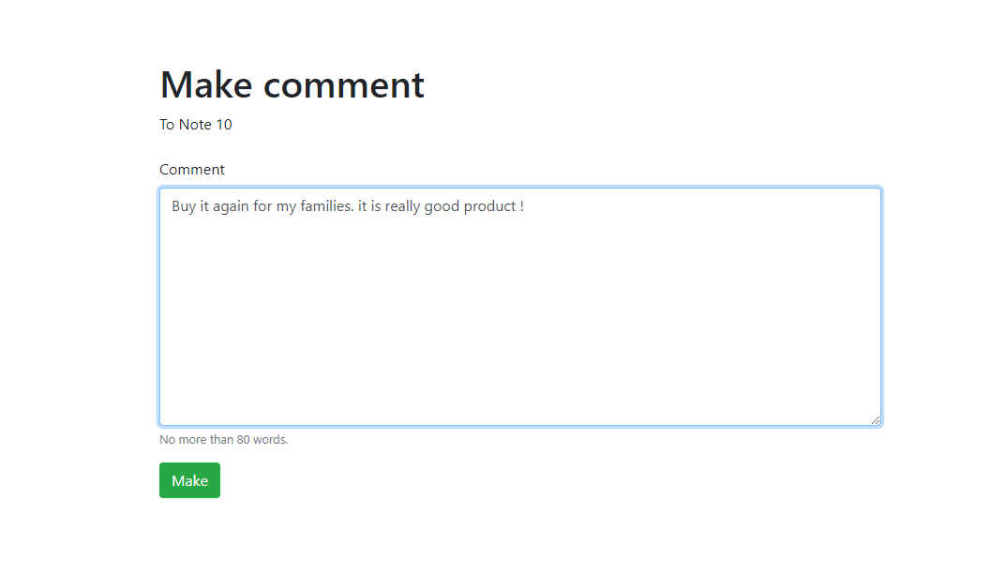

After making comment to this item, we can check this comment in item comment page:

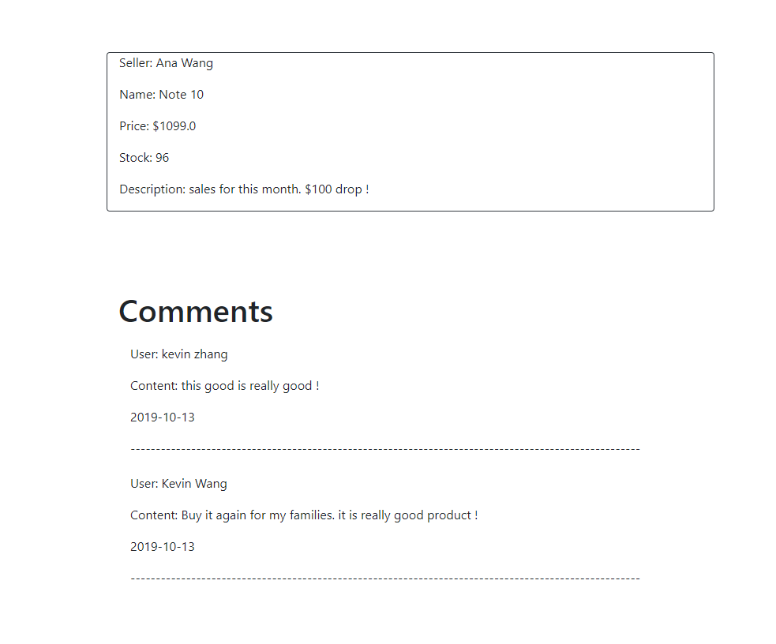

Also, it can be seen in personal page:

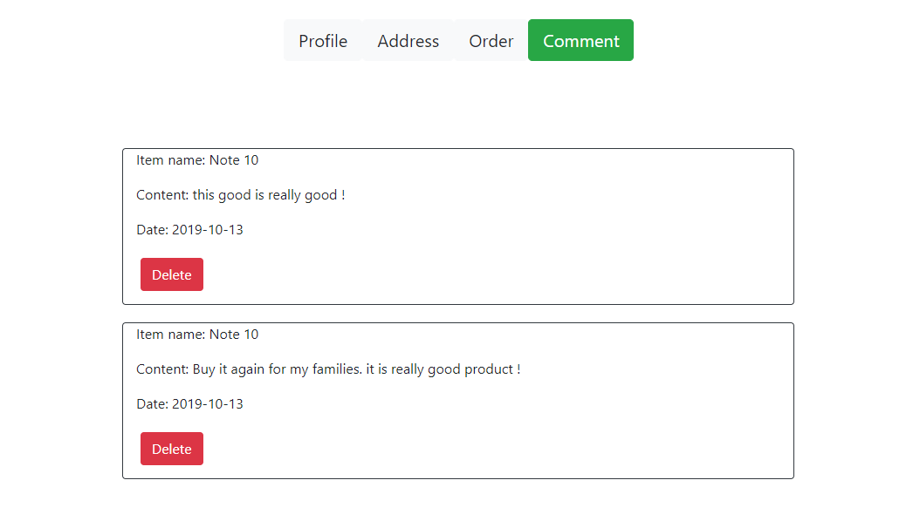

Now, lets try to send message to buyer:

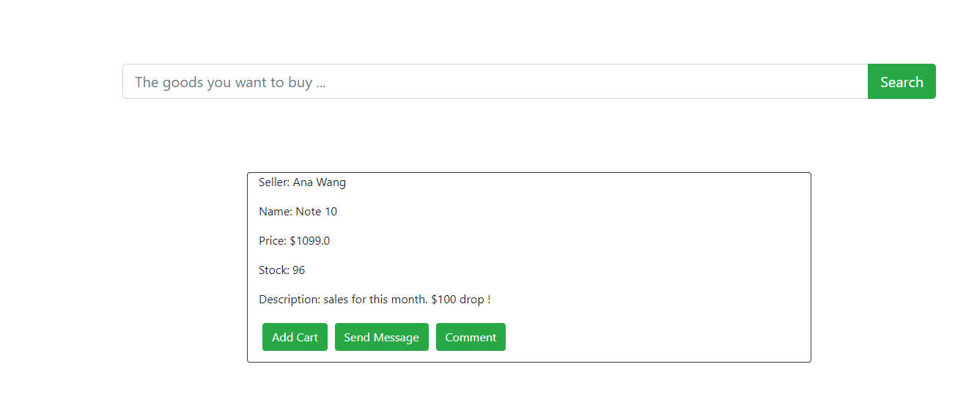

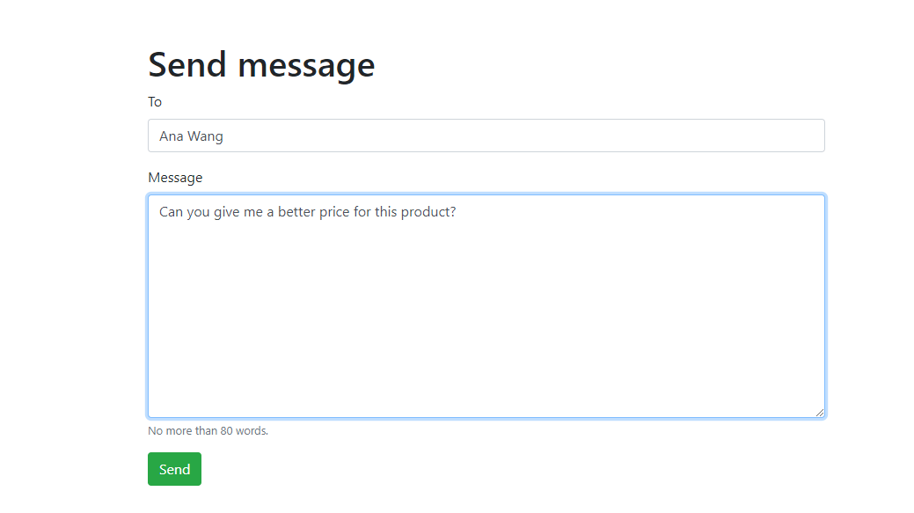

Then it can be seen by clicking message in navigation bar:

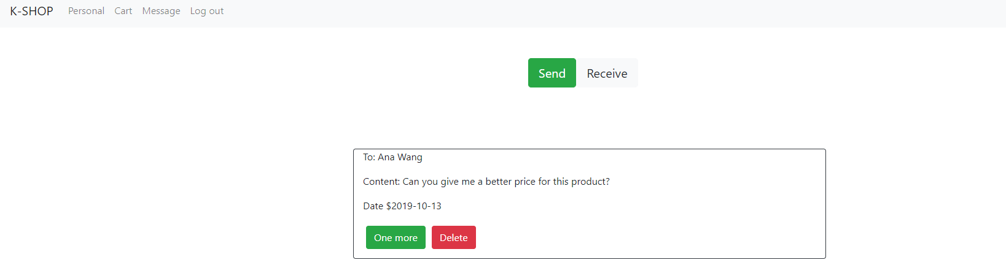

Once more can send one more message to this seller.

Now, lets log out and log in as seller to see what seller can do:

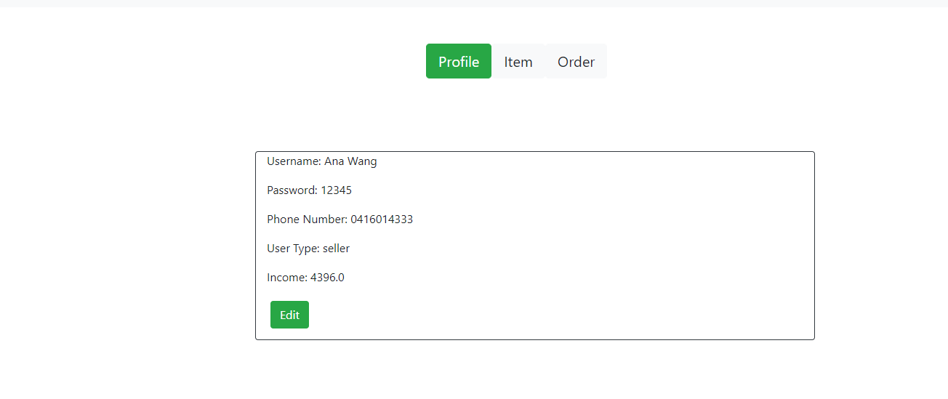

After Log in, it comes to main page of this seller:

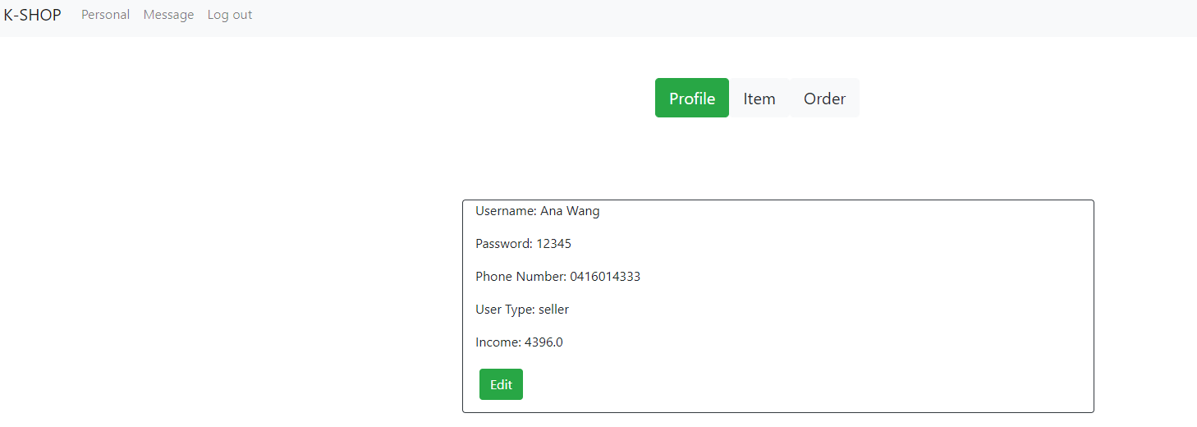

It can be seen information of this seller, and the number of income is exactly the same as kevin spend for purchase. By clicking order, Ana can see the order made by Kevin,

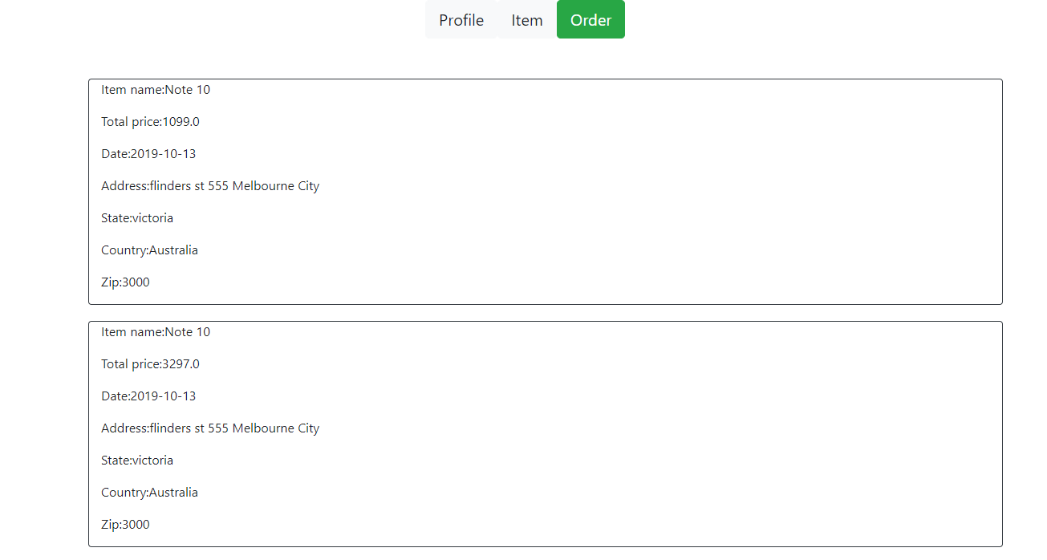

By click item, it can be seen the products sold by this seller:

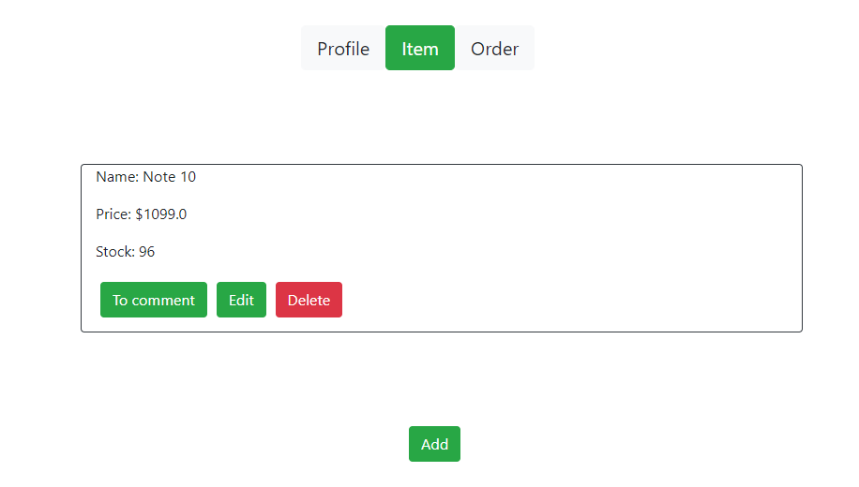

Lets add one more product:

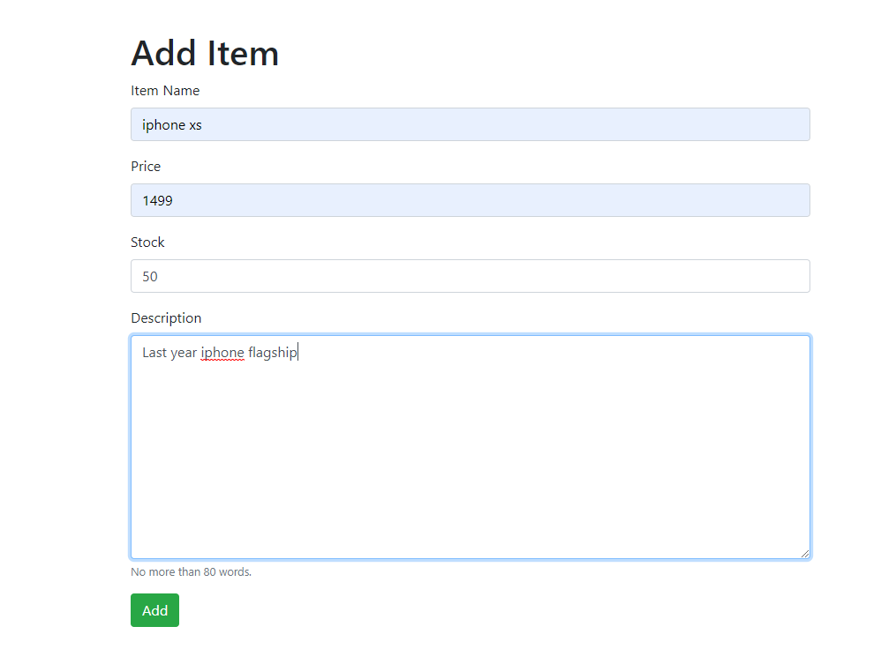

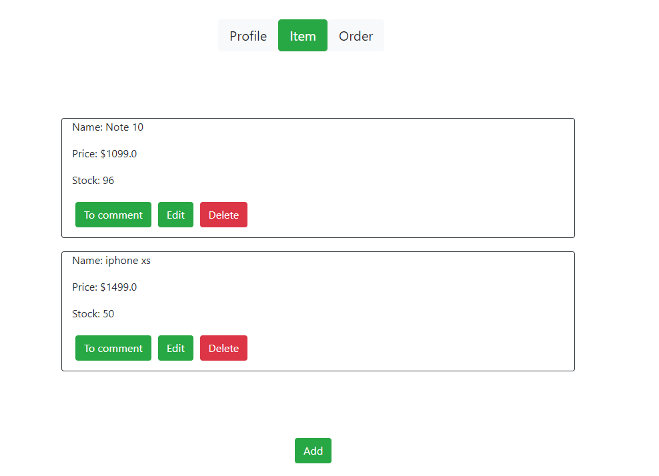

Now it becomes two item.

Lets go to message page by clicking message in navigation bar

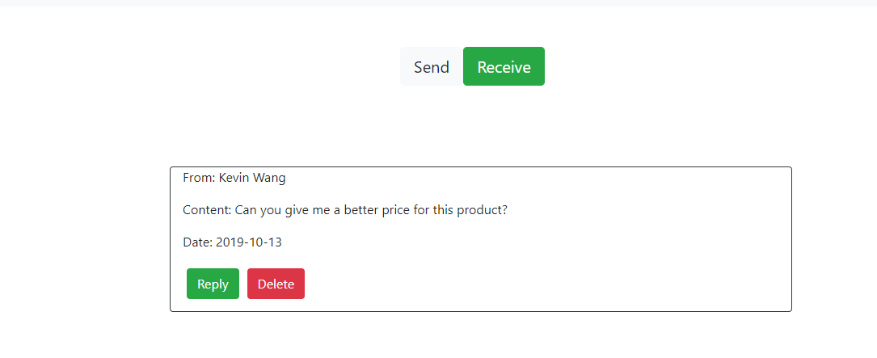

It can be seen message sent by Kevin just now.

As it is prohibited to view all trade-able items in this system when logging as user, lets log out and log in as Kevin to all products again:

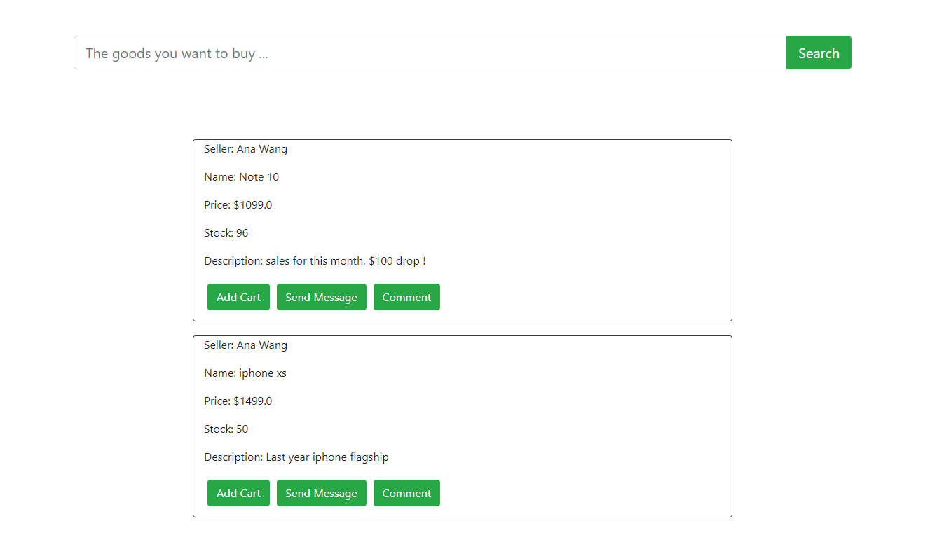

Now the iphone which added just now can be seen and brought. Lets try to search “iphone”

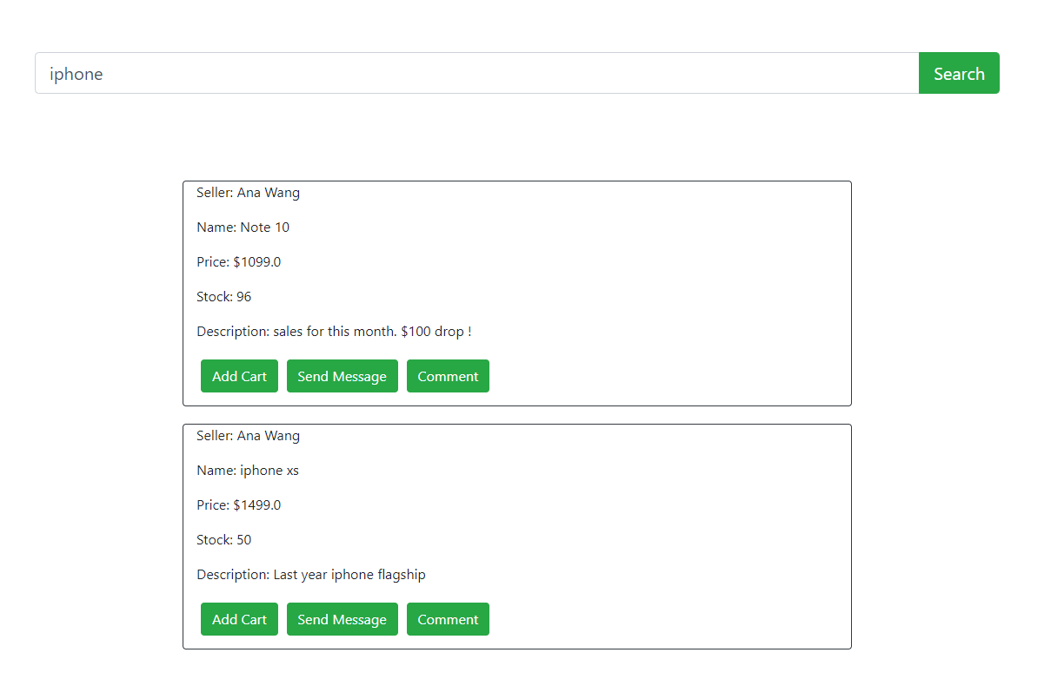

Now only iphone is shown in list.

