Front Porch Coin Co. Site Plan

Logan Welch

WDD 130

Overview

Purpose
The purpose of Front Porch Coin Co. is to provide free, expert in-person coin appraisals directly at the customer’s home. The site explains the service, builds trust, and allows users to easily schedule an appraisal.

Audience
Individuals in the Rexburg area who own coins—collectors, families with inherited coins, hobbyists, and anyone wanting trustworthy, no-hassle, face-to-face appraisal services.

Branding

Website Logo
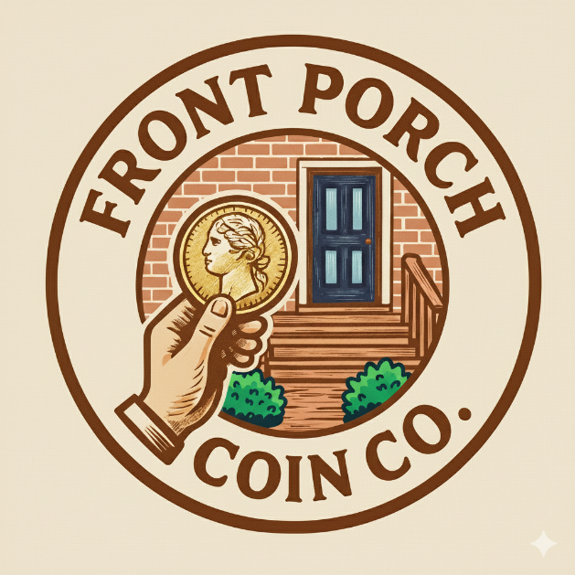

Style Guide

Color Palette
Primary | Secondary | Accent 1 | Accent 2
Primary: #6A3E12 | Secondary: #1F4D70 | Accent 1: #D2A55A | Accent 2: #F3E8C6
Style Guide
Typography
Heading Font: Playfair Display
Paragraph Font: Lato
Navigation
Home | Appraisal Services | About | Schedule Visit | Contact
Content
Home Page:
Real Appraisals, Real People—Right on Your Porch.
Welcome to Front Porch Coin Co., where expert coin appraisals come right to your door. Based in Rexburg, we offer free, in-person evaluations so you can discover the true value of your coins without ever leaving home.
No shipping, no waiting, no hassle—just clear answers about what your coins are worth and why they matter.
Appraisal Services Page:
Free at-home evaluations, grading explanation, rarity insights, selling guidance, and pressure-free advice.
About Page:
Front Porch Coin Co. believes every coin has a story. We provide simple, friendly, local expertise—brought straight to your doorstep.
Schedule Visit Page:
Form for name, address, phone, email, coin description, and preferred appointment time.
Contact Page:
Email, phone, service area map, and FAQs.
Wireframes:

