**Test Case Priority:** 2

**Idea:** Size changinginspection of flowchart blanks “Note” and “Terminator”.

**Additional info:**

Trial account in Lucidchart Pro - login:[bodi4ok@mail.ru](mailto:bodi4ok@mail.ru), passwd:789852

**Reproduce:**

1. Open web page [https://www.lucidchart.com](https://www.lucidchart.com/);
2. login to account;
3. click button “Documents”;
4. click button “+Document”;
5. select in *templates* “Standard” and *category* “Flowchart”;
6. click to button “Start Drawing”;
7. move blank “Note” from section *Standard* to the workspace with drag&drop method;
8. move blank “Terminator” from section *Flowchart* to the workspace with drag&drop method;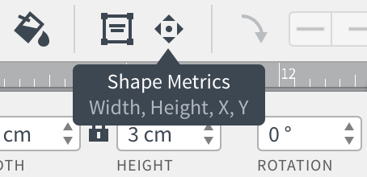
9. select blank “Note”, tap to button “Shape Metrics”;
10. input position X:0, Y:0 and size W:6, H:8;
11. select blank “Terminator”, tap to button “Shape Metrics”;
12. input position X:7, Y:2.5 and size W:6, H:3;

**Expected:** Size ofblanks should be changed.

**Actual:** PASS

**Created:** 16.10.2016 by Bogdan Trush