Gamapi  
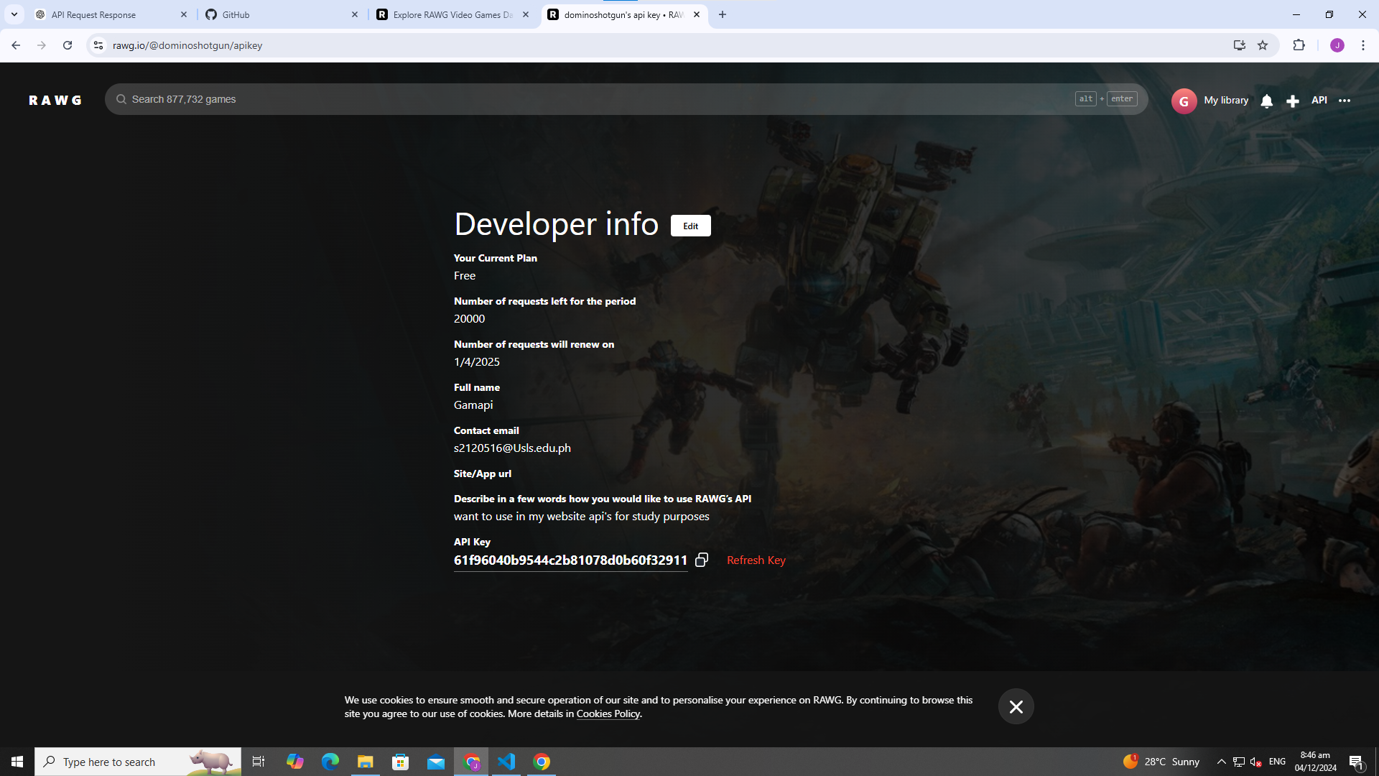

My website url for this:  
<https://rawg.io/@dominoshotgun/apikey>  
  
website url:  
<https://rawg.io/apidocs>