Data Analysis (Hotel - Booking)

Author: Sajid Ansari
Date:- 02/05/2026

Analysis and Findings

This hotel booking dataset contains nearly 1.19 lakh bookings. City Hotel gets more guests than Resort Hotel, and most visitors arrive in August, suggesting summer is the busiest season. Guests mostly prefer Bed & Breakfast and the majority come from Portugal. Most bookings happen through Online Travel Agencies and guests generally book without paying any advance deposit.

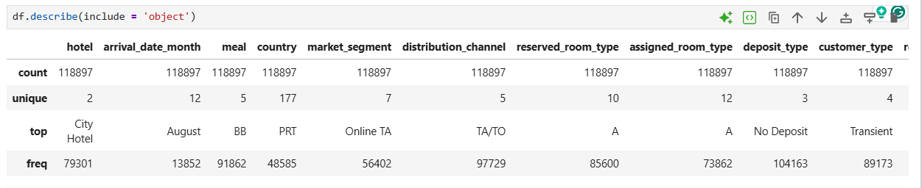
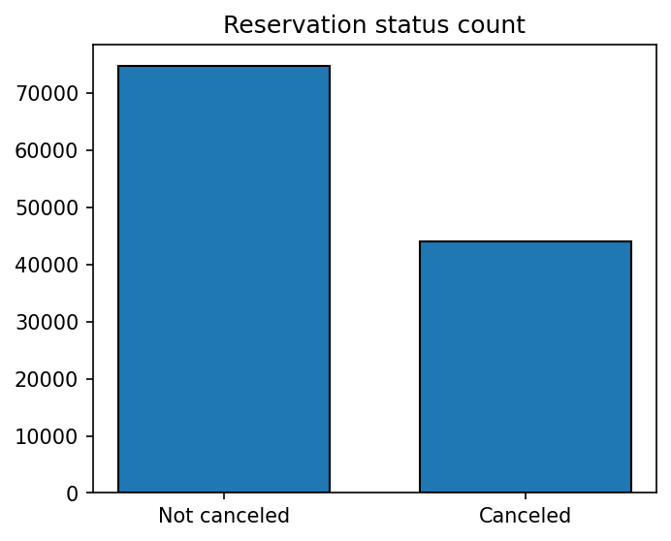

The provided text explains that the accompanying bar graph illustrates the percentage of reservations that were canceled compared to those that were not. While a significant number of reservations remain active, 37% of clients still cancel their bookings. This high frequency of cancellations creates a major impact on the hotels' total earnings.

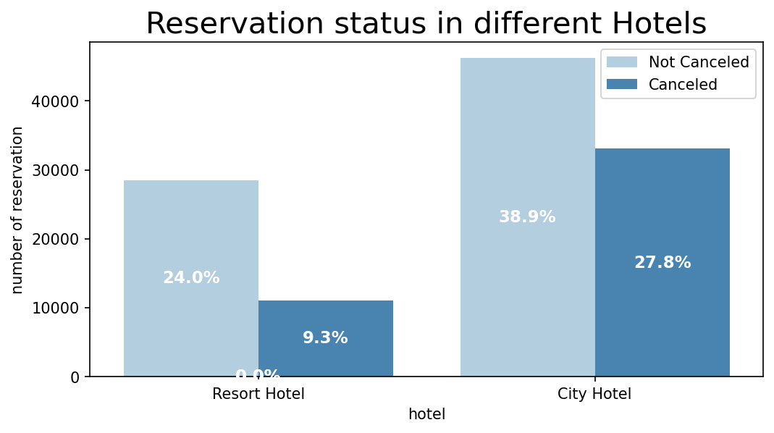

In comparison to resort hotels, city hotels have more booking. It’s possible that resort hotels are more expensive than those cities

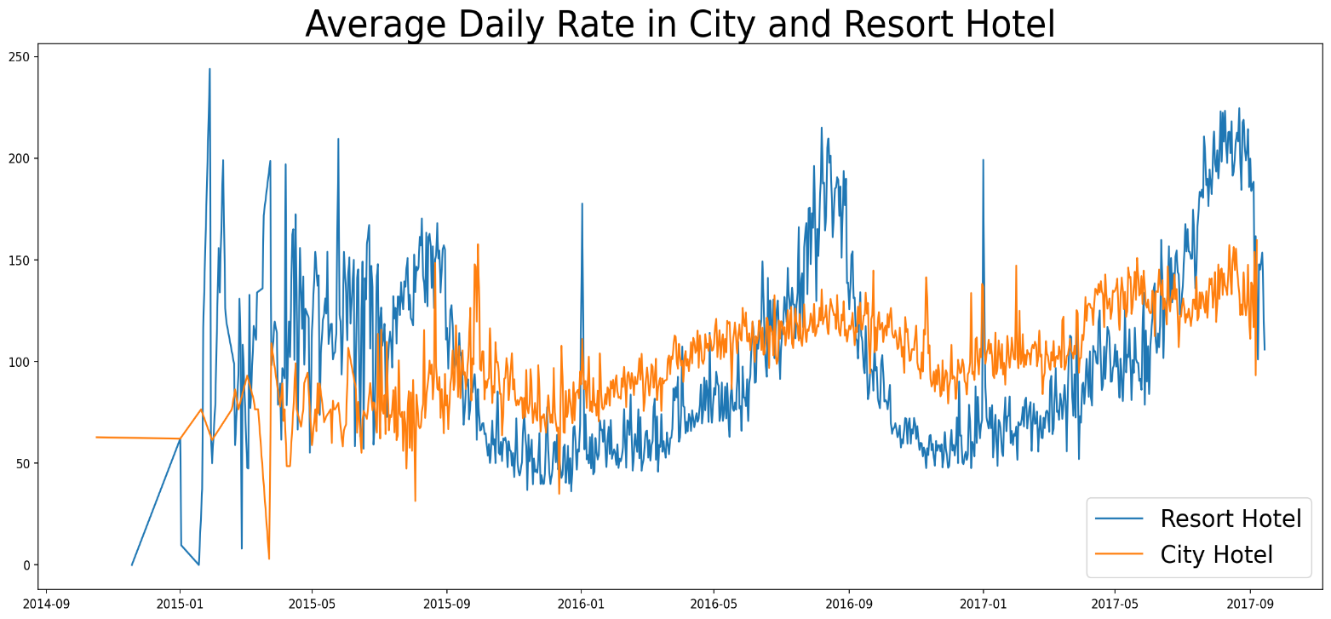

The line graph above shows that, on certain days, the average daily rate for a city hotel is less than that of a resort hotel, and on other days, it is even less. It goes without saying that weekends and holidays may see a rise in resort hotel rates.

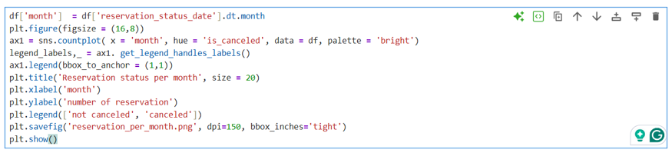

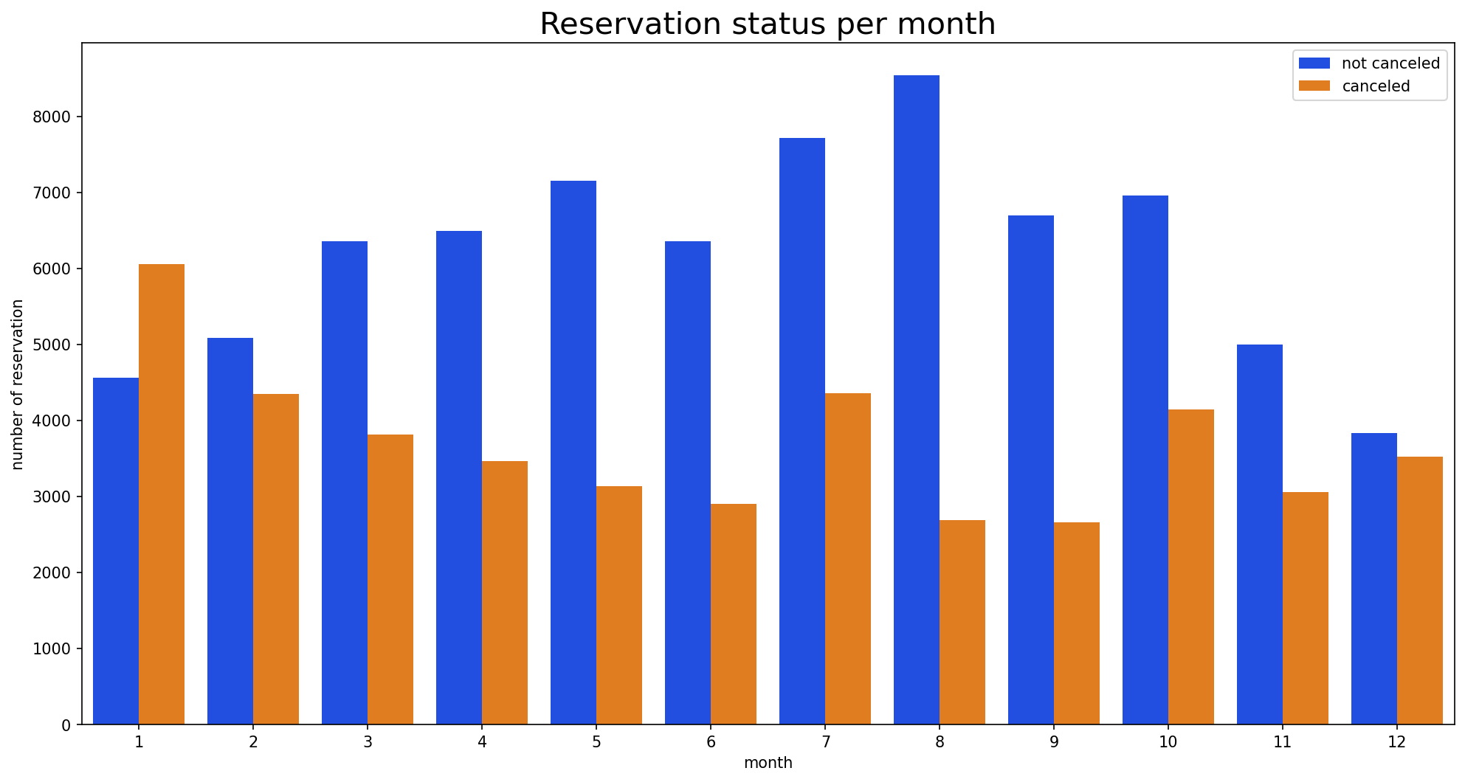

We have developed the grouped bar graph to analyze the Months with the highest and lowest reservation according to the Reservation status.
As can bee seen, Whereas January is the month the most cancelled reservation.

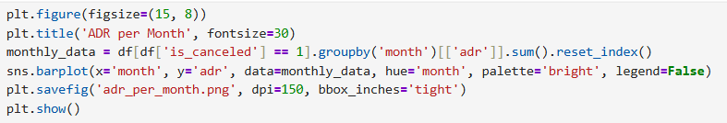

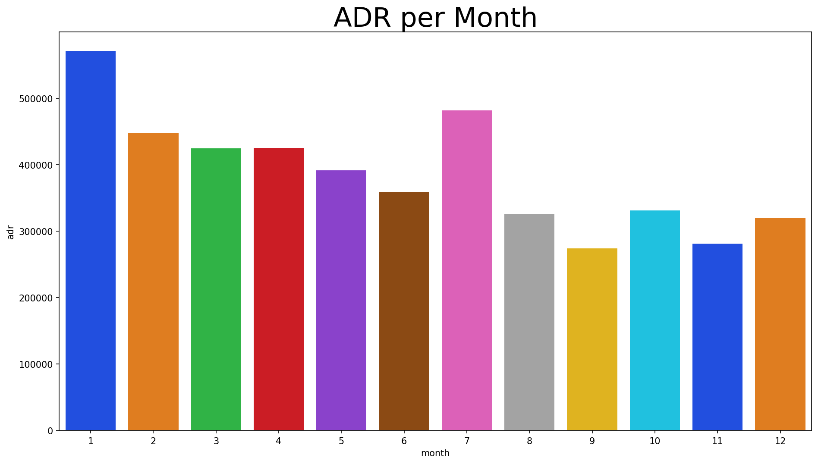

This bar graph clearly shows that cancellations are most common when prices are highest and least common when prices are lowest. Therefore, the cost of accommodation appears to be a major factor influencing cancellations.

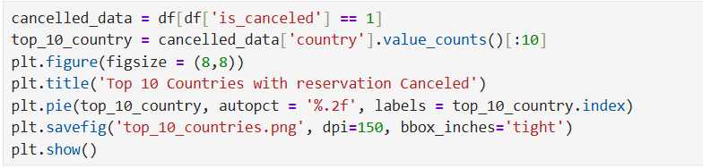
Now, let’s look at the top 10 countries with the most cancellations. As you can see, Portugal has the highest number of cancellations.

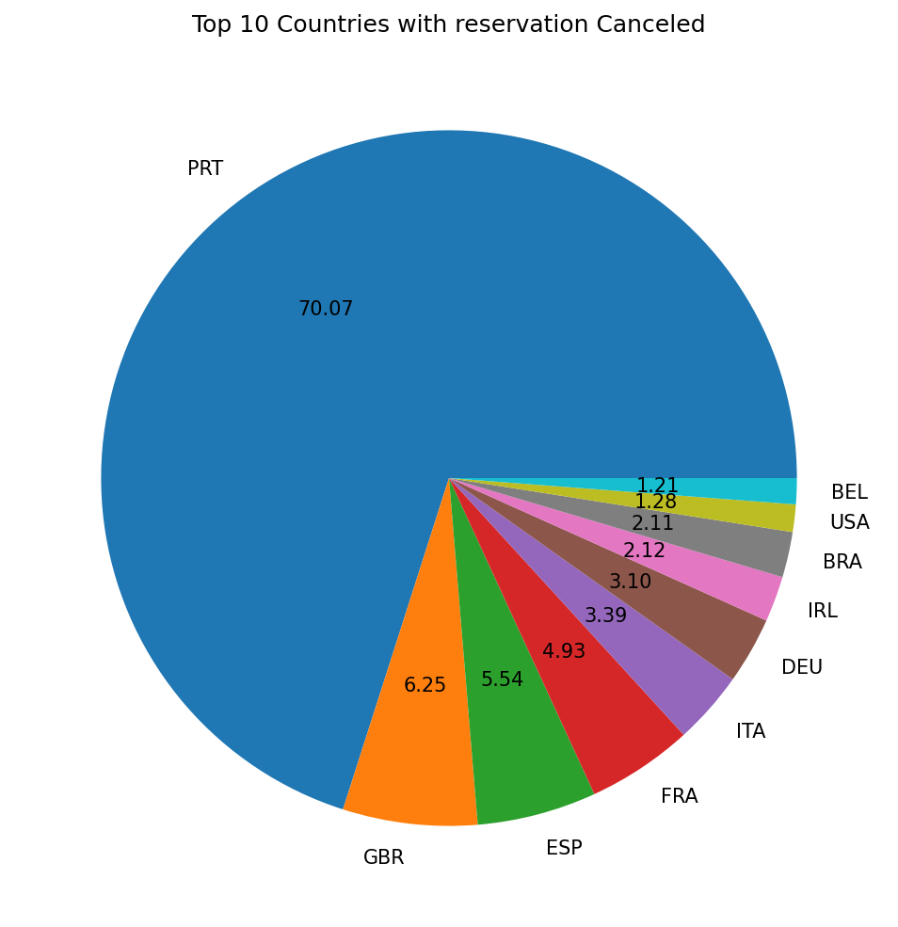
Portugal has 70% of the reservation cancellations as compared to other countries, this is very big number.

Solutions
- Social Media Marketing — Run targeted ads on Instagram and Facebook based on locations to attract more guests and increase brand visibility.
- Affordable Pricing Strategy — Decrease room prices to make stays affordable for every family, or enhance the value by offering more facilities and amenities at the current price.
- Online Platform Partnerships — Partner with popular booking platforms like Booking.com, MakeMyTrip, Agoda, and Goibibo to increase visibility and reach more customers worldwide.
- Influencer Collaboration — Collaborate with travel influencers to promote our hotel, showcase its facilities, and attract a wider audience through authentic content.
- Flexible Cancellation Policy — Offer free cancellation up to 48 hours before check-in to reduce the 37% cancellation rate and build customer trust.
- Early Bird Discounts — Offer lower prices for guests who book 30-60 days in advance to secure bookings early and reduce last-minute cancellations.
- Target International Guests — Since Portugal has the highest cancellations, focus marketing campaigns on other countries like UK, France, and Germany to diversify bookings.
- Weekend & Holiday Packages — Create special combo packages (stay + meals + activities) for weekends and holidays when Resort Hotel rates rise.
- Improve Online Presence — Maintain strong ratings on Booking.com, TripAdvisor, and Google Reviews since most bookings come through Online Travel Agencies.
- Email & WhatsApp Reminders — Send booking confirmation reminders to guests a few days before check-in to reduce no-shows and cancellations.
- Improve Online Presence — Maintain strong ratings on Booking.com, TripAdvisor, and Google Reviews since most bookings come through Online Travel Agencies.

