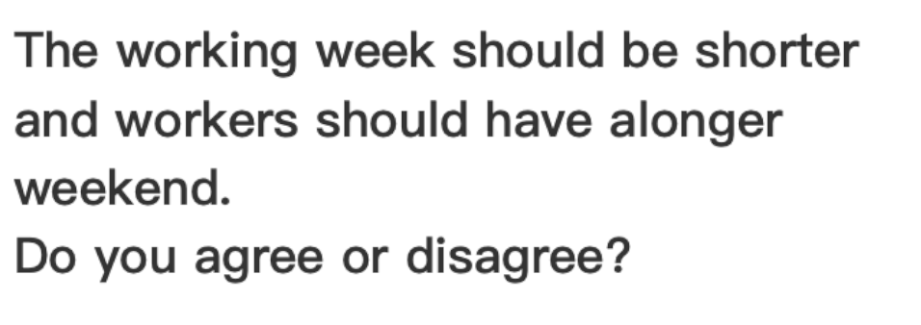

The week regulation has been used for hundreds years. However, whether the work days should be reduced is controvercial. My view is that while a longer weekend plays vital role in mitegating people’s pressure, societies cannot work effectively without people’s significant contributions.

On the one hand, extra rest time contributes to individuals’ physical and mental health. If workers are allocated a longer weekend such as 3 days off per week, they could spend more time on relaxing activities like participating a gym class or going for a hiking, which can not only alleviate the stress from work but also lead to a stronger body. Additionally, it offers a crucial opportunity for people to learn extra skills, who tend to promote themselves. Companies can also benefit from multi-skilled employees.

However, companies’ revenue would be negatively impacted by a shorter weekdays. This is because that factories have to not only pay salaries for the extra off day but also withstand the reduction of incom; ultimately leading to closing down. Moreover, consumers may experence a poor services due to the longer weekends. For example, people couldnot reclaim cashes from bank in time, patients cannot get efficient treatment during longer weekends and youth spend less time in school results in poor academic performance.

In conclusion, although a longer day off is beneficial for workers’ well-being, the tactic may slower the economic development and exert adverse influences in some aspects such as education and healthcare. Therefore, I think 2 days off is a balanced strategy.

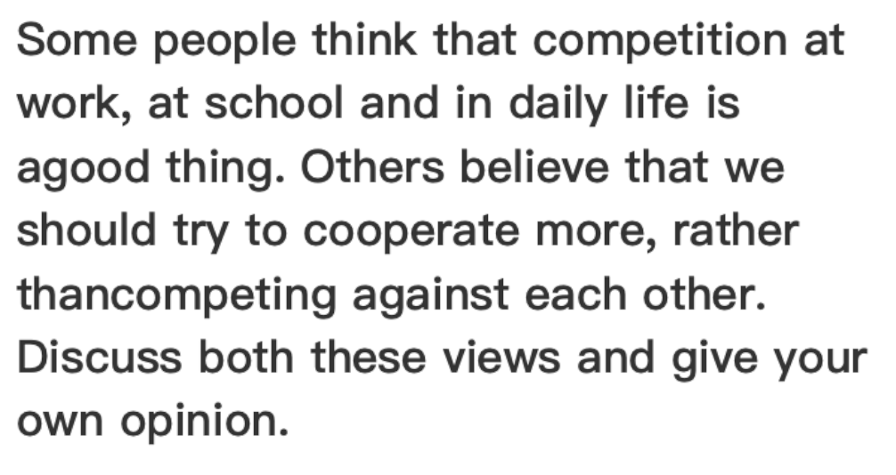

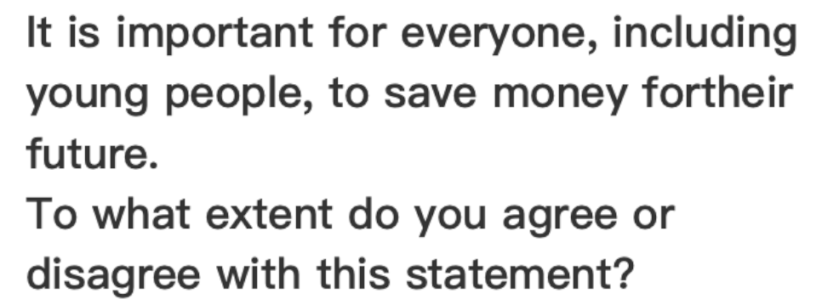

Money is the material fundation of our lives and most people place escessive emphasis on money. In my opinion, while saving money is essential for everyone, enjoying our present life is seen as equally important.

Accumulating adequate money plays a vital role in ensuring people’s basic material lives. saoIf people do not have any saving, they will face significant challenges when some accidents occur to them. For example, few years age, recession lead to financial problems in many companies, downsizing was adopted as a effective measure to enable companies to survive. Therefore, employees who lost jobs would be struggle to live a life without any accumulation. Additionally, young people are often interested in digital devices which are ususally expensive. Saving money offers an opportunity for them to purchase what they want.

While saving money for future is crucial, consuming for a high level live is also important.

It is essential for people to foster an approprait sense of consumption. Thus, if you have accumulated sufficient money before, you should pay attention to the quality of your lives and the dreams that haunts you for a long time. Moreover, remember that the ultimate goal of saving money is to enhance your lives and pursue your goals such as traveling around the world, purchasing a biger house and investing in your own business.

In conclusion, although saving money for the future is necessary for everyone, focusing on your own interests and dreams is more meaningful when you have saved amount of money. It really depends on individual personal circumstance.

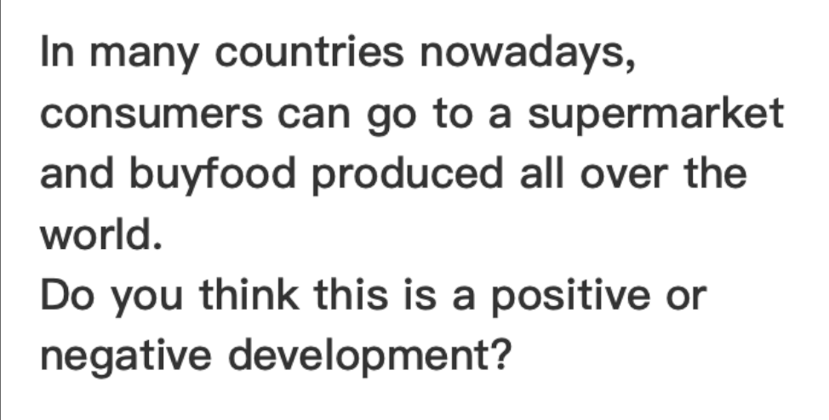

In recent years, many countries around the world have been united as an international group and global trade profoundly impacts the economic development. This trend offers people an opportunity to buy daily goods from worldwide at local markets. In my opinion, this development has both positive and negative effects on individuals and local governments.

One positive influence is that citizens can benefit from this trend. Various products from different countries sold in a supermarket provide local people with diverse options so that they can purchase what they desire without geographical limitations. For example, residents can buy red wine from France, fresh coconuts from Thailand and high-quality watches from Switzerland. Overall, this situation significantly fulfills people’s lives and meets people’s material demands to some extent.

On the other hand, importing foreign products negatively impacts the development of local industries. A diversity of external goods sold in supermarkets may lead to the reduction of income of some small-scale stores. This is because, with economic growth, the public prefers to purchase famous brand goods rather than spending less money on ordinary items. For instance, the electric car from Tesla is the most popular choice instead of a domestic unknown brand. Additionally, electric tools from Germany are more acceptable than some poor-quality but cheaper ones from local factories. As a result, some small-scale factories cannot survive the trade globalization, imposing economic burdens on local governments.

In conclusion, while importing external brands may result in some local industries closing, global trade makes it convenient for the public to enjoy diverse and high-quality goods from all over the world. However, the adverse effects on local factories can also be regarded as a motivation for them to enhance the quality of their products.

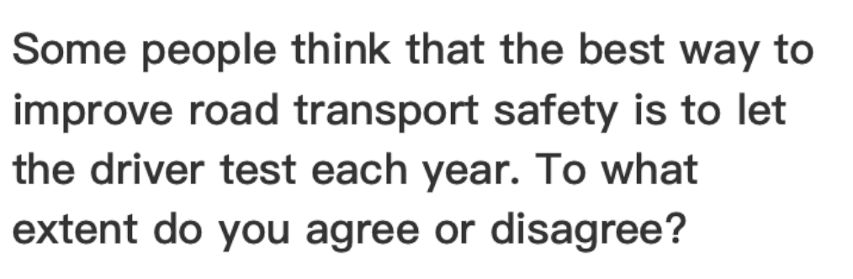

In recent years, the rate of transport accidents has significant increased. Although, requiring drivers to engage tests every year can be regarded as an effective way, the governments should focus on multi aspects to reduce the traffic accidents.

It offers an opportunity for drivers to deeply understand the traffic regulations through annual driver test. Without frequent examinations, drivers may be unfamiliar with transport rules or neglect some rules, leading to irreversible catastrophes. For example, drivers who lack the strong sense of transport safety may overlook the rules which require people to have a rest after four hours continuely driving, result in potential pitfalls. Consequently, the engagement of traffic rules test for drivers is necessary.

However, not all traffic accidents are cause by drivers, people who break the traffic rules should be responsible for the car crashes including pedestrians. Therefore, the governemnts should not only pay attention to drivers but also walkers. For instance, refining the lagislation of road transportation and elevating the conquence of illeagle behaviors serve a crucial means for enhancing the protection of the public.

In conclusion, while requiring driver test annually contributes to mitigating the rate of accidents on road, combining other strategies such as enhancing the outcome of breaking traffic rules and helping people deepen the sense of road transport safety can be seen as a balanced tactic.

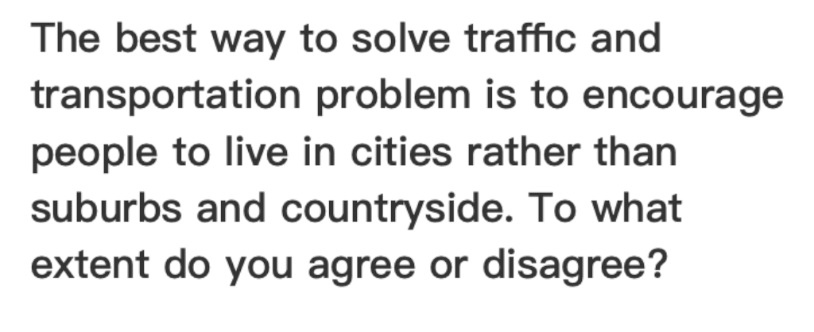

Convenient transportation plays a crucial role in people’s daily lives. However, it is not uncommon for most farmers suffer from the poor traffic condition in countrysides. Some argue that encouraging residents to move to cities is the best method to address traffic problems. I strongly disagreen with this statement.

One essential factor is that, while move to urban areas can make it easy for some people to experience convenient transportation, dramaticly increased population would cause excessive stress on public transport system, leading to significant traffic congestion and other issues. For example, if farmers reside in cities, they have to spend substantial time on the way to farms as farms are usually located in remote suburbs. Moreover, overpopulation caused by people’s migration would result in the shortage of resources in various aspects, such as education and medical care.

Consequetly, I think governments should pay close attention to the development of countryside, enhancing the public transportation system can be regarded as the best solution. For instance, governments can invest amount of funds in building wider roads and encourage factories to relocated in suburb areas to improve the economic growth in countryside. Meanwhile, placing some subsidy policies to ensure the public can afford for private cars.

In conclusion, encouraging people to move to cities would not only fail to solve the transportation issues but also cause significant resources problems in urban areas. Therefore, I believe that enhancing transport condition and motivate ecomonic develpment in countryside through building better road and delivering subsidy policies can contribute to the traffic problems.

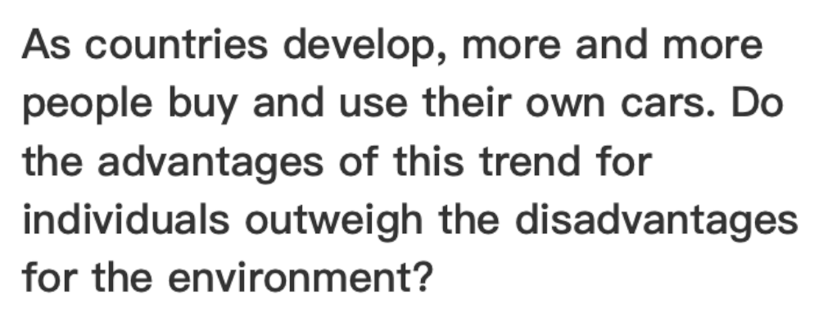

As the development of economy for some countries, people develop a preference for owning private cars. In my opinion, while this trend is particularly beneficial for people, the negative impact of it for environment is more important.

The use of private cars plays a crucial role in individuals’ lives. Without these cars, people’s traveling would be limited by the public transportation, this means that people may waste amount of time waiting for buses. Commuters would have a deep understand for the circumstance, when they attend to work in the morning, the lack of public transportation resources drives them to get up early to catch the buses. Consequently, the usage of private cars offers the public with high-quality lives, and saving precious time for essential items.

However, it is notable that excessive greenhouse gas emissions coused by private vehicles significantly contributes to environmental degradation. Global warming is one of the most severe consequences, which leading to the increase of global tempreture. Additionally, noise pollution produced by running cars also presents a threat to the environment where we live in, insomnia caused by traffic noise among people is the most common disease.

In conclusion, comparing with the convenience of owing private cars, the damages on environment are more likely to attract people’s attention. If we cannot implement effective measures to address environmental problems, humanity would suffer from the adverse influences caused by this trend.

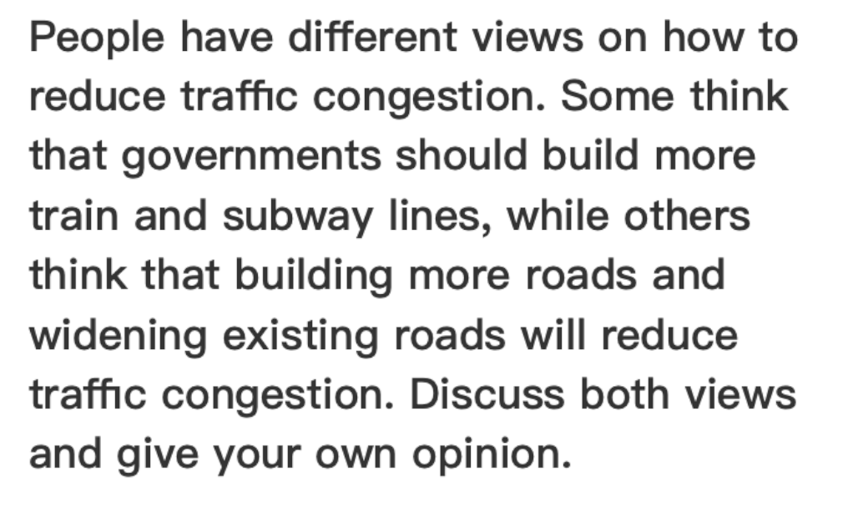

In recent years, the rapid increase of population has presented signiifcant challenge to traffic cnogestions. Whether constructing more train and subway lines is more effective than building roads and widening existing roads is controversial. In my opinion, there is no sigle measure can address this problem alone, striking a balance between the both suggestions is the best approach.

Building train and underground lines plays a vital role in improving public transport system, which offers an opportunity for residents to take more convenient public vehicles instead of driving private cars. The reason for people’s of preference of cars is that they usually s[end susbtantial amount of time waiting for a train or a subway, however driving cars can significatly save their time on road. Consequently, improving infrasturctural transportation contributes to mitigating traffic congestions by enhancing people’s travel experences.

On the other hand, constructing more and wider road also can be regards as an effective solution to traffic issues. As economy develops, the dramatically increased cars and poor road maintenace leads to aggravate traffic congestions. Improving the number and quality of roads can not noly serve as essential way to elevating traffic congestions but also contribute to transport safety. For example, wider roads enables more cars to across a conjunction at the same time, reducing the time for waiting transport lights. Additionally, a number of roads provide people with more options to the destination.

In conclusion, the capasity of a single measure is limited to meet people’s demands. A balance between constructing subway lines and new road is more comprehensive for different group of people. For instance, people who possess cars can benefical from wider and new roads. Conversely, without private cars, people present a preference to take public transportation, thereby building more train and underground lines can enhance their travel experences.

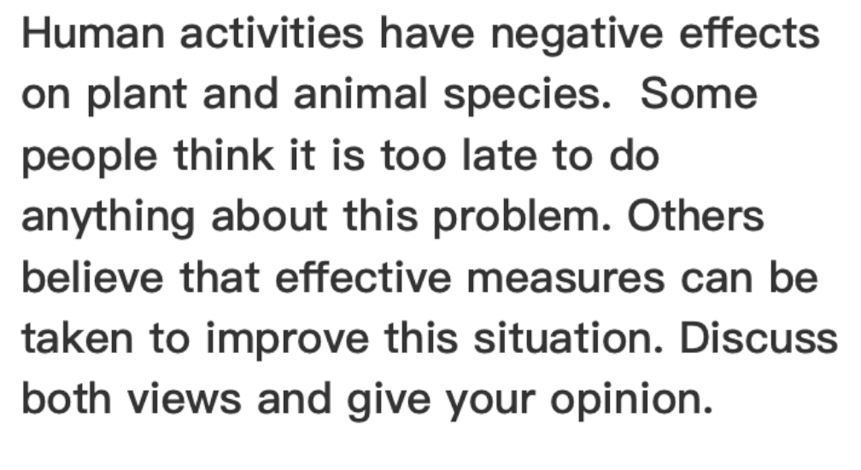

In recent years, eco-system has been negatively impacted by human activities. Some people argue that it is useless to make efforts about this issue, while others think that appropraite measures can be taken to address this problem. This essay will discuss about both views and deliver my opinion.

On the one hand, some people believe that humanity have caused irreversible catastrophe to vagetation and animal species, it means that any protection measures cannot bring extinct species back to life. Additionally, people’s development is contineously damaging the environment which various creatures significantly rely on. For example, the DongBei Tiger which inhabited in the north of China have died out for many years. Despite genetic technology has particularly developed, scientists still fail to clone them. Furthermore, the dramatically increased number of cars play a vital role in greenhouse gas emissions and lead to global warming, which present a crucial threat to biodiversity.

On the other hand, proponent tend to improve this circumstance by implementing several effective measures, which can reduce the number of dieing creatures. For instance, in countries like China, strict lagislation about animals and plants protection serve as an efficient measure to provide them with a safe living habitats. Furthermore, some non-benefit organizations spontaneously contribute to combating desertification by planting trees, this solution can not only be beneficial to biodiversity but also mitigate global warming.

In my opinion, while human technology is limited to comprehensively recover ecosystem, we shouldn’t forgo to address this problem. If people place sufficient emphasis on biodiversity protection through creating proper environment and develop a sense of environmental protection, we can live a peaceful life with all creatures on earth.

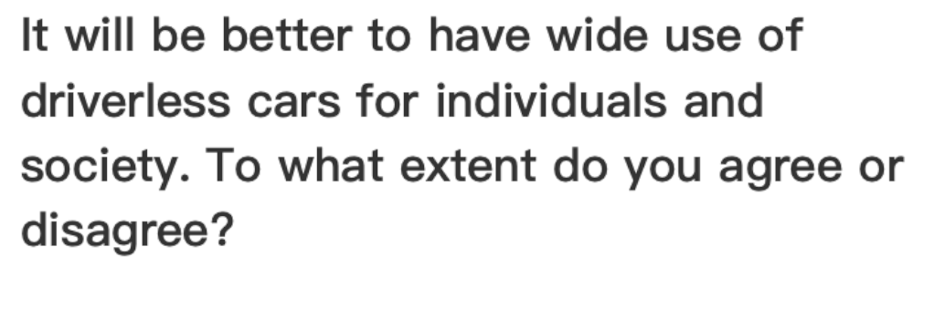

People’s lives have been significantly changed with technological advancements. Some people believe that wide use of driverless cars is beneficial for individuals and society. I partially agreen with this statement.

On the one hand, auto-driving technology plays a vital role in our society. The use of this technique presents a crucial merit in drive safety, which can dramatically reduce man-made errors while driving, such as drunk driving and over tired driving. According to investments, drunk driving is the most common reason for traffic accidents around the world, accounting up to 65 percents. Consequently, introducing driverless cars can be seen as an effective measure to dinimish accidents caused by humanity. Moreover, the usage of driverless cars can effectively address the issue of labour shortage. Taking advantages of cheaper machines instead of more expensive workforce to drive cars is a considerable strategy for some countries which are lack of labours such as France and Switzerland.

On the other hand, prevalent use of driverless cars negatively impact individuals’ chances of work, meanig that this trend would present a threat to people who work as drivers, like taxi drivers and especial drivers. For example, in cities like China and India, which possess substantial population, driver as a popular professional plays a essential role in many families. Wide use of auto-driving cars will lead to numerous drivers losing their jobs.

In conclusion, while use of driverless cars would result in jobless in some overpopulation countries, this technique is beneficial for some nations which are lack of labours, in additionally, it provides people safer travel experiences by auto-driving cars.

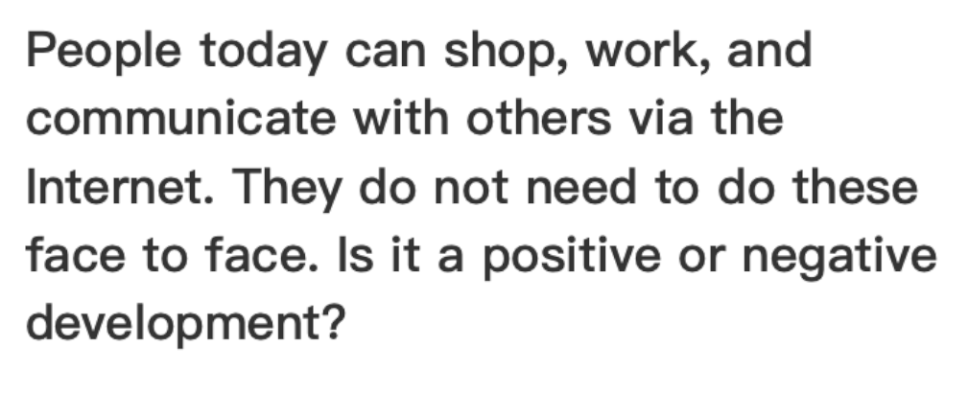

With technological advancements, it is not uncommon to shop, work and interact with others through the internet instead of face to face. In my opinion, this trend has both positive and negative impacts on people’s daily routines.

On the one hand, the internet, as an essential innovation of the modern age provides people with an opportunity to communicate with each other without the limitation of geographical distance. The public benefits from the internet due to its convenience and expansive usages. For example, online shopping is prevalent in China, several online platforms such as JingDong and TaoBao are popular among citizens. This is because these virtual stores enable people to purchase goods from home via the internet. Additionally, the method of shopping online offers people various options, including resources from other cities. Moreover, the usage of internet in work sector makes it possible to implementing paperless offices, contributing to the reduction of greenhouse gas emissions and deforestation caused by producing paper.

On the other hand, people’s significant reliance on internet leads to increasing online crime. Online interaction usually lack of strict suprivision due to its virtual nature. For instance, elderly are often attracted by small profits, thereby exposing their personal information such as phone number and bank account. Consequently, criminals take advantage of people’s vulnerabilities to operate online fraud. However, polices are incapable to send them to prison due to the property of internet.

In conclusion, while inappropriate use of internet may result in harming people’s interests, it is more important to focus on its advantages like online shopping and the contributors to the environment. Therefore, I believe that the positive influences of the internet are outweigh its adverse impacts.

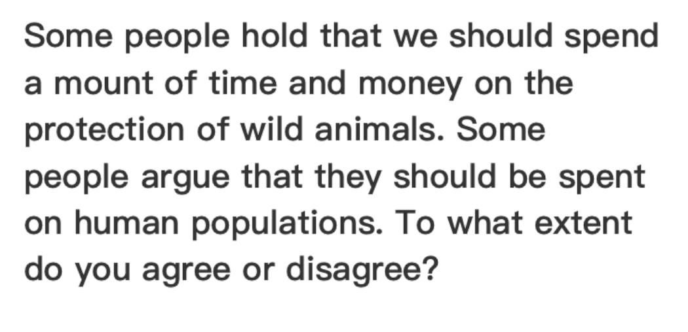

Human activities have caused irreversible catastrophe to wildlifes and their habitats. Therefore, some argue that we should invest substantial time and funds in the preservation of wild animals. While others believe that the resources should be spent on human problems. In my opinion, we should strike a balance between both views.

On the one hand, proponents support that we should place significant emphasis on wildlifes protection. This is because wild animals play a vital role in balancing ecosystems, meaning that the extinction of one species would lead to chain reaction in ecosystem. For example, according to a study, if wolves were extinction in forests, the number of rabits would dramatically climb, leading to a shortage of grass. Consequently, the ecosystem would be compeletly destoried due to the extermination of wolves. This study shows the importance of every creature on Earth, including wild animals, thereby we should bear the responsibility for safeguarding various wildlifes by investing a mount of time and money.

On the other hand, with the constantly increasing population, the lack of diverse resources and climate change have present a challenge to human sruvive. Therefore, others argue that we should prioritize human populations with limited time and funds. For instance, people in some poor areas like Africa are suffering hunger and diseases. If we donate substantial foods and money to them, this situation will be better in the future.

In conclusion, while it is essential for us to address the issue of overpopulation, protecting wildlifes is regarded as equaly important. Thus, we should balance the tactic, mitigating both negatively impacts with limited time and funds. For example, we can offer jobs to people who are undergoing hunger instead of donating money directly, additionally, enacting laws for preservating wild animals can be seen as an effective measure rather than spend money constructing protection areas.

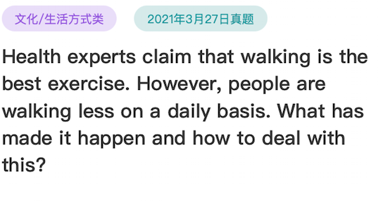

As we all know, walking as the basic exercise plays a vital role in keeping healthy. However, more and more people are neglecting the importance of walking in daily routines. This essay will explore the reasons for this circumstance and propose several possible measures to address this problem.

One of the most important factors for walking less may be that, the fast pace of life makes people busy all the time, leading to the result that they overlook the basic excrcise. Furthermore, some labors have developed the habit of staying home in spare time instead of walking for exercise. For example, in some large cities like ShangHai, people have used to spending long time on the way to work by subways, and they contribute substantial energy to adopt the dramatical development of economy, therefore, people usually get home in mid-night. The stress of live enforces them to pay less attention to their health and the basic exercise of walking.

In my opinion, the governments should bare the responsibility for people’s health by encouraging citizens to engage in outside walking and placing relative polices to require companies to mitigate people’s stress. For instance, governments should invest substantial funds in infrastructural establishment, such as constructing more gardens and playgrounds to motivate the public to walk more. As for enterprises, overworking should be baned strictly, instead, companies should offer free gyms for workforce to exercise, including walking.

In conclusion, the fast pace of life and stress from work are primary factors for this issue, the governments and firms should impetus people to walk for exercise by improving infrasturctures and alleviate the presure of labors.



In recent years, significant number of people focus on health care, however, others still maintain the habit of eating junk food even though they know the adverse consequence of that. This essay will explore the reasons for this situation and propose several possible measures for it.

Junk food, like hambugers, fry chickens and cola usually offer convenient and cheap accesses for people who are constant busy or not cooking themselves. Due to the fast-paced lifestyle, substantial people have no choice but eat in resturants, and many fast-food such as KFC, is one of the proper options for them. For example, in some large cities like ShangHai, workforce usually spend long hours on commuting leads to less time for breakfast, therefore, having hambugers and sandwiches are the best choice for them, even they are awear that junk food would result in obsity and other diseases.

In my opinion, initiatives about healthier eating habits and introductions of healthy fast-food can play an effective role in mitigating the impacts of this circumstance. People would prefer to improving their diet habits, if there were better choices. For instance, the government should take the responsibility to organize community campaigns to develop the sense of healthier and balanced diet among citizens. Additionally, investing significant resources in introducing nourishing fast-food such as BaoZi, JianBing and LaMian can be seen as an effective measure to address this issue.

In conclusion, the public pay more attention the convenience of fast-food than its nourishing value, even they know the negative influence of junk food. Consequently, cultivating the healthy eating habits and investing in healthier fast-food are necessary to solve the problem.

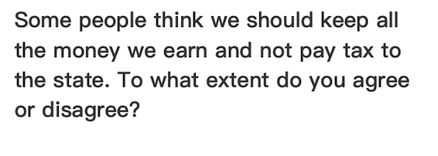

Nowadays, levying tax is a common regulation in most nations. However, whether should people keep all the money we earn or pay some tax to the country provokes a controversy. In my opinion, it is necessary for the public to pay tax to ensure the country’s development.

The government should take the responsibility to construct and maintain the infrustructures, which is beneficial to citizens and the country’s development. However, substantial funds from tax is the fundation of that. For example, China is famous of its CRH trains which are the fastest trians in the world, the high speed trains reduce the time during travel for passengers. Notably, part of the money that used to establish the trains is come from tax and this project cannot implement the achievement without tax. Consequently, the public should pay tax to the state to hasten the development.

While tax plays a vital role in country’s thriving, people’s salaries are limited in some remote or portery areas; if they were require to pay heavy tax from their little income, people would struggle to live. For instance, in China, famers are the low-salary group, tax may restrain the development of countrysides. Additionally, some basic workforce cannot pay for an apartment forever with tax from their income. Therefore, country should not only cancel their tax but also help them in finance.

In my opinion, whether people should pay tax significantly depends on their remunerations. The government should set up a basic criteria for levying tax, such as people should pay tax only if their income is more than 5000 Yuan.

In conclusion, tax contributes to the development of a country, thus the tax should be compulsory. However, a number as the start to leving tax also should be determined like 5000 Yuan to ensure the quality of lives of destitute citizens.

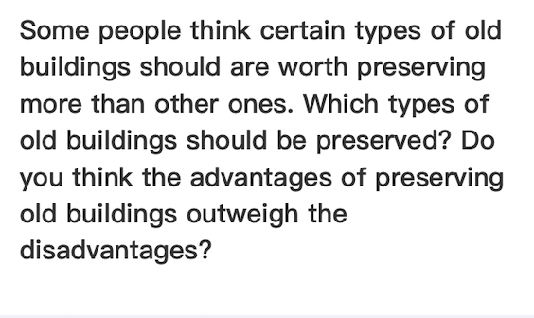

In recent years, whether certain categories of old complexes should be worth preserving more than others provokes controversy. This eassy will explore which types of old buildings should be preserved and deliver my own opinion to this.

Old buildings which play vital role in history or are the symbolics of certain events should be preserved. These categories of complexed are often the unique in the world. For example, the GuGong in China, is not only the sign of Chinese history but also the attractive place for tourists. Additionally, the ChangCheng is preceived as one of the eight marvel buildings among the world. Furthermore, the pyramids in Egypt fulfil unkonwn mysteries which appeal a substantial number of people. Consequently, old buildings which are valuable for science and history deserve proper protection.

While the governments have to invest significant amount of money in maintaining these buildings, the consequences are more valuable than the investments. If caused irreversable damages to these complexes, humanity would lose the chance of exploring history. For instance, Yuanming Park is a famous historical place which has essential historical value but had been burned several years ago, people struggle to recover it. Additionally, there are several old villages in China, houses there still remain the style which was popular thousand years ago. Therefor, they are the indepensiable resources for people to access our ancesstors’ life style.

In conclusion, old buildings with scientific and historical value should be protect appropriately. Comparing to the investments which spend on old complexes, the value of them is more significant.

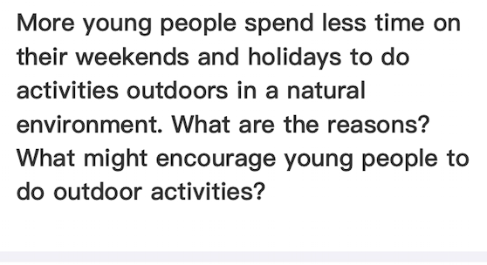

Young people prefer to participate in indoor entertainment instead of spending time on outdoor activities in a natural environment. This essay will explore the factors of this circumstance and propose several possible measures to motivate young people to join in outdoor campaigns.

One significant reason is that the allure of virtual devices attract youth to stay indoors. With the development of technology, it is not uncommon for teenagers to possess computers, cellphones, or game consoles. For example, the ‘Honor of Kings’ is a prevalent virtual game in China, and a substantial number of children and young adults are obsessed with it. Therefore, people waste most of their spare time playing games instead of playing basketball or going hiking with friends.

In my opinion, the government should be responsible for mitigating the negative impacts of the internet, which lead to fewer participants in physical activities. Implementing incentive policies and organizing community activities can be seen as effective solutions to this issue. For instance, developing infrastructure such as parks and playgrounds can attract young people to attend sports activities and get close to nature. Meanwhile, arranging community competitions among teenagers can encourage them to improve physical health.

In conclusion, the diverse attractions presented by electronic devices are the significant reasons for young people to stay at home, encouraging youth to keep in touch with nature by constructing more appealing infrastructure and setting up outdoor contests for juveniles can effectively alleviate the adverse influences of home attractions, leading to more outside participation.

Some people think that the increasing use of computers and mobile phones for communication has a negative effect on young people's reading and writing skills. Do you agree oor disagree?

With the advancement of technology, electronic devices have been regarded as indispensible part of our lives. However, some people argue that the frequent use of computers and cellphones for interaction negatively impacts juvenile’s reading and writing abilities. Personally, I partly agree with this viewpoint.

It is undeniable that significant reliance on virtual devices like tablets and smartphones does have adverse effects on reading and writing skils among youth to some extents. One essential reason is that, fragmented information is the primary trend on the internet, which may diminish young people’s ability of depth thinging. For example, short videos and slight comments on the twitter struggle to invoke teenagers’ reflect. Additionally, the intelligent features like auto-correct and predictive input offered by smart facilities gradually degrade young people’s writing skills. Consequently, excessive use of electronic devices would lead to degratation of literacy abilities.

Conversely, if juveniles received proper guidences on how to exploit electronic devices, these products can enchance their reading and writing skills. The internet provides youth with convenient access to various information, which can significantly expand their horizon. For instance, social media and blogs offer versatile platforms for youth to express themselves and access information from worldwild, which are essential for improving their literacy skills.

In recent years, the juvenile crime rate has been on the rise in many countries. It is argued that rehabilitated offenders are the best choice to deter teenagers from committing crimes. Personally, I think while there are great upsides when they are arranged to educate young people about the consequence of a crime, they are not the most suitable people.

It is true that the lecture delivered by ex-prisoners can be impressive and credible aschildren are more likely to accept advice from someone who can speak from experience. Ex-prisoners know why the children behave badly, because they did it themselves. They know how to encourage children to take responsibility because they have acquired it the hard way. They know the severe consequences of crime, because they have suffered the consequences big time.As such, this seems to be a good arrangement to let children have a better idea of the suffering of a criminal lifestyle.

However, I do not think presentations by ex-prisoners are the best approach to discouraging children from breaking the law. The police can be a much better alternativeas they can be just as effective as rehabilitated offenders without having all ofits potential side effects. The police have a good idea of the miserable life of being acriminal, which means their speech can be equally impressive and credible. Apart from that, they are a positive public image allthrough. This can dispel any ideas teenagers may have about that being a criminal is nota big deal as the criminal can eventually become a productive member and even a role model delivering lectures in school.

In conclusion, I admit that it can be a good arrangement to ask ex-prisoners to inform children about the danger of committing acrime, but I do not think this is the best approach.

Some students choose to work or travel after leaving school and before going to university. Many people, however, say that working experience is more useful in adult life than travel.Do you agree or disagree with this statement?

After graduating from senior school and before attending university, some students prefer to spend time travling on vacation, others intend to participate in part-time job to earn pocket money and experiences. In my opinion, while working experience is important in adult life, tourism is seen as euqally significant for their future.

Joining a part-time job can help students not only acquire experiences but also make an allowance, which can be beneficial for their career in the future. When students plan to join workforce after college, veterans are more competitive than novices, part-time job experience offers students more opportunity to access well-payed work. Additionally, students can start their own business with the allowance that made by part-time job. Overall, woking before going to university provides people with more positive situations to their adult life.

Similarly, travling druing the vacation also plays a essential role in student’s development. Excessed pressure of studying in high school leads to adverse impacts on students, which can be mitigated by travling various resorts. Moreover, visiting artificial complexes and getting close to nature offer teenagers an opportunity to broaden their horizon, and inspire them to set goals for their future lives.

In conclusion, both working experience and mitigating stress from study are important for young people’s development. The choise depends on students themselves, other people should not make decisions for them.

优化版：

Some students choose to work or travel after leaving school and before going to university. Many people, however, say that working experience is more useful in adult life than travel.Do you agree or disagree with this statement?

The debate over whether students should choose to work or travel after leaving school and before attending university is multifaceted. While some argue that working experience is more significant in future life than travel, I incline to disagree that, as both work and travel have unique merits and are equally crucial for students’ development.

It is undeniable that working experience plays an essential role in teenagers’ careers, as students can gain real experiences and job-related skills that are not covered in school courses by participating in a part-time job. For example, juveniles who work as a retailer assistant can foster a skill of effective communication with customers, which are not corporated in university but useful in all categories of jobs. Furthermore, the allowance earned by joining a part-time job can support students who plan to start their own business during school years. Overall, those with working experiences are more competitive than others in job market.

However, the significance of travel should not be underestimated. It offers students an opportunity to broaden their horizons. Exposing youth to grand artificial complexes and magnificent natural sceneries by traveling inspires them to reflect about their future. Additionally, contacting with different cultures during travel can also be seen as accumulating experience, which can invoke innovative ideas in their future work.

In conclusion, both work and travel are essential for students, as working experience can benefit them to integrate into social workforce and travel help them to consider the direction of future. Consequently, it depends on students’ personal circumstances whether to choose to work or travel after leaving school and before going to university.

## 双边讨论模版

The debate over whether students should choose to work or travel after leaving school and before attending university is multifaceted. While some argue that work experience is more significant in future life than travel, I incline to disagree, as both work and travel have unique merits and are equally crucial for students’ development.

It is undeniable that work experience plays an essential role in teenagers’ careers, as students can gain real experiences and job-related skills that are not covered in school courses by participating in a part-time job. For example, students who work as retail assistants can develop effective communication skills with customers, which are not typically taught in university but are useful in all types of jobs. Furthermore, the money earned from a part-time job can support students who plan to start their own business during school years. Overall, those with work experience are more competitive than others in the job market.

However, the significance of travel should not be underestimated. It offers students an opportunity to broaden their horizons. Exposing young people to diverse cultures and magnificent natural landscapes through travel inspires them to reflect on their future. Additionally, experiencing different cultures during travel can be seen as accumulating valuable life experiences, which can spark innovative ideas in their future work.

In conclusion, both work and travel are essential for students, as work experience can help them integrate into the workforce, and travel helps them consider their future direction. Consequently, the choice between work and travel depends on students’ personal circumstances and aspirations.

Many employees can now do their work from home using modern technology. However, this change may only benefit workers, not the employers. To what extent do you agree or disagree?

As the technology advancements, it is not uncommon to see employees work through computers, mobile phones or other high-tech from home. Some people would argue that only workers can beneift from this change, it has adverse impacts on employers. I partly agree with this statement, as I think this evolution is beneficial for both of them.

It is undeniable that remote work brings significant convenience to workers, as they can save a substantial amount of time and money which were spent on commuting, especially in big cities like Shanghai and Beijing. Additionally, remote work offers people an opportunity to participate in a job without limitation of geography distance due to the development of technology. Employees can corporate with peers by communicating on the internet. For example, it is convenient for programmers to commit their codes from worldwide mainly because their work compeletely depends on the internet.

However, the interests brought by working from home for employers cannot be neglected. Firstly, it can save a large amount of rent of workplaces and other office-related consumptions, which is an essential expense of invoice. Besides, it is possible for leaders or bosses to recruit employees who are professional from all over the world with rational remuneration. Consequently, it helps employers avoid multifaceted risks to lead businesses by remote work.

In conclusion, working from home can not only benefit workers but also brings greater revenue to employers, as the development of morder technology dinishes the restriction of distance, both of them can benefit from this change.

优化版：

As technology advances, it is not uncommon to see employees work through computers, mobile phones, or other high-tech devices from home. Some people argue that only workers benefit from this change and that it has adverse impacts on employers. I partly agree with this statement, as I think this evolution is beneficial for both of them.

It is undeniable that remote work brings significant convenience to workers, as they can save a substantial amount of time and money which were spent on commuting, especially in big cities like Shanghai and Beijing. Additionally, remote work offers people an opportunity to participate in a job without the limitation of geographical distance due to technological development. Employees can collaborate with peers by communicating on the internet. For example, it is convenient for programmers to commit their code from anywhere in the world mainly because their work completely depends on the internet.

However, the benefits brought by working from home for employers cannot be neglected. Firstly, it can save a large amount on workplace rent and other office-related expenses, which are significant costs for businesses. Besides, it is possible for leaders or bosses to recruit employees who are professional from all over the world with competitive remuneration. Consequently, it helps employers avoid multifaceted risks by leading businesses through remote work.

In conclusion, working from home can benefit both workers and employers as the development of modern technology diminishes the restriction of distance, allowing both parties to gain from this change.

More attention is paid to being 'responsible tourists' in order to preserve the cultural and environmental aspects of tourists places. However, some people think it is impossible to be a 'responsible tourist' in the society.To what extent do you agree or disagree?

Becoming responsible travelers is seen as an effective approach to addressing the cultural and environmental protection of tourist attractions. However, some argue that it is tough or impossible to become a responsible tourist in the modern age. I completely disagree with this statement.

First of all, helping tourists foster a sense of responsiblity of cultural and environmental preservation by

In some countries, people waste a lot of food which is bought in shops and restaurants. What do you think are the reasons? What can be done to solve this problem?

With the development of economy, people are increasingly tend to grab a bite in restaurants or purchase food in shops. However, people rarely pay attention to the negative impacts of wasting food. Understanding the reasons for this issue plays a vital role in reducing waste.

One of the primary reason of this trend is that the desire drives consumers losing control in assessing the quantity of food. Without planning the meal in advance, people prefer to try different cuisines to meet their appetite, resulting in overlooking the consequences of over-ordering. Furthermore, consumers wrongly perceive packageing uneaten food as a shame also contributes significantly to this problem.

To tackle the issue, governments and restaurants should take a role by implementing some effective measures to discourage consumers from wasting food. Such as organizing educational campaigns about why and how to save food while shopping in the shops and restaurants to raise a warenes of the adverse influences of wasting food. Additionally, restaurants should offer people more options about the portion of size and free package services to mitigate the waste trend.

In conclusion, the allure of selling strategies mainly causes the aggravation of this tendency, governments should take responsibilities to help citizens cultivate a sense of saving food and restaurants should provide more options to encourage consumers to make reasonable decisions.

改正错误后：With the development of the economy, people increasingly tend to grab a bite in restaurants or purchase food in shops. However, people rarely pay attention to the negative impacts of wasting food. Understanding the reasons for this issue plays a vital role in reducing waste.

One of the primary reasons for this trend is that desire drives consumers to lose control when assessing the quantity of food. Without planning meals in advance, people prefer to try different cuisines to satisfy their appetite, resulting in overlooking the consequences of over-ordering. Furthermore, consumers wrongly perceive packaging uneaten food as a shame, which also contributes significantly to this problem.

To tackle the issue, governments and restaurants should play a role by implementing effective measures to discourage consumers from wasting food, such as organizing educational campaigns about why and how to save food while shopping in shops and restaurants to raise awareness of the adverse influences of wasting food. Additionally, restaurants should offer people more options regarding portion size and provide free packaging services to mitigate the waste trend.

In conclusion, the allure of selling strategies mainly causes the aggravation of this tendency. Governments should take responsibility for helping citizens cultivate a sense of food conservation, and restaurants should provide more options to encourage consumers to make reasonable decisions.

Some people hold that we should spend a mount of time and money on the protection of wild animals. Some people argue that they should be spent on human populations. To what extent do you agree or disagree?

In recent years, the debate over whether to spend resources on the protection of wild animals or human populations has intensified. In my opinion, preserving wildlife is as the same importance as improving human well-being, we should strike a balance between the two views.

It is undeniable that protecting wildlife and their habitats palys a significnt role in maintaining biodiversity. The lack of any of species would cause enormity catastrophes to ecosystems, leading to worldwide chain reactiona. For example, the decline of the number of wolves offers a proper environment for rabbits to proliferate. Eventually, the amount of rabbits dramatically soars would contribute on the shortage of grass and have detrimental impacts on other animals. Consequently, investing money and time in creating a eco-friendly environment to safeguard wildlife is beneficial to humanity.

On the other hand, human are facing various urgent challengings from overpopulation, famine, lack of healthcare and so forth. In many developed countries, countless people are suffering from hunger, children cannot gain basic education and the lack of healthcare have significantly negative impacts on human development. Therefore, spending money on education, infrastructure and healthcare services are necessiary and play a essential role in saving lives, and improving the quality of people’s life.

In conclusion, while protecting wildlife can develope a eco-friendly sociaty, which has a long-term benefit to humanity, investing funds in addressing survival-related issues is equally impartant. Governments should adopt a balanced approach, instead of puting all eggs into one blanket.