C11 T4

The table compares the count of visitors to Ashdown Museum before it was rebuilt with that after it was reopened. The pie charts suggest the results of surveys about the satisfactory of visitors with the place during the same two periods.

The table presents a comparison between the visitor counts at Ashdown Museum before and after its reconstruction. Additionally, the pie charts depict the findings of visitor satisfaction surveys conducted during both periods.

Overall, the number of visitors increased obviously after the reconstruction of the museum, and visitors’s attitude about the museum changed a lot.

After the museum's reconstruction, the number of visitors increased significantly, and there was a noticeable shift in visitors' attitudes towards the museum.

As we can see, the count of visitors after the museum’s rebuild increased by 18000(from 74000 to 92000). Meanwhile, over 70% visitors satisfied about the place, with an increasing by 30% compared with it before. In contrast, the number of unsatisfactory visitors reduced from 50% to 20%, and only 5% visitors had a very uncomfortable experience in the museum.

C12T1

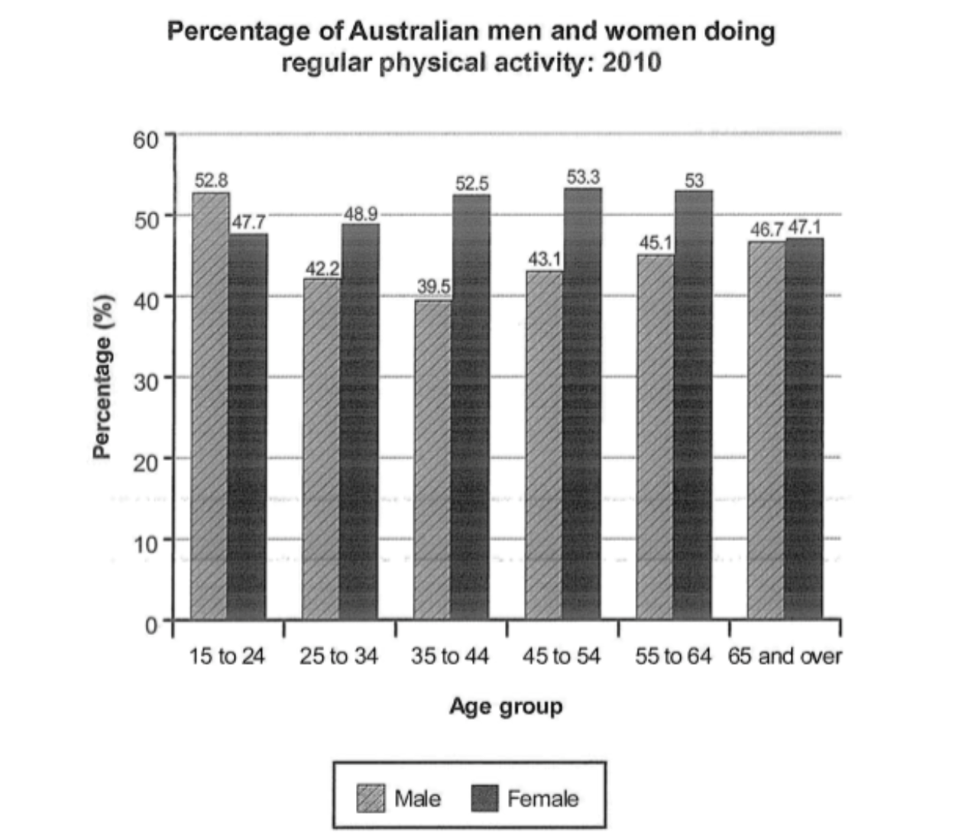

The bar chart compares the proportion of male and female in different age groups who did regular exercise in Australia in 2010.

The bar chart compares the proportions of males and females across different age groups who engaged in regular exercise in Australia in 2010.

The bar chart given displays the information about the percentage of men and women in Australia who participated in physical activity regularly in 2010, and the subjects are divided into six age groups ranging from 15 to 65 years old and over.

Overall, more female spent regular time on physical activity than male did across different age groups, only one group was is contrast. About half of female in the research did regular exercise, and male were lower than that.

Overall, more females spent regular time on physical activity than males across different age groups, except for one group. About half of the females in the research engaged in regular exercise, while males had a lower rate.

As we can see, the male between age of 15 to 24 had the largest proportion of male who engaged in exercise regularly, and it was the only group that male populations more than 50% of the term(52.8%). The index of the last age group had a minimum gap among male and female. Meanwhile the subjects with the largest contrast was the group during 35 to 45 years old, male is less than female over 10%.

As we can see, males aged 15 to 24 had the largest proportion of individuals who engaged in exercise regularly, accounting for 52.8% of the population. The age group with the smallest gender gap was the oldest one. Meanwhile, the group with the most significant contrast was between 35 and 45 years old, where the proportion of males engaged in exercise was over 10% lower than that of females.

detail1: 同类横向跨组比较

detial2: 异类组内单独比较

C13T2

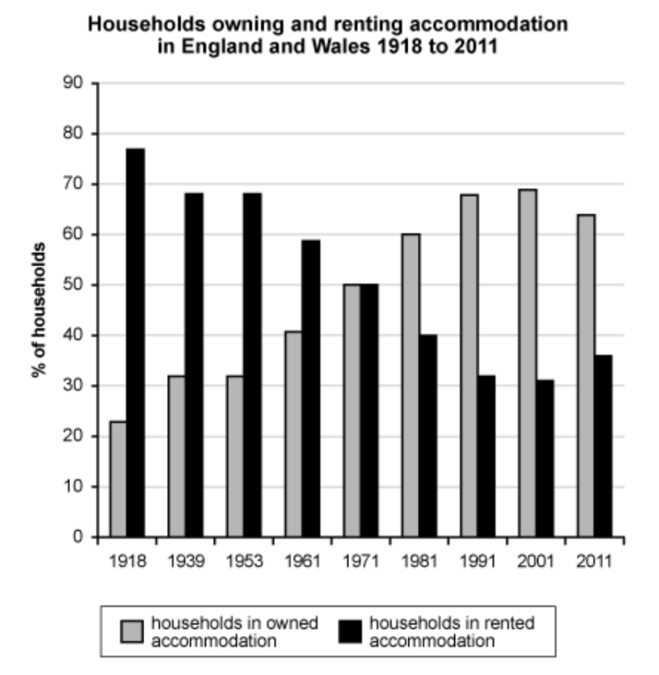

The bar chart depicts the information about the proportion of family in England and Wales in bought and rented dorm during 1918 to 2011.

Obviously, the ratio of owned and rented house had changed a lot in England and Wales. The proportion of bought dorm kept increasing, in contrast, the percentage of rented house saw an continuely reducing.

In 1918, most people lived in rented accommodation, just a few family owned a house. The proportion of rented house was about four time higher than the ratio of bought accommodation. Surprisingly, the number of people who owned a house was two times more than the figure of households in rented dorm in 2011. Both types of households got an equal, accounting for 50% each category. In addition, the percentage of family in bought dorm incread utill 2001, peaked at approximately 79 percent, and the data appeard the tendency of decline in 2011, but the ratio still more than 60 percent.

The bar chart depicts information about the proportion of families in owned and rented homes in England and Wales from 1918 to 2011.

Obviously, the ratio of owned and rented homes changed significantly in England and Wales. The proportion of owned homes kept increasing, while the percentage of rented homes saw a continuous reduction.

In 1918, most people lived in rented accommodation, with only a few families owning a home. The proportion of rented homes was about four times higher than that of owned accommodation. Interestingly, the number of people who owned a home was twice the number of households in rented homes in 2011. Both types of households were equal, each accounting for 50% in1971.

In addition, the percentage of families in owned homes increased until 2001, peaking at approximately 79%, and showed a tendency to decline in 2011, although it still remained above 60%.

C12T3

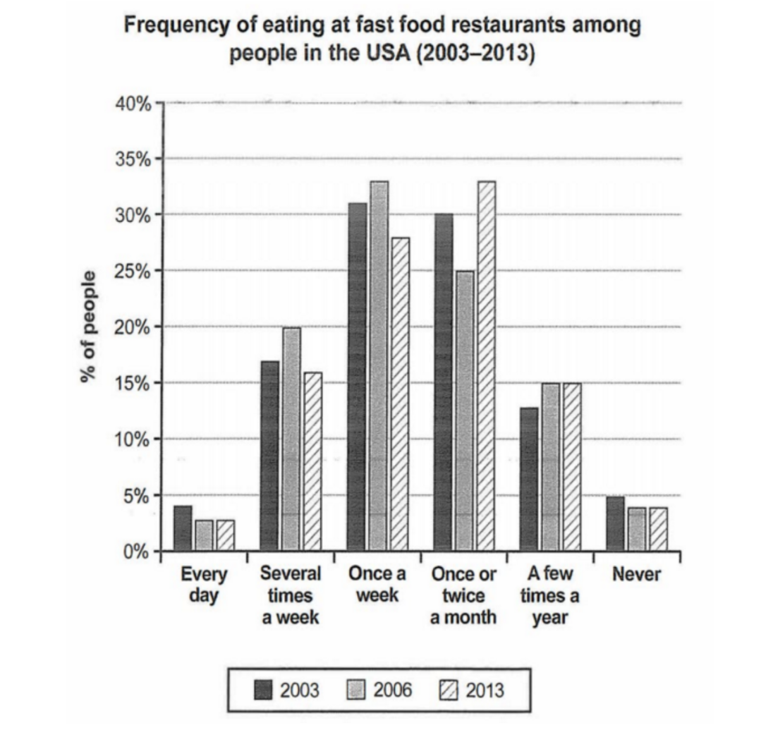

The bar chart illustrates the information about the frequency of eating at fast food restaurants among people in the USA during 2003 to 2013.

Overall, the majority of people had fast food once a week or twice per month, only few people did that every day or never eat fast food.

As we can see, only a litter people ate fast food every day in druing 2003 to 2013(counting for less 5%). The same situation occured to inhabitents who never tred fast food. The amount of people who ate fast food more than once a week in 2006 saw an increase compare the figures with 2006. People who ate fast food once a week counting from 25% to 35% during the years, with little changes. The interesting thing is that people who ate fast food once or twice a month dropped by approximately 5 percent in 2006 than the figure in 2003, however, the data increased over 5 percent in 2013.

The bar chart illustrates information about the frequency of eating at fast food restaurants among people in the USA from 2003 to 2013.

Overall, the majority of people ate fast food once a week or twice per month, with only a few eating it every day or never eating fast food.

As we can see, only a few people ate fast food every day during 2003 to 2013, accounting for less than 5%. The same situation occurred with inhabitants who never tried fast food. The number of people who ate fast food more than once a week in 2006 saw an increase compared to the figures in 2003. The percentage of people who ate fast food once a week ranged from 25% to 35% throughout the years, with little change. An interesting observation is that the percentage of people who ate fast food once or twice a month dropped by approximately 5% in 2006 compared to the figures in 2003, however, the data increased by over 5% in 2013.

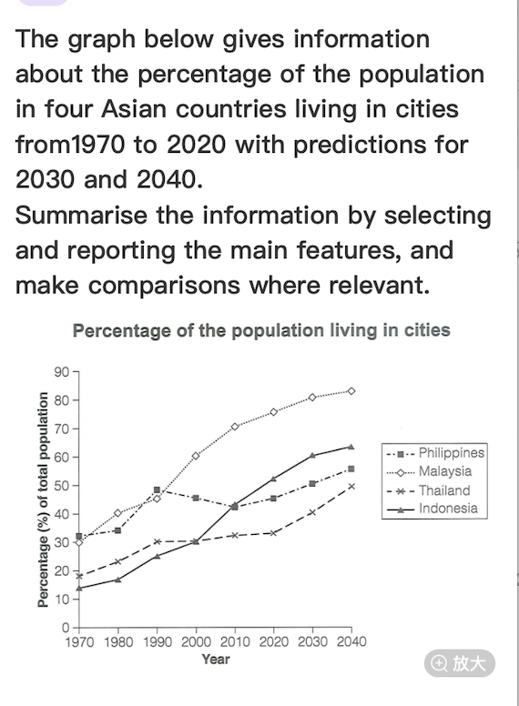

The line graph illustrates the percentages of the population from 1970 to 2020 and predictinos for 2030 and 2040 in four Asian nations.

According to the graph, the percentage of population in Indonesia saw the lowest at start point among four countries, at around 14%. The figures for Malaysia and Philippines were similar and higher than other two countries, accounting for about 30%. However, the data for predictions show some differences in 2040, Malasia will reach peak more than 80% and be the highest rate among these countries. The firugr for Indonesia will overtake Philippines and Thalland, with more than 60% population.

While four countries experience upward trend in generally during the period, Philippines presented a decline from 50% in 1990 to 40% in 2010. The percentage of other three countries climb rapidly between the span.

In summary, except Philippines, other nations saw an increase from 1970 to 2020 to various extent. And all of them are predicted to experience an expand in population during 2030 to 2040.

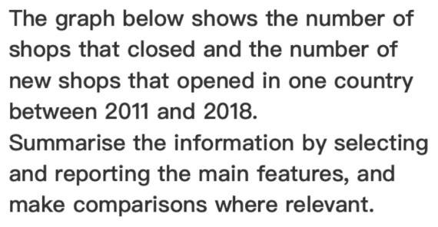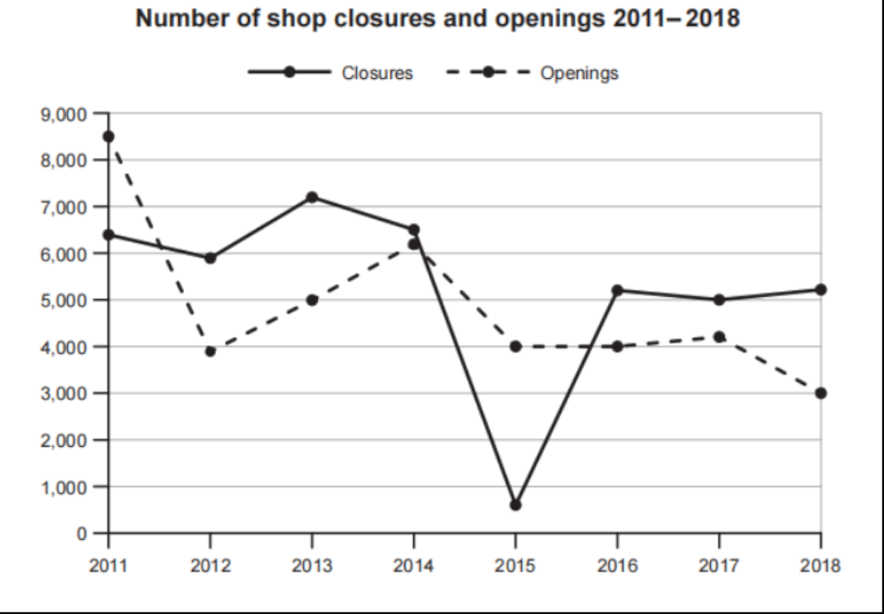

The line graph illustrates the number of stores which closed and newly opened in one country during the period from 2011 to 2018.

The number of shop closures was relatively high at starting point in 2011, at approximately 6500. The figure fluctuated slightly by 2014, before the closed stores bottoming out in 2015, where the number was lower than 1000. However, the number significantly climbed to more than 5000 in the next year. After that, the trend remained stable by 2018, with about 5000 shops closed.

The number of opened stores peaked at 8500 in 2011, following that, dramatically dropping to 4000 in 2012. Shop openings rose steadily to more than 6000 by 2014 before it decreasing again. The figure showed relatively stable in the next two years, at around 4000.

In summary, both of closed and opened stores saw a decline to varying extents over the span in generally, in additionally, two categories of shops presented obviously oscillations.

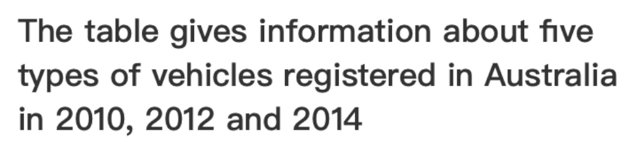

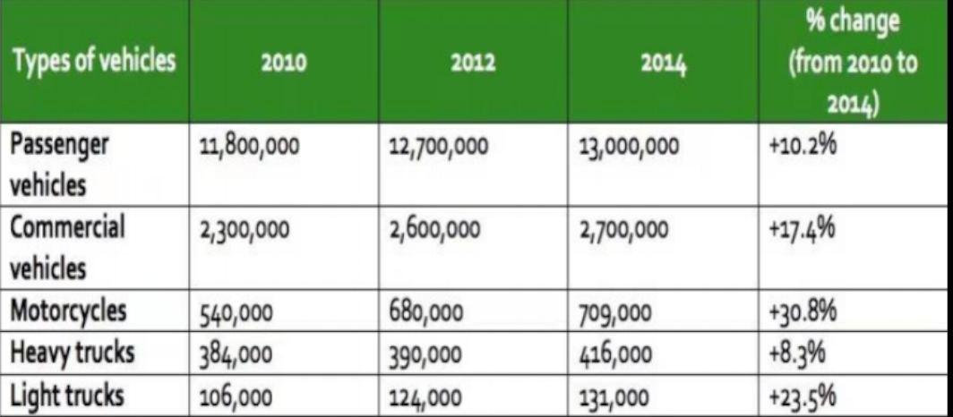

The table illustrates the information about the registration of five categories vehicles in Australia in three years(2010, 2012 and 2014).

According to the table, passenger vehicles had the most number of registrations among these types of vehicles in three years, reaching 11,800,000 in 2010, 12,700,000 in 2012 and 13,000,000 2014 respectively. Following that were the commercial vehicles, although the number was far less than passenger vehicles, still remained relatively higher than other three categories; especially, the number peaked at 2,700,000 in 2014. While the other three types of vehicles experienced increases to varying extents over the span, the total amounts were relatively lower than commerical vehicles.

However, the rate of change from 2010 to 2014 of vehicles registered showed significant difference from the number. The resgisterations of motorcycles saw a substantial climb during the period, reaching at 30.8%. Afterward, the proportion of light trucks dramatically grew as well, with more than 20% of increase.

In summary, the number of while passenger vehicles was the highest, the rate of change was relatively low than others. By contrast, the number of people who prefered motorcycles saw an upward trend in 2014 compared to in 2010.

The bar chart below shows the employment of all male and female workers by occupation in the Uk in the year 2005.

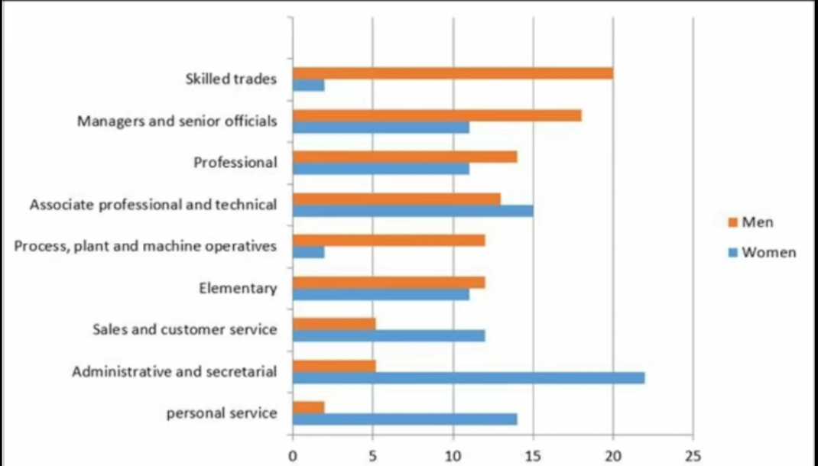

The bar chart illustrates the percentage of employment of men and women workers by occupation in the UK in 2005.

According to the bar chart, skilled trades was the most popular job for men, with 20% male choose it. Following that, managers and senior officals showed relatively high percentage, reaching 18%. More than 10% men preferred to professional, associate professional and technical, process, plant and machine operatives an delementary. However, the proportion of working for personal service was the lowest, only at about 2%.

The situation was different for women. Skilled trades and process, plant and machine operatives had significant lower rates than other professions, at approximately 2%. Compared to men, women were more likely to with administrative and secretarial, with more than 20% of women preferred it. Notably, female’s tendency of other jobs was comparable, the figures fluctuated between 10% to 15%.

In summary, different gender of people tended to different jobs. Men were more tended to skilled trades, by contrast, women showed a preference for personal service.

The table and charts below give information on the police budget for 2017 and 2018 in one area of Britain.The table shows where the money came from and the charts show how it was distributed. Summarise the information by selectingand reporting the main features, andmake comparisons where relevant.

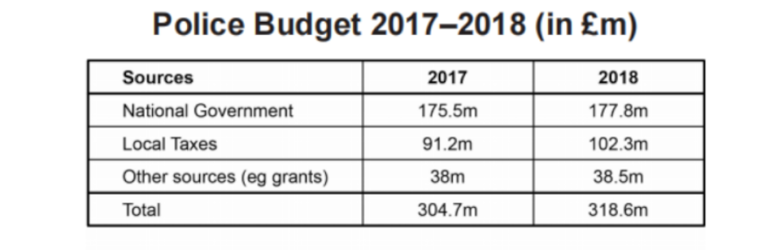

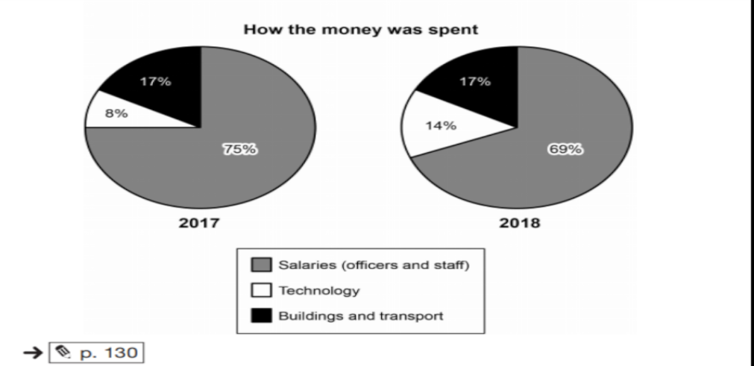

The table illustrates the the sources of budget for police in 2017 and 2018, and the pie charts show the percentages of the budget consumption in salaries, technology, and building and transport.

According to the table, the total amounts of budget in 2017 and 2018 were similar, at around 310 million. National government regarded as the primary funds source, contributing the most money to police, with 175.5 million in 2017 and 177.8 million in 2018 respectively. Following that, local taxes also played a vital role in police budget, and the financial support rose from 91.2 million to 102.3 million during the period. Finally, other sources donated a small part of the total amount of money, at approximately 38 million in two years respectively.

As shown in the pie charts, the percentages of salaries were the main expenses of the budget, accounting for 75% in 2017 and 69% in 2018 respectively. Notably, The consumption on buildings and transport was stable in the two years, reaching 17% of the total funds. 8% of the money was spent on technology in 2017, and the proportion increased by 6% in 2018, at 14%.

In summary, the sources of budget remained stable for 2017 and 2018. And the costs of salaries were the primary payment.

The charts below give information on the location and types of dance classes young people in a town in Australia are currently attending.Summarise the information by selectingand reporting the main features,andmake comparisons where relevant.

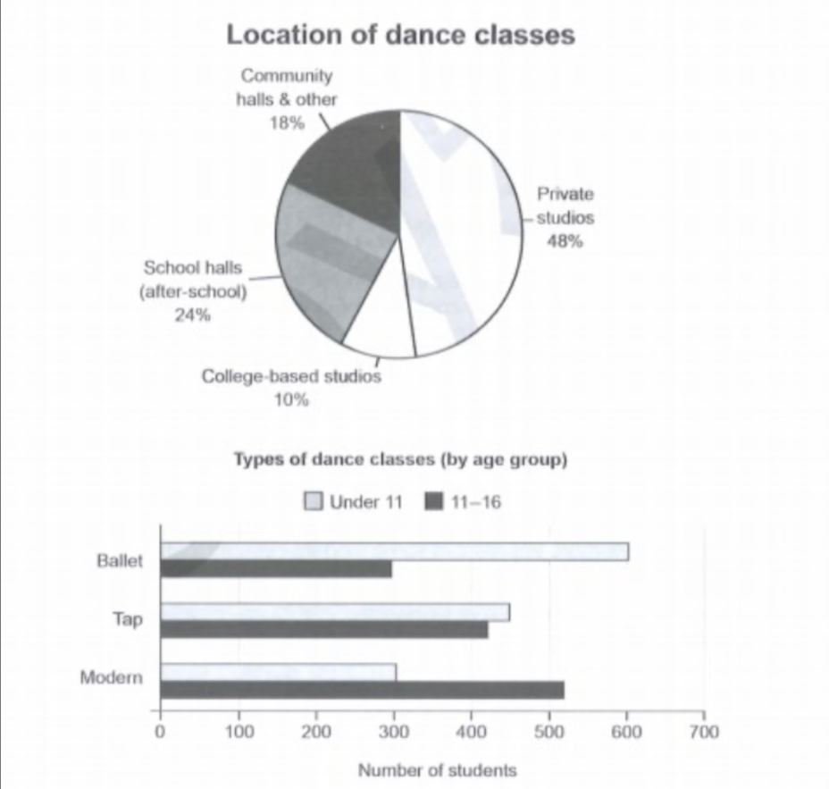

The pie chart illustrate the percentages of location of dance classes and the bar chart show the number of students who are attending various types of dance classes in a town in Australia.

According to the pie chart, the percentage of private studios reaches peak at 48%, which doubles the rate of sochool halls. Following the percentage of school halls, the community halls and others have a relatively lower proportion, accounting for 18%. Only 10% of location of dance classes are college-based studios, which is the lowest proportion.

As the bar chart shown, ballet is the most popular type of dance among children who are under 11 years old, and less children of this age group preper modern dance. By contrast, as the item of children who aged from 11 to 16, they show more interest in modern dance, and ballet dance is less attractive for them.

In summary, private studios are the primary location of dance classes in this town. Additionally, the preference of type of dance shows a significant variation among different age groups.

The graph below gives information on the numbers of participants for different activities at one social centre in Melbourne, Australia for the period 2000 to 2020.

Summarise the information by selecting and reporting the main features, and make comparisons where relevant.

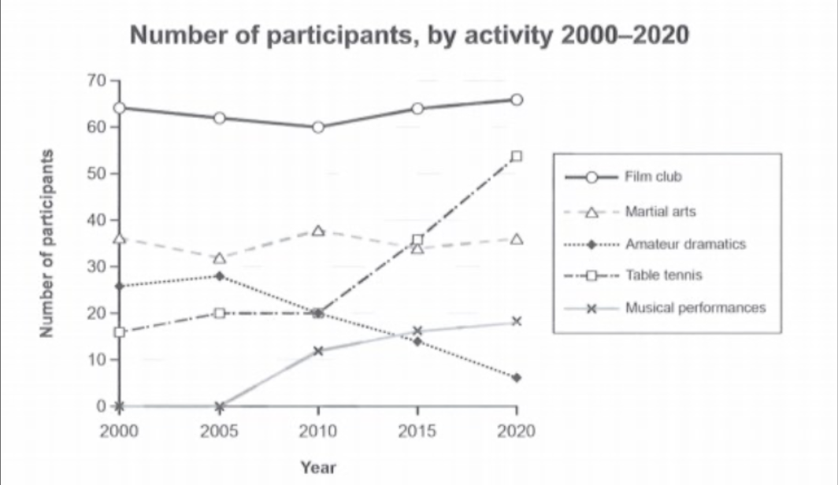

The line graph compares the numbers of participants in terms of five different activities at one social centre in Melbourne, Australia over the span from 2000 to 2020.

According to the line graph, the number of members in film clubs remained virtually unchanged at 65, film club was also seen as the most popular activity throughout the period. Martial arts had the similar pattern, fluctuating at around 35 over the two decades, although the total counts were relatively lower than file club.

The trends of other three activities were significantly different from film club and martial arts. Table tennis saw a slight increase before markedly soaring from 20 in 2010 to 55 in 2020. While musical performances was established in 2005, it experienced constantly increase in 15 years, with approximately 20 members in 2020. By contrast, only amateur dramatics showed a downward trend, which dropped from 27 in 2000 to 5 in 2020.

In summary, film club and martial arts had comparable patterns, oscillating slightly during the period. Both table tennis and musical performances showed an increase, but amateur dramatics declined markably.

The line graph illustrate the numbers of members for five activities at one social centre in Melbourne, Australia over the two decades from 2000 to 2020.

According to the line graph, the number of participants in film club experienced slight fluctuations over the span, with the number maintaining approximately at 60 - 65. While the martial arts showed similar trend, the total number of members was significantly lower than film club, at around 38.

However, other three types of activities experienced significant fluctuations during the period. After remaining stable with 20 participants in the first decade, table tennis climbed dramatically from 20 in 2010 to 53 in 2020. Similarly, musical performances was established in 2005, but saw a constantly upward trend, rising from 10 in 2010 to 18 in 2020. In particular, only amateur dramatics displayed a decline, dropping from 28 to 6 over the span.

In summary, the number of participants of table tennis club and musical performances club showed increase trend to varying extents. However, the situation of film club and martial arts stayed stable during the period.

The line graph illustrates the information about the members of five social activities, including film club, martial arts, amateur dramatics, table tennis and musical performances at one social centre in Melbourne, Australia over the span from 2000 to 2020.

According to the line graph, the number of participants of film club and martial arts saw slight fluctuations, with the number remaining at approximately 65 and 38 perspectively. Similary, the number of members of amateur dramatics was stable in 2000 and 2005, with round 28 people. Afterward, it experienced a constantly downward trend until 2020, and the number of participants declined to fewer than 10.

Conversely, the number of participants of table tennis showed a upward trend over the span, which increased from 18 to more than 50. In particular, musical performances club saw a constant increase after seting up in 2005, with round 20 members in 2020.

In summary, the number of participants of table tennis club and musical performances club showed increase trend to varying extents. However, the situation of film club and martial arts stayed stable during the period.

The graph below shows the average monthly change in the prices of three metals during 2014. Summarise the information by selecting and reporting the main features, and make comparisons where relevant.

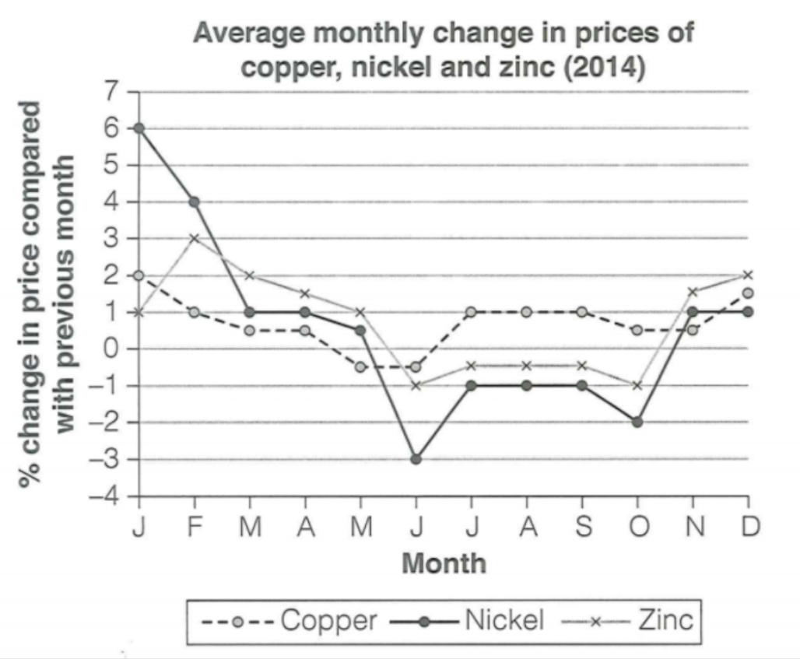

The line graph illustrates the prices monthly change in three metals, including copper, nickel and zinc, over the 2014.

As the line graph shown, the change in price of nickel reached peak at 6% in Jan. However, it experienced dramatically decrease over the half of year, from 6% to -3%. Afterward, its prices recovered to some extent in the next six months, reaching at 1% in Des. Similarly, the pattern of copper is comparable to nickel, showing a slight decline from 2% in Jan to -0.5% in Jun. In the end, the change in price backed to 1.5% in Des.

While the change in price of zinc started at a relatively low point at 1%, the figures kept higher than nickel in follow months. Moreover, the data overtook the other two metals and reached peak at 2% in Des.

In summary, the change in prices in three metals showed significant fluctuations to varying extent during the year. Furthermore, all of them saw a decrease in generally.

The chart below gives information on the percentage of British people giving money to charity by age range for the years 1990 and 2010.

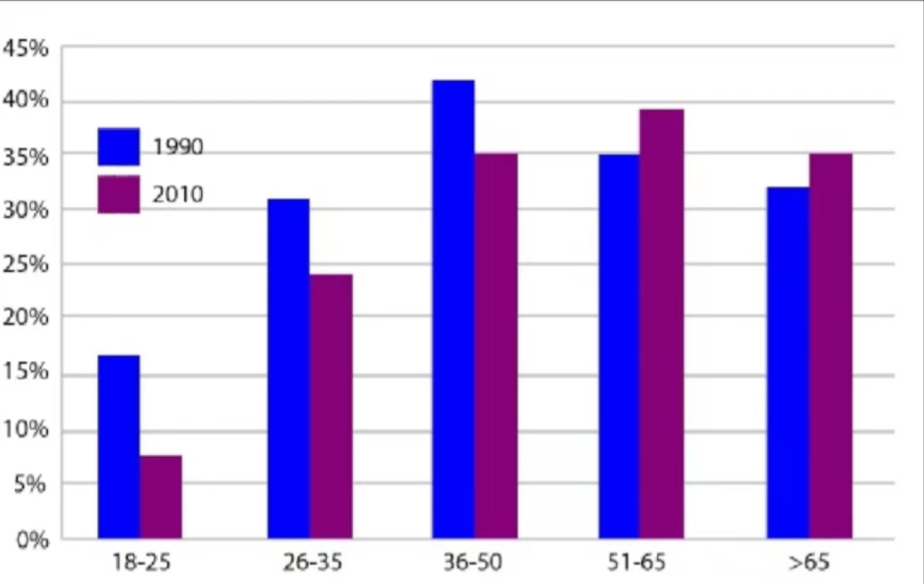

The bar chart illustrates the proportion of British public donating money to charity in five different age groups in 1990 and 2010.

In 1990, people who aged from 36 - 50 were the biggest part of citizens who gave money to charity, reaching a peak at 40%. Following that, around 35% people who aged from 51 - 65 were willing to give a hand to others by donating money to charity. Notably, the percentage of residents who came from 26 - 35 and older than 65 age groups were relatively higher, with rough 33% people. The last age group is 18 - 25, with 17% inhabitants were handy.

The situation had a litte difference in 2010. People who aged from 51 - 65 became the largest group, reaching at 39%. Similarly, compared to in 1990, older people (older than 65) saw an increase in giving money to charity, accounting for 35%. By contrast, the other three groups were relatively lower than in 1990, especially for age group 18 - 25, the figure dropped more than a half, at 7%.

In summary, elder people showed more preference to donate money to charity than younger, those aged from 36 - 65 were the mojor warm heart people.

The bar chart illustrates the proportion of the British public donating money to charity in five different age groups in 1990 and 2010.

In 1990, people aged 36-50 made up the largest proportion of citizens who gave money to charity, reaching a peak at 40%. Following that, around 35% of people aged 51-65 were willing to contribute to charity. Notably, the percentage of residents from the 26-35 and over 65 age groups was relatively higher, with approximately 33% of people. The last age group is 18-25, with 17% of inhabitants willing to contribute.

The situation showed a slight difference in 2010. People aged 51-65 became the largest group, reaching 39%. Similarly, compared to 1990, older people (those over 65) saw an increase in giving money to charity, now accounting for 35%. By contrast, the other three groups had comparatively lower percentages than in 1990, especially the 18-25 age group, where the figure dropped by more than half, reaching 7%.

In summary, older people showed a stronger preference for donating money to charity than younger people, with those aged 36-65 being the main contributors.

The chart below gives information about how families in one country spent their weekly income in 1968 and in 2018. Summarise the information by selecting and reporting the main features, and make comparisons where relevant.

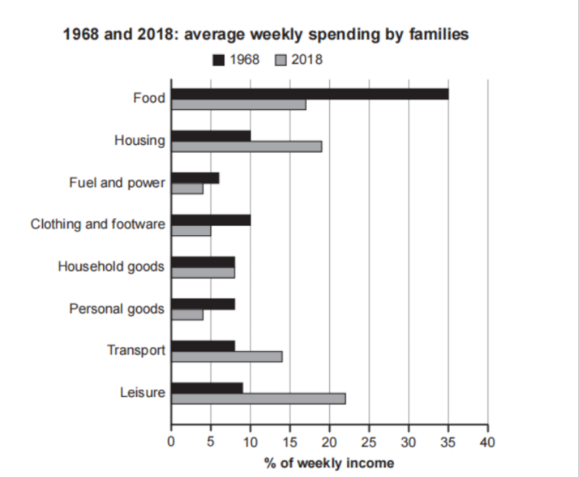

原版2:

The bar chart present changes of how residents spent their weekly income on various items in two separate years ( in 1968 and in 2018).

In 1968, public spent more than one of thired of weekly income on food, which was the main resource of expense. By contrast, only 7% of salary was used for fuel and power. The expenditures of the other items were less than 10% respectively.

The pattern of cost in 2018 showed sigficant changes. The expense on food dropped a half to 17% compared to the figure in 1968. Likewise, the spent on clothing and footware and personal goods experienced similary decline, accounting for 5% and 4% respectively in 2018. Conversely, the expenditures on leisure, transport and houseing soared by approximately 50% in 2018 compared to that in 1968, reaching 23%, 14% and 18% respectively.

In summary, inhabitants paid more attention to leisure and housing instead of food, with time went by. Markedly, the expenses on various item in 2018 were more balanced than those in 1968.

优化版2:

The bar chart presents changes in how residents spent their weekly income on various items in two separate years, 1968 and 2018.

In 1968, the public spent more than one-third of their weekly income on food, which was the main source of expenditure. By contrast, only 7% of income was spent on fuel and power. The expenditures on the other items were less than 10% each.

The spending pattern in 2018 showed significant changes. The expense on food dropped by half to 17% compared to the figure in 1968. Likewise, spending on clothing and footwear and personal goods experienced a similar decline, accounting for 5% and 4% respectively in 2018. Conversely, the expenditures on leisure, transport, and housing soared by approximately 50% in 2018 compared to 1968, reaching 23%, 14%, and 18% respectively.

In summary, inhabitants paid more attention to leisure and housing instead of food as time went by. Markedly, the expenses on various items in 2018 were more balanced than those in 1968.

优化版1:

The bar chart illustrates the percentage of how residents spent their weekly income in two separate years (1968 and 2018).

As shown in the bar chart, in 1968, food was the major source of expenses, reaching a peak of 35%, which was three times more than the other expenditure categories. Spending on fuel and power was the lowest, accounting for around 7%.

In 2018, the pattern of consumption underwent significant changes. The proportion of spending on food declined by half to 17% compared to the figure in 1968. Notably, leisure spending saw a dramatic increase, reaching 23% in 2018, surpassing the expenditure on food. Similarly, housing also emerged as one of the primary expenses, accounting for 18%.

In summary, with the development of the economy, the public paid more attention to leisure instead of food, and the differences in the cost of various items were more slight than before.

原版：

The bar chart illustrates the percentage of how residents spent their weekly income in two separate years (1968 and 2018).

As shown in the bar chart, in 1968, food was the majory source of expenses, reaching peak at 35%, which was 3 times more than the other cost items. The spending of fuel and power was the lowest among these items, accounting for around 7%.

In 2018, the pattern of consumtion had changed a lot. The proportion of cost in food declined by half at 17%, compared to the figure in 1968. Notably, leisure spending saw a dramatic increase, the data overtaked the cost in food, reaching 23%. Similarly, housing also became one of the primary expenses, accounting for 18%.

In summary, with the development of economy, public paied more attention on leisure instead of food, and the differences of the cost in different items were more slight than before.

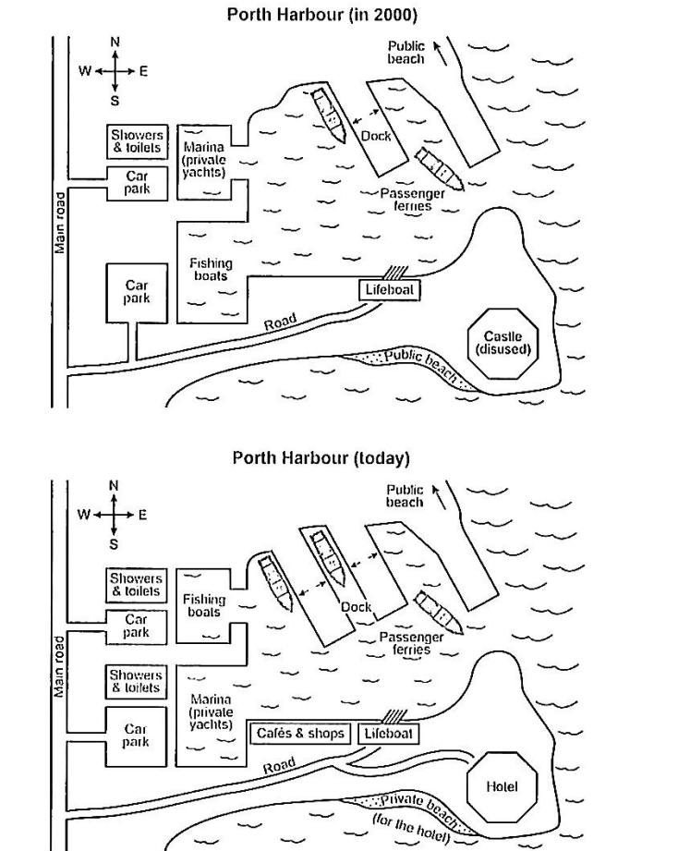

The two maps illustrate the changes in Porth Harbour, comparing its layout in 2000 to the current state.

Firstly, there are some newly developed buildings. You can see some showers and toilets between two car parks near the main road. Near the public beach, the number of docks increases to two. At the oppsite of the dock, there are a newly constructed cafe and a shop, just located at the west of lifeboat.

Some facilities have been reconstructed. The fishing boats and marina just swap the position, now, marina is biger than fishing boats. The castle which at the southeast of the harbour has been conversed to a hotel, and the public beach which located in the south of the castle is allocated to the hotel as its private area.

Overall, the Porth Harbour establishes or reconstructs some building, rather than demolishing any of them. It becomes more prosperous than previous.