Project Three Documentation
Mark Andrew Brannan
4/19/26
CS-210

This program is built to help the Corner Grocer analyze their daily produce sales. When it starts up, the code immediately opens the daily text file and reads the list of purchased items. It stores all this data inside a map structure. A map is really the best choice here because it easily pairs the name of the grocery item with the exact number of times it was bought. At the same time, it creates a backup file called frequency.dat to store a permanent record of the day's totals. Once the background stuff is done, the user sees a simple menu. They can search for a single item, view a full list of everything sold, or see a text based histogram of the data. I also made sure to include some input validation so the program doesn't just crash if the user accidentally types a letter instead of a number at the menu prompt.
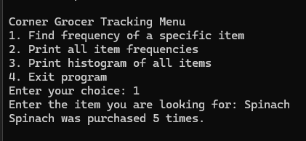
This screenshot shows the first menu option successfully locating a specific item and returning its total count.

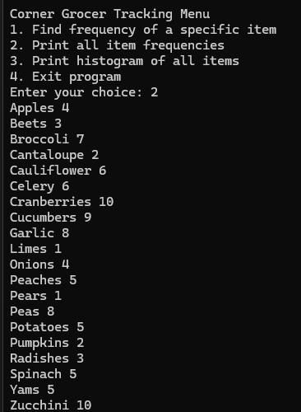
Here is the output for menu option 2 displaying the complete list of purchased items paired with their respective frequencies.
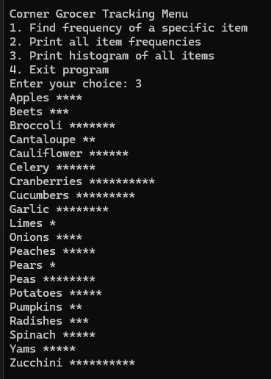
This shows the text based histogram generated by option 3 to visually represent the daily frequency of each item.

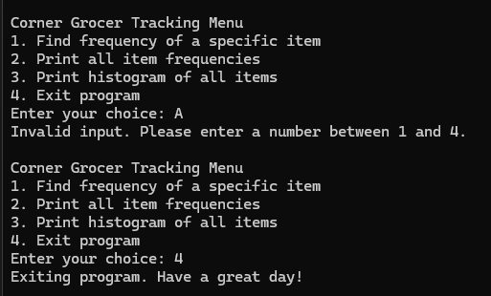
This screenshot proves the program handles invalid user input without crashing and successfully exits when option 4 is selected.

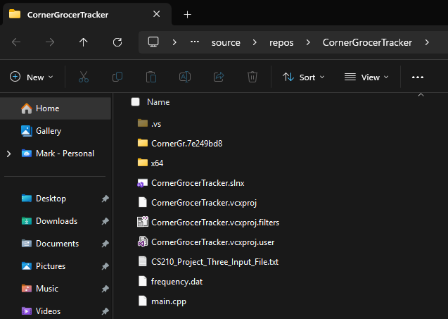
This shows the frequency.dat backup file that is automatically generated by the program on startup.

