|  |  |  |  |  |  |
| --- | --- | --- | --- | --- | --- |
| |  |  |  | | --- | --- | --- | | **Logo_FPT_University_doc** | **MINISTRY OF EDUCATION AND TRAINING** | | | **FPT UNIVERSITY** | | |
| Capstone Project |
| Home Delivery Management System  Software Requirements Specification |
| |  |  |  |  |  |  |  |  |  |  |  |  |  |  |  |  |  |  |  |  |  |  |  |  |  |  | | --- | --- | --- | --- | --- | --- | --- | --- | --- | --- | --- | --- | --- | --- | --- | --- | --- | --- | --- | --- | --- | --- | --- | --- | --- | --- | | |  |  |  |  | | --- | --- | --- | --- | | **Group 6** | | | | | **Group Members** | Lê Anh Đảo |  | 60142 | | Nguyễn Bá Linh |  | 60153 | | Hồ Hữu Tài |  | 60267 | | Thân Văn Thành |  | 60277 | | **Supervisor** | Lâm Hữu Khánh Phương | | | | **Capstone Project code** | HDMS | | | | |
| * Ho Chi Minh City, Oct / 2012 - |

# Table of Contents

[Table of Contents 2](#_Toc342392605)

[3.1 User Requirement Specification 4](#_Toc342392606)

[3.1.1 Common Features 4](#_Toc342392607)

[3.1.2 Account Management 4](#_Toc342392608)

[3.1.3 Customer’s Uses 4](#_Toc342392609)

[3.1.4 Customers Management 4](#_Toc342392610)

[3.1.5 Request Management 5](#_Toc342392611)

[3.1.6 Order Management 5](#_Toc342392612)

[3.1.7 Area Management 5](#_Toc342392613)

[3.1.8 Collection Planning 6](#_Toc342392614)

[3.1.9 Delivery Planning 6](#_Toc342392615)

[3.2 System Requirement Specification 6](#_Toc342392616)

[3.2.1 External Interface Requirements 6](#_Toc342392617)

[3.2.1.1 User Interfaces 6](#_Toc342392618)

[3.2.1.2 Hardware Interfaces 7](#_Toc342392619)

[3.2.1.3 Software Interfaces 7](#_Toc342392620)

[3.2.1.4 Communications Protocol 7](#_Toc342392621)

[3.2.2 System Features 8](#_Toc342392622)

[3.2.2.1 Manage Account 9](#_Toc342392623)

[3.2.2.2 Manage Requests 18](#_Toc342392624)

[3.2.2.3 Manage Orders 34](#_Toc342392625)

[3.2.2.4 Manage Customers 39](#_Toc342392626)

[3.2.2.5 Manage Master Data 50](#_Toc342392627)

[3.2.2.6 Manage Collection Plan 74](#_Toc342392628)

[3.2.2.7 Manage Delivery Plan 84](#_Toc342392629)

[3.2.3 Software System Attributes 94](#_Toc342392630)

[3.2.3.1 Reliability 94](#_Toc342392631)

[3.2.3.2 Availability 95](#_Toc342392632)

[3.2.3.3 Security 95](#_Toc342392633)

[3.2.3.4 Maintainability 95](#_Toc342392634)

# User Requirement Specification

## Common Features

* Only authenticated users can access the system. Users can log in and log out using their own accounts.
* Users can change their password.
* Only authorized users can use specific functions of the system.

## Account Management

* System administrators have privileges to create new account, enable or disable account, and reset account’s password.
* When the password of an account is reset, an email is sent to the account owner to announce the new password.

## Customer’s Uses

* Customers can create request when they want some orders to be delivered to the receivers. A request includes many orders. Each order is associated with one receiver. If the receiver is the buyer and the sender is the seller, this order is the same as the order that the buyer made to the seller. An order may include many items.
* When creating a new request, the customer must add new order with request information and items in that order. Another way to create new order is “upload excel file”, it’s helpful when there are a lot of order and items need to be delivered. The customer will input items into excel file (with predefined template) and upload, so the system will import all the data and show on the screen for customer to confirm.
* When a request is submitted, the customer has not permission to edit/cancel request.

## Customers Management

* Customers must have signed a contract with TicTac before they could use the delivery service. Then, office staff will create a new account. After **t**hat, they can use this account to access the system.
* Office staff can view all collection requesting of customers which were created. By this function, office staff can edit the order/items for customer if necessary.
* Office staff can update the information of customers whenever there is a change.
* Also, each customer may have one or many personnel for contacting and address with TicTac. The contact’s information and address’s information should also be stored in the system for use when needed.
* When a customer no longer uses TicTac’s services, this customer must be deleted from the system and all the accounts associated with this customer are blocked.

## Request Management

* When receiving a request by phone or email, office staff can create new Request for the customer by using web form or importing Excel file. A new request must have Customer’s company name (or Customer id), address for orders collecting and complete details of the orders/items include name of item, delivery address, amount of payment, etc.
* Office staff can manually choose to send confirmation e-mail of request to Customer if they find it necessary.
* Office Staff can view all requests, orders and items’ information for checking on their dates, statuses, payments, etc.
* Office Staff can filter all requests to manage and to do with it faster.
* Office Staff can approve for new requests, cancel request and add/ edit orders/ items if necessary.

## Order Management

* Office Staff can create new order inside a Request by selecting a Request and then add a new order into it.
* Office Staff can filter all orders to manage and to do with it faster.
* Office Staff can view all orders and items’ information for checking on their dates, statuses, payments, etc.
* Office Staff can cancel orders or update status is returned if order be returned.

## Area Management

* When login to HDMS with area manager roles, user can create new city/district/ward that helps addressing easy. Area manager can also update information or delete a city/district/ward.

## Collection Planning

* With collection manager roles, user can view request/order/item information that has been created. If collection manager feels the number of request is enough to collect, he can make a collection plan and assign it for collectors to go to the customers to receive goods.
* Collectors also have an information sheet for each item in the order for tracking and quality assurance. It will be attached on item when the collection staff come to customers’ place and collect goods.
* Staff can view collection plan detail to cancel collection plan, update status “finished” for it, update status “collected” for every request. Moreover, staff can use filter function to manage collection plan easier.

## Delivery Planning

* With delivery manager roles, user can view order/item information that has been collected. If delivery manager feels the number of item is enough to deliver, delivery manager can also make a delivery plan and assign it for delivery men to go to the receivers to deliver goods.
* Delivery men also have a delivery note for each order to be delivered. When delivering, the receiver will receive the item, check, pay money and sign in the delivery note.
* Staff can view delivery plan detail to cancel delivery plan, update status “finished” for it, update status “delivered” for every order. Moreover, staff can use filter function to manage collection plan easier

# System Requirement Specification

## External Interface Requirements

### User Interfaces

* The design should be simple and user-friendly. White and dark blue will be 2 main colors of the website while charts may have more color to visually express data more effectively. The text color should be white if the background is dark blue, and it should be dark gray if the background is white.
* The menu bar should be on the left and not take too much space of the screen. It consists of the list of main functions of the system that users can access.
* The design should be responsive. It means that the web components should be scaled according to a range of resolutions and devices to provide a consistent experience, no matter what.

### Hardware Interfaces

* To access to the system, users only need any type of computer, tablet, or mobile phone with a fair internet connection.

### Software Interfaces

* At the server side, the system should run on top of Windows 7, Windows Server 2008 or later versions of Windows Server. Besides, Microsoft .NET Framework 4 and MVC 3 should be installed on the server. The database management system use for HDMS is SQL Server 2008 R2.
* At the client side, users can use any modern browser that supports javascript and HTML 5 to access to the system.

### Communications Protocol

HTTP is the protocol used for loading the web site in browsers.

## System Features

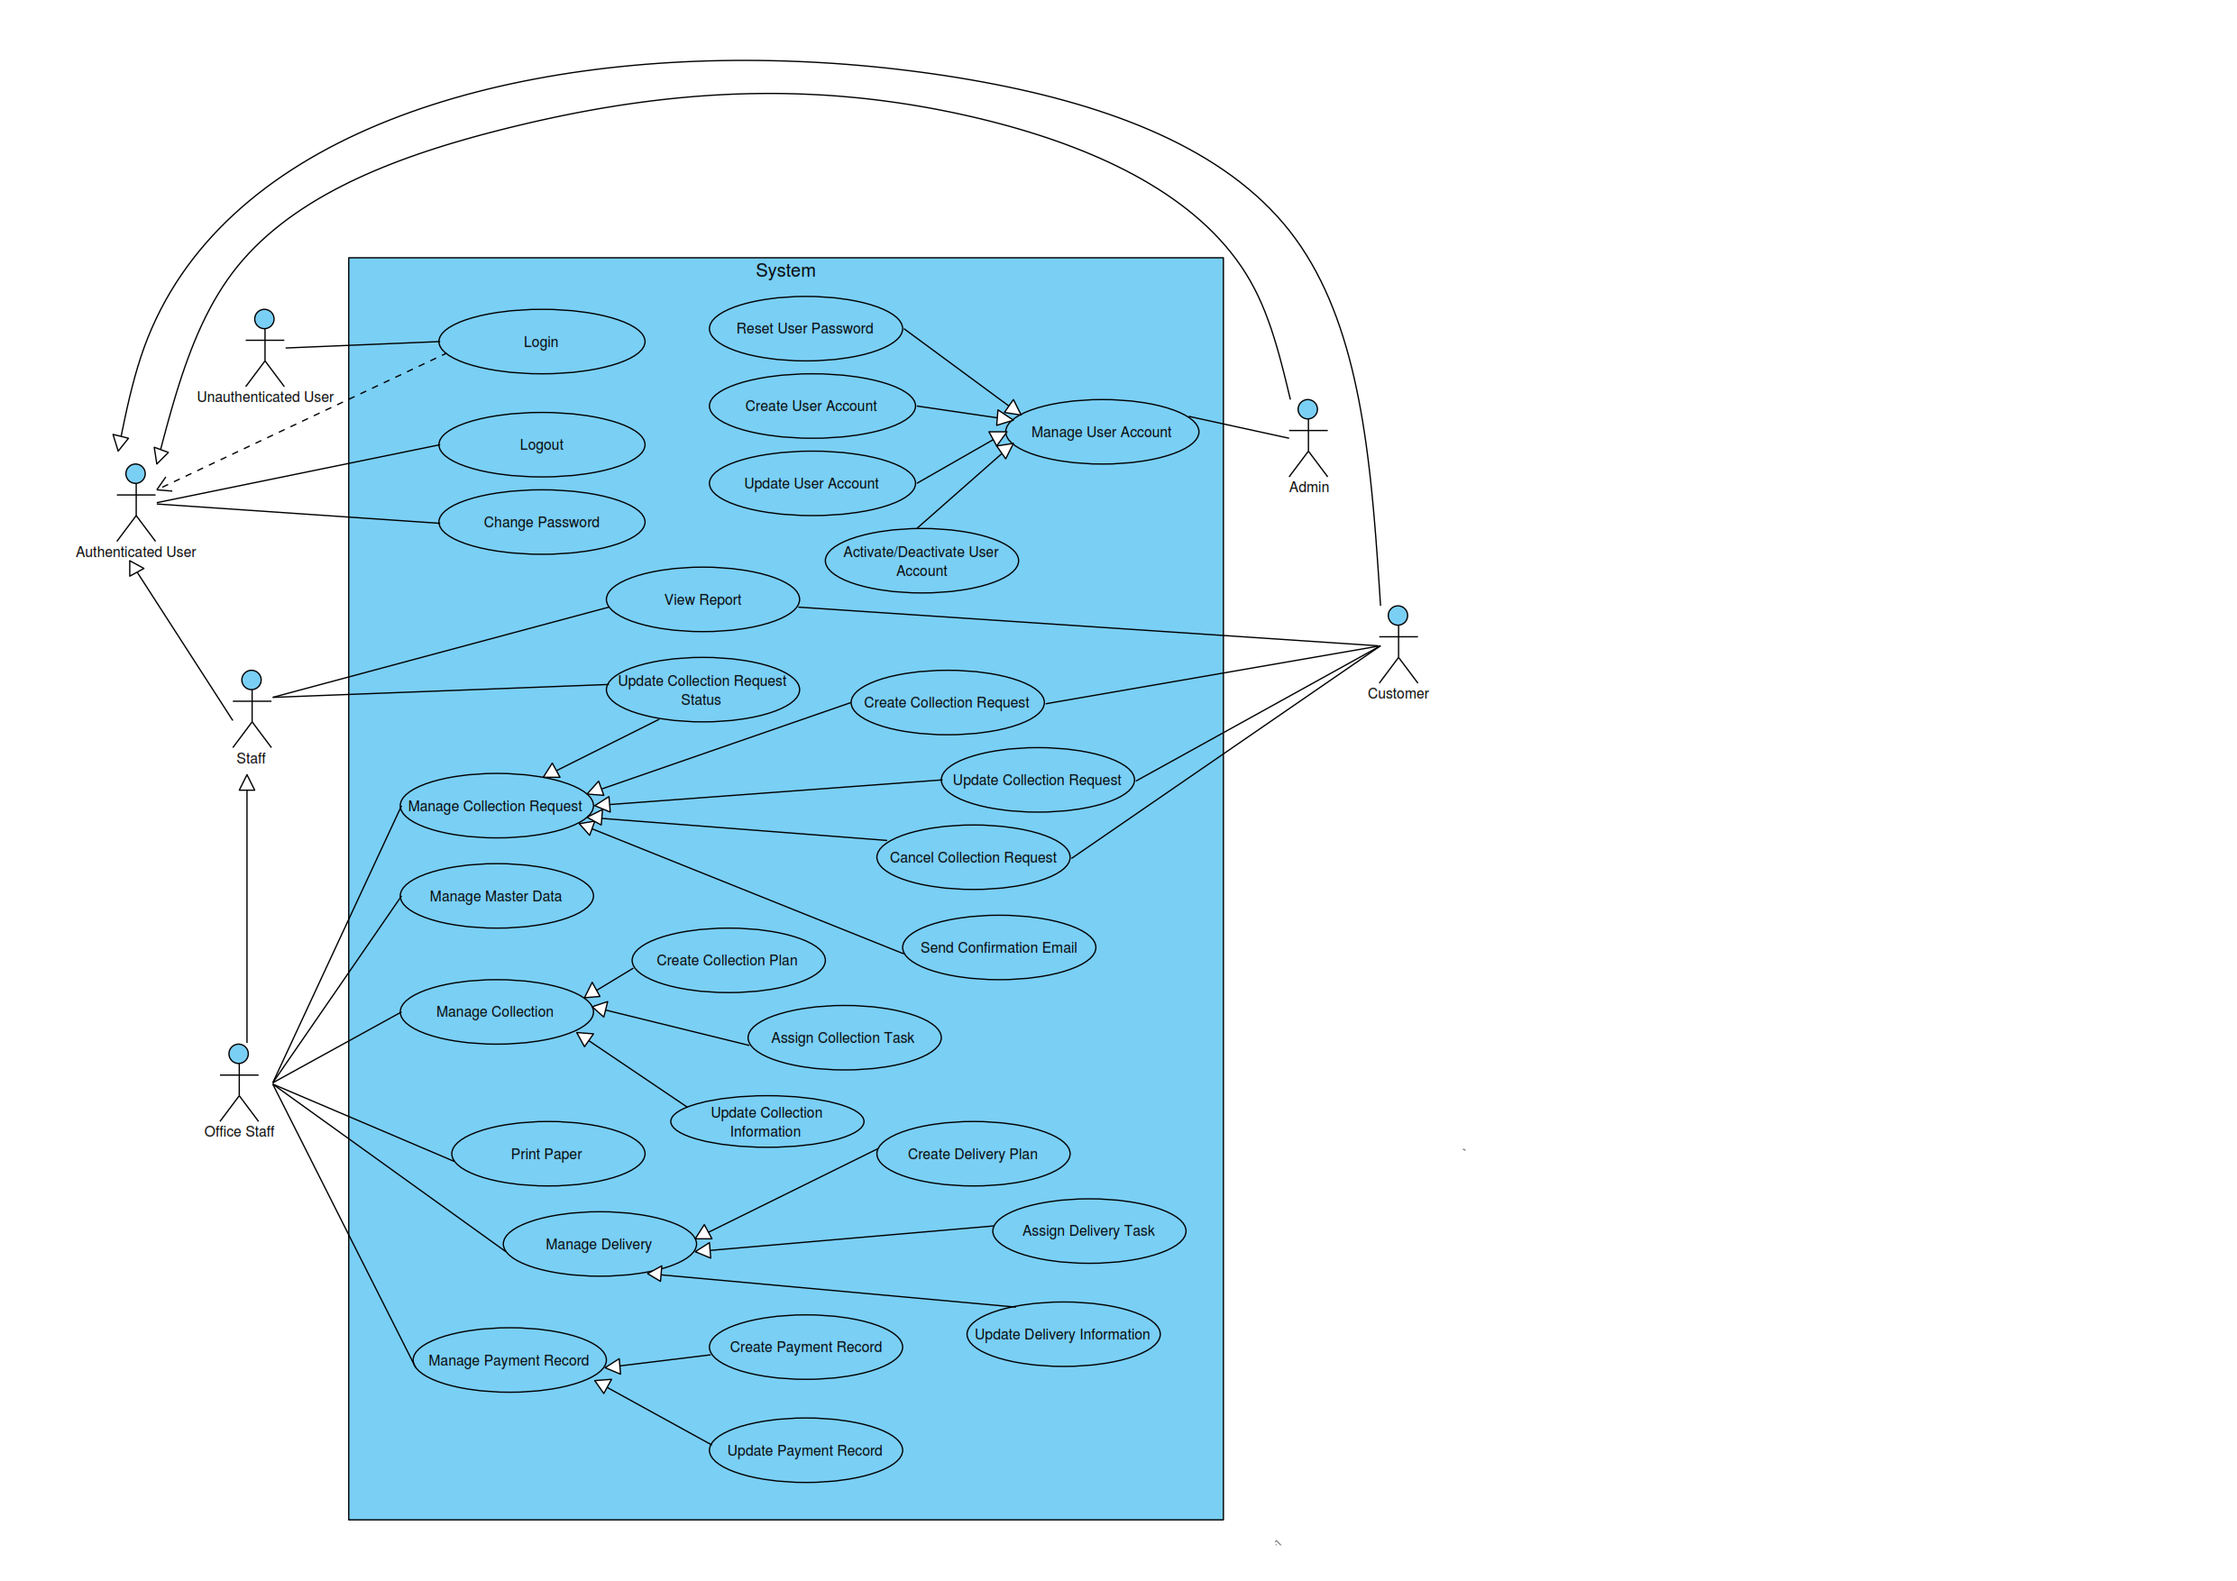

Figure 1 - General Use Case Diagram

### Manage Account

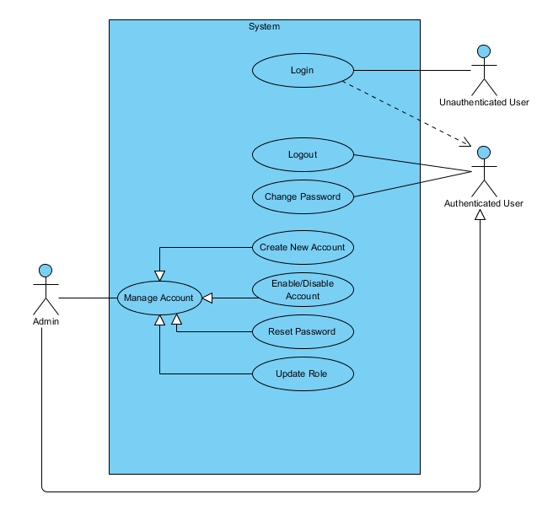

Figure 2 - Manage Account Use Case Diagram

#### Login

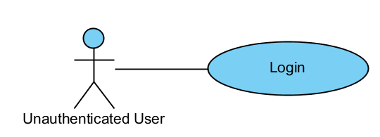

|  |  |  |  |
| --- | --- | --- | --- |
| USE CASE - LOGIN specification | | | |
| Use-case No. | UC01.1 | Use-case Version | 1.0 |
| Use-case Name | Login | | |
| Author | ThanhTV | | |
| Date | 21/11/2012 | Priority | Normal |
| **Actor:** Unauthenticated User  **Summary:** This use case is about how Unauthenticated User login  **Goal:** Have access to functions that require logging in  **Triggers:** Actor clicks “Login” button after typing in username and password  **Pre-conditions:** Actor is not logged in and actor types in valid username and password  **Post-conditions:** Actor is logged in  **Main Success Scenario:**   1. Actor clicks “Login” button after typing in username and password. 2. System will be redirect to “Dashboard” page.   **Alternative Scenario:**  N/A  **Exceptions:** When inputs wrong username or password, the system will notify and require input again  **Relationships:**  N/A  **Business Rules:** N/A | | | |

#### Logout

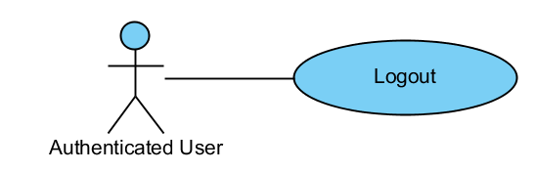

|  |  |  |  |
| --- | --- | --- | --- |
| USE CASE - LOGOUT specification | | | |
| Use-case No. | UC01.2 | Use-case Version | 1.0 |
| Use-case Name | Logout | | |
| Author | ThanhTV | | |
| Date | 21/11/2012 | Priority | Normal |
| **Actor:** Authenticated User  **Summary:** This use case is about how Authenticated User logout  **Goal:** Log out of the system  **Triggers:** Actor clicks “Logout” button  **Pre-conditions:** Actor is logged in  **Post-conditions:** Actor is logged out  **Main Success Scenario:**   1. User clicks to Account Navigation Button and select Logout. 2. System will be redirect to Login page.   **Alternative Scenario:**  N/A  **Exceptions:** N/A  **Relationships:**  N/A  **Business Rules:** N/A | | | |

#### Create New User Account

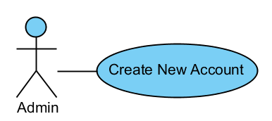

|  |  |  |  |
| --- | --- | --- | --- |
| USE CASE – CREATE NEW USER ACCOUNT specification | | | |
| Use-case No. | UC01.3 | Use-case Version | 1.0 |
| Use-case Name | Create User Account | | |
| Author | ThanhTV | | |
| Date | 21/11/2012 | Priority | Normal |
| **Actor:** Admin  **Summary:** This use case is about how to create new account.  **Goal:** Create a new user account in the system  **Triggers:** Admin clicks “Create new account” button  **Pre-conditions:** User is logged in with Admin role  **Post-conditions:** New account is successfully created  **Main Success Scenario:**   1. In Register page, Admin inputs request information and click “Register”. 2. System will be redirect to “Dashboard” page with user had just created.   **Alternative Scenario:**  N/A  **Exceptions:** If there is already an account with the same username or same email, the system will notify and require input again.  When inputs require information is invalid format or missed require information, the system will notify and require input again  **Relationships:**  N/A  **Business Rules:** N/A | | | |

#### Enable/Disable User Account

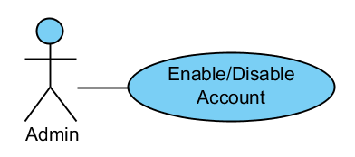

|  |  |  |  |
| --- | --- | --- | --- |
| USE CASE – ENABLE/DISABLE USER ACCOUNT specification | | | |
| Use-case No. | UC01.4 | Use-case Version | 1.0 |
| Use-case Name | Enable/Disable User Account | | |
| Author | ThanhTV | | |
| Date | 21/11/2012 | Priority | Normal |
| **Actor:** Admin  **Summary:** This use case is about how to enable/disable a user account.  **Goal:** Enable/Disable a user account.  **Triggers:** In User page, admin clicks “Enable”/”Disable” button of a user  **Pre-conditions:** User is logged in with Admin account, user account is disabled/enabled  **Post-conditions:** Account is successfully disabled/enabled  **Main Success Scenario:**   1. In User page, admin clicks “Disable” button of a user. 2. A confirm box will appear to confirm. 3. Admin clicks on “Yes” button to disable.   **Alternative Scenario:**  In step 3, if user wants to cancel the process, user can clicks to “Cancel” button to back the main page of Users.  If admin want to enable user, admin must click “Show disable user” and next, do 3 there steps with “Disable” button is changed to “Enable” button.  **Exceptions:** N/A  **Relationships:**  N/A  **Business Rules:** N/A | | | |

#### Reset Password

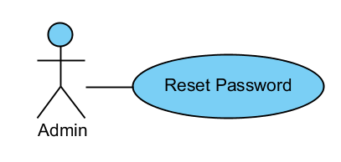

|  |  |  |  |
| --- | --- | --- | --- |
| USE CASE – RESET PASSWORD specification | | | |
| Use-case No. | UC01.5 | Use-case Version | 1.0 |
| Use-case Name | Reset Password | | |
| Author | ThanhTV | | |
| Date | 21/11/2012 | Priority | Normal |
| **Actor:** Admin  **Summary:** This use case is about how to reset password for a user account  **Goal:** Reset password for user account  **Triggers:** In main page of Users, Admin clicks “Reset password” button of a user  **Pre-conditions:** User is logged in with Admin account  **Post-conditions:** Password of that user will be reset  **Main Success Scenario:**   1. In main page of Users, Admin clicks “Reset password” button of a user. 2. A confirm box will be appear to confirm. 3. Admin clicks on “Yes” button to reset password.   **Alternative Scenario:**  In step 3, if user wants to cancel the process, user can clicks to “No” button to back the main page of Users  **Exceptions:** N/A  **Relationships:**  N/A  **Business Rules:** N/A | | | |

#### Change Password

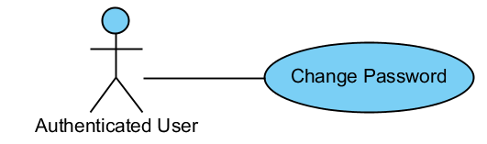

|  |  |  |  |
| --- | --- | --- | --- |
| USE CASE – CHANGE PASSWORD specification | | | |
| Use-case No. | UC01.6 | Use-case Version | 1.0 |
| Use-case Name | Change Password | | |
| Author | ThanhTV | | |
| Date | 21/11/2012 | Priority | Normal |
| **Actor:** Authenticated User  **Summary:** This use case is about how to change password.  **Goal:** Authenticated User can change password.  **Triggers:** Authenticated User clicks “Change Password” link.  **Pre-conditions:** User is logged in completed.  **Post-conditions:** Password is changed.  **Main Success Scenario:**   1. Authenticated User clicks “Change Password” link in Account Navigation Button. 2. System will redirect to “Change Password” page. 3. Authenticated User inputs current password, new password and clicks “Change Password” button. 4. Account password is changed.   **Alternative Scenario:**  N/A  **Exceptions:** When inputs current password be wrong or new password not satisfy with required, the system will notify and require input again  **Relationships:**  N/A  **Business Rules:** N/A | | | |

#### Update Role

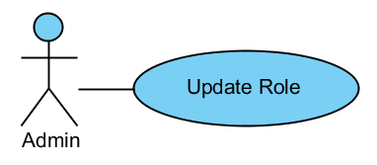

|  |  |  |  |
| --- | --- | --- | --- |
| USE CASE – UPDATE ROLE specification | | | |
| Use-case No. | UC01.7 | Use-case Version | 1.0 |
| Use-case Name | Update Role | | |
| Author | ThanhTV | | |
| Date | 21/11/2012 | Priority | Normal |
| **Actor:** Admin  **Summary:** This use case is about how to update role for a user account  **Goal:** Update role for user account  **Triggers:** In the main page of Users, Admin clicks “Update Role” button of a user  **Pre-conditions:** User is logged in with Admin account  **Post-conditions:** New user account password is generated and e-mailed to user e-mail address  **Main Success Scenario:**   1. In the main page of Users, Admin clicks “Update Role” button of a user. 2. System will show a popup to select new role. 3. Admin selects new role and clicks “Save” button.   **Alternative Scenario:**  In step 3, if user wants to cancel the process, user can clicks to “Close” button to back the main page of Users.  **Exceptions:** N/A  **Relationships:**  N/A  **Business Rules:** N/A | | | |

### Manage Requests

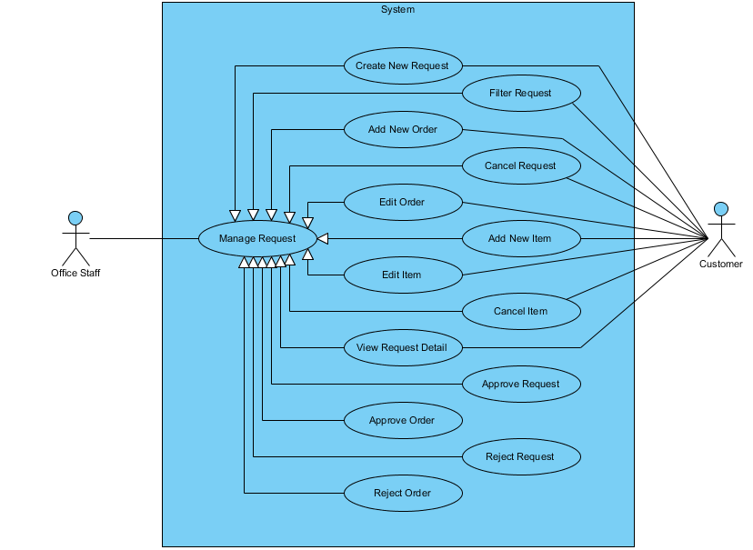

#### Create New Request

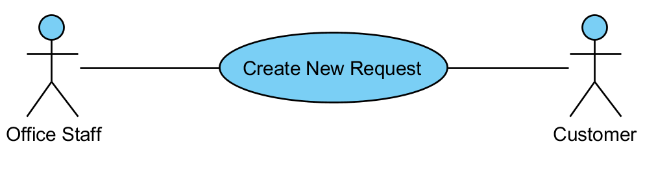

|  |  |  |  |  |
| --- | --- | --- | --- | --- |
| USE CASE - CREATE REQUEST SPECIFICATION | | | | |
| Use-case No. | UC02.1 | Use-case Version | | 1.0 |
| Use-case Name | Create Request | | | |
| Author | ThanhTV | | | |
| Date | 21/11/2012 | Priority | Normal | |
| **Actor:** Office Staff, Customer  **Summary:** This use case is about how to create new request.  **Goal:** User can create new request.  **Triggers:** In main page of requests, user click “Add” button.  **Pre-conditions:** User logged in with office staff/ customer role.  **Post-conditions:** Request is created successfully.  **Main Success Scenario:**   1. In main page of requests, user clicks “Add” button. 2. System appears a popup for user input information. 3. User input request information and click “Create” button. 4. System redirect to “Add Order to Request” page. 5. User click “Add new Orders”, input request information and click “Create” button. 6. User click “Add new Item”, input request information and click “Create” button. 7. User clicks “Submit Request”.   **Alternative Scenario:** In step 4 and step 5, if user wants to cancel the process, user can clicks to “Cancel” button to back the main page of requests.  **Exceptions:** When inputs require information is invalid format or missed require information, the system will notify and require input again.  When user click “Submit Request” while have not at least item in order, the system will appear a notification “One or more orders contain no item”.  **Relationships:**  N/A  **Business Rules:** N/A | | | | |

#### Filter Requests

**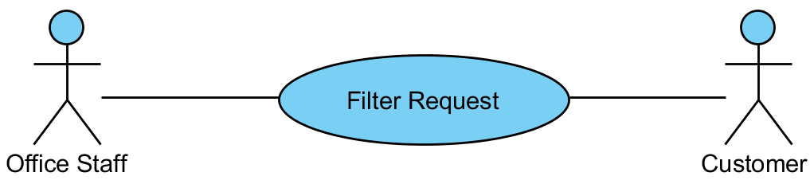**

|  |  |  |  |  |
| --- | --- | --- | --- | --- |
| USE CASE – FILTER REQUESTS SPECIFICATION | | | | |
| Use-case No. | UC02.2 | Use-case Version | | 1.0 |
| Use-case Name | Filter Request | | | |
| Author | ThanhTV | | | |
| Date | 21/11/2012 | Priority | Normal | |
| **Actor:** Office Staff, Customer  **Summary:** This use case is about how office staff filters requests.  **Goal:** User can filter requests.  **Triggers:** In main page of requests, user click “Filter” button.  **Pre-conditions:** User logged in with office staff/ customer role.  **Post-conditions:** Requests is filtered successfully.  **Main Success Scenario:**   1. In main page of requests, user selects conditions (status, start date, end date) and clicks “Filter” button. 2. System will show requests tally with conditions.   **Alternative Scenario:** N/A  **Exceptions:** N/A  **Relationships:**  N/A  **Business Rules:** N/A | | | | |

#### Approve Requests

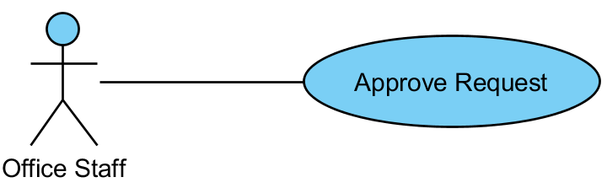

|  |  |  |  |  |
| --- | --- | --- | --- | --- |
| USE CASE – APPROVE REQUESTS SPECIFICATION | | | | |
| Use-case No. | UC02.3 | Use-case Version | | 1.0 |
| Use-case Name | Approve Requests | | | |
| Author | ThanhTV | | | |
| Date | 21/11/2012 | Priority | Normal | |
| **Actor:** Office Staff  **Summary:** This use case is about how to approve request.  **Goal:** Office staff can approve request.  **Triggers:** In main page of requests, user click “Approve Request” icon of “New” status.  **Pre-conditions:** User logged in with office staff role.  **Post-conditions:** Request was approved successfully.  **Main Success Scenario:**   1. In main page of requests, user click “Approve Request” icon of “New” status. 2. System will redirect to “Approve Request” page. 3. User inputs “Due Date” and “Fee” for Order and clicks “Approve Order” icon. 4. User clicks “Approve Request” button.   **Alternative Scenario:** N/A  **Exceptions:** When status of request is not “New”, the “Approve Request” icon will be hidden.  **Relationships:**  N/A  **Business Rules:** N/A | | | | |

#### Add New Order

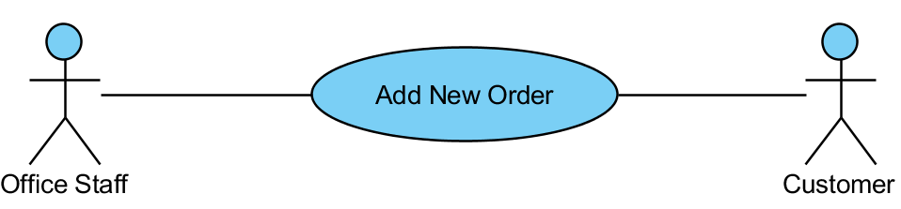

|  |  |  |  |  |
| --- | --- | --- | --- | --- |
| USE CASE – ADD NEW ORDER SPECIFICATION | | | | |
| Use-case No. | UC02.4 | Use-case Version | | 1.0 |
| Use-case Name | Add New Order | | | |
| Author | ThanhTV | | | |
| Date | 21/11/2012 | Priority | Normal | |
| **Actor:** Office Staff, Customer  **Summary:** This use case is about how to add new order.  **Goal:** User can add new order.  **Triggers:** In “Add Order to Request” page, user clicks “Add new Order” button.  **Pre-conditions:** User logged in with office staff/ customer role.  **Post-conditions:** Order is added successfully.  **Main Success Scenario:**   1. In main page of requests, user click “Edit” icon of “Draft” status. 2. System will redirect to “Add Order to Request” page. 3. User clicks “Add new Order” button. 4. System appears a popup for user input information. 5. User inputs request information and click “Create” button.   **Alternative Scenario:** In step 5, if user wants to cancel the process, user can clicks to “Cancel” button to back “Add Order to Request” page.  **Exceptions:** When inputs require information is invalid format or missed require information, the system will notify and require input again.  When status of collection plan is not “Draft”, the “Edit” icon will be hidden.  **Relationships:**  N/A  **Business Rules:** N/A | | | | |

#### Edit Order

**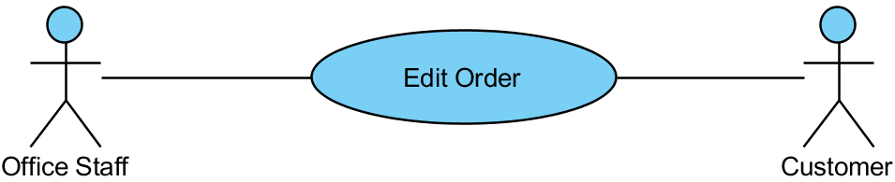**

|  |  |  |  |  |
| --- | --- | --- | --- | --- |
| USE CASE – EDIT ORDER SPECIFICATION | | | | |
| Use-case No. | UC02.5 | Use-case Version | | 1.0 |
| Use-case Name | Edit Order | | | |
| Author | ThanhTV | | | |
| Date | 21/11/2012 | Priority | Normal | |
| **Actor:** Office Staff, Customer  **Summary:** This use case is about how to edit order.  **Goal:** User can edit order.  **Triggers:** In “Add Order to Request” page, user clicks “Edit Order” icon of that order.  **Pre-conditions:** User logged in with office staff/ customer role.  **Post-conditions:** Order is edited successfully.  **Main Success Scenario:**   1. In main page of requests, user click “Edit” icon of “Draft” status. 2. System will redirect to “Add Order to Request” page. 3. User clicks “Edit Order” icon of that order. 4. System appears a popup for user input information again. 5. User click “OK” button to cancel.   **Alternative Scenario:** In step 5, if user wants to cancel the process, user can clicks to “Cancel” button to back “Add Order to Request” page.  **Exceptions:** When status of collection plan is not “Draft”, the “Edit” icon will be hidden.  When inputs require information is invalid format or missed require information, the system will notify and require input again.  **Relationships:**  N/A  **Business Rules:** N/A | | | | |

#### Add New Item

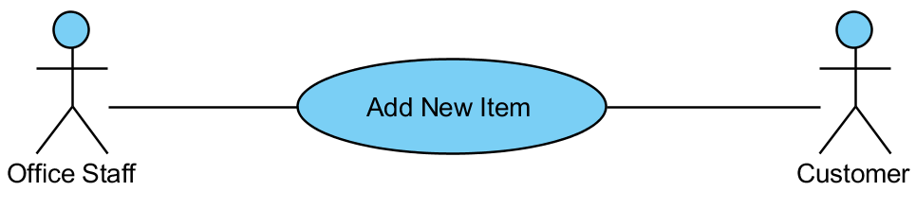

|  |  |  |  |  |
| --- | --- | --- | --- | --- |
| USE CASE – ADD NEW ITEM SPECIFICATION | | | | |
| Use-case No. | UC02.6 | Use-case Version | | 1.0 |
| Use-case Name | Add New Item | | | |
| Author | ThanhTV | | | |
| Date | 21/11/2012 | Priority | Normal | |
| **Actor:** Office Staff, Customer  **Summary:** This use case is about how to add new item.  **Goal: U**ser can add new item.  **Triggers:** In “Add Order to Request” page, user clicks “Add New Item” icon of that order.  **Pre-conditions:** User logged in with office staff/ customer role.  **Post-conditions:** Item is added successfully.  **Main Success Scenario:**   1. In main page of requests, user click “Edit” icon of “Draft” status. 2. System will redirect to “Add Order to Request” page. 3. User clicks “Add New Item” icon of that order. 4. System appears a popup to input. 5. User input request information and click “Create” button.   **Alternative Scenario:** In step 5, if user wants to cancel the process, user can clicks to “Cancel” button to back “Add Order to Request” page.  **Exceptions:** When status of collection plan is not “Draft”, the “Edit” icon will be hidden.  When inputs require information is invalid format or missed require information, the system will notify and require input again.  **Relationships:**  N/A  **Business Rules:** N/A | | | | |

#### View Request Detail

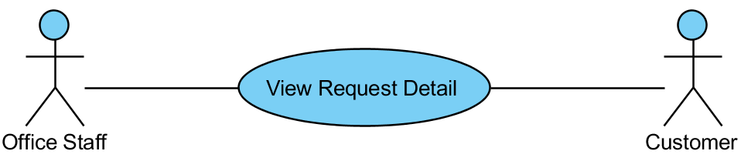

|  |  |  |  |  |
| --- | --- | --- | --- | --- |
| USE CASE – VIEW REQUEST DETAIL SPECIFICATION | | | | |
| Use-case No. | UC02.7 | Use-case Version | | 1.0 |
| Use-case Name | View Request Detail | | | |
| Author | ThanhTV | | | |
| Date | 21/11/2012 | Priority | Normal | |
| **Actor:** Office Staff, Customer  **Summary:** This use case is about how to view request detail.  **Goal:** User can view request detail.  **Triggers:** In main page of requests, user click “View request detail” icon.  **Pre-conditions:** User logged in with office staff/ customer role.  **Post-conditions:** User will view request detail.  **Main Success Scenario:**   1. In main page of request, user clicks “View request detail” icon. 2. System will redirect to “Request Details” page.   **Alternative Scenario:** N/A  **Exceptions:** N/A  **Relationships:**  N/A  **Business Rules:** N/A | | | | |

#### Cancel Request

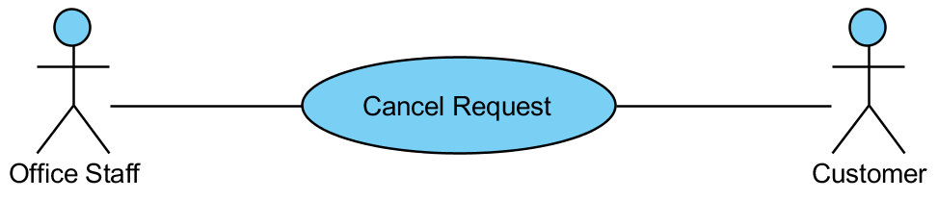

|  |  |  |  |  |
| --- | --- | --- | --- | --- |
| USE CASE – CANCEL REQUEST SPECIFICATION | | | | |
| Use-case No. | UC02.8 | Use-case Version | | 1.0 |
| Use-case Name | Cancel Request | | | |
| Author | ThanhTV | | | |
| Date | 21/11/2012 | Priority | Normal | |
| **Actor:** Office Staff, Customer  **Summary:** This use case is about how to cancel request.  **Goal:** User can cancel request.  **Triggers:** In main page of requests, user click “Cancel” icon.  **Pre-conditions:** User logged in with office staff/ customer role.  **Post-conditions:** Request will be canceled successful.  **Main Success Scenario:**   1. In main page of request, user clicks “Cancel” icon of that request. 2. System will appear a confirm box to confirm again. 3. User clicks “OK” button to cancel.   **Alternative Scenario:** In step 3, if user wants to cancel the process, user can clicks to “Cancel” button to back the main page of request.  **Exceptions:** N/A  **Relationships:**  N/A  **Business Rules:** N/A | | | | |

#### Approve Order

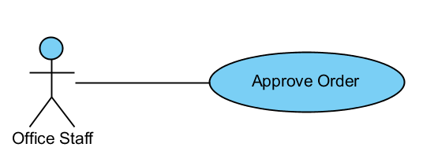

|  |  |  |  |  |
| --- | --- | --- | --- | --- |
| USE CASE – APPROVE ORDER SPECIFICATION | | | | |
| Use-case No. | UC02.9 | Use-case Version | | 1.0 |
| Use-case Name | Approve Order | | | |
| Author | ThanhTV | | | |
| Date | 21/11/2012 | Priority | Normal | |
| **Actor:** Office Staff  **Summary:** This use case is about how to approve order.  **Goal:** Office staff can approve order.  **Triggers:** In main page of requests, user click “Approve Request” icon of “New” status.  **Pre-conditions:** User logged in with office staff role.  **Post-conditions:** Order was approved successfully.  **Main Success Scenario:**   1. In main page of requests, user click “Approve Request” icon of “New” status. 2. System will redirect to “Approve Request” page. 3. User inputs “Due Date” and “Fee” for Order and clicks “Approve Order” icon.   **Alternative Scenario:** N/A  **Exceptions:** When status of request is not “New”, the “Approve Request” icon will be hidden.  **Relationships:**  N/A  **Business Rules:** N/A | | | | |

#### Edit Item

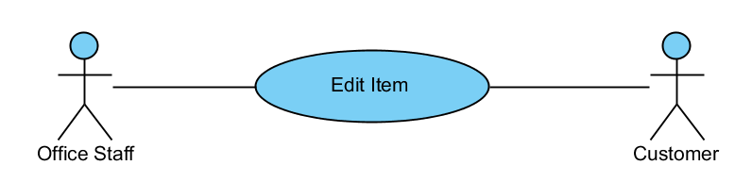

|  |  |  |  |  |
| --- | --- | --- | --- | --- |
| USE CASE – EDIT ITEM SPECIFICATION | | | | |
| Use-case No. | UC02.10 | Use-case Version | | 1.0 |
| Use-case Name | Edit Item | | | |
| Author | ThanhTV | | | |
| Date | 21/11/2012 | Priority | Normal | |
| **Actor:** Office Staff, Customer  **Summary:** This use case is about how to edit item.  **Goal:** User can edit item.  **Triggers:** In “Add Order to Request” page, user clicks “Edit Item” icon of that item.  **Pre-conditions:** User logged in with office staff/ customer role.  **Post-conditions:** Item is edited successfully.  **Main Success Scenario:**   1. In main page of requests, user click “Edit” icon of “Draft” status. 2. System will redirect to “Add Order to Request” page. 3. User clicks “Edit Item” icon of that item. 4. System appears a popup for user input information again. 5. User click “OK” button to cancel.   **Alternative Scenario:** In step 5, if user wants to cancel the process, user can clicks to “Cancel” button to back “Add Order to Request” page.  **Exceptions:** When status of collection plan is not “Draft”, the “Edit” icon will be hidden.  When inputs require information is invalid format or missed require information, the system will notify and require input again.  **Relationships:**  N/A  **Business Rules:** N/A | | | | |

#### Cancel Item

#### 

|  |  |  |  |  |
| --- | --- | --- | --- | --- |
| USE CASE – CANCEL ITEM SPECIFICATION | | | | |
| Use-case No. | UC02.11 | Use-case Version | | 1.0 |
| Use-case Name | Cancel Item | | | |
| Author | ThanhTV | | | |
| Date | 21/11/2012 | Priority | Normal | |
| **Actor:** Office Staff, Customer  **Summary:** This use case is about how to cancel item.  **Goal:** User can cancel item.  **Triggers:** In “Add Order to Request” page, user click “Cancel” icon.  **Pre-conditions:** User logged in with office staff/ customer role.  **Post-conditions:** Item will be canceled successful.  **Main Success Scenario:**   1. In main page of requests, user click “Edit” icon of “Draft” status. 2. System will redirect to “Add Order to Request” page. 3. User clicks “Delete” icon of that item. 4. System appears a confirm box to confirm again. 5. User click “OK” button to delete.   **Alternative Scenario:** In step 3, if user wants to cancel the process, user can clicks to “Cancel” button to back the main page of request.  **Exceptions:** When status of collection plan is not “Draft”, the “Edit” icon will be hidden.  **Relationships:**  N/A  **Business Rules:** N/A | | | | |

#### Reject Request

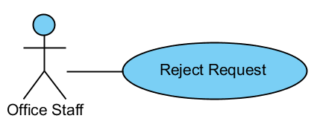

|  |  |  |  |  |
| --- | --- | --- | --- | --- |
| USE CASE – REJECT REQUEST SPECIFICATION | | | | |
| Use-case No. | UC02.12 | Use-case Version | | 1.0 |
| Use-case Name | Approve Order | | | |
| Author | ThanhTV | | | |
| Date | 21/11/2012 | Priority | Normal | |
| **Actor:** Office Staff  **Summary:** This use case is about how to reject request.  **Goal:** Office staff can reject request.  **Triggers:** In “Approve Request” page, clicks “Reject Request” button.  **Pre-conditions:** User logged in with office staff role.  **Post-conditions:** Request was rejected successfully.  **Main Success Scenario:**   1. In main page of requests, user click “Approve Request” icon of “New” status. 2. System will redirect to “Approve Request” page. 3. User clicks “Reject Request” button. 4. A confirm box appear to confirm again. 5. User clicks “OK” button to reject.   **Alternative Scenario:** In step 5, if user wants to cancel the process, user can clicks to “Cancel” button to back the “Approve Request” page.  **Exceptions:** When status of request is not “New”, the “Approve Request” icon will be hidden.  **Relationships:**  N/A  **Business Rules:** N/A | | | | |

#### Reject Order

#### 

### Manage Orders

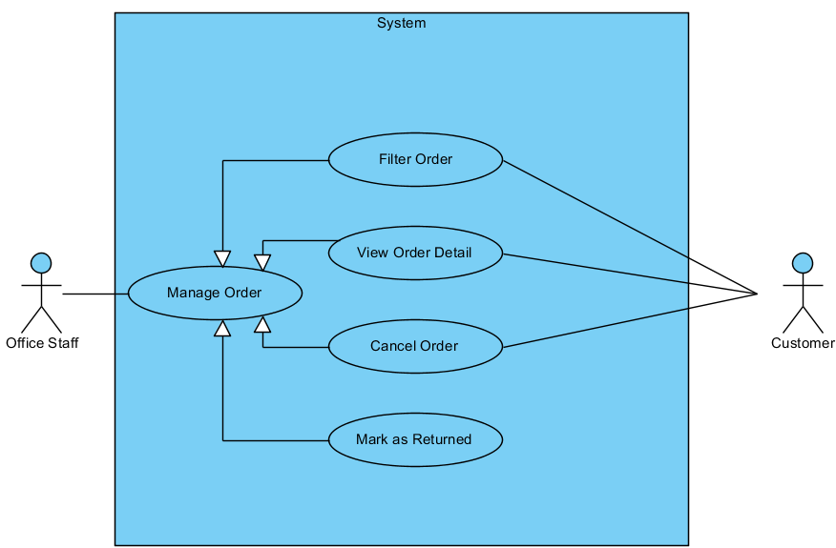

#### Filter Orders

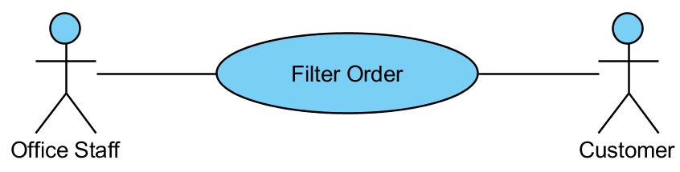

|  |  |  |  |  |
| --- | --- | --- | --- | --- |
| USE CASE – FILTER ORDERS SPECIFICATION | | | | |
| Use-case No. | UC03.1 | Use-case Version | | 1.0 |
| Use-case Name | Filter Orders | | | |
| Author | ThanhTV | | | |
| Date | 21/11/2012 | Priority | Normal | |
| **Actor:** Office Staff, Customer  **Summary:** This use case is about how office staff filters orders.  **Goal:** User can filter orders.  **Triggers:** In main page of orders, user click “Filter” button.  **Pre-conditions:** User logged in with office staff/ customer role.  **Post-conditions:** Orders is filtered successfully.  **Main Success Scenario:**   1. In main page of orders, user selects conditions (status, start date, end date) and clicks “Filter” button. 2. System will show orders tally with conditions.   **Alternative Scenario:** N/A  **Exceptions:** N/A  **Relationships:**  N/A  **Business Rules:** N/A | | | | |

#### View Order Detail

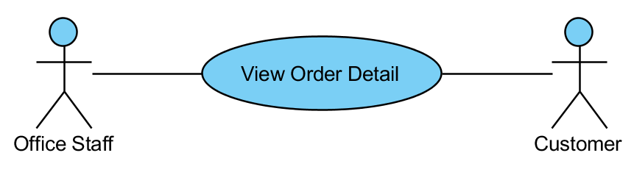

|  |  |  |  |  |
| --- | --- | --- | --- | --- |
| USE CASE – VIEW ORDERS DETAIL SPECIFICATION | | | | |
| Use-case No. | UC03.2 | Use-case Version | | 1.0 |
| Use-case Name | View Order Detail | | | |
| Author | ThanhTV | | | |
| Date | 21/11/2012 | Priority | Normal | |
| **Actor:** Office Staff, Customer  **Summary:** This use case is about how to view order detail.  **Goal:** User can view order detail.  **Triggers:** In main page of orders, user click “View order detail” icon.  **Pre-conditions:** User logged in with office staff/ customer role.  **Post-conditions:** User will view order detail.  **Main Success Scenario:**   1. In main page of order, user clicks “View order detail” icon. 2. System will redirect to “Order Details” page.   **Alternative Scenario:** N/A  **Exceptions:** N/A  **Relationships:**  N/A  **Business Rules:** N/A | | | | |

#### Cancel Order

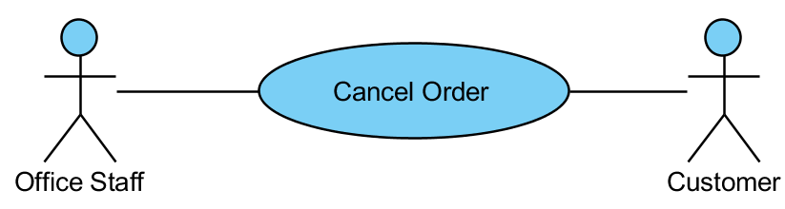

|  |  |  |  |  |
| --- | --- | --- | --- | --- |
| USE CASE – CANCEL ORDERS SPECIFICATION | | | | |
| Use-case No. | UC03.3 | Use-case Version | | 1.0 |
| Use-case Name | Cancel Order | | | |
| Author | ThanhTV | | | |
| Date | 21/11/2012 | Priority | Normal | |
| **Actor:** Office Staff, Customer  **Summary:** This use case is about how to cancel order.  **Goal:** User can cancel order.  **Triggers:** In main page of orders, user click “Cancel” icon.  **Pre-conditions:** User logged in with office staff/ customer role.  **Post-conditions:** Order will be canceled successful.  **Main Success Scenario:**   1. In main page of requests, user clicks “Cancel” icon of that order. 2. System will appear a confirm box to confirm again. 3. User clicks “OK” button to cancel.   **Alternative Scenario:** In Manage Request, user clicks “Edit” icon of “Draft” status. System will redirect to “Add Order to Request” page and user can to cancel order from step 1.  In step 3, if user wants to cancel the process, user can clicks to “Cancel” button to back the main page of request.  **Exceptions:** When status of collection plan is not “Draft”, the “Edit” icon will be hidden.  **Relationships:**  N/A  **Business Rules:** N/A | | | | |

#### Mark as Returned

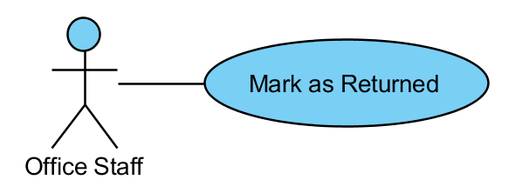

|  |  |  |  |  |
| --- | --- | --- | --- | --- |
| USE CASE – MARK AS RETURNED SPECIFICATION | | | | |
| Use-case No. | UC03.4 | Use-case Version | | 1.0 |
| Use-case Name | Mark as Returned | | | |
| Author | ThanhTV | | | |
| Date | 21/11/2012 | Priority | Normal | |
| **Actor:** Office Staff  **Summary:** This use case is about how to mark as returned for order.  **Goal:** Office staff can mark as returned for order.  **Triggers:** In main page of orders, user click “Mark as Returned” icon of “To Be Returned” status.  **Pre-conditions:** User logged in with office staff role.  **Post-conditions:** Office staff to mark as returned for order.  **Main Success Scenario:**   1. In main page of orders, user click “Mark as Returned” icon of “To Be Returned” status. 2. That order has status is “Returned”.   **Alternative Scenario:** N/A  **Exceptions:** When status of collection plan is not “To Be Returned”, the “Mark as Returned” icon will be hidden.  **Relationships:**  N/A  **Business Rules:** N/A | | | | |

### Manage Customers

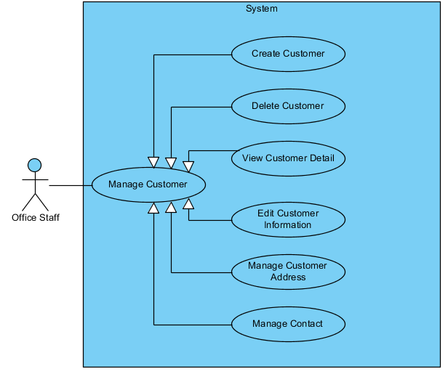

#### Create Customer

**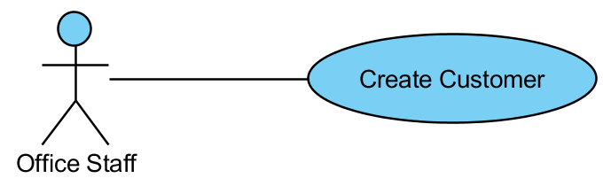**

|  |  |  |  |  |
| --- | --- | --- | --- | --- |
| USE CASE - CREATE CUSTOMER SPECIFICATION | | | | |
| Use-case No. | UC04.1 | Use-case Version | | 1.0 |
| Use-case Name | Create Customer | | | |
| Author | ThanhTV | | | |
| Date | 21/11/2012 | Priority | Normal | |
| **Actor:** Office Staff  **Summary:** This use case is about how office staff creates new customer.  **Goal:** Office staff can create new customer.  **Triggers:** In main page of customer, user click “Add” button.  **Pre-conditions:** User logged in with office staff role.  **Post-conditions:** Customer is created successfully.  **Main Success Scenario:**   1. In main page of customer, user clicks “Add” button. 2. System will appear a popup to input information. 3. User inputs request information and clicks “Create” button. 4. New customer appears in customer list.   **Alternative Scenario:** In step 3, if user wants to cancel the process, user can clicks to “Cancel” button to back the main page of customer.  **Exceptions:** When inputs require information is invalid format or missed require information, the system will notify and require input again.  **Relationships:**  N/A  **Business Rules:** N/A | | | | |

#### Delete Customer

**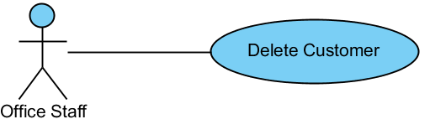**

|  |  |  |  |  |
| --- | --- | --- | --- | --- |
| USE CASE – DELETE CUSTOMER SPECIFICATION | | | | |
| Use-case No. | UC04.2 | Use-case Version | | 1.0 |
| Use-case Name | Delete Customer | | | |
| Author | ThanhTV | | | |
| Date | 21/11/2012 | Priority | Normal | |
| **Actor:** Office Staff  **Summary:** This use case is about how to delete a customer.  **Goal:** Office staff can delete a customer.  **Triggers:** In Customer page, user click “Delete” button.  **Pre-conditions:** User logged in with office staff role.  **Post-conditions:** Customer is deleted successfully.  **Main Success Scenario:**   1. In “Customer Details” page, user clicks “Delete Customer” button in Customer Information area. 2. System will appear a confirm box to selects. 3. User clicks “Yes” button to delete.   **Alternative Scenario:** In step 3, if user wants to cancel the process, user can clicks to “Cancel” button to back the main page of collection plan.  **Exceptions:** If that customer has order/ request in system, that customer will be unable to delete.  **Relationships:**  N/A  **Business Rules:** N/A | | | | |

#### View Customer Detail

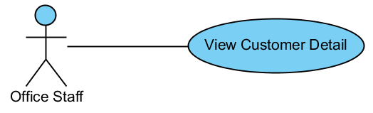

|  |  |  |  |  |
| --- | --- | --- | --- | --- |
| USE CASE – VIEW CUSTOMER DETAIL SPECIFICATION | | | | |
| Use-case No. | UC04.3 | Use-case Version | | 1.0 |
| Use-case Name | View Customer Detail | | | |
| Author | ThanhTV | | | |
| Date | 21/11/2012 | Priority | Normal | |
| **Actor:** Office Staff  **Summary:** This use case is about how to view customer detail.  **Goal:** Office staff can view customer detail.  **Triggers:** In main page of customer, user click “View customer detail” button.  **Pre-conditions:** User logged in with office staff role.  **Post-conditions:** User will view customer detail.  **Main Success Scenario:**   1. In main page of customer, user clicks “View customer detail” button. 2. System will redirect to “Customer Details” page.   **Alternative Scenario:** N/A  **Exceptions:** N/A  **Relationships:**  N/A  **Business Rules:** N/A | | | | |

#### Edit Customer Information

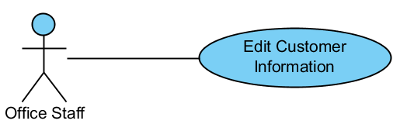

|  |  |  |  |  |
| --- | --- | --- | --- | --- |
| USE CASE - EDIT CUSTOMER INFORMATION SPECIFICATION | | | | |
| Use-case No. | UC04.4 | Use-case Version | | 1.0 |
| Use-case Name | Edit Customer Information | | | |
| Author | ThanhTV | | | |
| Date | 21/11/2012 | Priority | Normal | |
| **Actor:** Office Staff  **Summary:** This use case is about how to edit customer information.  **Goal:** Office staff can edit customer information.  **Triggers:** In “Customer Details” page, user click “Edit” icon in Customer Information area.  **Pre-conditions:** User logged in with office staff role.  **Post-conditions:** Customer information is edited successfully.  **Main Success Scenario:**   1. In “Customer Details” page, user click “Edit” icon in Customer Information area. 2. System will appear a popup to input information. 3. User inputs request information and clicks “Save” button. 4. New customer information appears in Customer Information area.   **Alternative Scenario:** In step 3, if user wants to cancel the process, user can clicks to “Cancel” button to back “Customer Details” page.  **Exceptions:** When inputs require information is invalid format or missed require information, the system will notify and require input again.  **Relationships:**  N/A  **Business Rules:** N/A | | | | |

#### Create Customer Address

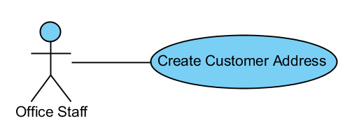

|  |  |  |  |  |
| --- | --- | --- | --- | --- |
| USE CASE - CREATE CUSTOMER ADDRESS SPECIFICATION | | | | |
| Use-case No. | UC04.5 | Use-case Version | | 1.0 |
| Use-case Name | Create Customer Address | | | |
| Author | ThanhTV | | | |
| Date | 21/11/2012 | Priority | Normal | |
| **Actor:** Office Staff  **Summary:** This use case is about how to create customer address.  **Goal:** Office staff can create customer address.  **Triggers:** In “Customer Details” page, user click “Add” icon in Address area.  **Pre-conditions:** User logged in with office staff role.  **Post-conditions:** Customer address is created successfully.  **Main Success Scenario:**   1. In “Customer Details” page, user click “Add” icon in Address area. 2. System will appear a popup to input information. 3. User inputs request information and clicks “Create” button. 4. New customer address appears in Address area.   **Alternative Scenario:** In step 3, if user wants to cancel the process, user can clicks to “Cancel” button to back the main page of customer.  **Exceptions:** When inputs require information is invalid format or missed require information, the system will notify and require input again.  **Relationships:**  N/A  **Business Rules:** N/A | | | | |

#### Delete Customer Address

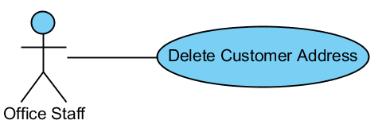

|  |  |  |  |  |
| --- | --- | --- | --- | --- |
| USE CASE – DELETE CUSTOMER ADDRESS SPECIFICATION | | | | |
| Use-case No. | UC04.6 | Use-case Version | | 1.0 |
| Use-case Name | Delete Customer Address | | | |
| Author | ThanhTV | | | |
| Date | 21/11/2012 | Priority | Normal | |
| **Actor:** Office Staff  **Summary:** This use case is about how to delete a customer address.  **Goal:** Office staff can delete a customer address.  **Triggers:** In “Customer Details” page, user click “Delete” icon in Address area.  **Pre-conditions:** User logged in with office staff role.  **Post-conditions:** Customer address is deleted successfully.  **Main Success Scenario:**   1. In “Customer Details” page, user click “Delete” icon in Address area. 2. System will appear a confirm box to selects. 3. User clicks “Yes” button to delete.   **Alternative Scenario:** In step 3, if user wants to cancel the process, user can clicks to “Cancel” button to back the main page of collection plan.  **Exceptions:** N/A  **Relationships:**  N/A  **Business Rules:** N/A | | | | |

#### Edit Customer Address

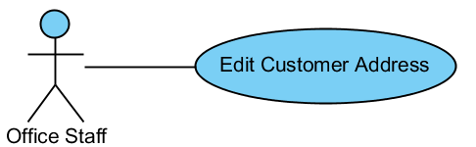

|  |  |  |  |  |
| --- | --- | --- | --- | --- |
| USE CASE - EDIT CUSTOMER ADDRESS SPECIFICATION | | | | |
| Use-case No. | UC04.7 | Use-case Version | | 1.0 |
| Use-case Name | Edit Customer Address | | | |
| Author | ThanhTV | | | |
| Date | 21/11/2012 | Priority | Normal | |
| **Actor:** Office Staff  **Summary:** This use case is about how to edit customer address.  **Goal:** Office staff can edit customer address.  **Triggers:** In “Customer Details” page, user click “Edit” icon in Customer Address area.  **Pre-conditions:** User logged in with office staff role.  **Post-conditions:** Customer address is edited successfully.  **Main Success Scenario:**   1. In “Customer Details” page, user click “Edit” icon in Customer Address area. 2. System will appear a popup to input information. 3. User inputs request information and clicks “Save” button. 4. New customer address appears in Customer Address area.   **Alternative Scenario:** In step 3, if user wants to cancel the process, user can clicks to “Cancel” button to back “Customer Details” page.  **Exceptions:** When inputs require information is invalid format or missed require information, the system will notify and require input again.  **Relationships:**  N/A  **Business Rules:** N/A | | | | |

#### Create Contact

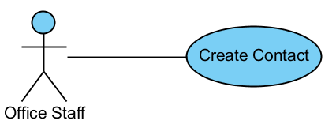

|  |  |  |  |  |
| --- | --- | --- | --- | --- |
| USE CASE - CREATE CONTACT SPECIFICATION | | | | |
| Use-case No. | UC04.8 | Use-case Version | | 1.0 |
| Use-case Name | Create Contact | | | |
| Author | ThanhTV | | | |
| Date | 21/11/2012 | Priority | Normal | |
| **Actor:** Office Staff  **Summary:** This use case is about how to create contact.  **Goal:** Office staff can create contact.  **Triggers:** In “Customer Details” page, user click “Add” icon in Contact area.  **Pre-conditions:** User logged in with office staff role.  **Post-conditions:** Contact is created successfully.  **Main Success Scenario:**   1. In “Customer Details” page, user click “Add” icon in Contact area. 2. System will appear a popup to input information. 3. User inputs request information and clicks “Create” button. 4. New contact appears in Contact area.   **Alternative Scenario:** In step 3, if user wants to cancel the process, user can clicks to “Cancel” button to back the main page of customer.  **Exceptions:** When inputs require information is invalid format or missed require information, the system will notify and require input again.  **Relationships:**  N/A  **Business Rules:** N/A | | | | |

#### Delete Contact

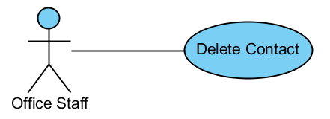

|  |  |  |  |  |
| --- | --- | --- | --- | --- |
| USE CASE – DELETE CONTACT SPECIFICATION | | | | |
| Use-case No. | UC04.9 | Use-case Version | | 1.0 |
| Use-case Name | Delete Contact | | | |
| Author | ThanhTV | | | |
| Date | 21/11/2012 | Priority | Normal | |
| **Actor:** Office Staff  **Summary:** This use case is about how to delete a contact.  **Goal:** Office staff can delete a contact.  **Triggers:** In “Customer Details” page, user click “Delete” icon in Contact area.  **Pre-conditions:** User logged in with office staff role.  **Post-conditions:** Contact is deleted successfully.  **Main Success Scenario:**   1. In “Customer Details” page, user click “Delete” icon in Contact area. 2. System will appear a confirm box to selects. 3. User clicks “Yes” button to delete.   **Alternative Scenario:** In step 3, if user wants to cancel the process, user can clicks to “Cancel” button to back the main page of collection plan.  **Exceptions:** N/A  **Relationships:**  N/A  **Business Rules:** N/A | | | | |

#### Edit Contact

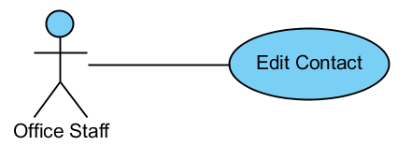

|  |  |  |  |  |
| --- | --- | --- | --- | --- |
| USE CASE - EDIT CONTACT SPECIFICATION | | | | |
| Use-case No. | UC04.10 | Use-case Version | | 1.0 |
| Use-case Name | Edit Contact | | | |
| Author | ThanhTV | | | |
| Date | 21/11/2012 | Priority | Normal | |
| **Actor:** Office Staff  **Summary:** This use case is about how to edit contact.  **Goal:** Office staff can edit contact.  **Triggers:** In “Customer Details” page, user click “Edit” icon in Contact area.  **Pre-conditions:** User logged in with office staff role.  **Post-conditions:** Contact is edited successfully.  **Main Success Scenario:**   1. In “Customer Details” page, user click “Edit” icon in Contact area. 2. System will appear a popup to input information. 3. User inputs request information and clicks “Save” button. 4. New contact appears in Contact area.   **Alternative Scenario:** In step 3, if user wants to cancel the process, user can clicks to “Cancel” button to back “Customer Details” page.  **Exceptions:** When inputs require information is invalid format or missed require information, the system will notify and require input again.  **Relationships:**  N/A  **Business Rules:** N/A | | | | |

### Manage Master Data

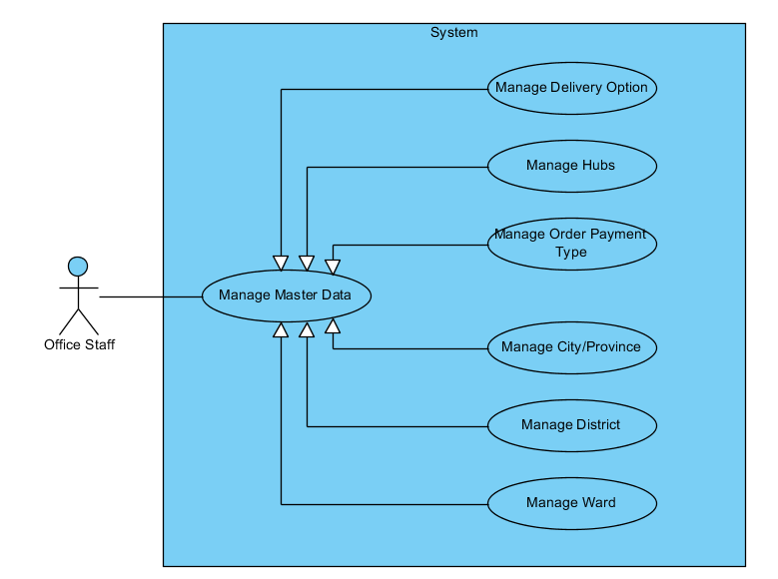

#### Manage Hubs

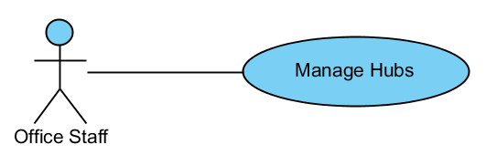

#### Create New Hub

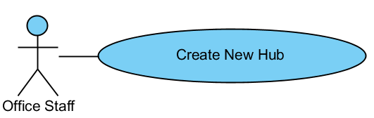

|  |  |  |  |  |
| --- | --- | --- | --- | --- |
| USE CASE - CREATE NEW HUB SPECIFICATION | | | | |
| Use-case No. | UC05.1.1 | Use-case Version | | 1.0 |
| Use-case Name | Create New Hub | | | |
| Author | ThanhTV | | | |
| Date | 21/11/2012 | Priority | Normal | |
| **Actor:** Office Staff  **Summary:** This use case is about how to create new hub.  **Goal:** Office staff can create new hub.  **Triggers:** In “Hubs” page, user click “Add” button.  **Pre-conditions:** User logged in with office staff role.  **Post-conditions:** Hub is created successfully.  **Main Success Scenario:**   1. In “Hub” page, user click “Add” button. 2. System will appear a popup to input. 3. User inputs request information and clicks “OK” button.   **Alternative Scenario:** In step 3, if user wants to cancel the process, user can clicks to “Cancel” button to back the main page of hubs.  **Exceptions:** When inputs require information is invalid format or missed require information, the system will notify and require input again.  **Relationships:**  N/A  **Business Rules:** N/A | | | | |

#### Edit Hub

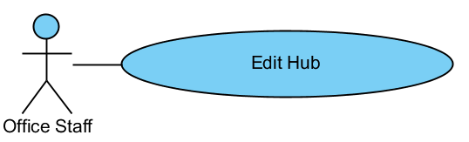

|  |  |  |  |  |
| --- | --- | --- | --- | --- |
| USE CASE - EDIT HUB SPECIFICATION | | | | |
| Use-case No. | UC05.1.2 | Use-case Version | | 1.0 |
| Use-case Name | Edit Hub | | | |
| Author | ThanhTV | | | |
| Date | 21/11/2012 | Priority | Normal | |
| **Actor:** Office Staff  **Summary:** This use case is about how to edit hub.  **Goal:** Office staff can edit hub.  **Triggers:** In “Hub” page, user click “Edit” icon of that hub.  **Pre-conditions:** User logged in with office staff role.  **Post-conditions:** Hub is edited successfully.  **Main Success Scenario:**   1. In “Hub” page, user click “Edit” icon of that hub. 2. System will appear a popup to input information again. 3. User inputs request information and clicks “Save” button.   **Alternative Scenario:** In step 3, if user wants to cancel the process, user can clicks to “Cancel” button to back the main page of customer payment types.  **Exceptions:** When inputs require information is invalid format or missed require information, the system will notify and require input again.  **Relationships:**  N/A  **Business Rules:** N/A | | | | |

#### Delete Hub

#### 

|  |  |  |  |  |
| --- | --- | --- | --- | --- |
| USE CASE – DELETE HUB SPECIFICATION | | | | |
| Use-case No. | UC05.1.3 | Use-case Version | | 1.0 |
| Use-case Name | Delete Hub | | | |
| Author | ThanhTV | | | |
| Date | 21/11/2012 | Priority | Normal | |
| **Actor:** Office Staff  **Summary:** This use case is about how to delete hub.  **Goal:** Office staff can delete hub.  **Triggers:** In “Hub” page, user click “Delete” icon of that hub.  **Pre-conditions:** User logged in with office staff role.  **Post-conditions:** Hub is canceled successfully.  **Main Success Scenario:**   1. In “Hub” page, user click “Delete” icon of that hub. 2. System will appear a confirm box to confirm again. 3. User clicks “Yes” button to cancel.   **Alternative Scenario:** In step 3, if user wants to cancel the process, user can clicks to “Cancel” button to back the main page of hub.  **Exceptions:** N/A  **Relationships:**  N/A  **Business Rules:** N/A | | | | |

#### Set Location

|  |  |  |  |  |
| --- | --- | --- | --- | --- |
| USE CASE – SET LOCATION SPECIFICATION | | | | |
| Use-case No. | UC05.1.4 | Use-case Version | | 1.0 |
| Use-case Name | Set Location | | | |
| Author | ThanhTV | | | |
| Date | 21/11/2012 | Priority | Normal | |
| **Actor:** Office Staff  **Summary:** This use case is about how to set location.  **Goal:** Office staff can set location.  **Triggers:** In “Hub” page, user click “Set Location” icon of that hub.  **Pre-conditions:** User logged in with office staff role.  **Post-conditions:** Location is set successful.  **Main Success Scenario:**   1. In “Hub” page, user click “Set Location” icon of that hub. 2. User select location of that hub in the map. 3. User clicks “Confirm Set Location” icon to set.   **Alternative Scenario:** In step 3, if user wants to cancel the process, user can clicks to “Cancel Set Location” icon to back the main page of hub.  **Exceptions:** N/A  **Relationships:**  N/A  **Business Rules:** N/A | | | | |

#### Manage Order Payment Type

#### C:\Users\Kim\Desktop\Untitled.png

#### Create New Order Payment Type

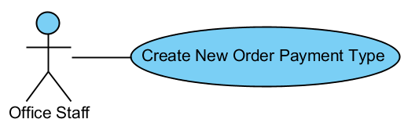

|  |  |  |  |  |
| --- | --- | --- | --- | --- |
| USE CASE - CREATE NEW ORDER PAYMENT TYPE SPECIFICATION | | | | |
| Use-case No. | UC05.2.1 | Use-case Version | | 1.0 |
| Use-case Name | Create New Order Payment Type | | | |
| Author | ThanhTV | | | |
| Date | 21/11/2012 | Priority | Normal | |
| **Actor:** Office Staff  **Summary:** This use case is about how to create new order payment type.  **Goal:** Office staff can create new order payment type.  **Triggers:** In “Order Payment Types” page, user click “Add” button.  **Pre-conditions:** User logged in with office staff role.  **Post-conditions:** Order payment type is created successfully.  **Main Success Scenario:**   1. In “Order Payment Types” page, user click “Add” button. 2. System will appear a popup to input. 3. User inputs request information and clicks “OK” button.   **Alternative Scenario:** In step 3, if user wants to cancel the process, user can clicks to “Cancel” button to back the main page of order payment type.  **Exceptions:** When inputs require information is invalid format or missed require information, the system will notify and require input again.  **Relationships:**  N/A  **Business Rules:** N/A | | | | |

#### Edit Order Payment Type

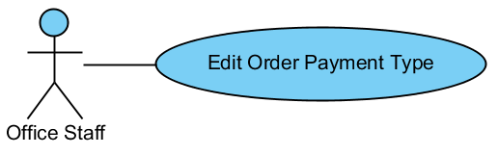

|  |  |  |  |  |
| --- | --- | --- | --- | --- |
| USE CASE - EDIT ORDER PAYMENT TYPE SPECIFICATION | | | | |
| Use-case No. | UC05.2.2 | Use-case Version | | 1.0 |
| Use-case Name | Edit Order Payment Type | | | |
| Author | ThanhTV | | | |
| Date | 21/11/2012 | Priority | Normal | |
| **Actor:** Office Staff  **Summary:** This use case is about how to edit order payment type.  **Goal:** Office staff can edit order payment types.  **Triggers:** In “Order Payment Types” page, user click “Edit” icon of that order payment type.  **Pre-conditions:** User logged in with office staff role.  **Post-conditions:** Order payment type is edited successfully.  **Main Success Scenario:**   1. In “Order Payment Types” page, user click “Edit” icon of that order payment type. 2. System will appear a popup to input information again. 3. User inputs request information and clicks “Save” button.   **Alternative Scenario:** In step 3, if user wants to cancel the process, user can clicks to “Cancel” button to back the main page of order payment type.  **Exceptions:** When inputs require information is invalid format or missed require information, the system will notify and require input again.  **Relationships:**  N/A  **Business Rules:** N/A | | | | |

#### Delete Order Payment Type

#### C:\Users\Kim\Desktop\Untitled.png

|  |  |  |  |  |
| --- | --- | --- | --- | --- |
| USE CASE – DELETE ORDER PAYMENT TYPE SPECIFICATION | | | | |
| Use-case No. | UC05.2.3 | Use-case Version | | 1.0 |
| Use-case Name | Delete Order Payment Type | | | |
| Author | ThanhTV | | | |
| Date | 21/11/2012 | Priority | Normal | |
| **Actor:** Office Staff  **Summary:** This use case is about how to delete order payment type.  **Goal:** Office staff can delete order payment type.  **Triggers:** In “Customer Payment Types” page, user click “Delete” icon of that order payment type.  **Pre-conditions:** User logged in with office staff role.  **Post-conditions:** Order payment type is deleted successfully.  **Main Success Scenario:**   1. In “Order Payment Type” page, user click “Delete” icon of that order payment type. 2. System will appear a confirm box to confirm again. 3. User clicks “Yes” button to cancel.   **Alternative Scenario:** In step 3, if user wants to cancel the process, user can clicks to “Cancel” button to back the main page of order payment type.  **Exceptions:** N/A  **Relationships:**  N/A  **Business Rules:** N/A | | | | |

#### Manage Delivery Option

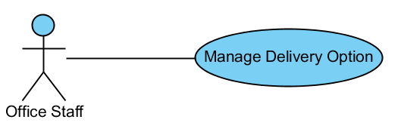

#### Create New Delivery Option

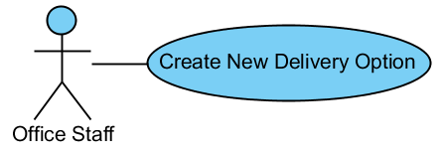

|  |  |  |  |  |
| --- | --- | --- | --- | --- |
| USE CASE - CREATE NEW DELIVERY OPTION SPECIFICATION | | | | |
| Use-case No. | UC05.3.1 | Use-case Version | | 1.0 |
| Use-case Name | Create New Delivery Option | | | |
| Author | ThanhTV | | | |
| Date | 21/11/2012 | Priority | Normal | |
| **Actor:** Office Staff  **Summary:** This use case is about how to create new delivery option.  **Goal:** Office staff can create new delivery option.  **Triggers:** In “Delivery Option” page, user click “Add” button.  **Pre-conditions:** User logged in with office staff role.  **Post-conditions:** Delivery option is created successfully.  **Main Success Scenario:**   1. In “Delivery Option” page, user click “Add” button. 2. System will appear a popup to input. 3. User inputs request information and clicks “OK” button.   **Alternative Scenario:** In step 3, if user wants to cancel the process, user can clicks to “Cancel” button to back the main page of delivery option.  **Exceptions:** When inputs require information is invalid format or missed require information, the system will notify and require input again.  **Relationships:**  N/A  **Business Rules:** N/A | | | | |

#### Edit Delivery Option

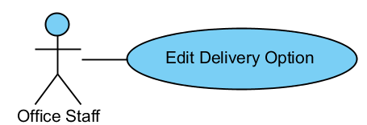

|  |  |  |  |  |
| --- | --- | --- | --- | --- |
| USE CASE - EDIT DELIVERY OPTION SPECIFICATION | | | | |
| Use-case No. | UC05.3.2 | Use-case Version | | 1.0 |
| Use-case Name | Edit Delivery Option | | | |
| Author | ThanhTV | | | |
| Date | 21/11/2012 | Priority | Normal | |
| **Actor:** Office Staff  **Summary:** This use case is about how to edit delivery option.  **Goal:** Office staff can edit delivery option.  **Triggers:** In “Delivery Option” page, user click “Edit” icon of that delivery option.  **Pre-conditions:** User logged in with office staff role.  **Post-conditions:** Delivery option is edited successfully.  **Main Success Scenario:**   1. In “Delivery Option” page, user click “Edit” icon of that delivery option. 2. System will appear a popup to input information again. 3. User inputs request information and clicks “Save” button.   **Alternative Scenario:** In step 3, if user wants to cancel the process, user can clicks to “Cancel” button to back “the main page of delivery option.  **Exceptions:** When inputs require information is invalid format or missed require information, the system will notify and require input again.  **Relationships:**  N/A  **Business Rules:** N/A | | | | |

#### Delete Delivery Option

#### C:\Users\Kim\Desktop\Untitled.png

|  |  |  |  |  |
| --- | --- | --- | --- | --- |
| USE CASE – DELETE DELIVERY OPTION SPECIFICATION | | | | |
| Use-case No. | UC05.3.3 | Use-case Version | | 1.0 |
| Use-case Name | Delete Delivery Option | | | |
| Author | ThanhTV | | | |
| Date | 21/11/2012 | Priority | Normal | |
| **Actor:** Office Staff  **Summary:** This use case is about how to delete delivery option.  **Goal:** Office staff can delete delivery option.  **Triggers:** In “Delivery Option” page, user click “Delete” icon of that delivery option.  **Pre-conditions:** User logged in with office staff role.  **Post-conditions:** Delivery option is canceled successfully.  **Main Success Scenario:**   1. In “Delivery Option” page, user click “Delete” icon of that delivery option. 2. System will appear a confirm box to confirm again. 3. User clicks “Yes” button to cancel.   **Alternative Scenario:** In step 3, if user wants to cancel the process, user can clicks to “Cancel” button to back the main page of delivery option.  **Exceptions:** N/A  **Relationships:**  N/A  **Business Rules:** N/A | | | | |

#### Manage City/Province

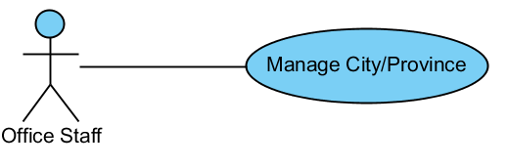

#### Create New City/Province

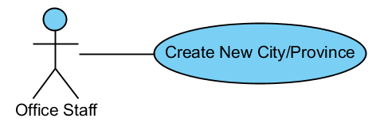

|  |  |  |  |  |
| --- | --- | --- | --- | --- |
| USE CASE - CREATE NEW CITY/PROVINCE SPECIFICATION | | | | |
| Use-case No. | UC05.4.1 | Use-case Version | | 1.0 |
| Use-case Name | Create New City/Province | | | |
| Author | ThanhTV | | | |
| Date | 21/11/2012 | Priority | Normal | |
| **Actor:** Office Staff  **Summary:** This use case is about how to create new city/province.  **Goal:** Office staff can create city/province.  **Triggers:** In “City/Province” page, user click “Add” button.  **Pre-conditions:** User logged in with office staff role.  **Post-conditions:** City/Province is created successfully.  **Main Success Scenario:**   1. In “City/Province” page, user click “Add” button. 2. System will appear a popup to input. 3. User inputs request information and clicks “OK” button.   **Alternative Scenario:** In step 3, if user wants to cancel the process, user can clicks to “Cancel” button to back the main page of city/province.  **Exceptions:** When inputs require information is invalid format or missed require information, the system will notify and require input again.  **Relationships:**  N/A  **Business Rules:** N/A | | | | |

#### Edit City/Province

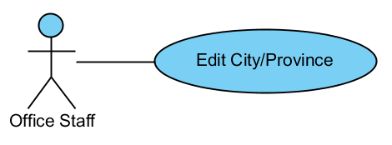

|  |  |  |  |  |
| --- | --- | --- | --- | --- |
| USE CASE - EDIT CITY/PROVINCE SPECIFICATION | | | | |
| Use-case No. | UC05.4.2 | Use-case Version | | 1.0 |
| Use-case Name | Edit City/Province | | | |
| Author | ThanhTV | | | |
| Date | 21/11/2012 | Priority | Normal | |
| **Actor:** Office Staff  **Summary:** This use case is about how to edit city/province.  **Goal:** Office staff can edit city/province.  **Triggers:** In “City/Province” page, user click “Edit” icon of that city/province.  **Pre-conditions:** User logged in with office staff role.  **Post-conditions:** City/Province is edited successfully.  **Main Success Scenario:**   1. In “City/Province” page, user click “Edit” icon of that city/province. 2. System will appear a popup to input information again. 3. User inputs request information and clicks “Save” button.   **Alternative Scenario:** In step 3, if user wants to cancel the process, user can clicks to “Cancel” button to back the main page of city/province.  **Exceptions:** When inputs require information is invalid format or missed require information, the system will notify and require input again.  **Relationships:**  N/A  **Business Rules:** N/A | | | | |

#### Delete City/Province

#### C:\Users\Kim\Desktop\Untitled.png

|  |  |  |  |  |
| --- | --- | --- | --- | --- |
| USE CASE – DELETE CITY/PROVINCE SPECIFICATION | | | | |
| Use-case No. | UC05.4.3 | Use-case Version | | 1.0 |
| Use-case Name | Delete City/Province | | | |
| Author | ThanhTV | | | |
| Date | 21/11/2012 | Priority | Normal | |
| **Actor:** Office Staff  **Summary:** This use case is about how to delete city/province.  **Goal:** Office staff can delete city/province.  **Triggers:** In “City/Province” page, user click “Delete” icon of that city/province.  **Pre-conditions:** User logged in with office staff role.  **Post-conditions:** City/Province is canceled successfully.  **Main Success Scenario:**   1. In “City/Province” page, user click “Delete” icon of that city/province. 2. System will appear a confirm box to confirm again. 3. User clicks “Yes” button to cancel.   **Alternative Scenario:** In step 3, if user wants to cancel the process, user can clicks to “Cancel” button to back the main page of city/province.  **Exceptions:** N/A  **Relationships:**  N/A  **Business Rules:** N/A | | | | |

#### Manage District

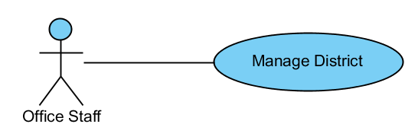

#### Create New District

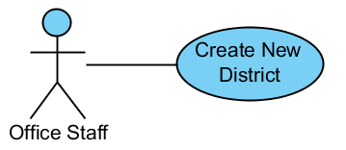

|  |  |  |  |  |
| --- | --- | --- | --- | --- |
| USE CASE - CREATE NEW DISTRICT SPECIFICATION | | | | |
| Use-case No. | UC05.5.1 | Use-case Version | | 1.0 |
| Use-case Name | Create New District | | | |
| Author | ThanhTV | | | |
| Date | 21/11/2012 | Priority | Normal | |
| **Actor:** Office Staff  **Summary:** This use case is about how to create new district.  **Goal:** Office staff can create new district.  **Triggers:** In “District” page, user click “Add” button.  **Pre-conditions:** User logged in with office staff role.  **Post-conditions:** District is created successfully.  **Main Success Scenario:**   1. In “District” page, user click “Add” button. 2. System will appear a popup to input. 3. User inputs request information and clicks “OK” button.   **Alternative Scenario:** In step 3, if user wants to cancel the process, user can clicks to “Cancel” button to back the main page of district.  **Exceptions:** When inputs require information is invalid format or missed require information, the system will notify and require input again.  **Relationships:**  N/A  **Business Rules:** N/A | | | | |

#### Edit District

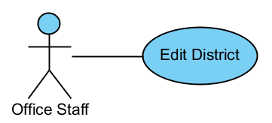

|  |  |  |  |  |
| --- | --- | --- | --- | --- |
| USE CASE - EDIT DISTRICT SPECIFICATION | | | | |
| Use-case No. | UC05.5.2 | Use-case Version | | 1.0 |
| Use-case Name | Edit District | | | |
| Author | ThanhTV | | | |
| Date | 21/11/2012 | Priority | Normal | |
| **Actor:** Office Staff  **Summary:** This use case is about how to edit district.  **Goal:** Office staff can edit district.  **Triggers:** In “District” page, user click “Edit” icon of that district.  **Pre-conditions:** User logged in with office staff role.  **Post-conditions:** District is edited successfully.  **Main Success Scenario:**   1. In “District” page, user click “Edit” icon of that district. 2. System will appear a popup to input information again. 3. User inputs request information and clicks “Save” button.   **Alternative Scenario:** In step 3, if user wants to cancel the process, user can clicks to “Cancel” button to back the main page of district.  **Exceptions:** When inputs require information is invalid format or missed require information, the system will notify and require input again.  **Relationships:**  N/A  **Business Rules:** N/A | | | | |

#### Delete District

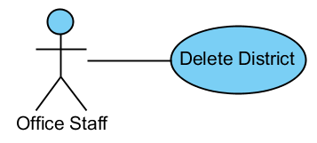

|  |  |  |  |  |
| --- | --- | --- | --- | --- |
| USE CASE – DELETE DISTRICT SPECIFICATION | | | | |
| Use-case No. | UC05.5.3 | Use-case Version | | 1.0 |
| Use-case Name | Delete District | | | |
| Author | ThanhTV | | | |
| Date | 21/11/2012 | Priority | Normal | |
| **Actor:** Office Staff  **Summary:** This use case is about how to delete district.  **Goal:** Office staff can delete district.  **Triggers:** In “District” page, user click “Delete” icon of that district.  **Pre-conditions:** User logged in with office staff role.  **Post-conditions:** District is canceled successfully.  **Main Success Scenario:**   1. In “District” page, user click “Delete” icon of that district. 2. System will appear a confirm box to confirm again. 3. User clicks “Yes” button to cancel.   **Alternative Scenario:** In step 3, if user wants to cancel the process, user can clicks to “Cancel” button to back the main page of district.  **Exceptions:** N/A  **Relationships:**  N/A  **Business Rules:** N/A | | | | |

#### Manage Ward

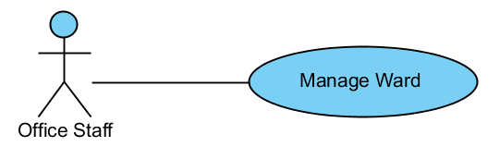

#### Create New Ward

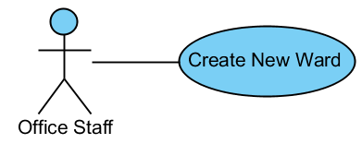

|  |  |  |  |  |
| --- | --- | --- | --- | --- |
| USE CASE - CREATE NEW WARD SPECIFICATION | | | | |
| Use-case No. | UC05.6.1 | Use-case Version | | 1.0 |
| Use-case Name | Create New Ward | | | |
| Author | ThanhTV | | | |
| Date | 21/11/2012 | Priority | Normal | |
| **Actor:** Office Staff  **Summary:** This use case is about how to create new ward.  **Goal:** Office staff can create new ward.  **Triggers:** In “Ward” page, user click “Add” button.  **Pre-conditions:** User logged in with office staff role.  **Post-conditions:** Ward is created successfully.  **Main Success Scenario:**   1. In “Ward” page, user click “Add” button. 2. System will appear a popup to input. 3. User inputs request information and clicks “OK” button.   **Alternative Scenario:** In step 3, if user wants to cancel the process, user can clicks to “Cancel” button to back the main page of ward.  **Exceptions:** When inputs require information is invalid format or missed require information, the system will notify and require input again.  **Relationships:**  N/A  **Business Rules:** N/A | | | | |

#### Edit Ward

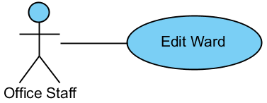

|  |  |  |  |  |
| --- | --- | --- | --- | --- |
| USE CASE - EDIT WARD SPECIFICATION | | | | |
| Use-case No. | UC05.6.2 | Use-case Version | | 1.0 |
| Use-case Name | Edit Ward | | | |
| Author | ThanhTV | | | |
| Date | 21/11/2012 | Priority | Normal | |
| **Actor:** Office Staff  **Summary:** This use case is about how to edit ward.  **Goal:** Office staff can edit ward.  **Triggers:** In “Ward” page, user click “Edit” icon of that ward.  **Pre-conditions:** User logged in with office staff role.  **Post-conditions:** Ward is edited successfully.  **Main Success Scenario:**   1. In “Ward” page, user click “Edit” icon of that ward. 2. System will appear a popup to input information again. 3. User inputs request information and clicks “Save” button.   **Alternative Scenario:** In step 3, if user wants to cancel the process, user can clicks to “Cancel” button to back the main page of ward.  **Exceptions:** When inputs require information is invalid format or missed require information, the system will notify and require input again.  **Relationships:**  N/A  **Business Rules:** N/A | | | | |

#### Delete Ward

#### C:\Users\Kim\Desktop\Untitled.png

|  |  |  |  |  |
| --- | --- | --- | --- | --- |
| USE CASE – DELETE WARD SPECIFICATION | | | | |
| Use-case No. | UC05.6.3 | Use-case Version | | 1.0 |
| Use-case Name | Delete Ward | | | |
| Author | ThanhTV | | | |
| Date | 21/11/2012 | Priority | Normal | |
| **Actor:** Office Staff  **Summary:** This use case is about how to delete ward.  **Goal:** Office staff can delete ward.  **Triggers:** In “Ward” page, user click “Delete” icon of that ward.  **Pre-conditions:** User logged in with office staff role.  **Post-conditions:** Ward is canceled successfully.  **Main Success Scenario:**   1. In “Ward” page, user click “Delete” icon of that ward. 2. System will appear a confirm box to confirm again. 3. User clicks “Yes” button to cancel.   **Alternative Scenario:** In step 3, if user wants to cancel the process, user can clicks to “Cancel” button to back the main page of ward.  **Exceptions:** N/A  **Relationships:**  N/A  **Business Rules:** N/A | | | | |

### Manage Collection Plan

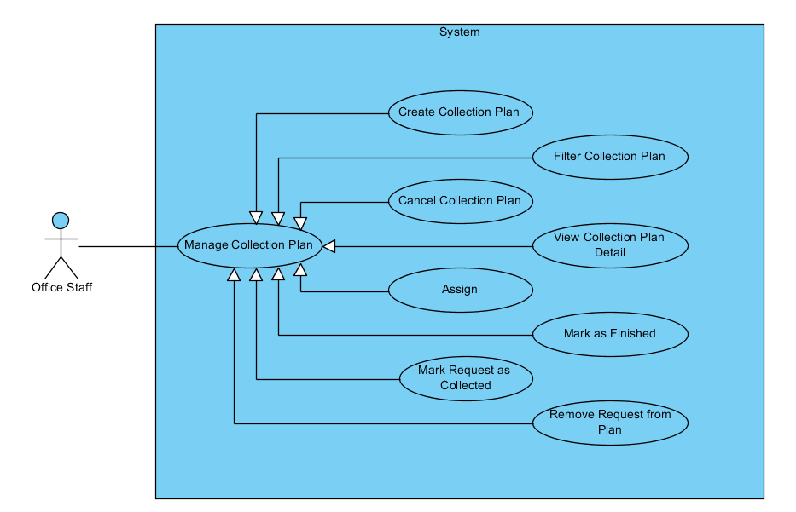

#### Create Collection Plan

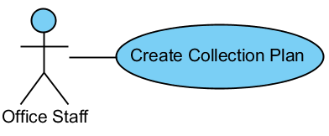

|  |  |  |  |  |
| --- | --- | --- | --- | --- |
| USE CASE - CREATE COLLECTION PLAN SPECIFICATION | | | | |
| Use-case No. | UC06.1 | Use-case Version | | 1.0 |
| Use-case Name | Create Collection Plan | | | |
| Author | ThanhTV | | | |
| Date | 21/11/2012 | Priority | Normal | |
| **Actor:** Office Staff  **Summary:** This use case is about how office staff creates new collection plan.  **Goal:** Office staff can create new collection plan.  **Triggers:** In main page of collection plan, user click “Add” button.  **Pre-conditions:** User logged in with office staff role.  **Post-conditions:** Collection plan is created successfully.  **Main Success Scenario:**   1. In main page of collection plan, user clicks “Add” button. 2. System will navigate to “Create” page. 3. User selects city, district and ward to list all requests in that. 4. User clicks to “Add to plan” icon in that requests to add requests to plan and clicks “Create Plan” button. 5. System redirect to “Collection Plan details” page, user sticks requests which want to add collection plan and clicks “Mark as Collected” button. 6. New collection plan appears in collection plan list.   **Alternative Scenario:** In step 4 and step 5, if user wants to cancel the process, user can clicks to “Cancel” button to back the main page of collection plan.  **Exceptions:** When inputs require information is invalid format or missed require information, the system will notify and require input again.  **Relationships:**  N/A  **Business Rules:** N/A | | | | |

#### Filter Collection Plan

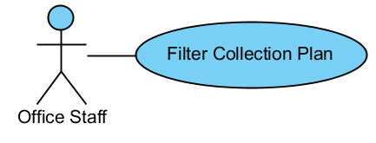

|  |  |  |  |  |
| --- | --- | --- | --- | --- |
| USE CASE – FILTER COLLECTION PLAN SPECIFICATION | | | | |
| Use-case No. | UC06.2 | Use-case Version | | 1.0 |
| Use-case Name | Filter Collection Plan | | | |
| Author | ThanhTV | | | |
| Date | 21/11/2012 | Priority | Normal | |
| **Actor:** Office Staff  **Summary:** This use case is about how office staff filters collection plan.  **Goal:** Office staff can filter collection plan.  **Triggers:** In main page of collection plan, user click “Filter” button.  **Pre-conditions:** User logged in with office staff role.  **Post-conditions:** Collection plan is filtered successfully.  **Main Success Scenario:**   1. In main page of collection plan, user selects conditions (status, start date, end date) and clicks “Filter” button. 2. System will show collection plans tally with conditions.   **Alternative Scenario:** N/A  **Exceptions:** N/A  **Relationships:**  N/A  **Business Rules:** N/A | | | | |

#### Cancel Collection Plan

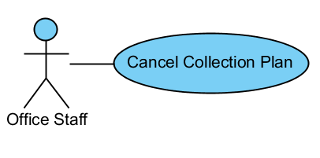

|  |  |  |  |  |
| --- | --- | --- | --- | --- |
| USE CASE – CANCEL COLLECTION PLAN SPECIFICATION | | | | |
| Use-case No. | UC06.3 | Use-case Version | | 1.0 |
| Use-case Name | Cancel Collection Plan | | | |
| Author | ThanhTV | | | |
| Date | 21/11/2012 | Priority | Normal | |
| **Actor:** Office Staff  **Summary:** This use case is about how office staff cancel collection plan.  **Goal:** Office staff can cancel collection plan.  **Triggers:** In Collection Plan Details page, user click “Cancel” button.  **Pre-conditions:** User logged in with office staff role.  **Post-conditions:** Collection plan is canceled successfully.  **Main Success Scenario:**   1. In Collection Plan Details page, user clicks “Cancel” button. 2. System will navigate a confirm box to selects. 3. User clicks “Yes” button to cancel.   **Alternative Scenario:** In step 3, if user wants to cancel the process, user can clicks to “Cancel” button to back the main page of collection plan.  When status of collection plan is finished, the “Cancel” button will be hidden.  **Exceptions:** N/A  **Relationships:**  N/A  **Business Rules:** N/A | | | | |

#### View Collection Plan Detail

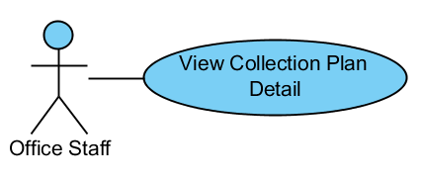

|  |  |  |  |  |
| --- | --- | --- | --- | --- |
| USE CASE – VIEW COLLECTION PLAN DETAIL SPECIFICATION | | | | |
| Use-case No. | UC06.4 | Use-case Version | | 1.0 |
| Use-case Name | View Collection Plan Detail | | | |
| Author | ThanhTV | | | |
| Date | 21/11/2012 | Priority | Normal | |
| **Actor:** Office Staff  **Summary:** This use case is about how to view collection plan detail.  **Goal:** Office staff can view collection plan detail.  **Triggers:** In main page of collection plan, user click “View collection plan detail” button.  **Pre-conditions:** User logged in with office staff role.  **Post-conditions:** User will view collection plan detail.  **Main Success Scenario:**   1. In main page of collection plan, user clicks “View collection plan detail” button. 2. System will navigate to “Collection Plan Details” page.   **Alternative Scenario:** N/A  **Exceptions:** N/A  **Relationships:**  N/A  **Business Rules:** N/A | | | | |

#### Assign

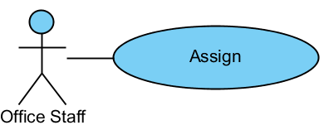

|  |  |  |  |  |
| --- | --- | --- | --- | --- |
| USE CASE – ASSIGN SPECIFICATION | | | | |
| Use-case No. | UC06.5 | Use-case Version | | 1.0 |
| Use-case Name | Assign To Staff | | | |
| Author | ThanhTV | | | |
| Date | 21/11/2012 | Priority | Normal | |
| **Actor:** Office Staff  **Summary:** This use case is about how office staff to assign work to staff.  **Goal:** Office staff can assign work to staff.  **Triggers:** In Collection Plan Details page, user click “Assign” button.  **Pre-conditions:** User logged in with office staff role.  **Post-conditions:** Office staff to assign work to staff.  **Main Success Scenario:**   1. In Collection Plan Details, user clicks “Assign” button. 2. System will navigate a popup to select a staff. 3. User selects a staff and clicks OK.   **Alternative Scenario:** In step 1, if have a staff was assigned, the button will appear with name “assign to another staff” and if user want to assign another staff, user must clicks to that button too.  In step 3, if user wants to cancel the process, user can clicks to “Cancel” button to back the main page of collection plan.  **Exceptions:** N/A  **Relationships:**  N/A  **Business Rules:** N/A | | | | |

#### Mark as Finished

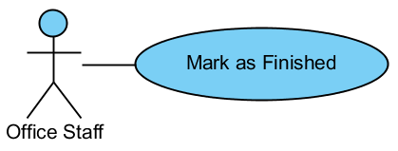

|  |  |  |  |  |
| --- | --- | --- | --- | --- |
| USE CASE – MARK AS FINISHED SPECIFICATION | | | | |
| Use-case No. | UC06.6 | Use-case Version | | 1.0 |
| Use-case Name | Mark as Finished | | | |
| Author | ThanhTV | | | |
| Date | 21/11/2012 | Priority | Normal | |
| **Actor:** Office Staff  **Summary:** This use case is about how mark as finished for collection plan.  **Goal:** Office staff can mark as finished for collection plan.  **Triggers:** In Collection Plan Details page, user click “Mark as Finished” button.  **Pre-conditions:** User logged in with office staff role.  **Post-conditions:** Office staff to mark as finished for collection plan.  **Main Success Scenario:**   1. In Collection Plan Details, user clicks “Mark as Finished” button. 2. That collection plan will has status is “Finished”   **Alternative Scenario:** N/A  **Exceptions:** That button will be shown when that collection plan has at least request with status is “collected”.  **Relationships:**  N/A  **Business Rules:** N/A | | | | |

#### Mark Request as Collected

#### C:\Users\Kim\Desktop\Untitled.png

|  |  |  |  |  |
| --- | --- | --- | --- | --- |
| USE CASE – MARK REQUEST AS COLLECTED SPECIFICATION | | | | |
| Use-case No. | UC06.7 | Use-case Version | | 1.0 |
| Use-case Name | Mark Request as Collected | | | |
| Author | ThanhTV | | | |
| Date | 21/11/2012 | Priority | Normal | |
| **Actor:** Office Staff  **Summary:** This use case is about how mark as collected for request.  **Goal:** Office staff can mark as collected request.  **Triggers:** In Collection Plan Details page, user click “Mark as Finished” button.  **Pre-conditions:** User logged in with office staff role.  **Post-conditions:** Office staff to mark as collected for request.  **Main Success Scenario:**   1. In Collection Plan Details, user selects requests which collected complete. 2. User click to “Mark as Collected” button. 3. That request will has status is “Collected”.   **Alternative Scenario:** N/A  **Exceptions:** That button will be shown when that collection plan has at least request with status is “Planned For Collecting”.  **Relationships:**  N/A  **Business Rules:** N/A | | | | |

#### Remove Request from Plan

#### 

|  |  |  |  |  |
| --- | --- | --- | --- | --- |
| USE CASE – REMOVE REQUEST FROM PLAN SPECIFICATION | | | | |
| Use-case No. | UC06.8 | Use-case Version | | 1.0 |
| Use-case Name | Remove Request From Plan | | | |
| Author | ThanhTV | | | |
| Date | 21/11/2012 | Priority | Normal | |
| **Actor:** Office Staff  **Summary:** This use case is about how to remove request.  **Goal:** Office staff can remove request.  **Triggers:** In Collection Plan Details page, user click “Remove from Plan” icon of that request.  **Pre-conditions:** User logged in with office staff role.  **Post-conditions:** User will remove request complete.  **Main Success Scenario:**   1. In main page of collection plan, user clicks “View collection plan detail” button. 2. System will redirect to “Collection Plan Details” page. 3. User click “Remove from Plan” icon of that request. 4. A confirm box will appear to confirm again. 5. User clicks “OK” to remove that request.   **Alternative Scenario:** In step 3, if user wants to cancel the process, user can clicks to “Cancel” button to back the main page of collection plan.  **Exceptions:** The “Delete” button will be shown when status of collection plan is “new”.  **Relationships:**  N/A  **Business Rules:** N/A | | | | |

### Manage Delivery Plan

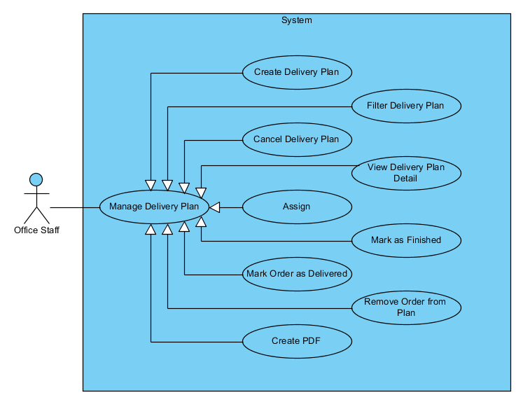

#### Create Delivery Plan

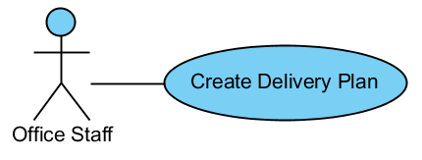

|  |  |  |  |  |
| --- | --- | --- | --- | --- |
| USE CASE - CREATE DELIVERY PLAN SPECIFICATION | | | | |
| Use-case No. | UC07.1 | Use-case Version | | 1.0 |
| Use-case Name | Create Delivery Plan | | | |
| Author | ThanhTV | | | |
| Date | 21/11/2012 | Priority | Normal | |
| **Actor:** Office Staff  **Summary:** This use case is about how office staff creates new delivery plan.  **Goal:** Office staff can create new delivery plan.  **Triggers:** In main page of delivery plan, user click “Add” button.  **Pre-conditions:** User logged in with office staff role.  **Post-conditions:** Delivery plan is created successfully.  **Main Success Scenario:**   1. In main page of delivery plan, user clicks “Add” button. 2. System will redirect to “Create” page. 3. User selects city, district and ward to list all orders in that. 4. User clicks to “Add to plan” icon in that orders to add orders to plan and clicks “Create Plan” button. 5. System redirect to “Delivery Plan Details” page, user sticks orders which want to add delivery plan and clicks “Mark as Collected” button. 6. New delivery plan appears in delivery plan list.   **Alternative Scenario:** In step 4 and step 5, if user wants to cancel the process, user can clicks to “Cancel” button to back the main page of delivery plan.  **Exceptions:** When inputs require information is invalid format or missed require information, the system will notify and require input again.  **Relationships:**  N/A  **Business Rules:** N/A | | | | |

#### Filter Delivery Plan

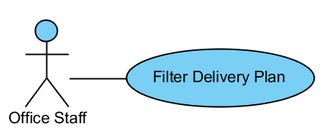

|  |  |  |  |  |
| --- | --- | --- | --- | --- |
| USE CASE – FILTER DELIVERY PLAN SPECIFICATION | | | | |
| Use-case No. | UC07.2 | Use-case Version | | 1.0 |
| Use-case Name | Filter Delivery Plan | | | |
| Author | ThanhTV | | | |
| Date | 21/11/2012 | Priority | Normal | |
| **Actor:** Office Staff  **Summary:** This use case is about how office staff filters delivery plan.  **Goal:** Office staff can filter delivery plan.  **Triggers:** In main page of delivery plan, user click “Filter” button.  **Pre-conditions:** User logged in with office staff role.  **Post-conditions:** Delivery plan is filtered successfully.  **Main Success Scenario:**   1. In main page of delivery plan, user selects conditions (status, start date, end date) and clicks “Filter” button. 2. System will show delivery plans tally with conditions.   **Alternative Scenario:** N/A  **Exceptions:** N/A  **Relationships:**  N/A  **Business Rules:** N/A | | | | |

#### Cancel Delivery Plan

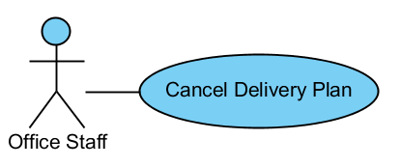

|  |  |  |  |  |
| --- | --- | --- | --- | --- |
| USE CASE – CANCEL DELIVERY PLAN SPECIFICATION | | | | |
| Use-case No. | UC07.3 | Use-case Version | | 1.0 |
| Use-case Name | Cancel Delivery Plan | | | |
| Author | ThanhTV | | | |
| Date | 21/11/2012 | Priority | Normal | |
| **Actor:** Office Staff  **Summary:** This use case is about how office staff cancel delivery plan.  **Goal:** Office staff can cancel delivery plan.  **Triggers:** In Delivery Plan Details page, user click “Cancel” button.  **Pre-conditions:** User logged in with office staff role.  **Post-conditions:** Delivery plan is canceled successfully.  **Main Success Scenario:**   1. In Delivery Plan Details page, user clicks “Cancel” button. 2. System will navigate a confirm box to selects. 3. User clicks “Yes” button to cancel.   **Alternative Scenario:** In step 3, if user wants to cancel the process, user can clicks to “Cancel” button to back the main page of delivery plan.  When status of delivery plan is finished, the “Cancel” button will be hidden.  **Exceptions:** N/A  **Relationships:**  N/A  **Business Rules:** N/A | | | | |

#### View Delivery Plan Detail

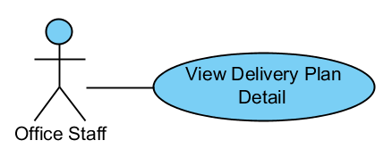

|  |  |  |  |  |
| --- | --- | --- | --- | --- |
| USE CASE – VIEW DELIVERY PLAN DETAIL SPECIFICATION | | | | |
| Use-case No. | UC07.4 | Use-case Version | | 1.0 |
| Use-case Name | View Delivery Plan Detail | | | |
| Author | ThanhTV | | | |
| Date | 21/11/2012 | Priority | Normal | |
| **Actor:** Office Staff  **Summary:** This use case is about how to view delivery plan detail.  **Goal:** Office staff can view delivery plan detail.  **Triggers:** In main page of delivery plan, user click “View delivery plan detail” button.  **Pre-conditions:** User logged in with office staff role.  **Post-conditions:** User will view delivery plan detail.  **Main Success Scenario:**   1. In main page of delivery plan, user clicks “View delivery plan detail” button. 2. System will redirect to “Delivery Plan Details” page.   **Alternative Scenario:** N/A  **Exceptions:** N/A  **Relationships:**  N/A  **Business Rules:** N/A | | | | |

#### Assign

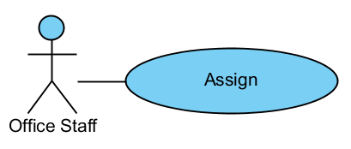

|  |  |  |  |  |
| --- | --- | --- | --- | --- |
| USE CASE – ASSIGN SPECIFICATION | | | | |
| Use-case No. | UC07.5 | Use-case Version | | 1.0 |
| Use-case Name | Assign To Staff | | | |
| Author | ThanhTV | | | |
| Date | 21/11/2012 | Priority | Normal | |
| **Actor:** Office Staff  **Summary:** This use case is about how office staff to assign work to staff.  **Goal:** Office staff can assign work to staff.  **Triggers:** In Delivery Plan Details page, user click “Assign” button.  **Pre-conditions:** User logged in with office staff role.  **Post-conditions:** Office staff to assign work to staff.  **Main Success Scenario:**   1. In Delivery Plan Details, user clicks “Assign” button. 2. System will navigate a popup to select a staff. 3. User selects a staff and clicks OK.   **Alternative Scenario:** In step 1, if have a staff was assigned, the button will appear with name “assign to another staff” and if user want to assign another staff, user must clicks to that button too.  In step 3, if user wants to cancel the process, user can clicks to “Cancel” button to back the main page of delivery plan.  **Exceptions:** N/A  **Relationships:**  N/A  **Business Rules:** N/A | | | | |

#### Mark as Finished

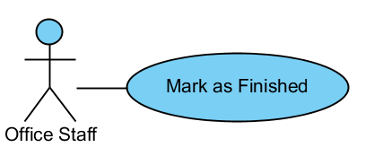

|  |  |  |  |  |
| --- | --- | --- | --- | --- |
| USE CASE – MARK AS FINISHED SPECIFICATION | | | | |
| Use-case No. | UC07.6 | Use-case Version | | 1.0 |
| Use-case Name | Mark as Finished | | | |
| Author | ThanhTV | | | |
| Date | 21/11/2012 | Priority | Normal | |
| **Actor:** Office Staff  **Summary:** This use case is about how to mark as finished for delivery plan.  **Goal:** Office staff can mark as finished for delivery plan.  **Triggers:** In Delivery Plan Details page, user click “Mark as Finished” button.  **Pre-conditions:** User logged in with office staff role.  **Post-conditions:** Office staff to mark as finished for delivery plan.  **Main Success Scenario:**   1. In Delivery Plan Details, user clicks “Mark as Finished” button. 2. That delivery plan will has status is “Finished”   **Alternative Scenario:** N/A  **Exceptions:** That button will be shown when that delivery plan has at least order with status is “delivered”.  **Relationships:**  N/A  **Business Rules:** N/A | | | | |

#### Mark Order as Delivered

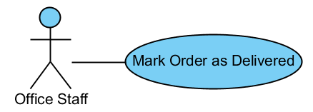

|  |  |  |  |  |
| --- | --- | --- | --- | --- |
| USE CASE – MARK ORDER AS DELIVERED SPECIFICATION | | | | |
| Use-case No. | UC07.7 | Use-case Version | | 1.0 |
| Use-case Name | Mark Order as Delivered | | | |
| Author | ThanhTV | | | |
| Date | 21/11/2012 | Priority | Normal | |
| **Actor:** Office Staff  **Summary:** This use case is about how mark as delivered for order.  **Goal:** Office staff can mark as delivered for order.  **Triggers:** In Delivery Plan Details page, user click “Mark as Delivered” button.  **Pre-conditions:** User logged in with office staff role.  **Post-conditions:** Office staff to mark as delivered for order.  **Main Success Scenario:**   1. In Delivery Plan Details, user selects orders which delivered complete. 2. User click to “Mark as Delivered” button. 3. That order will have status is “Delivered”.   **Alternative Scenario:** N/A  **Exceptions:** That button will be shown when that delivery plan has at least order with status is “Planned For Delivering”.  **Relationships:**  N/A  **Business Rules:** N/A | | | | |

#### Remove Order from Plan

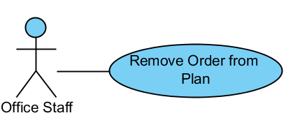

|  |  |  |  |  |
| --- | --- | --- | --- | --- |
| USE CASE – REMOVE ORDER FROM PLAN SPECIFICATION | | | | |
| Use-case No. | UC07.8 | Use-case Version | | 1.0 |
| Use-case Name | Remove Order From Plan | | | |
| Author | ThanhTV | | | |
| Date | 21/11/2012 | Priority | Normal | |
| **Actor:** Office Staff  **Summary:** This use case is about how to remove order.  **Goal:** Office staff can remove order.  **Triggers:** In Delivery Plan Details page, user click “Remove from Plan” icon of that order.  **Pre-conditions:** User logged in with office staff role.  **Post-conditions:** User will remove order completed.  **Main Success Scenario:**   1. In main page of delivery plan, user clicks “View delivery plan detail” button. 2. System will redirect to “Delivery Plan Details” page. 3. User clicks “Remove from Plan” icon of that order. 4. A confirm box will appear to confirm again. 5. User clicks “OK” to remove that order.   **Alternative Scenario:** In step 3, if user wants to cancel the process, user can clicks to “Cancel” button to back the main page of delivery plan.  **Exceptions:** The “Delete” button will be shown when status of delivery plan is “new”.  **Relationships:**  N/A  **Business Rules:** N/A | | | | |

#### Create PDF

**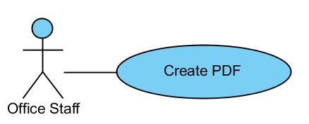**

|  |  |  |  |  |
| --- | --- | --- | --- | --- |
| USE CASE – CREATE PDF SPECIFICATION | | | | |
| Use-case No. | UC07.9 | Use-case Version | | 1.0 |
| Use-case Name | Create PDF | | | |
| Author | ThanhTV | | | |
| Date | 21/11/2012 | Priority | Normal | |
| **Actor:** Office Staff  **Summary:** This use case is about how to create PDF.  **Goal:** Office staff can create PDF.  **Triggers:** In Delivery Plan Details page, user click “Create PDF” button.  **Pre-conditions:** User logged in with office staff role.  **Post-conditions:** User will create PDF completed.  **Main Success Scenario:**   1. In main page of delivery plan, user clicks “View delivery plan detail” icon. 2. System will redirect to “Delivery Plan Details” page. 3. User clicks “Create PDF” button.   **Alternative Scenario:** N/A  **Exceptions:** N/A  **Relationships:**  N/A  **Business Rules:** N/A | | | | |

## Software System Attributes

### Reliability

* The database can be backed up easily and recovered if necessary.
* The system should never crash or hang, except for the cause from an operating system or network error.
* Mean Time Between Failures (MTBF): The acceptable failure is once a year. The failure should not be because of the database, or else the data may be lost and cannot be recovered.
* Mean Time To Repair (MTTR): When the failure occurs, it should take as little time as possible to repair. The acceptable mean time for a particular failure must be less than 8 hours.
* Maximum Bugs or Defect Rate: 05 bugs / KLOC

### Availability

* The uptime percentage should be at least 99.95%.
* The acceptable time for maintenance or backup should not be more than 8 hours per month.
* When the system goes in under-maintenance, the website should display a message to inform that.

### Security

* Only users with proper account can access certain information of the system. All the information of users must not be available for anyone or software that is not part of the system. User password is also encrypted and not available to the system administrators.

### Maintainability

* The code must follow C#.NET coding and naming convention.
* There should be comments in code files that explain the functions of each code segment.
* All the errors should be logged, which supports bug fixing and maintenance.
  1. **Entity Relationship Diagram**

