|  |  |  |  |  |  |
| --- | --- | --- | --- | --- | --- |
| |  |  |  | | --- | --- | --- | | **Logo_FPT_University_doc** | **MINISTRY OF EDUCATION AND TRAINING** | | | **FPT UNIVERSITY** | | |
| Capstone Project |
| Information System In Logistic Company  Report Summary |
| |  |  |  |  |  |  |  |  |  |  |  |  |  |  |  |  |  |  |  |  |  |  |  |  |  |  | | --- | --- | --- | --- | --- | --- | --- | --- | --- | --- | --- | --- | --- | --- | --- | --- | --- | --- | --- | --- | --- | --- | --- | --- | --- | --- | | |  |  |  |  | | --- | --- | --- | --- | | **Group 6** | | | | | **Group Members** | Lê Anh Đảo |  | 60142 | | Nguyễn Bá Linh |  | 60153 | | Hồ Hữu Tài |  | 60267 | | Thân Văn Thành  Lê Quang Tú |  | 60277  60037 | | **Supervisor** | Lâm Hữu Khánh Phương | | | | **Capstone Project code** | HDMS | | | | |
| * Ho Chi Minh City, Dec / 2012 - |

Table of Contents

[1. The real world problem 2](#_Toc342830318)

[1.1. E-Commerce in Vietnam 2](#_Toc342830319)

[1.2. Home Delivery Services 2](#_Toc342830320)

[1.3. The need for a Home Delivery Management System 2](#_Toc342830321)

[2. Summary of the project 3](#_Toc342830322)

[2.1. Introduction 3](#_Toc342830324)

[*2.1.1.* Project organization 3](#_Toc342830325)

[*2.1.2.* Overview 3](#_Toc342830326)

[*2.1.3.* Existing Methods 3](#_Toc342830327)

[*2.1.4.* Limitation of the existing system 3](#_Toc342830328)

[*2.1.5.* Benefits of expected system 3](#_Toc342830329)

[2.2. Software Project Management Plan 4](#_Toc342830330)

[*2.2.1.* Problem Definition 4](#_Toc342830331)

[*2.2.2.* Project organization 5](#_Toc342830334)

[2.3. Software Requirement Specification 8](#_Toc342830335)

[*2.3.1.* User Requirement Specification 8](#_Toc342830336)

[*2.3.2.* System Requirement Specification 9](#_Toc342830337)

[2.4. Software Design Description 11](#_Toc342830338)

[*2.4.1.* System Overview 11](#_Toc342830339)

[*2.4.2.* System Architectural Design 11](#_Toc342830340)

[*2.4.3.* Package Diagram 12](#_Toc342830341)

[*2.4.4.* State Diagrams 15](#_Toc342830342)

[*2.4.5.* Algorithms 17](#_Toc342830343)

# The real world problem

* 1. E-Commerce in Vietnam

Vietnam has 30 million internet users and e-commerce is blooming here. With the trend of groupon sites in the last 2 years, people have been familiar with buying stuff online. All the big corporates in the internet industry are trying hard to compete with each other and even with international companies in this big market. Thousands of e-commerce websites have been launched – from B2C platforms like lazada.vn, 123.vn, tiki.vn, zalora.vn to C2C platforms like vatgia.com, enbac.vn, 123mua.vn, sendo.vn or even the old school 5giay.vn. Besides, traditional offline shops are using their website as another sales channel since its effectiveness and low cost.

* 1. Home Delivery Services

Using e-commerce, buyers don’t go to the store and get stuff they bought. Their orders are processed and the items will be delivered within a couple of days.

Most of the big sites are maintaining their own in-house delivery team while this is a very big problem for small shops.

Therefore, a company is built to solve this problem.



TicTac Delivery is a company providing professional delivery services focusing on e-commerce. It helps shops be free from the delivery problem and focus on marketing and selling.

* 1. The need for a Home Delivery Management System

TicTac aims to be the leader in the industry with thousands of transactions per day. So it needs a powerful information system that helps speed up the business process and reduce labors. Moreover, the system should be able to increase the precision rate in all the tasks and the business data could be transformed into meaningful information quickly and easily.

# Summary of the project

1. 1. Introduction
      1. Project organization

Project Title:Home Delivery Management System

Project Code: HDMS

Date of Authorization: Aug 6th, 2012

Project Start Date: Sep 10th, 2012

Project Finish Date: Dec 20th, 2012

* + 1. Overview

TicTac is a company providing Home Delivery service for online and offline shops. As the business consists of many complex processes, a management system is needed for its operation. Therefore, HDMS is built to fulfill this need.

* + 1. Existing Methods

Currently, TicTac doesn’t have any management information system so all the management tasks are done manually by the staff.

* + 1. Limitation of the existing system

Manual work is not efficient in term of speed and cost, especially when it is information management work. Moreover, the precision of manual work is not guaranteed. It also takes a lot of time to gather all the information from other documents to create a regular report.

* + 1. Benefits of expected system

The benefits of the Management Information System:

* Reduce time and cost of paper work.
* Be able to retrieve information quickly and precisely.
* Can be accessed from anywhere with an internet connection.
* Customers can place orders anytime.
  1. Software Project Management Plan
     1. Problem Definition

2. * + 1. Name of this Capstone Project

Project Full name: **Information System In Logistic Company**

Project Code: **HDMS (Home Delivery Management System)**

* + - 1. Problem Abstract

TicTac is a company providing Home Delivery service for online and offline shops. The business consists of many complex processes such as delivery booking, items tracking, task assigning, etc. To increase efficiency in work and compete with other service providers in the industry, the company needs a powerful information system that helps complete management tasks quickly and easily.

* + - 1. Project Overview

**The Current System**

Currently, TicTac is not using any information system. All the tasks are done manually using paper and common software like Microsoft Word and Microsoft Excel. Customers are placing orders using phone calls or email.

**The Proposed System**

HDMS is developed as a web-based system. Below features are provided to support the management process:

* *Management*: Customers, Staff, Orders, and others are managed easily through the system.
* *Online Delivery Booking*: Customers can book deliveries online using TicTac’s website. They can also manage and track all the deliveries they have booked.
* *Collection and Delivery Planning*: The system will help managers at the company to create good plans for collecting and delivering items which are able to help increase efficiency and reduce cost.
* *Reporting (future feature)*: Daily, weekly, or any required type of report are created precisely and quickly by the system.

**Boundaries of the System**

* The system is intended to use for TicTac Co. only.
* All the functions of the system are built based on the requirements from TicTac.
* The system will be used only for managing the tasks related to the delivery process in TicTac. It does not include general management functions like accounting, customer relationship, salary managing, etc.

**Development Environment**

*Hardware Requirements:*

* Personal computers for developing with the minimum configuration: 2 GB of RAM, 40GB of hard disk, Core 2 Duo 2.0 GHz

*Software Requirements:*

* Operating system: Windows 7
* IDE: Visual Studio 2010 SP1
* Microsoft Office (Word, Excel)
* DBMS: SQL Server 2008 R2 Express
* Source Control: SVN
* Browser: Chrome/Firefox
  + 1. Project organization
       1. Software Development Process Model

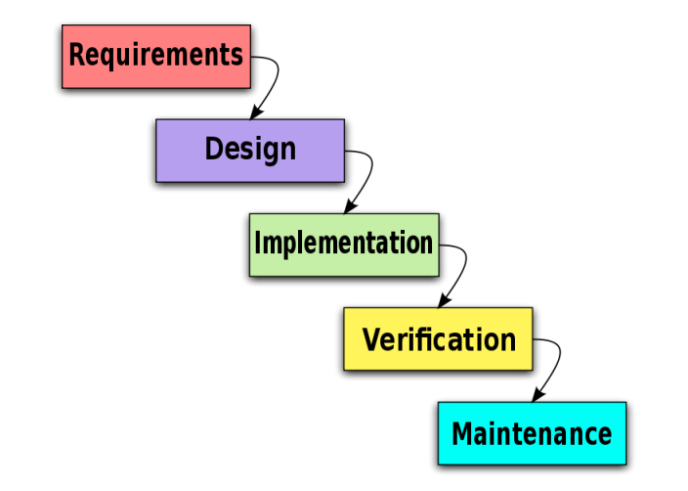Due to specific characteristics of a Capstone project, the model we use for developing this project is Waterfall model.

Figure - Waterfall Model

* + - 1. Roles and Responsibilities

|  |  |  |
| --- | --- | --- |
| Full name | Role in Group | Responsibilities |
| Lâm Hữu Khánh Phương | Supervisor | * Tracking & managing progress * Advising Idea & solutions * Suggesting & supporting in technologies |
| Lê Anh Đảo | Team Leader, Developer, Business Analyst, Tester, QA | * Tracking & managing progress * Designing database * Creating coding framework * Analyzing requirements * Planning & scheduling * Coding * Testing * Writing documents & reports |
| Nguyễn Bá Linh | Developer, Business Analyst, Tester | * Analyzing requirements * Coding * Writing documents * Testing |
| Hồ Hữu Tài | Developer, Business Analyst, Tester | * Analyzing requirements * Coding * Writing documents * Testing |
| Thân Văn Thành | Developer, Business Analyst, Tester | * Analyzing requirements * Coding * Writing documents * Testing |
| Lê Quang Tú | Developer, Business Analyst, Tester | * Analyzing requirements * Coding * Writing documents * Testing |

Table 1 - Roles and Responsibilities

* + - 1. Tools and Technologies

***Tools:***

* *Microsoft Visual Studio 2010*: Used to implement software modules.
* *Microsoft SQL server 2008 R2 Express*: Used as the database of the system.
* *Microsoft Excel*: For the team leader to manage tasks of the members and the progress of the project.
* *TortoiseSVN*: Control Source code of the whole project.
* *VisualSVN*: extension for using subversion (SVN) inside Visual Studio.
* *Google Cloud Connect*: Connect and synchronize the documents.
* *Assembla*: Used as SVN repository
* *Visual Paradigm*: Design database and draw use cases
* *Google Chrome, Firefox*: Used to test the system

**Technologies:**

* ASP.NET MVC 3
* LINQ
* HTML 5, CSS 3, AJAX, jQuery, Bootstrap
* Google Maps API
  1. Software Requirement Specification
     1. User Requirement Specification
        1. Common Features
* Only authenticated users can access the system. Users can log in and log out using their own accounts.
* Users can change their password.
* Only authorized users can use specific functions of the system.
  + - 1. Account Management
* System administrators have privileges to create new account, enable or disable account, and reset account’s password.
* When the password of an account is reset, an email is sent to the account owner to announce the new password.
  + - 1. Customer’s Uses
* Customers can create request when they want some orders to be delivered to the receivers. A request may include many orders. Each order is associated with one receiver. If the receiver is the buyer and the sender is the seller, this order is the same as the order that the buyer made to the seller. An order may include many items.
* When a request is submitted, the customer is not allowed to edit/cancel request. Any change must be done by the staff of TicTac.
  + - 1. Customers Management
* Customers must have signed a contract with TicTac before they could use the delivery service. Then, office staff will create a new account. After that, they can use this account to access the system. TicTac Staff can add/update Customers’ information.
  + - 1. Request Management
* When receiving a request by phone or email, office staff can create new Request for the customer by using web form or importing Excel file. A new request must have Customer’s company name (or Customer id), address for orders collecting and complete details of the orders/items include name of item, delivery address, amount of payment, etc.
* Office Staff can approve new requests, cancel requests and add/ edit orders if necessary.
  + - 1. Order Management
* Office Staff can create new order inside a Request by selecting a Request and then add a new order into it.
* If an order is canceled after collected, it must be returned to the customer.
  + - 1. Collection Planning
* Office staff can view request/order/item information that has been created. If collection manager feels the number of request is enough to collect, he can make a collection plan and assign it for collectors to go to the customers to collect items.
* Staff can view collection plan detail to cancel collection plan, update status “finished” for it, update status “collected” for every request.
  + - 1. Delivery Planning
* Office staff can view order/item information that has been collected. If delivery manager feels the number of item is enough to deliver, delivery manager can also make a delivery plan and assign it for delivery men to go to the receivers to deliver items.
* Staff can view delivery plan detail to cancel delivery plan, update status “finished” for it, update status “delivered” for every order.
  + 1. System Requirement Specification
       1. External Interface Requirements

**User Interfaces**

* The design should be simple and user-friendly. Green and dark blue will be 2 main colors of the website. The text color should be white if the background is dark, and it should be black if the background is light.
* The design should be responsive. It means that the web components should be scaled according to a range of resolutions and devices to provide a consistent experience, no matter what.

**Hardware Interfaces**

* To access to the system, users only need a computer with a fair internet connection.

**Software Interfaces**

* At the server side, the system should run on top of Windows 7, Windows Server 2008 or later versions of Windows Server. Besides, Microsoft .NET Framework 4 and MVC 3 should be installed on the server. The database management system use for HDMS is SQL Server 2008 R2.
* At the client side, users can use any modern browser that supports javascript and HTML 5 to access to the system.

**Communications Protocol**

HTTP is the protocol used for loading the web site in browsers.

* 1. Software Design Description
     1. System Overview

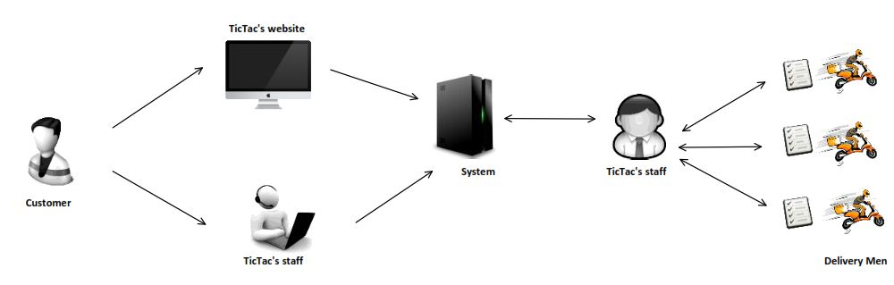

Figure 2 - System Overview

* + 1. System Architectural Design
       1. Choice of System Architecture

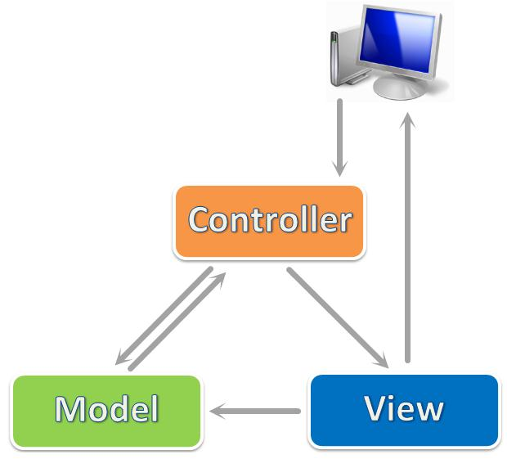

Figure 3 - MVC

We use ASP.NET MVC 3, which is a framework for building scalable, standards-based web applications using well-established design patterns and the power of ASP.NET and the .NET Framework. MVC stands for model-view-controller. MVC is a pattern for developing applications that are well architected and easy to maintain. MVC-based applications contain:

* **View**s are template files that your application uses for dynamically generating HTML responses.
* **Model**s are classes that represent the data of the application and that use validation logic to enforce business rules for that data.
* **Controller**s are classes that handle incoming requests to the application, retrieve model data, and then specify view templates that return a response to the client.
  + 1. Package Diagram

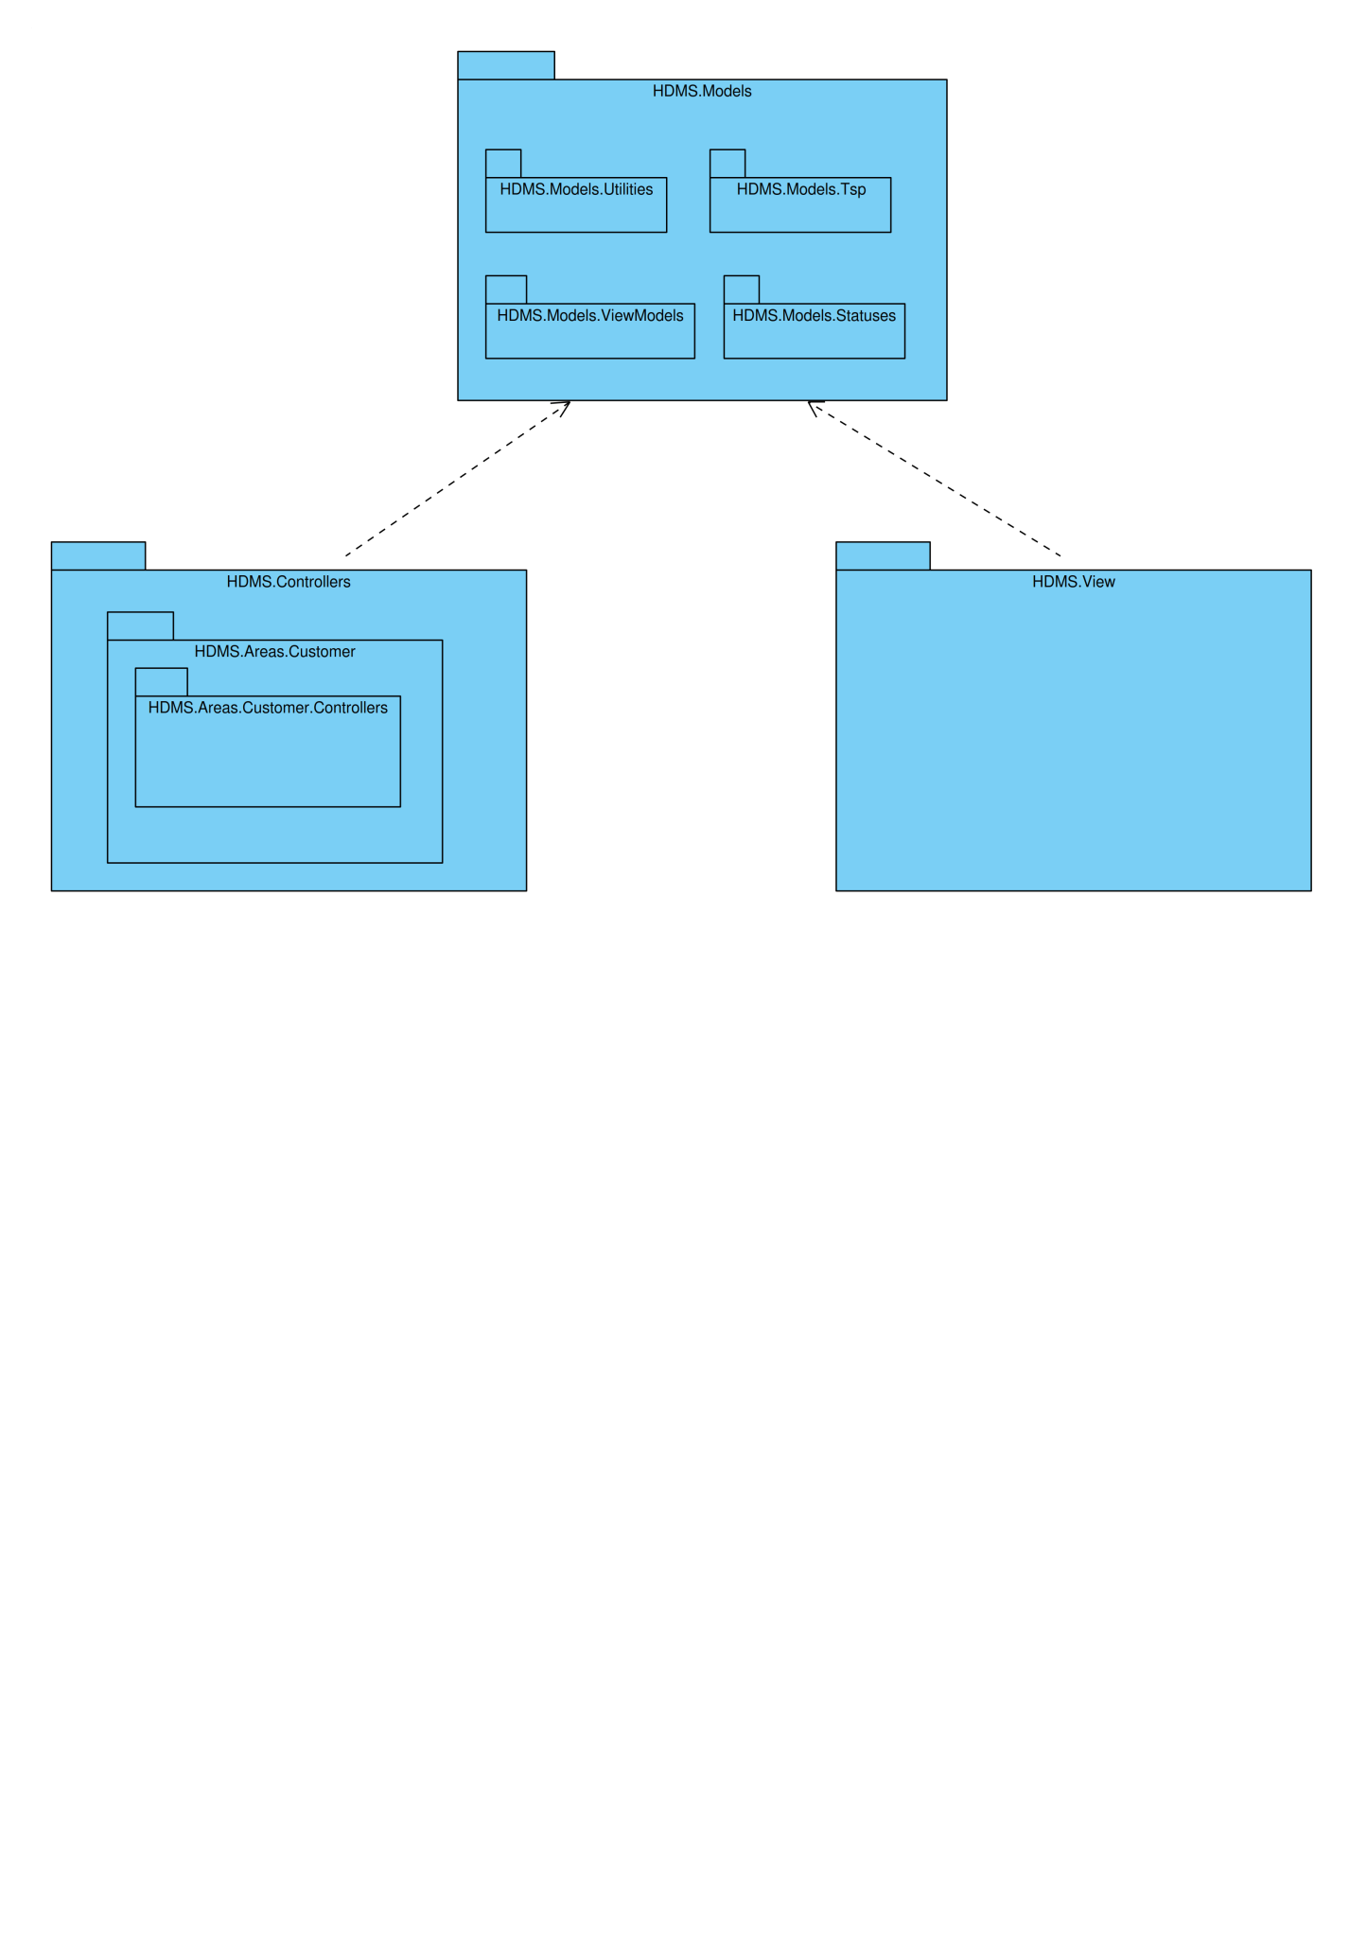

Figure 4 - General Package Diagram

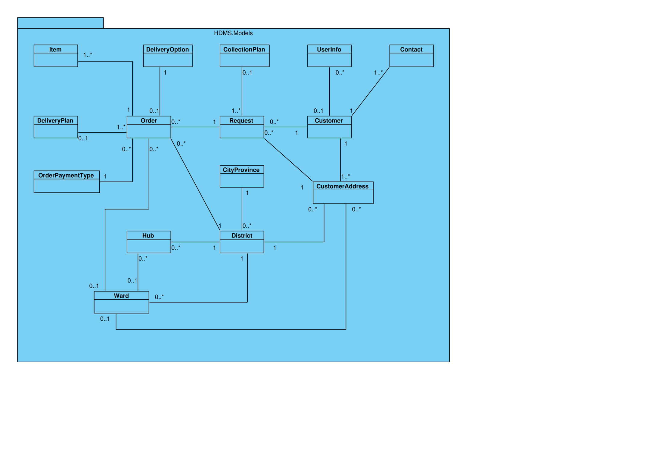

Figure 5 - HDMS.Models Package

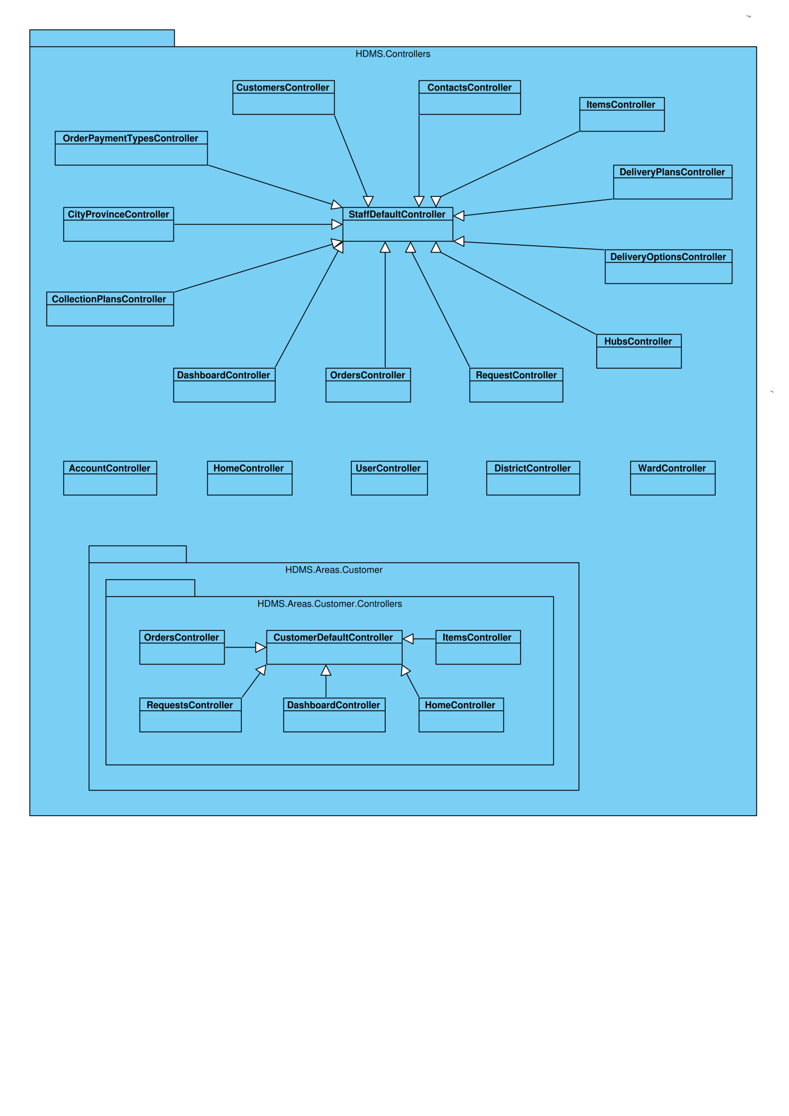

Figure 6 - HDMS.Controllers Package

* + 1. State Diagrams
       1. Request State Diagram

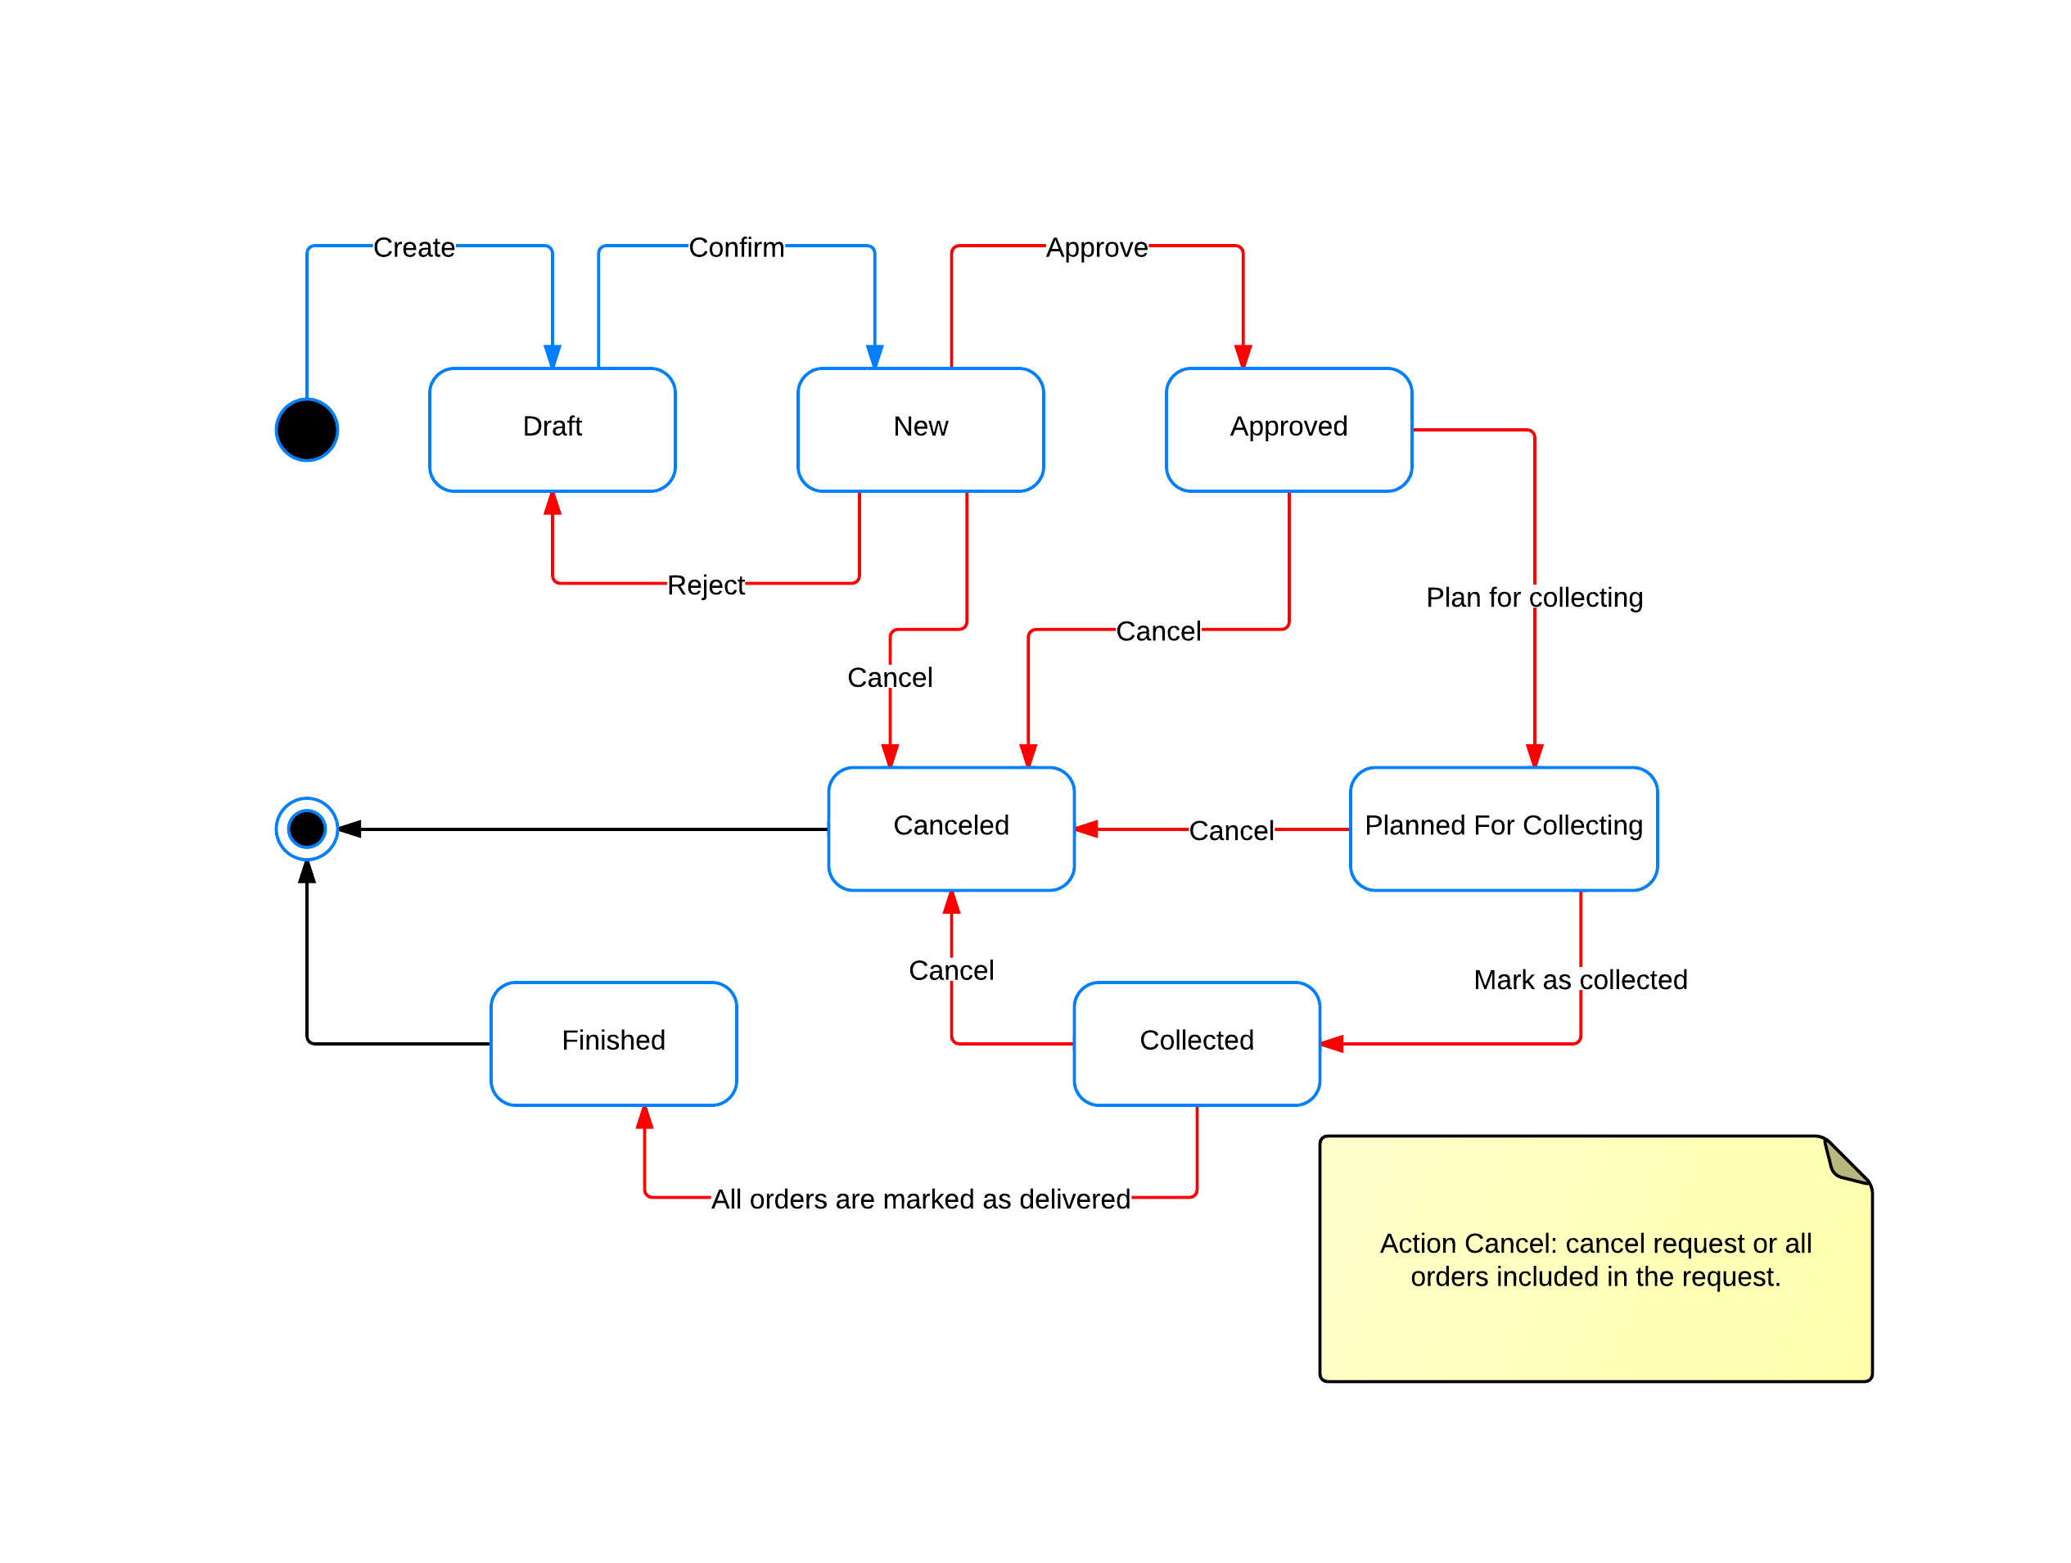

Figure 7 - Request State Diagram

States Description:

* **Draft**: the request is created by customers or staffs but not submitted for processing yet.
* **New**: the request is submitted for processing but not approved by staffs yet.
* **Approved**: the request and all included orders are approved.
* **Planned** **for collecting**: the request is in a collection plan but not collected yet.
* **Collected**: All orders included in the request have been collected to the warehouse.
* **Finished**: All orders included in the request have been processed completely (deliver, return)
* **Canceled**: the request is canceled by customers or staffs and will not continue being processed.
  + - 1. Order State Diagram

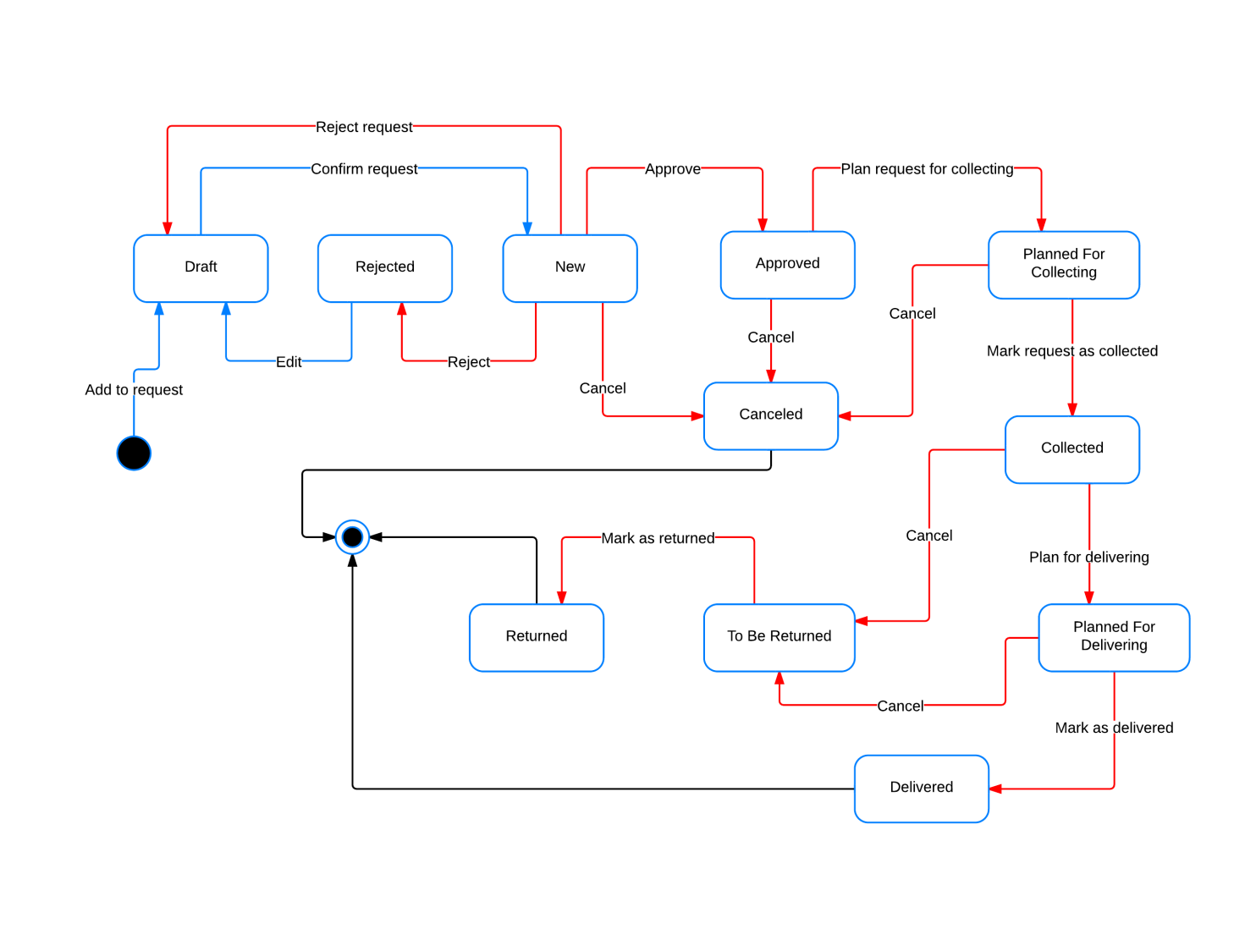

Figure 8 - Order State Diagram

States Description:

* **Draft**: Order is added to a request by customers or staffs but the request is not submitted for processing yet.
* **New**: the request containing the order is submitted for processing but the order is not approved by staffs yet.
* **Approved**: the order is approved, due date and fee have been set.
* **Rejected**: the order is identified as invalid by staffs and rejected.
* **Planned** **for collecting**: the request containing the order is in a collection plan but not collected yet.
* **Collected**: the order has been collected to the warehouse.
* **Planned** **for collecting**: the order is in a delivery plan but not delivered yet.
* **Delivered**: the order has been delivered to the receiver.
* **To be returned**: the order is canceled after collected to the warehouse and needs to be returned to the customer.
* **Returned**: the order has been returned to the customer.
* **Canceled**: the order is canceled by customers or staffs and will not continue being processed.
  + 1. Algorithms

To help reduce time and fuel cost, the system should find the best route for delivery mans to deliver all packages in a delivery plan. This problem is similar to a common problem named **Traveling Salesman Problem** (<http://en.wikipedia.org/wiki/Travelling_salesman_problem>).

There are many algorithms to solve this problem. In this project, we use a **Genetic Algorithm** published at <http://www.lalena.com/AI/TSP/>.