|  |  |  |  |  |  |
| --- | --- | --- | --- | --- | --- |
| |  |  |  | | --- | --- | --- | | **Logo_FPT_University_doc** | **MINISTRY OF EDUCATION AND TRAINING** | | | **FPT UNIVERSITY** | | |
| Capstone Project |
| Information System In Logistic Company  Software Design Description |
| |  |  |  |  |  |  |  |  |  |  |  |  |  |  |  |  |  |  |  |  |  |  |  |  |  |  | | --- | --- | --- | --- | --- | --- | --- | --- | --- | --- | --- | --- | --- | --- | --- | --- | --- | --- | --- | --- | --- | --- | --- | --- | --- | --- | | |  |  |  |  | | --- | --- | --- | --- | | **Group 5** | | | | | **Group Members** | Nguyễn Hoàng Việt Khánh |  | 60566 | | Nguyễn Thị Yên Thịnh |  | 60269 | | Nguyễn Đỗ Vượng |  | 60075 | | An Ngọc Anh |  | 60223 | | **Supervisor** | Lâm Hữu Khánh Phương | | | | **Capstone Project code** | SMDH | | | | |
| * Ho Chi Minh City, Feb / 2013 - |

# Table of Contents

[Table of Contents 3](#_Toc352130163)

[4.1 Design Overview 5](#_Toc352130164)

[4.2 System Architectural Design 6](#_Toc352130165)

[4.2.1 Choice of System Architecture 6](#_Toc352130166)

[4.2.2 Discussion of Alternative Designs 6](#_Toc352130167)

[4.3 Package Diagram 7](#_Toc352130168)

[4.4 Classes Detail Description 10](#_Toc352130169)

[4.4.1. Cargo 10](#_Toc352130170)

[4.4.2. City/Province 10](#_Toc352130171)

[4.4.3. Contact 10](#_Toc352130172)

[4.4.4. Customer 11](#_Toc352130173)

[4.4.5. Customer Address 12](#_Toc352130174)

[4.4.6. Delivery Men 13](#_Toc352130175)

[4.4.7. Delivery Men In Plan 13](#_Toc352130176)

[4.4.8. Delivery Option 13](#_Toc352130177)

[4.4.9. Delivery Type 14](#_Toc352130178)

[4.4.10. District 14](#_Toc352130179)

[4.4.11. Hub 15](#_Toc352130180)

[4.4.12. Hub Category 15](#_Toc352130181)

[4.4.13. Item 15](#_Toc352130182)

[4.4.14. Item Management 16](#_Toc352130183)

[4.4.15. Order 16](#_Toc352130184)

[4.4.16. Order Payment Type 19](#_Toc352130185)

[4.4.17. Plan 20](#_Toc352130186)

[4.4.18. Price Category 20](#_Toc352130187)

[4.4.19. User Info 21](#_Toc352130188)

[4.4.20. Ward 21](#_Toc352130189)

[4.4.21. Request 22](#_Toc352130190)

[4.4.22. Account controller 24](#_Toc352130191)

[4.4.23. DashboardController 25](#_Toc352130192)

[4.4.24. HomeController 25](#_Toc352130193)

[4.4.25. HubController 25](#_Toc352130194)

[4.4.26. ItemsController 25](#_Toc352130195)

[4.4.27. OrdersController 26](#_Toc352130196)

[4.4.28. RequestController 27](#_Toc352130197)

[4.5 Sequence Diagrams 28](#_Toc352130198)

[4.5.1. Check Order Info to Delivery 28](#_Toc352130199)

[4.5.2. Mark as Delivered 28](#_Toc352130200)

[4.5.3. View Order at Hub 29](#_Toc352130201)

[4.5.4. Change status at Hub 30](#_Toc352130202)

[4.5.5. Create Collection Plan 30](#_Toc352130203)

[4.5.6. Assign Delivery men to Collection Plan 31](#_Toc352130204)

[4.5.7. Aa 32](#_Toc352130205)

[4.5.8. Ss 32](#_Toc352130206)

[4.5.9. Da 32](#_Toc352130207)

[4.5.10. Aa 32](#_Toc352130208)

[4.5.11. Aa 32](#_Toc352130209)

[4.5.12. Aa 32](#_Toc352130210)

[4.5.13. Aa 32](#_Toc352130211)

[4.5.14. aa 32](#_Toc352130212)

[4.6 Databse Design Diagram 1](#_Toc352130213)

[4.7 State Diagrams 3](#_Toc352130214)

[4.7.1 Request State Diagram 3](#_Toc352130215)

[4.7.2 Order State Diagram 4](#_Toc352130216)

[4.8 Algorithms 8](#_Toc352130217)

# Design Overview

This document describes the technical and UI design of the Management Information System for TikTak Delivery Company. It includes the architectural design and the detailed design of common functions and business functions. It also includes the design of database model, and overall design of user interface.

The architectural design describes the overall architecture of the system, and the architecture of each main component and subsystem. It will describe the patterns being used, the role of each component and the role of the system in the working environment.

The detailed design describes static and dynamic structure for each component and function. It includes class diagrams, class explanations, and sequence diagrams of the main use cases. The detailed design uses notations of .NET framework 4.0 and C# 4.0, as they are the framework and language for developing the system.

The database design describes the relationship between entities, and details of each entity. It uses notations of SQL Server 2008 R2, as it is the database server for developing the system.

The user interface design describes the layout of the system, and some design for the screens.

# System Architectural Design

## Choice of System Architecture

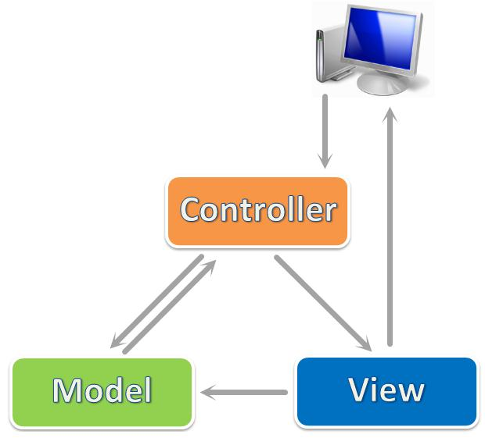

We use ASP.NET MVC 3, which is a framework for building scalable, standards-based web applications using well-established design patterns and the power of ASP.NET and the .NET Framework. MVC stands for model-view-controller. MVC is a pattern for developing applications that are well architected and easy to maintain. MVC-based applications contain:

* **View**s are template files that your application uses for dynamically generating HTML responses.
* **Model**s are classes that represent the data of the application and that use validation logic to enforce business rules for that data.
* **Controller**s are classes that handle incoming requests to the application, retrieve model data, and then specify view templates that return a response to the client.

## Discussion of Alternative Designs

At first glance, the three tiers may seem similar to the model-view-controller (MVC) concept; however, topologically they are different. A fundamental rule in three-tier architecture is that the client tier never communicates directly with the data tier; in a three-tier model, all communication must pass through the middle tier. Conceptually the three-tier architecture is linear. However, the MVC architecture is triangular: the view sends updates to the controller, the controller updates the model, and the view gets updated directly from the model.

# Package Diagram

***System Package***



***Model:***



***Controllers:***



# Classes Detail Description

## Cargo

|  |  |  |
| --- | --- | --- |
| Field | Type | Description |
| CargoId | int | Unique ID of each Cargo |
| Address | string | Address is where deliver |
| CargoColumn | int | Status of City/Province |
| PlanId | int | Plan associate with each cargo |
| CargoType | int | Type of cargo |
| RequestId | Int | Request associate with each cargo |
|  |  |  |

## City/Province

|  |  |  |
| --- | --- | --- |
| Field | Type | Description |
| CityProvinceId | int | Unique ID of each City/Province |
| Name | string | Name of City/Province |
| IsActive | bool | Status of City/Province |
| Districts | virtual ICollection<District> | Districts associate with each City/Province |

## Contact

|  |  |  |
| --- | --- | --- |
| Field | Type | Description |
| ContactId | int | Unique ID of each Contact |
| CustomerId | int | ID of Customer associates with Contact |
| Title | string | Title of Contact person |
| Name | string | Name of Contact person |
| Position | string | Position of Contact person |
| EmailAddress | string | Email address of Contact person |
| PhoneNumber | string | Phone number of Contact person |
| IsActive | bool | Status of Contact |
| Customer | virtual Customer | Customer associates with Contact |

## Customer

|  |  |  |
| --- | --- | --- |
| Field | Type | Description |
| CustomerId | int | Unique ID of each Customer |
| CompanyName | string | Name of Customer’s company |
| DisplayName | string | A more familiar name of Customer’s company |
| PhoneNumber | string | Phone number of Customer |
| CurrentContractNumber | string | Number of current contract with Customer |
| IsActive | bool | Status of Customer |
| Note | string | Optional information |
| Contacts | virtual ICollection<Contact> | Contacts associate with each Customer |
| CustomerAddresses | virtual ICollection<CustomerAddress> | Customer Addresses associate with each Customer |
| Requests | virtual ICollection<Request> | Requests associate with each Customer |
| UserInfoes | virtual ICollection<UserInfo> | UserInfoes associate with each Customer |

## Customer Address

|  |  |  |
| --- | --- | --- |
| Field | Type | Description |
| CustomerAddressId | int | Unique ID of each Customer Address |
| CustomerId | int | ID of Customer associates with Customer Address |
| Address | string | Address and street name |
| WardId | Nullable<int> | ID of Ward associate with Customer Address |
| DistrictId | int | ID of district in each Customer Address |
| Latitude | Nullable<decimal> | Latitude of each Customer Address in the map |
| Longitude | Nullable<decimal> | Longitude of each Customer Address in the map |
| IsActive | bool | Status of Customer Address |
| Note | string | Optional information |
| Customer | virtual Customer | Customer associates with Customer Address |
| Ward | virtual Ward | Ward associates with Customer Address |
| District | virtual District | District associates with Customer Address |
| Requests | virtual ICollection<Request> | Requests associate with each Customer Address |

## Delivery Men

|  |  |  |
| --- | --- | --- |
| Field | Type | Description |
| DeliveryMenId | int | Unique id of each delivery men |
| Name | string | Name of delivery men |
| Status | int | Status id of delivery men |

## Delivery Men In Plan

|  |  |  |
| --- | --- | --- |
| Field | Type | Description |
| DeliveryMenInPlanId | int | Unique id of each delivery men in plan |
| DeliveryMenId | int | Delivery men associate with delivery men in plan |
| PlanId | int | Plan associate with delivery men in plan |
| AssignedDate | date | Date assign delivery men in plan |
| EstimateDistance | double | Distance is estimated when delivering |
| EstimateTime | double | Time is estimated when delivering |

## Delivery Option

|  |  |  |
| --- | --- | --- |
| Field | Type | Description |
| DeliveryOptionId | int | Unique id of each delivery option |
| Name | string | Name of delivery option |
| Description | string | Describe about delivery option |
| IsActive | bool | Status of delivery option |
| Orders | virtual ICollection<Order> | Order associate with delivery option |

## Delivery Type

|  |  |  |
| --- | --- | --- |
| Field | Type | Description |
| DeliveryTypeId | int | Unique id of each delivery type |
| DeliveryName | string | Name of delivery type |

## District

|  |  |  |
| --- | --- | --- |
| Field | Type | Description |
| DistrictId | int | Unique id of each District |
| CityProvinceId | int | Unique id of each City/Province |
| Name | string | Name of District |
| IsActive | bool | Status of District |
| CityProvince | virtual CityProvince | City/province associate with District |
| CustomerAddresses | virtual ICollection<CustomerAddress> | Customer Address associate with District |
| Hubs | virtual ICollection<Hub> | Hubs associate with District |
| Orders | virtual ICollection<Order> | Order associate with District |
| Wards | virtual ICollection<Ward> | Ward associate with District |

## Hub

|  |  |  |
| --- | --- | --- |
| Field | Type | Description |
| HubId | int | Unique id of each Hub |
| Name | string | Name of each Hub |
| Address | string | Address and street name of each Hub |
| WardId | Nullable<int> | ID of Ward associate with Hub |
| DistrictId | int | ID of district in each Hub |
| Latitude | Nullable<decimal> | Latitude of each Customer Address in the map |
| Longitude | Nullable<decimal> | Longitude of each Customer Address in the map |
| IsActive | bool | Status of Hub |
| District | virtual District | District associates with Hub |
| Ward | virtual Ward | Ward associates with Hub |
| HubCategoryId | int | Hub Category associates with Hub |

## Hub Category

|  |  |  |
| --- | --- | --- |
| Field | Type | Description |
| HubCategoryId | int | Unique id of each Hub Category |
| HubName | string | Name of hub |
| isActive | bool | Hub is Active/Deactive |

## Item

|  |  |  |
| --- | --- | --- |
| Field | Type | Description |
| ItemId | int | Unique id of each item |
| OrderId | int | Unique id of each order |
| Name | string | Name of items |
| Quantity | int | Quantity of each item |
| IsFragile | bool | It is fragile or not? |
| HasHighValue | bool | It has high value or not? |
| Size | string | Size of item |
| Weight | string | Weight of item |
| Note | string | Comment about items |
| Order | virtual Order | Order associate with item |

## Item Management

|  |  |  |
| --- | --- | --- |
| Field | Type | Description |
| ItemId | int | Unique id of each item |
| VendorId | int | Vendor associates with order |
| Name | string | Name of items |
| price | int | Price of each item |
| ImageMime | string | Image of item |
| ImageData | string | Image of item |
| Description | string | Describe item detail |
| Category | string | Type of item |
| Status | int | Status of items |

## Order

|  |  |  |
| --- | --- | --- |
| Field | Type | Description |
| OrderId | int | Unique id of each order |
| RequestId | int | Id of the request that the order belong to |
| DeliveryOptionId | int | Id of the Delivery Option that apply to this order |
| OrderPaymentTypeId | int | Id of the Order Payment Type that apply to this order |
| HubId | int | Hub associates with Order |
| DueDate | Nullable<DateTime> | Deadline for the order to be delivered |
| CollectedDate | Nullable<DateTime> | Date of collection |
| DeliveryDate | Nullable<DateTime> | Date of delivery |
| ReceiverName | string | Name of the receiver |
| ReceiverPhone | string | Phone number of the receiver |
| ReceiverAddress | string | Address of the receiver |
| ReceiverAddressWardId | Nullable<int> | Id of the ward that the receiver address belong to |
| ReceiverAddressDistrictId | int | Id of the district that the receiver address belong to |
| AmountToBeCollectedFromReceiver | int | The amount to be collected from receiver |
| Latitude | Nullable<int> | Latitude of the receiver address |
| Longitude | Nullable<int> | Longitude of the receiver address |
| Fee | Nullable<int> | Amount of fee to be charged for the order |
| OrderStatus | int | Status Id of the order |
| Note | string | Comment about order |
| Request | virtual CollectionRequest | Request associate with order |
| DeliveryPlan | virtual Delivery | Delivery Plan associate with order |
| DeliveryOption | virtual DeliveryOption | Delivery option associate with order |
| Items | virtual ICollection<Item> | Item associate with order |
| Ward | virtual Ward | Ward associate with order |
| District | virtual District | District associate with order |
| OrderPaymentType | virtual OrderPaymentType | Order payment type associate with order |
| Status | OrderStatus | Status of the order |
| FullAddress | string | Full address of the receiver |
| AddToRequest(HDMSEntities context, Request request) | bool | Add the order to a request |
| Approve(HDMSEntities context, DateTime dueDate, int fee) | bool | Approve and set due date, fee to the order |
| Reject(HDMSEntities context) | bool | Reject order |
| Disapprove(HDMSEntities context) | bool | Disapprove order |
| Cancel(HDMSEntities context) | bool | Cancel order |
| Cancel(HDMSEntities context, bool commit) | bool | Cancel order |
| CustomerCancel(HDMSEntities context) | bool | Cancel order by customer |
| CustomerCancel(HDMSEntities context, bool commit) | bool | Cancel order by customer |
| MarkAsCollected(HDMSEntities context) | bool | Mark order as collected |
| MarkAsCollected(HDMSEntities context, bool commit) | bool | Mark order as collected |
| MarkAsDelivered(HDMSEntities context, List<Order> orders) | static bool | Mark orders as delivered |
| MarkAsDelivered(HDMSEntities context) | bool | Mark order as delivered |
| MarkAsDelivered(HDMSEntities context, bool commit) | bool | Mark order as delivered |
| MarkAsReturned(HDMSEntities context) | bool | Mark order as returned |
| AddToDeliveryPlan(HDMSEntities context, DeliveryPlan deliveryPlan) | bool | Add order to delivery plan |
| AddToDeliveryPlan(HDMSEntities context, DeliveryPlan deliveryPlan, bool commit) | bool | Add order to delivery plan |
| Delete(HDMSEntities context) | bool | Delete order |
| Delete(HDMSEntities context, bool commit) | bool | Delete order |
| AddToDeliveryPlan(HDMSEntities context, DeliveryPlan deliveryPlan, List<Order> orders) | static bool | Add orders to delivery plan |
| AddToDeliveryPlan(HDMSEntities context, DeliveryPlan deliveryPlan, List<Order> orders, bool commit) | static bool | Add orders to delivery plan |
| RemoveFromDeliveryPlan(HDMSEntities context, List<Order> orders) | static bool | Remove orders from delivery plan |
| RemoveFromDeliveryPlan(HDMSEntities context) | bool | Remove order from delivery plan |
| RemoveFromDeliveryPlan(HDMSEntities context, bool commit) | bool | Remove order from delivery plan |
| UpdateLocation(HDMSEntities context, decimal latitude, decimal longitude) | bool | Update location of the receiver address |
| BackToDraft(HDMSEntities context) | bool | Switch order back to draft |
| BackToDraft(HDMSEntities context, bool commit) | bool | Switch order back to draft |

## Order Payment Type

|  |  |  |
| --- | --- | --- |
| Field | Type | Description |
| OrderPaymentTypeId | int | Unique id of each order payment type |
| Name | string | Name of order payment type |
| Description | string | Describe about order payment type |
| IsActive | bool | Status of order payment type |
| Orders | virtual ICollection<Order> | Order associate with order payment type |

## Plan

|  |  |  |
| --- | --- | --- |
| Field | Type | Description |
| PlanId | int | Unique id of each plan |
| CreatedDate | date | The date that create plan |
| CreatedByUserId | int | User create plan |
| FinishedDate | date | The date that finish plan |
| Note | string |  |
| StaffId | int | Staff that create plan |
| PlanTypeId | int | Type of plan |
| StartDate | date | The date that start plan |
| Status | int | Status of plan |

## Price Category

|  |  |  |
| --- | --- | --- |
| Field | Type | Description |
| PriceCategoryId | int | Unique id of each price category |
| Price | double | Price of order after updated |
| EditDate | date | The date order is updated |
| OrderId | int | Order associates with price category |
| StaffId | int | Staff who update price of that order |

## User Info

|  |  |  |
| --- | --- | --- |
| Field | Type | Description |
| UserId | System.Guid | Unique id of each User |
| FullName | string | Full name of each user |
| Customer | virtual Customer | Customer associate with UserInfo |

## Ward

|  |  |  |
| --- | --- | --- |
| Field | Type | Description |
| WardId | int | Unique id of each Ward |
| DistrictId | int | Unique id of each District |
| Name | string | Name of Ward |
| IsActive | bool | Status of Ward |
| CustomerAddresses | virtual ICollection<CustomerAddress> | Customer address associate with Ward |
| District | virtual District | District associate with Ward |
| Hubs | virtual ICollection<Hub> | Hubs associate with Ward |
| Orders | virtual ICollection<Order> | Order associate with Ward |

## Request

|  |  |  |
| --- | --- | --- |
| Field | Type | Description |
| RequestId | int | Unique ID of each Request |
| CreatedByUserId | Guid | Id of the user that create the request |
| CustomerId | int | ID of Customer associates with Collection Request |
| CollectionAddressId | int | ID of address where goods will be collected |
| RequestedDate | Nullable<DateTime> | Date Collection Request was created |
| CollectionPlanId | Nullable<int> | ID of Collection Plan associates with Collection Request |
| RequestStatus | int | Status of the Request |
| Note | string | Optional information |
| CollectionPlan | virtual Collection | Collection plan associates with Collection Request |
| Customer | virtual Customer | Customer associates with Collection Request |
| CustomerAddress | virtual CustomerAddress | Customer Address associates with Collection Request |
| Orders | virtual ICollection<Order> | Orders associate with each Collection Request |
| Status | RequestStatus | Status of the Request |
| CollectionAddress | string | Collection address of the request |
| TotalFee | int | Total fee of orders in the request |
| TotalAmountToBeCollected | int | Total amount to collect of orders in the request |
| NumberOfItems | int | Number of items in the request |
| ValidOrders | List<Order> | Valid orders of the request at a specific time |
| AddToCollectionPlan(HDMSEntities context, CollectionPlan collectionPlan, List<Request> requests) | static bool | Add requests to a collection plan |
| AddToCollectionPlan(HDMSEntities context, CollectionPlan collectionPlan, bool commit) | bool | Add request to a collection plan |
| RemoveFromCollectionPlan(HDMSEntities context, List<Request> requests) | static bool | Remove requests from a collection plan |
| RemoveFromCollectionPlan(HDMSEntities context) | bool | Remove request from a collection plan |
| RemoveFromCollectionPlan(HDMSEntities context, bool commit) | bool | Remove request from a collection plan |
| Create(HDMSEntities context) | bool | Create new request |
| Confirm(HDMSEntities context) | bool | Submit request from processing |
| Approve(HDMSEntities context) | bool | Approve request |
| Reject(HDMSEntities context) | bool | Reject request |
| Cancel(HDMSEntities context) | bool | Cancel request |
| Cancel(HDMSEntities context, bool commit) | bool | Cancel request |
| CustomerCancel(HDMSEntities context) | bool | Cancel request by customer |
| CustomerCancel(HDMSEntities context, bool commit) | bool | Cancel request by customer |
| MarkAsCollected(HDMSEntities context, List<Request> requests) | static bool | Mark requests as collected |
| MarkAsCollected(HDMSEntities context) | bool | Mark request as collected |
| MarkAsCollected(HDMSEntities context, bool commit) | bool | Mark request as collected |
| Delete(HDMSEntities context) | bool | Delete request |
| Delete(HDMSEntities context, bool commit) | bool | Delete request |
| BackToDraft(HDMSEntities context) | bool | Switch request back to draft |
| BackToDraft(HDMSEntities context, bool commit) | bool | Switch request back to draft |

## Buyer/ HomeController

|  |  |  |
| --- | --- | --- |
| Method | Return type | Description |
| Index() | ActionResult | Display main page |
| ViewProductsByCustomerId (int customerId) | ActionResult | Allow user to view products by customerID |
| ConfirmCreateOrder (string itemsList, string quantitiesList, string pricesList, string receiverName, string receiverAddress, int receiverAddressWardId, int receiverAddressDistrictId, decimal longitude, decimal latitude, string receiverPhone, string receiverEmail, int deliveryType, int toBeCollectedAmount, int customerId, int hubId = -1) | ActionResult | Make an order |
| GetLatitudeAndLongitudeFromAddress (string address) | ActionResult | Display address by map |
| parseStringToList (string input) | Int[] | Parse string to list |

## Hub/DashboardController

|  |  |  |
| --- | --- | --- |
| Method | Return type | Description |
| Index() | ActionResult | Display main page |
| changestatustoInhub (int orderid) | ActionResult | Allow user to change status from *Sending to Hub* to *In hub* |
| getalldatasendingToHub() | ActionResult | Display data which has *SendingToHub* status |
| getalldatainhub() | ActionResult | Display data which has *InHub* status |
| getalldataDelivered() | ActionResult | Display data which has *Delivered* status |
| getalldataWaitingForReturn() | ActionResult | Display data which has *Waiting For Return* status |
| getalldataReturn() | ActionResult | Display data which has *Return* status |

## PlansController

|  |  |  |
| --- | --- | --- |
| Method | Return type | Description |
| AutoSchedule () | ViewResult | Redirect to appropriate page |
| GetSelectedRequests (int numberOfRequests, int numberOfPlans, float weightedDateScore, float weightedDeliveryTypeScore) | ActionResult | Display selected request |
| Index() | ActionResult | Display main page |
| ViewDeliveryPlans() | ViewResult | Display all delivery plans |
| ViewCollectionPlans() | ViewResult | Display all collection plans |
| CreateDeliveryPlan() | ActionResult | Allow user to create delivery plan |
| CreateCollectionPlan() | ActionResult | Allow user to create collection plan |
| ConfirmCreate() | ActionResult |  |
| ConfirmCreateCollectionPlan() | ActionResult |  |
| GetUnplannedOrdersByCityProvince(int id, int[] selectedOrderIds) | ActionResult |  |
| GetUnplannedOrdersByDistrict(int id, int[] selectedOrderIds) | ActionResult |  |
| GetUnplannedOrdersByWard(int id, int[] selectedOrderIds) | ActionResult |  |
| Assign(int PlanId, List<int> listdeliveryman, List<int> listNotAssignedDeliveryMen) | ActionResult |  |
| Cancel(int id) | ActionResult |  |
| GetUnplannedRequestsByCityProvince(int id, int[] selectedRequestIds) | ActionResult |  |
| GetUnplannedRequestsByDistrict(int id, int[] selectedRequestIds) | ActionResult |  |
| GetUnplannedRequestsByWard(int id, int[] selectedRequestIds) | ActionResult |  |
| AutoScheduleCollectionPlan(int cityId = 1, double weightedDeliveryTypeScore = 0.5, double weightedDateScore = 0.5) | ViewResult |  |
| Details(int id) | ActionResult |  |
| GroupRequestByCollectionAddressId(int maxRequest = -1, int cityId = 1, double weightedDeliveryTypeScore = 0.5, double weightedDateScore = 0.5) | ActionResult |  |
| GroupOrdersByDistrictId(int maxOrders = -1, int cityId = 1, double weightedDeliveryTypeScore = 0.5, double weightedDateScore = 0.5) | ActionResult |  |
| EditAutoScheduleCollectionPlanAJax(string requestsIdsList, int planNumber = 2, int selectedPlan = 0, double weightedDeliveryTypeScore = 0.5, double weightedDateScore = 0.5) | ActionResult |  |
| EditAutoScheduleCollectionPlan(string requestsIdsList, int planNumber = 2, int selectedPlan = 0, double weightedDeliveryTypeScore = 0.5, double weightedDateScore = 0.5) | ActionResult |  |
| GetRequestsInPlan(string selectedRequestsIds, int planNumber, int planId) | ActionResult |  |
| ConfirmCreateAutoScheduleCollectionPlan ( List<ListRequestsJsonModel> Entrys) | ActionResult |  |
| ViewDetailsCollectionPlans(string planIds) | ActionResult |  |
| AutoScheduleDeliveryPlan(int cityId = 1, double weightedDeliveryTypeScore = 0.5, double weightedDateScore = 0.5) | ActionResult |  |
| EditAutoScheduleDeliveryPlanAJax(string ordersIdLists, int planNumber = 2, int selectedPlan = 0, double weightedDeliveryTypeScore = 0.5, double weightedDateScore = 0.5) | ActionResult |  |
| EditAutoScheduleDeliveryPlan(string requestsIdsList, int planNumber = 2, int selectedPlan = 0, double weightedDeliveryTypeScore = 0.5, double weightedDateScore = 0.5) | ActionResult |  |
| CalculateRouteOfPlan(int id) | ActionResult |  |
| ConfirmCreateAutoScheduleDeliveryPlan (List<ListRequestsJsonModel> Entrys) | ActionResult |  |
| ViewDetailsDeliveryPlans(string planIds) | ActionResult |  |
| MarkAsFinished(int planId) | ActionResult |  |

## Customer/ProductController

|  |  |  |
| --- | --- | --- |
| Method | Return Type | Description |
| Index() | ViewResult | Display list of products |
| ConfirmCreate(Product product) | ActionResult | Create new product and redirect to Index |
| ConfirmEdit(Product product) | ActionResult | Allow user to update product info |
| Remove(int id) | ActionResult | Remove product based on product id |
| Create() | ActionResult | Display form for create product info |
| Edit(int id) | ActionResult | Display form for edit product information |

## Customer/DashboardController

|  |  |  |
| --- | --- | --- |
| Method | Return Type | Description |
| Index() | ActionResult | Display order/request number by status |

## Customer/OrdersController

|  |  |  |
| --- | --- | --- |
| Method | Return Type | Description |
| Index() | ViewResult | Display list of orders |
| Details(int id) | ViewResult | Display detail of an order based on Order Id |
| Create(int requestId) | ActionResult | Display form for create new order |
| ConfirmCreate(Order order) | ActionResult | Add new order to database |
| Edit(int id) | ActionResult | Display form for edit order’s information |
| ConfirmEdit(Order order) | ActionResult | Add new order’s information to Database |
| Cancel(int id) | ActionResult | Cancel this order |
| Approve() | ActionResult | Approve this order |
| Reject(int id) | ActionResult | Reject this order |
| Disapprove(int id) | ActionResult | Disapprove this order |
| MarkAsDelivered() | ActionResult | Mark this order as delivered |
| MarkAsReturned(int id) | ActionResult | Mark this order as returned |
| UpdateLocation(int id, decimal latitude, decimal longitude) | ActionResult | Update location of this order |
| RemoveFromDeliveryPlan(int id) | ActionResult | Remove this order from delivery plan |

## Customer/RequestController

|  |  |  |
| --- | --- | --- |
| Method | Return Type | Description |
| Index() | ViewResult | Display list of requests |
| Details(int id) | ViewResult | Display detail of a request based on Request Id |
| Create(int requestId) | ActionResult | Display form for create new request |
| ConfirmCreate(int CustomerId, int CollectionAddressId, string Note, HttpPostedFileBase excelFile) | ActionResult | Add new request to database |
| AddOrders(int id) | ActionResult | Add Orders to request |
| Submit(int id) | ActionResult | Submit this request |
| RemoveFromDeliveryPlan(int id) | ActionResult | Remove this order from delivery plan |
| GetTotalFee(int id) | ActionResult | Get total fee of this request |
| ApproveOrders(int id) | ActionResult | Approve orders of this request |
| Approve(int id) | ActionResult | Approve this request |
| Reject(int id) | ActionResult | Reject this request |
| Cancel(int id) | ActionResult | Cancel this request |
| MarkAsCollected() | ActionResult | Mark this request as collected |
| UpdateLocation(int id, decimal latitude, decimal longitude) | ActionResult | Update location of this request |

# Sequence Diagrams

## Check Order Info to Delivery



## Mark as Delivered



## View Order at Hub



## Change status at Hub



## Create Collection Plan



## Assign Delivery men to Collection Plan



## Create Delivery Plan

## Assign Delivery men to Delivery Plan

## Make an Order



## Aa

## Aa

## Aa

## Aa

## aa

# Databse Design Diagram

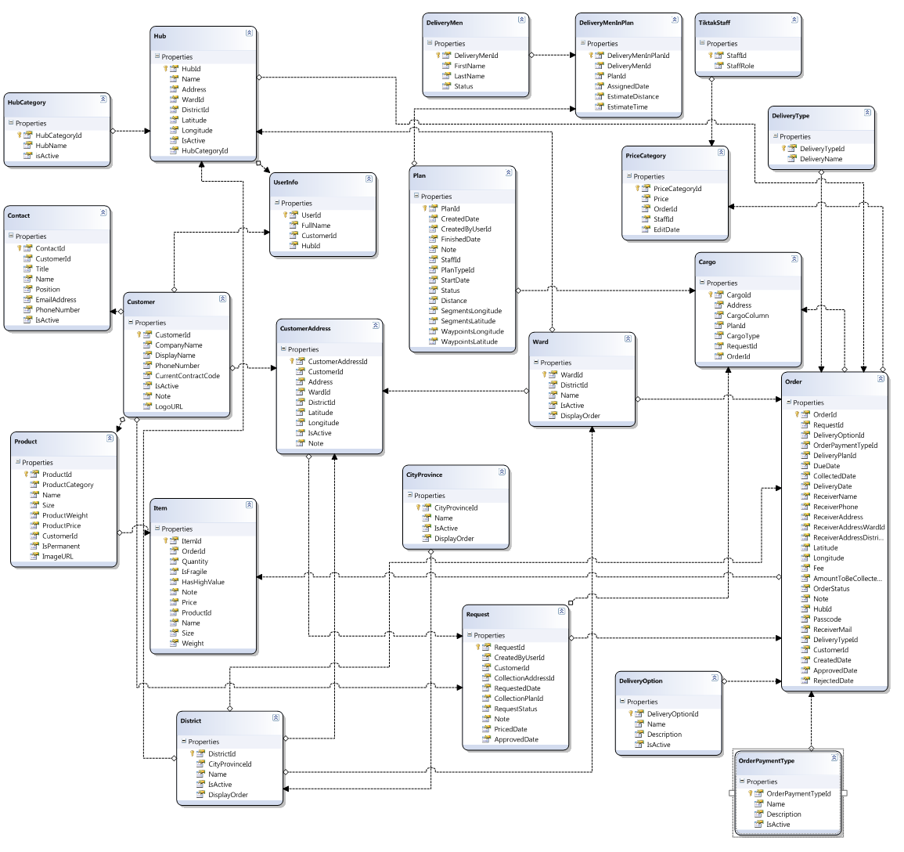

# State Diagrams

## Request State Diagram

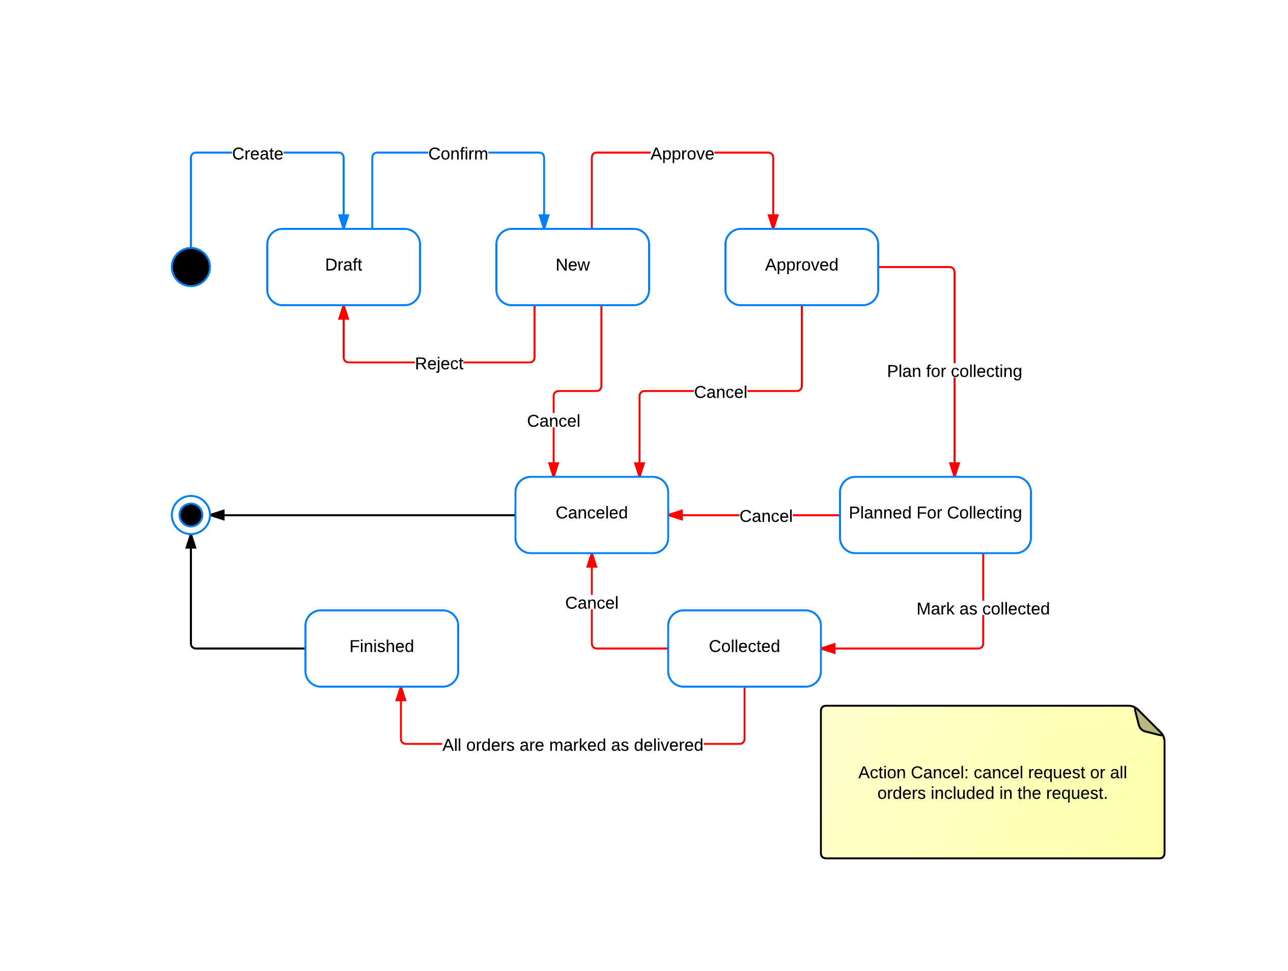

## Order State Diagram



# Algorithms