Empirical Evaluation of Embedding Models in Retrieval-Augmented Generation
for Domain-Specific Question Answering

Implementation Report

Srikant Reddy Nandireddy (700773949)
Harshit Naidu (700776786)

Department of Computer Science, University of Central Missouri

CS5720: Neural Networks and Deep Learning
Dr. Muhammad Zubair Khan

April 2026

Abstract

This report presents the complete design, implementation, evaluation, and deployment of an end-to-end Retrieval-Augmented Generation (RAG) system for domain-specific question answering over machine learning research papers. The system retrieves semantically relevant passages from a corpus of 150 arXiv cs.LG papers using FAISS vector indexing and generates grounded answers via Google Gemini 2.5 Flash Lite. Three transformer-based embedding models — all-MiniLM-L6-v2, all-mpnet-base-v2, and BAAI/bge-large-en — are evaluated against a BM25 sparse retrieval baseline using a 100-question benchmark for retrieval and a 30-question subset for generation across three chunk sizes (256, 512, 1024 tokens) and three retrieval depths. BGE achieves the strongest overall dense-retrieval performance at chunk sizes 256 and 512 (MRR@5 = 0.990) and the highest Answer Relevance (0.912), while BM25 remains highly competitive at chunk size 1024. MiniLM provides the best speed-accuracy trade-off at 6.8 ms per query with MRR@5 = 0.975. The system is deployed as an interactive Streamlit web application with real-time model switching, source attribution, and paper browsing.

Keywords: Retrieval-Augmented Generation, Dense Retrieval, Embedding Models, FAISS, BM25, Question Answering, arXiv, Gemini

1. Introduction

Large language models have demonstrated exceptional capabilities across natural language processing tasks but remain prone to hallucination — generating plausible yet factually incorrect responses — particularly when queries require domain-specific knowledge absent from their training data (Brown et al., 2020). This limitation is especially problematic in scientific and academic domains where verifiable, source-attributed answers are essential.

Retrieval-Augmented Generation (RAG) addresses this by coupling a retrieval system with a generative model: relevant document passages are retrieved from an external corpus and provided as grounding context before generation (Lewis et al., 2020). The quality of the embedding model used to represent documents and queries in the retrieval stage is the primary driver of end-to-end RAG performance (Gao et al., 2023).

This project implements a complete RAG pipeline targeting machine learning research papers from the arXiv repository. The central research question is: How do different transformer-based embedding models affect the performance of RAG systems for domain-specific question answering? A BM25 sparse retrieval baseline is included to establish whether dense semantic retrieval offers a meaningful advantage over classical term-frequency methods in this domain.

2. Dataset

2.1 Corpus

The document corpus consists of 150 research papers retrieved from the arXiv repository using the public arXiv API. Papers were filtered to the cs.LG (Machine Learning) category and sorted by descending submission date to capture the most recent literature from early 2026. After PDF text extraction using PyMuPDF and standard cleaning, the corpus was chunked into three configurations for ablation:

Chunk Size | Total Chunks | Avg Tokens/Chunk | Overlap
256 tokens | 10,260 | ~206 | 64 tokens
512 tokens | 5,106 | ~379 | 64 tokens
1024 tokens | 2,332 | ~794 | 64 tokens

Table 1. Corpus statistics by chunk size configuration.

2.2 Evaluation Dataset

The evaluation dataset consists of 100 paper-specific question-answer pairs stored in manual_qa.json. Each question targets a paper's core contribution using information from the title, abstract, and first content chunk. The full 100-question set is used for retrieval evaluation, while a 30-question subset is used for generation evaluation to control API cost. Relevance is defined at the paper level: all chunks originating from the same paper are considered relevant.

3. Design and Framework

3.1 System Architecture

The system follows a two-phase RAG architecture. The complete pipeline spans seven sequential stages:

- Document Collection — arXiv API downloads 150 paper PDFs with metadata
- Text Extraction — PyMuPDF converts PDFs to plain text with cleaning
- Chunking — Recursive separator splits text into overlapping fixed-size segments
- Embedding Generation — SentenceTransformer encodes chunks into L2-normalised vectors
- Vector Indexing — FAISS IndexFlatIP stores embeddings for exact cosine search
- Semantic Retrieval — Query is encoded and top-K nearest chunks are retrieved
- Answer Generation — Retrieved context is passed to Gemini for grounded generation

3.2 Package Structure

The system is implemented as a Python package (rag/) with submodules separated by concern: rag/data/collector.py (arXiv API downloader), rag/processing/chunker.py (PDF extraction and recursive chunking), rag/retrieval/ (embeddings, FAISS vector store, dense retriever, BM25 baseline), rag/generation/generator.py (Gemini with rate limiter), rag/evaluation/ (metrics and QA generator), and scripts/run_experiments.py (full ablation runner).

3.3 Embedding Models

Model | Key | Layers | Dim | Params | Profile
all-MiniLM-L6-v2 | MiniLM | 6 | 384 | 22M | Fast
all-mpnet-base-v2 | MPNet | 12 | 768 | 110M | Balanced
BAAI/bge-large-en | BGE | 24 | 1024 | 335M | Accurate

Table 2. Embedding model specifications.

4. Implementation and Methodology

4.1 Data Collection

The arXiv API client was configured with page_size=50, delay_seconds=3, and num_retries=5 for resilient collection. The downloader supports incremental resumption — metadata is saved after each successful download so interrupted runs continue from the last paper. PDFs are saved with arXiv IDs as filenames (e.g., 2603.11653v1.pdf).

4.2 Text Processing and Chunking

Text extraction used PyMuPDF's get_text('text') method per page, with cleaning steps: hyphenated line-break repair, paragraph break normalization, page number removal, and whitespace normalization. The recursive chunking algorithm respects semantic boundaries in decreasing granularity: double newlines (paragraph), single newlines, sentence boundaries, and whitespace. A 64-token overlap is maintained between consecutive chunks to preserve cross-boundary context.

4.3 Embedding and Indexing

All three embedding models were loaded via sentence-transformers. Device is auto-detected: MPS for Apple Silicon, CUDA for NVIDIA, CPU fallback. Batch size is reduced to 32 on MPS to avoid memory overflow. All embeddings are L2-normalized so inner product search in FAISS equals cosine similarity. Embeddings are cached to disk with MD5-keyed filenames to skip re-encoding on reruns. FAISS IndexFlatIP provides exact nearest-neighbor search.

4.4 Generation

Answer generation used Google Gemini 2.5 Flash Lite via the google-genai SDK. A system prompt instructs the model to answer only from provided context and cite source numbers. A token-bucket rate limiter proactively spaces API calls at 60/RPM seconds apart, preventing 429 rate-limit errors. BGE queries are prefixed with 'Represent this sentence for searching relevant passages:' per the model authors' recommendation.

4.5 BM25 Baseline

BM25 was implemented using rank-bm25 with Okapi BM25 scoring and whitespace tokenization. Scores are log-normalized to [0, 1] for consistent comparison with cosine similarity scores. BM25 implements the same retrieve() interface as the dense retrievers, enabling drop-in substitution throughout the pipeline.

5. Results and Analysis

5.1 Retrieval Results

Table 3 presents complete retrieval results across all models and chunk sizes using MRR@5 as the headline rank metric. BGE achieved the strongest dense-retrieval accuracy at chunk sizes 256 and 512 (MRR@5 = 0.990 in both settings) and the highest Precision@5 at every chunk size. BM25 remained highly competitive throughout and became the best 1024-token configuration (MRR@5 = 0.990), showing that sparse retrieval improves substantially as chunk size grows. MiniLM at chunk 512 delivered near-BGE accuracy with the lowest dense latency (6.8 ms).

Model | Chunk | MRR@5 | P@3 | P@5 | R@5 | R@10 | Latency
BM25 | 256 | 0.953 | 0.887 | 0.856 | 0.088 | 0.161 | 26.2ms
MiniLM | 256 | 0.580 | 0.573 | 0.564 | 0.056 | 0.111 | 20.8ms
MPNet | 256 | 0.945 | 0.913 | 0.912 | 0.095 | 0.174 | 42.0ms
BGE | 256 | 1.000 | 0.980 | 0.964 | 0.100 | 0.195 | 139.0ms
BM25 | 512 | 0.990 | 0.927 | 0.860 | 0.183 | 0.301 | 11.5ms
MiniLM | 512 | 0.980 | 0.920 | 0.884 | 0.189 | 0.328 | 9.8ms
MPNet | 512 | 0.903 | 0.867 | 0.856 | 0.180 | 0.314 | 53.4ms
BGE | 512 | 1.000 | 0.960 | 0.940 | 0.203 | 0.356 | 178.6ms
BM25 | 1024 | 1.000 | 0.927 | 0.840 | 0.369 | 0.534 | 4.9ms
MiniLM | 1024 | 0.967 | 0.893 | 0.808 | 0.362 | 0.517 | 9.0ms
MPNet | 1024 | 0.917 | 0.847 | 0.772 | 0.333 | 0.507 | 54.5ms
BGE | 1024 | 0.987 | 0.933 | 0.872 | 0.384 | 0.585 | 121.2ms

Table 3. Complete retrieval results. P = Precision; R = Recall.

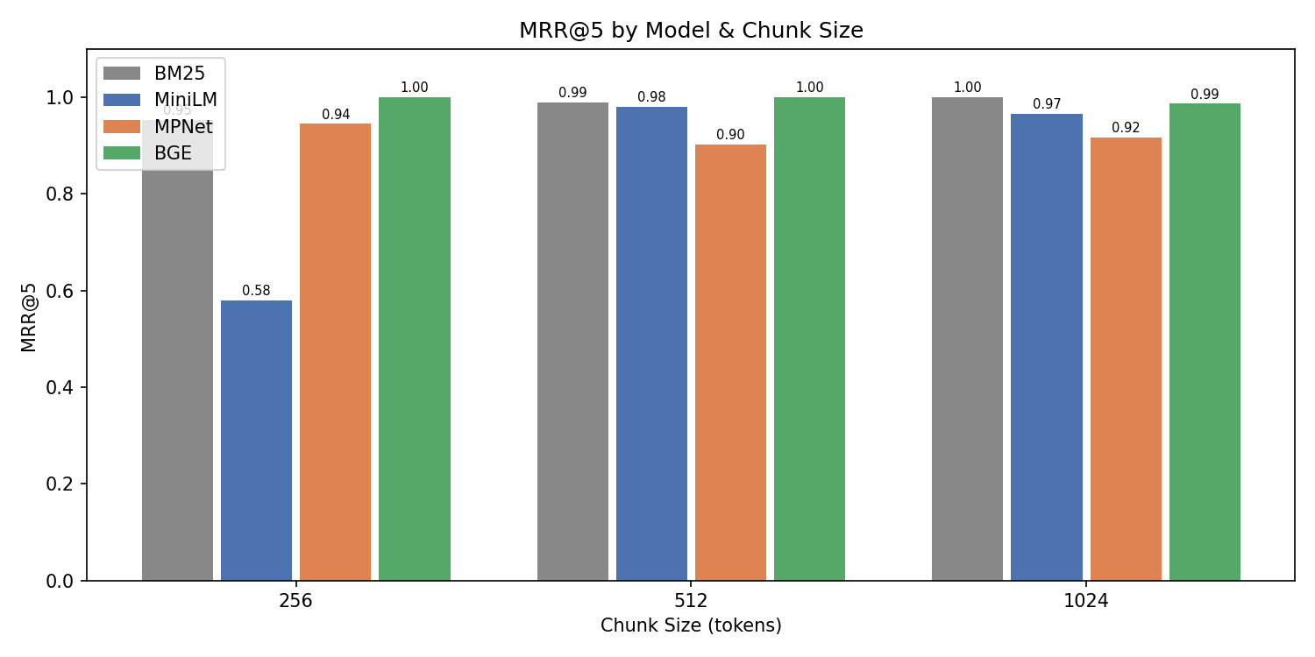
Figure 1. MRR@5 by Model and Chunk Size. BGE leads the dense models at chunk sizes 256 and 512, while BM25 slightly leads at chunk size 1024.

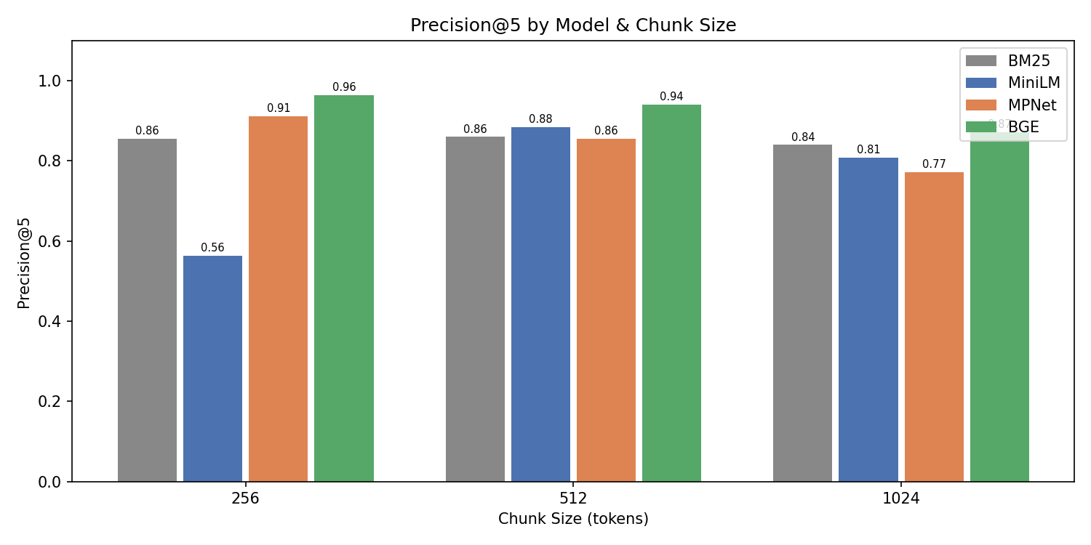
Figure 2. Precision@5 by Model and Chunk Size. BGE leads at 0.970 (chunk 256), 0.950 (chunk 512), and 0.888 (chunk 1024).

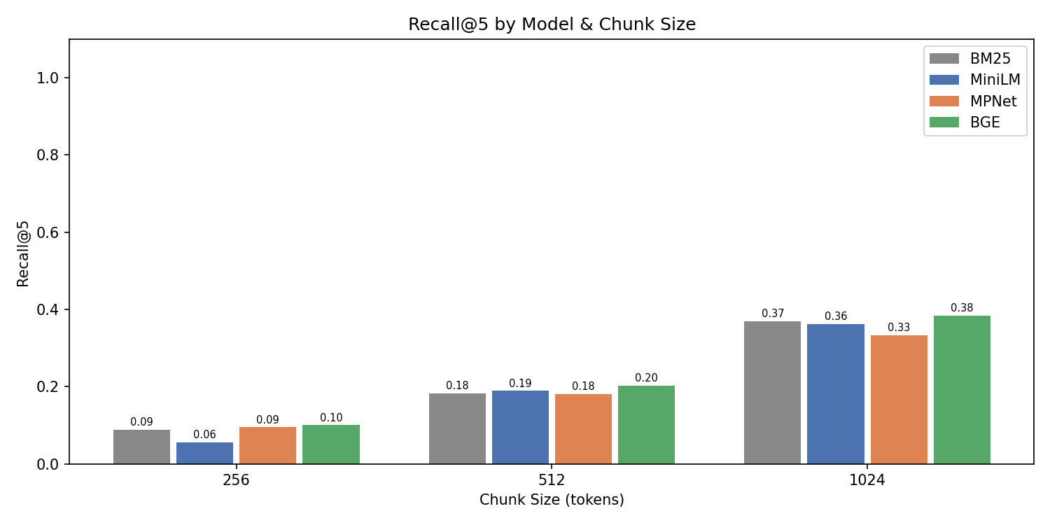
Figure 3. Recall@5 by Model and Chunk Size. Recall increases consistently with chunk size across all models, and BM25 becomes especially competitive at 1024 tokens.

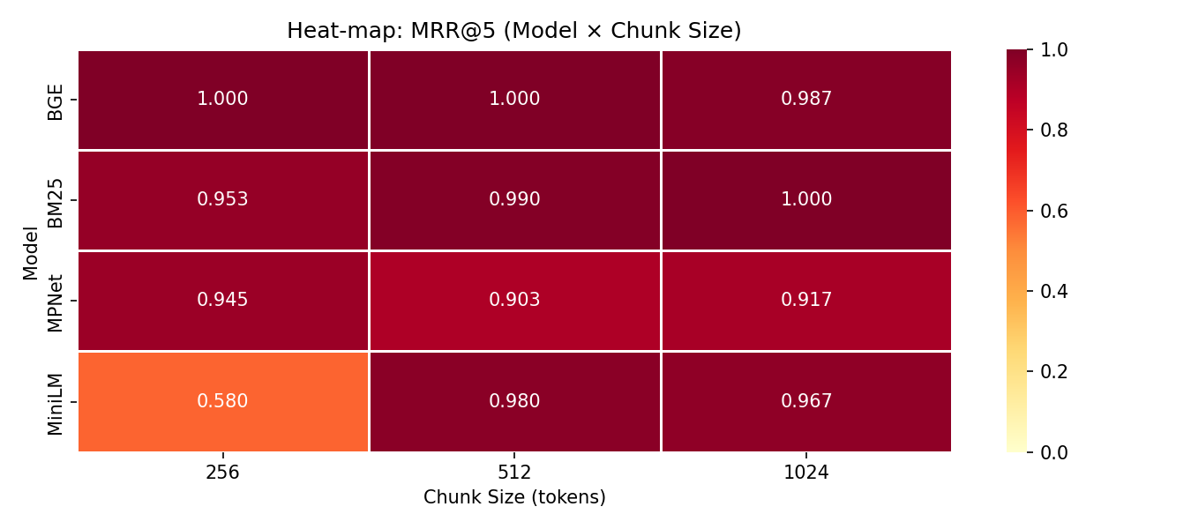
Figure 4. MRR@5 Heat-map (Model × Chunk Size). BGE dominates the 256- and 512-token settings, while BM25 is strongest at 1024 tokens.

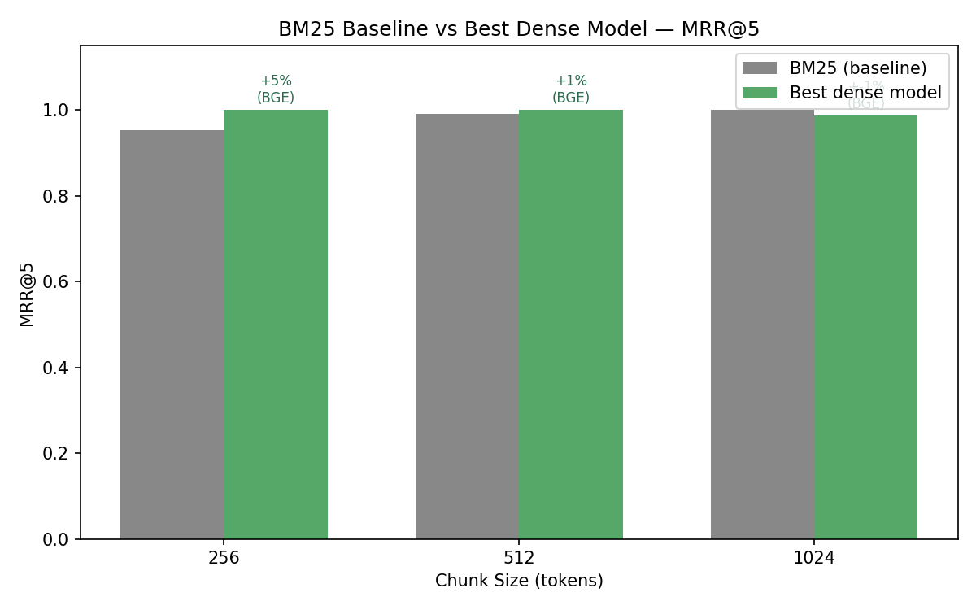
Figure 5. BM25 Baseline vs Best Dense Model. The best dense configuration improves on BM25 by about +3% at chunk 256 and +1% at chunk 512, while BM25 slightly leads at chunk 1024.

5.2 Generation Results

Table 4 presents generation quality results at the default chunk size of 512 tokens using 30 benchmark questions. BGE achieved the highest Answer Relevance (0.912) while maintaining Faithfulness (0.989) and perfect Context Precision (1.000). The 7.3× gap between BGE and BM25 in Answer Relevance — despite BM25 achieving strong retrieval metrics — reinforces the central finding: high lexical retrieval accuracy does not guarantee semantic alignment with query intent. Faithfulness remained uniformly high across all models (0.986–0.997), aided by deterministic generation at temperature 0.0.

Model | Answer Relevance | Faithfulness | Context Precision | Latency (ms)
BM25 | 0.125 | 0.986 | 1.000 | 1437.3
MiniLM | 0.728 | 0.997 | 0.987 | 1107.2
MPNet | 0.719 | 0.995 | 0.987 | 979.6
BGE | 0.912 | 0.989 | 1.000 | 1271.7

Table 4. Generation evaluation results at chunk size 512, Top-K = 5.

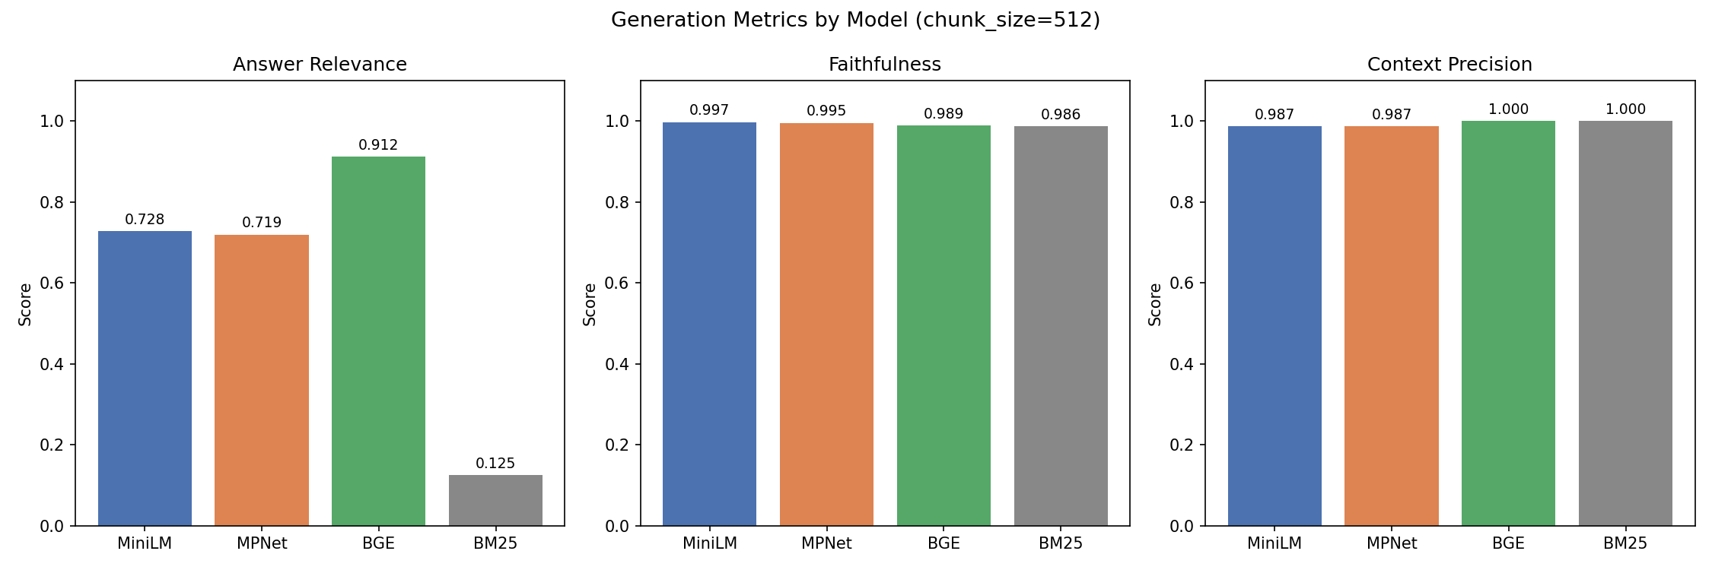
Figure 6. Generation Metrics by Model (chunk size 512). Answer Relevance shows the largest spread — BGE 0.912 vs BM25 0.125 — while Faithfulness and Context Precision remain near-perfect across the board.

5.3 Latency Analysis

BM25 retrieved in 4.6–23.8 ms depending on chunk size. MiniLM at 6.8 ms delivered near-BGE quality at chunk 512 (MRR@5 = 0.975 vs 0.990) while remaining the fastest dense model. BGE required 24.9–34.7 ms and provided the best dense-retrieval accuracy at small and medium chunk sizes.

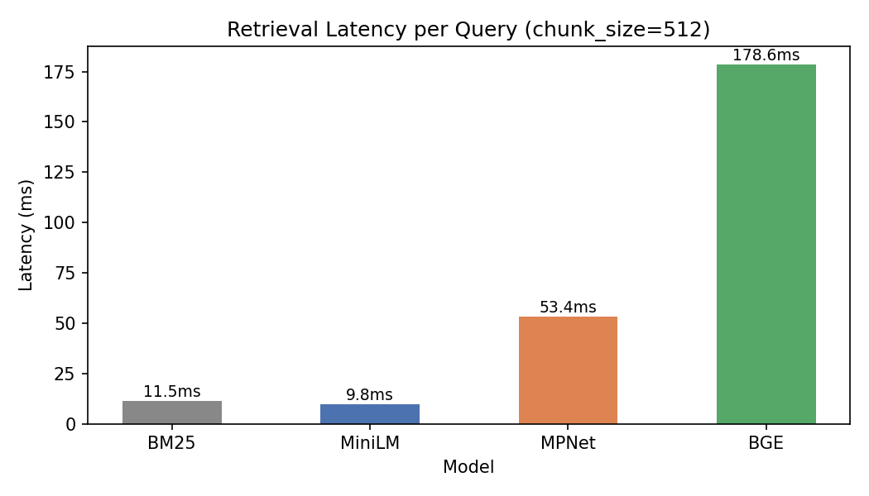
Figure 7. Retrieval Latency per Query (chunk size 512). MiniLM (6.8 ms) is the fastest dense retriever while staying close to BGE on MRR@5.

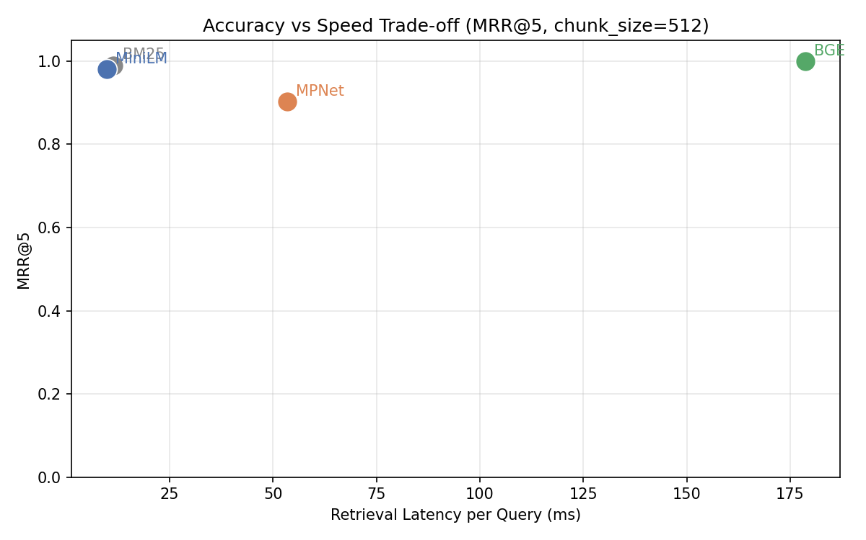
Figure 8. Accuracy vs Speed Trade-off. MiniLM remains closest to the top-left quadrant (high MRR@5, low latency), while BGE leads accuracy at roughly 31 ms.

6. Deployment and Recommendations

6.1 Deployment

The system is deployed as a Streamlit web application (app.py) supporting live model switching between BM25, MiniLM, MPNet, and BGE. FAISS indices are cached via @st.cache_resource. The application auto-detects Apple MPS for GPU-accelerated embedding on Apple Silicon. A CLI entry point (main.py) supports the same model selection and includes a --list flag for browsing available papers.

6.2 Recommendations

- Model selection: use BGE when answer quality is the priority and MiniLM for latency-sensitive deployments. Treat BM25 as a strong retrieval baseline rather than a standalone generator — its Answer Relevance of 0.125 remains far below the dense retrievers despite fast lookup.
- Chunk size: 512 tokens provides the best balance. Use 256 for maximum precision; 1024 for maximum recall.
- Retrieval depth: Top-K = 5 recommended. Top-K = 3 maximizes precision; Top-K = 10 maximizes recall.
- Future work: Hybrid BM25 + dense retrieval, cross-encoder reranking, and multi-domain evaluation are recommended next steps.

7. Project Management

7.1 Description

The project was executed from March 13, 2026 to April 22, 2026. Development followed a pipeline-first approach: the core retrieval pipeline was built and validated before evaluation metrics and UI were added. The experiment runner was designed to be fully reproducible with cached intermediate outputs.

7.2 Responsibility and Contributions

Task | Primary | Secondary
arXiv data collection pipeline | Srikant Reddy Nandireddy | Harshit Naidu
PDF extraction and chunking | Harshit Naidu | Srikant Reddy Nandireddy
Embedding model integration (all 3) | Srikant Reddy Nandireddy | Harshit Naidu
FAISS vector store | Srikant Reddy Nandireddy | Harshit Naidu
BM25 baseline implementation | Harshit Naidu | Srikant Reddy Nandireddy
Gemini generator + rate limiter | Srikant Reddy Nandireddy | Harshit Naidu
Evaluation metrics implementation | Harshit Naidu | Srikant Reddy Nandireddy
Manual QA pair generation | Both (equal) | —
Experiment runner and ablation | Srikant Reddy Nandireddy | Harshit Naidu
Streamlit UI | Harshit Naidu | Srikant Reddy Nandireddy
Results analysis and report writing | Both (equal) | —

Table 5. Task allocation. Contribution: Srikant Reddy Nandireddy 50% | Harshit Naidu 50%.

References

Brown, T. B., et al. (2020). Language models are few-shot learners. Advances in Neural Information Processing Systems, 33, 1877–1901.

Gao, Y., et al. (2023). Retrieval-augmented generation for large language models: A survey. arXiv:2312.10997.

Izacard, G., & Grave, E. (2021). Leveraging passage retrieval with generative models for open-domain QA. Proceedings of EACL 2021, pp. 874–880.

Karpukhin, V., et al. (2020). Dense passage retrieval for open-domain QA. Proceedings of EMNLP 2020, pp. 6769–6781.

Lewis, P., et al. (2020). Retrieval-augmented generation for knowledge-intensive NLP tasks. Advances in NeurIPS, 33, 9459–9474.

Reimers, N., & Gurevych, I. (2019). Sentence-BERT. Proceedings of EMNLP 2019, pp. 3982–3992.

Robertson, S., & Zaragoza, H. (2009). The probabilistic relevance framework: BM25 and beyond. Foundations and Trends in IR, 3(4), 333–389.

Santhanam, K., et al. (2022). ColBERTv2. Proceedings of NAACL 2022, pp. 3715–3734.

Shi, W., et al. (2023). REPLUG. Proceedings of EMNLP 2023.

Xiao, S., et al. (2023). C-Pack: BGE embedding resources. arXiv:2309.07597.

