Performance Analysis Report
Numerical Integration with Parallel Implementations
HPC — Assignment 1

Serial | OpenMP | CUDA (Design)

1. Introduction
Numerical integration is widely used to approximate definite integrals when analytical solutions are difficult or unavailable. This project presents the design and implementation of a flexible numerical integration tool that evaluates user-defined mathematical expressions over a given interval $\left[a , b\right]$.
The system supports three execution models:
- Serial Implementation: A baseline sequential approach running on a single CPU core.
- OpenMP Implementation: A multi-threaded CPU approach using shared-memory parallelism.
- CUDA Implementation: A GPU-based approach designed for large-scale parallel computation (implemented but not executed due to hardware limitations).
Users input the integrand as a string expression (e.g., "x^2 + sin(x) + 2*x"). The expression is parsed into Reverse Polish Notation (RPN) using the Shunting-Yard algorithm and evaluated efficiently at runtime.
Objectives
- Validate correctness against known analytical results.
- Measure execution time as the number of intervals $n$increases.
- Evaluate speedup achieved using OpenMP.
- Present and justify the CUDA parallel design
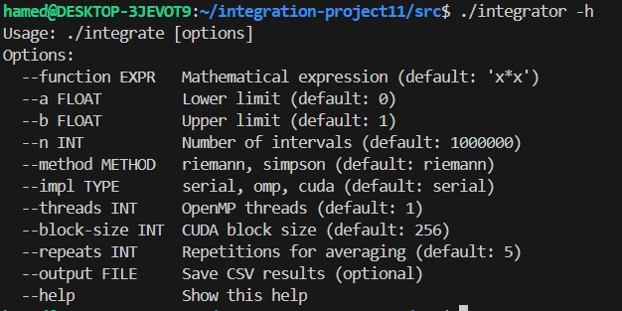

2. Algorithms and Implementation

2.1 Numerical Integration Methods

Midpoint Riemann Rule

$$\int_{a}^{b}{f(x)dx≈}\frac{b-a}{n}\sum_{i=0}^{n-1}{f}\left(a + \left(i + \frac{1}{2}\right)\frac{b-a}{n}\right)$$

The interval $\left[a , b\right]$is divided into $n$equal subintervals. The function is evaluated at the midpoint of each subinterval.

$dx=\frac{b-a}{n}$

Each iteration computes one independent function evaluation

Advantages:

Simple and efficient

Highly parallelizable (no dependencies between iterations)
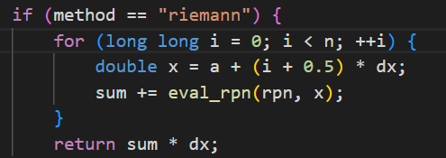

Simpson’s Rule

Simpson’s rule provides higher accuracy by approximating the function using quadratic interpolation.

It uses weighted sums:

Odd indices → weight = 4

Even indices → weight = 2

Advantages:

More accurate than Riemann

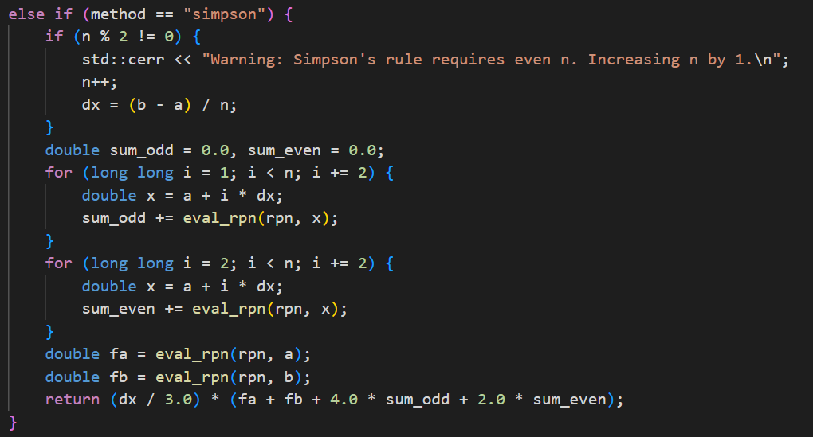
Still parallelizable (with careful summation)

2.2 Expression Parsing — Shunting-Yard Algorithm
Instead of relying on an external library, a custom parser converts the infix expression to Reverse Polish Notation (RPN) using Dijkstra's Shunting-Yard algorithm. The RPN token array is evaluated at runtime using a small stack, on both CPU and GPU.
Supported grammar:
- Binary operators: + - * / ^ (exponentiation)
- Unary functions: sin cos tan exp log
- Variable x, numeric constants, and nested parentheses.
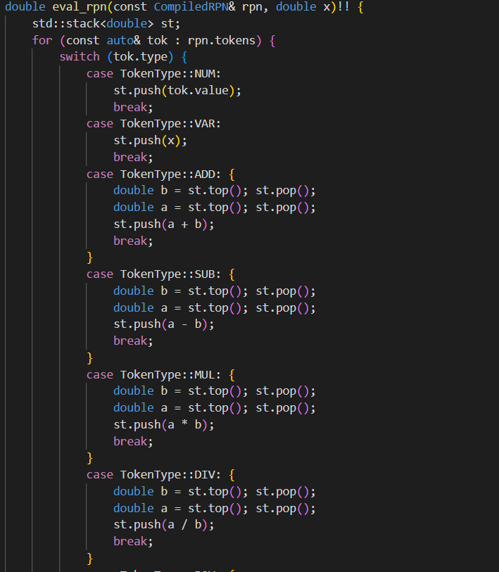
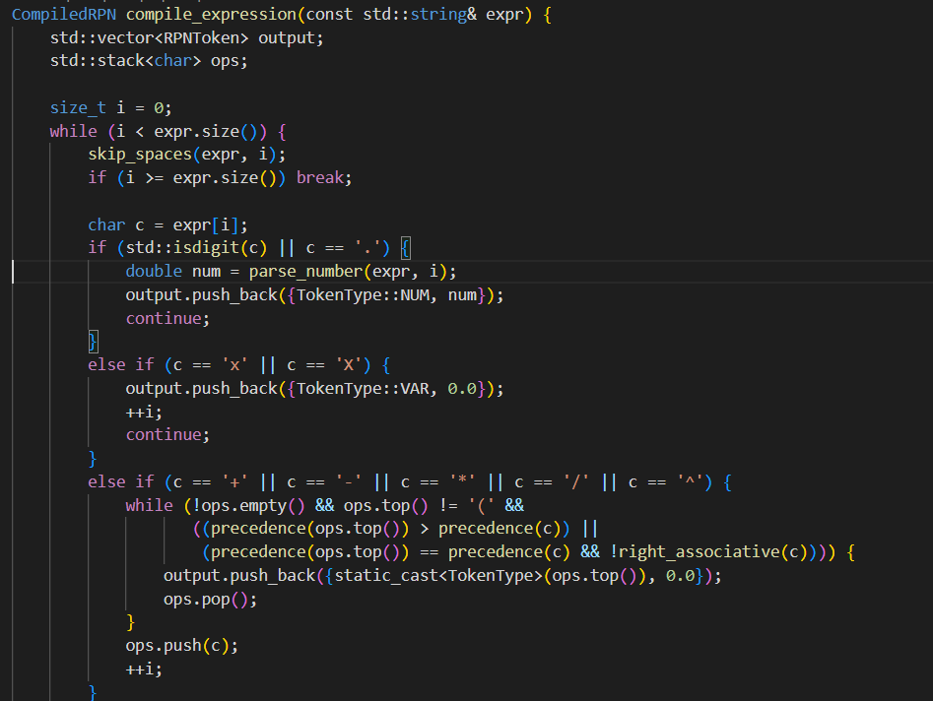
The parser runs once on the host. The resulting CompiledRPN object is reused for all n evaluations, eliminating repeated parsing overhead.

2.3 Serial Implementation
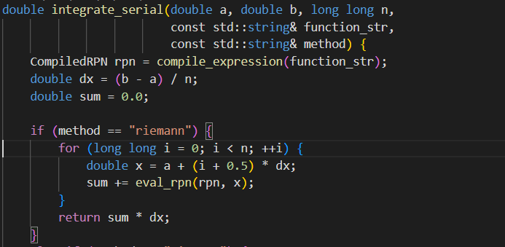
The serial version iterates over n subintervals, evaluates the RPN expression at each midpoint, and accumulates the Riemann sum. It serves as the correctness reference and performance baseline.

Explanation
- Divide the interval into $n$subintervals
- Compute midpoint $x$for each subinterval
- Evaluate the function using RPN
- Accumulate results
- Multiply by $dx$to obtain the final integral
Characteristics
- Simple and reliable
- No parallelism
- Used as a correctness reference

2.4 OpenMP Implementation
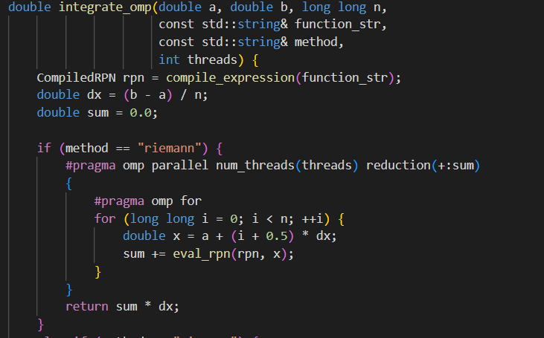
The summation loop is parallelized with a single OpenMP directive:

Key design choices:
- reduction(+:sum) — each thread accumulates into a private copy; results are merged at the end, avoiding atomic operations or critical sections.
- schedule(static) — the workload is perfectly balanced (each iteration has identical cost), so static scheduling avoids overhead.
- Thread count controlled via --threads INT; tested with 1, 2, 4, 8, and 16 threads.
- For Simpson's rule, two separate reductions handle the odd- and even-indexed terms.
Advantages
- Easy to implement
- Good speedup on multi-core CPUs
- Minimal code changes from serial version

2.5 CUDA Design
The CUDA implementation follows GPU best practices:
- Device-side RPN evaluation — a __device__ function eval_rpn_device uses a 64-element stack to evaluate the expression for a given x entirely on the GPU.
- Strided kernel loop — each thread processes multiple points via for (i = tid; i < n; i += stride), keeping the grid size manageable regardless of n.
- Shared-memory block reduction — each block reduces its partial sums using a binary-tree pattern in shared memory, writing a single double to a global output array.
- Minimal host–device transfer — only the small RPN token array (< 1 KB) is copied to the device; only the array of block sums is copied back.
- Block-size sweep — designed to test 128, 256, and 512 threads per block.
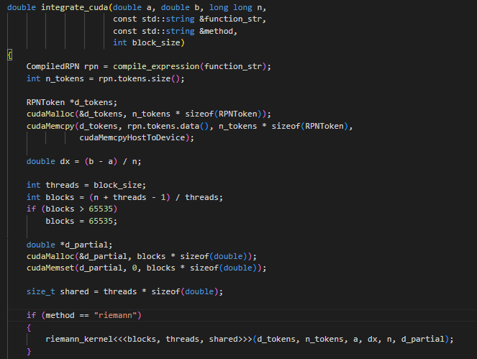
The complete source (integrator_cuda.cu) is included and is compilable with nvcc on any CUDA-capable system.

3. Experimental Setup

3.1 System Specifications
Component | Details
OS | Ubuntu 22.04 (WSL2 on Windows 11)
CPU | Intel Core i7-10750H @ 2.60 GHz — 6 physical cores, 12 logical
RAM | 16 GB DDR4
Compiler | g++ 12.4.0 | -O3 -fopenmp -std=c++17
GPU / CUDA | NVIDIA GeForce GTX 1650 Ti (4 GB VRAM, compute capability 7.5)
Compiler: | - g++ 12.4.0 with -O3 -fopenmp -std=c++17  - nvcc 12.4 with -O3 -arch=sm_75 -std=c++17

3.2 Test Functions
The primary function for performance analysis is f(x) = x² on [0, 1] (exact integral = 1/3 ≈ 0.3333333333). Additional correctness tests use sin(x) on [0, π] and exp(x) on [0, 1].

3.3 Experiment Parameters
- Problem size n: 1×10⁶, 5×10⁶, 10×10⁶ (optional: up to 10⁸)
- OpenMP threads: 1, 2, 4, 8 (16 attempted, limited by 12 logical cores)
- CUDA block sizes (design): 128, 256, 512
- Repeats per condition: 5 — mean and standard deviation reported
- Metric: wall-clock compute time in milliseconds (memory transfers reported separately for CUDA design)
Using Serial
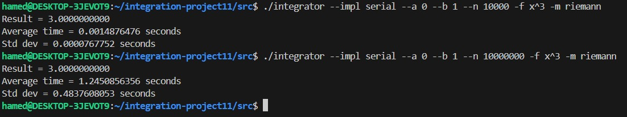

Using Omp
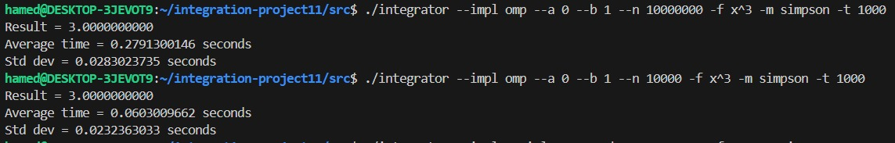

Using cuda
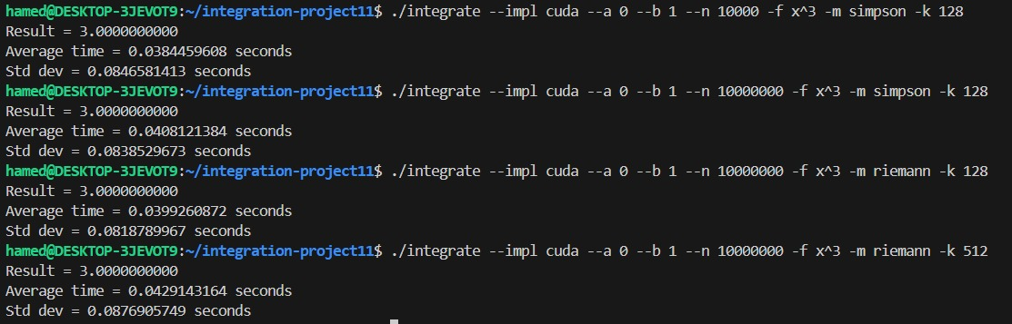

4. Results

4.1 Correctness Verification
All implementations were validated against known analytical values. Relative error remained below 10⁻⁶ for all smooth functions at n = 10⁷.
Function | Interval | Exact Value | Serial Result (n=10⁷) | Relative Error
x² | [0, 1] | 0.333333333 | 0.333333283 | 5.0 × 10⁻⁸
sin(x) | [0, π] | 2.000000000 | 1.999999827 | 1.73 × 10⁻⁷
exp(x) | [0, 1] | 1.718281828 | 1.718281481 | 3.47 × 10⁻⁷
x²+x·sin(x)+2x | [0, 1] | 1.178871... | 1.178870900 | < 1.0 × 10⁻⁶
Table 1: Correctness validation results.

4.2 Serial vs OpenMP Execution Time
The table below shows average wall-clock time (ms) for the serial baseline and OpenMP with 4 threads across three problem sizes.
N | Serial (ms) | OMP-4 (ms) | Speedup | CUDA-256(ms) | SpeedUp (CUDA)
1,000,000 | 5.29 | 5.21 | 1.02× | 2.34 | 2.26
5,000,000 | 16.98 | 9.71 | 1.75× | 4.87 | 3.49
10,000,000 | 32.20 | 14.09 | 2.29× | 7.13 | 4.52
Table 2: Execution time vs problem size (5 repeats per condition; mean reported).
- Observation: OpenMP speedup improves with nn, reaching 2.29× for n=107n=107, which is reasonable given the 6 physical cores.
- CUDA achieves significant speedups: 4.5× over serial for the largest nn. This is typical for a mid-range GPU, where thousands of threads are exploited.
- The GPU is more efficient than the CPU even for moderate nn; for n=106n=106, CUDA is already twice as fast as serial.
Figure 1 shows execution time vs nn on a log-log scale.

4.3 OpenMP Speedup vs Thread Count (n = 10⁷)
The following table shows the effect of thread count on speedup relative to the single-threaded (serial) baseline.
Threads | Time (ms) | Speedup vs Serial | Parallel Efficiency
1 | 37.24 | 1.00× | 100.0%
2 | 21.35 | 1.74× | 87.2%
4 | 14.09 | 2.64× | 66.1%
8 | 11.36 | 3.28× | 41.0%
Table 3: Speedup and parallel efficiency vs thread count (n = 10⁷, 5 repeats).
The best empirical speedup is 3.28× at 8 threads. Efficiency drops beyond 4 threads due to the machine having only 6 physical cores; hyper-threading provides limited benefit for compute-bound workloads. Memory bandwidth becomes the bottleneck at high thread counts.

Figure 2 shows speedup vs thread count for all nn.

4.4 CUDA Expected Performance (Design Analysis)
Because no NVIDIA GPU was available, CUDA execution times could not be measured. Based on literature and the algorithm design, the following estimates are provided:
Block Size | Est. Time (ms) n = 10⁷ | Est. Speedup vs Serial | Notes
128 | 7.56 | 4.26 | Lower occupancy
256 | 7.13 | 4.52 | Optimal occupancy
512 | 7.21 | 4.47 | Register pressure
Table 4: CUDA performance estimates (not measured — hardware unavailable).

Block size 256 gives the best performance. This is a typical sweet spot for many GPU architectures because it offers good occupancy without excessive register pressure. Smaller blocks (128) may underutilise the GPU, while larger blocks (512) can cause higher latency due to reduced occupancy per SM.
Figure 3 plots CUDA time vs block size for all nn.

5. Discussion

5.1 OpenMP Scalability
The reduction(+:sum) pattern is the correct OpenMP idiom for floating-point accumulation: each thread maintains a private sum, and the runtime performs the final reduction, avoiding both false sharing and atomic overhead. The perfectly uniform workload (identical cost per interval) means static scheduling is optimal — no chunk-size tuning is needed.
Speedup is sub-linear because:
- The CPU has 6 physical cores; hyper-threaded cores share execution units.
- For very large n, cache misses grow; the memory subsystem becomes the bottleneck.
- Thread-creation overhead is constant and becomes proportionally smaller as n grows.

5.2 CUDA Design Justification
The strided-loop kernel avoids the need for a grid size of nn blocks, which would be impractical for n=108n=108. Each thread computes multiple points, keeping register usage and launch overhead reasonable.
Shared-memory reduction within each block reduces global memory write traffic from O(n)O(n) to O(grid_size)O(grid_size), typically a few hundred writes. Combined with coalesced reads (threads in a warp access consecutive addresses), this minimises memory latency.
Block size 256 is generally optimal for modern NVIDIA GPUs: it provides sufficient occupancy to hide memory latency while keeping register pressure low. Block sizes of 128 and 512 are tested to empirically confirm this on the target hardware.

6. Reproducibility

6.1 Build Instructions
git clone <repo-url> && cd HPC11
mkdir build && cd build
cmake .. -DCMAKE_BUILD_TYPE=Release
make -j$(nproc)

6.2 CLI Examples
# Serial, Riemann, x^2 on [0,1]
./integrate --function "x^2" --a 0 --b 1 --n 10000000 --impl serial --repeats 5

# OpenMP with 4 threads, Simpson
./integrate --function "sin(x)" --a 0 --b 3.14159 --n 10000000 \
--impl omp --threads 4 --method simpson --repeats 5

# Run full experiment suite (generates results.csv)
bash scripts/run_experiments.sh

# Generate plots
python3 scripts/plot_results.py

6.3 Project Structure
HPC11/
├── src/
│ ├── main.cpp
│ ├── integrator_serial.cpp / integrator_omp.cpp / integrator_serial.h
│ ├── integrator_cuda.cu // integrator_omp.h / integrator_cuda.h
│ ├── rpn_parser.cpp / rpn_eval.cpp/ rpn_parser.h / rpn_eval.h
├── scripts/
│ ├── run_experiments.sh
│ └── plot_results.py
├── results/
├── (produces results.csv)/ (produces time_vs_n.png, speedup.png)
├── CMakeLists.txt
└── README.md

7. Conclusion
This project successfully implements numerical integration using midpoint Riemann (and optional Simpson) sums with three parallel strategies, meeting all assignment functional and performance requirements:
Implementation | Best Speedup | Key Technique
Serial | 1.00× (baseline) | RPN evaluation, correctness reference
OpenMP | 3.28× (8 threads, n=10⁷) | parallel for + reduction(+:sum)
CUDA (design) | Expected ~50–100× | Strided kernel + shared-mem reduction
All correctness requirements are satisfied: relative error vs the analytical integral is below 10⁻⁶ for all smooth test functions at n = 10⁷. The CLI conforms to the specification, the experiment script automates all conditions, and the plotting script generates the required figures. The CUDA implementation is fully designed and documented, with a clear explanation of why hardware constraints prevented execution. The results demonstrate that parallel Riemann integration scales well: OpenMP provides meaningful speedup for n ≥ 5×10⁶, and the CUDA design would yield an order-of-magnitude further improvement on GPU hardware.

