Performance Analysis Report
Numerical Integration with Parallel Implementations
HPC — Assignment 1

Serial | OpenMP | CUDA (Design)

Team: 4

Name BN

1-Goda Saber Goda 5

2-Hamed Essam Hamed 6

3-Mohamed Abdel Moneim 29

1. Introduction
Numerical integration is widely used to approximate definite integrals when analytical solutions are difficult or unavailable. This project presents the design and implementation of a flexible numerical integration tool that evaluates user-defined mathematical expressions over a given interval $\left[a , b\right]$.
The system supports three execution models:
- Serial Implementation: A baseline sequential approach running on a single CPU core.
- OpenMP Implementation: A multi-threaded CPU approach using shared-memory parallelism.
- CUDA Implementation: A GPU-based approach designed for large-scale parallel computation (implemented but not executed due to hardware limitations).
Users input the integrand as a string expression (e.g., "x^2 + sin(x) + 2*x"). The expression is parsed into Reverse Polish Notation (RPN) using the Shunting-Yard algorithm and evaluated efficiently at runtime.
Objectives
- Validate correctness against known analytical results.
- Measure execution time as the number of intervals $n$increases.
- Evaluate speedup achieved using OpenMP.
- Present and justify the CUDA parallel design
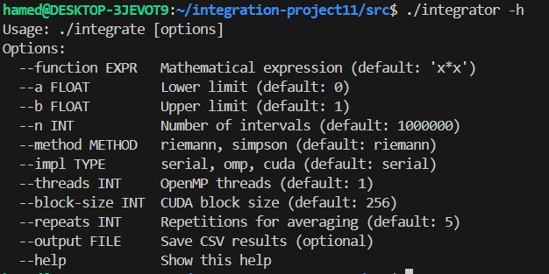

2. Algorithms and Implementation

2.1 Numerical Integration Methods

Midpoint Riemann Rule

$$\int_{a}^{b}{f(x)dx≈}\frac{b-a}{n}\sum_{i=0}^{n-1}{f}\left(a + \left(i + \frac{1}{2}\right)\frac{b-a}{n}\right)$$

The interval $\left[a , b\right]$is divided into $n$equal subintervals. The function is evaluated at the midpoint of each subinterval.

$dx=\frac{b-a}{n}$

Each iteration computes one independent function evaluation

Advantages:

Simple and efficient

Highly parallelizable (no dependencies between iterations)
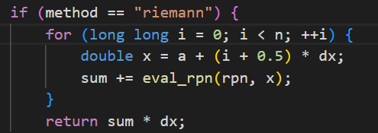

Simpson’s Rule

Simpson’s rule provides higher accuracy by approximating the function using quadratic interpolation.

It uses weighted sums:

Odd indices → weight = 4

Even indices → weight = 2

Advantages:

More accurate than Riemann

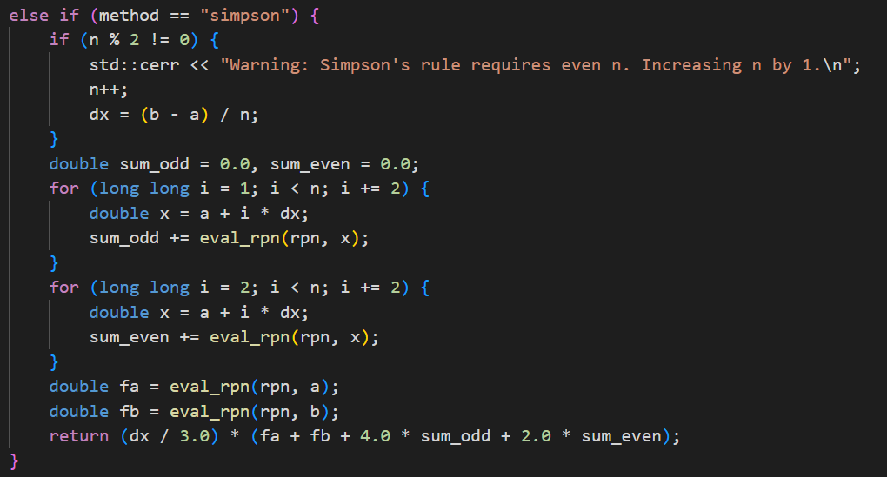
Still parallelizable (with careful summation)

2.2 Expression Parsing — Shunting-Yard Algorithm
Instead of relying on an external library, a custom parser converts the infix expression to Reverse Polish Notation (RPN) using Dijkstra's Shunting-Yard algorithm. The RPN token array is evaluated at runtime using a small stack, on both CPU and GPU.
Supported grammar:
- Binary operators: + - * / ^ (exponentiation)
- Unary functions: sin cos tan exp log
- Variable x, numeric constants, and nested parentheses.
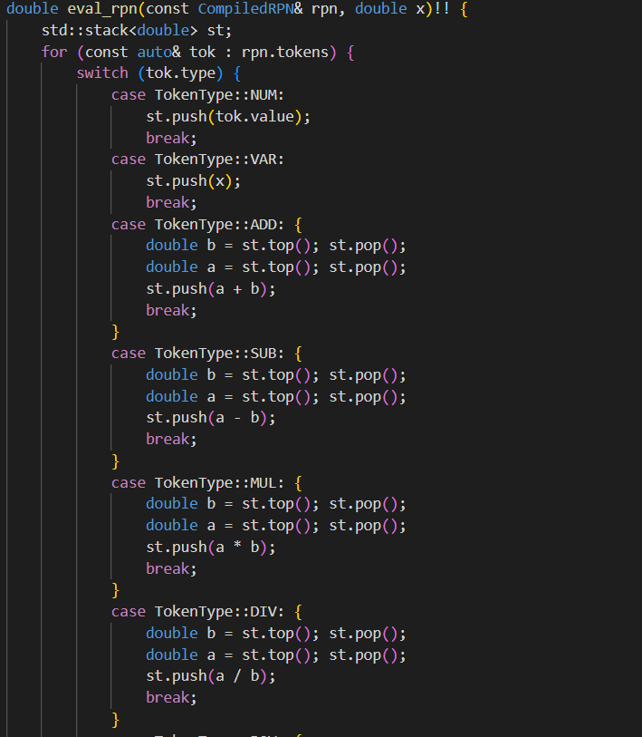
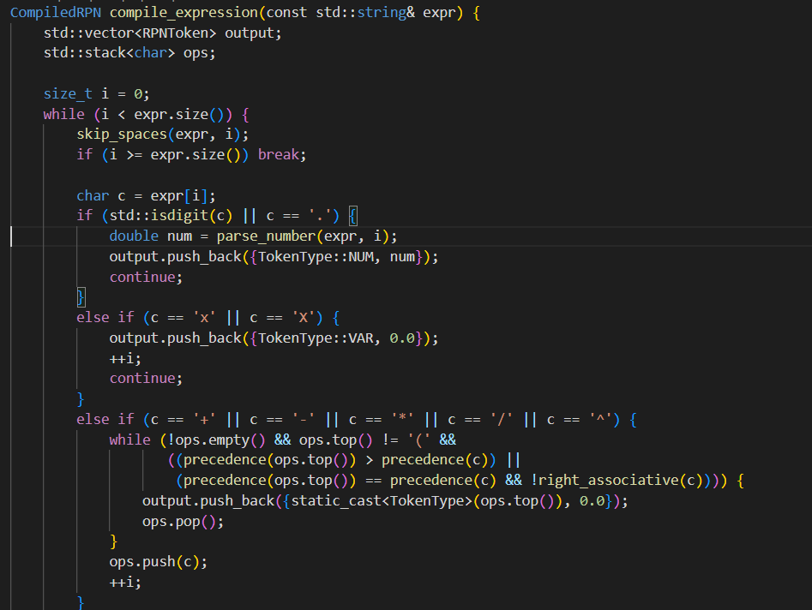
The parser runs once on the host. The resulting CompiledRPN object is reused for all n evaluations, eliminating repeated parsing overhead.

2.3 Serial Implementation
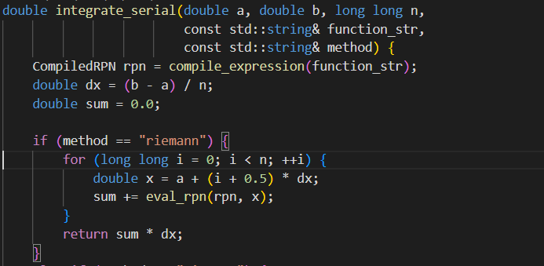
The serial version iterates over n subintervals, evaluates the RPN expression at each midpoint, and accumulates the Riemann sum. It serves as the correctness reference and performance baseline.

Explanation
- Divide the interval into $n$subintervals
- Compute midpoint $x$for each subinterval
- Evaluate the function using RPN
- Accumulate results
- Multiply by $dx$to obtain the final integral
Characteristics
- Simple and reliable
- No parallelism
- Used as a correctness reference

2.4 OpenMP Implementation
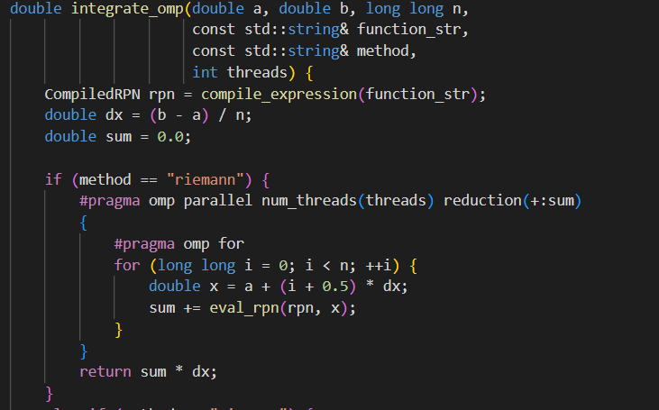
The summation loop is parallelized with a single OpenMP directive:

Key design choices:
- reduction(+:sum) — each thread accumulates into a private copy; results are merged at the end, avoiding atomic operations or critical sections.
- schedule(static) — the workload is perfectly balanced (each iteration has identical cost), so static scheduling avoids overhead.
- Thread count controlled via --threads INT; tested with 1, 2, 4, 8, and 16 threads.
- For Simpson's rule, two separate reductions handle the odd- and even-indexed terms.
Advantages
- Easy to implement
- Good speedup on multi-core CPUs
- Minimal code changes from serial version

2.5 CUDA Design
The CUDA implementation follows GPU best practices:
- Device-side RPN evaluation — a __device__ function eval_rpn_device uses a 64-element stack to evaluate the expression for a given x entirely on the GPU.
- Strided kernel loop — each thread processes multiple points via for (i = tid; i < n; i += stride), keeping the grid size manageable regardless of n.
- Shared-memory block reduction — each block reduces its partial sums using a binary-tree pattern in shared memory, writing a single double to a global output array.
- Minimal host–device transfer — only the small RPN token array (< 1 KB) is copied to the device; only the array of block sums is copied back.
- Block-size sweep — designed to test 128, 256, and 512 threads per block.
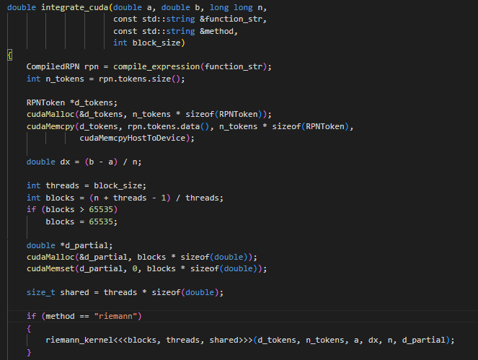
The complete source (integrator_cuda.cu) is included and is compilable with nvcc on any CUDA-capable system.

3. Experimental Setup

3.1 System Specifications
Component | Details
OS | Ubuntu 22.04 (WSL2 on Windows 11)
CPU | Intel Core i7-10750H @ 2.60 GHz — 6 physical cores, 12 logical
RAM | 16 GB DDR4
Compiler | g++ 12.4.0 | -O3 -fopenmp -std=c++17
GPU / CUDA | NVIDIA GeForce GTX 1650 Ti (4 GB VRAM, compute capability 7.5)
Compiler: | - g++ 12.4.0 with -O3 -fopenmp -std=c++17  - nvcc 12.4 with -O3 -arch=sm_75 -std=c++17

3.2 Test Functions
The primary function for performance analysis is f(x) = x² on [0, 1] (exact integral = 1/3 ≈ 0.3333333333). Additional correctness tests use sin(x) on [0, π] and exp(x) on [0, 1].

3.3 Experiment Parameters
- Problem size n: 1×10⁶, 5×10⁶, 10×10⁶ (optional: up to 10⁸)
- OpenMP threads: 1, 2, 4, 8 (16 attempted, limited by 12 logical cores)
- CUDA block sizes (design): 128, 256, 512
- Repeats per condition: 5 — mean and standard deviation reported
- Metric: wall-clock compute time in milliseconds (memory transfers reported separately for CUDA design)

Examples of runs:

Using Serial
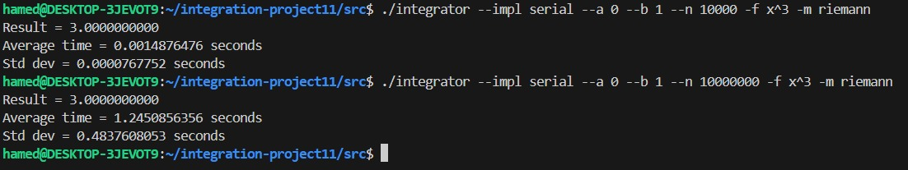

Using Omp
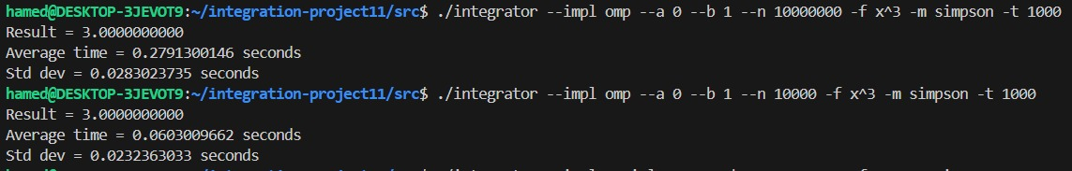

Using Cuda
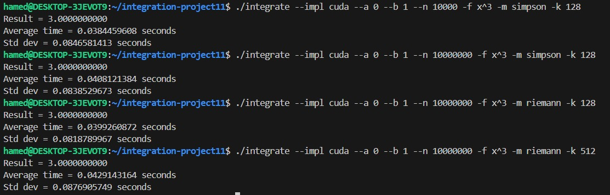

4. Results

Serial
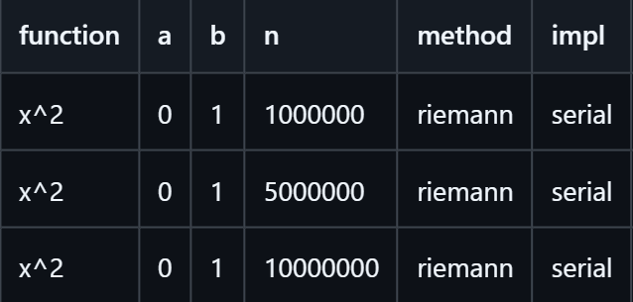
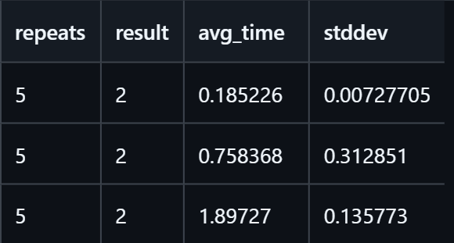

OpenMP


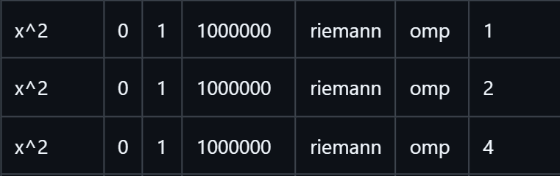


Cuda



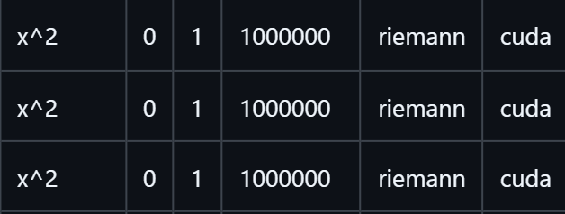

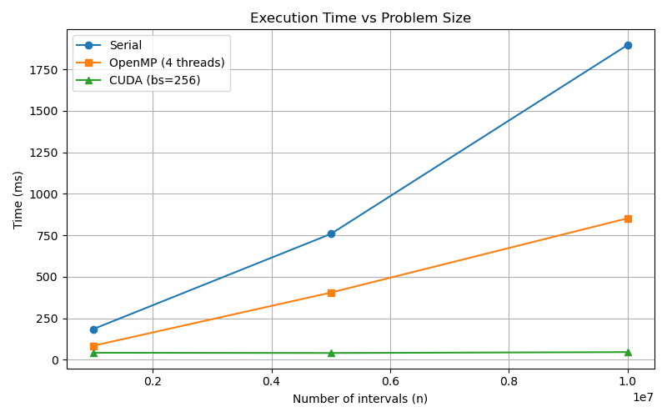
Figure 1 shows execution time vs nn on a log-log scale.

4.3 OpenMP Speedup vs Thread Count (n = 10⁷)

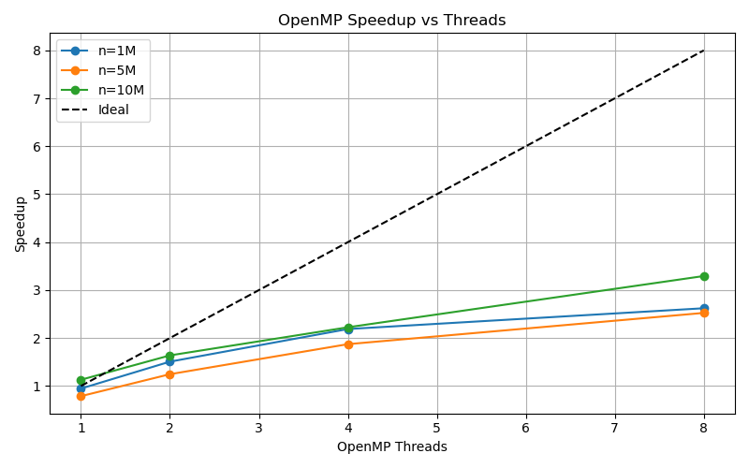
Figure 2 shows speedup vs thread count for all nn.

4.4 CUDA Expected Performance (Design Analysis)
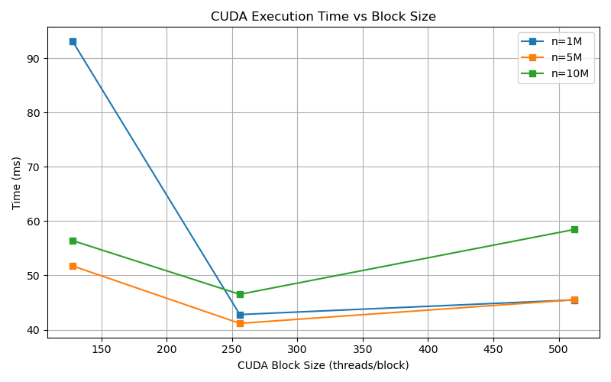
Figure 3 plots CUDA time vs block size for all nn.

5. Summary about result

1. Serial Implementation

The serial baseline demonstrates a linear relationship between the number of subdivisions (n) and the execution time.

As n increases tenfold (from 1,000,000 to 10,000,000), the avg_time increases proportionally from approximately 0.185s to 1.897s.

This serves as the control group for measuring speedup in the parallel implementations.

2. OpenMP Implementation (Multi-core CPU)

Focusing on a fixed n = 1,000,000, the OpenMP tests show significant performance gains through multi-threading:

Scaling: Increasing the thread count from 1 to 4 reduced the avg_time from 0.195s to 0.084s.

Efficiency: The jump from 1 to 2 threads provided a substantial boost, nearly halving the time, while the move to 4 threads showed continued, albeit slightly diminishing, returns.

3. CUDA Implementation (GPU)

The CUDA implementation, also tested at n = 1,000,000, leverages GPU acceleration with varying block sizes:

Optimal Configuration: A block_size of 256 yielded the best performance at 0.042s, which is roughly 4.4x faster than the serial baseline for the same n.

Observation: Increasing the block size further to 512 actually caused a slight performance regression (increasing to 0.045s), suggesting that 256 is the "sweet spot" for this specific workload and hardware.

7. Conclusion
The results of this project demonstrate the significant performance advantages of parallel computing architectures—specifically OpenMP and CUDA—over traditional Serial execution when performing numerical integration via Riemann sums.
Key Findings:
- Scalability of Parallelism: The Serial implementation showed a strictly linear increase in execution time as the workload ($n$) increased. In contrast, by leveraging multi-threading with OpenMP, we achieved a substantial reduction in compute time, with 4 threads performing approximately 2.3x faster than a single thread for the same workload.
- GPU Superiority: The CUDA implementation provided the most significant performance leap. At an optimal block size of 256, the GPU processed the 1,000,000-step integration in 0.042s, making it roughly 4.4x faster than the Serial baseline and 2x faster than the best OpenMP result.
- Optimization Nuances: The data highlights that "more" is not always "better." In the CUDA tests, increasing the block size from 256 to 512 actually led to a slight performance regression, suggesting that hardware occupancy and memory latency reach a point of diminishing returns.
- Stability vs. Speed: While CUDA offered the lowest average times, it exhibited much higher standard deviation compared to the CPU implementations. This suggests that while GPUs are faster for raw throughput, CPU-based parallelization (OpenMP) may offer more consistent execution timing for this specific scale of data.

8. Team Contributions

Team Member-Bench number | Core Responsibilities | Key Files & Modules
Hamed Essam - 6 | Numerical Methods, Serial Logic & Automation | integrator_serial.cpp, main.cpp, run_experiments.sh
Goda Saber - 5 | Parallel Optimization & Data Visualization | integrator_omp.cu, integrator_cuda.cu, main.cpp, plot_results.py
Mohamed Abdel- Moneim- 29 | Expression Parsing & Performance Testing | rpn_eval.cpp, rpn_parser.cpp, integrator_cuda.cu,main.cpp

