
UPI SENTINEL
An Explainable Multi-Agent System for Investigating
Suspicious UPI Transaction Networks and Potential Mule Accounts

CA-3 • Foundations of Agentic AI
Project report
October 2026

Submitted By:
Aditya Godar (24070126014)
Aditya Singh Sengar (24070126018)

Github Link:
https://github.com/Godar72/UPI-Sentinel

Purpose: demonstrate a reproducible, evidence-backed workflow that surfaces transaction patterns for investigation. A pattern is a lead for human review, not proof of fraud or mule-account activity.

1. Project overview
UPI Sentinel is a local academic proof of concept meant for analyzing potentially suspicious-looking transaction network patterns. It takes a CSV or a bundled synthetic fixture as an input, validates the records, constructs a directed account graph out of the passed rows, applies deterministic rules, and outputs the findings together with the transaction-level evidence. The Streamlit dashboard can be used to explore and inspect the results; an optional user-initiated local Ollama component can be used to rephrase a single finding’s evidence for the purposes of enhanced readability.
Attribute | Project definition
Domain | FinTech transaction monitoring and investigation triage, for payments systems similar to UPI.
Primary output | Explainable pattern findings and validations for a human investigator
Data | Small synthetic fixture; no real customer or bank data.
Detection | Deterministic validation, graph building, and configurable rules.
LLM role | Optional local explanation of selected existing evidence only, not detection

2. Problem statement and domain justification

Problem statement

Transaction investigators may have to piece together hundreds of records by sender, receiver, value, and time. Examination of individual rows could miss rapid relays or multiple senders consolidating at an intermediary and moving on. The project poses the question: can a compact, transparent process organize the data, recognize patterns that may have been programmed into the network, and retain enough detail on the reasoning behind each association for a human investigator to understand what may be of interest?

FinTech domain justification
Payments made digitally produce events that affect more than one account. A graph can represent the directional flow and retain parallel transactions, while validation ensures that faulty or duplicated records do not enter the analysis quietly. This lends the inspection of a transaction network as a use case for demonstrating the combination of data quality rules, graph analysis, explainable rules, and human judgment. The project makes no attempt to model the controls a bank would use in production or to determine what might have been the true intent of an account holder.

3. Investigation challenge and proposed solution
Investigation challenge | UPI Sentinel response
Inconsistent or malformed records | Canonical schema validation; accepted and rejected rows are preserved with source-row traceability and rationale.
Separate transfers obfuscate relationships | Accepted transfers become directed multiedges between account nodes; distinct transactions are preserved.
Pattern decisions are not easily justifiable | Rules emit involved accounts with supporting transaction IDs, times, thresholds, measurements, and rationale in natural language.
Automation may assume findings beyond evidence | Finding is annotated as investigation leads; reviewers may inspect trace rows and evidence.
LLM may invent wording not supported by evidence | Optional local helper sees a whitelisted item for one selected finding, is response-checked, and has a deterministic fallback.

4. Objectives and scope
- Provide one public analysis workflow for dashboard and tests.
- Validate required transaction fields and retain rejected records, not silently dropping them.
- Build an accepted-only directed account network with transaction-level traceability.
- Apply deterministic, configurable patterns and expose supporting evidence.
- Keep evaluation labels downstream of detection and report unavailable when unsuitable.
- Offer optional local natural-language explanation, not making it a detector.
- Demonstrate workflow behavior with controlled synthetic scenarios, not real-world performance claims.
Out of scope: live bank connectivity, real-person identity resolution, model training, calibrated production risk scores, public-dataset integration, case management, and automated blocking or reporting.

5. Multi-agent architecture and responsibilities
The analysis pipeline is implemented using a fixed Lang Graph, State Graph coordinating typical Python components, which are deterministic software agents with finite input and output, rather than independent LLM agents. LangGraph provides orchestration of stages; the actual checking and rules are implemented in ordinary Python.
Agent | Responsibility and output
Coordinator Agent | Run stages in order, pass structured results, record stage trace, and return one WorkflowResult.
Data Validation Agent | Invokes canonical validator; returns accepted rows, rejected rows, source-row provenance, reasons for rejections, and schema issues.
Network Analysis Agent | Constructs accepted-only NetworkX MultiDiGraph and summarizes account and transaction activity.
Pattern Analysis Agent | Executes deterministic rules on the graph; emits evidence-backed findings without label reading.
Explanation Agent | Summarizes actual counts, graph summary, and findings; does not add independent fraud classification.
Evaluation Agent | Runs after findings; compares transaction labels to the defined transaction-evidence indicator or reports evaluation unavailable.

Architecture flow
Stage | Input → output
Input | CSV or fixture DataFrame → raw records
Validation | Raw records → accepted rows + retained rejected rows/reasons
Network | Accepted rows → directed MultiDiGraph + summary
Detection | Graph + rule configuration → findings + evidence
Explanation | Validation counts + graph summary + findings → factual summary
Evaluation | Accepted transaction labels + completed findings → optional demo metrics/status
Dashboard | WorkflowResult → pages, tables, graph view, finding evidence
Optional local helper | User-selected finding whitelist → checked explanation or deterministic fallback

The evaluation route is downstream of pattern analysis and unable to affect graph construction or detection. The optional Ollama helper is external to the analysis StateGraph and only invoked after a user has selected a finding and requested an explanation.

6. Workflow, technologies, and detection rules

Canonical schema and validation
The canonical schema comprises the fields transaction_id, time, sender_id, receiver_id, amount, and transaction_type; label is optional and reserved for evaluation purposes. The synthetic fixture metadata source_row and scenario_id enable traceability. Validation ensures required columns, absence of blank ID fields, valid and increasing time, non-numeric, non-finite, or negative amounts, and duplicate IDs. In the case of a nonblank transaction ID duplication, all rows with such IDs are rejected, and these transactions will not appear in the graph.

Graph representation
In the graph representation, a sender or receiver is an account node, and each accepted transaction is a directed multiedge from the sender to the receiver, labeled by the transaction ID. The edge attributes include the amount, transaction type, time, and any additional information from the source row. The MultiDiGraph class is used to store multiple edges between two nodes. The dashboard has a limit of 60 accounts and 100 transactions to display, which does not affect the analysis.

Rule definitions and defaults
Additionally, the rules have default conditions and interpretations. The table below provides the rules, their default conditions, and the interpretations of their limitations.
Rule | Default condition | Interpretation limit
Rapid transfer chain | A → B then B → C, distinct transaction IDs, strictly increasing times, and elapsed time is ≤ 2 units (or hours, if datetime evidence) | Rapid transfer chain can appear as an innocent set of transfers and cannot indicate intent or fund tracing
Shared intermediary | At least two distinct senders transferred to a common account and at least one further transfer from that account within 3 time units with evidence for both directions. | The number of incoming transfers is not enough; contributors within the specified window are needed.
Substantial onward transfer | Outward transfer within 3 units is at least 80% of the sum of the aggregate recent inward transfers for the account. | Comparing the amount of an outward transfer to the aggregate amount of inward transfers is not sufficient to indicate some particular connection between the involved accounts.

Substantial onward transfer Outward transfer within 3 units is at least 80% of the sum of the aggregate recent inward transfers for the account. Comparing the amount of an outward transfer to the aggregate amount of inward transfers is not sufficient to indicate some particular connection between the involved accounts.

Technology stack

Python 3.12.10; Streamlit 1.51.0; pandas 2.2.3; NetworkX 3.6.1; Plotly 6.6.0; LangGraph 1.2.15 (for fixed workflow orchestration); pytest 9.1.1 (for tests). The optional Ollama HTTP client is implemented with Python’s standard library. See requirements.txt for explicit version pinning.

7. Optional local Ollama/Qwen explanation

The optional explanation component is implemented via Ollama's local HTTP endpoint at http://localhost:11434/api/chat with model qwen2.5:3b. The Streamlit user must explicitly request an explanation for a selected finding. The normal workflow is Ollama-agnostic, and analysis proceeds meaningfully even if Ollama is unavailable.

Isolation and safeguards
- Model gets only whitelisted evidence for the selected finding: finding/rule identifiers, involved account IDs, supporting transaction IDs, evidence fields, relevant times, thresholds, and measurements
- Model does NOT get the uploaded CSV, all transaction history, evaluation labels, unrelated records, or source-row identifiers
- Helper returns only explanatory text; it cannot create, remove, reclassify, or modify severity of findings
- Response is filtered for empty, malformed, excessive, and prohibited explicit fraud/mule claims. Timeout or other failure results in a deterministic evidence-based fallback.
- Timeout defaults to 60 seconds and can be adjusted via UPI_SENTINEL_OLLAMA_TIMEOUT_SECONDS
- These precautions reduce unsupported output risk but do not ensure a language model is accurate or free of hallucinations; always review its text against evidence

Privacy boundary: requests are sent to the local Ollama service on the same machine. This architecture does not deliberately expose the entire uploaded dataset to the model. Users should still consider what data they are storing in their local Ollama environment, and this academic prototype should not be used with production-grade sensitive information.

8. Streamlit dashboard
Page | Purpose
Overview | Current workflow state, input/accepted/rejected numbers, network stats, findings, conclusion.
Investigations | Search/filter findings, examine chosen evidence and thresholds, request local explanation if desired.
Network Explorer | Inspect limited interactive transaction network with account/edge information.
Transactions | Search accepted and rejected rows, examine validation reasons, trace source rows.
Methodology | See deterministic workflow, rules, LLM role, privacy limits, and limitations this approach has.

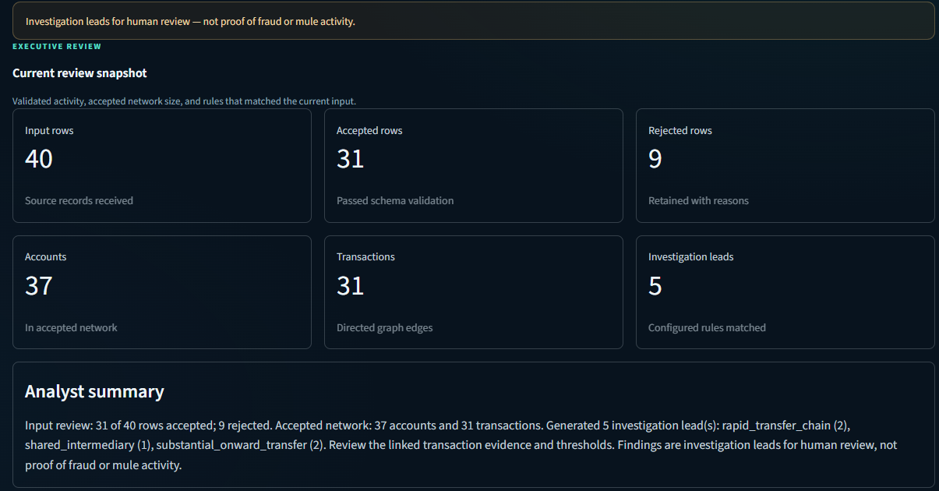
Figure 1. Actual Streamlit Overview capture from the project demo.
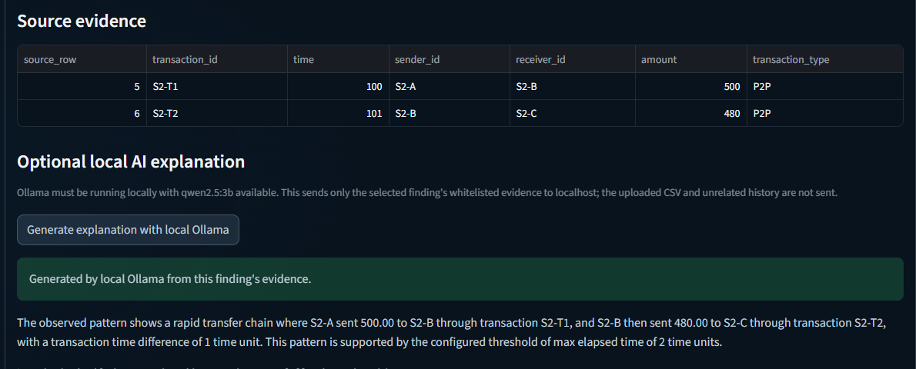
Figure 2. Actual selected-finding evidence and local explanation capture.

The captures above are project screenshots preserved with presentation work documents, they demonstrate the dashboard and optional explanation process. The browser live workflow was not independently re-tested as part of Github packaging procedures.

9. Synthetic scenarios and verified fixture results
The bundle holds 40 synthetic input rows. The most recent execution of the public run_analysis() produced 31 accepted, 9 rejected, 37 graph accounts, 31 graph transactions, and 5 findings. The rows are results of synthetic, not actual, fixture data.
Scenario | Fixture evidence and observed behavior | Status
S1 • ordinary P2P | S1-T1–S1-T4; four valid independent transfers; no rule finding. | Pass
S2 • rapid chain | S2-T1 A→B 500 at 100; S2-T2 B→C 480 at 101. Rapid-chain and onward findings are in conflict on two records. | Pass
S3 • shared intermediary | Three incoming records to S3-HUB at 200/201/202; onward at 204. First incoming is 4 units before onward and beyond 3-unit window; two recent senders qualify Partial | Partial
S4 • invalid rows | Nine rows rejected with reasons, including missing/blank data, invalid amount/time, negative amount, and two duplicate-ID rows. | Pass
S5 • merchant control | 18 accepted payments to S5-MERCHANT; incoming count only has no finding | Pass
S6 • split/refund | Two split payments and one refund; all accepted and no configured rule matches the fixture timing. | Pass

The current toy transaction-label comparison is available on this fixture: TP=5, FP=0, TN=25, FN=1. Predicted positive means that the transaction ID was found in at least one finding's evidence. The labels are synthetic values at the transaction level, not account level ("mule") as in P2P. These counts are not a generalization estimate, calibrated accuracy, or evidence of suitability for operational use.

10. Testing approach and actual results
The pytest suite implements schema validation, rejection details and duplicate policy, deterministic fixture generation, graph/rule behavior, temporal boundaries, finding evidence, label independence, workflow stages and failure behavior, dashboard helpers, and mocked ollama success/failure/timeout/fallback formatting. Ollama is not used in unit tests.
Verification | Result on 2026-10-19
Command | python -m pytest -q
Test result | 64 passed in 11.47 seconds
Fixture through public workflow | 40 input; 31 accepted; 9 rejected; 37 accounts; 31 graph transactions; 5 findings
PPTX package inspection | 10 slides; opened with python-pptx; all 10 slides contain speaker notes
Git status at initial audit | Folder was not a Git repository; no remote was configured

A passing test suite confirms that the tested behavior is implemented correctly in this local environment; it does not assert any claims about the accuracy of a model, the ability to detect fraud, browser compatibility on all computers, or readiness for production.

11. Limitations, ethics, and future scope

Limitations and safeguards
- All records, labels are synthetic, constructed by hand; coverage intentionally small.
- Thresholds exemplify, but are not tuned, and legitimate transfers can exhibit similarities; suspicious activity can exhibit divergences.
- The onward aggregate ratio does not indicate that particular funds have been passed; ratios can exceed 100%.
- The S3 scenario is partial because S3-IN-1 is not in the three-unit window.
- Toy metrics are transaction level only: can not identify mule account, can not indicate accuracy in the wild.
- The graph view is truncated for display purposes, but the analysis is over the same set of accepted transactions.
- Optional LLM output can be incorrect despite thorough inspection of the prompt and response, but deterministic output is available on fallback.
- Absent: live financial data, calibrated risk score, fairness study, security review, operational case process.
Ethics use findings as prompts to investigate, scrutinize source evidence, consider explanations, limit access to sensitive records, and avoid taking any adverse action based on the presence of a suspicious pattern or on the model's output.

Future scope
Follow-up work could include larger controlled synthetic cases, performance and usability testing with reviewers, documented threshold sensitivity analysis, improved provenance and audit logging, role-based access and secure data handling, and evaluation against appropriately licensed and documented account/network labels. Any real-data or operational deployment would require separate legal, privacy, security, and domain validation. None of these are implemented here.

12. Setup and execution
Prerequisite: python 3.12.10 has been confirmed to work. In the project root via PowerShell:
py -3.12 -m venv .venv
.\.venv\Scripts\Activate.ps1
python -m pip install -r requirements.txt
python -m streamlit run app.py
In the dashboard select Load synthetic fixture, or load a CSV matching the required schema, then click Run analysis. To re-generate the bundled synthetic CSV use python -m src.generate_synthetic, which will write to the generator's default fixture path, so make sure to have a copy of any local fixture modifications if desired. Run tests via python -m pytest -q .
Optional local explanation: install and start Ollama separately, then make sure the qwen2.5:3b model is available locally (e.g. ollama pull qwen2.5:3b), then start the Ollama service. The dashboard notes the requirement for a local service and only invokes it when the user requests an explanation for a finding of interest. Not required for analysis or testing.

13. Conclusion

UPI Sentinel has built a solution where a deterministic multi-agent system validates the input transaction data, constructs the directed account network, executes transparent procedures, and renders the evidence in an analyst-friendly dashboard. A local language model can be utilized to augment the final choice of words in a specific finding while keeping the process outside of detection. The project is a synthetic educational proof of concept; the contribution is traceability and reproducibility, and the results are investigation leads for human analysis.

14. Project references
Project file | What it documents or implements
README.md | Setup, schema, workflow, rules, privacy, fixture output, and limitations.
app.py | Five-page Streamlit user interface plus Ollama action.
src/schema.py; src/validation.py | Canonical fields + input validation.
src/graph_analysis.py; src/rules.py | Accepted-only graph, graph summaries, and deterministic rules.
src/agents.py | Six-agent structured workflow and post-detection evaluation.
src/llm_explanation.py | Whitelist payload, local request, response checks, and deterministic fallback.
src/generate_synthetic.py; data/samples/synthetic_transactions.csv | Reproducible synthetic scenarios and bundled fixture.
src/visualization.py; tests/ | Bounded graph display + automated regression coverage.
docs/acceptance_report.md | Earlier fixture audit, scenario evidence, and known limitations.
presentation/UPI_Sentinel_CA3_PPT.pptx; presentation/PRESENTER_NOTES_REFINED.md | Final 10-slide deck and refined presenter/viva notes.
requirements.txt; .streamlit/config.toml | Pinned dependencies + dashboard theme.

15. References
[1] National Payments Corporation of India. (n.d.). UPI frequently asked questions. Retrieved October 19, 2026, from https://www.npci.org.in/what-we-do/upi/faqs
[2] Weber, M., Domeniconi, G., Chen, J., Weidele, D. K. I., Bellei, C., Robinson, T., & Leiserson, C. E. (2019). Anti-money laundering in Bitcoin: Experimenting with graph convolutional networks for financial forensics. arXiv. https://doi.org/10.48550/arXiv.1908.02591
Related work on Bitcoin transaction graphs; it is not UPI data or a method implemented in UPI Sentinel.
[3] NetworkX Developers. (n.d.). MultiDiGraph—Directed graphs with self-loops and parallel edges. NetworkX documentation. https://networkx.org/documentation/stable/reference/classes/multidigraph.html
[4] LangChain, Inc. (n.d.). LangGraph overview. https://docs.langchain.com/oss/python/langgraph/overview
[5] Streamlit, Inc. (n.d.). Streamlit documentation. https://docs.streamlit.io/
[6] Ollama. (n.d.). Generate a chat completion. Ollama API documentation. https://github.com/ollama/ollama/blob/main/docs/api.md#generate-a-chat-completion
[7] Ollama. (n.d.). qwen2.5 model library. https://ollama.com/library/qwen2.5
[8] Plotly Technologies Inc. (n.d.). Graph objects in Python. Plotly documentation. https://plotly.com/python/graph-objects/

