A

Mini Project Report

on

**EXPLORING BHARAT CULTURE AND HERITAGE**

**STATES AND TRIBES**

Submitted for partial fulfillment of the requirements for the award of the degree of

**BACHELOR OF ENGINEERING**

in

**INFORMATION TECHNOLOGY**

by

**Karnati Dhanush Reddy** (2451-22-737-002)

**Bitla Sravya Reddy**(2451-22-737-006)

**Vangapally Godadevi** (2451-22-737-011)

Under the guidance of

**Mrs. Thuvva Anjali**

Assistant Professor

Department of IT



**MATURI VENKATA SUBBA RAO (M.V.S.R) ENGINEERING COLLEGE**

**(An Autonomous Institute)**

Department of Information Technology

(Affiliated to Osmania University & Recognized by AICTE)

Nadergul, Saroor Nagar Mandal, Hyderabad – 501 510

AY : 2023-24

i

**CERTIFICATE**

*This is to certify that the mini project work entitled “****Exploring Bharath Heritage and Culture: States and Tribes****” is a bonafide work carried out by* *Mr.Karnati Dhanush Reddy(2451-22-737-002), Ms.Bitla Sravya Reddy (2451-22-737-006), Ms.Vangaplly Godadevi (2451-22-737-011) in partial fulfilment of the requirements for the award of degree of Bachelor of Engineering in Information Technology from Maturi Venkata Subba Rao (M.V.S.R.) Engineering College, an Autonomous Institution, affiliated to Osmania University Hyderabad, during the Academic Year 2023-24 under our guidance and supervision.*

*The results embodied in this report have not been submitted to any other university or institute for the award of any degree or diploma.*

**Internal Guide Project Co-ordinator**

**Mrs.Thuvva Anjali Mr.M.Swapna**

Assistant Professor Assistant Professor

Department of IT Department of IT

MVSREC MVSREC

**HOD External Examiner**

**Dr. K. Venugopala Rao**

Dean – Academics, Professor & Head

Department of IT

MVSREC

ii

**DECLARATION**

This is to certify that the work reported in the present mini project entitled “***Exploring Bharath Heritage and Culture: States and Tribes***” is a record of bonafide work done by us in the Department of Information Technology,Maturi Venkata Subba Rao (M.V.S.R.) Engineering College, an Autonomous Institution, affiliated to Osmania University. The reports are based on the project work done entirely by us and not copied from any other source.The results embodied in this project report have not been submitted to any other University or Institute for the award of any degree or diploma to the best of our knowledge and belief.

Karnati Dhanush Reddy(2451-22-737-002)

Bitla Sravya Reddy (2451-22-737-006)

Vangapally Godadevi (2451-22-737-011)

iii

**ACKNOWLEDGEMENT**

We would like to express our sincere gratitude to our Project Guide  **Mrs. Thuvva Anjali,** Assistant Professor for her valuable suggestions and interest throughout the course of this project.

We would like to express our sincere gratitude and indebtedness to our Project Co-ordinator

**Mrs. M.Swapna ,** AssistantProfessor- Department of Information Technology, for her valued recommendations and attention throughout the course of this project.

We wish to extend our heartfelt gratitude and deep appreciation to our esteemed Professor

**Dr. H. Jayasree** Department of Information Technology for her invaluable guidance and unwavering support throughout the duration of this project.

We are also thankful to our Principal **Dr. G. Kanaka Dssurga**, **Professor**, **Dr. K. Venugopala Rao,** Professor and Head - Department of Information Technology, Dean-Academics, Maturi Venkata Subba Rao Engineering College, for providing excellent infrastructure and a nice atmosphere for completing this project successfully as a part of our B.E. Degree (IT).

We convey our heartfelt thanks to the lab staff for allowing us to use the required equipment whenever needed.

Finally, we would like to take this opportunity to thank our family for their support through the work. We sincerely acknowledge and thank all those who gave directly or indirectly their support in the completion of this work.

Karnati Dhanush Reddy(2451-22-737-002)

Bitla Sravya Reddy (2451-22-737-006)

Vangapally Godadevi (2451-22-737-043)

iv

**VISION & MISSION,**

**PROGRAM EDUCATIONAL OUTCOMES**

**Vision of the Department:**

To impart technical education producing competent and socially responsible engineering professionals in the field of Information Technology.

**Mission of the Department:**

M1. To make teaching learning process effective and stimulating.

M2. To provide adequate fundamental knowledge of sciences and Information Technology with positive attitude.

M3. To create an environment that enhances skills and technologies required for industry.

M4. To encourage creativity and innovation for solving real world problems.

M5. To cultivate professional ethics in students and inculcate a sense of responsibility towards society

**Program Educational Objectives**:

After 3 to 4 years of graduation, graduates of the Information Technology program will:

* Apply knowledge of mathematics and Information Technology to analyze, design and implement solutions for real world problems in core or in multidisciplinary areas.
* Communicate effectively, work in a team, practice professional ethics and apply knowledge of computing technologies for societal development.
* Engage in Professional development or postgraduate education to be a life-long learner.

v

**PROGRAM OUTCOMES & PROGRAM SPECIFIC OUTCOMES**

**PROGRAM OUTCOMES (POs)**

**Engineering Graduates will be able to:**

1. **Engineering knowledge**: Apply the knowledge of mathematics, science, engineeringfundamentals, and an engineering specialization to the solution of complex engineering problems.
2. **Problem analysis**: Identify, formulate, review research literature, and analyze complexengineering problems reaching substantiated conclusions using first principles of mathematics, natural sciences, and engineering sciences.
3. **Design/development of solutions**: Design solutions for complex engineering problems anddesign system components or processes that meet the specified needs with appropriate consideration for the public health and safety, and the cultural, societal, and environmental considerations.
4. **Conduct investigations of complex problems**: Use research-based knowledge and researchmethods including design of experiments, analysis and interpretation of data, and synthesis of the information to provide valid conclusions.
5. **Modern tool usage**: Create, select, and apply appropriate techniques, resources, and modernengineering and IT tools including prediction and modeling to complex engineering activities with an understanding of the limitations.
6. **The engineer and society**: Apply reasoning informed by the contextual knowledge to assesssocietal, health, safety, legal and cultural issues and the consequent responsibilities relevant to the professional engineering practice.
7. **Environment and sustainability**: Understand the impact of the professional engineering solutionsin societal and environmental contexts, and demonstrate the knowledge of, and need for sustainable development.
8. **Ethics**: Apply ethical principles and commit to professional ethics and responsibilities and norms ofthe engineering practice.
9. **Individual and team work**: Function effectively as an individual, and as a member or leader indiverse teams, and in multidisciplinary settings.
10. **Communication**: Communicate effectively on complex engineering activities with the engineeringcommunity and with society at large, such as, being able to comprehend and write effective reports and design documentation, make effective presentations, and give and receive clear instructions.
11. **Project management and finance**: Demonstrate knowledge and understanding of theengineering and management principles and apply these to one’s own work, as a member and leader in a team, to manage projects and in multidisciplinary environments.
12. **Life-long learning**: Recognize the need for, and have the preparation and ability to engage inindependent and life-long learning in the broadest context of technological change.

vi

**PROGRAM SPECIFIC OUTCOMES (PSOs):**

PSO1: **Hardware design**: An ability to analyze, design, simulate and implement computer hardware / software and use basic analog/digital circuits, VLSI design for various computing and communication system applications.

PSO2:S**oftware design**: An ability to analyze a problem, design algorithm, identify and define the computing requirements appropriate to its solution and implement the same.

vii

**COURSE OBJECTIVES & COURSE OUTCOMES**

**COURSE OBJECTIVES**

* Enable students learning by doing.
* Develop capability to analyse and solve real time problems.
* Inculcate innovative ideas.
* Impart team building and management skills.
* Instil writing and presentation skills.

**COURSE OUTCOMES**

After completion of the course student will be able to:

CO1 - Interpret Literature with the purpose to formulate a problem statement.

CO2 - Plan, Analyze, Design and implement a project.

CO3 - Find the solution of identified problem with the help of modern tools & technology.

CO4 - Plan to work as a team to exhibit team skills to meet deadlines.

CO5 - Prepare and submit the Report and deliver presentation.

viii

**ABSTRACT**

To explore the complex interplay between states and tribal communities, focusing on cultural, social, and economic dynamics. Examining the impact of government policies, it uncovers challenges and opportunities for promoting development within tribal regions. Emphasizing inclusive strategies, the study addresses the preservation of tribal heritage and traditions. Targeting policymakers and community stakeholders, it aims to offer valuable insights. It explores the delicate balance required for sustainable development, acknowledging the unique needs of tribal population. It also navigates about the delicate balance required for sustainable development; it considers the unique needs of tribal populations. Through this research, the study contributes practical knowledge to facilitate cooperation, ensuring a harmonious relationship between states and tribal communities, promoting inclusivity and cultural richness.

Karnati Dhanush Reddy(2451-22-737-002)

Bitla Sravya Reddy (2451-22-737-006)

Vangapally Godadevi (2451-22-737-011)

ix

**TABLE OF CONTENTS**

|  |  |
| --- | --- |
| **CONTENTS** | **PAGE NO** |
| Certificate | I |
| Declaration | ii |
| Acknowledgement | iii |
| Vision & Mission, PEOs | iv |
| POs and PSOs | v |
| Course Objectives & Outcomes | vi |
| Abstract | vii |
| Table of Contents | viii |
| List of Figures | ix |
| List of Tables | x |
| List of Abbreviations | xi |
| Chapters |  |
| * **Introduction** | 1 – 2 |
| * Problem statement * Existing system * Proposed system * Scope |  |
| * **System Requirement Specifications** | 3 – 4 |
| 2.1 Software Requirements  2.2 Hardware Requirements  2.3 System Architecture / Block Diagram |  |
| * **Design & Implementation** | 5-10 |
| 3.1 Features  3.2 Environmental Setup |  |
| * **Test & Results** | 11-15 |
| * Test cases * Results |  |
| * **Conclusion & Future Enhancements** | 16 |
| **References** | 17 |
| **Appendix**  **A: source/pseudo code** | 18-20 |

x

**LIST OF FIGURES**

|  |  |  |
| --- | --- | --- |
| **Figure No.** | **Figure Name** | **Page No.** |
| Fig 2.3.1 | Web Application Architecture | 3 |
| Fig-3.2.1 | Downloading VS Code for Mac | 5 |
| Fig-3.2.2 | Verifying the downloaded zip file | 6 |
| Fig-3.2.3 | Unzipping the VS Code zip file | 6 |
| Fig-3.2.4 | Listing the contents of the Visual Studio Code application file | 7 |
| Fig-3.2.5 | Launching the installer | 7 |
| Fig-3.2.6 | Opening the installer | 8 |
| Fig-3.2.7 | VS Code’s main window | 8 |
| Fig 3.2.8 | Live Server | 9 |
| Fig 4.1.1 | Home Page | 10 |
| Fig 4.2.1 | Interactive Map | 10 |
| Fig 4.3 | Sample : Telangana | 11 |

**CHAPTER 1**

**INTRODUCTION**

* **Problem Statement**

To design an engaging and informative website that has an interactive map of India that showcases the significance and culture aspects of popular tribes living all over the Bharat, highlighting various aspects like history ,origin and distribution, language and art ,festivals, lifestyle ,challenges and beliefs.

​

* **Abstract**

To explore the complex interplay between states and tribal communities, focusing on cultural, social, and economic dynamics. Examining the impact of government policies, it uncovers challenges and opportunities for promoting development within tribal regions. Emphasizing inclusive strategies, the study addresses the preservation of tribal heritage and traditions. Targeting policymakers and community stakeholders, it aims to offer valuable insights. It explores the delicate balance required for sustainable development, acknowledging the unique needs of tribal population. It also navigates about the delicate balance required for sustainable development; it considers the unique needs of tribal populations. Through this research, the study contributes practical knowledge to facilitate cooperation, ensuring a harmonious relationship between states and tribal communities, promoting inclusivity and cultural richness.

* **Existing System**

The current system may consist of a static website or web application with limited interactivity and information. It might not include a map of India.​

* **Proposed System**

The proposed system is an interactive map of India that offers a more engaging and informative experience. It includes features such as an interactive map, detailed information about every state's tribe, user-friendly interface and mobile responsiveness. Additionally, we've integrated a chatbot feature for user interaction, providing a seamless way for visitors to engage with our website and get instant assistance.​

* **Scope**

The website will provide educational content about the cultural significance of various tribal forms in India. Each state will have a dedicated profile page showcasing information of tribal people . This may include descriptions, images, videos, and audio samples. The website will require regular updates to ensure that the information remains current and accurate. The website may be expanded in the future to include additional features or content based on user feedback and evolving requirements.​ Additionally, we've integrated a chatbot feature for user interaction, providing a seamless way for visitors to engage with our website and get instant assistance."

**CHAPTER 2**

**SYSTEM REQUIREMENT SPECIFICATIONS**

* 1. **Software Requirement**
* Operating System - Windows 10
* Simulation Tools - Local Host
* Programming language - HTML , CSS ,JavaScript
* VS Code:Live server extension

**2.2 Hardware Requirements**

* Processor: Recommended 2GHz or more
* Memory (RAM): Recommended 4 GB or above
* Ethernet connection (LAN) ORa wireless adapter (Wi-Fi)

**2.3 System Architecture**

fig 2.3.1 Web Application Architecture

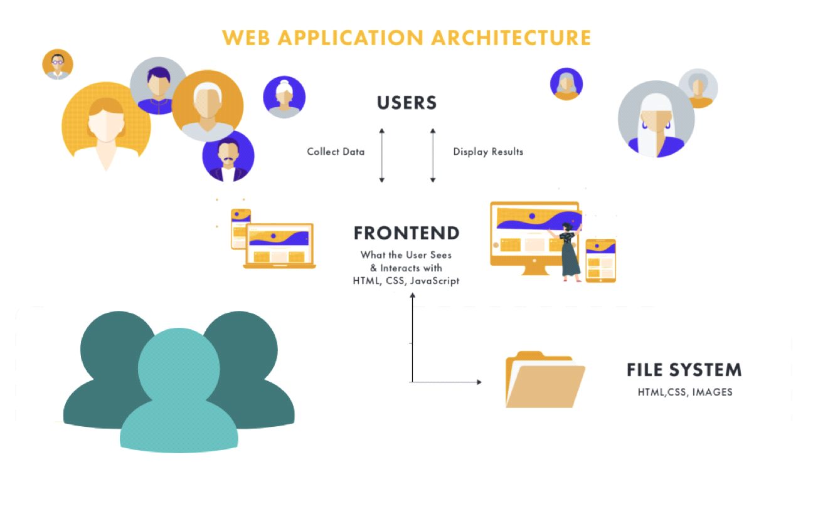

**CHAPTER 3**

**DESIGN & IMPLEMENTATION**

**3.1 Features**

The website prioritizes user engagement and accessibility through its design, showcasing a streamlined and user-friendly interface tailored for seamless navigation across different devices. Its implementation employs web technologies such as HTML, CSS, and JavaScript to integrate interactive components like the map and timeline. The content is carefully curated to offer valuable historical insights, enriched with multimedia elements to enrich the narrative and enhance user experience.

1. **Interactive Map:** Users can interact with a map of India, clicking on individual states to access information.
2. **State-specific Information:** Each state has its own page displaying information about its tribal people.
3. **Visual Representation:** The website visually represents India's cultural diversity through its interactive map and state-specific information.
4. **Limited Functionality:** Due to the frontend-only nature of the website, it lacks dynamic content updates and interactive features.
5. **Static Content:** The information provided on the website is static and does not change unless manually updated.
6. **User Engagement:** While users can engage with the content through the interactive map, there are limited opportunities for further interaction or exploration.
7. **Potential for Expansion:** There is potential to expand the website's features and functionality with backend development, allowing for dynamic updates and enhanced user engagement.
8. **3.2 Environmental Setup**

**Installing an editor**: Visual Studio (VS) Code

1. Open your favorite web browser, and head to the [VS Code download page](https://code.visualstudio.com/download).

2. Next, click on Apple Silicon under the Mac icon to download VS Code’s package installer for Mac in a ZIP file. This Apple Silicon (M1) version is the latest chip developed by Apple.

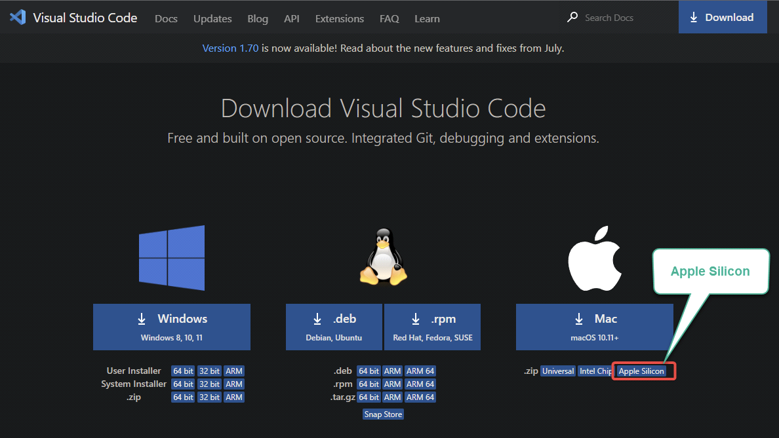

Fig-3.2.1 Downloading VS Code for Mac

3. Lastly, open your [terminal](https://adamtheautomator.com/iterm/) and run the following ls command to verify VS Code’s package installer you downloaded.

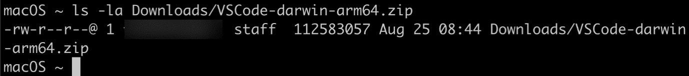

Fig 3.2.2 Verifying the downloaded zip file

4. Select the downloaded VS Code zip file → click the ellipsis icon (top-right) → Open to unzip the ZIP file. Once unzipped, you should have a new Visual Studio Code application in your Downloads folder.

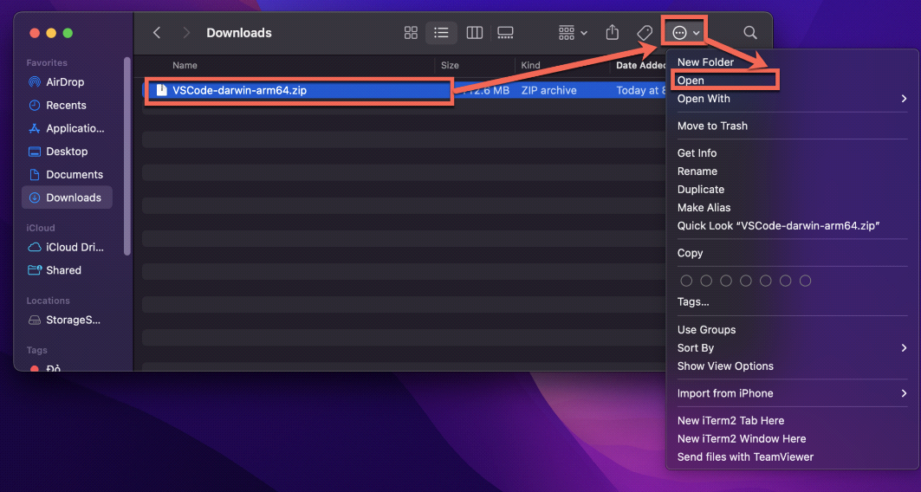

Fig 3.2.3 Unzipping the VS Code zip file

5. Next, run the ls command below to verify the application file. This command lists the contents of the Visual Studio Code application file.

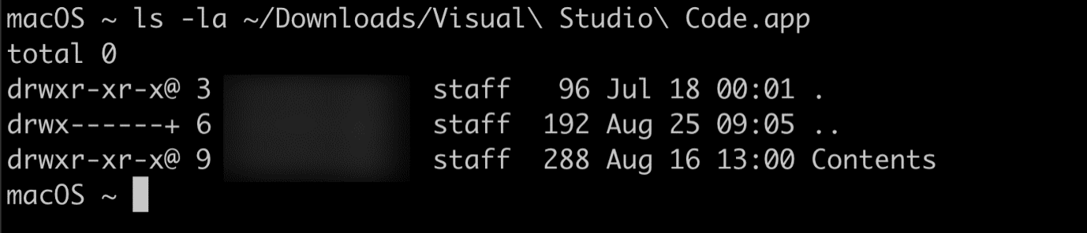

Fig 3.2.4 Listing the contents of the Visual Studio Code application file

6. Run the [open](https://scriptingosx.com/2017/02/the-macos-open-command/) command below to launch the installer in a new instance (-n).

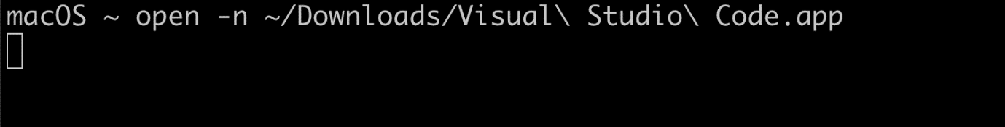

Fig 3.2.5 Launching the installer

7. Now, click Open to continue with the installation when you get the prompt below.

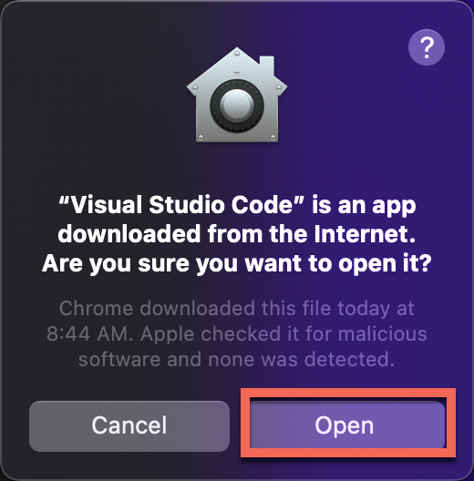

Fig 3.2.6 Opening the installer

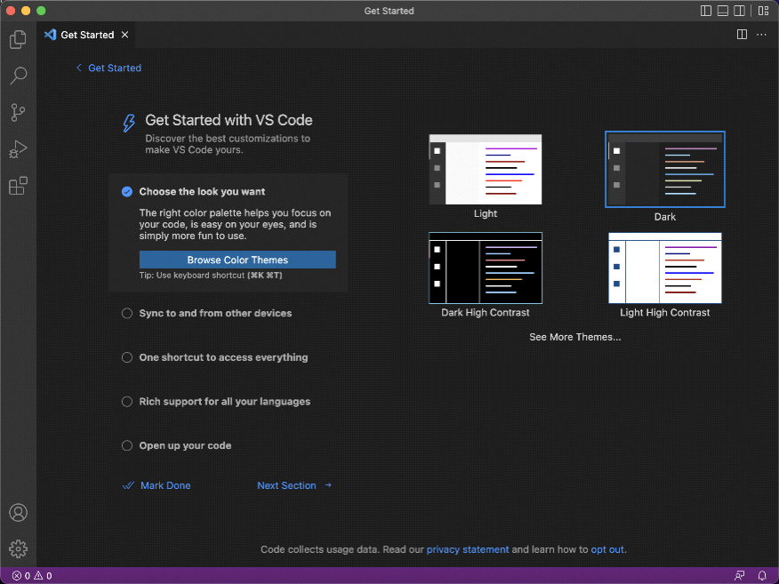8. Once installed, the VS Code application opens, and you’ll be greeted with the Get Started page below.

Fig 3.2.7 VS Code’s main window

**Installing Live Server in VS Code :** Install the Live Server extension from Marketplace. You can find it in the VS Code Activity Bar

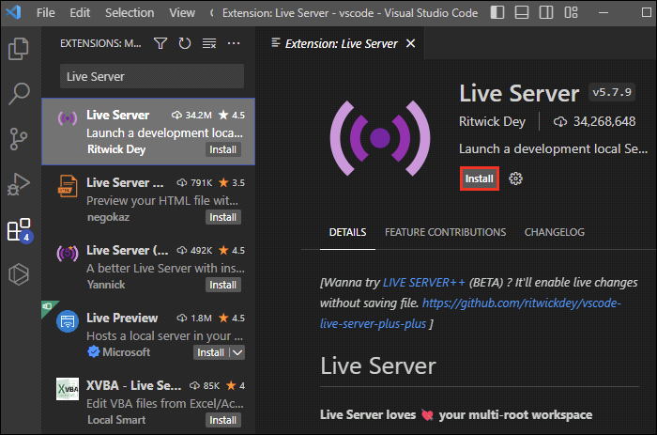

Fig 3.2.8 Live Server

**CHAPTER 4**

**RESULTS**

**4.1 Home Page**

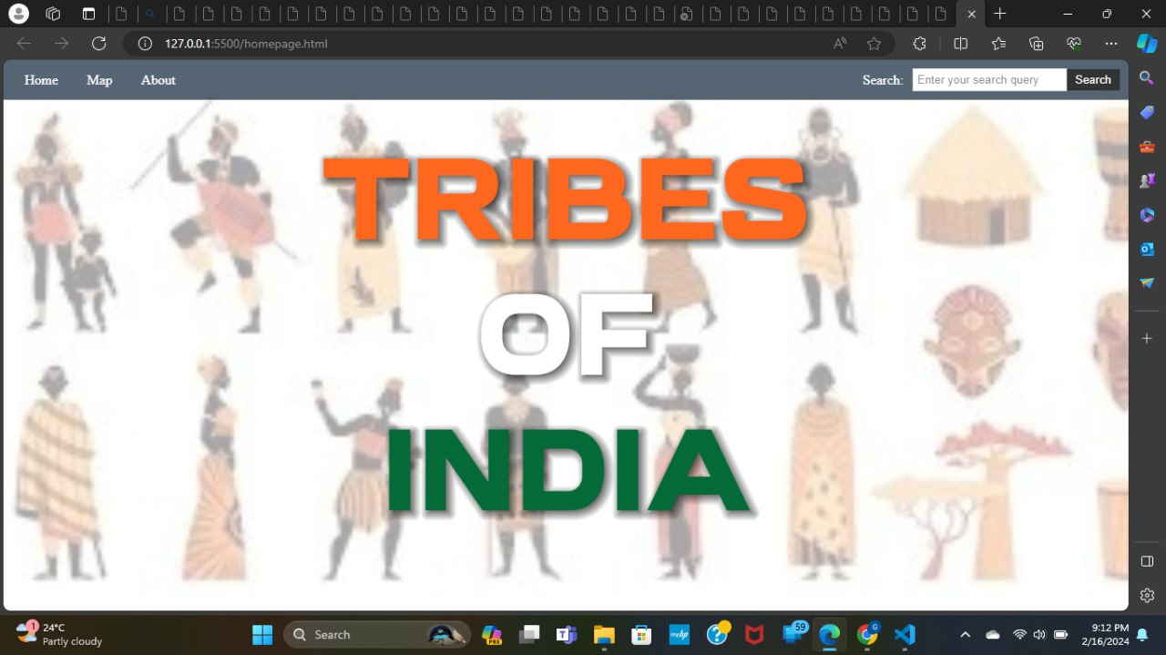

Fig 4.1.1 Home Page

**4.2 Interactive Map**

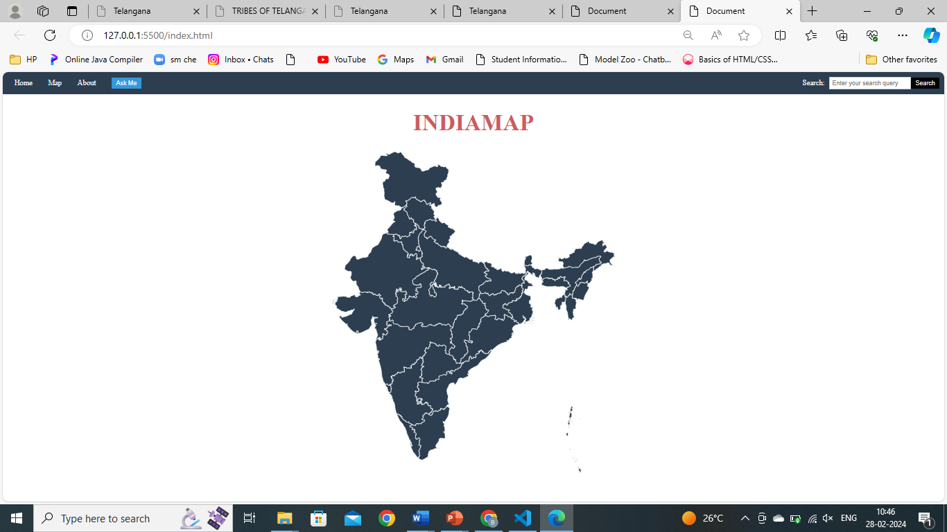

Fig 4.2.Interactive Map

**4.3 Sample : Telangana**

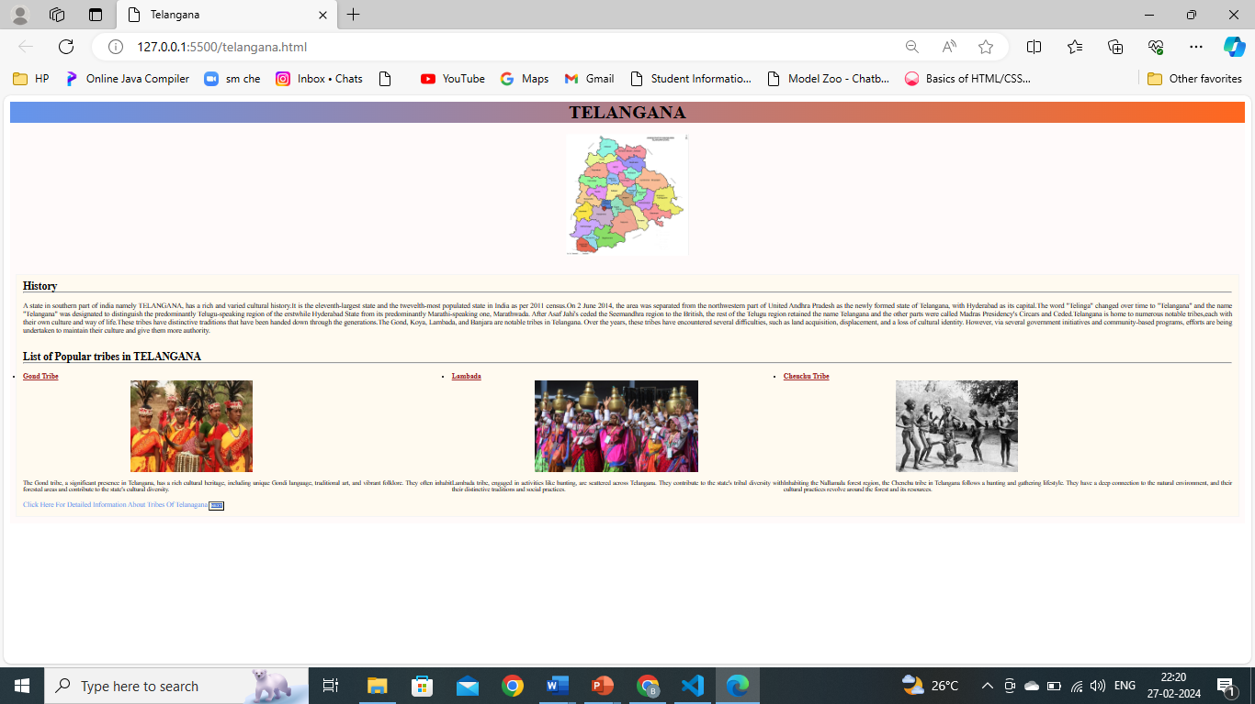

Fig 4.3.1 Telangana

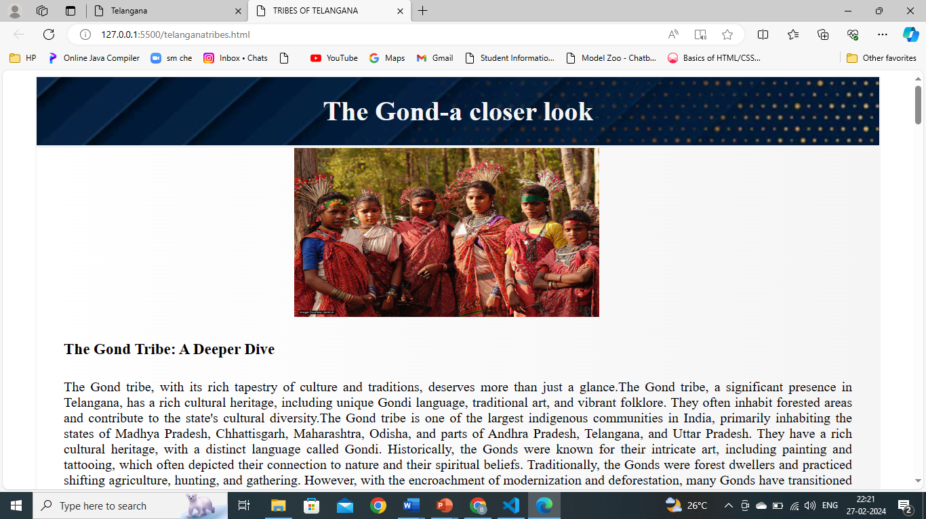

Fig 4.3.2 Telangana

**4.4 Chatbot**

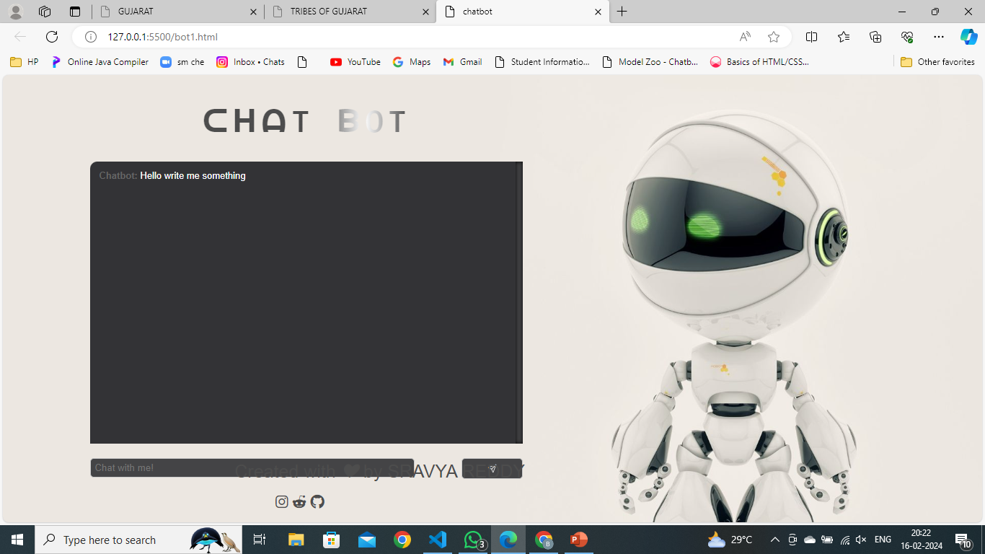

Fig 4.4 Telangana

**CHAPTER 5**

**CONCLUSION & FUTURE ENHANCEMENTS**

**5.1 Conclusion**

In conclusion, our mini project has brought to life a dynamic website featuring an interactive map of India. This collaborative effort has successfully translated our ideas into a visually appealing and functional platform .The interactive map allows users to explore India's Scheduled tribes by clicking on any state on the map. This innovative addition showcases the rich diversity of tribal culture across the nation, highlighting the importance of preserving and respecting indigenous heritage, encourage readers to learn more about specific tribes in their respective states, and emphasize the need for continued support and advocacy for tribal communities.

**5.2 Future Enhancements**

1.**Enhanced Interactive Features:** Expand the interactive India map feature to all the tribes in the state.

2.**Real-Time Updates:** Implement real-time updates feature to provide users with the latest news and developments related to ruling political parties, ensuring the website remains current and informative.

3.**User-Generated Content**: Introduce user-generated content features such as user-contributed articles, blogs, and opinion polls to encourage active user participation and engagement on the platform.

4.**Social Media Integration**: Integrate social media platforms to enable users to share website content easily and promote discussions on ruling political parties among their social networks.

5.**Data Analytics:** Incorporate advanced data analytics tools to analyze user interactions and preferences, allowing for personalized content recommendations and insights into user behavior.

**REFERENCES**

1. "Tribal Co-operative Marketing Development Federation of India" by Ministry of Welfare, Government of India – A marketing platform for the welfare of tribes.

Website: <https://trifed.tribal.gov.in/>

1. "Ministry of Tribal Affairs" by Government of India – Offers official information,policies,and initiatives related to tribal communities in India.

Website: <https://tribal.nic.in/>

1. “National Commission for Schedules Tribes " : Provides information about scheduled tribes in India including their rights, welfare schemes and development initiatives.

Website: <https://ncst.nic.in/>

1. "Tribal Culture Heritage in India" by Maps of India – Provides a documentation and preserving the various tribal groups in India.

Website: <https://indiantribalheritage.org>

1. "Joshua Project on People groups" - Provides resources and information about Indian tribes.

Website: <https://joshuaproject.net/countries/in>

**APPENDIX**

**homepage.html**

<!DOCTYPE html>

<html lang="en">

<head>

    <meta charset="UTF-8">

    <meta name="viewport" content="width=device-width, initial-scale=1.0">

    <title>Your Homepage</title>

    <link rel="stylesheet" href="homepage.css">

    <style>

        body {

            font-family: 'Times New Roman', Times, serif;

            margin: 0;

            padding: 0;

        }

        nav {

            background-color: #2c3e50;

            padding: 10px;

            color: white;

            display: flex;

            justify-content: space-between;

            align-items: center;

        }

        nav a {

            color: white;

            text-decoration: none;

            margin: 0 15px;

            transition: color 0.3s;

        }

        nav a:hover {

            color: black;

        }

        #ask-me-button {

            padding: 5px 10px;

            background-color: #3498db;

            color: white;

            border: none;

            cursor: pointer;

            transition: background-color 0.3s;

        }

**style1.css**

body {

  margin: 0;

  padding: 0;

  background-image: url(TRIBES\ OF\ INDIA.jpg);

  background-size: cover;

  background-position: center;

  background-repeat: no-repeat;

  background-attachment: fixed;

  opacity: 0.8; /* Adjust the opacity as needed */

}

.navbar{

background-color: #2c3e50; /* Dark background color */

  overflow: hidden;

}

.navbar a {

  float: left;

  display: block;

  color: white;

  text-align: center;

  padding: 14px 16px;

  text-decoration: none;

  font-size: 16px; /* Adjust font size */

}

.navbar a:hover {

  background-color: #34495e;

  color: #ecf0f1;

  transition: background-color 0.3s, color 0.3s;

}

.dropdown {

  display: inline-block;

}

.dropbtn {

  background-color: #2c3e50;

  color: white;

  padding: 14px 16px;

  font-size: 16px;

  border: none;

  cursor: pointer;

}

.dropdown-content

**telangana.html**

<!DOCTYPE html>

<html lang="en">

<head>

    <meta charset="UTF-8">

    <meta name="viewport" content="width=device-width, initial-scale=1.0">

    <title>Telangana</title>

    <link rel="stylesheet" href="telangana.css">

</head>

<style>

    body {

        font-family: 'Times New Roman', Times, serif;

        margin: 0;

        padding: 0;

    }

<div class="pagediv">

    <header id="heading1"><h1>TELANGANA</h1></header>

    <br>

    <br>

    <a class="telanganaimage"> <img src="https://diligentias.com/wp-content/uploads/2019/06/Telangana.jpg" alt="Telanganamap" height="400px" style="align-items: center"></a>

    <br>

    <br>

    <div class="paradiv">

      <h2 style=" text-align:left;font-family:sans-serif;">History</h2>

      <hr>

     <p><br>A state in southern part of india namely TELANGANA, has a rich and varied cultural history.It is the eleventh-largest state and the twevelth-most populated state in India as per 2011 census.On 2 June 2014, the area was separated from the northwestern part of United Andhra Pradesh as the newly formed state of Telangana, with Hyderabad as its capital.The word "Telinga" changed over time to "Telangana" and the name "Telangana" was designated to distinguish the predominantly Telugu-speaking region of the erstwhile Hyderabad State from its predominantly Marathi-speaking one, Marathwada. After Asaf Jahi's ceded the Seemandhra region to the British, the rest of the Telugu region retained the name Telangana and the other parts were called Madras Presidency's Circars and Ceded.Telangana is home to numerous notable tribes,each with their own culture and way of life.These tribes have distinctive traditions that have been handed down through the generations.The Gond, Koya,

**Telanganatribes.html**

!DOCTYPE html>

<html lang="en">

<head>

    <meta charset="UTF-8">

    <meta name="viewport" content="width=device-width, initial-scale=1.0">

    <title>TRIBES OF TELANGANA</title>

    <link rel="stylesheet" href="tribe.css">

</head>

    <div class="head"><h1  style="font-size: 40px;">The Gond-a closer look </h1></div>

            <div> <span class="image"><img src="https://gondsamajmahasabhamp.files.wordpress.com/2018/10/iamin-in_.jpg" height="250px" width="450px" HSPACE="350px" ></span>

    <h4 style="text-decoration: dashed;font-weight: 600; font-size: 23px;">The Gond Tribe: A Deeper Dive</h4>

        <p class="para">The Baiga tribe, indigenous to Central India, particularly in the states of Madhya Pradesh and Chhattisgarh, carries a rich history that intertwines with the region's dense forests and diverse ecosystems. Believed to be one of the oldest tribes in the subcontinent, the Baiga people have sustained a traditional lifestyle deeply connected to nature. Their history is marked by a profound knowledge of herbal medicine, intricate art forms, and a unique animistic belief system centered around the worship of deities residing in natural elements. Despite facing challenges such as displacement and socio-economic disparities, the Baiga tribe continues to preserve its cultural heritage, relying on age-old practices that harmonize with the environment and reflect a resilient history of survival and adaptation.

        </p>

        Here's a deeper dive into various aspects of their lives:

    <h4 style="font-size: 23px;font-weight:600">Origins and Distribution:<hr></h4>

        <p class="para">Believed to be one of the oldest tribes in India, tracing their ancestry back thousands of years.

         Primarily inhabit central and south-central India, with significant populations in Madhya Pradesh, Maharashtra,<img src="https://media.geeksforgeeks.org/wp-content/uploads/20231206110658/2.png" alt="origin" ALIGN="right" HSSPACE="20px" height="400px">Telangana, Andhra Pradesh, Chhattisgarh, and Odisha.Subdivided into various subgroups, each with distinct customs, dialects, and traditions.</p>

   <h4 style="font-size: 23px;font-weight: 600;">Language and Art:</h4>

   <ul><li><p class="para">Gondi: Their native language, belonging to the Dravidian family, is spoken by millions but lacks a standardized script.</li></p>

        <li><p class="para">Bhittichitra:Vibrant wall paintings depicting their mythology, nature, and daily life.</li></p>

        <li><p class="para">Metalwork:Skilled in crafting intricate jewelry, utensils, and figurines often adorned with animal motifs</li></p>

        <li><p class="para">Textiles:Renowned for their colorful embroidered fabrics and sarees.</li></p></ul>

    <h4 style="font-size: 24px;font-weight: 600;">Festivals<hr></h4>

</body>

</html>

**Chatbot.js**

!DOCTYPE html>

<html>

    <head>

        <meta charset="utf-8">

        <title>chatbot</title>

        <style type="text/css">

            body{

                background-image: url('1234.jpg');

                background-repeat: no-repeat;

                background-size: cover;

            }

        </style>

        <link rel='stylesheet' href="hptts://maxcdn.bootstrapcdn.com/bootstrap/3.3.6/css/bootstrap.main.css">

        <link rel="stylesheet" type="text/css" href="style.css">

        <link rel="stylesheet" href="https://cdnjs.cloudflare.com/ajax/libs/font-awesome/5.15.3/css/all.min.css">

    </head>

    <body>

        <div class="container">

            <h1 class="title">ᑕᕼᗩT ᗷOT</h1>

            <div class="chat"></div>

            <div class="busy"></div>

            <div class="input">

                <input type="text" placeholder="Chat with me!">

                <a><ion-icon name="paper-plane-outline"></ion-icon></a>

            </div>

        </div>

        <footer class="footer">

            <p>Created with <i>&#x2764;</i> by SRAVYA REDDY</p>

            </footer>

             <div class="wrapper">

                 <div class="button">

                       <i class="fab fa-instagram"></i><i> </i><i class="fab fa-reddit-alien"></i><i> </i><i class="fab fa-github"></i>

                 </div>

              </div>

        <script src='https://cdnjs.cloudflare.com/ajax/libs/jquery/3.1.0/jquery.min.js'></script>

        <script src='https://cdnjs.cloudflare.com/ajax/libs/twitter-bootstrap/3.3.7/js/bootstrap.min.js'></script>

        <script type="module" src="https://unpkg.com/ionicons@5.5.2/dist/ionicons/ionicons.esm.js"></script>

        <script nomodule src="https://unpkg.com/ionicons@5.5.2/dist/ionicons/ionicons.js"></script>

        <script src="main.js"></script>

    </body>

</html>