NEURAL NETWORK EXPERIMENT – 1
Name: Kulwant Singh
Roll No: 24UADS1027

Objective
To implement a single-layer Perceptron neural network for realizing the AND logic gate using Python, and to study its learning behavior through weight updates and decision boundary visualization.

Theory
A perceptron is the simplest form of a neural network used for binary classification. It computes a weighted sum of inputs and passes the result through a step activation function. For linearly separable problems such as the AND gate, a single-layer perceptron is guaranteed to converge.
The perceptron learning rule updates weights whenever a misclassification occurs, gradually adjusting the decision boundary until all inputs are classified correctly.

Algorithm
- Initialize weights to zero.
- Add a bias term to the input.
- Compute the weighted sum.
- Apply step activation function (0 treated as positive).
- Update weights if the prediction is incorrect.
- Repeat until no misclassifications occur.

Implementation
The perceptron is implemented using NumPy for numerical computation and Matplotlib for visualization. The decision boundary is plotted on a four-quadrant graph and updated after every weight change to clearly observe the learning process.
Output
- Weight updates are printed in the terminal during training.
- The decision boundary gradually shifts until convergence.
- Final weights are displayed after training completes.
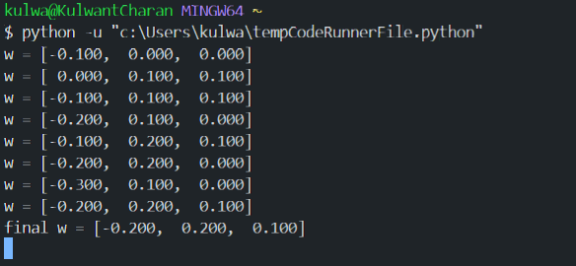
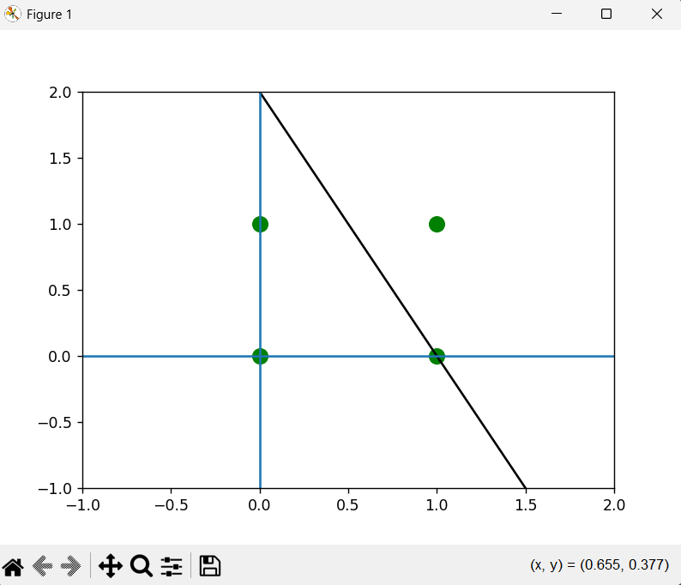
Result
The perceptron successfully learns the AND logic gate. After several weight updates, the decision boundary converges such that all inputs are correctly classified.

Conclusion
This experiment demonstrates the working of a single-layer perceptron on a linearly separable problem. Visualizing the decision boundary provides clear insight into how the perceptron learns by adjusting weights during training.

