DEVELOPMENT OF CONSTRUCTION MANAGEMENT FRAMEWORK FOR SHORELINE PROTECTION STRUCTURES BASED ON COASTAL EROSION RISK LEVELS IN APARRI, CAGAYAN
Presented to the Faculty of the College of Engineering and Architecture
CAGAYAN STATE UNIVERSITY
Carig Campus, Tuguegarao City, Cagayan
In Partial Fulfillment of the Requirements for the Degree
BACHELOR OF SCIENCE IN CIVIL ENGINEERING
RIZABELL F. BRUNO
SANDARA MARIE M. CABAUATAN
ROSS ANN D. MORA
PHOEBE KATE S. UBANDO

[Month Year of final defense]

APPROVAL SHEET
This thesis titled “DEVELOPMENT OF CONSTRUCTION MANAGEMENT FRAMEWORK FOR SHORELINE PROTECTION STRUCTURES BASED ON COASTAL EROSION RISK LEVELS IN APARRI, CAGAYAN”, prepared and submitted by RIZABELL F. BRUNO, SANDARA MARIE M. CABAUATAN, ROSS ANN D. MORA, and PHOEBE KATE S. UBANDO in partial fulfillment of the requirements for the degree, Bachelor of Science in Civil Engineering major in Construction Engineering Management, is hereby recommended for final oral examination.

ENGR. MARK LESTER CAGURANGAN
Adviser
Approved by the Tribunal on Oral Examination with a grade of ________.
ENGR. JOWELL JOHN B. TALOSIG
Chairman
ENGR. ARISTOTLE JAMES M. AGANON ENGR. FELIPE NEIL C. PINTUCAN
Member Member
ENGR. JOSEPH R. CABALBAG, ME
Department Chair
Accepted and approved in partial fulfillment of the requirements for the degree, Bachelor of Science in Civil Engineering major in Construction Engineering Management.
Date: ____________________ ENGR. JOHN MICHAEL B. CASIBANG, MSc
Dean, College of Engineering and Architecture

ACKNOWLEDGMENT
[STUDENTS: write the acknowledgment — thank the adviser, panel, the Aparri LGU/MDRRMO/DPWH offices, the 54 respondents, family. The project files contain no acknowledgment text, so none was invented.]

ABSTRACT
Title: DEVELOPMENT OF CONSTRUCTION MANAGEMENT FRAMEWORK FOR SHORELINE PROTECTION STRUCTURES BASED ON COASTAL EROSION RISK LEVELS IN APARRI, CAGAYAN
Researchers: RIZABELL F. BRUNO; SANDARA MARIE M. CABAUATAN; ROSS ANN D. MORA; PHOEBE KATE S. UBANDO Adviser: Engr. Mark Lester Cagurangan Institution: Cagayan State University – Carig Campus Degree: BS Civil Engineering
Coastal erosion threatens the barangays along the Aparri, Cagayan shoreline, yet shoreline protection structures are often chosen after damage has occurred and without a measured basis. This study classified the erosion of the open coast of eight barangays (Dodan, Maura, Bulala Norte, Bulala Sur, San Antonio, Linao, Paddaya and Punta), compared five shoreline protection structures through expert judgment, and proposed a construction management framework that links the two.
Shoreline positions for 1990, 2000, 2010, 2020 and 2025 were processed in a Geographic Information System (GIS). Along 415 lines drawn every 50 m across the coast (373 usable), the End Point Rate, the distance the shoreline moved between 1990 and 2025 divided by 35 years, was computed and classed as Low (below 2 m/year), Medium (2–5 m/year) or High (above 5 m/year) erosion. Fifty-four experts rated seawalls, revetments, riprap, breakwaters and mangrove rehabilitation on six criteria using a five-point scale, and the ratings were analyzed by weighted mean.
The median shoreline change was −1.46 m/year, and 94 % of the usable transects moved landward. Of the 18.8 km of classified open coast, 13.8 km (73 %) were Low and 5.0 km (27 %) were Medium; no stretch reached the High class. The highest mean erosion rates were in Bulala Norte (−3.35 m/year) and Bulala Sur (−2.74 m/year); both are entirely Medium. Because the class limits lie close to the typical rates, the Low/Medium boundary is uncertain for Dodan and Linao. The experts ranked the seawall first (overall mean 4.35, Very High), followed by mangrove rehabilitation (4.14), revetment (3.99), breakwater (3.71) and riprap (3.63). The proposed framework applies four management phases — planning, design, construction, and monitoring and maintenance — with stronger requirements for Medium than for Low stretches.
The results describe erosion rate only; exposure of buildings and people, field verification, and measured positional errors of the shorelines were not part of this study.
Keywords: coastal erosion; shoreline protection structures; shoreline change rate; risk classification; GIS; weighted mean; construction management framework

TABLE OF CONTENTS

ABSTRACT
CHAPTER I THE PROBLEM AND ITS BACKGROUND
Introduction
Statement of the Problem
Objectives of the Study
Conceptual Framework of the Study
Hypothesis of the Study
Significance of the Study
Scope and Delimitation
Definition of Terms
CHAPTER II REVIEW OF RELATED LITERATURE
Coastal Erosion Assessment
Remote Sensing, GIS and Erosion Analysis
Erosion Classification
Risk Classification
Coastal Risk Mapping
Prioritization of Coastal Management Areas
Coastal Protection and Management Strategies
Hard Engineering Approaches
Soft Engineering Approaches
Hybrid Coastal Protection Approaches
Selection of Appropriate Coastal Protection Measures
Instrument Validation and Reliability Assessment
Dynamic Shoreline Vulnerabilities and Structural Performance in the Philippines
Framework Development Process
Synthesis
CHAPTER III METHODOLOGY
3.1 General Overview
3.2 Study Area
3.3 Research Design
3.4 Shoreline Change and Risk Assessment Method
3.5 Population and Sample
3.6 Research Instrument
3.7 Data Gathering Procedure
3.8 Evaluation and Ranking of Shoreline Protection Structures
3.9 Framework Development Process
3.10 Reliability of the Instruments
3.11 Statistical Tools and Treatment
3.12 Ethical Consideration
CHAPTER IV RESULTS AND DISCUSSION
4.1 Introduction
4.2 Multi-Temporal Shoreline Change
4.3 Computation of the Shoreline Change Rate
4.4 Barangay-Level EPR and Coastal Erosion Risk Results
4.5 Coastal Erosion Risk Map
4.6 Discussion of the Coastal Erosion Risk Map
4.7 Barangays for First Field Inspection
4.8 Profile of the Expert Respondents
4.9 Evaluation of Shoreline Protection Structures
4.10 Test of the Hypothesis
4.11 Proposed Construction Management Framework
4.12 Limits of the Results
CHAPTER V SUMMARY, CONCLUSION AND RECOMMENDATIONS
5.1 Summary
5.2 Conclusion
5.3 Recommendations
5.4 Limitations
REFERENCES
APPENDICES
Appendix A. Work Breakdown Schedule
Appendix B. Research Questionnaire
Appendix C. GIS Settings Used
Appendix D. Data Audit Summary
Appendix E. Field Verification
Appendix F. Respondents’ Data
Appendix G. Permission Letters and Consent

LIST OF TABLES
Table 3.1. Classification of coastal erosion risk level
Table 3.2. Interpretation of the weighted mean
Table 4.1. Barangay-level EPR and coastal erosion risk results, 1990–2025
Table 4.2. Kilometers of shoreline per risk class and number of transects
Table 4.3. Order of barangays for first field inspection
Table 4.4. Professional background of the expert respondents
Table 4.5. Years of professional experience of the expert respondents
Table 4.6. Experience, familiarity and training related to shoreline protection structures
Table 4.7. Decision matrix: weighted mean evaluation of shoreline protection structures
Table 4.8. Proposed construction management framework by erosion risk class

LIST OF FIGURES
Figure 1.1. Conceptual framework of the study
Figure 3.1. Map of Aparri, Cagayan
Figure 3.2. Baseline, transects and shoreline positions used to measure change
Figure 4.1. Multi-temporal shoreline change map of the selected coastal barangays in Aparri, Cagayan, 1990–2025
Figure 4.3. Shoreline change rate along the open coast of the eight study barangays, 1990–2025
Figure 4.2. Coastal erosion risk map of the selected coastal barangays in Aparri, Cagayan
Figure 4.4. Share of the coast in each class under different technical choices and class limits
Figure 4.5. Agreement between the two independent shoreline sets
Figure 4.6. Proposed construction management framework

CHAPTER I
THE PROBLEM AND ITS BACKGROUND

Introduction
Coastal erosion can be viewed as a major problem that has been concerned to the environmental and engineering fields, considering the permanent loss of land, infrastructures, and natural environments such as mangroves and beaches that act as natural storm protectors. Scientific studies have shown that 70% of the world's sandy beaches experience erosion, which has become a threat to the world’s coastal ecosystems and the highly populated communities (WS Dong et al., 2024). Despite the fact that more than 30% of the world’s coastline is occupied by beaches, which is a major threat of disappearance due to rising sea levels, storm surges, and human induced environmental changes. In addition to that, Rocha et al., 2023 affirms that this problem has come to be of great concern, leading to the loss of land due to erosion in coastline, which affects millions of people who rely on the coastal environment to survive.
In the case of the Philippines, coastal erosion has been a problem given the length of the coastline and the severe weather conditions. The country has been known to be one of the most disaster-prone countries in the world, with an average of 20 tropical cyclones every year (Rivera and Dela Vega et al., 2025). Apart from typhoons, another cause of coastal erosion in the country is the existence of monsoon winds. The southeast and northeast monsoons lead to prolonged rough seas, which cause erosion through strong winds that gradually weaken the coastline (Taslin et al., 2024).
As pointed out in Nguyen et al., (2025), natural events only turn into disaster when they begin to negatively affect people’s lives, economic activities, and production systems. It is not possible to avoid natural hazards, but it is possible to minimize the negative impacts of these phenomena through proper planning and application of effective disaster risk reduction and adaptation. It is, therefore, necessary to enhance the resilience of the coastal areas, particularly those with high population and economic zones. The issue of climate change has already started affecting the Philippines through the rise in sea levels and the intensification of the levels of monsoon waves and currents. The issue of coastal erosion is, therefore, expected to worsen in the Philippines.
At the local scale, the situation in Aparri, Cagayan, is a clear indication of the worsening problem of coastal erosion in Northern Luzon. Aparri has a total land area of 28,664 ha and 18 km coastline (Ballad et al., 2021). In relation to this, erosion along the coastline of Aparri, Cagayan is influenced by intense national processes and human activities. The Local Government Unit (LGU) of Aparri, along with other national government agencies, worked to reduce coastal erosion by implementing shoreline protection projects including seawalls, revetment, and mangrove rehabilitations (DPWH et al., 2021). However, it is observed that most of these projects were implemented as a response measure to the problem after the erosion has already caused damage to the shoreline and its surrounding areas. The evaluation of the effectiveness of these projects is essential to determine whether these projects have successfully reduced the rates of erosion and increased the stability of the shoreline (DB Angnuureng et al 2025). Even though various approaches and frameworks manage coastal zones, existing frameworks have limitations, such as being overly technical and lacking consistent application across different regions which reduces their effectiveness in addressing coastal erosion conditions (Toledo et al., 2025).

Statement of the Problem
The coastal regions of Aparri, Cagayan are currently becoming more susceptible to erosion because of the influence of natural phenomena such as waves, tidal currents, and sedimentation along with human-made factors like coastal development and changing land use. While many different shoreline structures exist for the purpose of erosion control, their application and implementation are usually not determined based on an evaluation of the erosion-related hazards and the degree of risks, which results in inefficient approaches and inappropriate choices of shore protection systems in certain localities.
Despite the numerous approaches and frameworks used to handle coastal areas, existing frameworks have limitations such as over technicality and inconsistency across regions making them inefficient when dealing with coastal erosion problems.
In response, this research will seek to categorize their erosion risks based on low, medium, and high risks. Assess and compare the best types of shoreline protection structures according to expert opinion and weighted means. At the end of the day, the research will attempt to establish a well-established construction management framework that is appropriate for different erosion risks.

Objectives of the Study

General Objective
To develop a construction management framework for shoreline protection structures in Aparri, Cagayan based on coastal erosion risk levels.

Specific Objectives
1. To classify the coast of the study area into low, medium, and high levels of coastal erosion risk;
2. To determine the most suitable shoreline protection structures in terms of their perceived efficiency and feasibility;
3. To rank the shoreline protection structures for the study area as a whole and to relate the ranking to the erosion risk levels found along the coast; and
4. To develop a construction management framework for shoreline protection structures according to the coastal erosion risk levels in Aparri, Cagayan.

Conceptual Framework of the Study
Figure 1.1 shows the framework of the study. The inputs are the shoreline positions of five years and the opinions of expert respondents. In the process, the shoreline positions are analyzed in a Geographic Information System to obtain the shoreline change rate of each stretch of coast, and each stretch is classified as Low, Medium or High erosion. The expert ratings are summarized with the weighted mean and entered in a decision matrix. The outputs are the erosion risk map, the ranking of the structures and the construction management framework. Coastal erosion factors such as waves, sediment supply and coastal development are discussed from the literature (Chapter II) to help explain shoreline behavior; they were not measured in this study.
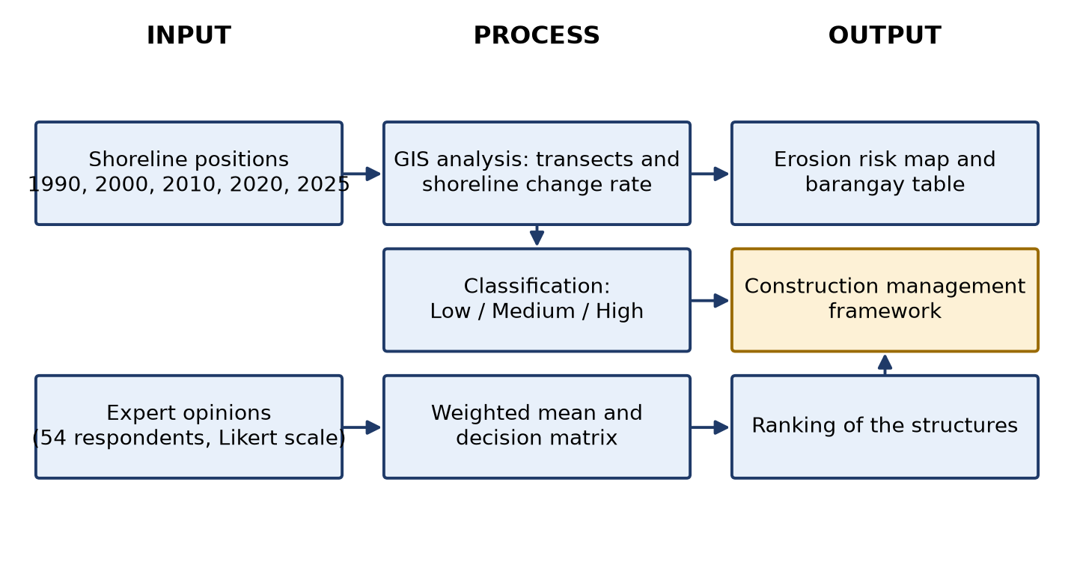
Figure 1.1. Conceptual framework of the study

Hypothesis of the Study
The following hypothesis was tested at the 0.05 level of significance:
• Ho1: There is no significant difference in the perceived suitability (efficiency and feasibility) among the shoreline protection structures evaluated by the expert respondents.
• Ha1: There is a significant difference in the perceived suitability (efficiency and feasibility) among the shoreline protection structures evaluated by the expert respondents.
The questionnaire asked each expert to rate every structure once for the study area as a whole. It did not ask for separate ratings at Low, Medium and High erosion; therefore the hypothesis compares the structures with one another, and the matching of structures to risk levels in the framework is presented as the researchers’ proposal based on the ratings and the literature (Chapter IV).

Significance of the Study
This study will benefit various stakeholders because it proposes the creation of a construction management framework in the context of coastal erosion factors in Aparri.
For local government units (LGUs) and policymakers, this will become a useful framework in their efforts to manage the coastlines and make plans accordingly in terms of priority allocation of budget to different locations that have higher erosion risk levels than others.
For the coastal communities of Aparri, Cagayan, this study will contribute to developing more effective ways to address the problem of coastal erosion to minimize the risks associated with it and safeguard the lives, properties, and livelihoods of people in the community.
For civil engineers and construction practitioners, who are provided in the research with the risk-based construction management framework supported by coastal erosion factors that may serve as an instrument of their work related to shoreline protection.
For students and teachers, especially those pursuing civil engineering studies are also potential beneficiaries, as the research will be considered by them as a reference concerning coastal erosion analysis, risk classification and construction management.
For future researchers, this research offers insights for developing a framework for assessing coastal erosion, classifying risks, and management of construction. The approach and results presented in this study can also be adopted or improved to be used in different coastal areas that experience similar issues with coastal erosion.

Scope and Delimitation
This research deals with a construction management framework for shoreline protection structures along the open, sea-facing coast of the coastal barangays of Aparri, Cagayan, namely Linao, Maura, Punta, San Antonio, Bulala Sur, Bulala Norte, Dodan and Paddaya, which together form a continuous shoreline experiencing coastal erosion.
The erosion risk level was determined from the shoreline change rate between 1990 and 2025 using shoreline positions of 1990, 2000, 2010, 2020 and 2025. The classes therefore describe the speed of shoreline movement only; they do not measure the exposure of buildings, roads or people, or the physical condition of existing structures. The banks of the Cagayan River mouth, where the shoreline is also shaped by river discharge, were separated from the open coast and were not classified.
The efficiency and feasibility of shoreline protection structures were evaluated, compared and ranked through the weighted mean of expert judgment. The study did not design or build any structure, did not perform physical or numerical modeling of waves and sediments, and did not include field measurements of coastal erosion factors.

Definition of Terms
Accretion. Seaward movement of the shoreline; the beach grows. In this study it has a positive rate.
Anthropogenic. Caused by human activities, for example coastal development or sand extraction.
Baseline. A reference line drawn on land, behind all shorelines, from which distances to each shoreline are measured.
Coastal Erosion. The wearing away of the coast so that the shoreline moves toward the land.
Coastal Erosion Factors. Natural and human influences that affect shoreline behavior, such as waves, tides, sediment supply, sea-level rise, storms and coastal development.
Construction Management Framework (CMF). An organized set of steps and requirements that guides the planning, design, construction and monitoring of shoreline protection structures.
Cronbach’s Alpha. A number from 0 to 1 that shows whether the items of a questionnaire give consistent results. A value of 0.70 or more is considered acceptable.
End Point Rate (EPR). The distance the shoreline moved between the first and the last year, divided by the number of years. A negative EPR means erosion (landward movement); a positive EPR means accretion.
Erosion Risk Map. A map that colors each stretch of shoreline as Low, Medium or High according to its erosion rate, to show where attention is needed first.
Geographic Information System (GIS). Computer software for storing, measuring and mapping data that have a location, such as shorelines.
Google Earth Engine. A free online service of Google for processing satellite images.
Hybrid Engineering. Combining hard structures (for example a seawall) with soft, natural measures (for example mangroves).
Landsat. A series of Earth-observation satellites whose images have a pixel size of 30 m.
Likert Scale. A rating scale; here 1 (Not Appropriate) to 5 (Highly Appropriate).
Linear Regression Rate (LRR). The shoreline change rate obtained by fitting a straight line through the shoreline positions of all years.
Net Shoreline Movement (NSM). The total distance, in meters, between the earliest and the latest shoreline along a transect.
Normalized Difference Water Index (NDWI). A value computed from satellite image bands that separates water from land.
Open Coast. The sea-facing shoreline, as distinguished from the banks of a river mouth.
Pixel. One square cell of a satellite image; for Landsat it measures 30 m by 30 m.
Scouring. The removal of sand or soil at the base of a structure by waves or currents, which can undermine the structure.
Shoreline. The line where land meets the sea, used as a reference to track changes along the coast.
Shoreline Protection Structures. Man-made or nature-based works that reduce shoreline erosion: seawalls, revetments, riprap, breakwaters and mangrove rehabilitation.
Transect. A straight line drawn across the coast at right angles to the baseline, along which the position of each year’s shoreline is measured.
Weighted Mean. The average of ratings in which each rating is multiplied by how many respondents gave it.

CHAPTER II
REVIEW OF RELATED LITERATURE

Coastal Erosion Assessment
Coastal erosion is a dynamic geomorphological process involving the gradual removal of shoreline materials through the action of waves, tides, currents, storm surges, and sea-level rise. Human activities, such as coastal development, land reclamation, sand mining, and the construction of coastal infrastructure, further accelerate shoreline retreat by disrupting the natural sediment transport system. As climate change continues to intensify coastal hazards, shoreline erosion has become one of the most pressing environmental concerns worldwide because of its impacts on coastal ecosystems, infrastructure, and communities (Tsiakos, C. A. D., & Chalkias, C., 2023).
Recent studies emphasize that understanding coastal erosion requires continuous monitoring of shoreline movement over time. According to Tsiakos, C. A. D., & Chalkias,.
C. (2023), shoreline retreat results from the combined effects of natural coastal processes and anthropogenic pressures. Their review explained that increasing sea levels, stronger storm events, and expanding coastal development have accelerated shoreline changes in many parts of the world, highlighting the need for accurate and timely monitoring to support sustainable coastal management. They further noted that advances in remote sensing technologies have significantly improved the ability of researchers to detect, monitor, and quantify shoreline changes across various coastal environments.
Similarly, Cavalli, R. M. (2024) conducted a systematic review of remote sensing applications in coastal environments and found that coastal zones are highly vulnerable because they are continuously influenced by interactions among terrestrial, marine, atmospheric, and human-induced processes. The review demonstrated that remote sensing has become an essential tool for monitoring coastal phenomena due to its ability to provide consistent spatial and temporal observations over large geographic areas. The author also emphasized that regular monitoring of shoreline conditions enables early identification of erosion-prone areas, allowing government agencies and coastal managers to implement evidence-based mitigation and adaptation strategies.
The growing importance of shoreline monitoring is likewise supported by Sun, W. et al. (2023), who explained that coastlines represent one of the most dynamic boundaries on Earth because they constantly respond to natural processes and human activities. Their review highlighted that accurate coastline extraction is fundamental for assessing shoreline evolution, evaluating erosion and accretion patterns, and supporting coastal planning and hazard mitigation. The authors further noted that recent developments in satellite remote sensing have greatly improved the precision and efficiency of shoreline mapping, enabling researchers to perform long-term analyses of coastal change.
Furthermore, the need to develop a local management framework becomes more critical because of the “triple whammy” hitting Aparri, which includes rising sea levels, heavier monsoon seasons, and the distinctive sediment processes at the mouth of the Cagayan River. Civil engineering deals with the designs for constructing seawalls and revetments, while construction management takes care of making them last.
Among the most geographically vulnerable areas in the Philippines is the Municipality of Aparri in the province of Cagayan, which is situated at the delta of.
Cagayan River, considered to be the longest river system in the entire country, and is also exposed to the strong energy currents of the Babuyan Channel. This area has been experiencing a constant battle between the discharge of water from the river and the energy currents coming from the sea, wherein in recent years the latter has prevailed by causing substantial loss of land.
Coastal erosion can be caused by natural factors as well as anthropogenic factors. According to Felipe, A. J. et al. (2026), the erosion processes with the lower Cagayan River are caused by the presence of very high levels of sand and silt (above 95%). Additionally, International Tests conducted by Woodroffe, et al. (2025) reveal that “sediment starvation”, which usually results from upstream practices like mining and building dams, is the main reason for coastal erosion. When there is not enough sand being brought by the river to the river mouth in Aparri, there will be an intrusion by the sea because the seawalls constructed have not taken this scenario into consideration.
An important and frequently underestimated phenomenon behind erosion is the relative sea level rise (RSLR) coupled with land subsidence. According to OECD (2026) and Nature Communications (2022), while global sea levels rise, some coasts in the Philippines are actually subsiding because of excessive use of groundwater resources and sediment compaction in river deltas. In estuaries such as Aparri, this “doubled effect” creates deeper water near the shore where high-energy waves may occur without being weakened by the seafloor. As a result, such a situation increases the pace at which coastal infrastructure is undermined. According to Nerves, A. et al. (2024), the most vulnerable areas to change are those located along the coast at river deltas (such as Aparri). As was demonstrated through GIS maps, changes within the shoreline along such river delta outlets can exceed up to 150+ meters during a span of 30 years. [VERIFY CITATION]
Based on data from Calapini, W. D. et al. (2025), the rate of sea-level rise for the West Philippine Sea and Northern Luzon is measured to be 4-6 mm/yr, more than double the global rate. Coupled with land subsidence, seawalls, which are typically built at a certain height, can easily fail through overtopping. In high energy areas such as Aparri, vertical structures tend to promote erosion by reflecting waves, thereby creating scour holes at the bottom of the structures. This problem can be addressed through an approach based on a preference for slopping/staged revetment designs. [VERIFY CITATION]
In addition, an interference caused by man in terms of sediment movement has an important effect on the “starvation” of Aparri coastline. As revealed by research published in Elsevier’s Anthropocene (2023), the presence of large infrastructures and mining operations at the upper parts of the Cagayan River Basin has drastically altered the amount of sand carried to the river mouth. Whenever this natural movement of sedimentation is prevented, then the “longshore drift”will cause erosion by carrying away more sediments than it deposits. This is why contemporary construction models need to incorporate Sediment Impact Assessments (SIA), which will determine whether the shoreline structure will hasten erosion in other barangays.
The effect of extreme weather frequency plays an important role in the durability of the defenses located within northern Cagayan. As per the findings from Nieuwenhout,. [VERIFY CITATION]
C. et al. (2023), due to the clustering of typhoons, meaning several typhoons occurring successively, there would be no time for the beach to recover from its initial state post occurrence of only one storm. Such a process leads to weathering of concrete and dislodging of armor blocks of revetments.
The literature consistently demonstrates that coastal erosion is not only an environmental issue but also a significant socio-economic concern. Continuous shoreline monitoring provides scientific evidence necessary for coastal resource management, infrastructure protection, disaster risk reduction, and sustainable land-use planning. These findings support the present study which aims to assess shoreline changes and erosion rates using geospatial techniques to identify erosion-prone coastal areas and provide information that can assist local planning and coastal management decisions.

Remote Sensing, GIS and Erosion Analysis
Remote sensing and Geographic Information Systems (GIS) have become essential technologies for monitoring shoreline dynamics because they provide efficient, accurate, and cost-effective means of analyzing coastal changes over large spatial and temporal scales. Compared with conventional field surveys, satellite remote sensing enables repeated observations of coastal environments, while GIS facilitates the storage, processing, visualization, and analysis of spatial data. The integration of these technologies allows researchers to identify shoreline positions from multi-temporal satellite imagery, quantify shoreline movement, and evaluate erosion and accretion patterns with greater precision. These capabilities have made remote sensing and GIS indispensable tools in coastal management, environmental monitoring, and disaster risk reduction (Tsiakos, C. A. D., & Chalkias, C. 2023).
The authors explained that recent advances in remote sensing have significantly improved shoreline monitoring through the availability of high-resolution satellite imagery, machine learning algorithms, and GIS-based analytical techniques. The authors further stated that integrating remote sensing with GIS provides reliable spatial information for detecting shoreline retreat, assessing coastal erosion, and supporting evidence-based coastal planning and management.
Similarly, Cavalli, R. M. (2024) conducted a systematic review of remote sensing applications for coastal monitoring and found that satellite-derived data have become increasingly valuable for mapping coastal phenomena, including shoreline changes, coastal morphology, sediment dynamics, and environmental hazards. The review highlighted that remote sensing platforms provide continuous observations over extensive coastal regions, enabling researchers to monitor changes that would otherwise require significant time and financial resources through ground surveys. Furthermore, the study emphasized that integrating remotely sensed data with GIS enhances spatial analysis, allowing decision-makers to identify vulnerable coastal areas and develop appropriate mitigation strategies.
Supporting these findings, Sun, W. et al. (2023) reviewed recent developments in coastline extraction using remote sensing and reported that advances in Earth observation technologies have substantially improved the accuracy and efficiency of shoreline mapping. According to the authors, multi-temporal satellite imagery combined with GIS-based processing techniques enables researchers to monitor coastline evolution, quantify shoreline displacement, and evaluate coastal changes over extended periods.
They also emphasized that remote sensing-derived shorelines provide essential baseline information for coastal management, hazard assessment, and sustainable development planning.
Likewise, Zhou, X. et al. (2023) noted that coastlines extraction has become one of the most fundamental applications of remote sensing because coastline represents the interface between terrestrial and marine environments. Their review discussed numerous shoreline extraction approaches using optical satellite imagery and GIS techniques, concluding that advances in image processing and spatial analysis have significantly improved the reliability of coastline delineation. The authors further explained accurate shoreline extraction is critical for monitoring coastal evolution, assessing erosion hazards, and supporting coastal resource management.
The reviewed literature consistently demonstrates that remote sensing and GIS provide reliable, efficient, and scientifically accepted methods for shoreline monitoring and coastal erosion assessment. Their capability to analyze historical and contemporary shoreline positions using multi-temporal satellite imagery supports accurate measurement of shoreline changes and erosion rates. These findings provide a strong theoretical foundation for the present study, which employs GIS and remote sensing techniques to extract shoreline positions and analyze coastal erosion trends within the study area.

Erosion Classification
In contemporary coastal engineering literature, the shoreline is no longer conceptualized as a static, linear boundary, but rather as a highly dynamic, time-dependent socio-ecological interface where intense geomorphological exchanges occur between terrestrial and marine systems (Li, C., & Fang, S., 2026). Consequently, shoreline change is defined as the net spatial and temporal horizontal displacement of this boundary line, manifesting as a bidirectional process: landward retreat (erosion) or seaward advancement (accretion) (Gao, W. et al., 202).
Recent studies emphasize that modern shoreline change trends are governed by a complex compounding relationship between natural hydrodynamic forces and accelerating human interventions (Tora, Dkawlama, et al., 2026).
• Natural Drivers: Chronic sea-level rise, fluctuating wave energy distributions, tidal currents, and episodic severe weather events (such as typhoons and storm surges) cause rapid short-term morphological flux (Tikekar, Omkar, et al., 2026).
• Anthropogenic Drivers: Human activities- such as coastal urbanization, land reclamation, sand mining, and the construction of maritime structures like ports, jetties-distrupt natural longshore sediment transport (Elemin, S. A. et al., 2026). This disruption traps sediment on the updrift side while causing severe sediment starvation and accelerated erosion along downdrift coastal cells.
To establish a quantifiable matrix for coastal risk levels, the End Point Rate (EPR) method serves as a primary metric for determining the net annualized rate for shoreline change between two distinct historical positions. As utilized in this study, the mathematical formulation is expressed as:
Erosion Rate = 2 1.
Where S2 represents the spatial shoreline position in the later year, S1 denotes the initial baseline position in the earlier year, and T signifies the time interval expressed in years. Within this algebraic structure, the sign of the numerical output indicates the directional behavior of the coast: negative computational product signifies landward retreat (erosion), whereas a positive product yields localized sediment accumulation (accretion). The standard engineering unit of measurement for this velocity vector is expressed uniformly in meters per year (m/year).
The mathematical rationale for employing a difference-over-time model is extensively validated in global spatial remote sensing studies. Research utilizing the Digital Shoreline Analysis System (DSAS) framework confirms that the linear EPR approach is highly reliable when evaluating long-term coastal changes where data points are constrained to specific historical map epochs or multi-decadal aerial surveys ( Thieler, et al., 2009). Because the formula requires only two operational shoreline vectors, it avoids the statistical over complication that can occur when intermediate historical maps contain missing or highly fragmented spatial data (USGS,2023).
Furthermore, applications within the Philippine marine architecture confirm the reliability of this formula in analyzing highly active river deltas and estuarine environments. A geographic study conducted by Nerves et al. (2024) tracking deltaic changes in open bay regions demonstrated that dividing cross-shore movement (ΔS) by chronological duration (T) provides a mathematically rigorous, repeatable baseline for capturing structural risk trends. Their findings confirmed that calculating the delta of orthogonal shoreline distances over explicit time intervals accurately captures severe, localized erosion patterns driven by compounding monsoonal wave actions and deltaic sediment fluctuations. [VERIFY CITATION]
The classification of shoreline erosion into different risk levels is an essential component of coastal hazard assessment because it enables researchers and decision-makers to identify areas requiring varying levels of intervention. Erosion rate thresholds provide a standardized basis for interpreting shoreline retreat and prioritizing coastal management strategies. Although, threshold values differ depending on coastal characteristics and study objectives, several studies have established that increasing shoreline retreat rates correspond to increasing erosion susceptibility.
The United States Geological Survey (USGS, 2023) recognizes shoreline retreat rate as one of the primary indicators of coastal vulnerability. According to the agency, sustained shoreline retreat of several meters per year reflects active coastal erosion, while higher retreat rates indicate severe coastal instability that may threaten infrastructures, ecosystems, and coastal communities. The USGS recommends that shoreline change rates must be incorporated into coastal hazard mapping to identify areas requiring management and protection measures. This reinforces the use of erosion rate thresholds as a basis for classifying shoreline erosion risk.
A global assessment conducted by Luijendijk et al. (2018) analyzed approximately 33 years of satellite-derived shoreline data covering more than 100,000 km. of sandy coastlines worldwide. This study found that coastlines experiencing shoreline retreat greater than 5 m/year represent rapidly eroding environments, while lower retreat rates generally indicate relatively stable shoreline conditions. The researchers emphasized that areas with rapid erosion require priority attention because of their greater exposure to coastal hazards and land loss. These findings provide scientific support for using greater than 5 m/year as the threshold for high erosion risk. [VERIFY CITATION]
Collectively, these studies demonstrate that shoreline erosion rates provide a scientifically sound basis for classifying erosion susceptibility and supporting coastal management decisions. Guided by these findings, an existing study by Osondu, I. et al. (2025) also adopts an erosion-risk classification of Low (<2 m/year), Medium (2-5 m/year), and High (>5 m/year). The authors explained that these thresholds were adopted from established coastal risk assessment frameworks to distinguish shoreline segments according to erosion severity. Coastlines experiencing erosion greater than 5 m/year were identified as highly vulnerable because they exhibited rapid shoreline retreat associated with strong hydrodynamic processes, while erosion rates below 2 m/year represented relatively stable shoreline conditions. Moderate erosion rates of 2-5 m/year indicated shoreline sections undergoing noticeable retreat that require continuous monitoring and appropriate coastal management measures.

Risk Classification
In the architectural design of resilient coastal defense systems, the Erosion Rate serves as an objective, empirical measure of physical hazard intensity. It captures the long-term, backshore horizontal retreat of a boundary line under unconstrained conditions, typically computed via change models like the End Point Rate (EPR).
However, a high erosion rate does not automatically equate to a high Erosion Risk. As established by comprehensive natural disaster risk frameworks, Erosion Risk is a multi-dimensional function that represents the potential for real asset loss, environmental degradation, or structural failure when a physical hazard intersects with human receptors, socioeconomic exposure, and structural vulnerability indicators (Ouyang & Wang, 2024).
For instance, a natural, unpopulated mangrove zone experiencing a rapid horizontal retreat of >5 m/yr exhibits a high erosion rate but presents a relatively low erosion risk due to its inherent ecological buffer and the absence of high-value structural assets. Conversely, a heavily built-up urban center or vital port facility situated along an estuary experiencing a lower retreat velocity of only 1 m/yr can represent an exceptionally high erosion risk because the local infrastructure has high exposure and susceptibility to immediate scouring, undermining, or structural collapse. Contemporary coastal management strategies emphasize that framework development must transition away from using raw physical baseline velocities alone, instead integrating complex exposure and vulnerability dimensions to prioritize structural implementations effectively (Ouyang & Wang, 2024). For instance, a natural, unpopulated mangrove zone experiencing a rapid horizontal retreat of >5 m/yr exhibits a high erosion rate but presents a relatively low erosion risk due to its inherent ecological buffer and the absence of high-value structural assets. Conversely, a heavily built-up urban center or vital port facility situated along an estuary experiencing a lower retreat velocity of only 1 m/yr can represent an exceptionally high erosion risk because the local infrastructure has high exposure and susceptibility to immediate scouring, undermining, or structural collapse.
Contemporary coastal management strategies emphasize that framework development must transition away from using raw physical baseline velocities alone, instead integrating complex exposure and vulnerability dimensions to prioritize structural implementations effectively (Ouyang & Wang, 2024).

Coastal Risk Mapping
Coastal risk mapping has become an essential component of shoreline management because it transforms quantitative erosion information into spatially explicit products that facilitate decision-making. By integrating shoreline change data, erosion-rate classifications, geographic information systems (GIS), coastal risk maps enable planners to identify erosion hotspots and visualize the spatial distribution of areas requiring intervention. Compared with tabular results, risk maps provide a clearer representation of the severity and extent of coastal hazards, allowing decision-makers to prioritize monitoring and mitigation efforts more effectively (Tzepkenlis, A. et al., 2022).
Recent studies demonstrate the growing application of GIS in coastal risk mapping. The authors developed an integrated coastal monitoring system that combined remote sensing, GIS, and machine learning to monitor coastal hazards, including shoreline erosion. Their study emphasized that spatial monitoring systems improve the detection of erosion hotspots and support evidence-based coastal management by integrating multiple geospatial datasets into a unified decision-making support framework.
Similarly, Thirumurthy, S. et al. (2022) integrated GIS with multi-criteria analysis to produce coastal vulnerability maps that identified areas with varying levels of susceptibility to coastal hazards. Their findings demonstrated that GIS-based spatial classification enables coastal managers to distinguish between low-, medium-, and high-risk zones, thereby improving planning and resource allocation.
Likewise, Igbokwe, J. I. et al. (2024) utilized GIS and the Analytic Hierarchy Process (AHP) to model and map coastal erosion vulnerability. The study concluded that thematic erosion-risk maps provide an effective basis for identifying critical shoreline sections and developing appropriate management strategies.
In the planning phase of coastal engineering, deciding which structural or non-structural intervention is most appropriate relies heavily on Multi-Criteria Decision Analysis (MCDA). As researchers globally seek to balance ecological impact, economic cost, and engineering efficiency, quantitative decision matrices have become standard.
The reviewed literature supports the present study because the classified erosion rates are likewise converted into GIS-based coastal risk maps. Presenting erosion-risk classes spatially enables the identification of erosion hotspots and provides a practical tool for coastal planning, monitoring, and decision-making.

Prioritization of Coastal Management Areas
The identification of priority coastal management areas is a fundamental step in erosion-risk assessment because coastal resources available for mitigation are often limited. Rather than implementing interventions uniformly across an entire coastline, management efforts are commonly directed toward shoreline segments exhibiting the greatest erosion severity and potential impacts. Prioritization enables government agencies and coastal managers to allocate financial, technical, and environmental resources more efficiently while maximizing the effectiveness of erosion mitigation programs (Cao, C. et al., 2022).
Recent literature emphasizes the importance of prioritizing erosion-prone areas through spatial decision-supported approaches. Cao, C. et al., 2022 investigated the evolution of coastal erosion vulnerability in the Pearl River Estuary and demonstrated that identifying highly vulnerable shoreline sections provides valuable information for planning adaptive coastal management measures. The authors highlighted that spatial prioritization enables decision-makers to focus interventions on shoreline segments experiencing the most significant erosion pressures.
Furthermore, Tzepkenlis, A. et al. (2022) emphasized that integrated coastal monitoring systems not only identify hazard-prone locations but also function as decision-support tools that assist policymakers in determining where management actions should be implemented first. The study demonstrated that spatial prioritization strengthens coastal resilience by enabling timely and targeted interventions.
The reviewed studies support the present research because, after classifying shoreline erosion risk, the identified high-risk coastal segments serve as the basis for determining priority management areas. This approach provides a scientific basis for recommending which shoreline sections require immediate attention and supports evidence-based coastal planning.

Coastal Protection and Management Strategies
Coastal protection strategies are implemented to minimize shoreline erosion, reduce the impacts of coastal hazards, and enhance the resilience of coastal communities and ecosystems. Recent literature classifies coastal protection measures into hard engineering, soft engineering (nature-based solutions), and hybrid approaches, emphasizing that no single strategy is universally applicable because coastal environments differ in geomorphology, hydrodynamic conditions, sediment characteristics, and land use. Consequently, the selection of an appropriate coastal protection measure should be based on site-specific conditions and the severity of shoreline erosion (Amos, D., & Akib, S., 2023).

Hard Engineering Approaches
Hard engineering approaches involve the construction of permanent structures that protect coastlines by resisting wave forces and reducing shoreline retreat. Common examples include seawalls, revetments, groynes, detached breakwaters, and bulkheads. These structures are widely implemented in densely populated coastal areas where critical infrastructure, transportation networks, and residential communities require immediate protection from erosion and coastal flooding. Although hard engineering provides effective shoreline stabilization, it may interrupt natural sediment transport, increase erosion in adjacent coastal areas, and require substantial construction and maintenance costs. Therefore, recent studies recommend that structural interventions be implemented only after comprehensive coastal assessment and engineering evaluation (Amos, D., & Akib, S., 2023).

Soft Engineering Approaches
Soft engineering approaches utilize natural processes and ecosystem restoration to reduce shoreline erosion while maintaining ecological integrity. These measures include beach nourishment, dune restoration, mangrove rehabilitation, saltmarsh restoration, seagrass conservation, and living shorelines. Unlike conventional structural defenses, soft engineering techniques enhance sediment retention, dissipate wave energy, improve biodiversity, and provide multiple ecosystem services. Jordan, P., & Fröhle, P. (2022) emphasized that coastal ecosystems function as effective nature-based solutions by providing shoreline stabilization while simultaneously conserving coastal habitats. Likewise, Perricone, V. et al. (2023) reported that mangroves, coral reefs, oyster reefs, salt marshes, seagrasses, and other coastal ecosystems significantly attenuate wave energy and contribute to long-term shoreline protection,making them sustainable alternatives or complements to conventional engineering structures.

Hybrid Coastal Protection Approaches
Hybrid coastal protection combines conventional engineering structures with nature-based solutions to achieve both structural stability and ecological sustainability. Rather than relying solely on hard or soft engineering, hybrid systems integrate engineered defenses with natural coastal ecosystems to enhance shoreline resilience under changing climatic conditions. Singhvi, A. et al. (2022) described this concept as a continuum ranging from traditional “grey” infrastructure to fully “green” nature-based interventions, emphasizing that integrated approaches provide greater adaptability to sea-level rise and future coastal hazards. Similarly, Perricone, V. et al. (2023) concluded that combining engineering design with natural coastal ecosystems improves coastal protection while preserving environmental functions and ecosystem services.

Selection of Appropriate Coastal Protection Measures
The selection of an appropriate coastal protection strategy should consider erosion severity, shoreline morphology, hydrodynamic conditions, environmental sensitivity, socio-economic factors, and the importance of exposed coastal assets. Amos, D., & Akib, S., 2023 emphasized that coastal protection measures should be selected according to site-specific coastal behavior because different shoreline environments respond differently to engineering interventions. Accordingly, recent literature recommends adaptive coastal management that combines scientific risk assessment with appropriate engineering interventions to maximize both shoreline protection and environmental sustainability.
The reviewed literature supports the present study because the identified coastal erosion risk levels provide the scientific basis for recommending suitable coastal protection measures. By matching erosion severity with appropriate hard engineering, soft engineering, or hybrid approaches, the proposed framework facilitates evidence-based decision-making for sustainable coastal management.

Instrument Validation and Reliability Assessment
According to Sauvé, P. et al. (2022), selecting appropriate Coastal Defence Measures (CDMs)-such as concrete seawalls, rock armour, or soft interventions-is inherently complex due to conflicting stakeholder interests and localized wave dynamics. Their study establishes that an expert-driven weighting phase integrated into a systematic decision matrix effectively minimizes bias and translates qualitative engineering judgement into a prioritized ranking system. This provides rigorous theoretical validation for using expert questionnaires scored on numerical scales (e.g., Likert scales and weighted means) to calculate structural suitability in targeted coastal areas.
Decision matrices are widely used in engineering and infrastructure planning to evaluate and rank alternative solutions based on multiple criteria. They provide a systematic and transparent approach for comparing alternatives by assigning scores to predetermined evaluation criteria, enabling decision-makers to identify the most suitable option. The method is particularly useful when technical, economic, environmental, and operational factors must be considered simultaneously (Dodgson, J. S. et al., 2009).
Furthermore, global adaptation initiatives emphasize that mapping indicators of technology options into a standardized decision matrix ensures that the overall value scores directly reflect localized environmental pressures. When criteria weights are distributed systematically (where the cumulative sum of weights equals 1.0), the resulting total weighted scores provide a reliable, transparent ranking mechanism to select the most viable shoreline protection technology for vulnerable coastal zones (Wilson, E. Tenesee, and T. N. A. E. P. A. Liberia, 2019).
Developing a comprehensive construction management framework requires moving away from traditional, fragmented “design-and-forget” paradigms toward whole-life-cycle optimization. In marine construction, frameworks must reconcile policy constraints, socio-environmental factors, and local technical capacities.
Gu, J. et al. (2025) introduced a comprehensive “conflict-coordination framework” for coastal defense lines, proving that managing structural implementation across its lifecycle requires an interdisciplinary framework combining baseline technical capacity with site-specific risk assessments. The study reveals that integrating ecological metrics with hard engineering parameters (such as seawall positioning and structural durability) within a unified management framework successfully coordinates multi-objective outcomes-reducing environmental conflict intensity while maximizing structural resilience.
Instrument reliability is an important aspect of questionnaire development because it determines the consistency of the items in measuring the intended construct. A reliable instrument produces stable and consistent results, thereby increasing the credibility of the data collected. Among the available measures of reliability, Cronbach's Alpha is the most widely used statistic for evaluating the internal consistency of multi-item questionnaires (Taber, K. S., 2018). It measures the extent to which questionnaire items are correlated and collectively assess the same concept.
Methodological literature generally considers a Cronbach's Alpha coefficient of.
0.70 or higher as the minimum acceptable level of internal consistency, indicating that the questionnaire items reliably measure the intended construct (Taber, K. S., 2018). Therefore, the present study adopts Cronbach's Alpha to determine the reliability of the developed questionnaire before its administration to experts, ensuring that the instrument provides consistent and dependable measurements.

Dynamic Shoreline Vulnerabilities and Structural Performance in the Philippines
In the local context, the Department of Public Works and Highways (DPWH) sets baseline standard specifications for public infrastructure yet coastal structures in regions like Northern Luzon face unique field implementation vulnerabilities. This disconnect between conceptual design and actual construction workmanship often leads to premature failures during extreme weather events.
A post-disaster construction audit conducted by Narafu, T. et al. (2015) in the Philippines evaluated the performance of infrastructure under severe typhoon and surge forces, explicitly categorizing the main drivers of structural failure into poor quality of materials, deficit localized design, lack of post-construction maintenance, and poor workmanship during site execution. The study concluded that standard design guidelines alone are insufficient; there is a critical need for comprehensive capacity development and common structural management frameworks on-site to guide DPWH personnel and contractors throughout the actual construction phases.
Furthermore, engineering reliability assessments of Philippine coastal defenses emphasize that wave impact forces act significantly harsher on structural stability than standard terrestrial forces. Recent simulations of local mega-dikes show that resisting structural failures requires dynamic site management frameworks that account for localized wave elevations, embankment stability,and soil-sliding resistance, reinforcing the necessity of matching structural selection explicitly to coastal erosion risk levels (Bartolome, I. S., & Griño Jr, A., 2026).

Framework Development Process
Developing an effective framework for shoreline protection requires integrating scientific risk assessment with engineering planning, construction management, and long-term monitoring. Recent studies emphasize that coastal infrastructure should follow a systematic framework that begins with hazard assessment, continues through planning and design, and extends to implementation and post-construction evaluation to ensure sustainability and resilience against coastal hazards.

Synthesis
It is evident from the literature that coastal erosion is becoming an escalating geomatics and socioeconomic risk all around the world due to a series of interactions between nature-based hydrodynamics and human activities. In terms of methodology, the combination of Remote Sensing and Geographic Information Systems (GIS) with linear computing models like the End Point Rate (EPR) method has already been proven scientifically accurate for quantification of shoreline changes over decades and pinpointing areas with erosion risk. Moreover, the literature reveals the need for shifting risk assessment frameworks into multi-criteria analyses in order to consider not only physical speeds but also local vulnerabilities.
Despite these advancements, a critical examination of global and local literature reveals three major research gaps that remain unaddressed:
• Paradigm Gap Between Erosion Mapping and Structural Construction: Although there is a lot of information available on the geospatial analysis techniques used to map erosion rates and assess any natural or man-made structural protection measures, there is a clear gap between planning-level macro-analysis and actual construction implementation. All spatial analysis techniques are concerned with categorizing risks and making a passive map out of those, yet do not convert risk categorizations into a construction management paradigm that is required to withstand difficult estuary conditions.
• The Ineffectiveness and Inconsistency of Standard, Reactive Coastal Management Approaches: From a national perspective, prevailing coastal management practices have been known to have inherent weaknesses, typically identified as either too technical or lacking local environmental fine-tuning in various geomorphic environments. In locations such as Aparri, Cagayan, where there is a unique "triple whammy" effect of rapid sea level rise, intense monsoonal clustering, and extreme sediment starvation, design standards are always applied on a reactive basis after damage has been incurred. Literature suggests that in the absence of an alignment between physical risk level and engineering feasibility at the site level, standard structures are likely to fail due to overtopping, wave reflection scouring, and concrete weathering among others.
• Shortcomings in Dynamic Structural Integrity Decision-Making for Field Application: Post-disaster audits in the Philippines indicate that traditional infrastructure design guidelines are not sufficient enough to cope with the highly dynamic marine environment since they do not include capacity building and life cycle management of sites to direct DPWH officers and contractors in active construction stages. Literature is devoid of a well-defined decision-making matrix that uses the local expert judgment to rate, prioritize, and implement the use of hard, soft, and hybrid structures (e.g., seawalls, revetments, riprap, breakwaters, and mangroves) based purely on the quantitative risk matrix of low, moderate, and high erosion risks.
This research directly addresses these shortcomings by creating an integrated Construction Management Framework for Shoreline Protection Structures that is specific to the unique and dynamic nature of Aparri, Cagayan’s estuary environment. As opposed to simply creating a static risk assessment, this research integrates both the quantified GIS-based End Point Rate risk levels and qualitative expert analysis through the use of an explicit multi-criteria decision matrix. This Framework divides the construction process into specific, manageable phases from the beginning to the end of the project life cycle, including site evaluation, selection of a risk matched structure, localized design considerations, and long-term maintenance.

CHAPTER III
METHODOLOGY
This chapter explains how the study was carried out: the study area, the research design, the way the shoreline change was measured and classified, the survey of experts, and the statistical tools used.

3.1 General Overview
The study used a mixed-method design. The quantitative part measured the movement of the shoreline in a Geographic Information System and classified the erosion risk; the second part gathered the judgment of experts on five shoreline protection structures and analyzed it with the weighted mean. Both results were then combined into a construction management framework.

3.2 Study Area
The study was conducted in eight barangays of Aparri, Cagayan, namely Linao, Maura, Punta, San Antonio, Bulala Sur, Bulala Norte, Dodan and Paddaya. These barangays share one continuous shoreline and are influenced by the same coastal processes, including wave action, storm surges and monsoon winds. The open coast covered by the analysis measured about 20 km (Figure 3.1).
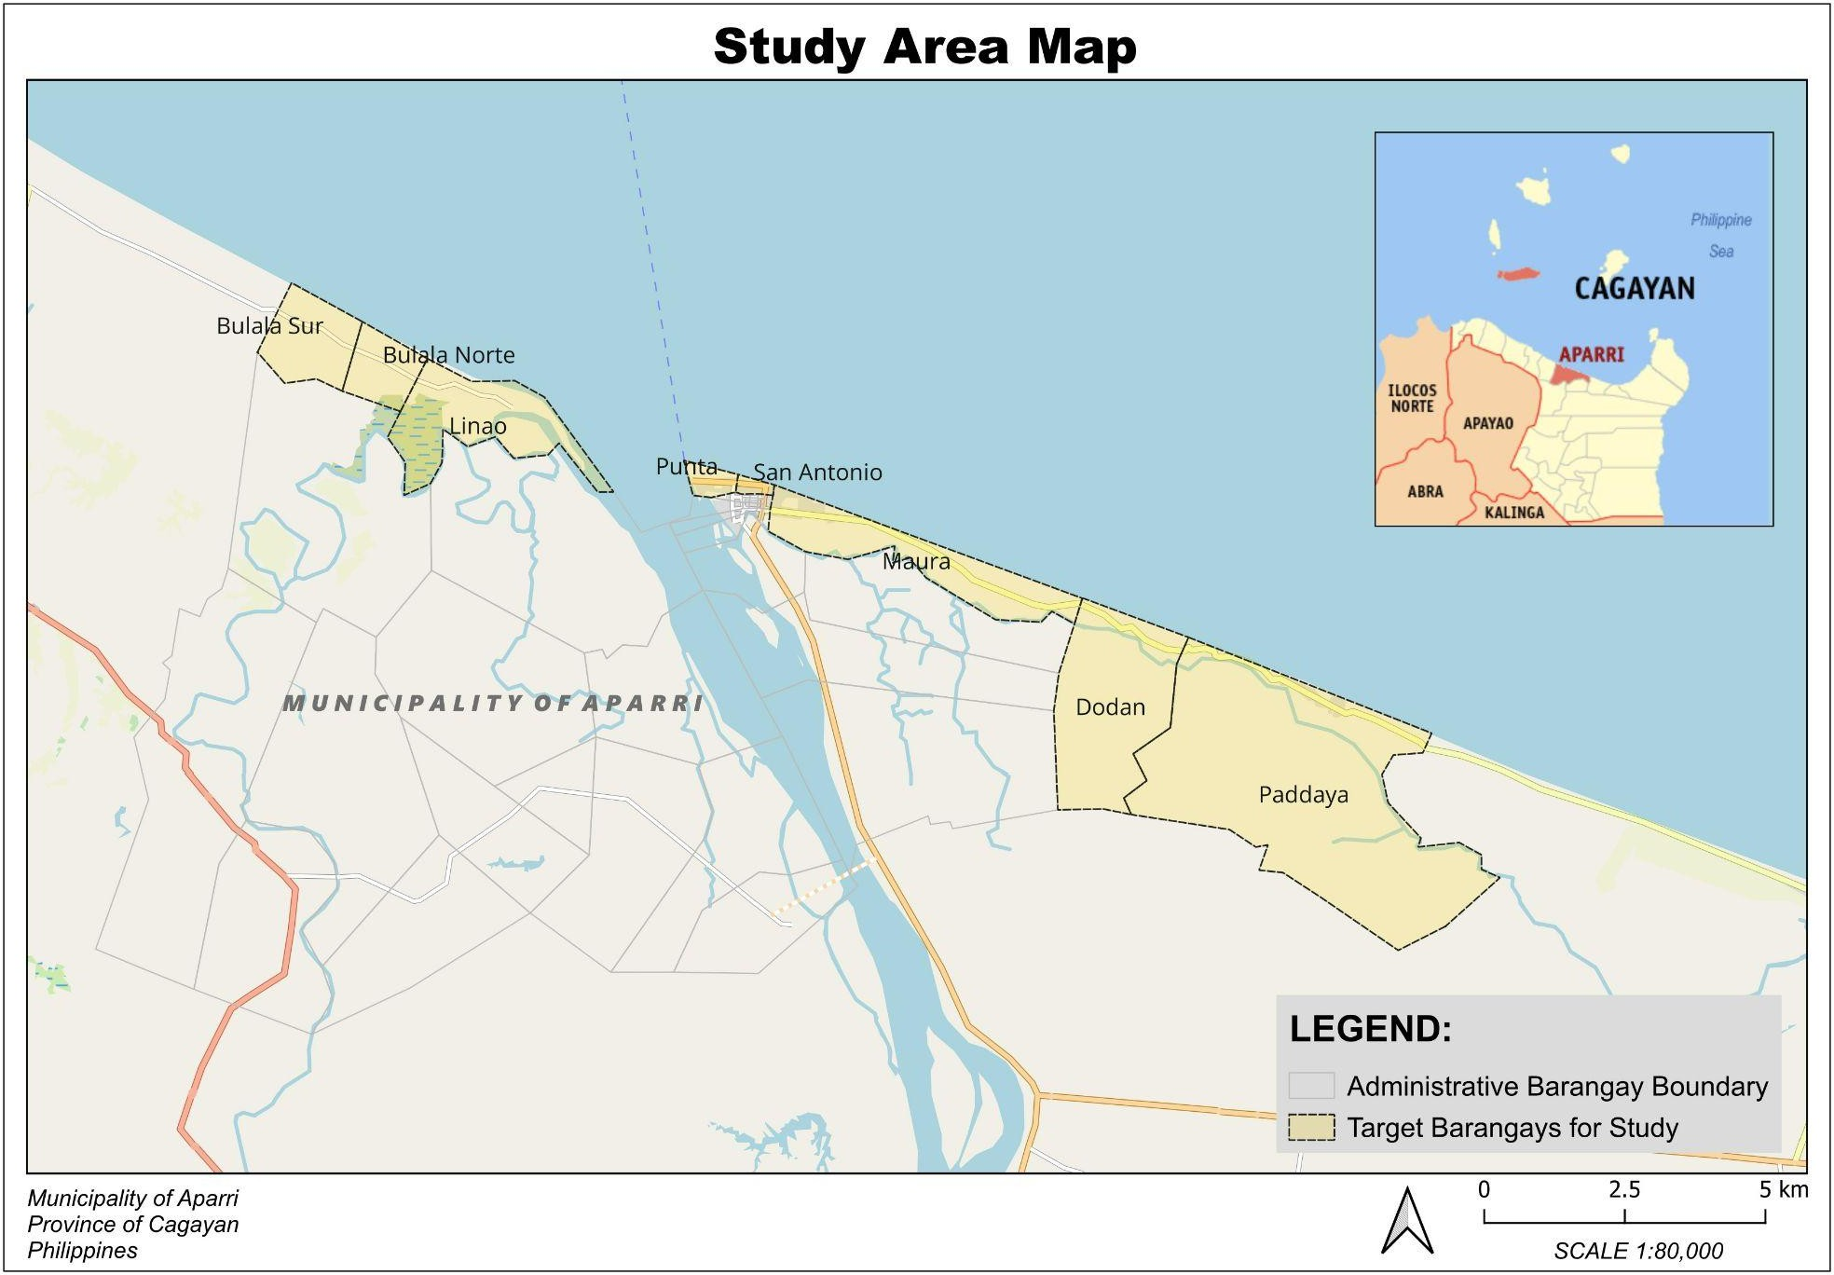
Figure 3.1. Map of Aparri, Cagayan

3.3 Research Design
The design combined quantitative GIS analysis and an expert survey. First, the shoreline change rate was computed and used to classify erosion risk as low, medium or high. Second, five shoreline protection structures were evaluated by experts and ranked using weighted means. Third, the two results were combined into a construction management framework suited to the local conditions of the selected parts of Aparri.

3.4 Shoreline Change and Risk Assessment Method

3.4.1 Shoreline data
Shoreline positions for 1990, 2000, 2010, 2020 and 2025 were represented as lines in a Geographic Information System. Two sets of shorelines were available. The main set consisted of shoreline lines supplied in the project files; the second set was traced from Landsat water-index images (Normalized Difference Water Index, McFeeters, 1996 [VERIFY CITATION]) prepared in Google Earth Engine (Gorelick et al., 2017 [VERIFY CITATION]) at 30 m resolution, and was used as an independent check. [STUDENTS: state who prepared the main shoreline lines, from which imagery (sensor and acquisition date of each year) and which shoreline indicator (for example the water line) was used; the project files do not record this.]

3.4.2 Preparation of the shoreline lines
All data were converted to the WGS 84 / UTM zone 51N coordinate system (EPSG:32651) so that distances and areas are in meters. The shoreline lines arrived as 19 loose pieces for the five years. A scripted and logged procedure removed stretches digitized twice within a year (18.3 km in 2010), joined ends closer than 5 m, removed small self-crossing loops (shorter than 50 m), and set aside one feature whose year could not be read, which was not analyzed. The cleaned lines were then divided into the open sea-facing coast and the banks of the Cagayan River mouth by a fixed geometric rule (distance of 350 m from the outer outline of all shorelines). Only the open coast, about 20 km per year, was classified, because river banks respond to river flow and sandbar movement and not to waves alone.

3.4.3 Baseline and transects
A baseline was drawn on the land side of all shorelines. It was made by smoothing the 1990 shoreline over 200 m and shifting it landward by the largest landward position of any year plus 150 m. The land side was decided by testing which side contained the barangay areas. Transects, straight lines at right angles to the baseline, were generated every 50 m (Figure 3.2). This produced 415 transects, of which 373 were valid, meaning that they crossed both the 1990 and the 2025 shoreline and did not cross a neighboring transect. This approach follows the Digital Shoreline Analysis System of the U.S. Geological Survey (Thieler et al., 2009).
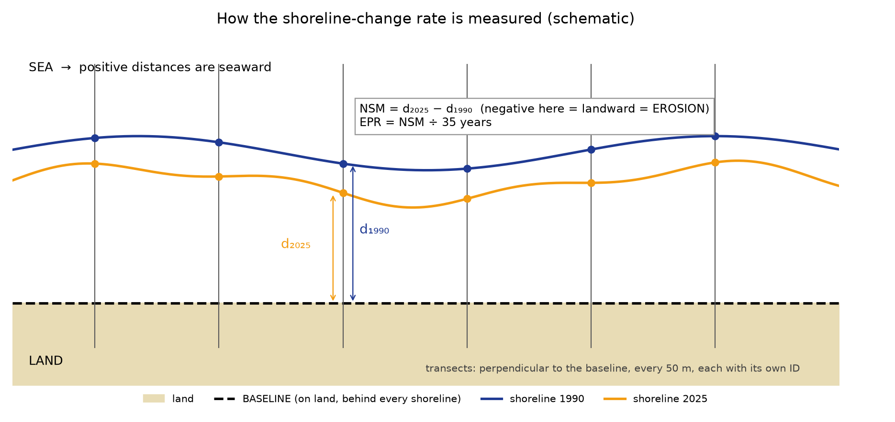
Figure 3.2. Baseline, transects and shoreline positions used to measure change

3.4.4 Shoreline change rates
On every transect the distance from the baseline to each year’s shoreline was measured. Three quantities were computed:
• Net Shoreline Movement (NSM) = distance in 2025 − distance in 1990, in meters;
• End Point Rate (EPR) = NSM ÷ T, where T = 35 years (2025 − 1990);
• Linear Regression Rate (LRR), the slope of the straight line fitted through the shoreline positions of all five years, reported beside the EPR.
EPR = (S₂ − S₁) / T
where S₂ is the shoreline position in the later year (2025), S₁ the position in the earlier year (1990) and T the time between them in years. A negative value means the shoreline moved landward (erosion); a positive value means it moved seaward (accretion). The exact acquisition dates of the images were not available; the difference of the years was used for T.

3.4.5 Classification and summary by barangay
Each transect was assigned an erosion risk class from the size of its landward rate (Table 3.1). Transects with positive EPR (accretion) were counted as Low and marked as accreting. Transects that crossed their neighbors, found near the river mouth, were left unclassified. The 2025 shoreline was cut into segments at the mid-points between transects, and each segment took the class of its transect. Segments were assigned to the nearest study barangay within 500 m. For each barangay the mean, minimum and maximum EPR and the length of shoreline in each class were computed. Areas in hectares were obtained as length multiplied by a 100 m coastal strip, so that kilometers remain the primary measure.
Table 3.1. Classification of coastal erosion risk level
Risk level | Erosion rate (m/year)
Low | less than 2
Medium | 2 to 5 (limits included)
High | more than 5
Note: Erosion rate is the size of a negative EPR. The limits follow the classes used in the literature reviewed in Chapter II (see Luijendijk et al., 2018 [VERIFY CITATION]).

3.4.6 Uncertainty and quality checks
The images have a pixel of 30 m. If each shoreline is uncertain by one pixel, a 35-year end-point rate is uncertain by √2 × 30 ÷ 35 = 1.21 m/year. Because no measured positional error was available, this value was used only as a what-if band to label the confidence of the classes; the classification was not adjusted by it. The computer procedure was tested with artificial shorelines of known movement (a straight coast retreating exactly 2.000 m/year or advancing 1.500 m/year, circular arcs, missing years, loops and reversed land/sea sides). It was also compared with the second shoreline set (Landsat-traced), and its sensitivity to the technical choices (transect spacing, smoothing, baseline distance, which crossing to keep) and to the class limits was tested.

3.5 Population and Sample
The respondents were people with knowledge and experience in coastal engineering, construction management and shoreline protection: licensed civil engineers, engineers of the Department of Public Works and Highways (DPWH), coastal or environmental engineers, contractors, and technical personnel of local government units (LGUs). Purposive sampling was used, so that only those qualified and knowledgeable about shoreline erosion and protection were selected. A total of 54 experts responded. [STUDENTS: state how many were invited, the response rate and the period of data gathering.]

3.6 Research Instrument
Three instruments were used. First, GIS software processed the spatial data and computed the shoreline change rates (QGIS and Python, with the settings listed in Appendix C). Second, an Expert Evaluation Questionnaire (Appendix B) collected the ratings of professionals on the efficiency and feasibility of the structures using a five-point Likert scale. Third, secondary data such as maps, reports and literature supported the interpretation of the results.

3.7 Data Gathering Procedure
The research adviser and the Dean of the College of Engineering and Architecture endorsed the study, and permission was sought from the offices concerned for the secondary data. The secondary data consisted of shoreline lines, satellite images and government records on the shorelines of Aparri for the years 1990, 2000, 2010, 2020 and 2025. The questionnaire was given to the chosen respondents after the purpose of the study had been explained, their participation was voluntary and their answers were assured to be confidential. The retrieved questionnaires were compiled and analyzed together with the shoreline results. Field observation of the shoreline was not part of the analysis reported here; it is listed as a limitation and a recommendation in Chapter V, and a field verification form is provided in Appendix E. [STUDENTS: confirm that the endorsement and permission letters were obtained as planned, and whether site visits were made; if yes, add the dates, barangays and findings here.]

3.8 Evaluation and Ranking of Shoreline Protection Structures
The respondents rated five structures (seawall, revetment, riprap, breakwater and mangrove rehabilitation) on six criteria: stability, effectiveness, cost of construction, durability, maintenance requirements and environmental impact. The weighted mean of each criterion was computed, and the six criterion means were averaged with equal weights into an overall mean that was entered in a decision matrix. The structure with the highest overall mean was ranked first. The overall means were interpreted with the scale in Table 3.2.
Table 3.2. Interpretation of the weighted mean
Scale | Description | Range | Interpretation
5 | Highly Appropriate | 4.21–5.00 | Very High
4 | Appropriate | 3.41–4.20 | High
3 | Moderately Appropriate | 2.61–3.40 | Moderate
2 | Slightly Appropriate | 1.81–2.60 | Low
1 | Not Appropriate | 1.00–1.80 | Very Low

3.9 Framework Development Process
The construction management framework was built by organizing the project phases of planning, design, construction, and monitoring and maintenance, and by specifying, for each erosion risk class, the structure options and the requirements of each phase. The structure options follow the expert ranking (Table 4.6) and the hard, soft and hybrid approaches reviewed in Chapter II. The framework is intended as a decision-making guide and not as a final engineering design.

3.10 Reliability of the Instruments
The reliability of the questionnaire was checked with Cronbach’s Alpha, the standard being 0.70 or higher (Taber, 2018). The coefficient is computed as
α = [k / (k − 1)] × [1 − (Σσᵢ² / σₜ²)]
where k is the number of items, σᵢ² the variance of each item and σₜ² the variance of the total score. [STUDENTS: report the Cronbach’s alpha of the pilot test and of the final data (the program in this project computes it as soon as the respondents’ answers are entered), or state that no pilot test was done.] For the GIS work, reliability was supported by repeating the processing on a second shoreline set, by tests with artificial shorelines of known change, and by sensitivity runs (Section 3.4.6).

3.11 Statistical Tools and Treatment
Descriptive statistics. Shoreline change rates were summarized by mean, minimum, maximum and median, and shown in tables, maps and graphs.
Frequency and percentage distribution. The respondents were described by profession, years of experience and familiarity with shoreline protection structures. Frequency is the number of respondents in a category; percentage is that number divided by the total of 54, multiplied by 100.
Weighted mean. The ratings were averaged with
x̄ = Σ(f · x) / N
where x̄ is the weighted mean, f the number of respondents giving a rating, x the rating (1 to 5) and N the total number of responses.
Test of the hypothesis. To test whether the structures differ in perceived suitability, the Friedman test is used because the same respondents rated all structures; pairs of structures are compared afterward with the Wilcoxon signed-rank test with Holm’s correction, at α = 0.05.

3.12 Ethical Consideration
The study will be done according to ethical principles that will ensure credible and responsible research in the creation of a construction management framework for shoreline protection structures in Aparri, Cagayan. Coordination with the proper Local Government Units and other concerned agencies will be done before proceeding with data gathering. Activities in the field will conform to current rules and will not intrude into the environment and people in the area.
Respondents such as engineers and technical specialists will participate in the research voluntarily. Informed consent will be sought, and the goals of the study and the part played by participants will be clearly stated. All information will be kept private and respondents will be assured of anonymity. The results of the data collected from fieldwork, GIS analysis, and expert opinions will be correctly recorded, safely stored, and only used for academic purposes without distortion.
Secondary sources of information will be cited appropriately to uphold academic integrity. Only authentic and ethically obtained information will be utilized. Being an engineering recommendation, the management framework to be created will be presented as a decision-making tool and not a finalized design.

CHAPTER IV
RESULTS AND DISCUSSION

4.1 Introduction
This chapter presents the results in the order of the objectives: the shoreline change and erosion risk classification (Objective 1), the profile of the respondents and the evaluation of the structures (Objectives 2 and 3), and the proposed construction management framework (Objective 4). In the tables, a negative rate means erosion and a positive rate means accretion.

4.2 Multi-Temporal Shoreline Change
Figure 4.1 shows the open-coast shorelines of 1990, 2000, 2010, 2020 and 2025. Along the straight coast from Bulala Sur to Bulala Norte the 1990 shoreline lies seaward of the later shorelines; the mean net movement from 1990 to 2025 was −96 m at Bulala Sur and −117 m at Bulala Norte, compared with −49 m at Maura, −68 m at Dodan and −49 m at Paddaya. At the Linao spit and the river mouth the lines diverge and cross each other; transects there are not comparable and were left unclassified. River banks are drawn dashed and were not analyzed.
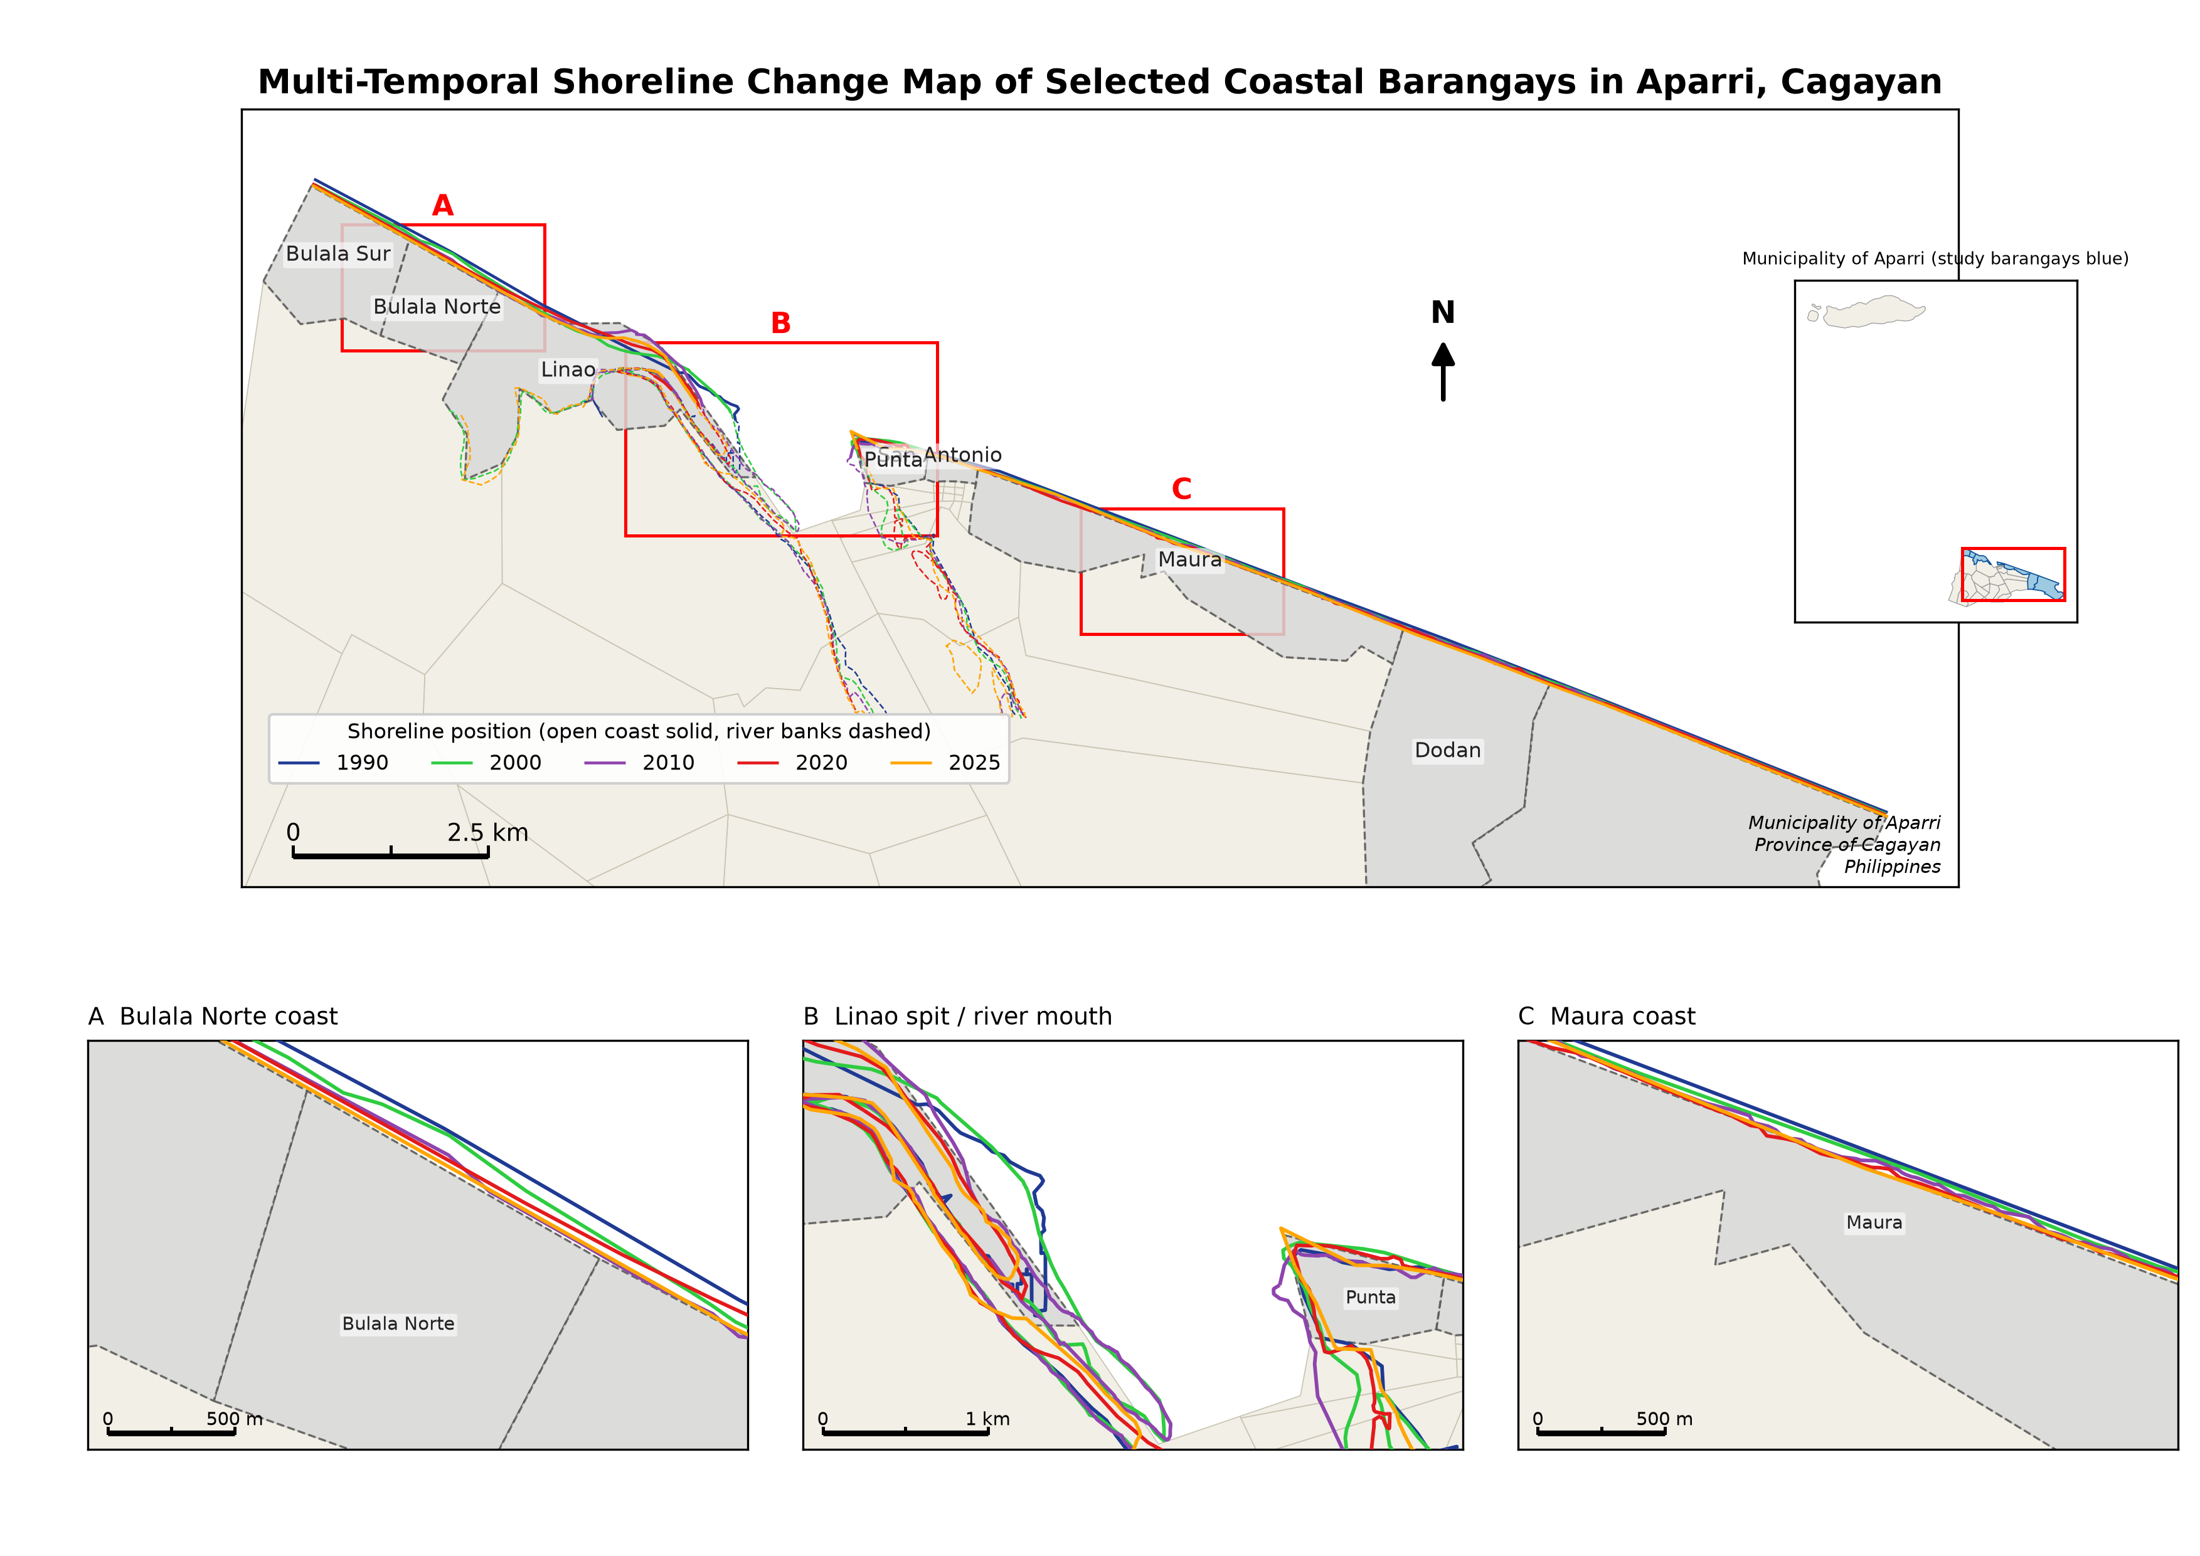
Figure 4.1. Multi-temporal shoreline change map of the selected coastal barangays in Aparri, Cagayan, 1990–2025

4.3 Computation of the Shoreline Change Rate
A total of 415 transects spaced 50 m apart were generated and 373 were valid. The End Point Rate from 1990 to 2025 of the valid transects ranged from −3.49 to +5.30 m/year (mean −1.57; median −1.46 m/year), and 94 % of the valid transects had a negative EPR, meaning landward movement. The largest erosion rate was 3.49 m/year; no valid transect reached the 5 m/year limit of the High class. Figure 4.3 shows the rate along the coast from the northwest end to Paddaya; the positive peak at Linao is the growing sand spit.
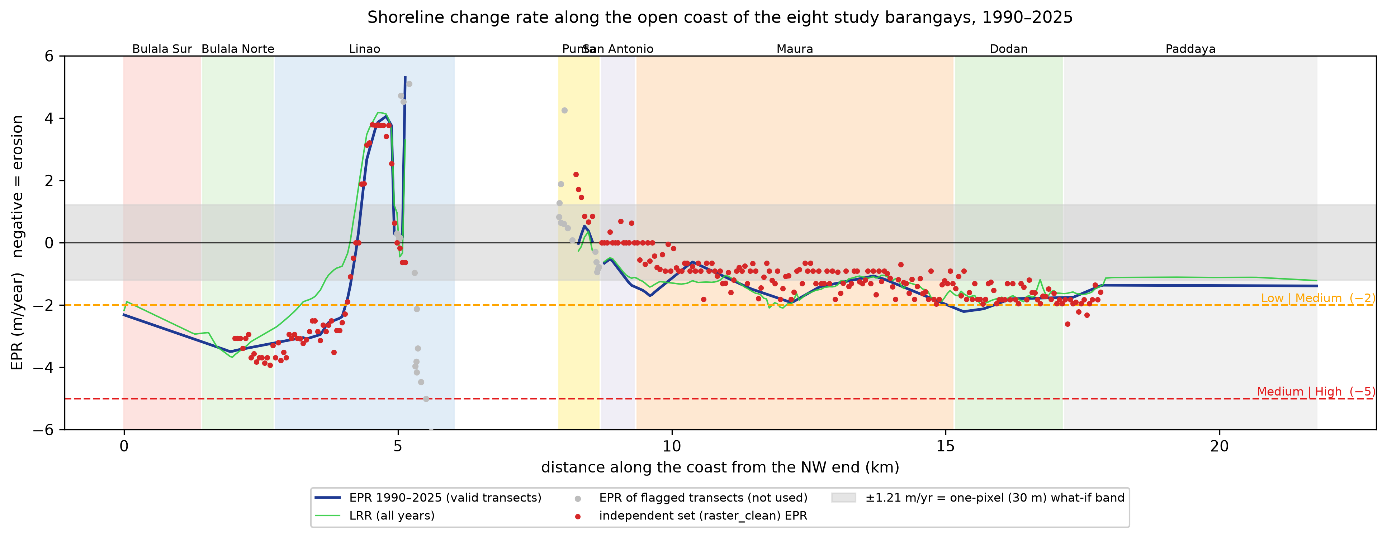
Figure 4.3. Shoreline change rate along the open coast of the eight study barangays, 1990–2025

4.4 Barangay-Level EPR and Coastal Erosion Risk Results
Table 4.1 gives the EPR and the risk-class areas of each barangay; Table 4.2 gives the same results in kilometers of shoreline, which is the primary measure, with the number of valid transects.
Table 4.1. Barangay-level EPR and coastal erosion risk results, 1990–2025
Barangay | Mean EPR (m/yr) | Min. EPR (m/yr) | Max. EPR (m/yr) | Low (ha) | Medium (ha) | High (ha)
Dodan | −1.93 | −2.21 | −1.76 | 12.50 | 7.49 | 0.00
Maura | −1.39 | −2.07 | −0.62 | 56.97 | 1.50 | 0.00
Bulala Norte | −3.35 | −3.49 | −3.19 | 0.00 | 13.46 | 0.00
San Antonio | −0.91 | −1.41 | −0.53 | 6.51 | 0.00 | 0.00
Linao | −0.70 | −3.21 | +5.30 | 12.79 | 13.09 | 0.00
Paddaya | −1.41 | −1.76 | −1.36 | 46.50 | 0.00 | 0.00
Punta | +0.19 | −0.05 | +0.53 | 3.02 | 0.00 | 0.00
Bulala Sur | −2.74 | −3.16 | −2.32 | 0.00 | 14.35 | 0.00
Hectares = kilometers of classified shoreline × a 100 m coastal strip.
Table 4.2. Kilometers of shoreline per risk class and number of transects
Barangay | Low (km) | Medium (km) | High (km) | Not classified (km) | Valid transects | Flagged transects
Dodan | 1.25 | 0.75 | 0.00 | 0.00 | 40 | 0
Maura | 5.70 | 0.15 | 0.00 | 0.00 | 117 | 0
Bulala Norte | 0.00 | 1.35 | 0.00 | 0.00 | 27 | 0
San Antonio | 0.65 | 0.00 | 0.00 | 0.00 | 13 | 0
Linao | 1.28 | 1.31 | 0.00 | 0.65 | 48 | 34
Paddaya | 4.65 | 0.00 | 0.00 | 0.00 | 93 | 0
Punta | 0.30 | 0.00 | 0.00 | 0.75 | 6 | 13
Bulala Sur | 0.00 | 1.44 | 0.00 | 0.00 | 29 | 1
Flagged transects crossed a neighbor (river mouth and spit) and were not classified.
In order of mean EPR, the largest landward movement was recorded at Bulala Norte (−3.35 m/year), followed by Bulala Sur (−2.74) and Dodan (−1.93). Of the 18.8 km of classified shoreline, 13.8 km (73 %) fell in the Low class, 5.0 km (27 %) in the Medium class and none in the High class; 1.4 km near the river mouth could not be classified. Bulala Norte and Bulala Sur are entirely Medium; Linao is mixed (1.28 km Low, 1.31 km Medium); Dodan has 0.75 km and Maura 0.15 km of Medium shoreline; Paddaya, San Antonio and Punta are Low. Punta’s mean rate is positive (+0.19 m/year) but only 6 of its 19 transects were valid.

4.5 Coastal Erosion Risk Map
Figure 4.2 shows the classified shoreline. Medium stretches lie along Bulala Sur and Bulala Norte, in parts of Linao, and in short stretches of Dodan and Maura; Low stretches occur elsewhere. Accreting segments (blue triangles) total 1.97 km, at Linao (1.26 km) and Punta (0.70 km). The High class does not occur on the open coast. Dotted segments have low confidence.
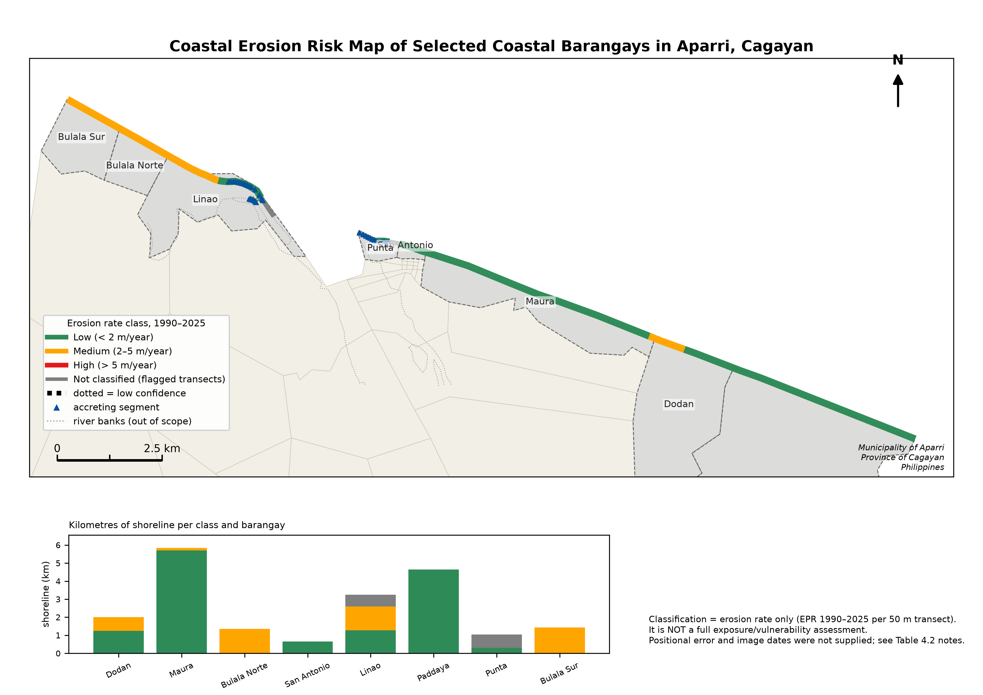
Figure 4.2. Coastal erosion risk map of the selected coastal barangays in Aparri, Cagayan

4.6 Discussion of the Coastal Erosion Risk Map
The Medium class along Bulala Sur and Bulala Norte shows where the shoreline retreated fastest during the 35 years. Since the movement is a long-term average, it does not show whether the retreat happened gradually or in a few storms. Linao’s result is mixed because the spit near the river mouth moves seaward while its neighboring stretch retreats.
How reliable is the classification? The class limits (2 and 5 m/year) lie close to the typical rates, so the map is more sensitive to the limits than to any technical choice. Changing the transect spacing, the smoothing, the baseline distance or the crossing rule changed the share of any class by at most 0.5 percentage points. Moving both class limits by ±0.5 m/year, however, changed the Medium share of the coast from 27 % to between 19 % and 48 % (Figure 4.4). With the one-pixel what-if band of ±1.21 m/year, the class of Maura, Bulala Norte, San Antonio, Paddaya, Punta and Bulala Sur did not change across the tests, while Dodan and Linao were not stable. A second, independent shoreline set gave the same class for 92 % of 253 transects (correlation of the rates r = 0.89; Figure 4.5).
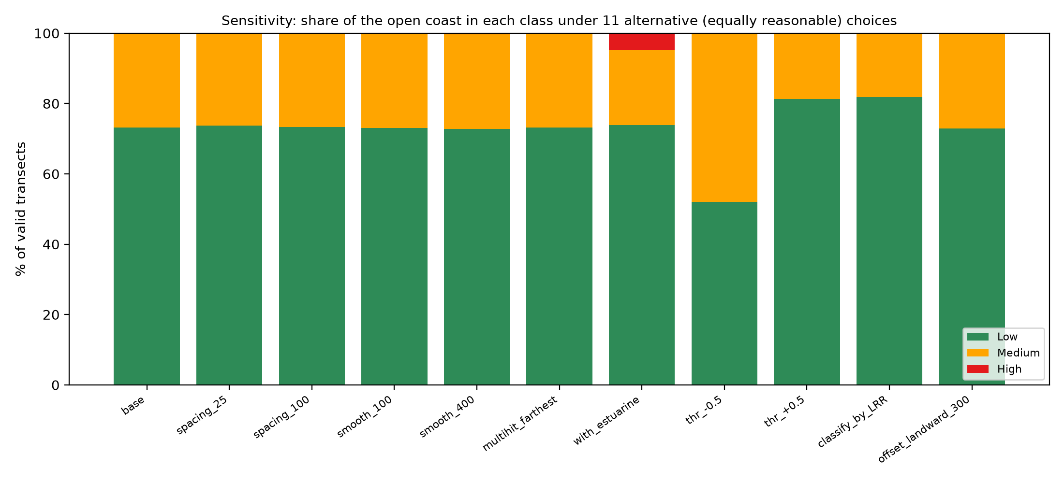
Figure 4.4. Share of the coast in each class under different technical choices and class limits
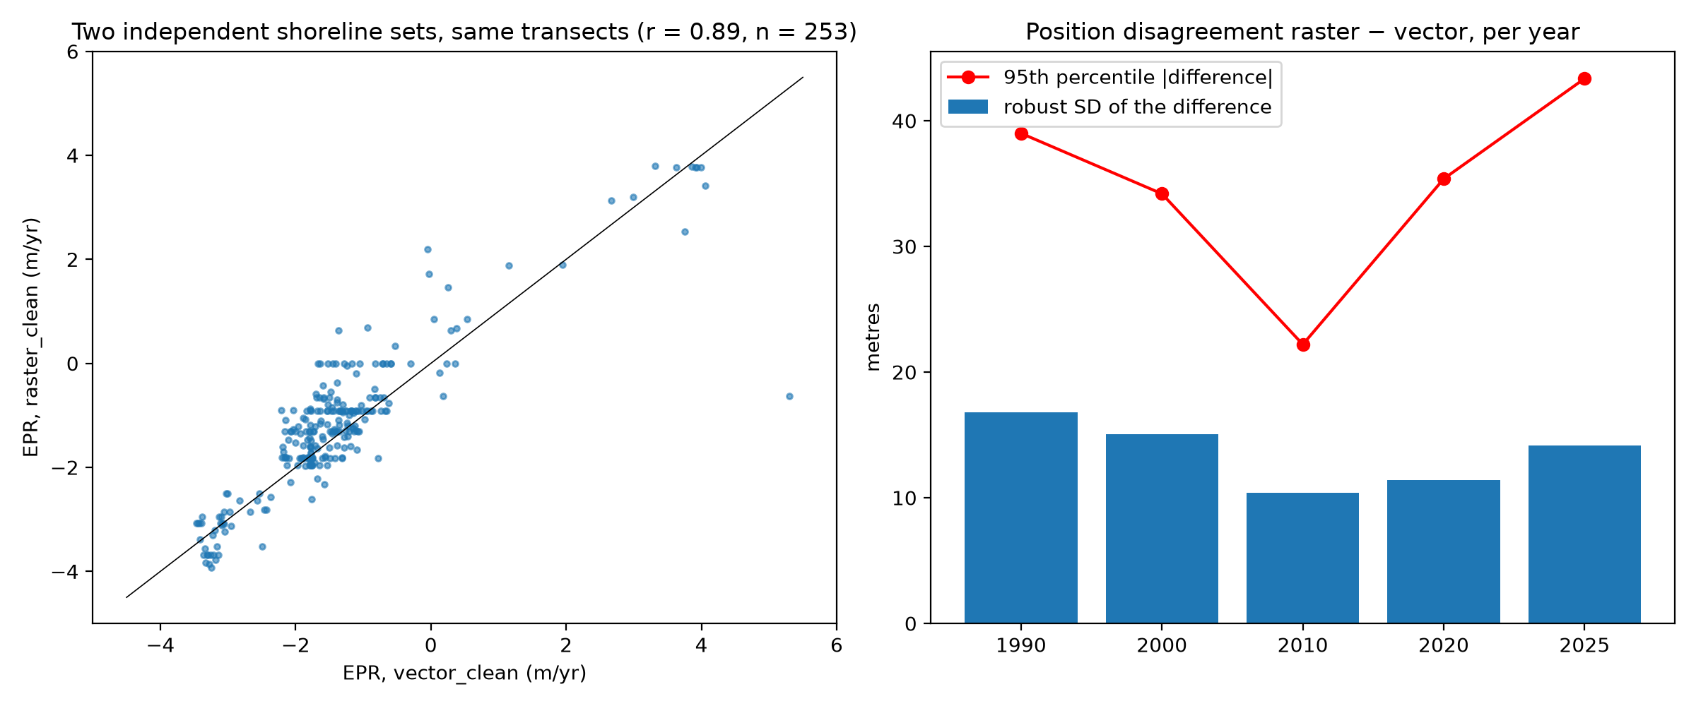
Figure 4.5. Agreement between the two independent shoreline sets
Difference from the proposal-stage map. The map shown at the proposal stage placed High risk along Bulala Sur and Bulala Norte. That map could not be reproduced from its source layers, and the rebuilt analysis gives Medium there (−2.74 and −3.35 m/year). The rebuilt result is the one reported in this thesis (Appendix D).

4.7 Barangays for First Field Inspection
To help the local government decide where to look first, the barangays were ordered by two things only: how fast the shoreline retreated (mean erosion rate) and how long the Medium or High stretch is. Each was scaled from 0 to 1 and the two were averaged with equal weights (Table 4.3). This order is not a risk index, since buildings, roads and people were not included.
Table 4.3. Order of barangays for first field inspection
Rank | Barangay | Mean erosion rate (m/yr) | Medium or High shoreline (km) | Score (0–1)
1 | Bulala Norte | 3.35 | 1.35 | 0.97
2 | Bulala Sur | 2.74 | 1.44 | 0.91
3 | Linao | 1.65 | 1.31 | 0.70
4 | Dodan | 1.93 | 0.75 | 0.55
5 | Maura | 1.39 | 0.15 | 0.26
6 | Paddaya | 1.41 | 0.00 | 0.21
7 | San Antonio | 0.91 | 0.00 | 0.13
8 | Punta | 0.01 | 0.00 | 0.00

4.8 Profile of the Expert Respondents
The respondents are described by profession and experience. Of the 54 experts, 21 (38.9 %) were civil engineers, 18 (33.3 %) DPWH engineers, 12 (22.2 %) coastal or environmental engineers, 2 (3.7 %) LGU technical personnel and 1 (1.9 %) a contractor (Table 4.4). The respondents therefore cover different fields relevant to shoreline protection and construction management.
Table 4.4. Professional background of the expert respondents
Professional background | Frequency | Percentage
Civil Engineer | 21 | 38.9%
DPWH Engineer | 18 | 33.3%
Coastal/Environmental Engineer | 12 | 22.2%
LGU Technical Personnel | 2 | 3.7%
Contractor | 1 | 1.9%
Total | 54 | 100%

Regarding experience (Table 4.5), 29 respondents (53.7 %) had less than 5 years, 16 (29.6 %) had 5–10 years, 6 (11.1 %) had 11–20 years and 3 (5.6 %) had more than 20 years. More than half of the respondents are therefore early-career professionals, which should be kept in mind when interpreting the ratings.
Table 4.5. Years of professional experience of the expert respondents
Years of experience | Frequency | Percentage
Less than 5 years | 29 | 53.7%
5–10 years | 16 | 29.6%
11–20 years | 6 | 11.1%
More than 20 years | 3 | 5.6%
Total | 54 | 100%

Table 4.6 shows experience and familiarity with shoreline protection structures. Forty-nine respondents (90.7 %) were familiar with the structures, 21 (38.9 %) had education or training in coastal engineering, and 15 (27.8 %) had worked on or supervised such a structure. Although direct work experience and formal training were limited, most respondents were familiar with the structures they rated.
Table 4.6. Experience, familiarity and training related to shoreline protection structures
Question | Yes (n) | Yes (%) | No (n) | No (%)
Worked on or supervised a shoreline protection structure | 15 | 27.8% | 39 | 72.2%
Familiar with the types of shoreline protection structures | 49 | 90.7% | 5 | 9.3%
Received education or training in coastal engineering or shoreline protection | 21 | 38.9% | 33 | 61.1%

4.9 Evaluation of Shoreline Protection Structures
The experts rated seawalls, revetments, riprap, breakwaters and mangrove rehabilitation on stability, effectiveness, cost, durability, maintenance and environmental impact. The weighted means are in the decision matrix of Table 4.7.
Table 4.7. Decision matrix: weighted mean evaluation of shoreline protection structures
Structure | Stab. | Effect. | Cost | Dura. | Maint. | Env. | Overall | Interpretation | Rank
Seawall | 4.5370 | 4.5741 | 4.2778 | 4.2037 | 4.2963 | 4.2037 | 4.3488 | Very High | 1
Revetment | 4.2593 | 4.1296 | 3.9074 | 3.7593 | 4.0000 | 3.8704 | 3.9877 | High | 3
Riprap | 3.8148 | 3.5741 | 3.5741 | 3.3704 | 3.8148 | 3.6111 | 3.6265 | High | 5
Breakwater | 3.8519 | 3.8148 | 3.6667 | 3.4630 | 3.7963 | 3.6481 | 3.7068 | High | 4
Mangrove Rehabilitation | 4.0185 | 4.1667 | 4.3519 | 3.8889 | 3.9074 | 4.4815 | 4.1358 | High | 2
Stab. = stability; Effect. = effectiveness; Dura. = durability; Maint. = maintenance requirements; Env. = environmental impact. The overall mean is the average of the six criteria with equal weights. (Breakwater × effectiveness is 206 ÷ 54 = 3.8148 and was printed as 3.8149 at the proposal stage.)
The seawall was the highest-rated structure (overall mean 4.3488, Very High), followed by mangrove rehabilitation (4.1358), revetment (3.9877), breakwater (3.7068) and riprap (3.6265), all High. The seawall received the highest ratings for stability (4.5370), effectiveness (4.5741), durability (4.2037) and maintenance (4.2963), while mangrove rehabilitation received the highest ratings for environmental impact (4.4815) and cost (4.3519). Each structure therefore has different perceived strengths.
Does the order depend on the weights? The overall mean gives the six criteria equal weight. Re-ranking with double weight on cost, on environmental impact, or on stability and durability left the order unchanged (seawall, mangrove rehabilitation, revetment, breakwater, riprap). Looking only at engineering criteria, the revetment moved ahead of mangrove rehabilitation, and with cost and environment only, mangrove rehabilitation ranked first. Over 20,000 random weightings the seawall ranked first in about 96 % of cases. The statement “seawall first, riprap last” is therefore firm, while the order of mangrove rehabilitation and revetment depends on how much weight engineering performance receives. All averages lie between 3.37 and 4.57, so the respondents rated every structure fairly high.

4.10 Test of the Hypothesis
The weighted means differ, from 4.35 for the seawall to 3.63 for riprap. Whether the difference is statistically significant is decided by the Friedman test on the individual answers. [STUDENTS: enter the respondents’ answers in the survey file and run the program; then write χ², df, p-value and the decision at α = 0.05 here. The answers of the 54 respondents were not in the project files, so this test could not be computed.]

4.11 Proposed Construction Management Framework
The framework turns the results into steps (Figure 4.6). It first uses the erosion risk class of a shoreline stretch (Objective 1), then chooses structure options from the expert ranking and the approaches reviewed in Chapter II (Objectives 2 and 3), and finally sets requirements for the four management phases (Objective 4). Because the respondents rated each structure once for the whole area, the matching of structures to a risk class in Table 4.8 is the researchers’ proposal, based on the ratings and the literature. [ADVISER REVIEW: confirm the contents of Table 4.8.]
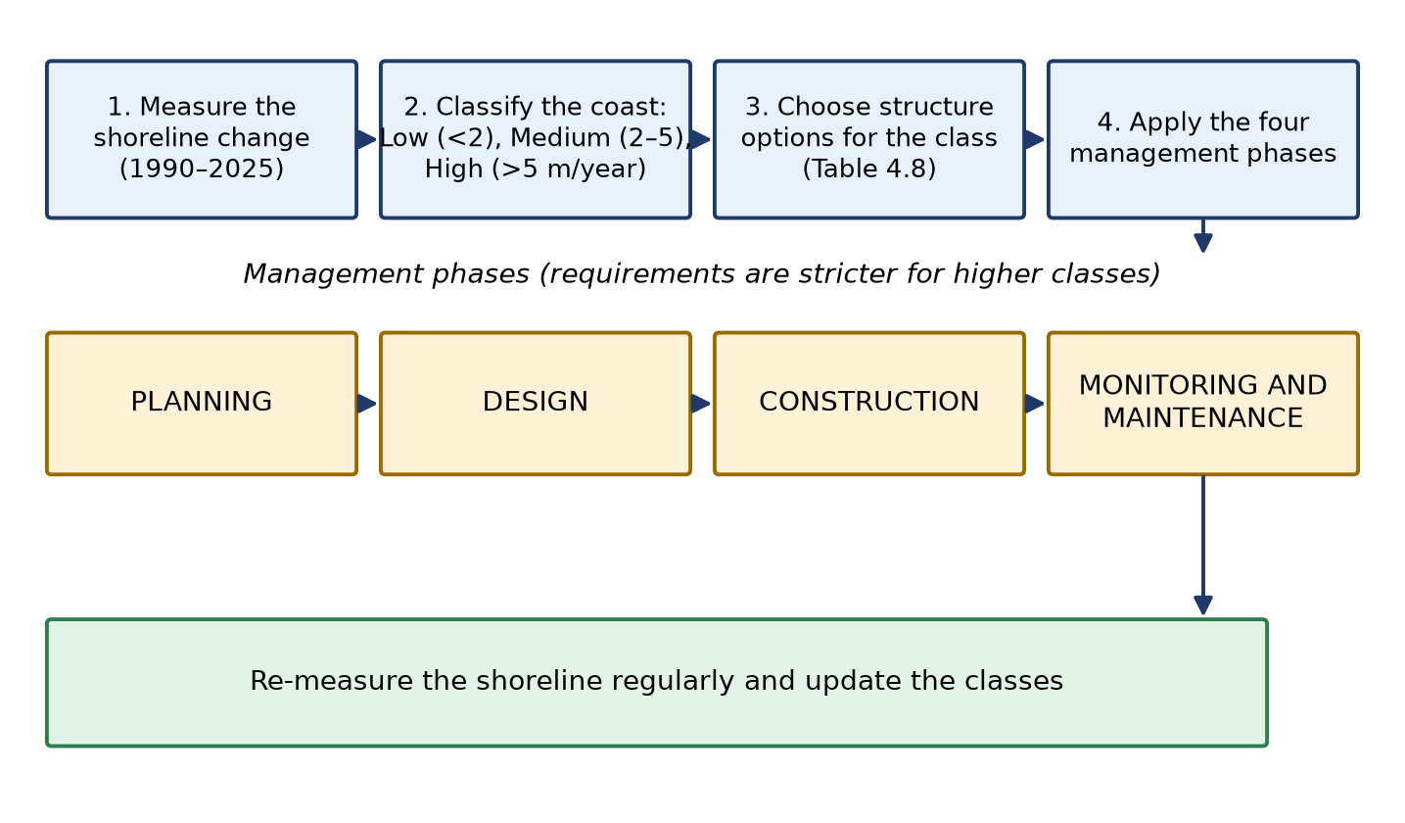
Figure 4.6. Proposed construction management framework
Table 4.8. Proposed construction management framework by erosion risk class
Risk class | Structure options | Planning | Design | Construction | Monitoring and maintenance
Low  (< 2 m/yr)  13.8 km: Maura, Paddaya, San Antonio, Punta; parts of Dodan and Linao | Mangrove rehabilitation and other soft measures (rank 2; best environmental and cost ratings); maintain existing structures. No new hard structure unless a site-specific hazard is found. | Include the stretch in the coastal inventory; confirm the class with a field visit. | Light, low-cost nature-based design; check that planted areas can survive local waves. | Community-based planting and protection of existing mangroves; supervised by LGU/engineer. | Re-measure the shoreline with the same method; inspect after typhoons.
Medium  (2–5 m/yr)  5.0 km: Bulala Sur and Norte; parts of Linao, Dodan, Maura | Seawall or revetment (ranks 1 and 3; highest stability and effectiveness), combined with mangrove or other soft measures where site conditions allow (hybrid approach). | First priority for field inspection (Table 4.3); gather topography, soil, wave and cost information before choosing a structure. | Site-specific design by a licensed engineer; include protection against scouring at the toe; check the environmental effect. | Staged construction with quality control and supervision; schedule work outside the typhoon season. | Inspect the structure after each major storm; repeat the shoreline survey regularly and keep maintenance records.
High  (> 5 m/yr)  not found on the open coast, 1990–2025 | Contingency only: seawall or revetment, possibly with a breakwater, supported by a detailed coastal study. | Immediate hazard assessment of people and property at risk. | Detailed engineering study (waves, currents, sediments) before any design. | Emergency or phased works with strict supervision. | Frequent monitoring until the shoreline stabilizes.
Proposal of the researchers, derived from Table 4.7 and Chapter II. It is a decision guide and does not replace a site-specific engineering design.
Worked example. Bulala Norte has a mean EPR of −3.35 m/year and 1.35 km of Medium shoreline, with the highest field-inspection priority (Table 4.3). Under the framework, the planning phase starts with a field inspection and the collection of topographic, soil and wave data; the design phase considers a seawall or revetment (the highest-rated structures) combined with soft measures, with toe protection against scouring; construction is staged and supervised outside the typhoon season; and monitoring repeats the shoreline survey and inspects the structure after each major storm.

4.12 Limits of the Results
The results should be read with these limits: (1) the classes are based on the erosion rate only; exposure and vulnerability were not assessed; (2) the 30 m image pixel is coarse compared with the 2 m/year class limit, and positional errors, image dates and tide levels were not available; (3) the shorelines at the river mouth were not classified; (4) the survey did not ask for ratings by risk level, and more than half of the respondents had under five years of experience; and (5) the results were not verified in the field.

CHAPTER V
SUMMARY, CONCLUSION AND RECOMMENDATIONS

5.1 Summary
The study aimed to develop a construction management framework for shoreline protection structures in Aparri, Cagayan, based on coastal erosion risk levels. Shoreline positions of 1990, 2000, 2010, 2020 and 2025 for the open coast of eight barangays were analyzed with 415 transects spaced 50 m apart (373 valid) using the End Point Rate, and the coast was classified as Low (below 2 m/year), Medium (2–5 m/year) or High (above 5 m/year). Fifty-four experts rated five shoreline protection structures on six criteria with a five-point scale, and the ratings were analyzed by weighted mean. The framework was assembled from the classification, the ranking and the literature.

5.2 Conclusion
Objective 1. Of the 18.8 km of classified open coast, 13.8 km (73 %) were Low, 5.0 km (27 %) Medium and none High. The highest mean erosion rates were in Bulala Norte (−3.35 m/year) and Bulala Sur (−2.74 m/year), both entirely Medium, while Maura, Paddaya, San Antonio and Punta were mainly Low. Dodan and Linao lie near the Low–Medium boundary and their class is less certain. These classes describe the erosion rate only.
Objective 2. The experts considered the seawall the most suitable structure (overall mean 4.35, Very High), followed by mangrove rehabilitation (4.14), revetment (3.99), breakwater (3.71) and riprap (3.63). The first and last places held under all tested weightings, while the order of mangrove rehabilitation and revetment depended on the weight given to engineering criteria.
Objective 3. The ranking is for the study area as a whole. The matching of structures to risk levels — hybrid or hard structures for Medium stretches and soft, nature-based measures for Low stretches — rests on the ratings and on the literature, and was not rated by the respondents for each risk level.
Objective 4. The proposed framework links the erosion risk class to structure options and to the requirements of the planning, design, construction, and monitoring and maintenance phases, with stronger requirements for Medium than for Low stretches (Table 4.8). Hypothesis: [STUDENTS: state the result of the Friedman test after it is computed — see Section 4.10.]

5.3 Recommendations
To the Local Government Unit and MDRRMO: give first priority to field inspection of the Medium stretches, beginning with Bulala Norte and Bulala Sur, and start a regular shoreline monitoring program (for example repeated GPS surveys of the shoreline at the same tide and season).
To DPWH and practicing engineers: use the framework as a guide together with a site-specific coastal engineering design, keeping in mind that the classes describe the erosion rate only.
To future researchers: (a) record the date and tide of each image and use seasonal composites; (b) measure the positional error of the shorelines; (c) add exposure of buildings and roads and the vulnerability of the population; (d) ask the experts to rate the structures separately for Low, Medium and High erosion; (e) verify the results in the field (form in Appendix E); and (f) study the Cagayan River mouth with a method suited to river mouths.
To the department: keep the computer files, settings and logs of the GIS analysis with the thesis so that the results can be reproduced.

5.4 Limitations
The study is limited to the erosion rate; to 30 m imagery without measured error, dates or tide; to the open coast outside the river mouth; to a survey not stratified by risk level and with mostly early-career respondents; and to results not yet verified in the field.

REFERENCES
[STUDENTS: the following in-text citations in Chapters I–II have no matching entry in this list. Add the entry or remove the citation: Dong et al. (2024); Rocha et al. (2023); Rivera & Dela Vega (2025); Taslin et al. (2024); Nguyen et al. (2025); Ballad et al. (2021); DPWH (2021); Angnuureng (2025); Toledo et al. (2025); Zhou et al. (2023); Thirumurthy et al. (2022); OECD (2026); Nature Communications (2022); Elsevier’s Anthropocene (2023); Ouyang & Wang (2024).]
Amos, D., & Akib, S. (2023). A review of coastal protection using artificial and natural countermeasures—Mangrove vegetation and polymers. Eng, 4(1), 941–953.
Bartolome, I. S., & Griño Jr, A. (2026). Reliability analysis of Dampalit Mega Dike using Monte Carlo simulation against sliding failure. GEOMATE Journal, 30(137), 43–51.
Calapini, W. D., Tan, F. J., Monjardin, C. E. F., & Gacu, J. G. (2025). Geospatial analysis of flood hazard using GIS-based hydrologic–hydraulic modeling: A case of the Cagayan River Basin, Philippines. Geomatics, 5(4), 64. https://doi.org/10.3390/geomatics5040064
Cao, C., Zhu, K., Cai, F., Qi, H., Liu, J., Lei, G., ... & Su, Y. (2022). Vulnerability evolution of coastal erosion in the Pearl River Estuary Great Bay Area due to the influence of human activities in the past forty years. Frontiers in Marine Science, 9, 847655.
Cavalli, R. M. (2024). Remote data for mapping and monitoring coastal phenomena and parameters: A systematic review. Remote Sensing, 16(3), 446.
Dodgson, J. S., Spackman, M., Pearman, A., & Phillips, L. D. (2009). Multi-criteria analysis: A manual. Department for Communities and Local Government, UK.
Elemin, S. A., Fekhaoui, M., Cheikh, M. A. S., Pizzigalli, C., Sidoumou, Z., & Avoulwatt, M. (2026). Port-induced shoreline change and ecological implications in an arid coastal system: Evidence from N’Diago Port, Mauritania. Ecological Engineering & Environmental Technology, 27(5), 359–375.
Felipe, A. J. B., Alejo, L. A., Padre, R. J., & Bareng, J. L. R. (2026). Past and future river bank trend assessment of lower Cagayan River, Philippines. Environment, Development and Sustainability, 28(2), 3363–3398. https://link.springer.com/article/10.1007/s10668-024-05113-3
Gao, W., Du, J., Gao, S., Xu, Y., Li, B., Wei, X., ... & Li, P. (2023). Shoreline change due to global climate change and human activity at the Shandong Peninsula from 2007 to 2020. Frontiers in Marine Science, 9, 1123067. https://doi.org/10.3389/fmars.2022.1123067
Gorelick, N., Hancher, M., Dixon, M., Ilyushchenko, S., Thau, D., & Moore, R. (2017). Google Earth Engine: Planetary-scale geospatial analysis for everyone. Remote Sensing of Environment, 202, 18–27. [VERIFY CITATION]
Gu, J., Wei, X., Han, Y., Zeng, J., Hu, M., & Gong, Z. (2025). A conflict-coordination framework for constructing living shorelines: A case study of ecological seawalls. Sustainability, 17(22), 10050. https://www.mdpi.com/2071-1050/17/22/10050
Igbokwe, J. I., Obasohan, J. N., & Igbokwe, E. C. (2024). GIS-based analytical hierarchy process modelling and mapping of erosion vulnerability in the coastal areas of Rivers State, Nigeria. Asian Journal of Geographical Research, 7(2), 11–25.
Jordan, P., & Fröhle, P. (2022). Bridging the gap between coastal engineering and nature conservation? A review of coastal ecosystems as nature-based solutions for coastal protection. Journal of Coastal Conservation, 26(2), 4. https://link.springer.com/article/10.1007/s11852-021-00848-x
Li, C., & Fang, S. (2026). Coastal land use transitions and their cascading impacts on ecosystem resilience: A global bibliometric review. Regional Ecology and Management, 1(1), 7.
Luijendijk, A., Hagenaars, G., Ranasinghe, R., Baart, F., Donchyts, G., & Aarninkhof, S. (2018). The state of the world’s beaches. Scientific Reports, 8(1), 6641.
McFeeters, S. K. (1996). The use of the Normalized Difference Water Index (NDWI) in the delineation of open water features. International Journal of Remote Sensing, 17(7), 1425–1432. [VERIFY CITATION]
Narafu, T., Shimizu, T., Sanada, Y., Tamura, Y., Mita, N., Takahashi, S., ... & Itsuki, A. (2015). Lessons learnt from damage to buildings by Bohol earthquake and typhoon Yolanda 2013 in the Philippines. Bulletin of International Institute of Seismology and Earthquake Engineering, 49, 39–61.
Nerves, A., Rivera, F. D., Blanco, A., Tirol, Y., & Nadaoka, K. (2024). Shoreline change analysis in New Washington, Aklan using Digital Shoreline Analysis System (DSAS). ISPRS Annals of the Photogrammetry, Remote Sensing and Spatial Information Sciences, X-5-2024, 111–117. https://doi.org/10.5194/isprs-annals-X-5-2024-111-2024
Nieuwenhout, C., & Andreasson, L. M. (2023). The legal framework for artificial energy islands in the northern seas. The International Journal of Marine and Coastal Law, 39(1), 39–72. https://doi.org/10.1163/15718085-bja10151
Osondu, I., Imoni, O., Chukwuemeka, P., Amos, M. D., Ajibade, D. I., Mene-Ejegi, O. O., ... & Akajiaku, C. U. (2025). Machine learning-based shoreline change prediction and erosion analysis: A case study of Ogu/Bolo, Nigeria. Discover Civil Engineering, 2(1), 230.
Perricone, V., Mutalipassi, M., Mele, A., Buono, M., Vicinanza, D., & Contestabile, P. (2023). Nature-based and bioinspired solutions for coastal protection: An overview among key ecosystems and a promising pathway for new functional and sustainable designs. ICES Journal of Marine Science, 80(5), 1218–1239.
Sauvé, P., Bernatchez, P., & Glaus, M. (2022). Multicriteria decision analysis to assist in the selection of coastal defence measures: Involving coastal managers and professionals in the identification and weighting of criteria. Frontiers in Marine Science, 9, 845348.
Senatilleke, U., Herath, R., Fonseka, P. U., Kantamaneni, K., & Rathnayake, U. (2026). Assessment of shoreline change in Southeast Ireland using geospatial techniques. Sustainability, 18(7), 3280. https://www.mdpi.com/2071-1050/18/7/3280
Singhvi, A., Luijendijk, A. P., & van Oudenhoven, A. P. (2022). The grey–green spectrum: A review of coastal protection interventions. [VERIFY CITATION: journal name, volume and pages are missing in the proposal]
Sun, W., Chen, C., Liu, W., Yang, G., Meng, X., Wang, L., & Ren, K. (2023). Coastline extraction using remote sensing: A review. GIScience & Remote Sensing, 60(1), 2243671.
Taber, K. S. (2018). The use of Cronbach’s alpha when developing and reporting research instruments in science education. Research in Science Education, 48(6), 1273–1296. https://link.springer.com/article/10.1007/s11165-016-9602-2
Thieler, E. R., Himmelstoss, E. A., Zichichi, J. L., & Ergul, A. (2009). The Digital Shoreline Analysis System (DSAS) version 4.0 — an ArcGIS extension for calculating shoreline change (Open-File Report 2008-1278). U.S. Geological Survey. https://pubs.usgs.gov/publication/ofr20081278
Tikekar, O., Saha, S., Deshpande, G., & Sengupta, S. (2026). Integrated DSAS–InVEST modeling for quantitative assessment of shoreline dynamics and coastal exposure along the Raigad coast, India. Environmental Systems Research.
Tora, D., Fontolan, G., Fracaros, S., & Bezzi, A. (2026). Coastal vulnerability and risk analysis along the littoral of Togo. Coasts, 6(2), 18. https://www.mdpi.com/2673-964X/6/2/18
Tsiakos, C. A. D., & Chalkias, C. (2023). Use of machine learning and remote sensing techniques for shoreline monitoring: A review of recent literature. Applied Sciences, 13(5), 3268.
Tzepkenlis, A., Grammalidis, N., Kontopoulos, C., Charalampopoulou, V., Kitsiou, D., Pataki, Z., ... & Nitis, T. (2022). An integrated monitoring system for coastal and riparian areas based on remote sensing and machine learning. Journal of Marine Science and Engineering, 10(9), 1322.
U.S. Geological Survey. (2023). Coastal Change Hazards Program. https://www.usgs.gov/programs/cmhrp
Wilson, E. T., & Liberia, T. N. A. E. P. A. (2019). Coastal zone’s technology needs assessment for climate change adaptation. https://ekmsliberia.info/wp-content/uploads/2020/12/tna-report-coastal-zone-liberia.pdf
Woodroffe, C. D., Evelpidou, N., Delgado-Fernandez, I., Green, D., Sengupta, D., Karkani, A., & Ciavola, P. (2025). Coastline changes: A reconsideration of the prevalence of recession on sandy shorelines. Cambridge Prisms: Coastal Futures, 3, e18.
Zhang, Y., Ouyang, Z., Xu, C., Wu, T., & Lu, F. (2024). A multi-hazard framework for coastal vulnerability assessment and climate-change adaptation planning. Environmental and Sustainability Indicators, 21, 100327.
Zhao, K., Wang, Y., & Liu, P. L. F. (2024). A guide for selecting periodic water wave theories — Le Méhauté (1976)’s graph revisited. Coastal Engineering, 188, 104432. https://doi.org/10.1016/j.coastaleng.2023.104432

APPENDICES

Appendix A. Work Breakdown Schedule
No. | Year | 2026
No. | Month | Jan. | Feb. | March | April | May | June | July | Aug. | Sept. | Oct.
No. | Research Activities
1 | TOPIC SELECTION
2 | GAP IDENTIFICATION AND PROPOSED TITLE ORGANIZATION
3 | PROBLEM STATEMENT
4 | OBJECTIVES
5 | CONCEPTUAL FRAMEWORK
6 | LITERATURE REVIEW
7 | METHODOLOGY DESIGN
8 | PROPOSAL DRAFT
9 | PROPOSAL SUBMISSION
10 | PROPOSAL DEFENSE
11 | DATA COLLECTION
12 | PILOT TESTING
13 | STATISTICAL TOOLS
14 | RESULTS & DISCUSSION
15 | WRITING REVISION
16 | FINAL DEFENSE
17 | FORMATTING

Appendix B. Research Questionnaire
Dear Respondent,
We are fourth-year civil engineering students of Cagayan State University-Carig Campus currently conducting a research entitled, “Development of Construction Management Framework for Shoreline Protection Structures Based on Coastal Erosion Risk Levels in Aparri, Cagayan ”.
In line with this, we humbly request your participation in answering our survey questionnaire intended for Civil Engineers, DPWH Engineers, Contractors, Coastal/Environmental Engineers, and LGU Technical Personnel. The questionnaire aims to evaluate different shoreline structures and proposes a framework based on your professional knowledge and experience. It will only take a few minutes to accomplish and maybe answered in your most convenient time. Rest assured that all information gathered will be used only for academic purposes.
We would like to sincerely thank you for your support and cooperation. Additionally, we would be grateful for your willingness to participate in this study, as your insights will significantly contribute to the completion and success of our study.
Your effort in accomplishing this questionnaire is highly appreciated. Thank you very much.
Yours truly,
Rizabell F. Bruno
Sandara Marie M. Cabauatan
Ross Ann D. Mora Phoebe Kate S. Ubando
EVALUATION OF SHORELINE PROTECTION STRUCTURES
Name (Optional):
Position:
Office/Agency:
Years of Experience:
Civil Engineer
DPWH Engineer
Coastal/Environmental Engineer
Contractor
LGU Technical Personnel
Less than 5 years
5–10 years
11–20 years
More than 20 years
Have you worked on or supervised a Shoreline Protection Structures?
Yes No
Are you familiar with different types of Shoreline Protection Structures (Seawalls, Revetments, Riprap, Breakwater, Mangrove Rehabilitation) ?
Yes No
Have you received any education or training related to Coastal Engineering or Shoreline Protection?
Yes No
INSTRUCTION: Please check the rate of each shoreline protection structures based on the criteria below using the scale:
5 - Highly Appropriate 4 - Appropriate
3 - Moderately Appropriate
2 - Slightly Appropriate 1 - Not Appropriate
Seawalls
Statements | 1 | 2 | 3 | 4 | 5
1. Seawalls are structurally stable.
2. Seawalls provide adequate protection against coastal erosion .
3. Seawalls provide a cost-effective solution for shoreline protection.
4. Seawalls are your most recommended erosion protection structure according to its durability.
5. Seawalls require manageable maintenance throughout their service life.
6. Environmental benefits of seawalls outweigh its potential adverse environmental impact.

Revetments
Statements | 1 | 2 | 3 | 4 | 5
1. Revetments are structurally stable.
2. Revetments provide adequate protection against coastal erosion .
3. Revetments provide a cost-effective solution for shoreline protection.
4. Revetments are your most recommended erosion protection structure according to its durability.
5. Revetments require manageable maintenance throughout their service life.
6. Environmental benefits of revetments outweigh its potential adverse environmental impact.

Riprap
Statements | 1 | 2 | 3 | 4 | 5
1. Ripraps are structurally stable.
2. Ripraps provide adequate protection against coastal erosion .
3. Ripraps provide a cost-effective solution for shoreline protection.
4. Ripraps are your most recommended erosion protection structure according to its durability.
5. Ripraps require manageable maintenance throughout their service life.
6. Environmental benefits of ripraps outweigh its potential adverse environmental impact.

Breakwater
Statements | 1 | 2 | 3 | 4 | 5
1. Breakwaters are structurally stable.
2. Breakwaters provide adequate protection against coastal erosion .
3. Breakwater provides a cost-effective solution for shoreline protection.
4. Breakwater is your most recommended erosion protection structure according to its durability.
5. Breakwater requires manageable maintenance throughout their service life.
6. Environmental benefits of breakwater outweigh its potential adverse environmental impact.

Mangrove Rehabilitation
Statements | 1 | 2 | 3 | 4 | 5
1. Mangrove rehabilitation is structurally stable.
2. Mangrove rehabilitation provides adequate protection against coastal erosion .
3. Mangrove rehabilitation provides a cost-effective solution for shoreline protection.
4. Mangrove rehabilitation is your most recommended erosion protection structure according to its durability.
5. Mangrove rehabilitation requires manageable maintenance throughout their service life.
6. Environmental benefits of mangrove rehabilitation outweigh its potential adverse environmental impact.

Appendix C. GIS Settings Used
Item | Value
Coordinate system for measuring | WGS 84 / UTM zone 51N (EPSG:32651); source data in EPSG:4326
Years analyzed | 1990, 2000, 2010, 2020, 2025; EPR end points 1990 and 2025 (T = 35 years)
Baseline | 1990 open-coast shoreline smoothed over 200 m, shifted landward 150 m beyond the farthest landward year
Transects | Every 50 m, 600 m seaward and 600 m landward; nearest crossing kept
Cleaning of the lines | Join ends < 5 m; remove loops < 50 m; remove stretches digitized twice in one year
Open coast / river banks | 350 m from the outer outline of all shorelines
Risk classes | Low < 2; Medium 2–5 (limits included); High > 5 m/year
Barangay assignment | Nearest barangay within 500 m; areas = kilometers × 100 m strip
Positional uncertainty | Not measured; one-pixel what-if of 30 m per date (±1.21 m/year)
Software | QGIS, Python (GeoPandas, Shapely); all steps scripted with a log

Appendix D. Data Audit Summary
Before the analysis, the supplied files were audited. The shoreline lines were found as 19 loose pieces; one feature had an unreadable year and was not used; 18.3 km of the 2010 shoreline had been digitized twice. The risk map of the proposal stage consisted of 117 cells on the 30 m pixel grid and 7 hand-drawn polygons, and it could not be reproduced from the shoreline lines with the rate limits of Table 3.1; the Medium and High labels of that map were carried by the seven hand-drawn polygons. For this reason the risk map was rebuilt from the shoreline lines, and the rebuilt version is the one reported in Chapter IV. The full audit is kept in the project files (Technical Annex).

Appendix E. Field Verification
A field verification form and a list of suggested check points (the Medium stretches first) are provided with the project files. [STUDENTS: attach the completed forms if the field verification was done.]

Appendix F. Respondents’ Data
[STUDENTS: attach the anonymized answers of the 54 respondents and the Cronbach’s alpha computation.]

Appendix G. Permission Letters and Consent
[STUDENTS: attach the endorsement and permission letters and the informed-consent form.]
ACKNOWLEDGMENT

