Technical Annex — GIS analysis of shoreline change, Aparri, Cagayan [DRAFT – FOR STUDENT REVIEW]
*Generated 2026-10-03 by make annex from the repository. Purpose: let a reader repeat and check the GIS work.*

1. How to repeat the analysis
make setup # creates .venv and installs the pinned requirements
make test # 85 automated tests
make all # audit, audit-gee, clean-lines, raster-lines, transects, risk, tables, maps, sensitivity, web
make priority qgis drafts annex survey
Every step reads config/config.yaml (all parameters, with comments) and writes outputs/reports/run_<step>_<time>.json (parameters, input checksums, software versions, counts, warnings).

2. Input data (read-only, checksums)
file | sha256 (first 16)
./Aparri/Aparri Barangays.shp | d480fdbfcbc965c5
./Aparri/Aparri_Brgy_Study.shp | f0ebd12de1e4b7f5
./gee_outputs/Aparri_Barangay_Erosion_Statistics_1990_2025.csv | c56dbeaf6ddc68be
./gee_outputs/Aparri_EPR_1990_2025.tif | 75fd1e8a946019f3
./gee_outputs/Aparri_Shoreline_2025.tif | a7975099905dd5ee
./gee_outputs/Code.docx | 132f58cc361a7e93
./risk_zip/Aparri_MultiTemporal_Erosion_Risk_1990_2025.shp | ea89db6ed9c50cfc
./shoreline_changes/Shoreline Changes.shp | b1c498b74fd9bba9
All 65 files in data/raw/ are listed with SHA-256 in data/raw/MANIFEST.sha256; the test suite fails if any raw file changes.

3. Software
package | version
python | 3.11.15
geopandas | 1.2.0
shapely | 2.1.2
pyproj | 3.7.2
pandas | 3.0.6
numpy | 2.4.6
scipy | 1.17.1
statsmodels | 0.15.0
rasterio | 1.4.4
scikit-image | 0.26.0
matplotlib | 3.11.2
openpyxl | 3.1.5
python-docx | 1.2.0
pyyaml | 6.0.3

4. Parameters used
parameter | value
Working CRS | EPSG:32651 (WGS 84 / UTM 51N, metres)
Years | [1990, 2000, 2010, 2020, 2025]
Shoreline set (primary) | vector_clean
Baseline | 1990 open-coast shoreline, smoothed 200 m, offset landward by max excursion + 150 m
Transects | every 50 m, 600 m seaward / 600 m landward, multi-hit rule: nearest
Open-coast rule | within 350 m of the concave-hull outline (ratio 0.1); estuarine banks excluded
Cleaning | snap 5 m; loops < 50 m removed; duplicate stretches (80% within 60 m) removed
Class limits | Low < 2.0, Medium 2.0–5.0 (inclusive), High > 5.0 m/yr; accretion -> Low (tagged)
Hectare strip | 100 m
Barangay join tolerance | 500 m
Acquisition dates | NOT PROVIDED (EPR over 35 calendar years)
Positional uncertainty | NOT PROVIDED (what-if ±30 m only for the confidence label)

5. Results
Table 4.2 (kilometres of shoreline are in the extended table):
Barangay | Mean EPR (m/year) | Minimum EPR (m/year) | Maximum EPR (m/year) | Low Risk (ha) | Medium Risk (ha) | High Risk (ha)
Dodan | -1.93 | -2.21 | -1.76 | 12.50 | 7.49 | 0.00
Maura | -1.39 | -2.07 | -0.62 | 56.97 | 1.50 | 0.00
Bulala Norte | -3.35 | -3.49 | -3.19 | 0.00 | 13.46 | 0.00
San Antonio | -0.91 | -1.41 | -0.53 | 6.51 | 0.00 | 0.00
Linao | -0.70 | -3.21 | 5.30 | 12.80 | 13.09 | 0.00
Paddaya | -1.41 | -1.76 | -1.36 | 46.50 | 0.00 | 0.00
Punta | 0.19 | -0.05 | 0.53 | 3.02 | 0.00 | 0.00
Bulala Sur | -2.74 | -3.16 | -2.32 | 0.00 | 14.35 | 0.00
Barangay | Low risk (km) | Medium risk (km) | High risk (km) | Unclassified (km) | n transects | n valid | n flagged | % eroding | % classes that may flip
Dodan | 1.25 | 0.75 | 0.00 | 0.00 | 40 | 40 | 0 | 100.00 | 100.00
Maura | 5.70 | 0.15 | 0.00 | 0.00 | 117 | 117 | 0 | 100.00 | 94.02
Bulala Norte | 0.00 | 1.35 | 0.00 | 0.00 | 27 | 27 | 0 | 100.00 | 3.70
San Antonio | 0.65 | 0.00 | 0.00 | 0.00 | 13 | 13 | 0 | 100.00 | 53.85
Linao | 1.28 | 1.31 | 0.00 | 0.65 | 77 | 48 | 34 | 62.50 | 58.33
Paddaya | 4.65 | 0.00 | 0.00 | 0.00 | 93 | 93 | 0 | 100.00 | 100.00
Punta | 0.30 | 0.00 | 0.00 | 0.75 | 19 | 6 | 13 | 33.33 | 0.00
Bulala Sur | 0.00 | 1.44 | 0.00 | 0.00 | 29 | 29 | 1 | 100.00 | 100.00
Figures: outputs/maps/Fig_4_1_v2_multitemporal_shorelines.png, Fig_4_2_v2_erosion_risk_map.png, Fig_4_3_epr_profile_along_coast.png, Fig_legacy_vs_rebuilt.png.
Field-inspection priority (erosion information only; weights in config):
Barangay | mean_erosion_rate_m_yr | km_medium_or_high | share_class_not_sensitive | priority_score | rank
Bulala Norte | 3.35 | 1.35 | 0.96 | 0.97 | 1
Bulala Sur | 2.74 | 1.44 | 0.00 | 0.91 | 2
Linao | 1.65 | 1.31 | 0.42 | 0.70 | 3
Dodan | 1.93 | 0.75 | 0.00 | 0.55 | 4
Maura | 1.39 | 0.15 | 0.06 | 0.26 | 5
Paddaya | 1.41 | 0.00 | 0.00 | 0.21 | 6
San Antonio | 0.91 | 0.00 | 0.46 | 0.13 | 7
Punta | 0.01 | 0.00 | 1.00 | 0.00 | 8

6. Quality assurance
* Automated tests: 85 automated tests — synthetic coasts of known change (straight 2.000 m/yr retreat, 1.500 m/yr advance, circular arcs, missing years, loops, mirrored orientation), cleaning rules, class boundaries (exactly 2.0 and 5.0 are Medium), survey statistics against hand computations, web-map smoke test.
* Sensitivity (share of valid transects, %):
scenario | description | pct_Low | pct_Medium | pct_High
base | base run | 73.2 | 26.8 | 0.0
spacing_25 | transect spacing 25 m | 73.7 | 26.3 | 0.0
spacing_100 | transect spacing 100 m | 73.3 | 26.7 | 0.0
smooth_100 | baseline smoothing 100 m | 73.1 | 26.9 | 0.0
smooth_400 | baseline smoothing 400 m | 72.8 | 26.9 | 0.3
multihit_farthest | multi-hit rule: farthest crossing | 73.2 | 26.8 | 0.0
with_estuarine | include estuarine banks | 73.9 | 21.3 | 4.8
thr_-0.5 | thresholds shifted -0.5 m/yr | 52.0 | 48.0 | 0.0
thr_+0.5 | thresholds shifted +0.5 m/yr | 81.2 | 18.8 | 0.0
classify_by_LRR | classify with LRR instead of EPR | 81.8 | 18.2 | 0.0
offset_landward_300 | baseline offset 300 m instead of 150 m | 72.9 | 27.1 | 0.0
* Stability of the barangay classes across runs:
barangay | base_dominant | base_worst | runs | pct_runs_same_dominant | pct_runs_same_worst | robust | classes_seen
Dodan | Low | Medium | 10 | 90 | 80 | False | Low,Medium
Maura | Low | Low | 10 | 100 | 90 | True | Low
Bulala Norte | Medium | Medium | 10 | 100 | 100 | True | Medium
San Antonio | Low | Low | 10 | 100 | 100 | True | Low
Linao | Medium | Medium | 10 | 70 | 90 | False | Low,Medium
Paddaya | Low | Low | 10 | 100 | 90 | True | Low
Punta | Low | Low | 10 | 90 | 90 | True | Low,no data
Bulala Sur | Medium | Medium | 10 | 100 | 100 | True | Medium

7. Findings about the legacy outputs (summary; full text in `docs/01_data_audit.md`, `docs/01b_gee_audit.md`)
The supplied risk polygons, Earth Engine barangay statistics and raster change layers could not be reproduced or were not valid for the thesis purpose; they were not used in any result.

8. Limitations
See docs/02_method.md §7: erosion rate only; 30 m imagery with no recorded dates, tide or measured error; river mouth excluded; no field verification yet.

9. File index
config/ parameters · src/aparri/ code · data/raw/ inputs (read-only) · data/interim/ cleaned shorelines + review package · data/processed/ transects and segments · outputs/tables|maps|layers|web|field_validation|reports/ results · docs/ audit, method, drafts, Q&A.
Fig_4_1_v2_multitemporal_shorelines.png
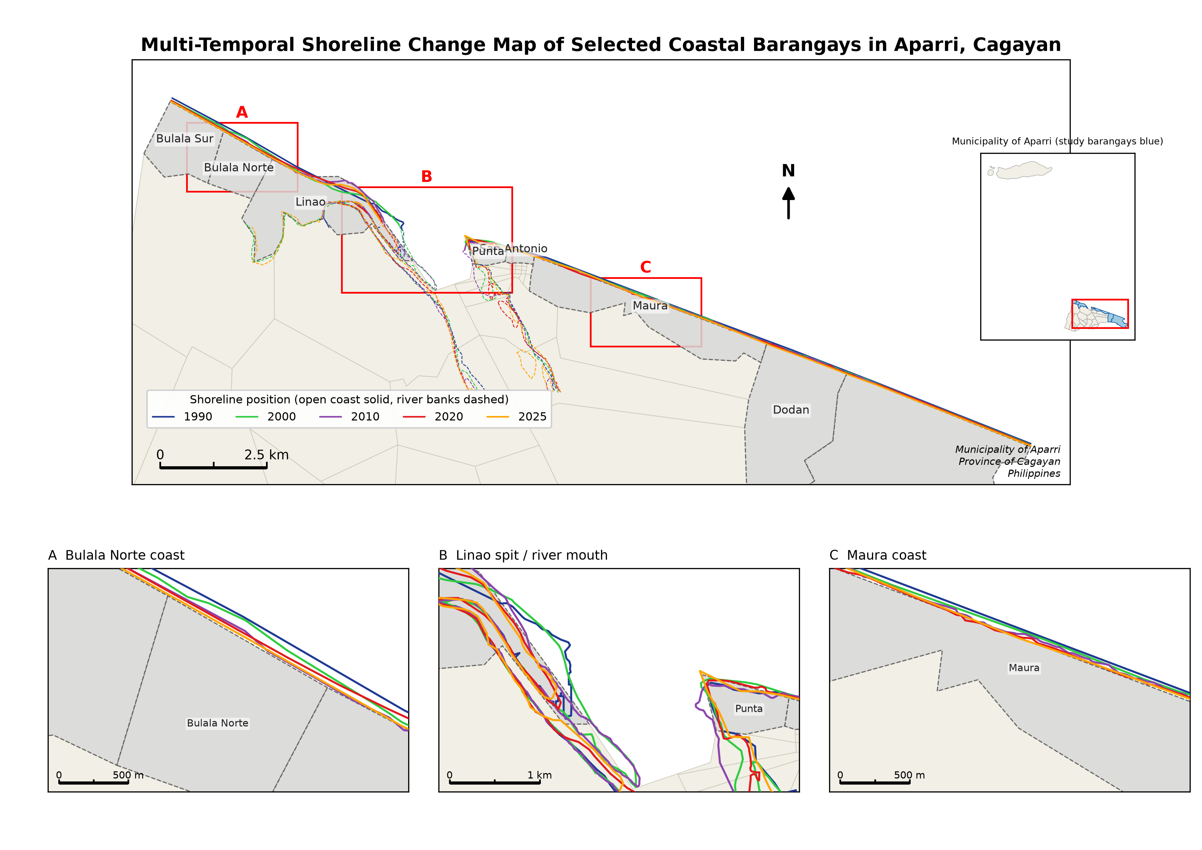
Fig_4_2_v2_erosion_risk_map.png
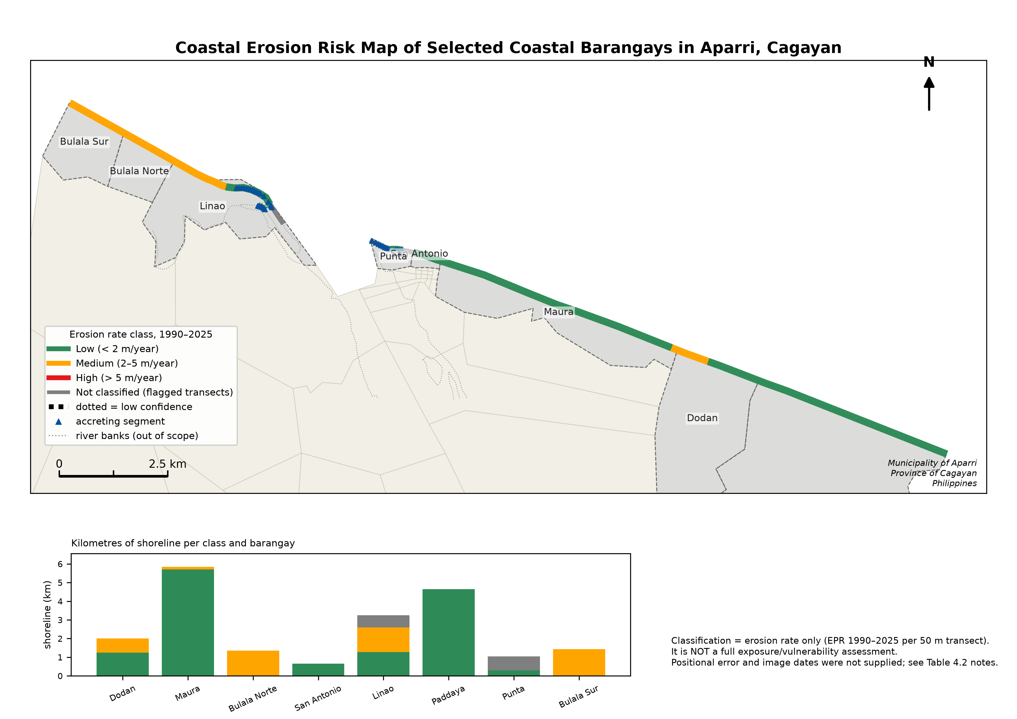
Fig_4_3_epr_profile_along_coast.png
