TECHNICAL DATA SHEET
CCTV SURVEILLANCE SYSTEM
Permanent Installation - Powerhouse & Desander Weir

PROJECT | DED for 11.3MW Upper Tumauini HEPP | CLIENT | Philnew Hydro Power Corporation (PHPC)
LOCATION CODE | LUZ-21-009 | SCOPE AREA | Powerhouse & Desander Weir
REFERENCE TICKET | ITSM-119777 / TU1ITA-433A

1.0 PURPOSE & SCOPE

This Technical Data Sheet (TDS) is submitted in support of the permanent CCTV installation at the Powerhouse and Desander Weir of the Upper Tumauini HEPP, raised under IT Operations Department ticket ITSM-119777 and coordinated with the MEPF Department. It sets out the equipment schedule and the minimum technical requirements for the cameras, recording, network, and display equipment to be procured and installed — for QC Department review, PHPC (Owner) approval, and as the basis for Receiving Inspection on site.
This document covers IT/electronic equipment only — cameras, NVR, PoE switch, monitor, patch panel, UPS, and structured cabling. Conduit, junction boxes for cable routing, and other civil/electrical bulk materials are procured under the separate CLARA Forms request and associated Order-to-Purchase documentation, and are referenced here only where they interface directly with the IT scope.
2.0 SYSTEM OVERVIEW

The system consists of 12 Hikvision 4MP PoE IP cameras (6 outdoor bullet, 6 indoor turret) split between the Powerhouse (Turbine Floor, Ground Floor, 2nd Floor) and the Desander control house, terminating in Cat6 structured cabling routed back to local Pull Boxes and their respective Communications Racks.
Each site has its own recording rack. The Powerhouse rack houses a 16-channel NVR (DS-7616NI-M2); the Desander rack houses an 8-channel NVR (DS-7608NI-M2). Each rack also carries its own 16-port PoE switch (DS-3E1518P-SI-16P2F), a 32″ monitor, and a UPS (AWP AID3000 Pro LCD, 3000VA/1800W), all housed in a 5.8ft 40U rack cabinet with cooling fan.
The two racks are linked over single-mode fiber using a matched pair of Mikrotik S-3553LC20D SFP modules and TP-Link TL-FC311A-20 media converters, per the FDAS/CCTV/Voice & Data drawing note calling for the Desander NVR to be linked to the main Powerhouse CCTV system via media converter and fiber-optic cable. Structured indoor-rated Cat6 cable (Belden) is used for all camera and data drops, terminated at 12-port RJ45 patch panels in each Data Cabinet.
Camera counts and HDD sizing are taken directly from the CCTV Components list made by Carlo Falderon, “CCTV COMPONENTS — TUMAUINI HEPP PERMANENT INSTALLATION.”

3.0 EQUIPMENT SCHEDULE / BILL OF MATERIALS

Brand, model, and quantities below are taken from the CCTV Components list (“CCTV COMPONENTS — TUMAUINI HEPP PERMANENT INSTALLATION”). Section 4.0 provides the manufacturer-published specification, features, and functions for each line item.
No. | Description | Brand | Model | Qty | UoM | Remarks
1 | NVR 16 Channel | Hikvision | DS-7616NI-M2 | 1 | Unit | Powerhouse
2 | NVR 8 Channel | Hikvision | DS-7608NI-M2 | 1 | Unit | Desander
3 | Hard Disk 4TB | Western Digital | WD40PURZ | 1 | Unit | Desander (3 Camera; 64 Days Retention)
4 | Hard Disk 4TB | Western Digital | WD40PURZ | 2 | Unit | Powerhouse (9 Camera; 43 Days Retention)
5 | 4MP Outdoor Bullet Camera | Hikvision | DS-2CD2T47G2-L(2.8mm) | 6 | Unit | —
6 | 4MP Indoor Turret Camera | Hikvision | DS-2CD2347G2-LU(2.8mm) | 6 | Unit | —
7 | 16-Port Gigabit Smart PoE Switch | Hikvision | DS-3E1518P-SI-16P2F | 2 | Unit | —
8 | 32-Inch Monitor | Hikvision | — (to be confirmed at ordering) | 2 | Unit | —
9 | SFP Module | Mikrotik | S-3553LC20D | 2 | Unit | —
10 | SC to LC Fiber Patch Cord | FS | SC-LC | 4 | Pcs | —
11 | SC to SC Patch Cord | FS | SC-SC | 10 | Pcs | —
12 | Media Converter | TP-Link | TL-FC311A-20 | 4 | Pcs | —
13 | 5.8ft 40U Rack Cabinet w/ Cooling Fan & Extension Cord | — | — | 2 | Unit | —
14 | RJ45 Connector | D-Link | — | 100 | Pcs | —
15 | UTP Cable CAT6 Indoor | Belden | Cat 6 Indoor | 720 | Meters (2 Box) | —
16 | UPS | AWP | AID3000 Pro LCD | 2 | Unit | —
17 | Junction Box | Hikvision | DS-1280ZJ-S | 6 | Unit | —
18 | Junction Box | Hikvision | DS-1280ZJ-PT6 | 6 | Unit | —

4.0 TECHNICAL SPECIFICATIONS — AS-SELECTED EQUIPMENT

The specifications below reflect the published manufacturer datasheet values for the brand and model selected in Section 3.0, organized one item at a time for QC cross-checking. The manufacturer's official datasheet for each item is to be attached to this TDS when submitted for approval.
4.1 Network Video Recorder — Powerhouse (16-Channel) | Hikvision — DS-7616NI-M2
Features & Functions  - 16-channel IP video input, supporting resolutions up to 32 MP per channel (up to 8 channels at 32/24 MP simultaneously)  - H.265+ / H.265 / H.264+ / H.264 video compression for efficient bandwidth and storage use  - Two SATA interfaces for hard disk installation, each accepting drives up to 16 TB  - Independent HDMI (up to 8K/30Hz or 4K/60Hz) and VGA outputs for local monitor display  - ONVIF (v2.2) conformant for open, standards-based integration with third-party VMS  - Remote viewing, playback, and system management via Hik-Connect / iVMS-4200 client software  Application in this Project  Installed in the Powerhouse Communications Rack (2F); records the 9 Powerhouse cameras and receives the Desander feed over the fiber backbone described in Item 4.9. |  | 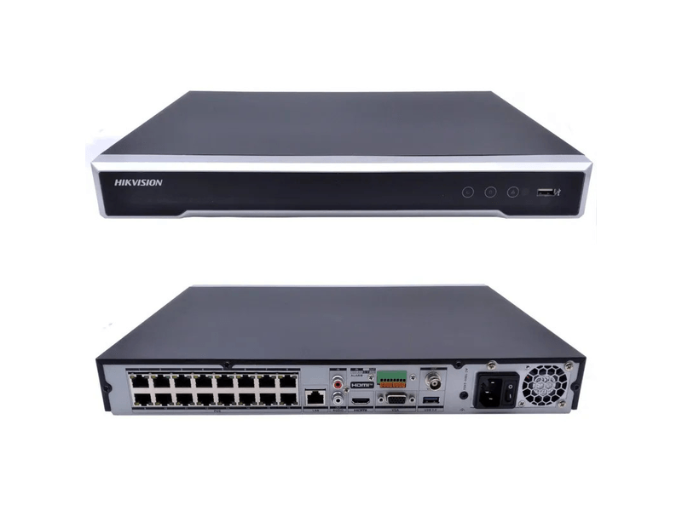  KEY SPECIFICATIONS  Video Input 16-ch IP, up to 256 Mbps incoming  Storage Bays 2 × SATA, up to 16 TB each  Compression H.265+/H.265/H.264+/H.264  Video Output 1 × HDMI, 1 × VGA  Network 1 × RJ45 10/100/1000 Mbps  Protocols ONVIF, TCP/IP, HTTPS, SNMP, NTP, iSCSI, UPnP

4.2 Network Video Recorder — Desander (8-Channel) | Hikvision — DS-7608NI-M2
Features & Functions  - 8-channel IP video input, supporting resolutions up to 32 MP per channel  - H.265+ / H.265 / H.264+ / H.264 video compression, reducing storage requirements by up to 75% versus H.264  - Two SATA interfaces for hard disk installation, each accepting drives up to 16 TB  - Independent HDMI (up to 8K/30Hz) and VGA outputs for local monitor display  - ONVIF (v2.2) conformant network protocol support  - Interfaces with the Powerhouse CCTV system over the site-to-site fiber link for centralized monitoring  Application in this Project  Installed in the Desander Communications Rack; records the 3 Desander cameras and forwards its feed to the Powerhouse NVR via the Mikrotik SFP / TP-Link media converter fiber link (Item 4.9). |  | 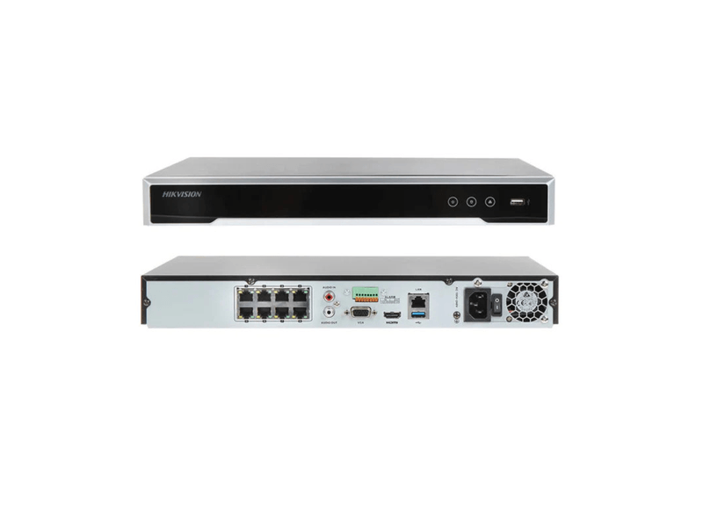  KEY SPECIFICATIONS  Video Input 8-ch IP, up to 128 Mbps incoming  Storage Bays 2 × SATA, up to 16 TB each  Compression H.265+/H.265/H.264+/H.264  Video Output 1 × HDMI, 1 × VGA  Network 1 × RJ45 10/100/1000 Mbps  Protocols ONVIF, TCP/IP, HTTPS, SNMP, NTP, iSCSI, UPnP

4.3 Surveillance Hard Disk Drive, 4 TB | Western Digital — WD Purple WD40PURZ
Features & Functions  - Purpose-built surveillance-class drive rated for 24/7 always-on recording duty  - AllFrame technology reduces frame loss and pixelation across multi-drive, multi-stream NVR systems  - Rated workload of up to 180 TB per year and supports up to 64 camera streams per drive (multi-bay system)  - SATA 6 Gb/s interface, 5400 RPM class, 64 MB cache  - 3-year manufacturer warranty, designed specifically for DVR/NVR environments  Application in this Project  One drive installed in the Desander NVR (3 cameras, 64-day retention) and two drives installed in the Powerhouse NVR (9 cameras, 43-day retention), per the retention remarks in Section 3.0. |  | 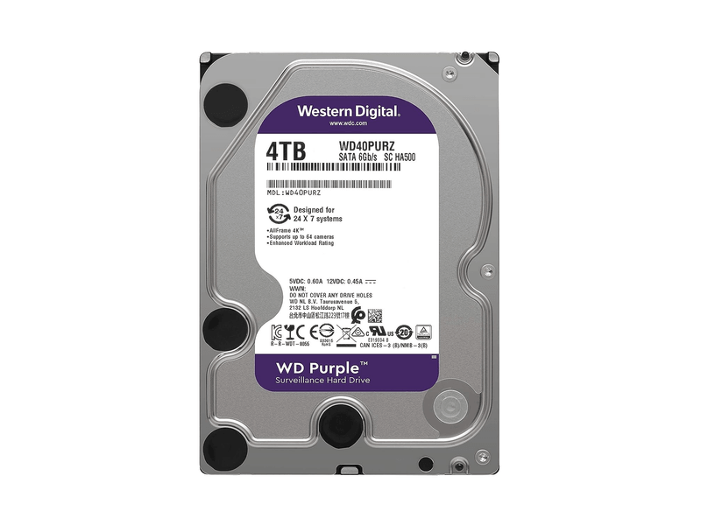  KEY SPECIFICATIONS  Capacity 4 TB  Interface SATA III, 6 Gb/s  Cache 64 MB  Workload Rating Up to 180 TB/yr  Duty Cycle 24×7 surveillance

4.4 4MP Outdoor Bullet Camera, 2.8mm | Hikvision — DS-2CD2T47G2-L(2.8mm)
Features & Functions  - ColorVu technology with F1.0 super-aperture lens for 24/7 full-color imaging, even in near-total darkness  - 1/1.8″ progressive scan CMOS sensor, maximum resolution 2688 × 1520 (4 MP)  - 130 dB wide dynamic range for clear imaging against strong backlight  - AcuSense analytics — human/vehicle target classification to reduce nuisance and false alarms  - IP67-rated housing for outdoor exposure; PoE (IEEE 802.3af) single-cable power and data  - H.265+ / H.265 / H.264+ / H.264 compression; wide operating range of −30°C to 60°C  Application in this Project  Six units deployed as outdoor perimeter and area coverage cameras across the Powerhouse and Desander sites, per the camera layout drawing. |  | 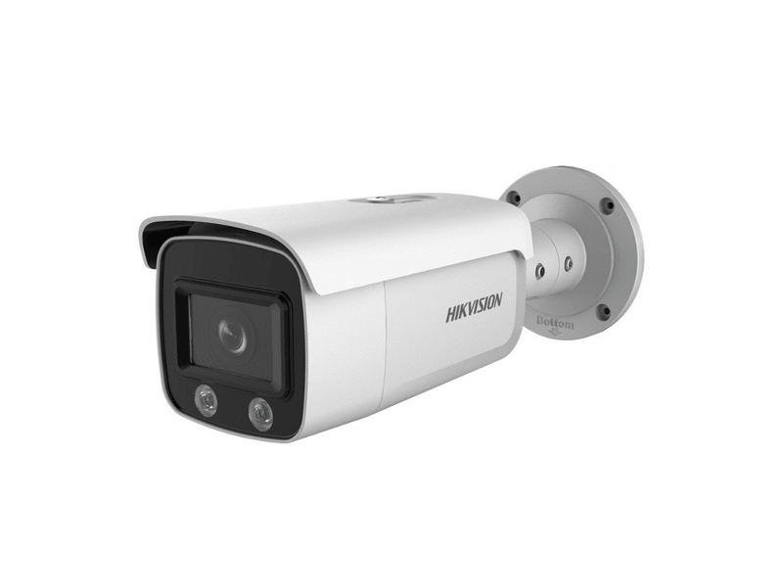  KEY SPECIFICATIONS  Sensor 1/1.8″ CMOS, 4 MP  Lens Fixed 2.8 mm, F1.0  Min. Illumination 0.0005 lux (color, AGC on)  Field of View 112° (H) / 61° (V)  WDR 130 dB  Ingress Protection IP67  Power PoE, IEEE 802.3af

4.5 4MP Indoor Turret Camera, 2.8mm | Hikvision — DS-2CD2347G2-LU(2.8mm)
Features & Functions  - ColorVu technology with dual illumination (IR + supplemental white light) for continuous full-color imaging  - 1/1.8″ progressive scan CMOS sensor, maximum resolution 2688 × 1520 (4 MP)  - Built-in microphone for real-time audio capture alongside video  - 130 dB wide dynamic range and AcuSense human/vehicle target classification  - Compact turret housing rated IP67, suited to indoor and sheltered outdoor mounting  - PoE (IEEE 802.3af Class 3) single-cable power and data  Application in this Project  Six units deployed indoors / under-roof at the Powerhouse turbine floor, office wing, and Desander control house for close-range room and corridor coverage. |  | 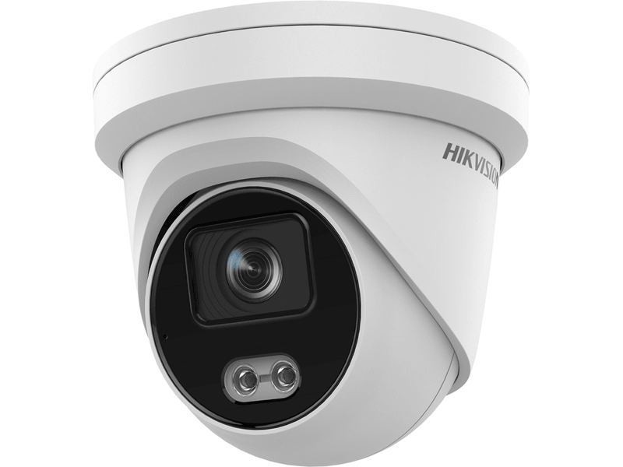  KEY SPECIFICATIONS  Sensor 1/1.8″ CMOS, 4 MP  Lens Fixed 2.8 mm, F1.0  Field of View 112° (H)  Audio Built-in microphone  WDR 130 dB  Ingress Protection IP67  Power PoE, IEEE 802.3af Class 3

4.6 16-Port Gigabit Smart PoE Switch | Hikvision — DS-3E1518P-SI-16P2F
Features & Functions  - 16 × 10/100/1000M PoE ports plus 2 × 100/1000M SFP uplink ports for fiber connection  - 230 W total PoE budget, IEEE 802.3af/at compliant, sufficient for all connected cameras  - Smart-managed features: VLAN (802.1Q) segmentation, STP/RSTP/ERPS loop prevention with storm control  - PoE watchdog automatically detects and restarts unresponsive cameras without a truck roll  - 6 kV surge protection on PoE ports for lightning- and switching-transient resilience  - Static link aggregation and QoS for prioritized, resilient video traffic  Application in this Project  One unit installed per rack (Powerhouse and Desander), powering and switching all local IP cameras; SFP ports carry the fiber uplink between the two sites. |  | 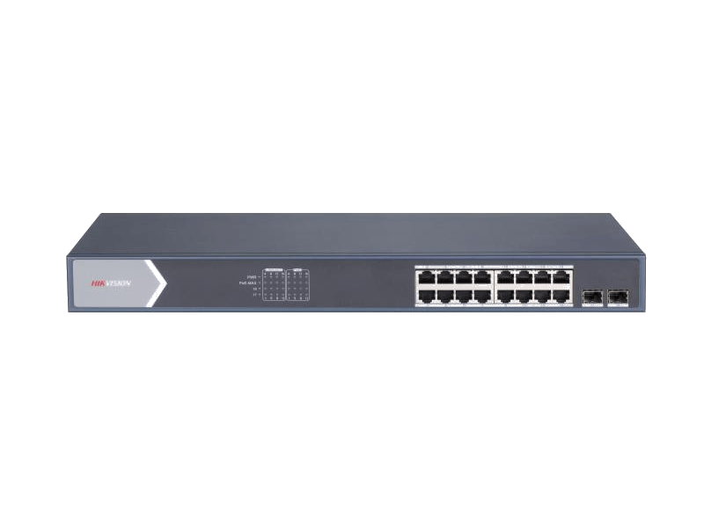  KEY SPECIFICATIONS  PoE Ports 16 × 10/100/1000M  Uplink 2 × 100/1000M SFP  PoE Budget 230 W (802.3af/at)  Management VLAN, STP/RSTP/ERPS, QoS  Surge Protection 6 kV  Operating Temp. 0°C to 45°C

4.7 32-Inch Surveillance Monitor | Hikvision — 32″ LCD Monitor
Features & Functions  - Full HD 1920 × 1080 resolution LCD panel purpose-built for continuous 24/7 control-room duty  - Wide 178° horizontal / 178° vertical viewing angle for shared-room monitoring  - HDMI and VGA inputs for direct NVR connection, with BNC/CVBS input on most current models  - Metal bezel and chassis for durability in an industrial/control-room environment  - VESA-compatible mounting pattern for wall or rack-shelf installation  Application in this Project  One monitor per rack (Powerhouse and Desander) connected to the local NVR's HDMI output for on-site live view. Exact current-generation model (e.g., DS-D5032 series) to be confirmed at ordering and reflected on the manufacturer datasheet submitted with procurement. |  |   KEY SPECIFICATIONS  Screen Size 32″ (81.3 cm)  Resolution 1920 × 1080 (Full HD)  Viewing Angle 178° (H) / 178° (V)  Inputs HDMI, VGA (+ BNC/USB typical)  Mount VESA wall/bracket mount

4.8 SFP Fiber Optic Module (WDM Pair) | Mikrotik — S-3553LC20D
Features & Functions  - Bi-directional (BiDi) WDM transceiver — transmits and receives on a single fiber strand using two wavelengths  - Matched pair required at opposite ends of the link: an S-35 (Tx1310/Rx1550) unit paired with an S-53 (Tx1550/Rx1310) unit  - Single power supply 3.3V; hot-pluggable, SFP MSA-compatible form factor  - 1.25G Ethernet support over single-mode fiber, LC connector, link distance up to 20 km  - RoHS-compliant construction for cost-effective, higher port-density fiber uplinks  Application in this Project  Installed in the SFP uplink port of each rack's PoE switch (Item 4.6), forming the inter-site fiber link between Powerhouse and Desander. |  | 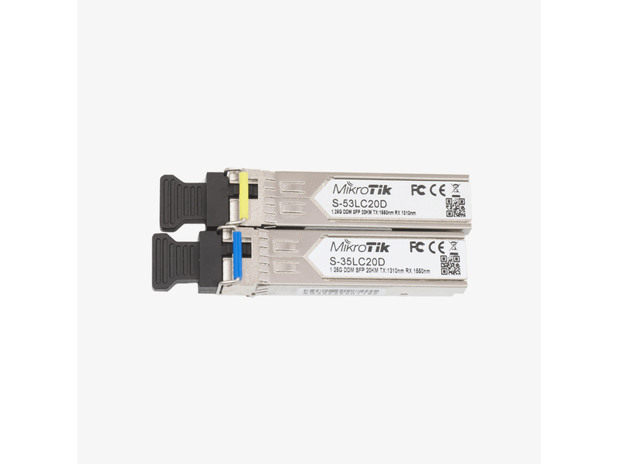  KEY SPECIFICATIONS  Data Rate 1.25 Gbps (Gigabit Ethernet)  Fiber Type Single-mode, single-strand BiDi  Connector LC  Distance Up to 20 km  Wavelengths S-35: Tx1310/Rx1550; S-53: Tx1550/Rx1310

4.9 Fiber Optic Patch Cords | FS — SC-LC & SC-SC
Features & Functions  - Factory-terminated single-mode fiber patch cords for rack and cross-connect terminations  - SC-LC variant bridges SC-terminated backbone runs to LC-terminated SFP transceivers  - SC-SC variant used for straight cross-connects between patch panels / ODF ports  - Low insertion loss, UPC/APC polished connectors typical of FS single-mode patch cord lines  - Color-coded (yellow) jacket for easy single-mode fiber identification during maintenance  Application in this Project  Used inside each Communications Rack to connect the media converter, SFP-equipped switch port, and fiber distribution/ODF hardware forming the Powerhouse–Desander backbone. |  | 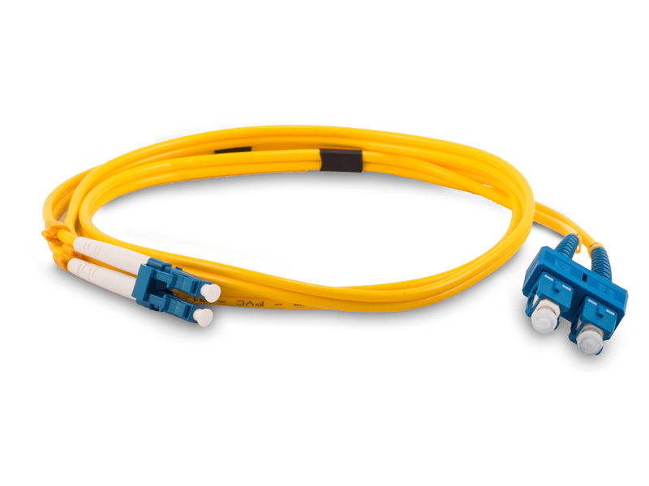  KEY SPECIFICATIONS  Fiber Type Single-mode (9/125 µm)  SC-LC Qty 4 pcs  SC-SC Qty 10 pcs  Connector Finish UPC (typical)  Use Rack / ODF cross-connects

4.10 Gigabit Fiber Media Converter | TP-Link — TL-FC311A-20
Features & Functions  - Converts Gigabit Ethernet (RJ45) to single-mode fiber (SC) and back, extending Ethernet reach beyond copper limits  - WDM (bi-directional) single-fiber operation at Tx1550/Rx1310 nm, paired with a complementary Tx1310/Rx1550 unit  - Supports link distances of up to 20 km over single-mode fiber  - 1 × SC fiber port + 1 × RJ45 10/100/1000M port, plug-and-play with auto-negotiation  - Compact desktop/rack-mount form factor with LED link/activity indicators  Application in this Project  Provides the copper-to-fiber conversion point per the FDAS/CCTV drawing note calling for the Desander NVR to be linked to the Powerhouse CCTV system via media converter and fiber-optic cable. |  | 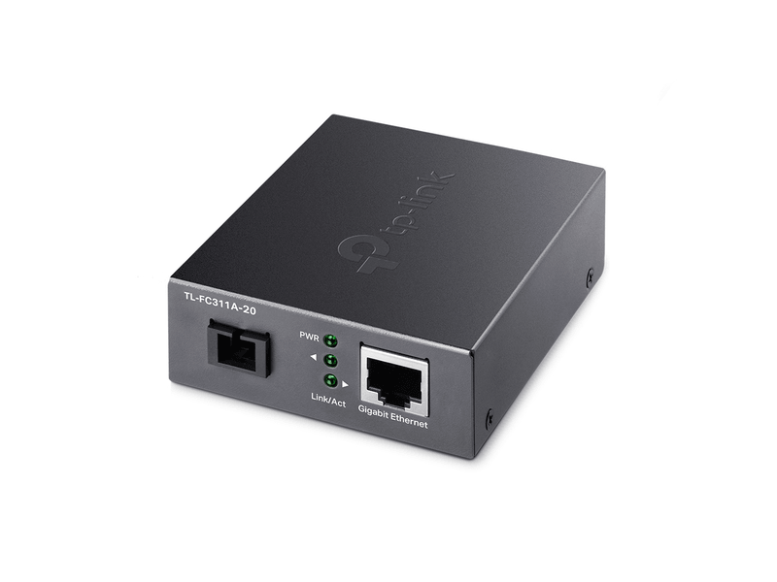  KEY SPECIFICATIONS  Ports 1 × SC (fiber), 1 × RJ45 (10/100/1000M)  Fiber Mode Single-mode, WDM (BiDi)  Wavelength Tx1550/Rx1310 nm  Distance Up to 20 km  Standard IEEE 802.3, 802.3u, 802.3ab

4.11 40U Rack Cabinet, 5.8 ft | Generic / Site-Standard — 40U w/ Cooling Fan
Features & Functions  - 40U (5.8 ft) floor-standing enclosure providing rack-mount space for the NVR, PoE switch, patch panel, and UPS  - Integrated cooling fan module (roof or rear-mounted) for forced-air thermal management of active equipment  - Front glass/steel door and removable side panels for equipment access and airflow management  - Cable management accessories (vertical/horizontal organizers) supporting structured Cat6 and fiber routing  - Supplied with an extension cord / PDU strip for distributing rack power to installed equipment  Application in this Project  One cabinet installed per site (Powerhouse and Desander); the Powerhouse cabinet is shared with the Data/Voice and Intercom systems per the combined equipment list. |  | 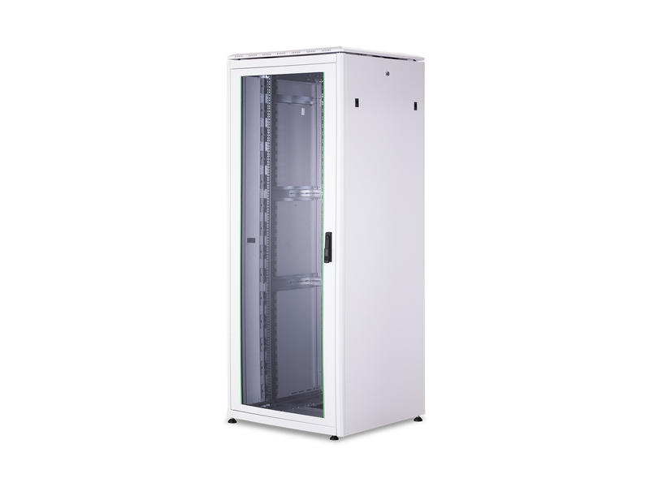  KEY SPECIFICATIONS  Height 40U (5.8 ft / ~ 1.98 m)  Cooling Integrated cooling fan  Included Extension cord / PDU strip  Mounting 19″ standard EIA rack rail

4.12 RJ45 Modular Connector | D-Link — Cat6 RJ45 Plug
Features & Functions  - 8P8C modular plug for terminating structured Cat6 UTP cable at camera, patch panel, and switch ends  - Gold-plated contacts for reliable, low-resistance signal and PoE current transfer  - Compatible with standard T568A/T568B wiring schemes used throughout the installation  - Rated for Cat6 performance (up to 250 MHz), supporting Gigabit Ethernet and PoE/PoE+ loads  Application in this Project  Used to terminate all Cat6 UTP camera and data drops at the patch panel, switch ports, and camera-side field connections. |  | 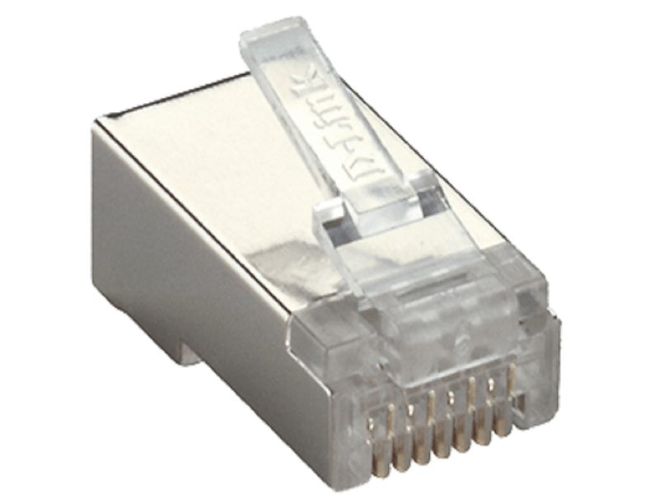  KEY SPECIFICATIONS  Type 8P8C (RJ45) modular plug  Category Cat6  Contacts Gold-plated  Wiring T568A / T568B

4.13 Uninterruptible Power Supply, 3000 VA | AWP — AID3000 Pro LCD
Features & Functions  - Line-interactive design with Automatic Voltage Regulation (AVR), correcting brown-outs/surges without switching to battery  - 3000 VA / 1800 W capacity, sufficient to ride through the NVR, PoE switch, and media converter/SFP uplink on each rack  - LCD display for real-time load, battery status, and input/output condition monitoring  - Auto-sensing 50/60 Hz input (±10%) with 6 universal/NEMA 5-15 output sockets  - Sealed lead-acid battery bank (4 × 12V/9Ah) with a 6–8 hour recharge time  Application in this Project  One unit per rack (Powerhouse and Desander), backing the NVR, PoE switch, and fiber media converter/SFP uplink through momentary outages and utility fluctuations. |  | 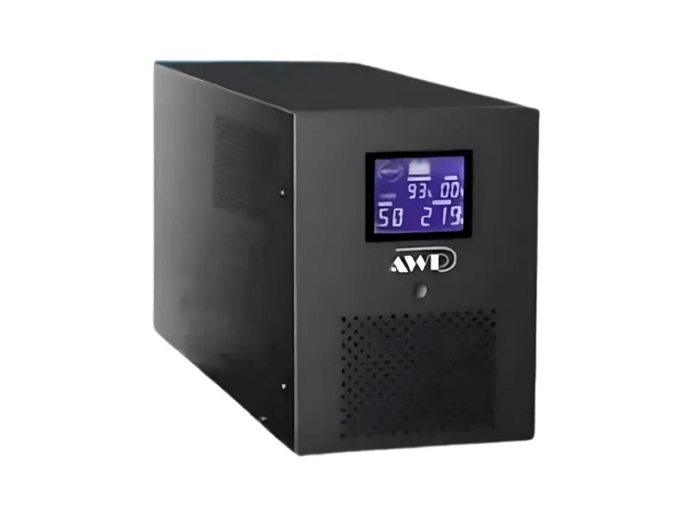  KEY SPECIFICATIONS  Rating 3000 VA / 1800 W  Type Line-interactive, AVR  Battery 4 × 12V/9Ah SLA  Outlets 6 × universal/NEMA 5-15  Recharge Time 6–8 hours

4.14 Junction Box — Turret / Dome Mount | Hikvision — DS-1280ZJ-S
Features & Functions  - Aluminum-alloy junction box providing a clean cable-management base beneath turret/dome cameras  - Hikvision-white finish for a uniform, factory-matched appearance with the installed cameras  - Side and bottom cable inlets, waterproof rubber grommet for outdoor/sheltered applications  - Maximum load capacity of approximately 4.5 kg, well above the camera's own mounting weight  Application in this Project  Six units used as the surface-mount base for the indoor turret cameras (Item 4.5), housing the home-run cable termination behind each camera. |  | 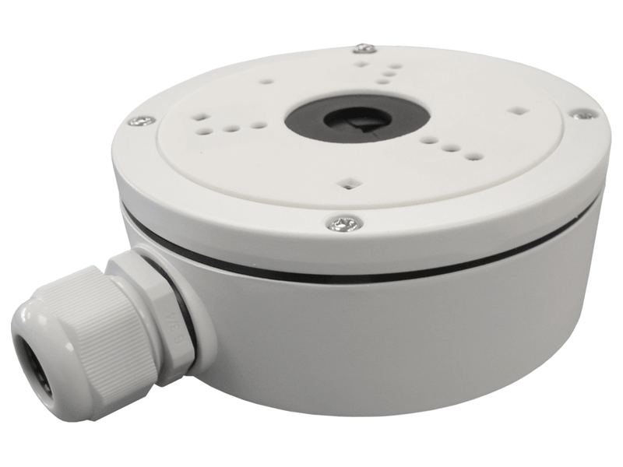  KEY SPECIFICATIONS  Material Aluminum alloy  Dimensions ~137 × 54 × 171.5 mm  Weight ~660 g  Max. Load ~4.5 kg  Finish Hikvision White

4.15 Junction Box — Pole / Wall Mount | Hikvision — DS-1280ZJ-PT6
Features & Functions  - Compact aluminum-alloy wall/pole mounting base for bullet-style cameras  - Hikvision-white finish matching the outdoor bullet camera housing  - Low-profile design (~42 mm depth) suited to pole-mount or wall-mount bullet camera brackets  - Waterproof rubber grommet required for outdoor exposure; rated for a wall/pole capable of supporting at least 3× the combined camera and bracket weight  Application in this Project  Six units used as the pole/wall-mount base for the outdoor bullet cameras (Item 4.4), with the exposed home-run cable drop entering through the box before terminating at the camera. |  | 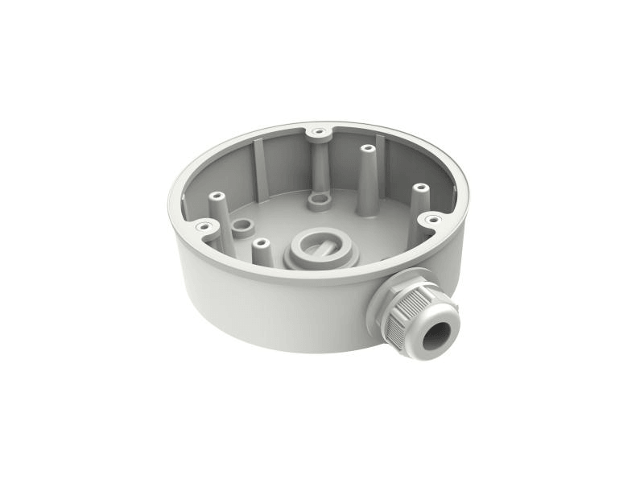  KEY SPECIFICATIONS  Material Aluminum alloy  Dimensions ~Ø137 × 42 mm  Weight ~280 g  Max. Load ~3–4.5 kg (bracket-dependent)  Finish Hikvision White

5.0 STRUCTURED CABLING

This section identifies the cable types used for the CCTV data and fiber backbone. Conduit, pull boxes, and other cable-routing raceway are civil/electrical bulk materials procured under the separate CLARA Forms request referenced in Section 1.0, and are not repeated here.
5.1 Structured Cat6 UTP Cable | Belden — Cat6 Indoor
Features & Functions  - 4-pair, 23 AWG solid bare copper conductors, unshielded twisted pair (U/UTP) construction  - Rated for Category 6 performance up to 250 MHz, supporting Gigabit Ethernet and PoE/PoE+ delivery  - PVC (indoor-rated) jacket suited to the protected, conduit-routed runs used throughout this installation  - Used for every camera home-run and data drop, terminated in RJ45 connectors (Item 4.12) at both ends  Application in this Project  Runs from each camera location to its nearest Pull Box, then onward to the Communications Rack, terminating at the 12-port RJ45 patch panel. All runs are held within the 100 m TIA/EIA-568 structured cabling limit. |  | 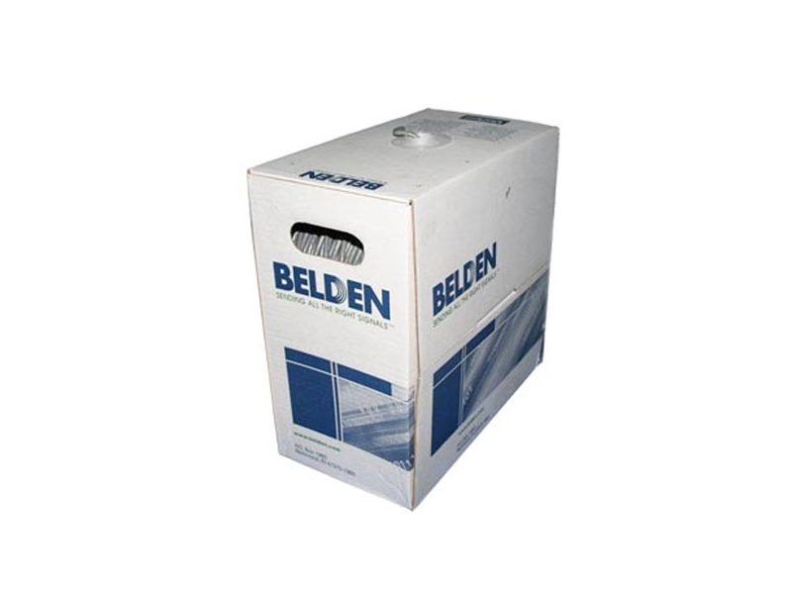  KEY SPECIFICATIONS  Category Cat6 (250 MHz)  Conductors 4-pair, 23 AWG solid bare copper  Jacket PVC, indoor-rated  Supports Gigabit Ethernet + PoE/PoE+  Quantity 720 m (2 boxes)

5.2 Single-Mode Fiber Optic Patch Cords | FS — SC-LC / SC-SC
Features & Functions  - 9/125 µm single-mode fiber, factory-terminated and tested for low insertion loss  - SC-LC cords bridge the media converter / patch panel side to the SFP-equipped switch uplink port  - SC-SC cords provide straight-through cross-connects at the patch panel / fiber distribution point  - Forms the sole physical link carrying the inter-site video traffic between Powerhouse and Desander  Application in this Project  Used inside each Communications Rack to complete the fiber path between the media converter (Item 4.10), the SFP module (Item 4.8), and the patch/distribution point. |  | 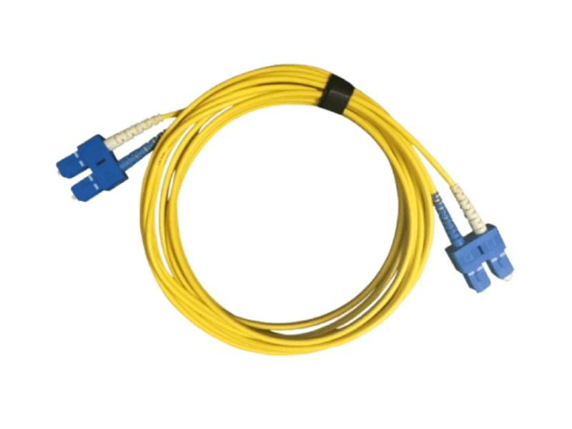  KEY SPECIFICATIONS  Fiber Type Single-mode, 9/125 µm  SC-LC 4 pcs  SC-SC 10 pcs  Application Rack / fiber cross-connects

6.0 INSTALLATION & MOUNTING STANDARDS

- Camera cable routing (conduit, pull boxes, and raceway) is furnished and installed under the separate civil/electrical bulk-materials package; this TDS addresses only the IT/electronic equipment and its termination points.
- Turret-type cameras are surface-mounted on a junction box with mounting bracket (DS-1280ZJ-S), suited to indoor / sheltered locations, per Detail A (Dome Type CCTV Camera, scale 1:25).
- Bullet-type cameras are surface-mounted on a junction box with pole/wall bracket (DS-1280ZJ-PT6), per Detail B (Bullet Type CCTV Camera, scale 1:25).
- All camera home-run cabling terminates at the nearest Pull Box before continuing to the Communications Rack, then to the 12-port RJ45 patch panel in the Data Cabinet.
- The Desander NVR is linked to the Powerhouse CCTV monitoring system via media converter and single-mode fiber-optic cable (SFP + media converter per Items 4.8–4.10).
- 5.8ft 40U rack cabinets (with cooling fan) house each site's NVR, PoE switch, patch panel, and UPS; the Powerhouse cabinet is shared with the Data/Voice and Intercom systems per the combined equipment list.

7.0 QUALITY ASSURANCE & SUBMITTAL REQUIREMENTS

Per MEPF Department coordination on this request, all materials for the SCIC permanent project supply are subject to Site QA/QC submittal and Owner approval; this basis also serves the Receiving Inspection on site. This Technical Data Sheet is to be submitted to the QC Department together with the manufacturer's official Technical Data Sheet for each selected brand and model, for PHPC's official approval prior to procurement.
8.0 APPROVAL / SIGN-OFF

PREPARED BY  Marc Harrold Salva  IT Support — Project Site | REVIEWED BY  IT Operations Department / Central Office | NOTED BY  Nathaniel Principe  Deputy Project Manager | APPROVED BY  PHPC (Owner/Client) / QC Department

