FunboxEasyEnum- Easy
Attacker IP: 192.168.49.118
Victim IP: 192.168.118.132

Recon
Commands:
Nmap: sudo nmap -sC -sV -Pn 192.168.118.132
gobuster gobuster dir -u http://192.168.118.132 -w /usr/share/seclists/Discovery/Web-Content/directory-list-2.3-medium.txt -x php,txt -t 100 -e

Nmap
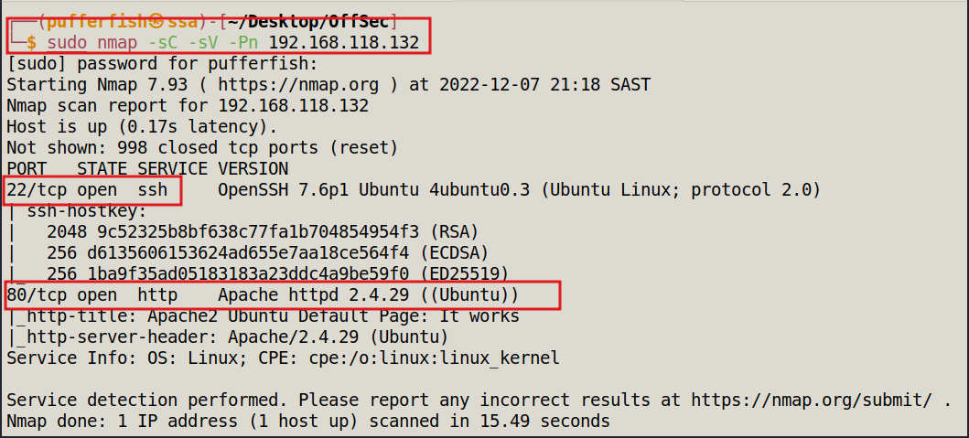

Gobuster

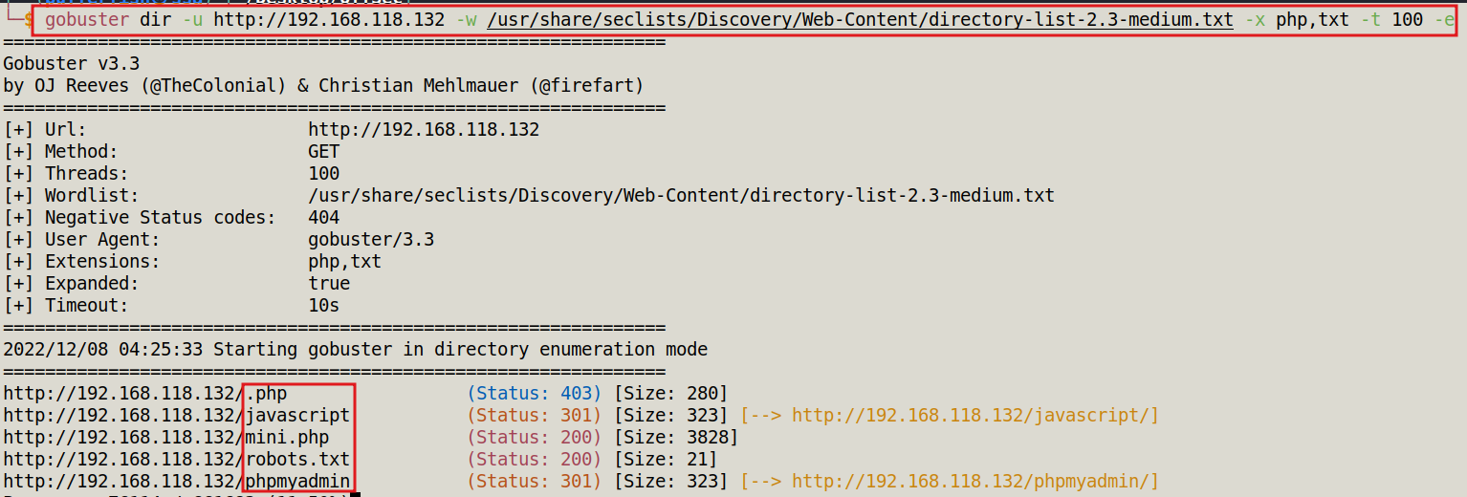

Port 80

/robots.txt

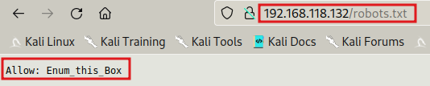

/myphpadmin

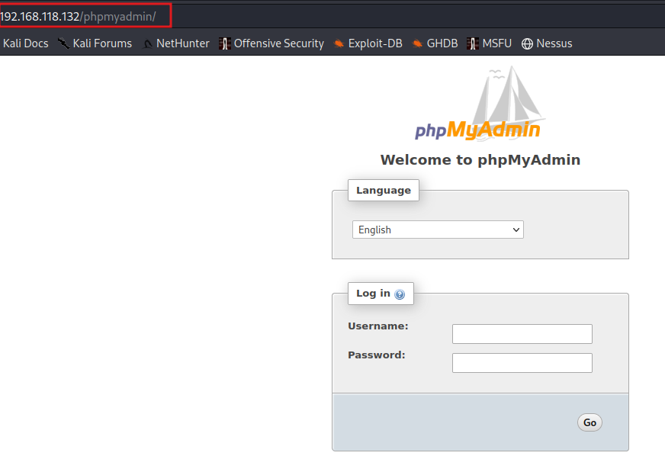

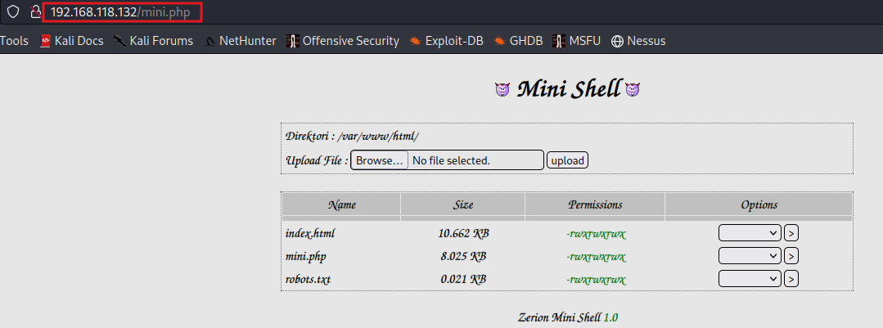
/mini.php

Explotation
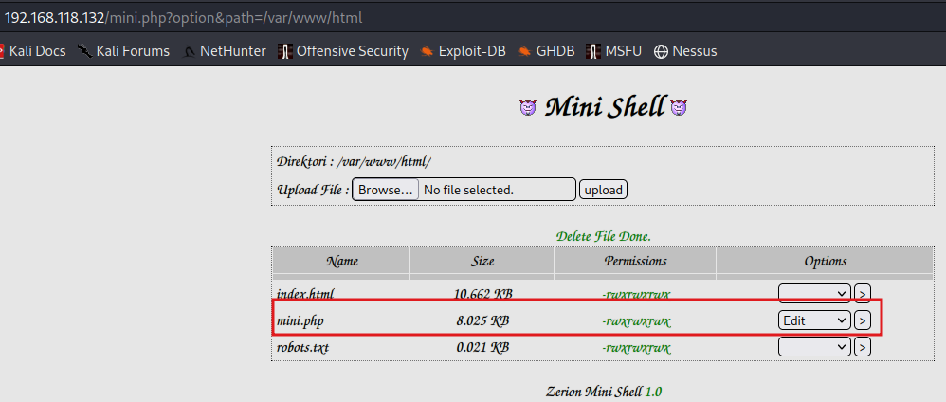

Edit php reverse-shell by pentest monkey and edit mini.php file
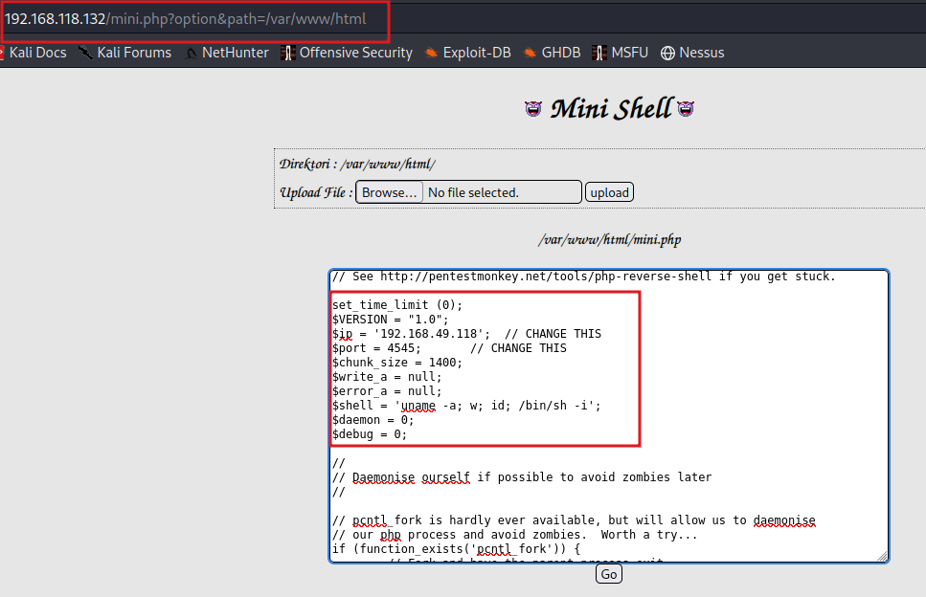
start Netcat Listner
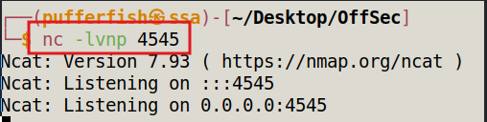

Connected
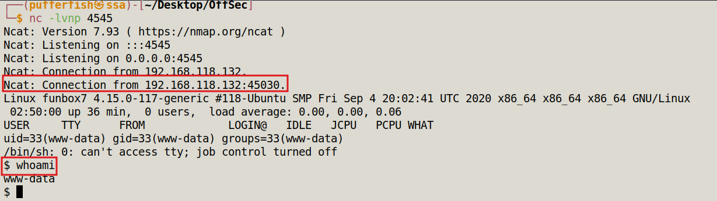

stablize the shell

python3 -c 'import pty;pty.spawn("/bin/bash")'

We get a hint from the mini.php on where to take alook for the user flag

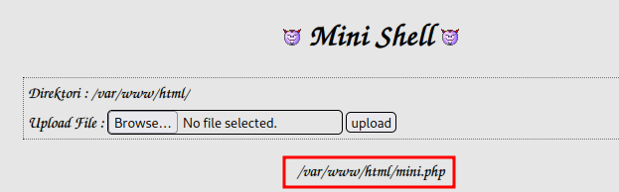

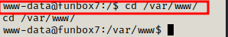

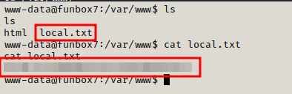

We go to home directory to start looking there
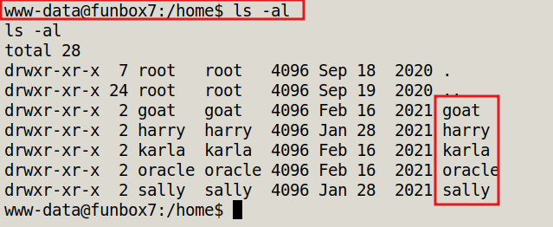
Search through direstories to see if anything of interesting find a lot of users after going through all users and found nothing decided to try brute force the ssh using hydra

We check to see if we can access the password file

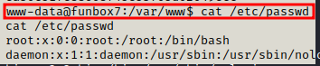

We can and we get a hash for the user oracle

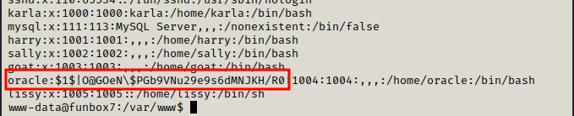

Hashcat to decrypt the hash
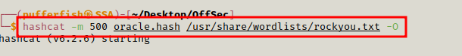
Cracked
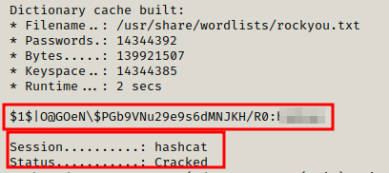

Lets see what info we can get from the phpmyadmin directory
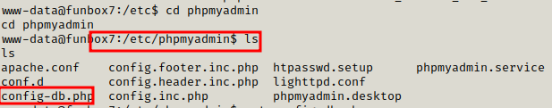
We get the admin pasword for the page
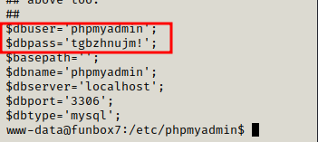

Privilidge Escalation
ssh using the above credentials for Karla
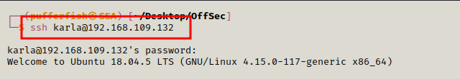

Check what sudo privilidges she has
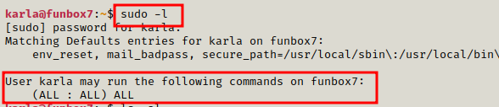
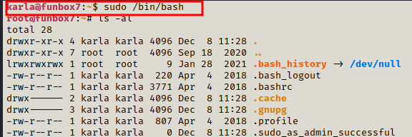

We go back till the main directory then cd into root
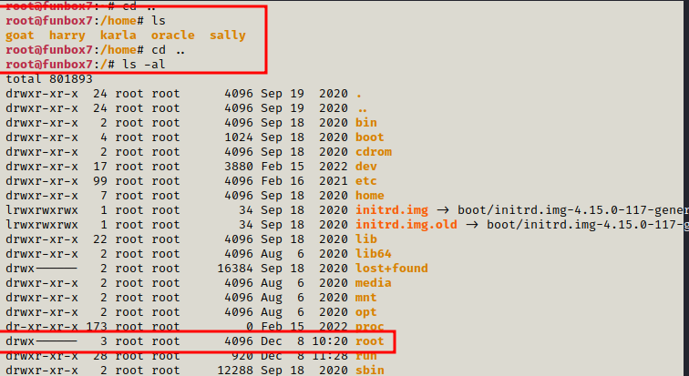
We look for the flag and
