MoneyBox -Easy
Attacker IP: 192.168.49.223
Victim IP: 192.168.223.230

Criteria:

Recon:
Nmap Scan: sudo nmap -sC -sV -Pn 192.168.223.230
Dirb: dirb http://192.168.223.230

Nmap Results

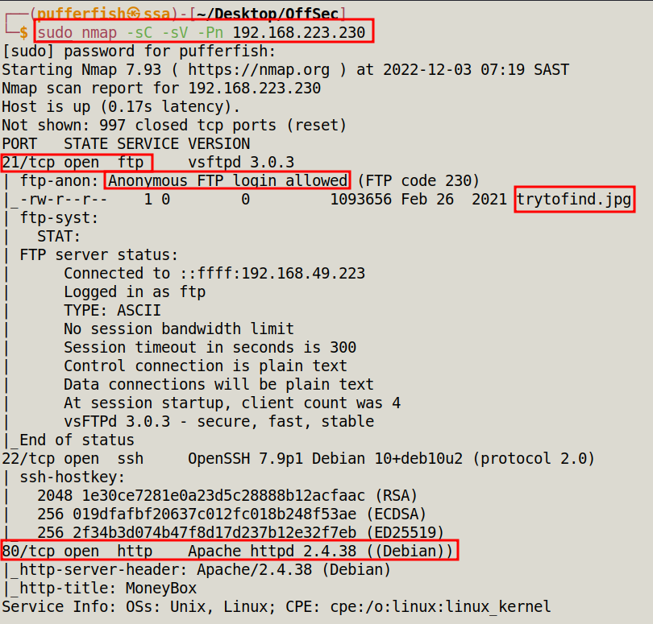

Dirb Results

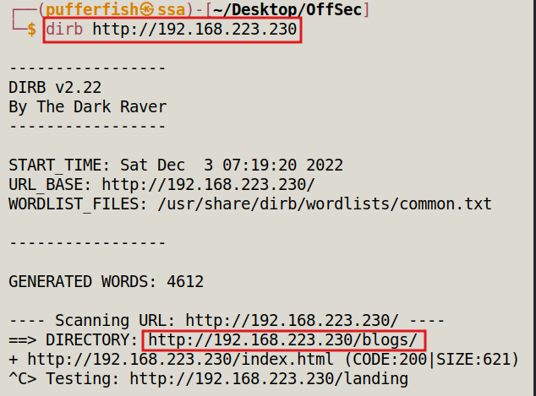
Port 80 - HTTP

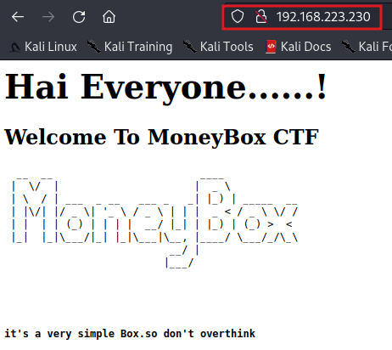

While running dirb we found a directory called /blogs

http://192.168.223.230/blogs/

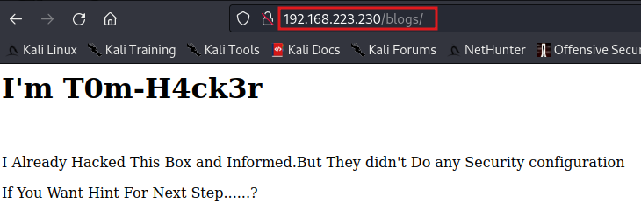
We dont find anything interesting on the page. Lets check the source code

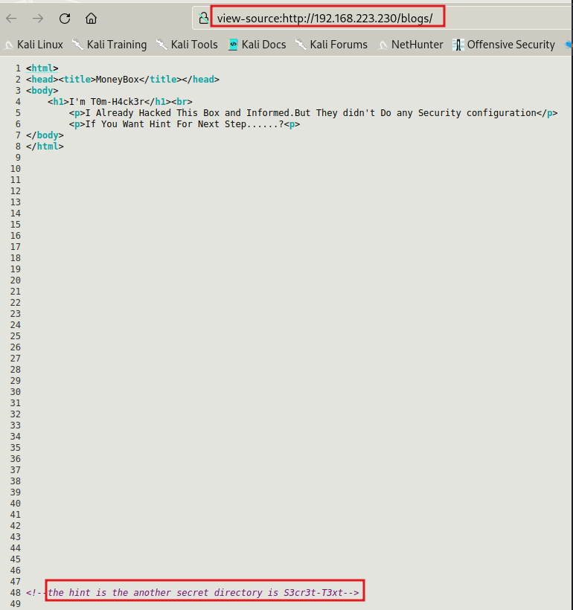

We find a hint to another Directory called S3cr3t-T3xt, We go to the directory and to investigate.

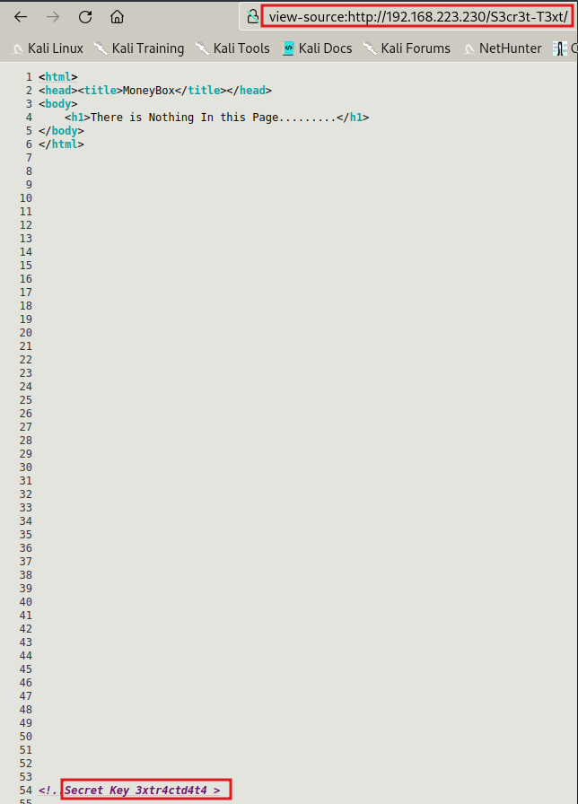

A secret key is located 3xtr4ctd4t4

PORT 21 - FTP

Log into Port 21 using anonymous credentials

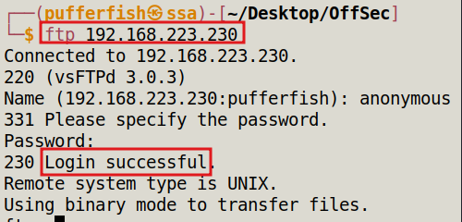

Located a .jpg file
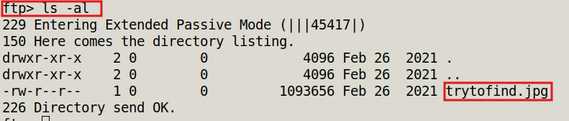

We download the .jpg file

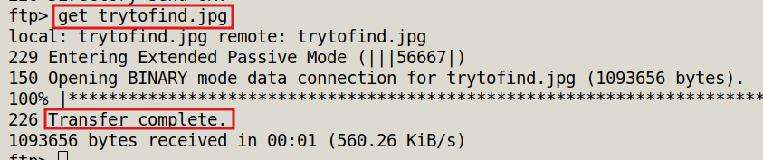

The image is strange as its data size is very large for a normal image. This could indicate that there might be data hidden in the image.

Cryprography - Steghide

Command: steghide --extract -sf trytofind.jpg

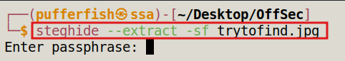

It requires a passphrase, Lets try the secret key from earlier. 3Xtr4ctd4t4

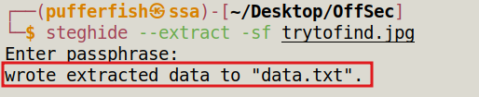

We can cat the data.txt file to see what it says.
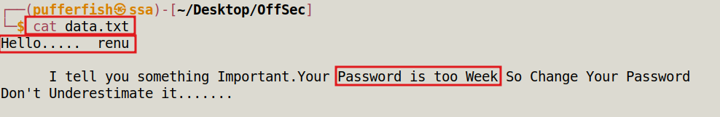

We can see that there is user named renu and also indicates that his password is weak. Lets try SSH into Port 22 using hydra to find the password.

Port 22 – SSH

Command: hydra -l renu -P /usr/share/wordlists/rockyou.txt 192.168.223.230 ssh
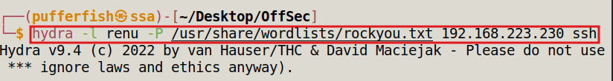
Password found: 987654321

Login into SSH

Command: ssh renu@192.168.223.230
Password: 987654321
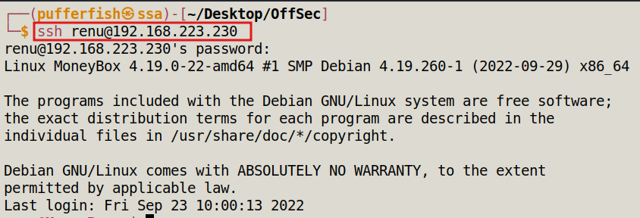
Logged in Successfull
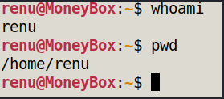

Flag 1

We find the Location of a file called local.txt

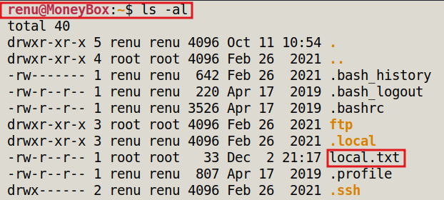

Cat the local.txt file to get the first flag

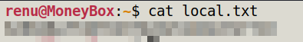

Flag 2 – Priviledge Escalation (Root)

We go back to home directory to see if there is any other information that could help us.

We find another user called lily and access her file.

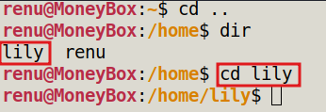

While looking around we find a file called authorized_keys. We cat the file. And find and ssh -rsa key and that we could getto lily through the machine

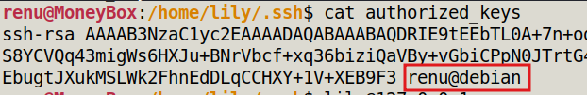

SSH into lily
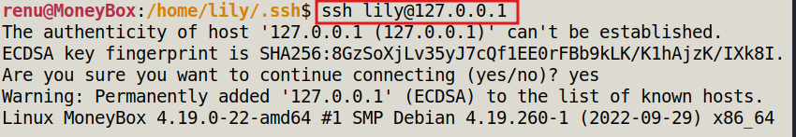

Logged in as lily
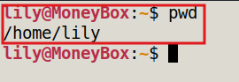

Check what sudo privilidges lily has.

Command: sudo -l

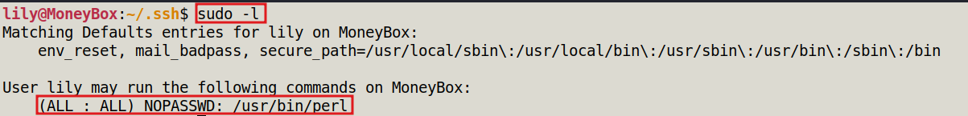
Lily can use perl as privilidge escalation we take a look at gtfobins to see what we can do

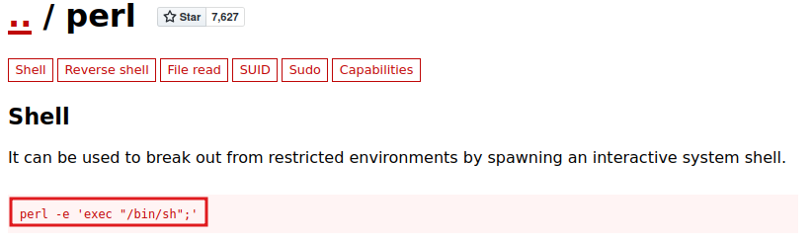
We run the script to get root

Command: sudo perl -e 'exec "/bin/sh";'

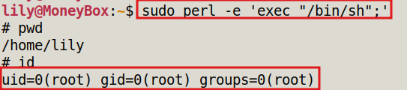

cd into root Directory and find proof.txt

