SYSTEM DESIGN SPECIFICATION
Online Auction System — Mbarara City
Phase 2 — Architecture, Database Design, State & Sequence Models, Security

1. System Architecture
The system follows a layered Django architecture. Business rules live in a dedicated service layer, not in views or templates, so bidding logic can be unit-tested independently of HTTP concerns and reused by both the web views and the REST API.
Figure 1. Layered request flow.
Views delegate to ten modular Django apps, each owning one bounded concern:
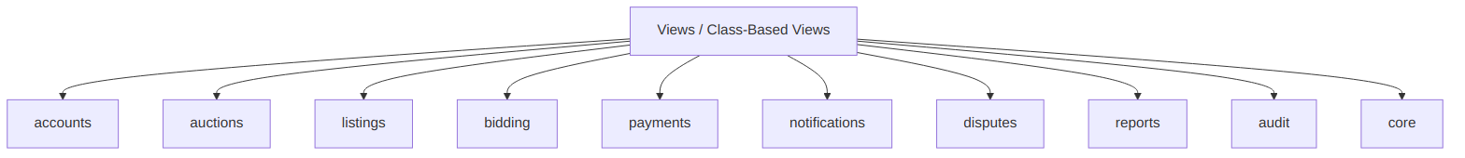
Figure 2. Django app decomposition.
App | Responsibility
accounts | Authentication, roles, user & profile management
auctions | Auction entity, category, lifecycle/state transitions
listings | Listing creation/edit workflow, images, approval queue
bidding | Bid model, validation, concurrency-safe bid service
payments | Payment status tracking (scaffold only in MVP)
notifications | In-app notification model & delivery
disputes | Dispute creation, evidence, resolution workflow
reports | Reporting & price-discovery analytics
audit | Immutable audit log of critical actions
core | Shared utilities, base models, permissions helpers

2. Database Design
PostgreSQL is used via the Django ORM. Bid and audit records are treated as append-only: rows are never destructively updated after acceptance, only superseded by a status change with a recorded reason, so the historical record stays intact for transparency and dispute resolution.
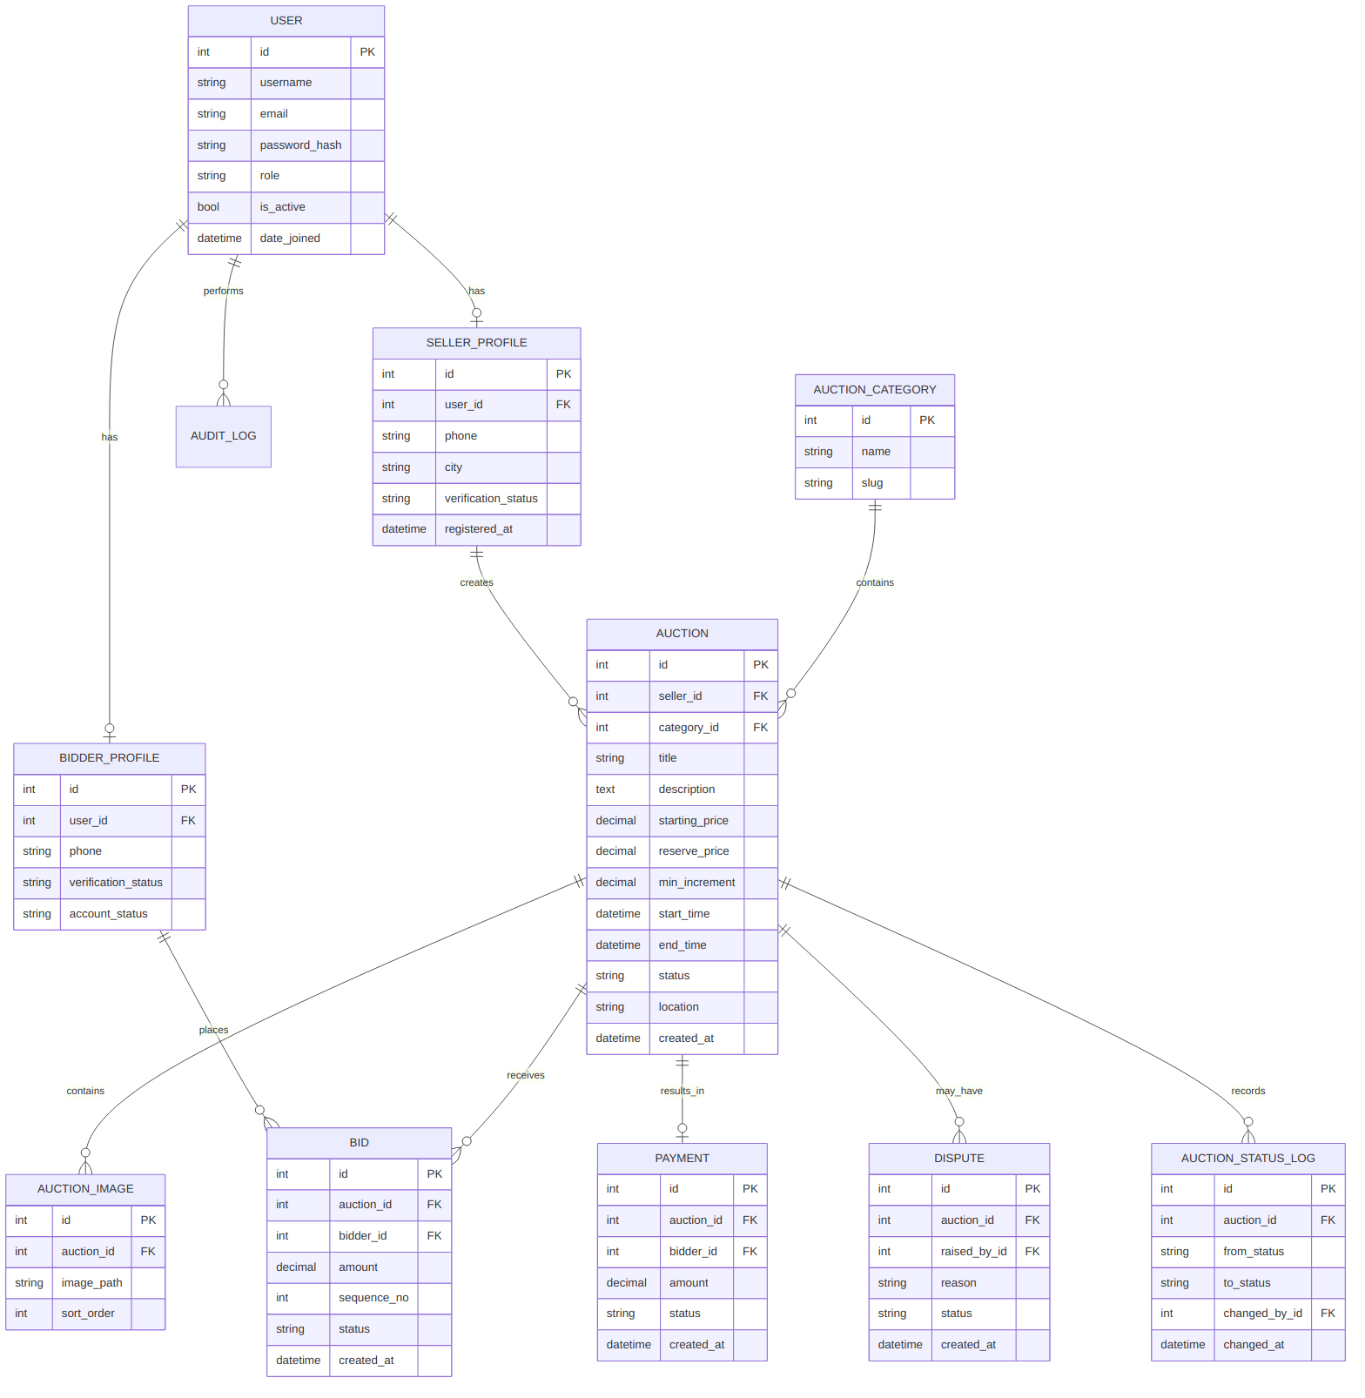
Figure 3. Entity-relationship diagram.

2.1 Key constraints
- Auction.starting_price, min_increment > 0 (CHECK constraint).
- Auction.start_time < Auction.end_time (CHECK constraint).
- Bid.amount > 0 (CHECK constraint); Bid.auction_id and Bid.bidder_id are NOT NULL foreign keys.
- Auction.status restricted to the enumerated lifecycle values (DB-level choices + application-level state machine).
- Unique index on (auction_id, sequence_no) in Bid to make ordering and tie-breaking deterministic.
- SellerProfile.user_id and BidderProfile.user_id are unique — one profile of each type per user, per the ERD's has relationship.

3. Auction Lifecycle (State Machine)
Every status transition is authorized in the service layer, never by direct field assignment from a view or template, per Business Rule BR-11 established in Phase 1.
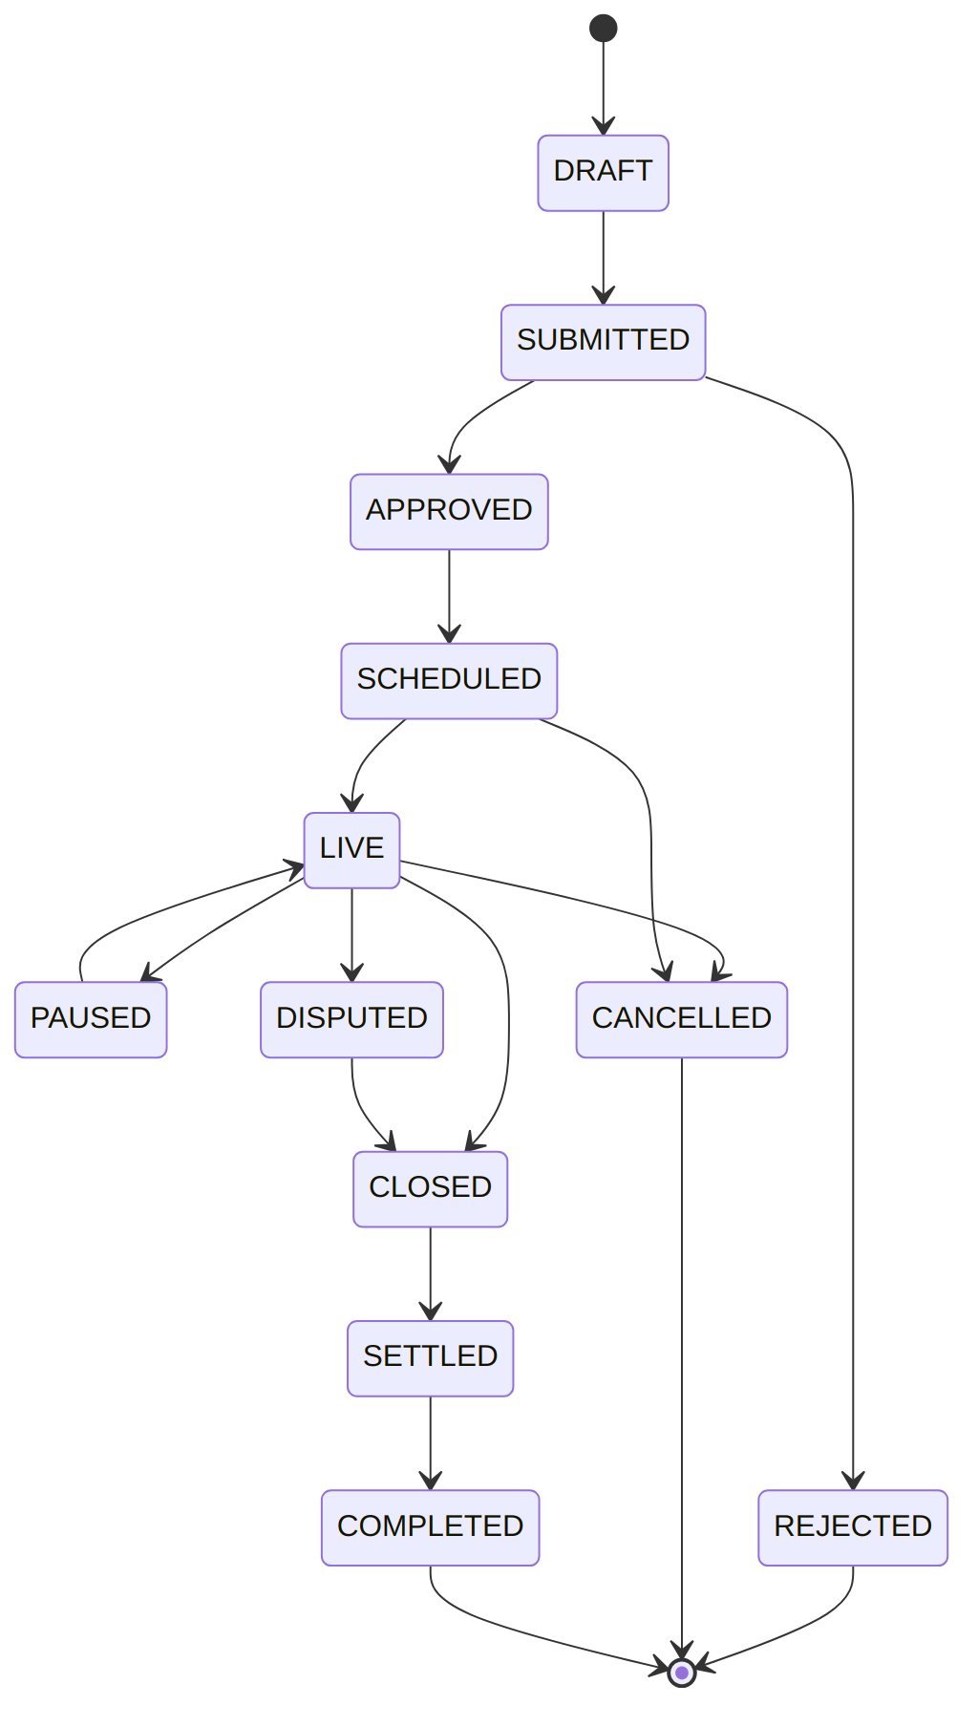
Figure 4. Auction status state machine.

4. Bid Submission Sequence
The bidding endpoint is server-authoritative end to end: eligibility, timing, and amount are all re-validated inside a single atomic transaction against a row-locked auction, closing the race-condition window described in Section 19/40 of the master specification.
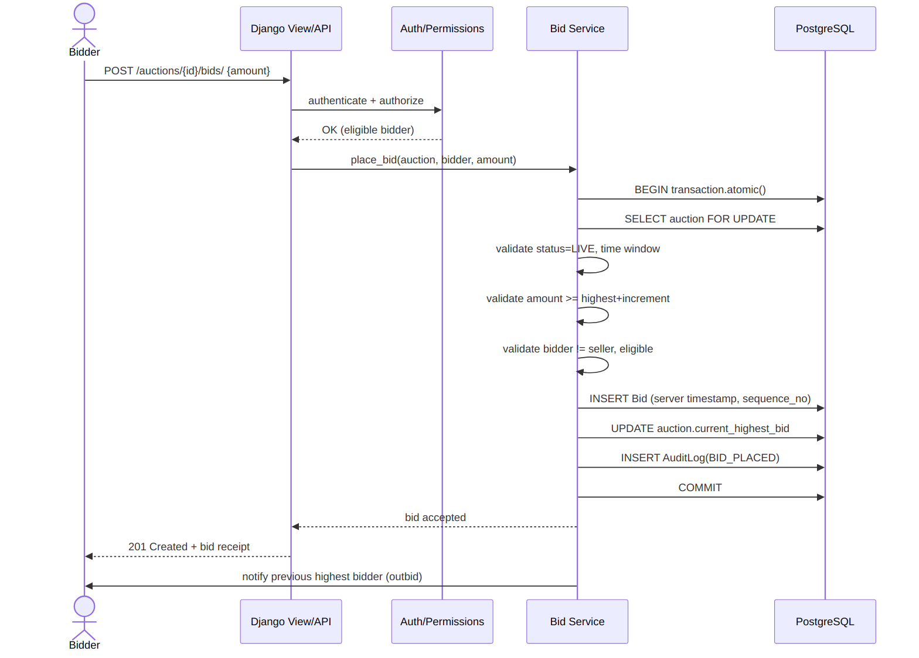
Figure 5. Bid placement sequence (concurrency-safe).
Concurrency approach: transaction.atomic() wraps the whole operation; Auction.objects.select_for_update().get(id=...) locks the row so two simultaneous bids on the same auction are serialized by PostgreSQL rather than racing in application code. The losing request re-reads the now-updated highest bid and is rejected with a clear 'you have been outbid' response rather than silently failing.

5. Auction Closing Sequence
Closing is triggered by a scheduled task (Celery beat, or a management command run by cron as a simpler MVP alternative), never by a browser request, per Section 25 of the master specification.
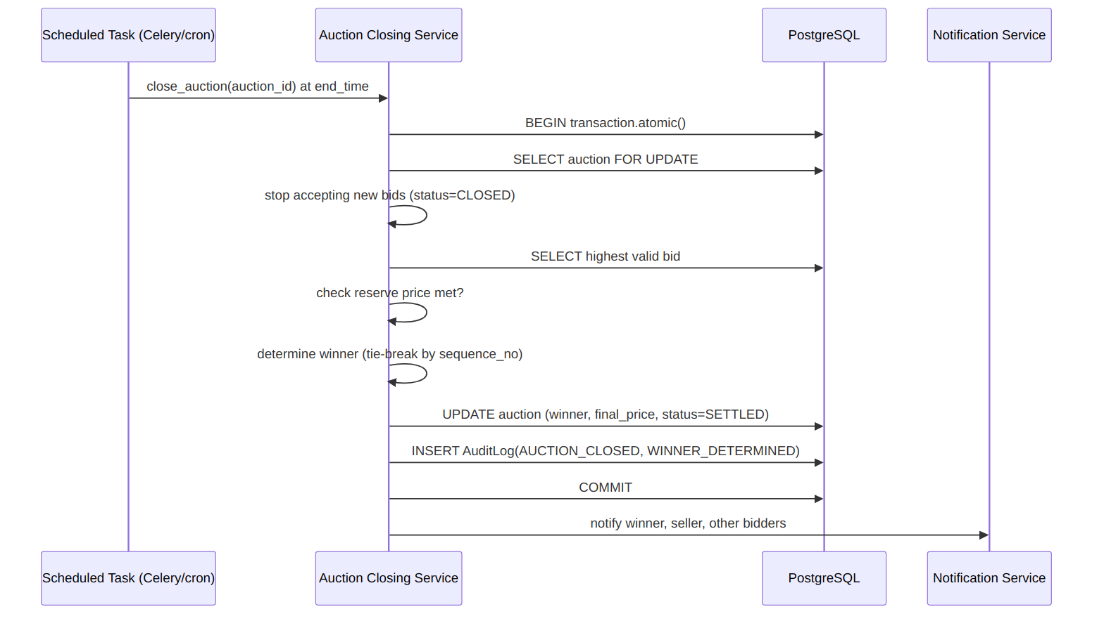
Figure 6. Automated auction closing & winner determination.

6. Transparency & Privacy Model
Audience | Sees
Public / guest | Auction details, current highest bid, bid count, anonymized bid history (e.g. 'Bidder A')
Authenticated bidder | All of the above, plus their own real identity on their own bids and full personal bid history
Seller (own auction) | Full bid history for their auction, still with bidder identities anonymized unless a sale/dispute requires disclosure
Administrator | Full identifying detail where operationally necessary (fraud review, disputes, support)
Reserve price, if configured, is never exposed publicly — only whether it was met at close (Section 24).

7. Security Threat Model (Summary)
Threat | Likelihood | Impact | Mitigation
Bid tampering / replay | Medium | High | Immutable bid rows; server timestamps; CSRF tokens; idempotency check on submission
Seller self-bidding | Medium | Medium | Service-layer check: bidder.user_id != auction.seller.user_id
Race condition on simultaneous bids | High | High | select_for_update() + transaction.atomic()
IDOR (editing another user's auction/bid) | Medium | High | Object-level permission check server-side on every mutating view
Session hijacking / brute force login | Low-Medium | High | Django auth, HTTPS-only cookies, login throttling
Malicious file upload (auction images) | Medium | Medium | MIME/type validation, size limits, storage outside executable paths
Unauthorized auction closure via API | Low | High | Closing only triggerable by the scheduled task / admin action, not a public endpoint

8. UI/UX Key Screens (Wireframe Description)
Auction Detail Page
- Image gallery, title, description, seller (verified badge), category, location
- Starting price / current bid / minimum increment displayed prominently
- Live status badge + server-driven time-remaining countdown (display only, not authoritative)
- Place Bid button → confirmation modal showing current highest bid and minimum permitted bid before submit
- Chronological bid history list with anonymized bidder labels and timestamps
Dashboards
- Administrator: pending approvals, active/scheduled/completed auctions, disputes, suspicious-activity flags
- Seller: my auctions, current highest bids, completed auctions and winning prices
- Bidder: active bids, auctions I'm winning/losing, won/lost history, ending-soon list

9. Deployment Architecture
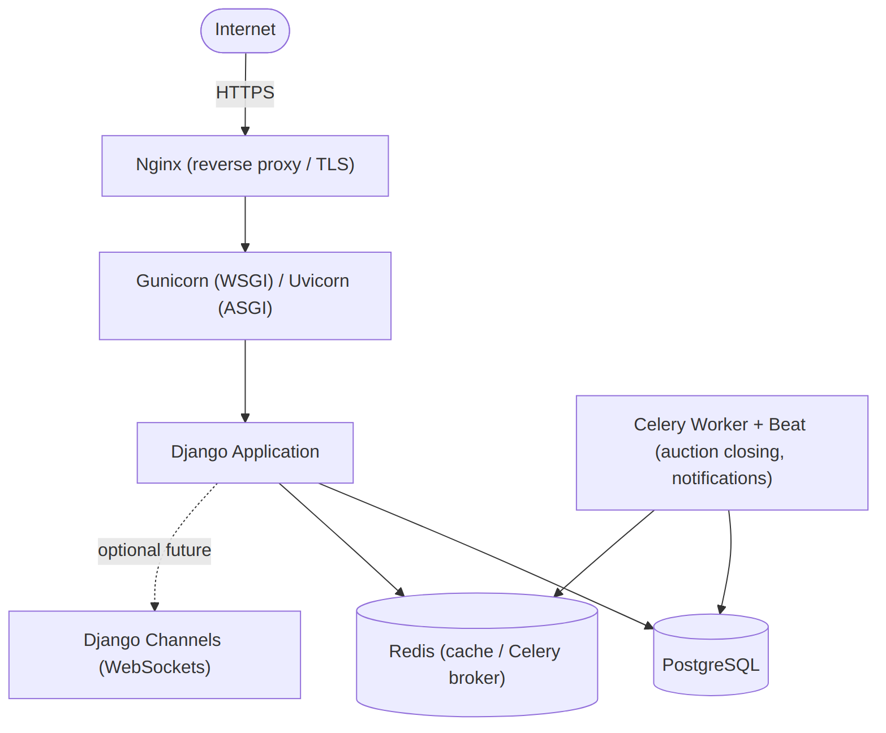
Figure 7. Production deployment topology.
Celery + Redis handle scheduled auction closing and asynchronous notification delivery so these never block a web request. Django Channels is noted only as a future enhancement for real-time bid updates (Section 54) — not required for MVP, which uses periodic polling on the auction detail page.

10. Next Steps
With architecture, data model, lifecycle, sequencing, and security direction fixed, Phase 3 begins Django implementation: project scaffolding, settings split (base/dev/test/prod), environment configuration, PostgreSQL connection, base templates, and the accounts app with authentication — per Phases 3–4 of the master specification.

