Programming projects semester 1
2021
REPORT
WERIWOH MBANG Goddy Clinton JUNIOR
LASALLE | Sant Joan

INDEX
Statement summary for projects………………………………………………………………………………………………………1
Activity diagram for project 1.1………………..………………………………………………………………………………………2
Activity diagram for project 1.2………………………………………………………………………………………………………..3
Activity diagram for project 1.3………………………………………………………………………………………………………..4
Difficulties and solutions employed………………………………………………………………………………………………….5
Conclusion and time spent……………………………………………………………………………………………………………….6

Statement summary project 1.1
Here, we have 2 options to choose from, and the third is just to exit. It is in summary, managing and showing satellites storage. In managing satellite storage (adding, removing satellites), which is in option 1, and to be able to remove a satellite, the user must have at least entered one satellite. In option 2, it is for the showing of our satellite storage in a certain order beginning from a starting point, indicated by the user, and then going round like a loop back to that number. And note that here, satellites are represented by positive integer numbers.

Statement summary project 1.2
In project 1.2, it is a kind of combination of 3 games, in which the program terminates when all 3 tasks have been completed or when the user exists manually which is the fourth option.
In option 1, which is “Guess divisor” the user inputs an integer depending on certain conditions, and then successfully input a total of 3 divisors of that number to complete this.
In option 2, “The reverse password”, the user inputs a positive integer of no more than 7 digits and should input a ”password” which must be the first number in reverse so as to complete this task.
In option 3, “The labyrinth”, the user is in a kind of labyrinth, whereby he/she is on position (0, 0) to start and tries to get on position (3, 4) as fast as the user can, having at his disposal a maximum of 10 moves so as to complete this task. These moves are done with keys N for upward movement in y axis, S for downward movement in y axis, W fore left movement in x axis, E for right movement in x axis.

Statement summary project 1.3
In project 1.3, it has to do with locations whereby, the user is presented with 3 options to choose from and the last to exist.
In option 1, “add location”, the user should enter a set of information describing the location he wishes to store. These different information are separated using # , the data entered are Name, location type, location rating, position(first for latitude, second longitude separated by a “|“), time(start time and end time separated with “-“) which represents the opening and closing hours of the entered location. All this data is checked here, and return a message when errors are found and return to menu, else then the location is stored.
In option 2, “List locations”, its basically just to show the list of all locations entered in option 1 with all their characteristics. If empty, just an error message is shown and user sent back to menu.
In option 3, “Show suggestions”, it is to show all the locations that suits the user’s demand ordered in increasing distance from the user. The user’s demand is determined by the user entering certain information: time he wants to visit, latitude and longitude of the user’s current position. After entry, the suggestions are displayed.

Activity diagram 1.1
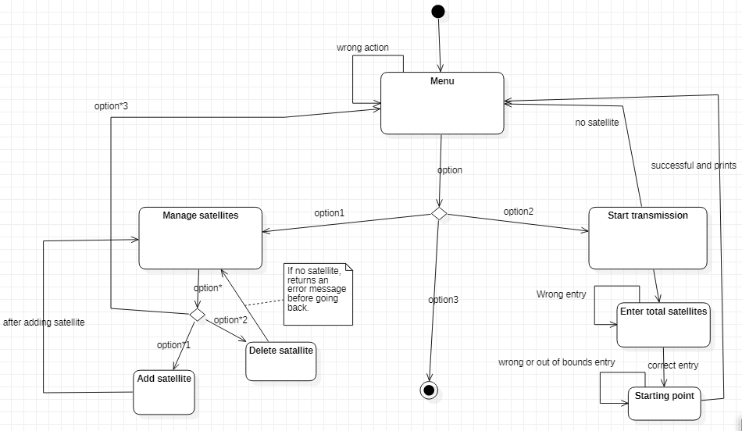

Activity diagram 1.2
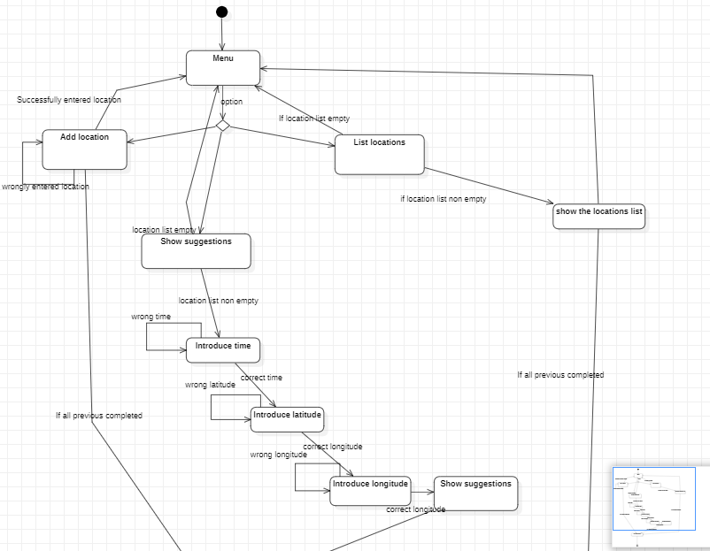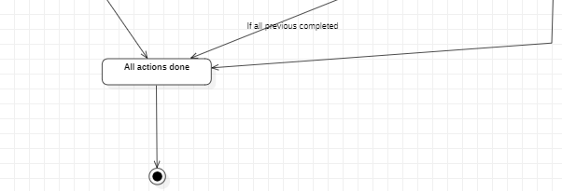

Activity diagram project 1.3
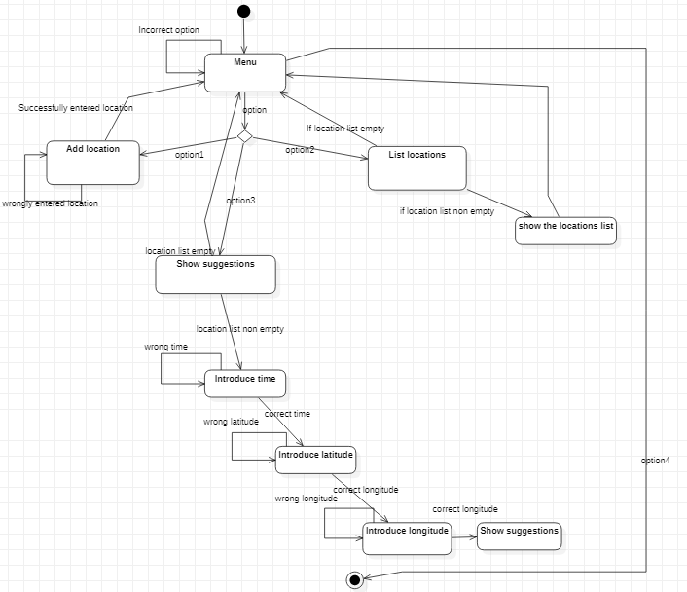

Difficulties and solutions employed

Project 1.1
In project 1.1 no major difficulties were faced in the development of the project.

Project 1.2
Here, the main difficulty I experienced where the numerous checking to be done, if the entry is prime, less than 7 digits, reverting numbers and checking loops, basically all these were resolved using numerous functions, each representing a particular checking or determination.
Also, at the level of terminating the program when all games have been completed, or not repeating a completed task, this was solved using the variables, “opt1_done”, “opt2_done” and “opt3_done”, whereby with appropriate position of if’s at the beginning of each option and end of each, this problem was solved.

Project 1.3
Here, the major difficulty I had was at the point of the atoi with the negative float number entry of position so, what I did was that I made 2 atois, one specifically for the position, and the other one, specifically for the time. In the first atoi I had to just use a special value, “sign” to deal with the negative sign.
Another problem faced here was the arranging in order of distance in the “show suggestions” option. This was solved by creating a completely new array of floats containing just distance values calculated in which each index is the same as the index of its corresponding location and the ordering was done by swapping of distance positions according to size followed by the exact swap on the array of locations, so the printing out was correct.

Conclusion
In conclusion, in order to structure and make a program more visible, easy to understand and manage, the use of functions, structures and procedures are very useful. And also, using variables as Boolean(0 or 1) help in determining many conditions without stress.

Time spent

Project 1.1
4 days

Project 1.2
1 week

Project 1.3
1week

