Environment Setup

Repository Link: <https://github.com/Godelvatai/web-231>

GitHub Pages Link: <https://godelvatai.github.io/web-231>

HTML Validation Screenshot:

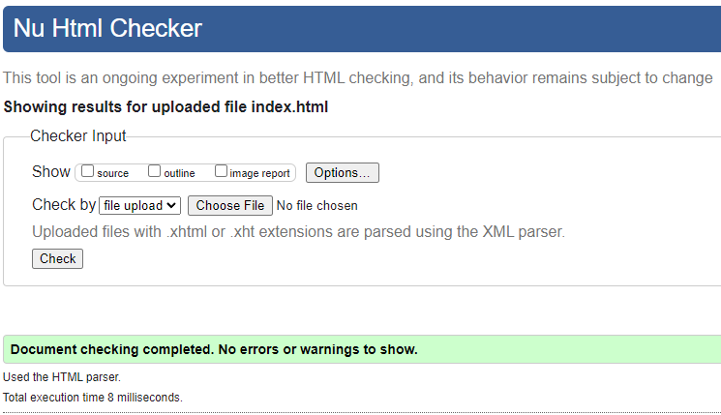

CSS Validation Screenshot:

