GitHub Repository Setup Deliverables

Repository Link: <https://github.com/Godelvatai/web-231>

Repository Screenshots:

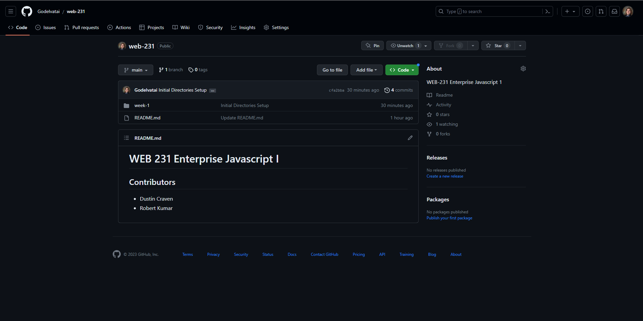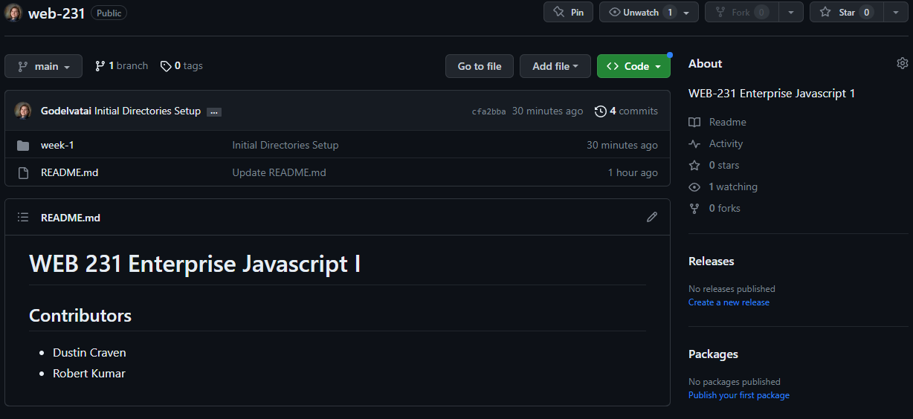

Directory Screenshot:

