Exercise 2.2 Hello JavaScript – 8/27/2023

Repository Link: <https://github.com/Godelvatai/web-231>

GitHub Pages Link: <https://godelvatai.github.io/web-231/week-2/craven-exercise2.html>

HTML Validation

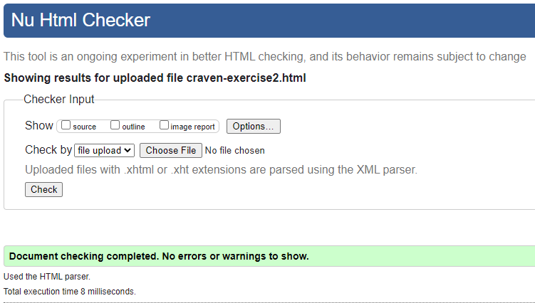

CSS Validation:

