Bangalore,Karnataka-560049

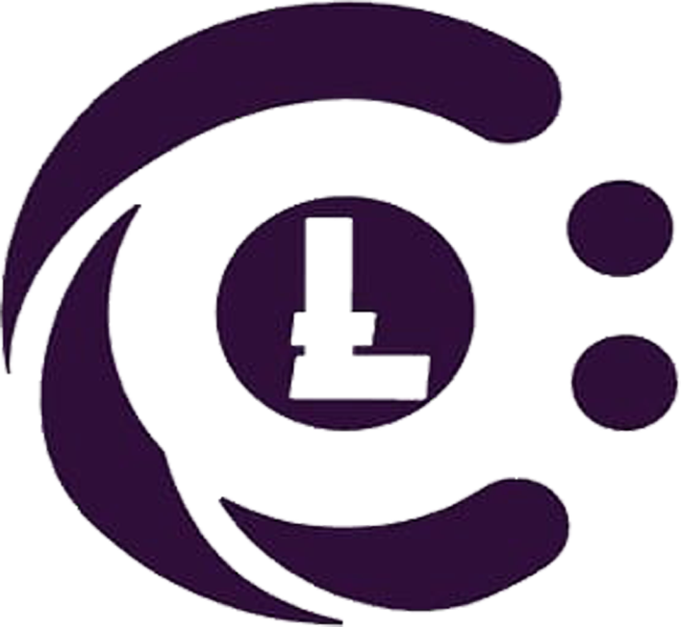

**ConsoleLancer**

***Python Development***

**Internship**

2020-21

No.50,4th cross,4th Main, Vinayaka Layout,Bhattarahalli, Bangalore,Karnataka-560049

Bangalore,Karnataka-560049