**Candidate models**

Model 1: completedegree extentravel intrstcltrs religimport [Enter Method]

Model 2: RWA.tot Travellers Regeneration

**Variables**

3rd level education : people with degrees less likely to be prejudiced against travellers

RWA : Significant indicator of prejudice against travellers

**Right-wing authoritarianism**

Right-wing authoritarianism (RWA) is a personality and ideological variable studied in political, social, and personality psychology. It is defined by three attitudinal and behavioral clusters which correlate together:

**Authoritarian submission** — a high degree of submissiveness to the authorities who are perceived to be established and legitimate in the society in which one lives.

**Authoritarian aggression** — a general aggressiveness directed against deviants, outgroups, and other people that are perceived to be targets according to established authorities.

**Conventionalism** — a high degree of adherence to the traditions and social norms that are perceived to be endorsed by society and its established authorities, and a belief that others in one's society should also be required to adhere to these norms

**Statistical conclusion validity (SCV)** establishes the existence and strength of the co-variation between the cause and effect variables. This type of validity involves ensuring adequate sampling procedures, appropriate statistical tests, and reliable measurement procedures.

* Sample Size
* Power
* Significance
* Effect size

An effect size is a measure of the strength of the relationship between two variables in a statistical population, or a sample-based estimate of that quantity.

An effect size calculated from data is a descriptive statistic that conveys the estimated magnitude of a relationship without making any statement about whether the apparent relationship in the data reflects a true relationship in the population.

**Variable : Age Range (Ratio)**

Average age is 27 years (26.85). Average age is not particularly relevant to

The dispersion of age is more relevant.

Summary Statistics

Max value: 17 Minimum value: 65 Range : 48 years

Skewness: 1.741 Kurtosis value: 1.930

The Skew value is greater than 1: Very positively skewed. This means that there is a majority of people in the lower age brackets. (i.e. mass of the distribution is concentrated to the left. It has relatively few high values.)

The kurtosis value is greater than 1 : Peaked. (leptokurtic)

Age follows a peaked, positively skewed distribution. Therefore it is not normally distributed.The variable “age” is not normally distributed, so should use the median and IQR range

[Median age 22 , Q1 = 22 , Q3 = 27.75 , IQR = 6.75]

A visual inspection of the dataset implies that a substantial proportion are in their twenties. This is confirmed by the Skew/Kurtosis.

Also 91 of the sample are university students. (is this representative of general population?)

Nobody over 65 is in sample 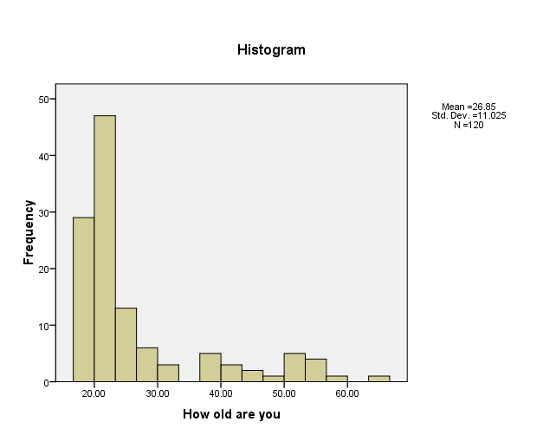

**Variable: Sex (Categorical)**

The mean value of the age variable is 54.63% this means that there neither sex is disproportionaltey represented in the same.

(good split between males and females, but too many 20-somethings to be representative)

**Variables: Education (Categorical)**

116 completed secondary school ( the four that didn’t are older than 39)

91 (75.83%) are university students 35 (29.16%) are graduates

4 have not completed Secondary (03.33%)

Larger sample is desirable: but with more representation from older people.

**Suggestion:** no mention of whether or not the person is from a urban or rural area. Might include this in a future study ??

**Variable: RWA ( Right Wing authoritarian) (Ratio)**

Normally distributed. [Kurtosis approx = 1, Skew approx = 0]

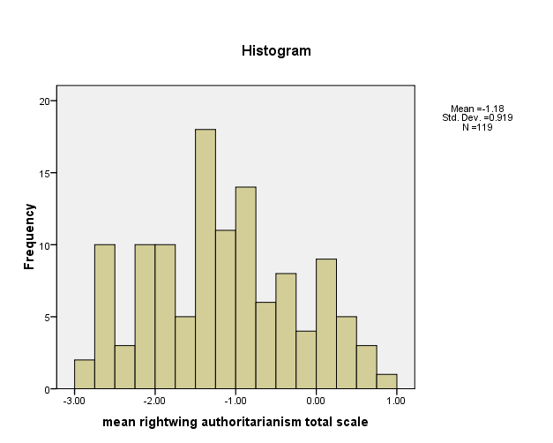

**SYNTAX CODE**

Syntax code to create previous outputs .

( **File > New >Syntax** , paste in code pieces below, then press the arrow in the menu bar)

examine RWA.tot

/plot boxplot stemleaf histogram

/percentiles(5,10,25,50,75,90,95,99).

examine Age

/plot boxplot stemleaf histogram

/percentiles(5,10,25,50,75,90,95,99).

**Using Variable Selection procedures**

Forward Selection procedure using the following candidate Independent variables

***completedegree extentravel intrstcltrs religimport RWA.tot Travellers Regeneration***

Variables selected for model

1. ***RWA.tot***
2. ***completedegree***

Using Backward Selection procedure, the same variables are selected.

**R-square** 0.166

**Adjusted R –Square** 0.151