**Basic idea**

In the contact tracing model, a transmission leads to an Exposed individuals becoming Infected with the rate σ. A proportion δ of infecteds are symptomatic/diseased ID. The rest are therefore asymptomatic IA.

Among the symptomatics (ID), some can get detected and have their contacts traced. We call this class IQ, which is basically the infecteds to be quarantined. By quarantine here we mean isolation, hospitalization, and self-quarantining.

The proportion of symptomatics that can be detected depends on a probability of detection p, and these individuals are detected and quarantined with a detection rate τ. We note that an infected to be quarantined IQ can still recover before being quarantined.

Each time an infected to be quarantined IQ is detected (i.e. IQ is moved to the Q class), the contacts of this individual are traced and immidiately moved to quarantine as well (see dashed orange lines).

*PS: The sims are (currently) based on the next model, but I’m moving to the one after which I expect will give practically the same thing, but it will be more correct (in the second one, the S that are quarantined go back to the pool of susceptibles after 2 weeks).*

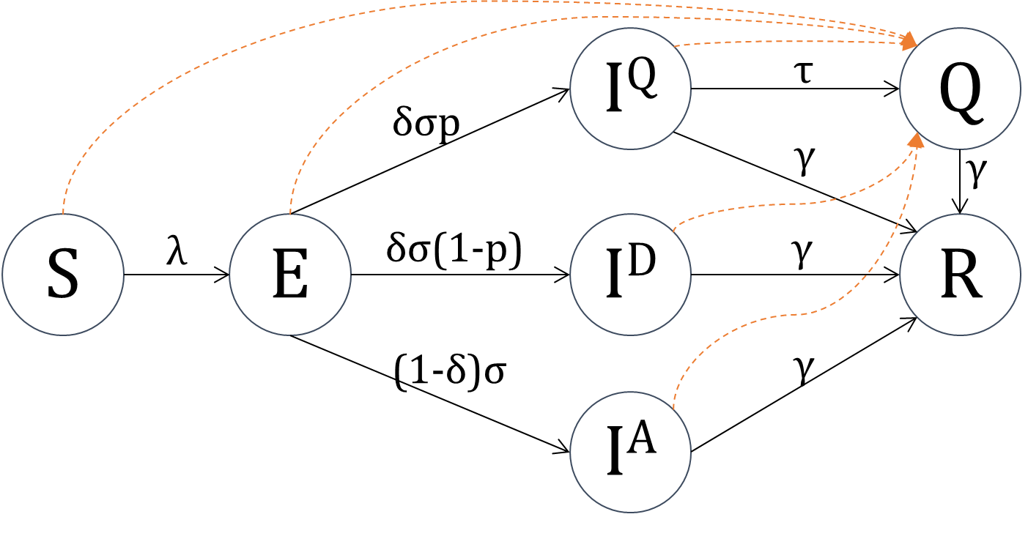

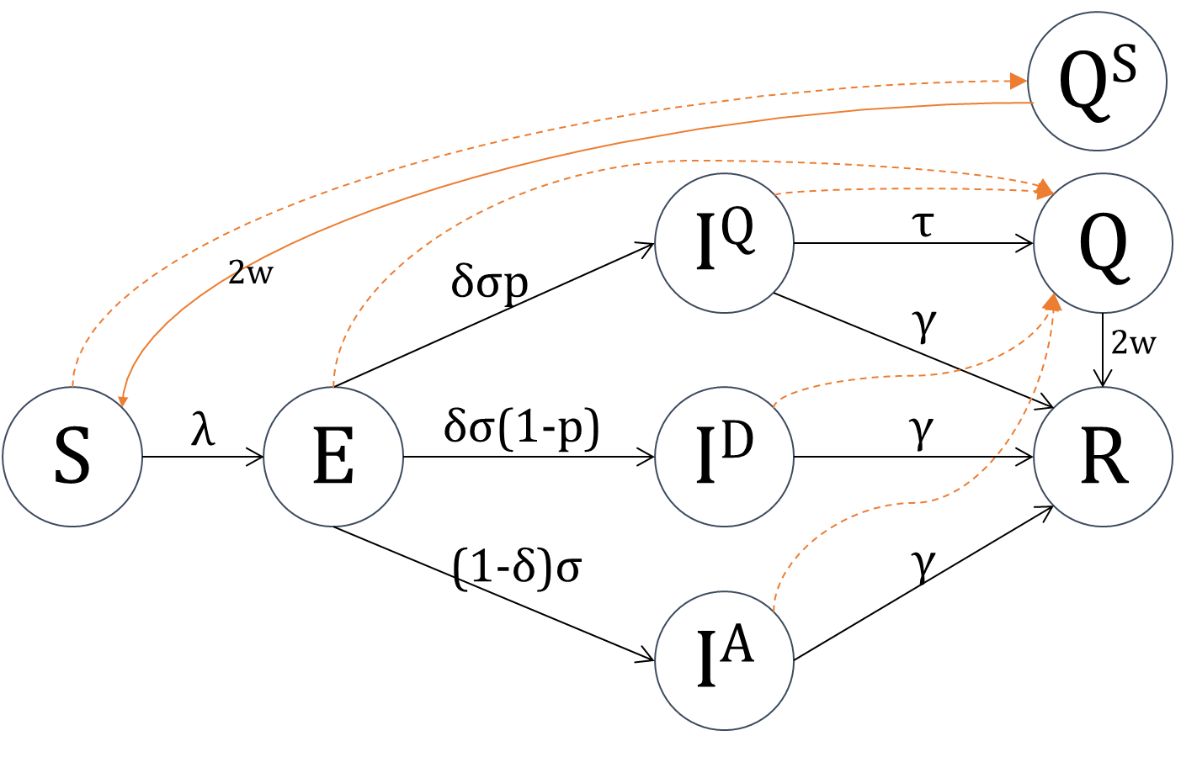

**Contact tracing** depends on several parameters. In this model, these prameters include:

* What counties (or wide areas) are doing the contact tracing. We’ll be focusing on Kilifi in the following simulations.
* What is the total number of individuals that can be contacted (and quarantined). This number can vary by county (parameter Κ_max_capacity)
* Each individual makes contacts based on a poisson process. Hence we indicate the mean number of possible contacts per person per day (parameter κ)
* For each detected person, how far back in time do we do the tracing (the tracing period in days is described with the parameter Δκ)
* For each detected infected, we put a threshold to the number of his contacts that we do trace and quarantine (parameter κ_per_event4)

**Simulations**

We focus on the area of Kilifi. However, the underlying model is simulating all Kenya …………. Spatial mixing……………….

In the following scenarios, we assume the introduce 5 infecteds into Nairobi at the beginning of the simulation. Then we

The parameters of the simulated scenarios are as follows:

* Beta… spatial mixing…
* The detection rate τ=1/3
* The number of daily contacts per person is based on a poisson process with the mean κ=10
* The tracing duration for each detected IQ is Δκ = 7 days
* The maximum number of contacts traced and quarantined per detected IQ is κ_per_event4=50
* The tracing is only happening in Kilifi, with a maximal capacity of
  + Scenario I: Κ_max_capacity[Kilifi]=1 000
  + Scenario II: Κ_max_capacity[Kilifi]=5 000
  + Scenario III: Κ_max_capacity[Kilifi]=10 000
* For each scenario, we’ll simulate 1000 runs with different probabilities of detection p: No detection p=0% , p=25%, p=50%, p=75%, and p=90

*PS: Incubation is not re-randomized for each sim. Will adapt it after merging with Sam’s master version*

|  |  |  |  |  |  |  |  |  |
| --- | --- | --- | --- | --- | --- | --- | --- | --- |
|  | **τₚ_list** | **P.τ  (detection rate)** | **P.κ  (mean nb contacts/day)** | **Δₜ  (tracing period)** | **P.κ_per_event4** | **Κ_max_capacity  (tracing capacity)** | **n_traj** | **session num** |
| **Scenario 1** | [0.0,0.25,0.5,0.75,0.9] | 1/3. | 10 | 7 | 50 | **Kilifi=1e3** | 200 | 43 |
| **Scenario 2** | [0.0,0.25,0.5,0.75,0.9] | 1/3. | 10 | 7 | 50 | **Kilifi=5e3** | 200 | 44 |
| **Scenario3** | [0.0,0.25,0.5,0.75,0.9] | 1/3. | 10 | 7 | 50 | **Kilifi=1e4** | 200 | 45 |

Seeded 5 infecteds in Nairobi, and checked the incidence in Kilifi

|  |  |  |
| --- | --- | --- |
| **Scenario 1** | **Scenario 2** | **Scenario 3** |
| **Example of one simulation per taup: S, R** | | |
|  |  |  |
| **Example of one simulation per taup: I (A+D+IQ)** |  |  |
|  |  |  |
| **Example of one simulation per taup: Q** |  |  |
|  |  |  |
| **Example of one simulation per taup: CumConctacts** | |  |
|  |  |  |
| **Time of introduction into Kilifi** |  |  |
|  |  |  |
| **Time from introduction to peak into Kilifi** |  |  |
|  |  |  |