**Basic model description**

In the contact tracing model, a transmission leads to an Exposed individual becoming Infected with the rate σ. A proportion δ of infecteds are symptomatic (or diseased) ID. The rest are therefore asymptomatic IA.

Among the symptomatics (ID), some can get detected and have their contacts traced. We call this class IQ, which is basically the infecteds to be quarantined. By quarantine here we mean isolation, hospitalization, and self-quarantining.

The proportion of symptomatics that can be detected depends on a probability of detection p, and these individuals are detected and quarantined with a detection rate τ. We note that an infected to be quarantined IQ can still recover before being quarantined.

Each time an infected to be quarantined IQ is detected (i.e. IQ is moved to the Q class), the contacts of this individual are traced and immidiately moved to quarantine as well (see dashed orange lines). In quarantine, we can find individuals that were detected infecteds (IQ), traced exposeds (E), traced infecteds (ID, IA, IQ), and traced susceptibles (S).

After a quarantine period in days (Q\_dur), all quarantined leave this class to be recovered (R), except for the quarantined susceptibles who go back to the S pool. Therefore, wehave separate qurantine classes: QS for quarantined susceptibles and Q for all other quarantined.

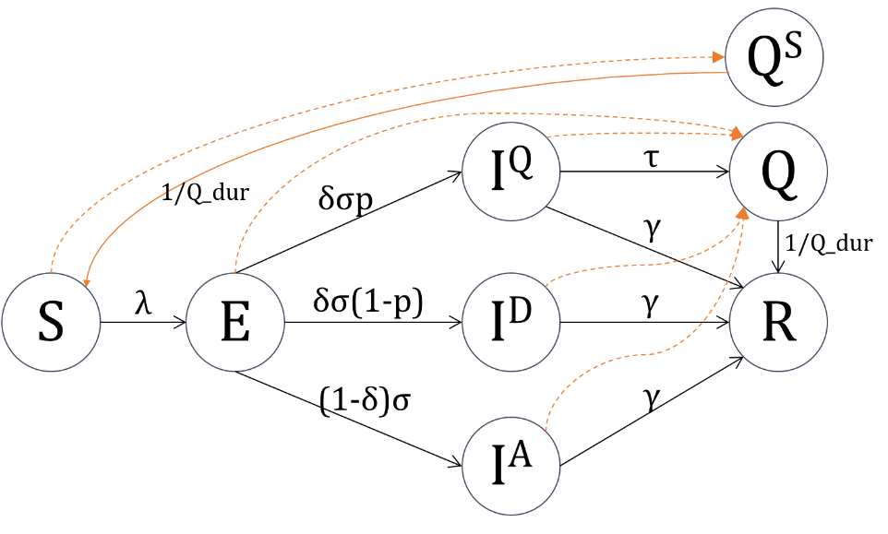

**Contact tracing**

Contact tracing depends on several parameters. In this model, these prameters include:

* What counties (or wide areas) are doing the contact tracing. We’ll be focusing on Kilifi in the following simulations.
* What is the total number of individuals that can be contacted (and quarantined). This number can vary by county (parameter Κ\_max\_capacity)
* Each individual makes contacts based on a poisson process. Hence we indicate the mean number of possible contacts per person per day (parameter κ)
* For each detected person, how far back in time do we do the tracing (the tracing period in days is described with the parameter Δκ)
* For each detected infected, we put a threshold to the number of his contacts that we do trace and quarantine (parameter κ\_per\_event4)
* The quarantine duration Q\_dur

**Simulations**

We focus on the area of Kilifi. However, the underlying model is simulating all Kenya.

In the following scenarios, we assume the introduce 5 infecteds into Nairobi at the beginning of the simulation. Then we

The parameters of the simulated scenarios are as follows:

*PS: basic parameters are not re-randomized for each sim on purpose. This is to focus only on the effect of the contact tracing. Will adapt it after merging with Sam’s master version*

* R0… (will be adapted to the master version)
* The detection rate τ=1/3
* The number of daily contacts per person is based on a poisson process with the mean κ=10
* The tracing duration for each detected infected is Δκ = 7 days
* The maximum number of contacts traced and quarantined per detected IQ is κ\_per\_event4=50
* The quarantine duration Q\_dur is of two weeks
* The tracing only happens in Kilifi, with a maximal capacity of
  + Scenario 1: Κ\_max\_capacity[Kilifi]=1 000
  + Scenario 2: Κ\_max\_capacity[Kilifi]=5 000
  + Scenario 3: Κ\_max\_capacity[Kilifi]=10 000
* Seeded 5 infecteds in Nairobi (and checked the dynamics in Kilifi)
* For each scenario, we’ll simulate 1000 (100 per case for now) runs with different probabilities of detection p: No detection p=0% , p=25%, p=50%, p=75%, and p=90%

|  |  |  |  |  |  |  |  |  |
| --- | --- | --- | --- | --- | --- | --- | --- | --- |
|  | **τₚ\_list** | **P.τ  (detection rate)** | **P.κ  (mean nb contacts/day)** | **Δₜ  (tracing period)** | **P.κ\_per\_event4** | **Κ\_max\_capacity  (tracing capacity)** | **n\_traj** | **session num** |
| **Scenario 1** | [0.0,0.25,0.5,0.75,0.9] | 1/3. | 10 | 7 | 50 | **Kilifi=1e3** | 100 | 55 |
| **Scenario 2** | [0.0,0.25,0.5,0.75,0.9] | 1/3. | 10 | 7 | 50 | **Kilifi=5e3** | 100 | 56 |
| **Scenario 3** | [0.0,0.25,0.5,0.75,0.9] | 1/3. | 10 | 7 | 50 | **Kilifi=1e4** | 100 | 57 |

Colour coding (in all plots): (1)blue=0%detection, (2)orange=25%detection, (3)purple=50%detection, (4)brown=75%detection, (5)gold=90%detection

|  |  |  |
| --- | --- | --- |
| **Scenario 1** | **Scenario 2** | **Scenario 3** |
| **Final cumulative infecteds in Kilifi (summed for all ages)**   * The horizontal segments are flat boxplots (due to the non re-randomness of initial parameters). I think this means that for the same parameters, even with a stochastic model, we get almost the same final number of cumulative infecteds. * The bars are: **Final cumI in each detection rate – Final cumI with no detection**   We notice that contact tracing reduces the overall number of infecteds by:   * + In **scenario 1** with maximal contact capacity of **1e3**: 25% detection: 33201.0, 50%: 70726.5, 75%:113773.0, 90%: 142053.5   + In **scenario 2** with maximal contact capacity of **5e3**: 25% detection: 42891.0, 50%: 92065.5, 75%:149219.5, 90%: 188101.5   + In **scenario 3** with maximal contact capacity of **1e4**: 25% detection: 85281.0, 50%: 124767.5, 75%: 169125.5, 90%: 198568.5 | | |
|  |  |  |
| **Time from introduction to peak into Kilifi**  With no detection, I don’t calculate introduction. So no values for the first case. | | |
| C:\Users\rabia\AppData\Local\Microsoft\Windows\INetCache\Content.Word\jl_intro2peak_kilifi.png | C:\Users\rabia\AppData\Local\Microsoft\Windows\INetCache\Content.Word\jl_intro2peak_kilifi.png |  |

I remember Matt asking to see the results for one sim:

|  |  |  |
| --- | --- | --- |
| **Scenario 1** | **Scenario 2** | **Scenario 3** |
| **Example of one simulation in Kilifi: S, R** | | |
| C:\Users\rabia\AppData\Local\Microsoft\Windows\INetCache\Content.Word\jl_ONE_SIM_SR_kilifi.png | C:\Users\rabia\AppData\Local\Microsoft\Windows\INetCache\Content.Word\jl_ONE_SIM_SR_kilifi.png | C:\Users\rabia\AppData\Local\Microsoft\Windows\INetCache\Content.Word\jl_ONE_SIM_SR_kilifi.png |
| **Example of one simulation in Kilifi: I (A+D+IQ)** | | |
| C:\Users\rabia\AppData\Local\Microsoft\Windows\INetCache\Content.Word\jl_ONE_SIM_I_kilifi.png | C:\Users\rabia\AppData\Local\Microsoft\Windows\INetCache\Content.Word\jl_ONE_SIM_I_kilifi.png | C:\Users\rabia\AppData\Local\Microsoft\Windows\INetCache\Content.Word\jl_ONE_SIM_I_kilifi.png |
| **Example of one simulation in Kilifi: Cumulative I (IA+ID+IQ)** | | |
| **C:\Users\rabia\AppData\Local\Microsoft\Windows\INetCache\Content.Word\jl_ONE_SIM_CumI_kilifi.png** | **C:\Users\rabia\AppData\Local\Microsoft\Windows\INetCache\Content.Word\jl_ONE_SIM_CumI_kilifi.png** | **C:\Users\rabia\AppData\Local\Microsoft\Windows\INetCache\Content.Word\jl_ONE_SIM_CumI_kilifi.png** |
| **Example of one simulation in Kilifi: Q (including QS)** | | |
| C:\Users\rabia\AppData\Local\Microsoft\Windows\INetCache\Content.Word\jl_ONE_SIM_Q_kilifi.png | C:\Users\rabia\AppData\Local\Microsoft\Windows\INetCache\Content.Word\jl_ONE_SIM_Q_kilifi.png | C:\Users\rabia\AppData\Local\Microsoft\Windows\INetCache\Content.Word\jl_ONE_SIM_Q_kilifi.png |