Exploring the effectiveness of quarantine and contact tracing interventions in the COVID-19 epidemic in Kilifi (Kenya)

Abstract

… impact of the interventions

Proportion and infectiousness of asymptomatics

Age-structured social mixing

Different detection probability

Introduction

… symptomatics, asymptomatics, detected symps. Means of detection and quarantine..

This work offers insights on the effectiveness of isolation and contact tracing…

Methods

Basic KenyaCoV model description

KenyaCoV [REF] is a metapopulation framework used to simulate the SARS-CoV2 epidemic [REF Sam] and the recent COVID-19 transmission dynamics in Kenya. It’s a discrete stochastic spatial model that incorporates movements of people between 20 areas in Kenya (based on the mobility data of [REF]) with subpopulations that are stratified by age, with 17 age groups. The subpopulation sizes per location and age are parametrized using the 2019 Kenyan census [REF].

Different moving behaviours for different age groups, and age-mixing..

SEIR with Q and IA/ID

|  |
| --- |
| We developed an epidemic metapopulation modelling framework to simulate SARS-CoV2 transmission in Kenya, KenyaCoV. KenyaCoV was used to simulate SARS-CoV2 transmission both within, and between, different Kenyan regions and age groups. KenyaCoV was parameterized using a combination of human mobility data between 20 Kenyan regions, the recent 2019 Kenyan census, and estimates of age group social interaction rates specific to Kenya. Key epidemiological characteristics such as the basic reproductive number and the age-specific rate of developing COVID-19 symptoms after infection with SARS-CoV2, were adapted for the Kenyan setting from a combination of published estimates and analysis of the age distribution of cases observed in the Chinese outbreak. |
| The force of infection (the rate at which each susceptible becomes infected) for each individual in region *i* and age group *a* depended on her movements and age-dependent social contact rates.  The force of infection on each susceptible individual **currently in region $j$**  and age group |
| Where $ϵ_{A}$ is the infectiousness of a subclinical case relative to a clinical case |
| the transition rates given in equation (4) should be interpreted as stochastic rates for each event |

**Modelling contact making**

One way of modelling a mixing population with a contact tracing intervention would probably be an individual-based model where each individual is represented by an entity (object or variable). At every time step, individuals meet each other and store that information. When an infected individual is detected, we can trace exactly who they met and when, based on their memory. Such a model is quite straightforward and common [REFs..]. However, individual-based models are better suited for small populations [REFs] whereas, in our case, the Kenyan population counts for over 47 million people [REF 2019 census]. Therefore, keeping track of all possible daily contacts can be an expensive process ~~(memory and execution time)~~.

In the case of an epidemic, and without any other intervening measures in place, the only contacts needed are the ones made by people who are going to be detected. For all the others (undetected infected, susceptible, etc.) contact information is more likely to be irrelevant/useless. However, an obvious fact is that contacts happen before detection. So it is difficult to know beforehand who to keep track of their contacts and who not to.

To solve this and avoid useless costs, we assume that infected people can be detected if they show sufficient symptoms and we propose to memorize only the contacts of the individuals that will be detected.

In our model (Figure 1), a transmission leads to an Exposed individual becoming Infected ~~with the rate σ~~. A proportion δ of infecteds are symptomatic (or diseased) ID. The rest are therefore asymptomatic IA.

Among the symptomatic pool ID, some can later be detected and have their contacts traced. We call this class IQ, which is basically the infecteds to be quarantined. By quarantine here we mean all means of isolation (hospitalization and self-quarantine).

The proportion of symptomatic individuals that can be detected depends on a probability of detection ~~p~~α. Then, these individuals are detected and quarantined with a delay 1/τ. We note that an infected to be quarantined IQ can still recover before being quarantined.

Each time an ~~infected to be quarantined~~ IQ is detected (i.e. IQ is moved to the Q class), the contacts of this individual are traced and ~~immidiately~~ isolated as well (see dashed orange lines in Figure 1). In quarantine, we can find individuals that were detected infected (IQ), traced latent (E), traced infected (ID, IA, IQ), and traced susceptible (S).

~~As the literature shows [REFs], COVID-19 infected individuals can be either symptomatic or asymptomatic. Only those showing symptoms have a chance of being detected and isolated. Hence, our model assumes that a (1-\delta) proportion of infecteds are asymptomatic and the rest (\delta) are symptomatic with a probability of detection (p).~~

After a quarantine period ~~(Q_dur)~~, all isolated individuals recover ~~(R)~~, except for the quarantined susceptibles who go back to the S pool. Therefore, we have two separate quarantine classes: QS for quarantined susceptibles and Q for all other quarantined individuals.

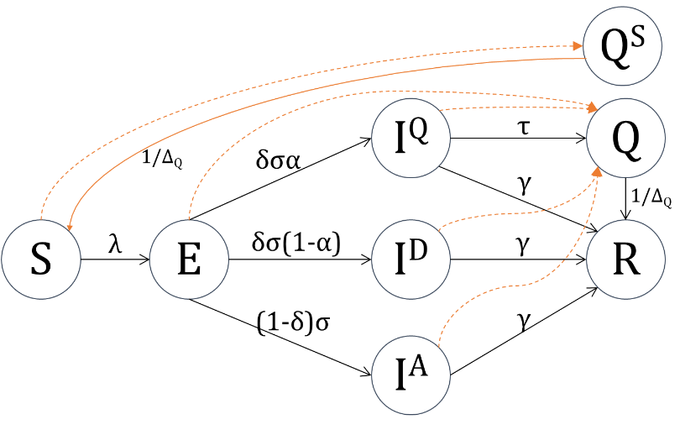

Figure 1. Transmission dynamics based on a derivative of the SEIR model, with infecteds represented by asymptomatics (IA), symptomatic (ID), and to be detected symptomatic (IQ). Arrows in orange represent the contact tracing events of contact isolation (dashed) and susceptible recovery (solid)

**Modelling contact tracing**

Let $κ_{i}^{max}$ be the capacity threshold per region i. Once this capacity is reached, contact tracing in that region stops. This translates the limit of the means and/or infrastructure used to fight the epidemic in each location.

Tracking IQ

In this model, transition events happen at stochastic rates and are specified by region i and age a. For each event E⟶IQ, we add a new element $I_{ia}^{Q}$ to a list $L_{I^{Q}}$ in order to keep track of their contacts through time. If an $I_{ia}^{Q}$ recovers, a random element (with the same region and age) is deleted from $L_{I^{Q}}$ along with their contacts. If one is isolated, then a random $I_{ia}^{Q}$ is also removed from $L_{I^{Q}}$ and their contacts for the past period Δκ are traced and isolated.

* For each detected infected, we put a threshold to the number of his contacts that we do trace and quarantine (parameter κ_per_event4)

Making contacts

Each individual makes contacts based on a Poisson process with a mean number of possible contacts κ (per person per day). For each contact, the relevant information that we gather ~~in our model are~~ is (i) the region where the contact happened, (ii) the age of the contacted, (iii) the time it occurred, and (iv) the state of the contacted.

1. *Contact region:* In the current model, we keep track of the contacts happening at the same location as the infected IQ.
2. *Age of the contacted:* This is calculated using the social age-structure mixing data [KenyaCoV REF].
3. *Contact time:* we save the time the contact was made and, for optimization purposes, we forget the contact after a certain period (unless traced and isolated). This period needs to be be greater or equal to the tracing period Δκ.
4. *State of the contacted:* When registering a new contact, we use probabilities to choose the state of the contacted. Let $Ρ$ be a matrix of state probabilities (specified by region, age, and state). It describes the chance of a contact to be S, E, IA, ID, IQ, Q, QS, or R. We note that contacts can be of any state except quarantined Q and QS. The matrix of state probabilities $P$ is calculated as follows:

$$\left\{\begin{matrix}if s∈\{S,E,I^{A},I^{D},I^{Q},R\} & P\left(i,a,s,t\right)=\frac{s_{ia}(t)}{\sum_{s^{'}∈\left\{S,E,I^{A},I^{D},I^{Q},R\right\}}{ s_{ia}^{'}(t)}} \\ if s∈\left\{Q,Q^{S}\right\} & 0\end{matrix}\right.$$

Updating contact states

At each time step, all contacts that were previously made can change their state, which is important to keep track of when tracing contacts. Let us consider the exemple of a susceptible that was contacted at t1 and traced (and isolated) at t2. At t2, this person can still be a susceptible, or they may have contracted the infection. It is important to model the state evolution of the contacted individuals in order to know which event will happen after the person is traced: S⟶QS, E⟶Q, IA⟶Q, ID⟶Q, or IQ⟶Q.

Let $E(t,s_{ia}^{1}→s_{ia}^{2})$ be the number of events at time t where a person from location i and age a change their state from $s^{1}$ to $s^{2}$. The probability of a person to have their state change can be calculated as: $p\left(t,s_{ia}^{1}→s_{ia}^{2}\right)={E(t,s_{ia}^{1}→s_{ia}^{2})}/{s_{ia}^{1}(t)}$

For instance, if a contact was susceptibel, the probability that their state changes at t is: $p\left(t,S_{ia}→E_{ia}\right)={E(t,S_{ia}→E_{ia})}/{S_{ia}(t)}$. And if they were latent, the probability is: $p\left(t,E_{ia}→I_{ia}^{Q}\right)+p\left(t,E_{ia}→I_{ia}^{D}\right)+p\left(t,E_{ia}→I_{ia}^{A}\right)$, where: $\left\{\begin{aligned}p\left(t,E_{ia}→I_{ia}^{Q}\right)={E(t,E_{ia}→I_{ia}^{Q})}/{E_{ia}(t)} \\ p\left(t,E_{ia}→I_{ia}^{D}\right)={E(t,E_{ia}→I_{ia}^{D})}/{E_{ia}(t)} \\ p\left(t,E_{ia}→I_{ia}^{A}\right)={E(t,E_{ia}→I_{ia}^{A})}/{E_{ia}(t)}\end{aligned}\right.$

Contact tracing

For each detected person, we isolate their contacts for a tracing period of Δκ

Once the $κ_{i}^{max}$ threshold is reached, besides stopping contact tracing in the region i, we can either choose to stop detecting and quarantining infecteds or continue to do so.

Results

* Assume population is all susceptible at first
* Contact isolation happens immediately after the IQ has been quarantined.

~~Simulations~~

We assume all the Kenyan population is initially susceptible to COVID-19, with no We introduce 5 infecteds into Nairobi and inspect the epidemic dynamics in Kenya with a focus on the Kilifi region (Kilifi-Mombassa area). We also assume a tracing period Δκ of 10 days and a mean number of daily contacts per person κ=12.

We present the results of six simulation sessions with different combinations of R0 (3 and 2.5) and proportions of symptomatic cases δ (20%, 50% and 80%). For each session, we run 17 scenarios with 100(50) simulations each. The first scenario is for no detection or contact tracing. And the other 16 combine the following parameters:

* We only do the tracing in the region of Kilifi. So the region capacity threshold is $\left\{\begin{matrix}κ_{Kilifi}^{max}ϵ\left\{1e3, 1e4, 5e4, 1e5\right\} \\ κ_{i≠Kilifi}^{max}=0\end{matrix}\right.$
* Do we stop detecting and quarantining infecteds when we reach the region capacity threshold $κ_{i}^{max}$ (yes or no)
* The symptomatic detection rate $α∈\left\{50\%, 90\%\right\}$

In the following, ….describe the simulation protocol:

* No detection: results in all Kenya and in Kilifi + compare with results from other studies
* Contact tracing in Kilifi
* Contact tracing in all Kenya

No interventions

Without any intervention, our model estimates that the final number of cases in all Kenya is 22864557±5330.49 (48.07% of the total Kenyan population) and 19449362.5±7405.35 (40.88%) for $R_{0}=3$ and $R_{0}=2.5$. In the region of Kilifi, the number of cases for both $R_{0}$ values would be 1.0601145e6±1146.46 (49.58%) and 902755.5±1231.58 (42.56%). The peak times in Kilifi are at days 117±6.28 and 152±10.44.

With 82% are infected in the over-60 age groups.

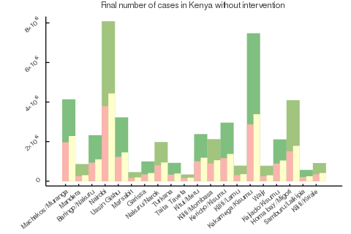

Figure . Estimation of final number of cases in Kenya with R0=2.5 (red) and R0=3 (yellow) compared to the population sizes (green) per region [REF 2019 census]

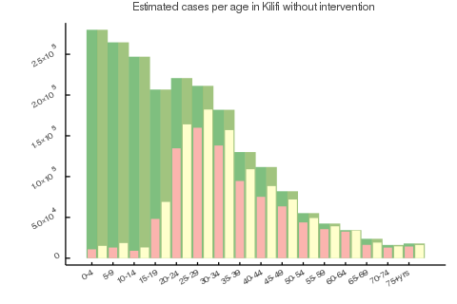

Figure 3. Estimated cases in Kilifi per age group [REF 2019 census] without intervention with R0=2.5 (red) and R0=3 (yellow) compared to age group sizes (green)

Contact tracing in Kilifi

We applied detection and contact tracing for $R_{0}∈\left\{2.5, 3\right\}$, $α∈\left\{50\%, 90\%\right\}$ and contact tracing duration of 30 days, 60 days and 90 days.

…

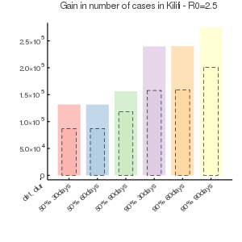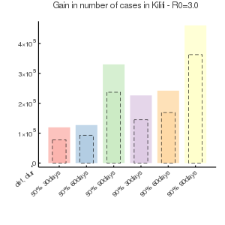

Figure 4. Gain in cases in Kilifi compared to no intervention for R0=2.5 (left) and R0=3 (right), with a symptomatic detection rate $α∈\left\{50\%, 90\%\right\}$ and a tracing of 30, 60 and 90 days. All scenarios were executed for a proportion of symptomatic δ=30% (dashed bars) and δ=70% (solid bars)

Such intervention lead to the following numbers of contacted people in Kilifi.

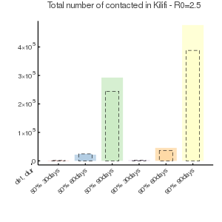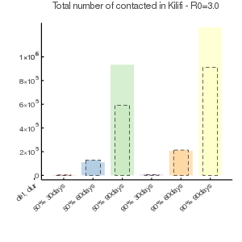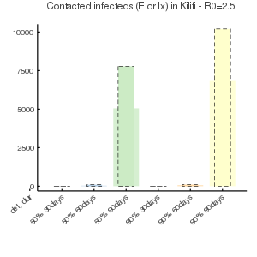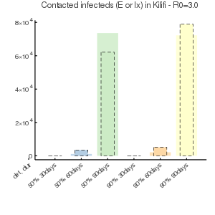

Figure . Total numbers of contacted individuals per scenario (top) and number of isolated infecteds due to contact tracing (bottom)

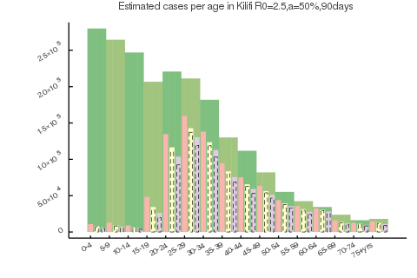

For all cases, peak happens at day 124±4.5 days. Peak gain from the applied intervention is of mean 4.9±2 days. Hence, the set intervention does not allow a safe delay of the epidemic in Kilifi.

Contact tracing in all Kenya

Discussion

* … The mean number of daily contacts per person κ is not specified by region, age or state. Adapting contacts to the actual situation in Kenya can lead to more realistic insights.
* If the rate of detection τ is high enough, most IQ individuals will be quarantined before recovering, which helps reduce the local force of infection.