Exploring the effectiveness of quarantine and contact tracing during the COVID-19 epidemic in Kenya

Abstract

Introduction

Methods

Basic KenyaCoV model description

KenyaCoV is a metapopulation framework used to simulate the SARS-CoV2 epidemic [REF Sam] and the recent COVID-19 transmission dynamics in Kenya. It’s a discrete stochastic spatial model that incorporates movements of people between 20 areas in Kenya (based on the mobility data (Wesolowski et al., 2012)) with subpopulations that are stratified by age, with 17 age groups. The subpopulation sizes per location and age are parametrized using the 2019 Kenyan census *(Kenya National Bureau of Statistics, 2019)*.

Different moving behaviours for different age groups, and age-mixing…

Transmission dynamics for contact tracing

One way of modelling a mixing population with a contact tracing intervention would probably be an individual-based model where each individual is represented by an entity (object or variable). At every time step, individuals meet each other and store that information. When an infected individual is detected, we can trace exactly who they met and when, based on their memory. Such a model is quite straightforward and common [REFs..]. However, individual-based models are better suited for small populations [REFs] whereas, in our case, the Kenyan population counts for over 47 million people *(Kenya National Bureau of Statistics, 2019)*. Therefore, keeping track of all possible daily contacts can be an expensive process.

In the case of an epidemic, and without any other intervening measures in place, the only contacts needed are the ones made by people who are going to be detected. For all the others (undetected infected, susceptible, etc.) contact information is more likely to be irrelevant/useless. However, an obvious fact is that contacts happen before detection, so it is difficult to know beforehand who to keep track of their contacts and who not to.

To solve this and avoid useless costs, we assume that infected people can be detected if they show sufficient symptoms and we propose to memorize only the contacts of the individuals that will be detected.

In our model (Figure 1), a transmission leads to an Exposed individual becoming Infected. A proportion δ of infecteds are symptomatic (or diseased) ID. The rest are therefore asymptomatic IA. Among the symptomatic pool ID, some can later be detected and have their contacts traced. We call this class IQ, which is basically the infecteds to be quarantined. By quarantine here we mean all means of isolation (hospitalization and self-quarantine).

The proportion of symptomatic individuals that can be detected depends on a probability of detection α. These individuals are then detected and quarantined with a delay 1/τ. We note that an infected to be quarantined IQ can still recover before being quarantined.

Each time an IQ is detected (i.e. IQ is moved to the Q class), the contacts of this individual are traced and isolated as well (see dashed orange lines in Figure 1). In quarantine, we can find individuals that were detected infected (IQ), traced latent (E), traced infected (ID, IA, IQ), and traced susceptible (S). After a quarantine period, all isolated individuals recover, except for the quarantined susceptibles who go back to the S pool. Therefore, we have two separate quarantine classes: QS for quarantined susceptibles and Q for all other quarantined individuals.

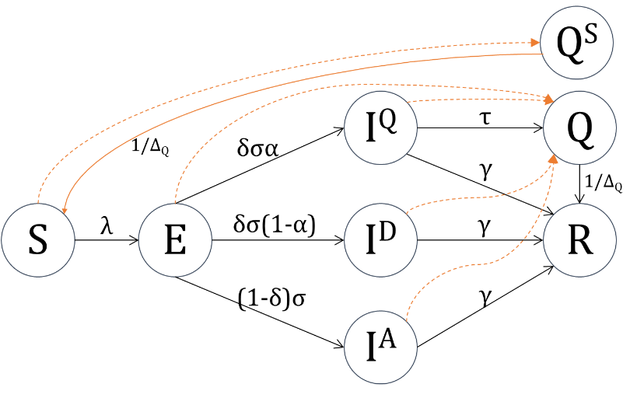

Figure . Transmission dynamics, with infecteds represented by asymptomatics (IA), symptomatic (ID), and to be detected symptomatic (IQ). Arrows in orange represent the contact tracing events of contact isolation (dashed) and susceptible recovery (solid)

Modelling contact tracing

Tracking IQ

In this model, transition events happen at stochastic rates and are specified by region i and age a. For each transmission event E⟶IQ, we add a new element $I_{ia}^{Q}$ to a list $L_{I^{Q}}$ in order to keep track of their contacts through time. If an $I_{ia}^{Q}$ recovers, a random element (with the same region and age) is deleted from $L_{I^{Q}}$ along with their contacts. If one is isolated, then a random $I_{ia}^{Q}$ is also removed from $L_{I^{Q}}$ and their contacts for the past period Δκ are traced and isolated.

Making contacts

Each individual makes contacts based on a Poisson process with a mean number of possible contacts κ (per person per day). For each contact, the relevant information that we gather is (i) the region where the contact happened, (ii) the age of the contacted, (iii) the time it occurred, and (iv) the state of the contacted.

1. *Contact region:* In the current model, we keep track of the contacts happening at the same location as the infected IQ.
2. *Age of the contacted:* This is calculated using the social age-structure mixing data (Prem et al., 2017).
3. *Contact time:* we save the time the contact was made and, for optimization purposes, we forget the contact after a certain period (unless traced and isolated). This period needs to be be greater or equal to the tracing period Δκ.
4. *State of the contacted:* When registering a new contact, we use probabilities to choose the state of the contacted. Let $Ρ$ be a matrix of state probabilities (specified by region, age, and state). It describes the chance of a contact to be S, E, IA, ID, IQ, Q, QS, or R. We note that contacts can be of any state except quarantined Q and QS. The matrix of state probabilities $P$ is calculated as follows:

$$\left\{\begin{matrix}if s∈\{S,E,I^{A},I^{D},I^{Q},R\} & P\left(i,a,s,t\right)=\frac{s_{ia}(t)}{\sum_{s^{'}∈\left\{S,E,I^{A},I^{D},I^{Q},R\right\}}{ s_{ia}^{'}(t)}} \\ if s∈\left\{Q,Q^{S}\right\} & 0\end{matrix}\right.$$

Updating contact states

At each time step, all contacts that were previously made can change their state. Let us consider the exemple of a susceptible that was contacted at t1 and traced (and isolated) at t2. At t2, this person can still be a susceptible, or they may have contracted the infection. It is important to model the state evolution of the contacted individuals in order to know which event will happen after the person is traced: S⟶QS, E⟶Q, IA⟶Q, ID⟶Q, or IQ⟶Q.

Let $E(t,s_{ia}^{1}→s_{ia}^{2})$ be the number of events at time t where a person from location i and age a change their state from $s^{1}$ to $s^{2}$. The probability of a person to have their state change can be calculated as: $p\left(t,s_{ia}^{1}→s_{ia}^{2}\right)={E(t,s_{ia}^{1}→s_{ia}^{2})}/{s_{ia}^{1}(t)}$

For instance, if a contact was susceptibel, the probability that their state changes at t is: $p\left(t,S_{ia}→E_{ia}\right)={E(t,S_{ia}→E_{ia})}/{S_{ia}(t)}$. And if they were latent, the probability to change is: $p\left(t,E_{ia}→I_{ia}^{Q}\right)+p\left(t,E_{ia}→I_{ia}^{D}\right)+p\left(t,E_{ia}→I_{ia}^{A}\right)$, where:

$\left\{\begin{aligned}p\left(t,E_{ia}→I_{ia}^{Q}\right)={E(t,E_{ia}→I_{ia}^{Q})}/{E_{ia}(t)} \\ p\left(t,E_{ia}→I_{ia}^{D}\right)={E(t,E_{ia}→I_{ia}^{D})}/{E_{ia}(t)} \\ p\left(t,E_{ia}→I_{ia}^{A}\right)={E(t,E_{ia}→I_{ia}^{A})}/{E_{ia}(t)}\end{aligned}\right.$

Contact tracing

For each detected person, we isolate their contacts for a tracing period of Δκ. …

Results

We assume all the Kenyan population is initially susceptible to COVID-19, with no cross-immunity from other viruses. We introduce 5 infecteds into Nairobi and inspect the epidemic dynamics in Kenya with a focus on the Kilifi region (Kilifi-Mombassa area). We assume that disease induced deaths only happens in the symptomatic classes. Hence we add a disease-death rate, specified by age. In the current model, we used the age-specified death rates proposed in (CDC-China, 2020).

The simulation protocol will be presented as follows:

* No detection: results in all Kenya and in Kilifi
* Detection (and isolation) in Kilifi
* Detection and contact tracing in Kilifi
* Contact tracing in Nairobi
* Contact tracing in Nairobi and Kilifi

No interventions

Without any intervention, our model estimates that the final number of cases in all Kenya is 19303579.5±11372.73 (40.58% of the total Kenyan population) and 22758871.5±6188.98 (47.85%) for $R_{0}∈\left\{2.5, 3\right\}$ and a symptomatic rate δ=30% (Figure 2).

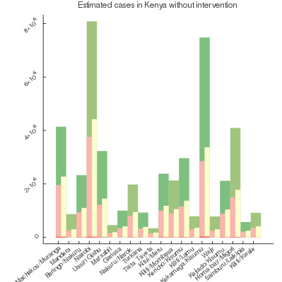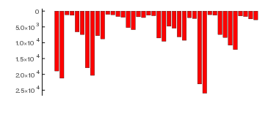

Figure . Estimation of final number of cases in Kenya (top) with a symptomatic rate δ=30%, R0=2.5 (pink) and R0=3 (yellow) compared to the population sizes (green) per region (Kenya National Bureau of Statistics, 2019) and the death counts per region (red)

In the region of Kilifi, the number of cases for both $R_{0}$ values would be 896551.0 (42.16%) and 1055161 (49.62%). With 81.69% are infected in the over-60 age groups (Figure 3). The estimated number of deaths in Kilifi is 4785.5± and 11151.5± for $R_{0}∈\left\{2.5, 3\right\}$.

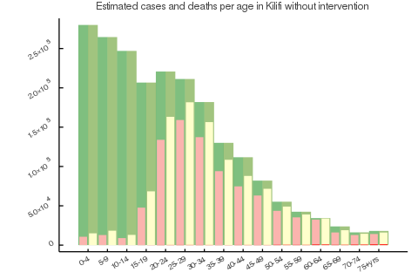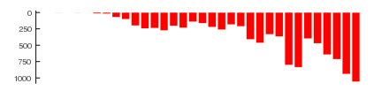

Figure . Estimated cases in Kilifi per age group (top) (Kenya National Bureau of Statistics, 2019) without intervention with R0=2.5 (pink) and R0=3 (yellow) compared to age group sizes (green) and estimated age specified deaths in Kilifi (bottom)

Detection intervention in Kilifi (without contact tracing)

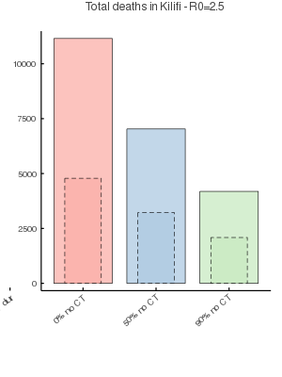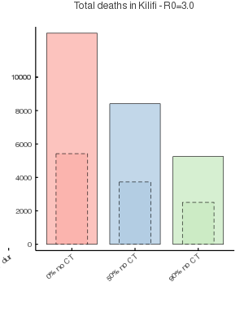

Figure . Estimated deaths in Kilifi for no intervention (red) and detection intervention (without contact tracing) with a symptomatic rate δ=30% (dashed) and 70% (solid) and a detection rate of α=50% (blue) and 90% (green)

We investigated the effectiveness of a detection and isolation intervention in Kilifi without contact tracing. In terms of fatalities, and with R0=3 and a symptomatic rate δ=30% (see plot on the right, dashed bars in Figure 4), detection and isolation leads to less deaths of 1693.0 and 2915.5 for a detection rate α=50% and 90%. As for the total number of cases (Figure 5), such a setting leads to a gain of 76586.50± and 143639.0±.

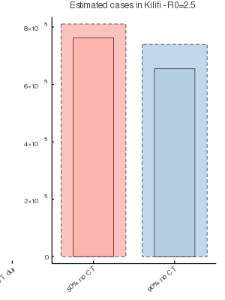

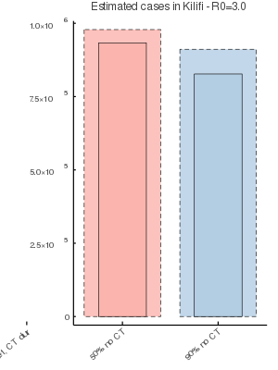

Figure . Estimated cases in Kilifi for no intervention (red) and detection intervention (without contact tracing) with a symptomatic rate δ=30% (dashed) and 70% (solid) and a detection rate of α=50% (blue) and 90% (green)

Contact tracing in Kilifi

We applied detection and contact tracing for $R_{0}∈\left\{2.5, 3\right\}$, a proportion of symptomatic cases $δ∈\left\{30\%, 70\%\right\}$, a detection rate $α∈\left\{50\%, 90\%\right\}$ and a contact tracing duration of 30 days, 60 days and 90 days. Tracing at region i starts after detecting five symptomatic cases from any age, i.e. when $I_{i}^{D}\left(t\right)+I_{i}^{Q}\left(t\right)=5$.

We also assume a tracing period of 10 days per contact and a mean number of 12 daily contacts per person. Each time a person is contacted, they’re moved to quarantine immediately as this model does not include delays of contact quarantining.

Our results suggest no significant gain from contact tracing for 1 or 2 months (Figure 6). The gain in numbers of cases after a tracing and isolation of contacts for 3 months are calculated in Table 1. This leads however to large numbers of contacted individuals …, and these latter include … of contacted latent or infected people.

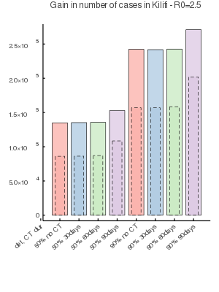

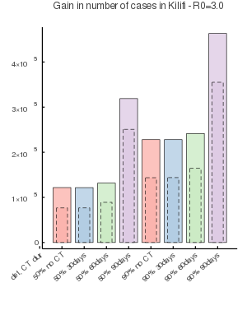

Figure . Gain in cases in Kilifi compared to no intervention with a symptomatic detection rate $α∈\left\{50\%, 90\%\right\}$ and a tracing of 0 (no tracing), 30, 60 and 90 days. All scenarios were executed for a proportion of symptomatic δ=30% (dashed) and δ=70% (solid)

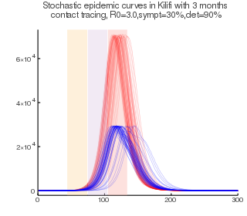

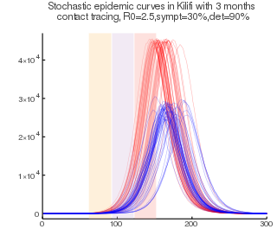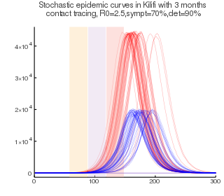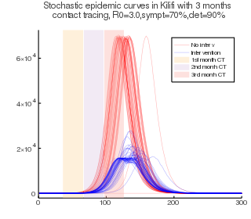

Figure . The stochastic epidemic curves in Kilifi for a contact tracing period of 3 months, a detection rate α=90%, $R_{0}∈\left\{2.5, 3\right\}$, and a symptomatic rate 𝛿

Table . Calculated gain in number of cases

|  |  |  |  |  |
| --- | --- | --- | --- | --- |
| **Scenario parameters** | | | **Gain compared to no intervention** | **Gain compared to detection and no tracing** |
| R0 =2.5 | δ=30% | α=50% | 108533.00 | 22468.00 |
|  |  | α=90% | 201888.00 | 44938.50 |
|  | δ=70% | α=50% | 149167.00 | 17854.50 |
|  |  | α=90% | 267288.50 | 28711.50 |
| R0 =3 | δ=30% | α=50% | 250909.00 | 174322.5 |
|  |  | α=90% | 355113.00 | 211474 |
|  | δ=70% | α=50% | 316824.00 | 197194.5 |
|  |  | α=90% | 461161.00 | 235281 |

In our model, we suppose that only symptomatic individuals can face disease mortality. Hence, a bigger symptomatic rate δ leads to more deaths (see Figure 8). In Kilifi and with R0=2.5, no intervention amounts to a total number of deaths of 4785.5 and 11151.5 for δ=30% and 70%. With detection and contact tracing, we expect the best case scenarios in cumulative deaths for both δ values to be 1970.0 and 4068.50, corresponding to a 90% detection rate and 90 days of contact tracing.

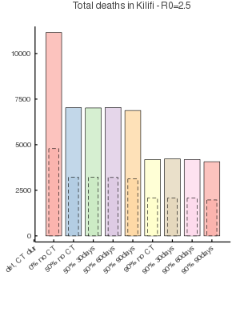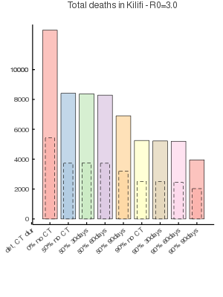

Figure . Estimated death counts for R0=2.5 (left) and 3 (right), a symptomatic rate of δ=30% (solid) and 70% (dashed), different detection rate $α∈\left\{50\%, 90\%\right\}$ and contact tracing durations of 30, 60 and 90 days

Contact tracing in Nairobi

Contact tracing in Nairobi and Kilifi

Discussion

* ~~… The mean number of daily contacts per person κ is not specified by region, age or state. Adapting contacts to the actual situation in Kenya can lead to more realistic insights.~~
* ~~If the rate of detection τ is high enough, most I~~~~Q~~ ~~individuals will be quarantined before recovering, which helps reduce the local force of infection.~~
* We believe the model the contact tracing will be more efficient (and closer to reality) in a model that includes households.

Bibliography

CDC-China, 2020. The Epidemiological Characteristics of an Outbreak of 2019 Novel Coronavirus Diseases (COVID-19) — China, 2020. China CDC Wkly. 2, 113–122.

Kenya National Bureau of Statistics, 2019. 2019 Kenya Population and Housing Census Volume 1: Population by County and Sub-County, 2019 Kenya Population and Housing Census.

Prem, K., Cook, A.R., Jit, M., 2017. Projecting social contact matrices in 152 countries using contact surveys and demographic data. PLOS Comput. Biol. 13, e1005697. https://doi.org/10.1371/journal.pcbi.1005697

Wesolowski, A., Eagle, N., Tatem, A.J., Smith, D.L., Noor, A.M., Snow, R.W., Buckee, C.O., 2012. Quantifying the impact of human mobility on malaria. Science (80-. ). 338, 267–270. https://doi.org/10.1126/science.1223467