|  |  |  |  |  |  |  |  |  |
| --- | --- | --- | --- | --- | --- | --- | --- | --- |
| **τₚ_list** | **P.τ  (detection rate)** | **P.κ  (mean nb contacts/day)** | **κₘ=Δₜ  (memory & tracing period)** | **P.κ_per_event4** | **Κ_max_capacity  (tracing capacity)** | **n_traj** | **session num** |  |
| [0.0,0.25,0.5,  0.75,0.9] | 1/3. | 10 | 7 | 50 | Nairobi=1e3 | 200 | 20 | Session20 Running 200 sims for τₚ=0.0 322.019146 seconds (5.29 G allocations: 117.243 GiB, 4.94% gc time) Session20 Running 200 sims for τₚ=0.25 417.853990 seconds (6.70 G allocations: 164.213 GiB, 9.38% gc time) Session20 Running 200 sims for τₚ=0.5 465.380005 seconds (6.62 G allocations: 161.609 GiB, 17.32% gc time) Session20 Running 200 sims for τₚ=0.75 449.716149 seconds (6.53 G allocations: 158.466 GiB, 17.67% gc time) Session20 Running 200 sims for τₚ=0.9 456.834434 seconds (6.51 G allocations: 158.014 GiB, 17.94% gc time) |
| [0.0,0.25,0.5,  0.75,0.9] | 1/3. | 10 | 7 | 50 | Nairobi=1e3 Mombassa=1e3 | 200 | 21 | Session21 Running 200 sims for τₚ=0.0 335.654335 seconds (5.29 G allocations: 117.288 GiB, 5.23% gc time) Session21 Running 200 sims for τₚ=0.25 465.765592 seconds (7.37 G allocations: 194.208 GiB, 10.84% gc time) Session21 Running 200 sims for τₚ=0.5 495.388642 seconds (7.28 G allocations: 191.140 GiB, 19.02% gc time) Session21 Running 200 sims for τₚ=0.75 497.745998 seconds (7.26 G allocations: 190.629 GiB, 18.27% gc time) Session21 Running 200 sims for τₚ=0.9 493.368206 seconds (7.23 G allocations: 189.397 GiB, 18.97% gc time) |
| [0.0,0.25,0.5,  0.75,0.9] | 1/3. | 10 | 7 | 50 | Nairobi=1e3 Mombassa=1e3 All others = 1e2 | 200 | 22 | Session22 Running 200 sims for τₚ=0.0 408.752327 seconds (5.27 G allocations: 116.212 GiB, 23.90% gc time) Session22 Running 200 sims for τₚ=0.25 589.263548 seconds (11.32 G allocations: 355.409 GiB, 18.57% gc time) Session22 Running 200 sims for τₚ=0.5 705.803741 seconds (11.97 G allocations: 384.555 GiB, 25.88% gc time) Session22 Running 200 sims for τₚ=0.75 789.517263 seconds (11.64 G allocations: 376.236 GiB, 30.35% gc time) Session22 Running 200 sims for τₚ=0.9 764.713482 seconds (11.26 G allocations: 361.700 GiB, 29.63% gc time) |

SESSION 20

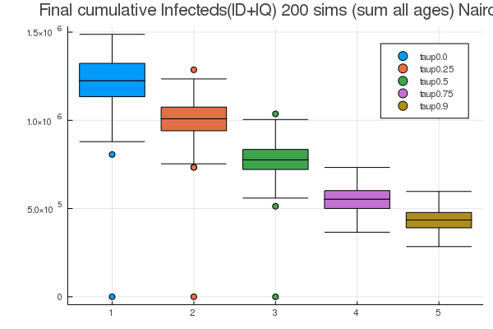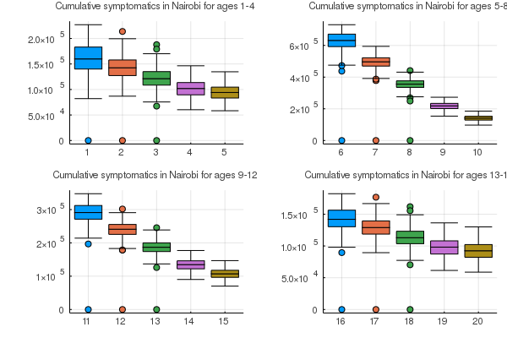

jl_cumulative_symptomatics_map

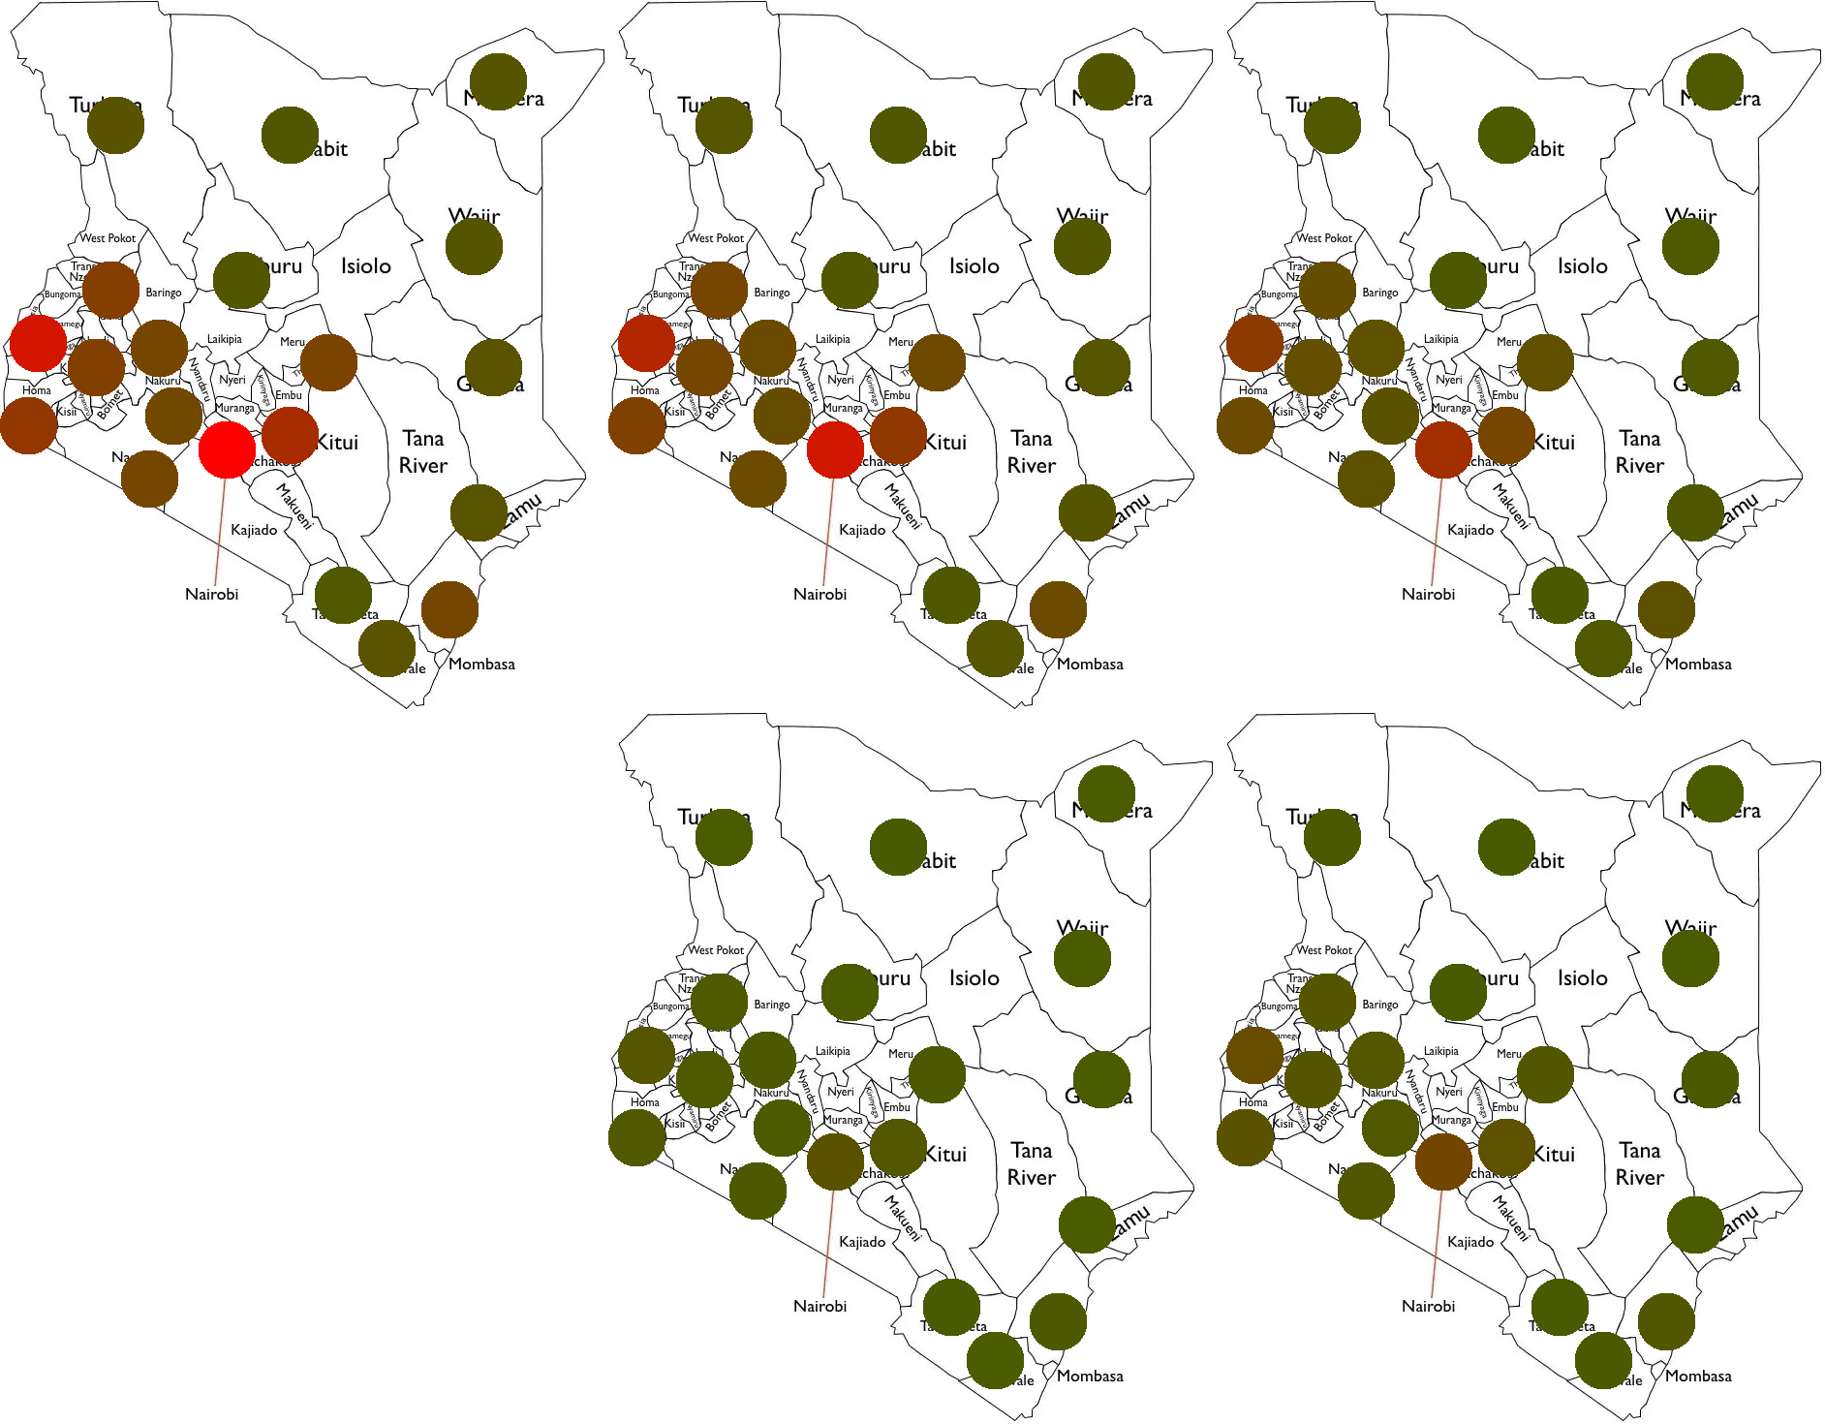

jl_cumulative_symptomatics_map_perc

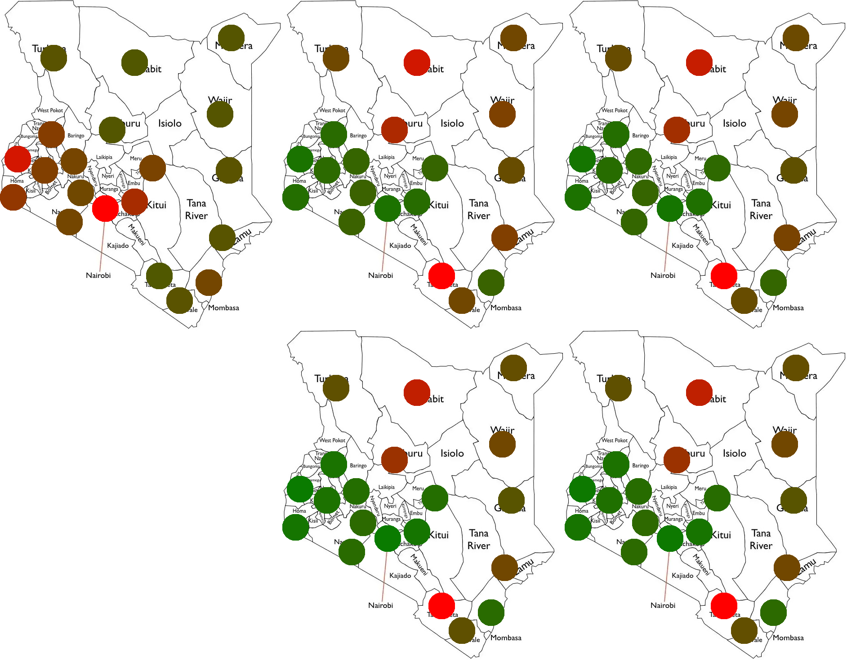

SESSION 21

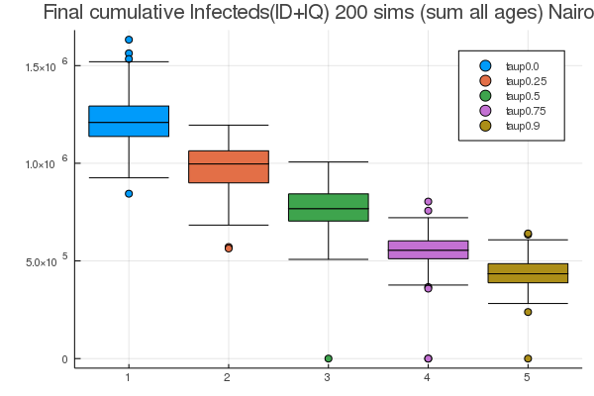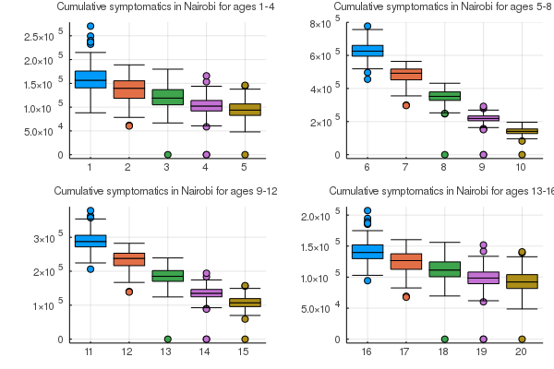

jl_cumulative_symptomatics_map

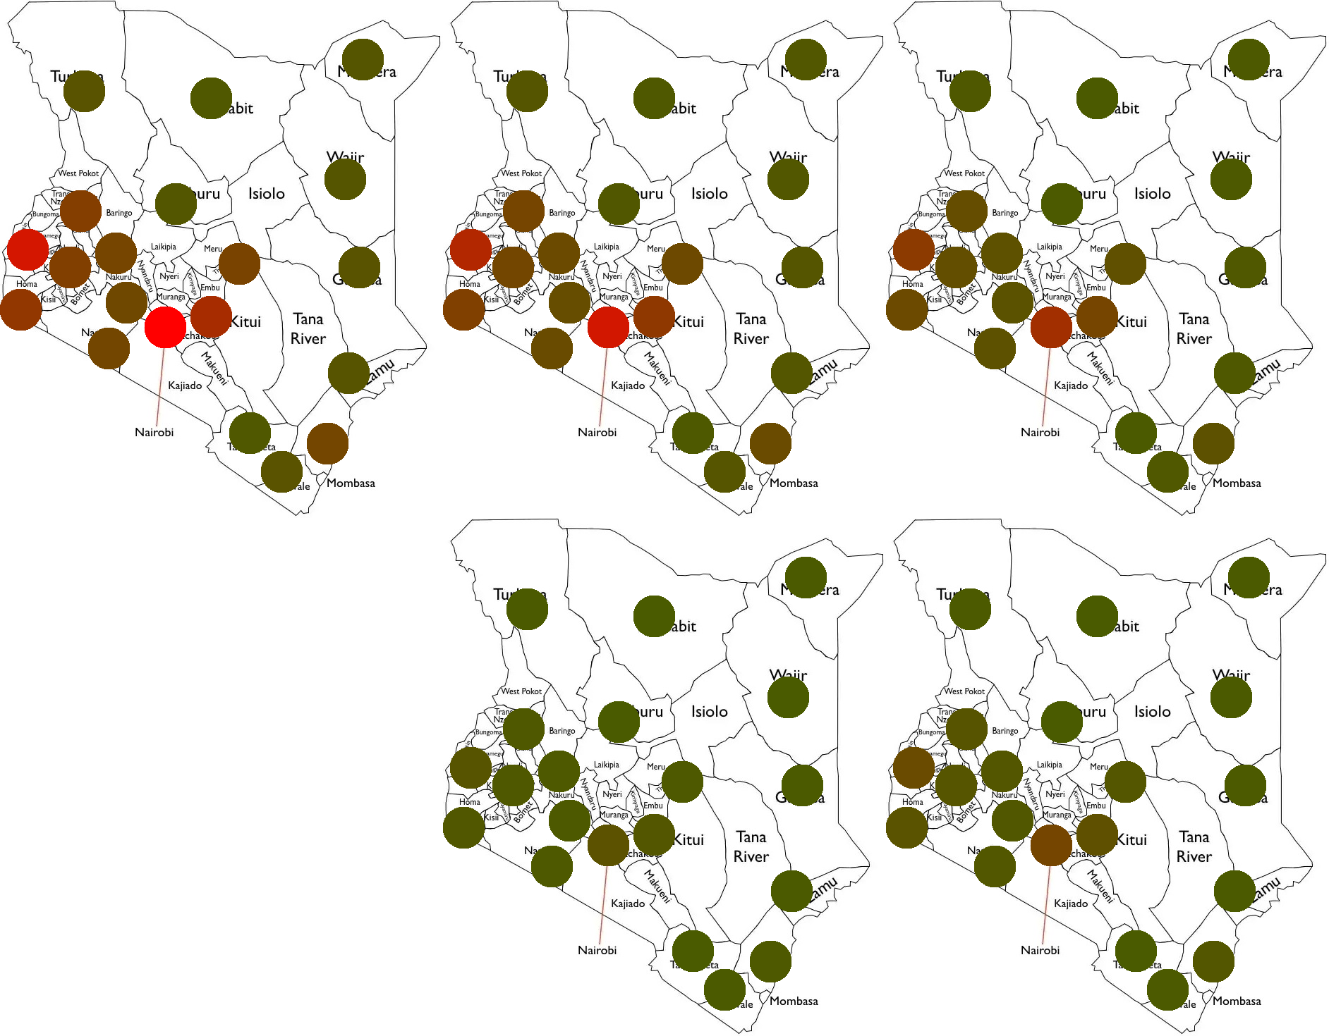

jl_cumulative_symptomatics_map_perc

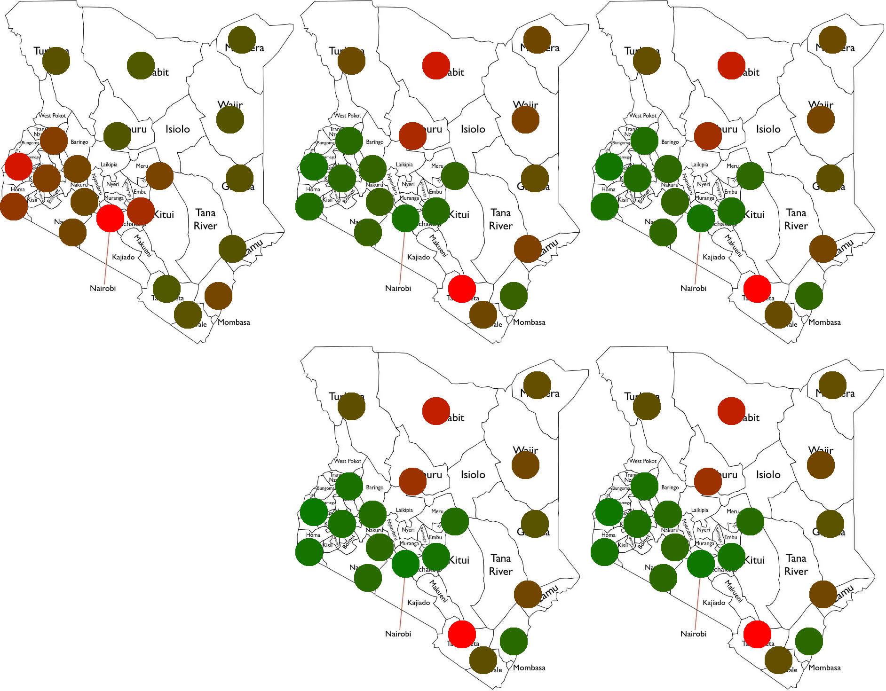

SESSION 22

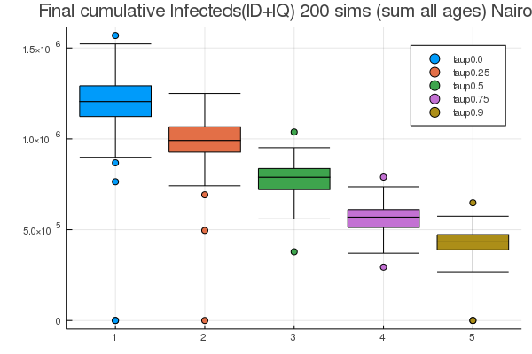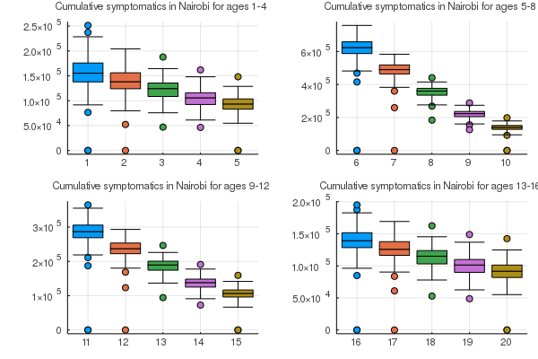

jl_cumulative_symptomatics_map

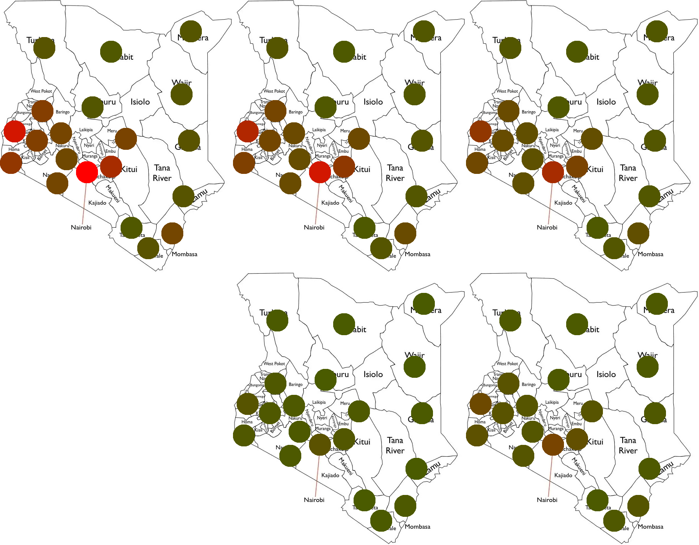

jl_cumulative_symptomatics_map_perc

