BookMyShow Theatre Show Database Design – Debayan Ray

This document contains the complete database design for a movie ticketing scenario similar to BookMyShow. It includes the list of all tables with their attributes, sample rows, SQL statements to create the tables following 1NF, 2NF, 3NF, and BCNF, and the SQL query to fetch all shows for a given date and theatre.

# Tables and Attributes

## 1. Theatre

Attributes:  
• theatre_id (PK)  
• name  
• location

## 2. Movie

Attributes:  
• movie_id (PK)  
• title  
• language  
• format (e.g., 2D, 3D, 4DX)  
• certificate (UA, U, etc.)

## 3. ShowDetails

Attributes:  
• show_id (PK)  
• theatre_id (FK → Theatre)  
• movie_id (FK → Movie)  
• show_date (DATE)  
• show_time (TIME)  
• screen

# Sample Data

## Theatre Table

|  |  |  |
| --- | --- | --- |
| theatre_id | name | location |
| 1 | PVR: Nexus Forum Mall | Bangalore |
| 2 | Inox: City Centre | Kolkata |
| 3 | Miraj Cinemas | Pune |
| 4 | UpTown Hall | Dehli |

## Movie Table

|  |  |  |  |  |
| --- | --- | --- | --- | --- |
| movie_id | title | language | format | certificate |
| 1 | Dasara | Telugu | 2D | UA |
| 2 | Kisi Ka Bhai Kisi Ki Jaan | Hindi | 2D | UA |
| 3 | Tu Jhoothi Main Makkaar | Hindi | 2D | UA |
| 4 | Avatar: The Way of Water | English | 3D | UA |

## ShowDetails Table

|  |  |  |  |  |  |
| --- | --- | --- | --- | --- | --- |
| show_id | theatre_id | movie_id | show_date | show_time | screen |
| 1 | 1 | 1 | 25-04-2023 | 12:15:00 | Screen 1 |
| 2 | 3 | 2 | 25-04-2023 | 13:00:00 | Screen 2 |
| 3 | 2 | 2 | 25-04-2023 | 16:10:00 | Screen 2 |
| 4 | 1 | 2 | 25-04-2023 | 18:20:00 | Screen 2 |
| 5 | 4 | 2 | 25-04-2023 | 19:20:00 | Screen 2 |
| 6 | 3 | 2 | 25-04-2023 | 22:30:00 | Screen 2 |
| 7 | 1 | 3 | 25-04-2023 | 13:15:00 | Screen 3 |
| 8 | 4 | 4 | 25-04-2023 | 19:20:00 | Screen 4 |

# SQL Statements

## P1: Create Tables

CREATE TABLE Theatre (  
 theatre_id INT AUTO_INCREMENT PRIMARY KEY,  
 name VARCHAR(100) NOT NULL,  
 location VARCHAR(150) NOT NULL  
);  
  
CREATE TABLE Movie (  
 movie_id INT AUTO_INCREMENT PRIMARY KEY,  
 title VARCHAR(150) NOT NULL,  
 language VARCHAR(50) NOT NULL,  
 format VARCHAR(50) NOT NULL,  
 certificate VARCHAR(10) NOT NULL  
);  
  
CREATE TABLE ShowDetails (  
 show_id INT AUTO_INCREMENT PRIMARY KEY,  
 theatre_id INT NOT NULL,  
 movie_id INT NOT NULL,  
 show_date DATE NOT NULL,  
 show_time TIME NOT NULL,  
 screen VARCHAR(20),  
 FOREIGN KEY (theatre_id) REFERENCES Theatre(theatre_id),  
 FOREIGN KEY (movie_id) REFERENCES Movie(movie_id)  
);

## Sample Inserts

INSERT INTO Theatre (theatre_id,name, location) VALUES

('1','PVR: Nexus Forum Mall', 'Bangalore'),

('2','Inox: City Centre', 'Kolkata'),

('3','Miraj Cinemas', 'Pune'),

('4','UpTown Hall','Dehli');

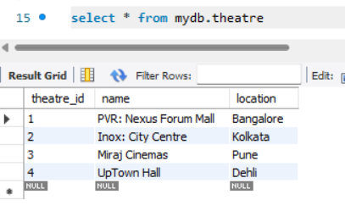

INSERT INTO Movie (movie_id, title, language, format, certificate) VALUES

(1, 'Dasara', 'Telugu', '2D', 'UA'),

(2, 'Kisi Ka Bhai Kisi Ki Jaan', 'Hindi', '2D', 'UA'),

(3, 'Tu Jhoothi Main Makkaar', 'Hindi', '2D', 'UA'),

(4, 'Avatar: The Way of Water', 'English', '3D', 'UA');

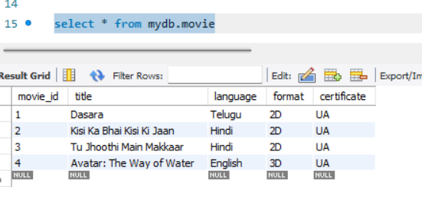

-- Show timings for 2023-04-25

INSERT INTO ShowDetails (show_id, theatre_id, movie_id, show_date, show_time, screen) VALUES

(1, 1, 1, '2023-04-25', '12:15:00', 'Screen 1'),

(2, 3, 2, '2023-04-25', '13:00:00', 'Screen 2'),

(3, 2, 2, '2023-04-25', '16:10:00', 'Screen 2'),

(4, 1, 2, '2023-04-25', '18:20:00', 'Screen 2'),

(5, 4, 2, '2023-04-25', '19:20:00', 'Screen 2'),

(6, 3, 2, '2023-04-25', '22:30:00', 'Screen 2'),

(7, 1, 3, '2023-04-25', '13:15:00', 'Screen 3'),

(8, 4, 4, '2023-04-25', '19:20:00', 'Screen 4');  
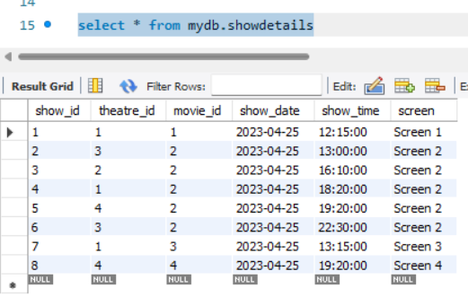

## P2: Query for Shows by Date and Theatre

**PVR: Nexus Forum Mall**  
SELECT

m.title AS Movie,

m.language AS Language,

m.format AS Format,

m.certificate AS Certificate,

s.show_date AS ShowDate,

TIME_FORMAT(s.show_time, '%h:%i %p') AS ShowTime

FROM mydb.ShowDetails s

JOIN mydb.Movie m ON s.movie_id = m.movie_id

JOIN mydb.Theatre t ON s.theatre_id = t.theatre_id

WHERE t.name = 'PVR: Nexus Forum Mall'

AND s.show_date = '2023-04-25'

ORDER BY m.title, s.show_time;

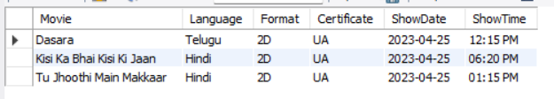

**Inox: City Centre**

SELECT

m.title AS Movie,

m.language AS Language,

m.format AS Format,

m.certificate AS Certificate,

s.show_date AS ShowDate,

TIME_FORMAT(s.show_time, '%h:%i %p') AS ShowTime

FROM mydb.ShowDetails s

JOIN mydb.Movie m ON s.movie_id = m.movie_id

JOIN mydb.Theatre t ON s.theatre_id = t.theatre_id

WHERE t.name = 'Inox: City Centre'

AND s.show_date = '2023-04-25'

ORDER BY m.title, s.show_time;



**Miraj Cinemas**

SELECT

m.title AS Movie,

m.language AS Language,

m.format AS Format,

m.certificate AS Certificate,

s.show_date AS ShowDate,

TIME_FORMAT(s.show_time, '%h:%i %p') AS ShowTime

FROM mydb.ShowDetails s

JOIN mydb.Movie m ON s.movie_id = m.movie_id

JOIN mydb.Theatre t ON s.theatre_id = t.theatre_id

WHERE t.name = 'Miraj Cinemas'

AND s.show_date = '2023-04-25'

ORDER BY m.title, s.show_time;

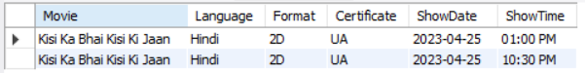

**UpTown Hall**

SELECT

m.title AS Movie,

m.language AS Language,

m.format AS Format,

m.certificate AS Certificate,

s.show_date AS ShowDate,

TIME_FORMAT(s.show_time, '%h:%i %p') AS ShowTime

FROM mydb.ShowDetails s

JOIN mydb.Movie m ON s.movie_id = m.movie_id

JOIN mydb.Theatre t ON s.theatre_id = t.theatre_id

WHERE t.name = 'UpTown Hall'

AND s.show_date = '2023-04-25'

ORDER BY m.title, s.show_time;

