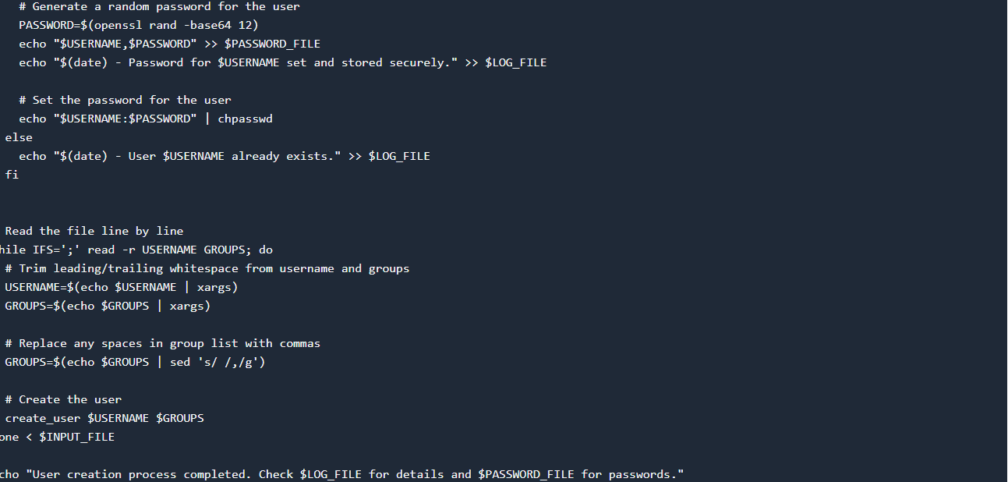Automating User Management with Bash Scripting

In a growing organization, managing user accounts efficiently is crucial for maintaining security and accessibility. As a SysOps engineer, I was tasked with automating the process of creating user accounts for new developers using a bash script on Ubuntu Linux. This script reads from a text file containing Yoruba names as usernames and their associated groups, creates the users and groups, assigns passwords, and logs all actions for auditing purposes.

Script Overview

The `create_users.sh` script automates the following tasks:

1. R eading Input: It reads usernames and associated groups from a specified text file.

2. User and Group Creation: For each line in the input file, it creates a user with a home directory and assigns them to their specified primary and secondary groups.

3. Password Generation: A random password is generated securely for each user and set using `chpasswd`.

4. Logging: All actions performed by the script are logged in `/var/log/user_management.log`.

5. Password Storage: Generated passwords are stored securely in `/var/secure/user_passwords.txt`, accessible only to the file owner.

Implementation Details

The script ensures error handling for scenarios like existing users and invalid input formats. Each step is carefully designed to adhere to best practices in user management and security protocols.

Example Usage

To use the script, simply provide a text file containing usernames and groups formatted as `username;groups`, where groups are comma-separated. Here's an example:

```

ade;developers

bolu;developers,admin

dayo;admin

```

Links to HNG Internship

For those interested in learning more about the HNG Internship program and similar opportunities, check out the following links:

- [HNG Internship](https://hng.tech/internship)

- [HNG Hire](https://hng.tech/hire)

These resources provide valuable insights into career development and opportunities in the tech industry.

Conclusion

Automating user management with bash scripting not only enhances operational efficiency but also strengthens security by ensuring consistent user creation practices. The `create_users.sh` script exemplifies how automation can streamline administrative tasks while maintaining robust security measures.

---

This technical article aims to provide a concise yet comprehensive overview of the script's implementation and its benefits. Adjustments can be made based on specific organizational requirements and security policies.

Thanks.