Course Code: IT2312 | IT Service Management
Activity: 04 Performance Task 1 – Security KPIs Analysis
Student: Godwyn Neri | Date: September 24, 2026 | Topic: ITSM Governance and Information Security KPIs

1. Executive Summary & Case Background
TeleMarketeers has operated as a specialized BPO company for the past 10 years, delivering chat and voice support for major Internet Service Providers (ISPs). The organization maintains comprehensive layered defense units: a Network Team for connectivity and traffic integrity, a Firewall Team for rule management and perimeter filtering, Tier-1 IT Desktop Support for endpoint troubleshooting, and a strategic Blue Team formulating defensive policies. For their decade anniversary, TeleMarketeers formed an elite white-hat unit called 'Fast Attack' specifically targeting malware threats that standard firewall and network toolsets could not resolve.
On a single business day, 20 agent terminals simultaneously exhibited severe performance degradation, crashes, and locked credentials. Initially misclassified as routine desktop glitches, the event escalated into a high-severity spyware attack originating from a compromised internal server. Leveraging an enterprise anti-malware system configured for >100 nodes and coordinating directly with the network and firewall teams, Fast Attack wiped the threat clean within 3 hours.
Core Incident Finding: Initial triage delay occurred because tier-1 support misclassified simultaneous multi-endpoint failures as low-risk desktop anomalies. Automated event correlation is mandatory under ITSM governance.

2. Identification and Breakdown of Security KPIs
Based on ITIL / ITSM Information Security Management guidelines (specifically IT2312 Handout 04), six (6) essential Key Performance Indicators (KPIs) are identified and tracked in the TeleMarketeers case study:

KPI 1: Number of Implemented Preventative Measures
ITSM Definition: Charts the number of security measures and controls implemented based on perceived vulnerability or a known or successful intrusion attempt to standardize resolutions and track security changes (IT2312 Handout 04).
Case Study Findings & Evidence:
- Network Team: Dedicated infrastructure oversight and connectivity integrity.
- Firewall Team: Continuous traffic monitoring and perimeter defense rules.
- IT Desktop Support Team: Rapid workstation assistance and tier-1 issue resolution.
- Blue Team: Strategic security controls and defense-in-depth policy formulation.
- Fast Attack Security Unit: Specialized anti-malware and proactive white-hat testing unit.
- Malware-Specific Hardware & Diagnostic Software: Targeted threat detection utilities.
- Enterprise Scaled Anti-Malware System (>100 Systems): Upgraded multi-node deployment.
- Cross-Functional Collaboration Protocol: Unified coordination across Fast Attack, Network, and Firewall units.
Information Tracked Metric: 8 Implemented Preventative Measures documented across organizational and technical tiers.

KPI 2: Implementation Duration
ITSM Definition: Tracks the elapsed time between the point a justified security concern is identified and the point in time when an effective resolution is placed (IT2312 Handout 04).
Case Study Findings & Evidence:
- Identification Timestamp: 1:00 PM (Fast Attack formally diagnosed spyware attack and pinpointed affected server).
- Resolution Timestamp: 4:00 PM (Server wiped, threat eradicated, full operations restored).
- Active Implementation Duration: Exactly 3.0 Hours.
- Overall Incident Lifecycle Duration: 6.0 Hours (Initial agent reports at 10:00 AM to complete resolution at 4:00 PM).
Information Tracked Metric: 3.0 Hours Active Implementation Duration (and 6.0 Hours Total Incident Lifecycle Duration).

KPI 3: Number of High-Risk Security Incidents
ITSM Definition: Tracks the number of security incidents categorized with specific severity levels to prioritize major threats that jeopardize core organizational operations over routine desktop errors (IT2312 Handout 04).
Case Study Findings & Evidence:
- Classification: 1 High-Risk Security Incident (Critical Severity).
- Threat Indicators Tracked: Compromised and locked agent credentials, arbitrary keystroke injections (keylogging), unauthorized browsing behavior, and multiple frozen client support nodes.
- Scope: 20 agent support workstations and 1 mission-critical internal server.
Information Tracked Metric: 1 High-Risk Security Incident (with 4 critical threat symptom markers documented).

KPI 4: Number of Security-Related Downtimes
ITSM Definition: Tracks downtime events preventing service from being delivered to customers due to security concerns, capturing cause, affected operations, duration time, and resolution (IT2312 Handout 04).
Case Study Findings & Evidence:
- Downtime Events: 1 Major Security-Related Downtime Event.
- Affected Operations: 20 BPO chat and voice support agents across diverse customer ISP accounts.
- Duration Time: 6 hours total operational impairment (10:00 AM - 4:00 PM), yielding ~120 agent-hours of lost customer service availability.
- Root Cause: Server-borne spyware attack.
- Resolution: Collaborative eradication using enterprise >100-node disinfection system.
Information Tracked Metric: 1 Downtime Event (capturing all 4 mandatory ITSM reporting parameters: cause, operations, duration, resolution).

KPI 5: Number of Security Tests
ITSM Definition: Measures proactive steps taken to audit existing data security and uncover vulnerabilities before external exploitation occurs, including white-hat simulations and trials (IT2312 Handout 04).
Case Study Findings & Evidence:
- Security Test 1: Pilot assessment conducted on five (5) computer terminals (successful performance).
- Security Test 2: Stress-test assessment conducted on twenty (20) computer terminals (uncovered performance bottlenecks).
Information Tracked Metric: 2 Proactive Security Tests executed by the Fast Attack team.

KPI 6: Number of Identified Shortcomings During Security Tests
ITSM Definition: Plots measurements from KPI 5 against vulnerabilities and deficiencies observed during testing to categorize and remediate security weaknesses (IT2312 Handout 04).
Case Study Findings & Evidence:
- Shortcoming 1 (Resolution Latency): Delays in the effectiveness and responsiveness of the malware resolution.
- Shortcoming 2 (Throughput Degradation): Slower remediation progress under concurrent multi-terminal load.
- Shortcoming 3 (Data Integrity Failure): Complete corruption of local files during automated remediation routines.
Information Tracked Metric: 3 Identified Shortcomings systematically categorized during the 20-terminal stress test.

3. Synthesis Data Table of Tracked Security KPIs
Structured comparison of official metrics, tracked data points, and operational impacts:
KPI Code | Security KPI Name | Tracked Value | ITSM Target Focus | Operational Impact
KPI 1 | Implemented Preventative Measures | 8 Measures | Defense-in-depth controls | Multi-layered defense across network, endpoint, and server tiers
KPI 2 | Implementation Duration | 3.0 Hours | Resolution responsiveness | Rapid eradication restoring ISP chat/voice support in same business day
KPI 3 | High-Risk Security Incidents | 1 Incident | Severity categorization | Elevated response to protect critical agent login credentials
KPI 4 | Security-Related Downtimes | 1 Event (120 hrs) | Service availability | Transparent documentation of impacted BPO customer accounts
KPI 5 | Security Tests Conducted | 2 Tests | Proactive vulnerability audit | Uncovered critical scalability defects prior to live intrusion
KPI 6 | Identified Test Shortcomings | 3 Defects | Defect root-cause analysis | Directly justified upgrade to enterprise >100 system tools

4. Visual Charts of Information Tracked
As required by the assessment instructions and grading rubric, the visual charts below detail the quantitative information tracked per KPI and the chronological response progression.

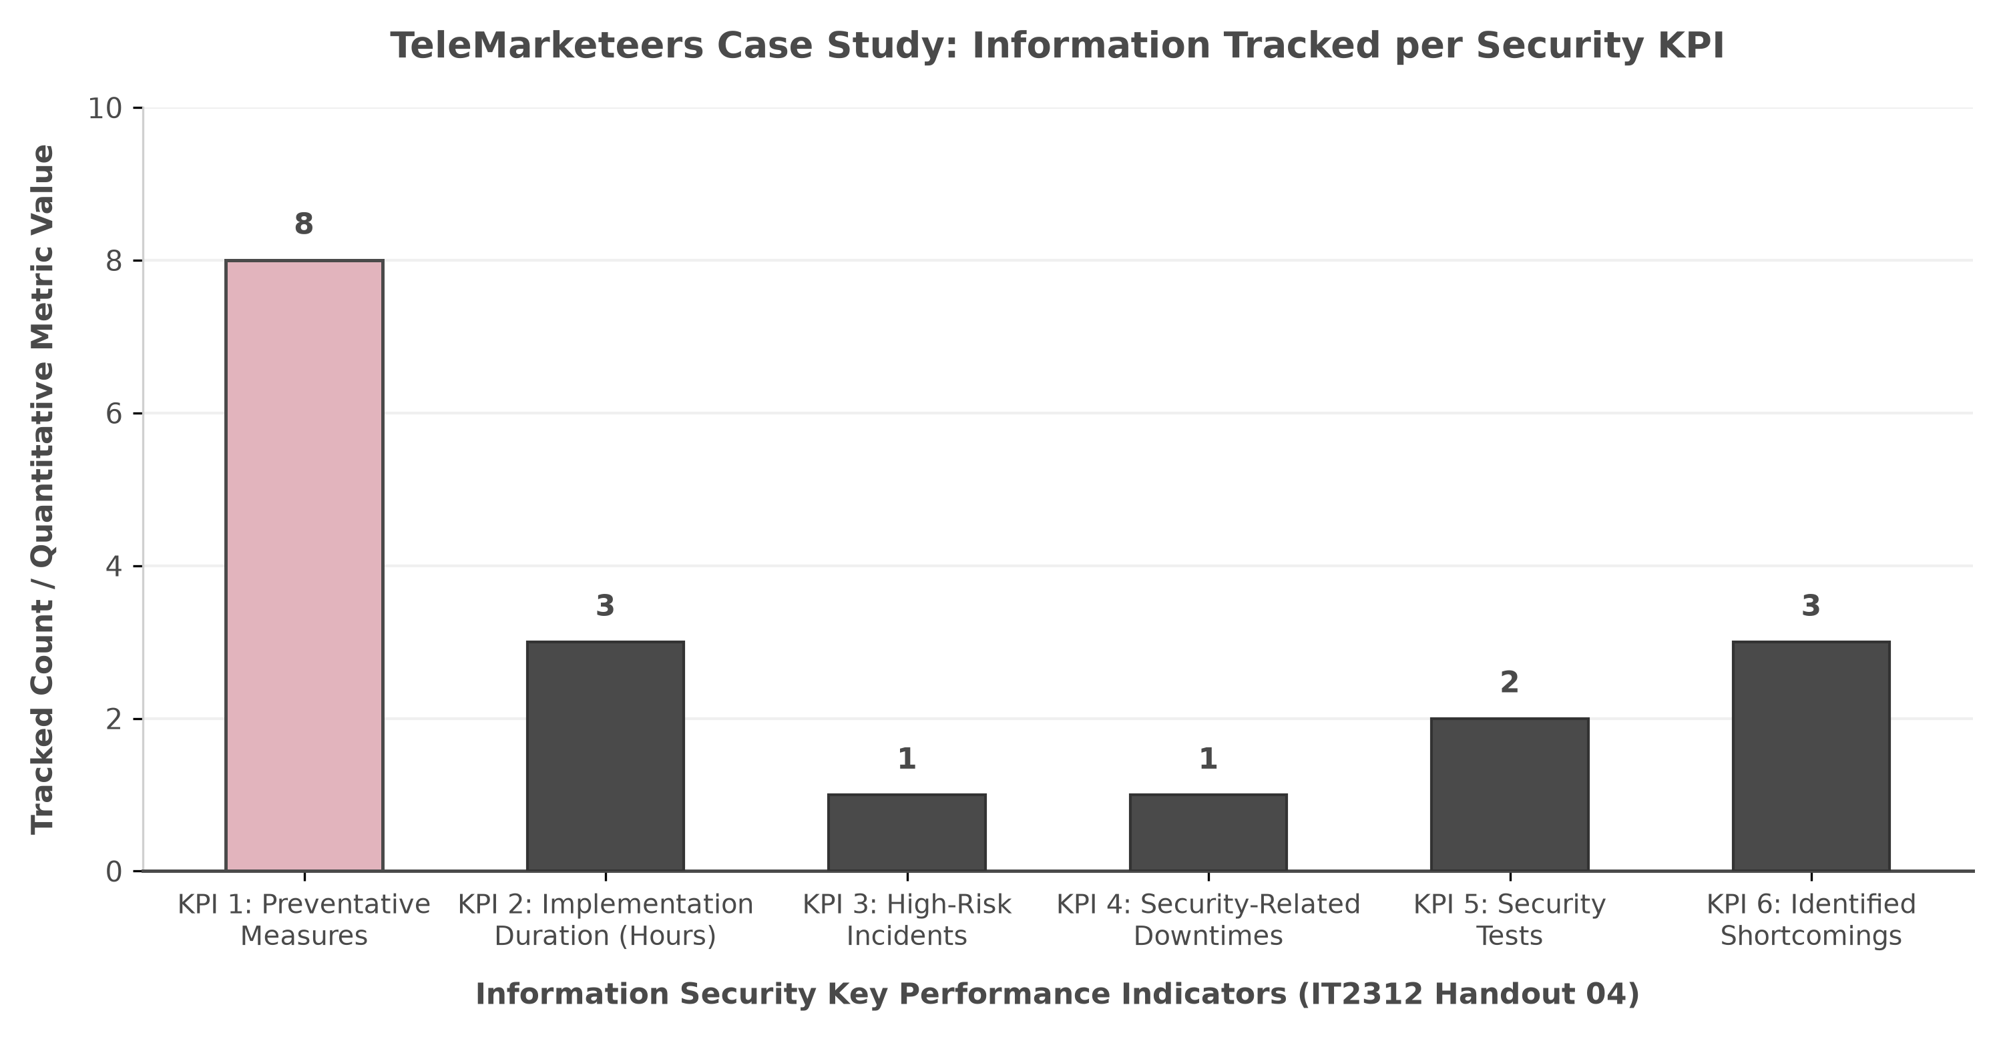
Figure 1: Minimalist Distribution Chart of Tracked Information Items per Security KPI

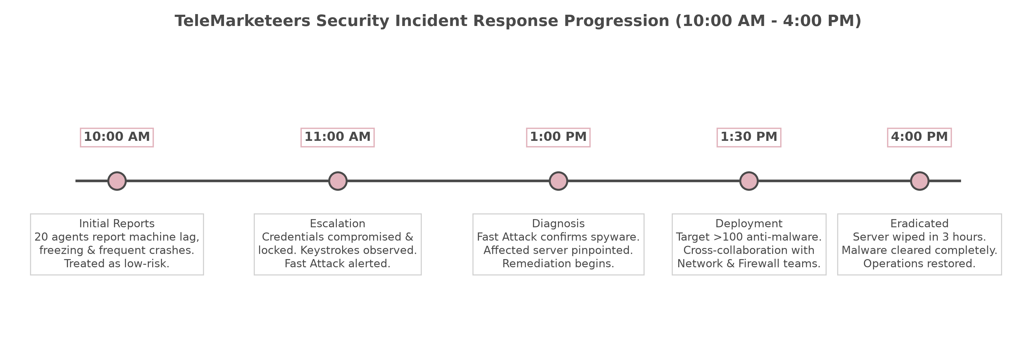
Figure 2: Chronological Progression of the TeleMarketeers Security Incident Lifecycle

5. Strategic Service Vision Based on ITSM Processes
To fulfill the exercise objective ('Formulate a strategic service vision based on ITSM processes') and establish long-term governance (COBIT / ITIL framework, Handout 04), TeleMarketeers must institutionalize a three-pillar Strategic Service Vision:
Pillar 1: Proactive Incident & Automated Event Management: The initial 3-hour lag (10:00 AM - 1:00 PM) occurred because tier-1 support handled widespread concurrent failures as disconnected desktop anomalies. TeleMarketeers must deploy an Automated Event Correlation Engine to immediately aggregate multiple simultaneous terminal freezing events, automatically triggering a critical High-Risk Major Incident protocol.

Pillar 2: Standardized Pre-Deployment Scalability & Capacity Thresholds: The Fast Attack team's second trial (on 20 terminals) exposed fatal resolution delays and complete file corruption. Under ITSM Capacity Management, security software must pass formal non-destructive scalability testing before production rollout. The subsequent acquisition of the >100 system enterprise platform perfectly exemplifies how KPI 6 data should directly steer IT capital investments.

Pillar 3: Unified Cyber Defense Operations Center (CDOC) Governance: The ultimate eradication of the spyware in 3 hours was made possible solely by cross-departmental collaboration between Fast Attack, Network, and Firewall teams. TeleMarketeers should formalize this ad-hoc alignment into a permanent Cyber Defense Operations Center (CDOC), aligning Security Management with ITIL Incident and Problem Management to guarantee continuous operational resilience.

