STI COLLEGE ALABANG
DEPARTMENT OF INFORMATION TECHNOLOGY EDUCATION
05 LABORATORY EXERCISE 1: DESIGN A VPC

STUDENT NAME: Godwyn Neri | COURSE / CODE: Network Technology 2 (IT2607 / INTE1030)
PROGRAM & SECTION: BSIT / BSIT711 | TERM & ACADEMIC YEAR: Midterm, SY2026-2027 1T
DATE ACCOMPLISHED: September 22, 2026 | SUBMISSION PORTAL: STI eLMS (Dropbox)

I. Completed VPC Architecture Diagram
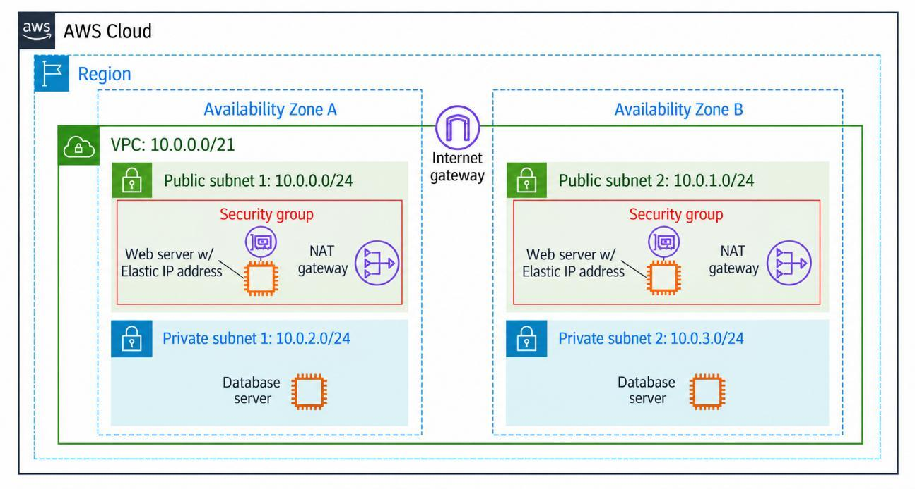
Figure 1: High-Availability Multi-AZ Amazon VPC Architecture Diagram (AWS 2026 Stencils)
II. Subnet Allocation & IP Addressing Specification
Subnet Name | Type | Availability Zone | CIDR Block | Total IPs | Usable IPs | Primary Role
Public Subnet 1 | Public | Availability Zone A | 10.0.0.0/24 | 256 | 251 | Web Server 1 & NAT Gateway 1
Public Subnet 2 | Public | Availability Zone B | 10.0.1.0/24 | 256 | 251 | Web Server 2 & NAT Gateway 2
Private Subnet 1 | Private | Availability Zone A | 10.0.2.0/24 | 256 | 251 | Backend Database Server 1
Private Subnet 2 | Private | Availability Zone B | 10.0.3.0/24 | 256 | 251 | Backend Database Server 2
* Parent VPC CIDR: 10.0.0.0/21 (2,048 Total IPv4 addresses). AWS reserves 5 IP addresses per subnet (Network, VPC Router, DNS Resolver, Future Reserved, and Broadcast), yielding 251 usable host IPs each.
III. Scenario Requirements & Architectural Justification
1. Separation of the Web Server and Database Server
- Architectural Isolation: The architecture strictly bifurcates the application stack into two distinct tiers: a public-facing presentation tier and an isolated data persistence tier. Web servers are situated within Public Subnet 1 (10.0.0.0/24) and Public Subnet 2 (10.0.1.0/24), while database servers reside within Private Subnet 1 (10.0.2.0/24) and Private Subnet 2 (10.0.3.0/24).
- Security & Confidentiality: By placing customer database instances into private subnets lacking direct route table associations to the Internet Gateway, the backend data tier is completely shielded from external reconnaissance, zero-day port scans, and unsolicited internet ingress.
2. 256 Total IPv4 Addresses per Subnet
- CIDR Mathematical Proof: A /24 subnet prefix mask allocates 24 network bits and 8 host bits (32 - 24 = 8). The total IPv4 address capacity per subnet is 2^8 = 256 addresses, satisfying the scenario constraint precisely.
- Addressing Scheme & AWS Reservations: The network starts at 10.0.0.0 as mandated. The four subnets consume 10.0.0.0/24, 10.0.1.0/24, 10.0.2.0/24, and 10.0.3.0/24 within the parent 10.0.0.0/21 block. In AWS VPCs, 5 addresses per subnet are reserved: .0 (Network Address), .1 (VPC Router), .2 (Amazon DNS Server), .3 (Future Use), and .255 (Subnet Broadcast), providing 251 dynamically or statically assignable addresses for compute instances, ENIs, and gateways.
3. Customer Access to the Web Server
- Internet Gateway & Routing: A horizontally scaled, highly available Internet Gateway (IGW) is attached directly to the root VPC border. The custom route tables linked to Public Subnets 1 and 2 define a default route (0.0.0.0/0 -> IGW).
- Static Public Addressing: Each EC2 Web Server is bound to an Elastic Network Interface (ENI) configured with an Elastic IP address (static public IPv4). This enables global customers to consistently access the web application over standard HTTP (port 80) and HTTPS (port 443) protocols with zero DNS propagation delays during instance rebuilds.
4. Internet Access for Database Patch Updates
- Outbound-Only Egress Architecture: To allow database servers to retrieve critical operating system security patches, firmware updates, and database engine bug fixes without exposing them to incoming internet connections, a Managed NAT Gateway is deployed inside the public subnet of each Availability Zone.
- Asymmetric Traffic Flow: The route tables associated with the private subnets contain a default egress route (0.0.0.0/0) pointing to the respective Availability Zone's NAT Gateway. The NAT Gateway performs Network Address Translation, proxying the outbound update requests using its public Elastic IP while dropping any unsolicited inbound connection attempts from the public internet.
5. High Availability and Custom Firewall Protection
- Multi-AZ Redundancy: The entire topology spans two physically isolated and independent AWS Availability Zones (Availability Zone A and Availability Zone B). All core application components—including Web Servers, NAT Gateways, and Database Servers—are deployed in redundant pairs across both zones. In the event of a power outage, fiber cut, or facility failure in one AZ, traffic automatically fails over to the surviving zone, providing continuous high availability.
- Multi-Layered Firewall Protection (Security Groups): Custom Security Groups act as stateful virtual firewalls at the Elastic Network Interface (ENI) level. The Web Security Group restricts ingress to web traffic (ports 80/443) from 0.0.0.0/0. The Database Security Group enforces zero-trust access control by restricting database ingress (e.g., TCP 3306 / 5432) exclusively to packets originating from the Web Security Group ID, establishing an impenetrable defense-in-depth perimeter.
--- End of Report | Prepared for eLMS Evaluation (40/40 Points Target) ---

