Course Code: Information Assurance and Security (Data Privacy) - SY2627-1T
02 Performance Task 2: CyberQ Exam Preparation (Modules 8 & 9)
Student: Godwyn Neri | Date: September 27, 2026

Activity Overview: Submission of 100% completed progressive assessment test results for EC-Council Cyber Quotient (Ethical Hacking Essentials v1 Exam Prep) covering Module 8 (Wireless Attacks and Countermeasures) and Module 9 (Mobile Attacks and Countermeasures).

Module | Test Topic | Status | Score
Module 08 | Wireless Terminology | Passed | 100%
Module 08 | Wireless Encryption | Passed | 100%
Module 08 | Wireless Network-Specific Attacks | Passed | 100%
Module 08 | Bluetooth Attacks | Passed | 100%
Module 08 | Wireless Attack Countermeasures | Passed | 100%
Module 09 | Mobile Attack Anatomy | Passed | 100%
Module 09 | Mobile Platform Attack Vectors and Vulnerabilities | Passed | 100%
Module 09 | Mobile Attack Countermeasures | Passed | 100%

Part 1: Module 8 — Wireless Attacks and Countermeasures
The following tests evaluate concepts in 802.11 wireless security, encryption protocols (WEP, WPA, WPA2, WPA3), attack vectors, Bluetooth vulnerabilities, and defensive countermeasures.
Topic 1: Wireless Terminology
Assessment covering wireless network standards, SSID broadcasting, transmission spectrums, and antenna fundamentals.
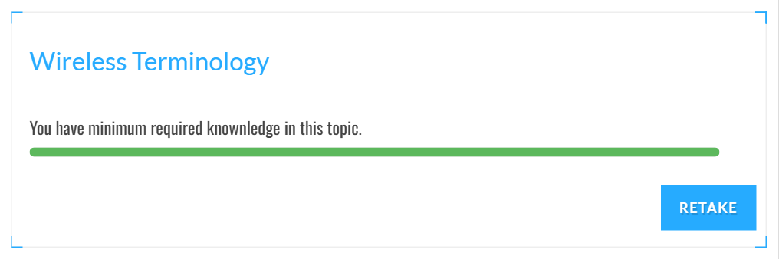

Topic 2: Wireless Encryption
Assessment covering RC4, TKIP, CCMP/AES, pre-shared key handshakes, and enterprise authentication protocols.
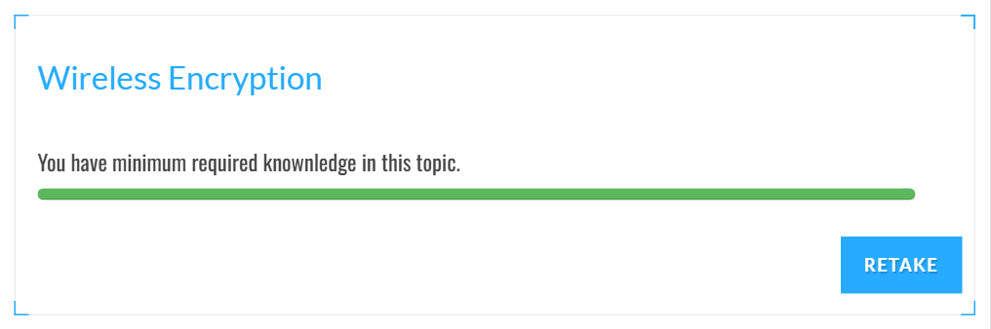

Topic 3: Wireless Network-Specific Attacks
Assessment covering Evil Twin, Rogue AP, Deauthentication flooding, WPA 4-way handshake cracking, and MAC spoofing.


Topic 4: Bluetooth Attacks
Assessment covering Bluesnarfing, Bluejacking, Bluebugging, and pairing protocol vulnerabilities.


Topic 5: Wireless Attack Countermeasures
Assessment covering WPA3 deployment, 802.1X network access control, Wireless IDS/IPS, and rogue AP detection.

Part 2: Module 9 — Mobile Attacks and Countermeasures
The following tests assess vulnerabilities in mobile platforms (Android and iOS), app sandboxing, malicious permissions, and mobile security mitigations.
Topic 1: Mobile Attack Anatomy
Assessment covering mobile attack vectors, device compromise pathways, SMS phishing (smishing), and root/jailbreak mechanisms.
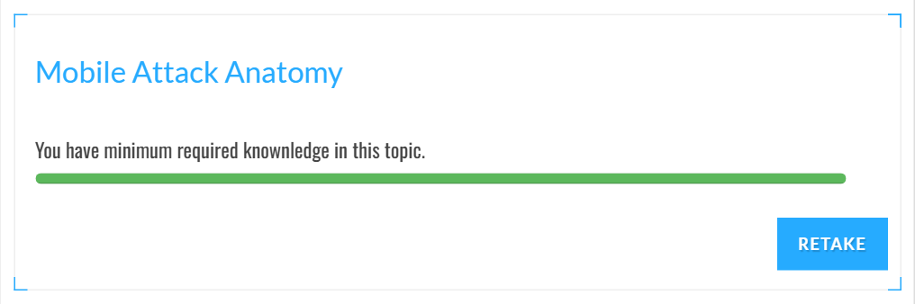

Topic 2: Mobile Platform Attack Vectors and Vulnerabilities
Assessment covering insecure data storage, weak server-side controls, SSL/TLS interception, and IPC abuse.
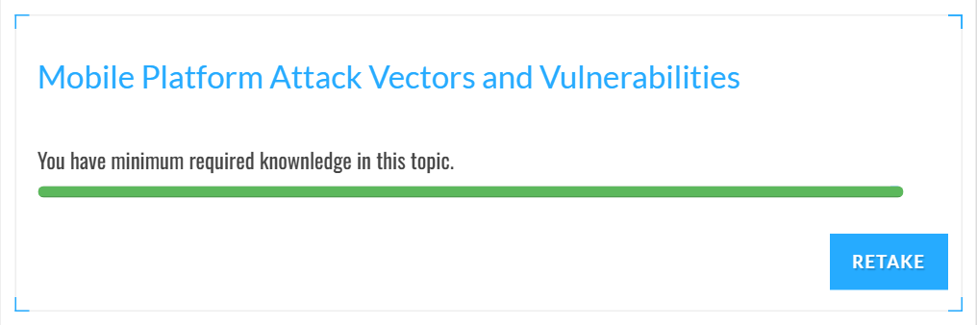

Topic 3: Mobile Attack Countermeasures
Assessment covering mobile application vetting, certificate pinning, enterprise containerization, and endpoint management.

Part 3: Verified Progressive Assessment Report
Official progressive report from EC-Council Cyber Quotient verifying that all Module 8 and Module 9 topics have been successfully passed under student Godwyn Neri:
EC-Council Cyber Quotient Official Detailed Progress Report
