Course Code: Information Assurance and Security (Data Privacy) - SY2627-1T
04 Performance Task 2: CyberQ Exam Preparation (Module 10)
Student: Godwyn Neri | Date: October 3, 2026

Summary of Completed Assessments
Module | Test Topic | Status | Score
Module 10 | IoT Concepts | [PASS] | 100%
Module 10 | IoT Threats and Attacks | [PASS] | 100%
Module 10 | IoT Attack Countermeasures | [PASS] | 100%
Module 10 | OT Concepts | [PASS] | 100%
Module 10 | OT Threats and Attacks | [PASS] | 100%
Module 10 | OT Attack Countermeasures | [PASS] | 100%

Part 1: Module 10 – IoT and OT Attacks and Countermeasures
The following tests evaluate core concepts in smart device connectivity, industrial automation security, threat vectors, and defensive countermeasures.
Topic 1: IoT Concepts
Test covering what IoT devices are, how smart sensors and gadgets connect to the internet, and how they share operational data.
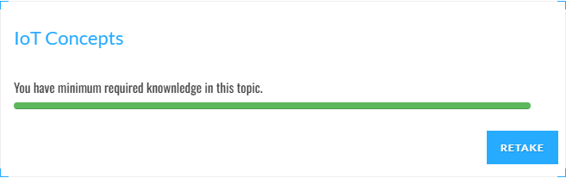
Topic 2: IoT Threats and Attacks
Test covering common weaknesses in smart devices, such as default factory passwords, unpatched firmware, and hacker botnets like Mirai.
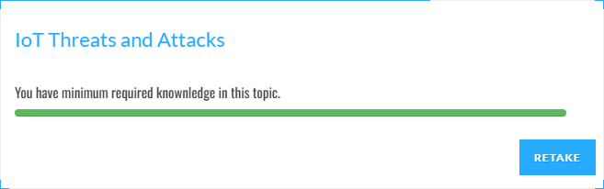
Topic 3: IoT Attack Countermeasures
Test covering how to protect smart devices using strong passwords, encrypted connections, secure firmware updates, and network firewalls.
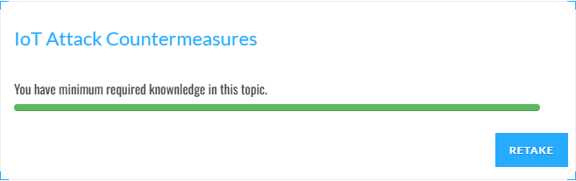
Topic 4: OT Concepts
Test covering Operational Technology (OT) basics, how factory computers (PLCs and SCADA) control physical machines, and the Purdue Model.
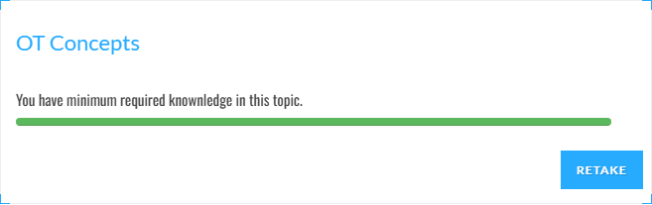
Topic 5: OT Threats and Attacks
Test covering attacks on industrial equipment, such as abusing old communication protocols (Modbus), network flooding (DoS), and data theft.
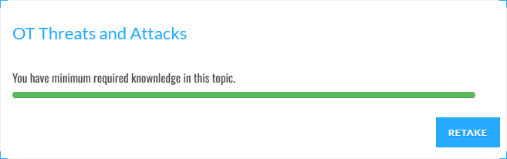
Topic 6: OT Attack Countermeasures
Test covering ways to secure industrial plants, including separate security zones (IDMZ), strict access controls, regular patching, and continuous monitoring.
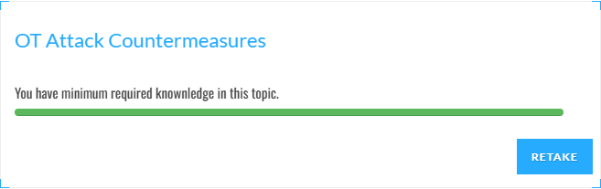
Part 2: Verified Progressive Assessment Report
Official progressive report from EC-Council Cyber Quotient verifying that all Module 10 topics have been successfully passed at 100% under student Godwyn Neri:
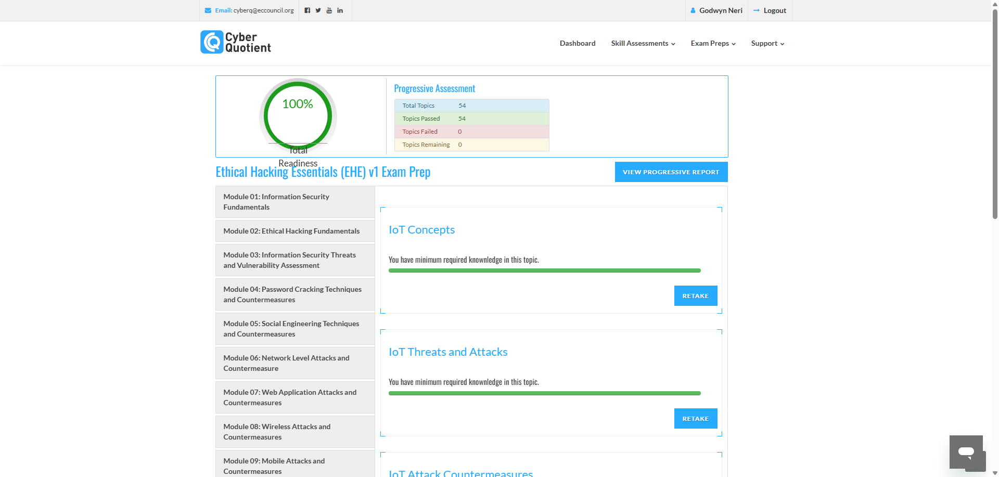
Official EC-Council Cyber Quotient Comprehensive Topic Completion Breakdown:
