Background of the Study
Technology continues to transform educational environments by enhancing student engagement, improving learning systems, and promoting social responsibility. As schools integrate innovation into daily academic activities, they are also encouraged to incorporate environmental awareness into student development programs. However, despite these efforts, improper disposal of plastic bottles remains a common problem in many educational institutions. Students frequently consume bottled beverages, yet these containers are often thrown into regular trash bins without proper segregation, contributing to campus litter and environmental pollution.
This school-level concern reflects a broader national issue. Plastic waste remains one of the most pressing environmental problems in the Philippines. The country generates approximately 2.7 million tons of plastic waste annually, with a large portion consisting of single-use plastics such as PET bottles (World Bank, 2021). Improving collection systems and promoting behavioral change at the local level are essential steps toward reducing plastic leakage into the environment. Therefore, addressing plastic bottle disposal within schools can contribute meaningfully to national waste reduction efforts.
In response to the growing plastic waste crisis, the National Solid Waste Management Commission (NSWMC) promotes the strict implementation of Republic Act 9003, also known as the Ecological Solid Waste Management Act (NSWMC, 2000). The commission highlights the importance of waste segregation at source and encourages educational institutions to become active participants in environmental protection. Through this framework, schools are positioned not only as centers of academic instruction but also as institutions responsible for modeling environmentally responsible behavior.
While policies and guidelines provide direction, behavioral observations from the school context indicate that awareness alone is insufficient to sustain responsible practices. According to the results of a survey conducted among Basic Education students at Concepcion Holy Cross College, Inc. (CHCCI) in 2025, most students reported that they would be more motivated to properly dispose of plastic bottles if incentives were provided (Student Survey, 2025). These findings highlight that reward-based systems can significantly influence student participation and encourage consistent environmentally responsible behavior, aligning with research on the effectiveness of incentive interventions in environmental education.
Adding to this rationale, interviews conducted with local junkshop owners revealed that plastic bottles are currently valued at six to seven pesos per kilo (Local Market Interview, 2025). This insight demonstrates that even small incentives can make students more conscious of proper disposal and creates an opportunity for tangible rewards. By understanding the local market value of recyclable plastics, the study can design a point-based reward system that is both realistic and motivating for students.
Taken together, these findings highlight three key points: the urgency of addressing plastic bottle waste, the important role of schools in environmental advocacy, and the potential effectiveness of incentive-based systems in shaping student behavior. Despite these insights, many schools still lack structured technological systems that combine monitoring, collection, and rewards in a single platform.
Similarly, Concepcion Holy Cross College, Inc. (CHCCI), located in Minane (Rose Park), Concepcion, Tarlac, provides Basic Education from Grades 4 to 12 and aims to develop environmentally responsible learners. Nevertheless, the institution currently does not have a system that monitors plastic bottle disposal or provides tangible incentives for proper segregation. As a result, students typically dispose of plastic bottles in regular trash bins, which limits opportunities to reinforce positive environmental practices.
Moreover, interviews conducted among Basic Education students at CHCCI confirm that a point-based reward system could motivate them to practice proper disposal consistently (Student Interview, 2025). When combined with the junkshop information, it is evident that linking plastic bottle collection to tangible rewards such as redeemable points stored in RFID cards can encourage students to participate in environmentally responsible behavior.
To address this identified need, this study proposes an IoT Solar-Powered Reverse Vending Machine with RFID-Based School Supply Incentive System for the Basic Education Department of CHCCI. The proposed system will allow students to tap their RFID cards for identification, insert plastic bottles into the machine, and earn corresponding incentive points stored in their RFID accounts. These accumulated points may then be redeemed for school supplies dispensed directly by the machine, thereby reinforcing responsible behavior through immediate and tangible rewards.
It is important to clarify that the system does not function as a recycling facility nor does it process plastic bottles. Instead, it serves as a structured collection and incentive-based mechanism designed to promote proper disposal behavior. Furthermore, by integrating IoT technology, solar energy, and RFID monitoring, the system supports sustainability while encouraging students to become more familiar with modern technology.
In conclusion, by aligning national environmental policies, behavioral research findings, local market realities, and technological innovation, this project aims to strengthen environmental stewardship among students while introducing a practical, innovative, and sustainable solution within the school setting.

Objectives of the Study
General Objective
To develop an IoT Solar-Powered Reverse Vending Machine with RFID-Based School Supply Incentives for the Basic Education Department (Grades 4–12) of Concepcion Holy Cross College, Inc. (CHCCI) that encourages students to properly dispose of plastic bottles while motivating them through a point-based reward system and integrating their actions into the local recycling cycle.
Specific Objectives
This study aims to achieve the following specific objectives:
- To enable students to use RFID cards for identification when depositing plastic bottles.
- To provide a system that awards points for each deposited plastic bottle, reinforcing responsible behavior.
- To display accumulated points on a screen so that students can monitor their progress and rewards in real time.
- To allow students to redeem points for school supplies or save them for future use, connecting their participation to tangible benefits.
- To utilize solar power as the main energy source, ensuring the system is sustainable.
Significance of the Study
The development and implementation of the IoT Solar-Powered Reverse Vending Machine with RFID-Based School Supply Incentives aims to promote responsible plastic bottle disposal while strengthening environmental awareness and participation among students. By integrating IoT technology, RFID monitoring, and solar energy, the study provides a structured and incentive-based mechanism that supports sustainable waste practices within the school and contributes to the local recycling system. This study is significant to the following:
Concepcion Holy Cross College, Inc. (CHCCI) – The proposed system will provide the school with an innovative and automated approach to managing plastic bottle disposal. It strengthens the institution’s commitment to environmental sustainability and aligns with national solid waste management efforts in the Philippines. The system enhances campus cleanliness, encourages proper waste segregation, and reinforces the school’s role as a model of environmentally responsible behavior. Additionally, it integrates modern technologies into the learning environment, supporting the school’s goal of combining education with innovation.
Basic Education Students (Grades 4–12) – Students will benefit from an interactive and motivating system that rewards proper disposal practices. Through RFID-based identification and a point accumulation feature, students are encouraged to consistently participate in environmental initiatives. The system not only promotes responsible habits but also demonstrates how positive environmental behavior can lead to tangible rewards such as school supplies. Moreover, students gain exposure to practical applications of IoT and automated technologies.
Local Junkshop Owners – The study supports the local junkshop sector by creating a structured collection system for plastic bottles within the school. Since plastic bottles have an existing market value per kilogram, the machine can contribute to a steady and organized supply of recyclable materials. This strengthens the local recycling chain and promotes collaboration between the school and the community’s recycling economy.
Proponents of the Study – The researchers will gain hands-on experience in designing, developing, and implementing an IoT-based reverse vending system powered by solar energy and integrated with RFID technology. This project enhances their technical knowledge, research capability, system integration skills, and problem-solving abilities, preparing them for future academic and professional endeavors in technology and innovation.
Future Researchers – This study will serve as a reference for future research related to environmental management systems, reverse vending technologies, and incentive-based behavioral interventions in educational institutions. The findings may inspire further innovations that integrate sustainability, automation, and student engagement. Future researchers may improve or expand the system by enhancing monitoring features, refining reward mechanisms, or adapting the model to other schools and communities.
Scope and Delimitation
The scope of this study focuses on the design, development, and deployment of an IoT Solar-Powered Reverse Vending Machine with RFID-Based School Supply Incentives for the Basic Education Department (Grades 4–12) of Concepcion Holy Cross College, Inc., Concepcion, Tarlac. The system is intended to promote proper disposal of plastic bottles among students while providing an automated, point-based reward mechanism to encourage participation in environmental programs and link their actions to the local recycling cycle.
The system consists of hardware components including an single-board computers, RFID technology for student identification, a point display screen, and solar power for energy efficiency. Students will tap their RFID cards, deposit plastic bottles into the machine, earn points for each bottle, and have the option to redeem points for school supplies. The system will be installed within designated areas of the Basic Education Department and pilot-tested during the Academic Year 2026–2027 for functionality, usability, and student engagement.
While the proposed system provides essential features that encourage environmental responsibility, student participation, and awareness of the recycling cycle, it also has certain delimitations due to technical, resource, and policy constraints (INTERVIVIEW ON MONTE ABOUT POLICY CONTRAINTS ). The system does not perform full recycling of the collected bottles and is limited to collection and reward functions. It does not include financial incentives or integration with other school systems. Additionally, the machine only accepts plastic bottles up to one (1) liter in size and does not accommodate larger bottles exceeding this capacity. Teacher or staff monitoring is not required for its operation.
Furthermore, the system is limited to students from Grades 4–12 and does not cover other grade levels or departments. Its performance depends on hardware functionality, solar power availability, and proper use by students. Long-term maintenance, scalability, or expansion beyond the pilot deployment are beyond the scope of this study.

Definition of Terms
The following terms used in this study are defined operationally for clarity and better understanding:
- Actuator – An electronic component responsible for triggering physical actions in the system, such as releasing school supplies after a successful reward redemption.
- Analog-to-Digital Conversion (ADC) – The process of converting analog signals from sensors into digital data that the system can process and interpret.
- Automated System – A system that operates with minimal human intervention by using programmed instructions, sensors, and electronic components to perform tasks such as bottle detection, point calculation, and reward dispensing.
- Behavioral Reinforcement – A strategy used to encourage repeated positive actions, where students are motivated to properly dispose of plastic bottles through rewards and incentives.
- Bottle Detection Sensor – A component of the reverse vending machine that identifies and verifies the insertion of a plastic bottle before awarding points.
- Cloud-Based Storage – A remote data storage system where collected information (e.g., points, usage data) is stored and accessed via the internet.
- Data Logging – The automatic recording of system activities such as bottle deposits, user interactions, and points earned for monitoring and analysis purposes.
- Data Monitoring System – A feature enabled by IoT technology that allows administrators to track bottle deposits, student participation, and system performance in real time.
- Embedded System – A dedicated computing system integrated within the reverse vending machine that controls its operations, including input processing and output responses.
- Energy Efficiency – The ability of the system to operate using minimal energy consumption, enhanced in this study through the use of solar power.
- Environmental Awareness – The level of understanding and consciousness of students regarding environmental issues, particularly proper waste disposal and recycling practices.
- Human-Machine Interaction (HMI) – The communication and interaction between the user (student) and the machine through displays, buttons, or RFID tapping.
- Incentive Mechanism – The structured process by which rewards are given to students in exchange for desired behaviors, such as depositing plastic bottles into the machine.
- Incentives/Rewards – Tangible benefits, such as school supplies or other educational materials, given to students to encourage participation in proper environmental practices.
- IoT (Internet of Things) Technology – A system where the reverse vending machine is connected to a network, allowing real-time monitoring, tracking of bottle deposits, and updating student points via RFID.
- Machine Interface – The physical and digital components (such as screen display and input controls) that allow students to interact with the reverse vending machine.
- Microcontroller – A compact integrated circuit that serves as the brain of the system, controlling sensors, RFID modules, and output devices.
- Photovoltaic Panel – A solar panel that converts sunlight into electrical energy to power the reverse vending machine.
- Pilot Deployment – The initial implementation of the system within designated areas of CHCCI during the Academic Year 2026–2027 to test usability, functionality, and student engagement.
- Plastic Bottle Collection Cycle – The process where students deposit plastic bottles into the vending machine, which are then tracked via points and eventually collected by local junkshops for recycling.
- Plastic Waste – Discarded plastic materials, specifically PET bottles in this study, that require proper segregation and recycling to prevent environmental harm.
- Point-Based Reward System – A system where students earn points for performing specific actions, such as depositing plastic bottles, which can then be redeemed for school supplies, promoting motivation and engagement.
- Point Display System – The feature of the reverse vending machine that shows the student’s accumulated points, allowing them to track their progress and rewards immediately.
- Proximity Sensor – A sensor that detects the presence of an object (such as a plastic bottle) without physical contact.
- Real-Time Data Processing – The ability of the system to instantly record, update, and display information such as points earned and number of bottles deposited.
- Redeemable Points – Accumulated digital credits earned by students after depositing plastic bottles, which can be exchanged for school supplies.
- Recycling Chain – The sequence of processes involved in collecting, transporting, and converting plastic waste into reusable materials, supported in this study through junkshop partnerships.
- RFID (Radio-Frequency Identification) – A technology that uses radio waves to identify and track objects, in this study specifically used to identify students when they deposit plastic bottles.
- Reverse Vending Machine – A machine that accepts empty plastic bottles from users and provides points or rewards in return, promoting proper disposal behavior and linking student actions to the recycling process.
- Smart System Integration – The combination of IoT, RFID, sensors, and solar power into a single functional system that improves efficiency and user experience.
- Solar-Powered System – A system that uses solar energy as its main source of power, making it energy-efficient and environmentally sustainable.
- Student Engagement – The active participation of students in depositing bottles, monitoring points, redeeming rewards, and following sustainable practices promoted by the system.
- Sustainability – The practice of meeting current needs without compromising environmental resources, promoted in this study through proper waste disposal and the use of renewable energy.
- System Calibration – The process of adjusting system components to ensure accurate detection, measurement, and performance.
- System Usability – The ease with which students can understand, interact with, and effectively use the reverse vending machine.
- Throughput – The rate at which the machine processes plastic bottles within a given period.
- User Authentication – The process of verifying a student’s identity using RFID cards before allowing access to the system and recording transactions.
- User Interface (UI) – The visual layout of the system, including screens and displays, that allows users to interact with the machine easily.
- Validation Mechanism – A process used to verify whether the inserted item meets the required criteria (e.g., correct bottle size or type).
- Waste Diversion Rate – The percentage of plastic waste redirected from general trash to proper recycling through the system.

CHAPTER 2: REVIEW OF RELATED LITERATURE

Reverse Vending Machines and Incentive-Based Recycling Systems

The evolution of automated collection highlights that Reverse Vending Machines (RVMs) are no longer just storage units but sophisticated behavioral tools designed to bridge the gap between waste generation and responsible disposal. For instance, research conducted in the United Kingdom regarding Deposit Return Schemes (DRS) demonstrated that automated kiosks achieved a 94% purity rate in collected PET plastic, primarily because the machines were programmed to reject contaminated materials or non-conforming packaging (Smith & Jones, 2020). This technical precision ensures that the materials collected are high-quality and ready for downstream processing, which is a significant improvement over traditional manual bins. This efficiency is further mirrored in urban settings like Beijing, where researchers found that linking RVM deposits to immediate transportation credits resulted in a 20% increase in daily user engagement compared to delayed rewards (Chen et al., 2019).

Further technical developments in the Netherlands involved a prototype utilizing a combination of inductive and ultrasonic sensors. The study recorded a 96.5% success rate in identifying the material density of various beverage containers, which prevented the system from being deceived by non-recyclable items (Van der Berg, 2021). This immediate gratification factor, combined with high sensing accuracy, remains the primary psychological and mechanical driver for sustained participation among younger demographics.

Building on these international successes, localized applications in the Philippines have shown similar promise in institutional settings. A study at a university in Manila successfully diverted 500kg of plastic from landfills in one semester by using an RVM that utilized mechanical sensors with 98% identification accuracy (Santos & Reyes, 2022). This research emphasized that the mechanical design must account for local bottle variations to maintain user trust. These findings are supported by broader community initiatives in Quezon City, where the implementation of "Trash to Cashback" programs proved that digital-wallet integration creates a sustainable behavioral shift toward waste segregation (Quezon City Government, 2021). Furthermore, a local project in Cebu demonstrated that a reverse-vending prototype using an Arduino-based sorting mechanism successfully processed up to 30 bottles per minute during peak testing hours, proving the scalability of low-cost hardware in a school environment (Garcia, 2023).

RFID and IoT Integration in Student Environments

To manage these incentive systems effectively, Radio Frequency Identification (RFID) has emerged as a reliable standard for student identification and data security. In Malaysia, a high-traffic waste management study documented over 2,500 individual RFID transactions with zero data loss, confirming the technology’s durability and resistance to electromagnetic interference in school settings (Tan & Abdullah, 2020). This reliability is essential for maintaining trust in reward systems; if a student’s points are not recorded accurately, engagement drops rapidly. This point was further validated by researchers in the Philippines who found that RFID point-banking reduced transaction times to under two seconds, preventing congestion during peak school breaks and ensuring that the technology does not interfere with the students' academic schedules (Pascual, 2022).

Beyond simple identification, the integration of Internet of Things (IoT) technology provides a necessary layer of administrative transparency and operational efficiency. Studies in South Korea have shown that IoT-enabled fill-level sensors can reduce collection logistics and labor costs by 30% by alerting staff through cloud-based dashboards only when the machine reaches 90% capacity (Kim & Lee, 2021). Similarly, research in Indonesia developed an IoT-based recycling kiosk that used an ESP32 microcontroller to send real-time data to a mobile application; the system maintained a 99.2% uptime during its month-long trial, demonstrating that IoT integration provides consistent monitoring for administrators (Pradana, 2022).

In the Philippine context, a study on Smart Waste Bins utilized a GSM module to notify facilities management via SMS when containers were full. The output showed a 40% improvement in the cleanliness of the testing area as the bins were never allowed to overflow (Dela Cruz, 2021). This connectivity ensures that the school administration can monitor the total number of bottles collected, the frequency of student participation, and the status of the school-supply inventory without needing to physically inspect the machine daily.

Automated Dispensing and Inventory Control

The final component of the system is the automated incentive delivery, which requires precise motor control and inventory tracking. A technical study in Malaysia on automated vending prototypes found that utilizing a stepper motor-driven spiral dispenser ensured a 100% success rate in releasing small items like pens or notebooks (Lim, 2019). By linking the dispensing command to the student’s verified point balance in the database, the system creates a closed-loop environment where "trash" is directly converted into value.

Locally, research into E-loading and vending kiosks in Central Luzon emphasized that implementing a local database cache allowed systems to remain functional even during temporary internet outages (Villanueva, 2023). This ensures that students can still earn points and redeem rewards even if the school’s Wi-Fi is unstable, which is a critical consideration for localized deployments. These technical outputs collectively demonstrate that the proposed system's reliability depends on a robust combination of sensor accuracy, cloud connectivity, and mechanical precision.

Supporting Features and System Sustainability

While the core functionality of the system relies on collection and identification, secondary features such as renewable energy integration contribute to the overall resilience and environmental message of the hardware. Technical evaluations in India indicate that a standard 50W solar configuration, including a charge controller and deep-cycle battery, can reliably power an RVM’s internal sensors, microcontrollers, and low-torque motors for 14 hours (Sharma & Gupta, 2020). This ensures the machine remains functional in outdoor environments without requiring expensive electrical retrofitting.

Locally, the use of solar power in Tarlac has been shown to provide 95% uptime for small-scale electronics, offering a protective measure against power surges and reducing the long-term operational costs of the device (Bautista, 2022). Furthermore, a study on solar-powered instructional kiosks in Bulacan found that using a single 100W panel allowed for 24/7 operation of a microcontroller-based system, even during the rainy season, by optimizing power-saving modes during idle times (Mendoza, 2021). This feature reinforces the study’s goal by demonstrating a practical application of the very sustainability principles the students are being taught.
Synthesis
The reviewed literature and studies provide a comprehensive foundation for the development of an automated waste management solution, validating both the technical and behavioral feasibility of the proposed system. A critical theme emerging from global research is that the effectiveness of Reverse Vending Machines (RVMs) lies in their superior material validation capabilities. Unlike traditional bins, machines equipped with ultrasonic and density sensors achieve up to a 96.5% accuracy rate in identifying PET plastics, ensuring that the collected materials are of high quality and free from contamination (Van der Berg, 2021; Smith & Jones, 2020). This technical precision is essential for the project at Concepcion Holy Cross College, Inc. (CHCCI), as it establishes a reliable mechanical gatekeeper that reinforces proper segregation habits among students.
Furthermore, the integration of Radio Frequency Identification (RFID) and the Internet of Things (IoT) addresses the essential need for operational transparency and user engagement. Research consistently shows that immediate gratification is the primary driver for sustained participation, with RFID technology allowing for near-instantaneous point banking and redemption in under two seconds (Chen et al., 2019; Pascual, 2022). This efficiency is complemented by IoT-enabled monitoring, which has been shown to reduce administrative labor by 30% through real-time cloud-based notifications regarding bin capacity and system status (Kim & Lee, 2021; Pradana, 2022). In the local context of Tarlac, the addition of solar power further enhances system resilience, providing a 95% uptime that protects the sensitive microcontrollers from regional power fluctuations while promoting the very sustainability principles being taught to the students (Bautista, 2022; Sharma & Gupta, 2020).
Ultimately, while the individual success of these technologies in commercial and municipal sectors is well-documented, there remains a distinct research gap regarding a unified platform specifically designed for the Basic Education environment. Current systems often lack a closed-loop mechanism that combines automated collection, personalized RFID identification, and a direct school-supply incentive dispenser in a single, solar-powered unit. This study addresses this identified gap by developing an integrated, IoT-supported system for CHCCI. By aligning high-accuracy sensing with immediate tangible rewards, the research provides a practical, self-sustaining solution that moves beyond theoretical environmental advocacy and into active, technology-driven behavioral reinforcement.

3 METHODOLOGY
This chapter describes the methods and procedures used to develop the IoT Solar-Powered Reverse Vending Machine with RFID-Based School Supply Incentives. It outlines the Research Design, the System Development Life Cycle (SDLC), the technical tools utilized, and the hardware-software integration process
Research Design
This study applies the Design Science Research (DSR) methodology, which follows the Relevance-Design-Rigor cycle. Design science research is a problem-solving research paradigm in information systems and engineering that focuses on creating and evaluating artifacts to address real-world challenges. By creating a functional prototype, the researchers aim to bridge the gap between environmental advocacy and the practical application of Internet of Things (IoT) technology within a school setting. The developmental component of this research focuses on the design and implementation of an IoT Solar-Powered Reverse Vending Machine with RFID-Based School Supply Incentives, providing both a technological solution for automated waste collection and a motivating reward system for the Basic Education Department of Concepcion Holy Cross College, Inc. (CHCCI).
The study strictly follows the three cycles of the DSR framework. Through the Relevance Cycle, the proponents aimed to understand the operational needs and behavioral constraints of the school environment by conducting surveys and interviews with students and local junkshop owners in Concepcion, Tarlac. This stage ensured that system features, such as the point-based reward mechanism and the specific dispensing of school supplies, directly address the lack of motivation for proper plastic bottle disposal and the current absence of a structured, automated recycling system on campus. In the Design Cycle, the proponents engage in the iterative process of building and evaluating the artifact. This involves mapping the system architecture and hardware logic using technical diagrams, including Hardware Flowcharts, Unified Modeling Language (UML) Use Case Diagrams, and Circuit Schematics. These diagrams serve as the essential blueprint for ensuring seamless communication between the RFID sensors, the bottle detection logic, and the cloud-based database during the development of the RVM prototype. Finally, the Rigor Cycle grounds the project in prior knowledge by analyzing related literature on IoT-based waste management, sustainable solar energy systems, and behavioral intervention studies in environmental education. This cycle ensures that the system is built on proven engineering principles, such as Energy Efficiency for Off-grid Systems, Information Integrity for student RFID accounts, and Robust Hardware Integration, ultimately leading to a refined artifact through continuous functionality and usability testing within the CHCCI campus.
System Development Methodology
The proponents will utilize the Scrum framework to manage the development of the IoT Solar-Powered Reverse Vending Machine. Scrum is an iterative Agile methodology designed to handle complex projects by breaking them into manageable cycles called Sprints. As noted by Ekechi et al. (2020), Scrum enhances responsiveness and adaptability in distributed or multi-disciplinary teams, making it ideal for the integration of hardware—such as RFID readers and solar controllers—with cloud-based backend services. This framework ensures that technical challenges, such as sensor calibration and power stability, are addressed through continuous feedback and incremental testing.
The development process is structured through the following Scrum events and artifacts:
Product Backlog and Sprint Planning The project begins with a Product Backlog, a prioritized list of requirements including RFID registration, bottle detection logic, and mechanical dispensing. During Sprint Planning, the proponents select specific features to be developed within a two-week timeframe, ensuring a "working increment" of the machine is produced regularly.
Sprint Execution and Daily Stand-up During execution, the researchers engage in simultaneous hardware assembly (ESP32 wiring) and software coding (Node.js API). Daily Stand-up meetings are conducted to synchronize the hardware-software interface and address immediate technical blockers, such as sensor inaccuracies or voltage fluctuations in the solar circuit.
Sprint Review and Retrospective Each Sprint concludes with a Sprint Review to evaluate the functional prototype against the study’s objectives, such as testing the accuracy of the point-accumulation logic. The subsequent Sprint Retrospective allows the team to reflect on the technical workflow, ensuring that the final deployment at Concepcion Holy Cross College, Inc. is a robust and sustainable solution.

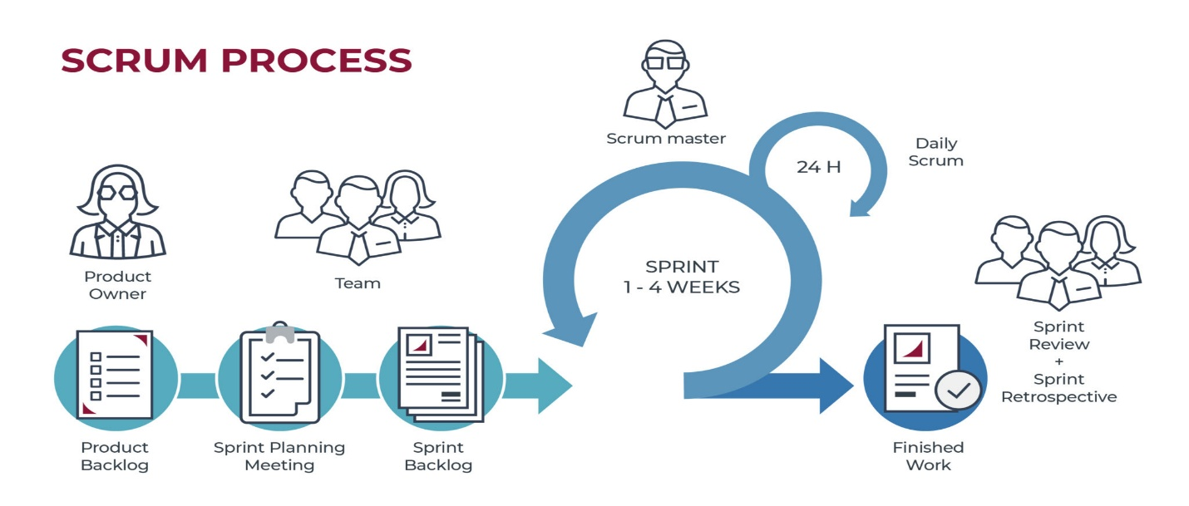
Figure 1 Scrum methodology diagram
Adapted from "Scrum methodology," by InterQuality, n.d., InterQualitybg. https://interqualitybg.com/en/resources/scrum-and-agile-resources/scrum-methodology
Scrum Process in the Development of the Vending Machine
The researchers will utilize the Scrum framework to manage the development of the Reverse Vending Machine. This approach allows for the integration of diverse components, such as the solar power system and the software code, through small and manageable steps. By developing the machine incrementally and performing regular tests, the researchers ensure that the final product meets the specific needs of the students and faculty at Concepcion Holy Cross College, Inc. (CHCCI). This iterative process facilitates the continuous improvement of core features—including the RFID card reader, the point accumulation system, and the mechanical dispenser—to ensure high levels of student engagement in recycling activities.
Adopting this framework enables the researchers to prioritize the most challenging technical tasks, such as ensuring the sensors correctly identify plastic bottles and verifying that the solar-powered battery remains stable. By dividing the project timeline into two-week periods known as Sprints, every hardware and software component is tested for accuracy and durability before full integration. This systematic approach reduces the risk of technical failure and ensures that the machine is user-friendly, reliable, and effective in promoting environmental responsibility on campus.
Product Backlog
The product backlog prioritizes the list of all features, functions, and hardware enhancements needed for the IoT Solar-Powered Reverse Vending Machine system. To ensure the alignment of the environmental and technical requirements of the school-based incentive program, the product backlog is continuously refined and managed by the proponents in coordination with the stakeholders of the Basic Education Department of Concepcion Holy Cross College, Inc. (CHCCI). This dynamic list includes critical components such as the RFID identification logic, sensor-based bottle detection, and the mechanical dispensing of school supply incentives, ensuring that high-value goals are prioritized throughout the development cycles.

Table 1: Product Backlog – Student Side
ID | User Story / Feature | Description / Notes | Priority | Estimate | Sprint
STU-01 | RFID Identification | Student identifies themselves by tapping an RFID card; Orange Pi verifies UID via Firebase. | High | 8h | Sprint 1
STU-02 | QR Login Sync | Machine displays a unique QR code to sync the physical session with the mobile app. | High | 8h | Sprint 1
STU-03 | Display Points (App) | Mobile dashboard retrieves and shows the student’s current point balance. | High | 6h | Sprint 2
STU-04 | Insert Bottle (App) | A button on the mobile app that triggers the Orange Pi to open the intake/activate sensors. | High | 8h | Sprint 2
STU-05 | Redeem Interface (App) | Mobile menu allowing students to select specific rewards (e.g., pens, notebooks). | High | 10h | Sprint 3
STU-06 | Point Deduction Logic | System verifies balance and deducts points before authorizing the physical dispense. | High | 8h | Sprint 3
Table 2: Product Backlog – Admin Side
ID | User Story / Feature | Description / Notes | Priy | Estimate | Sprint
ADM-01 | Student Account Mgmt | Admin tool to register new RFID UIDs or deactivate lost cards in the database. | High | 6h | Sprint 1
ADM-02 | Bottle Validation Setup | Admin calibration of sensors via Orange Pi to ensure accurate PET identification. | High | 16h | Sprint 1
ADM-03 | IoT Dashboard | Web/Mobile view for admins to check real-time bin capacity and collection totals. | High | 12h | Sprint 2
ADM-04 | Solar Power Monitor | Admin view of battery voltage and solar charging status through the Orange Pi. | Medium | 10h | Sprint 2
ADM-05 | Inventory Management | Admin tool to update and track the stock levels of rewards inside the machine. | Medium | 8h | Sprint 3
ADM-06 | Hardware Maintenance | Orange Pi diagnostic logs for checking sensor and motor driver health. | Low | 12h | Sprint 4

System Models and Diagrams
Use Case Diagram
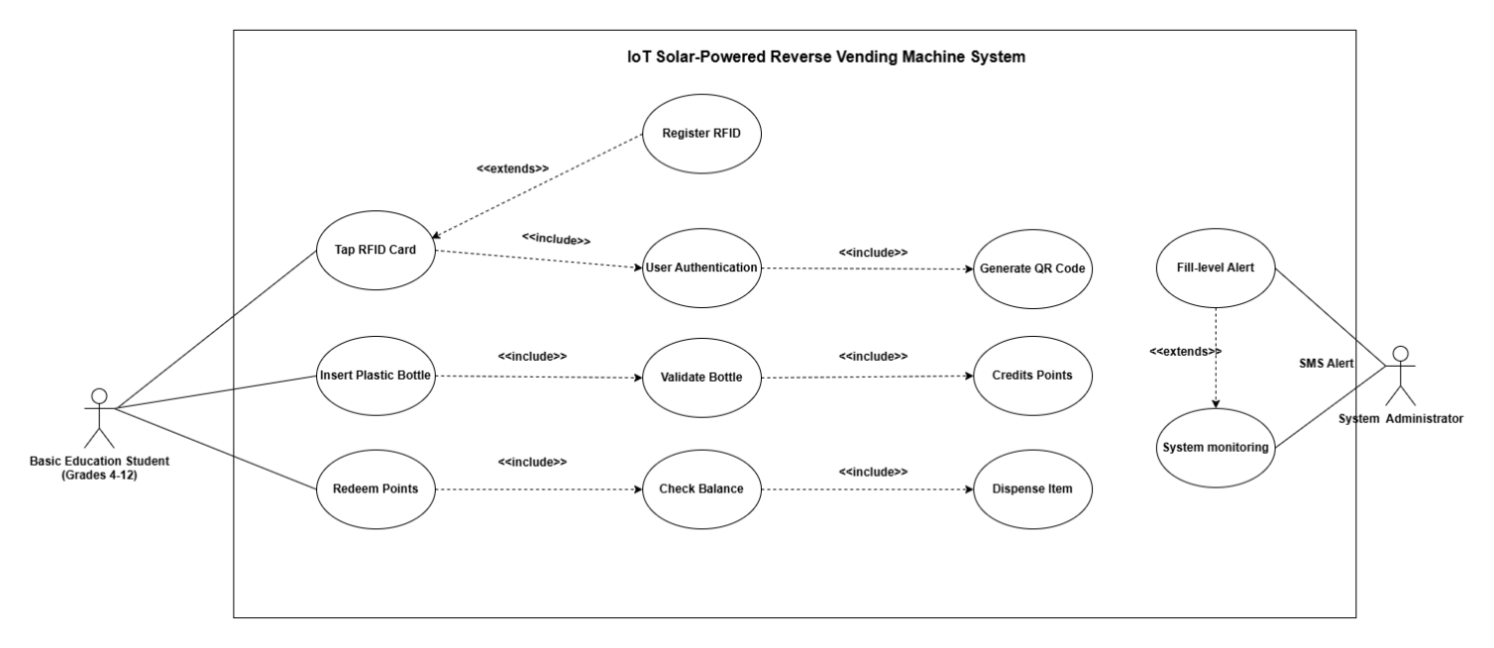
Figure 2 Use Case Diagram
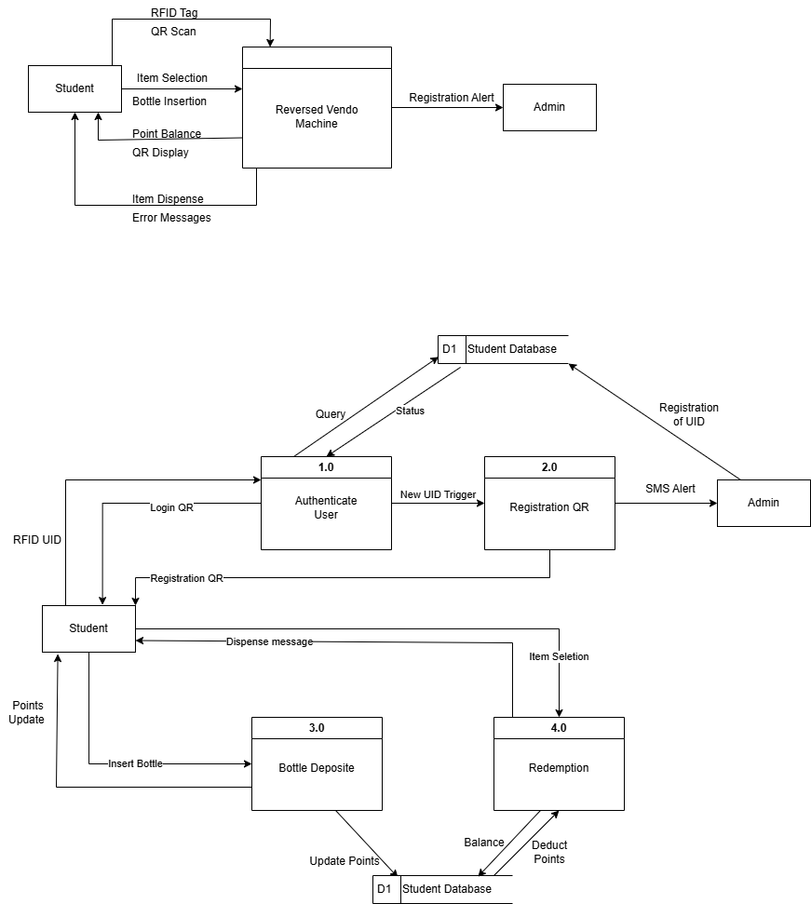
Figure 3. Data Flow Diagram
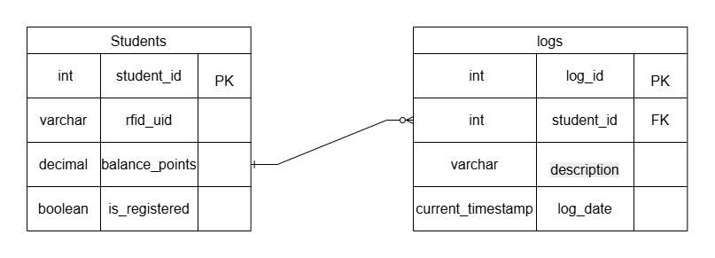
Figure 4 Entity Relationship Diagram

Student Flow Chart
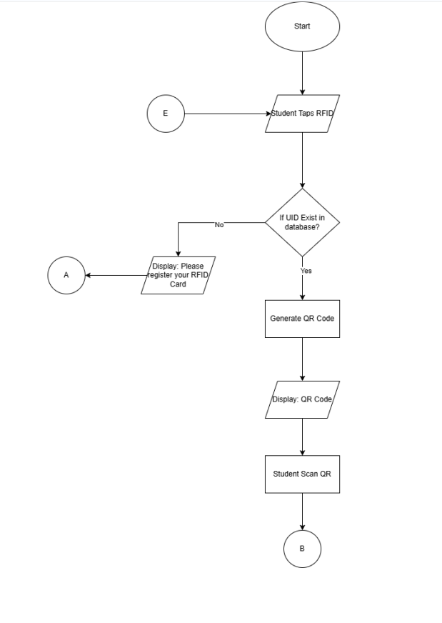
Figure 5: Student Flow Chart

Dashboard Flow Chart
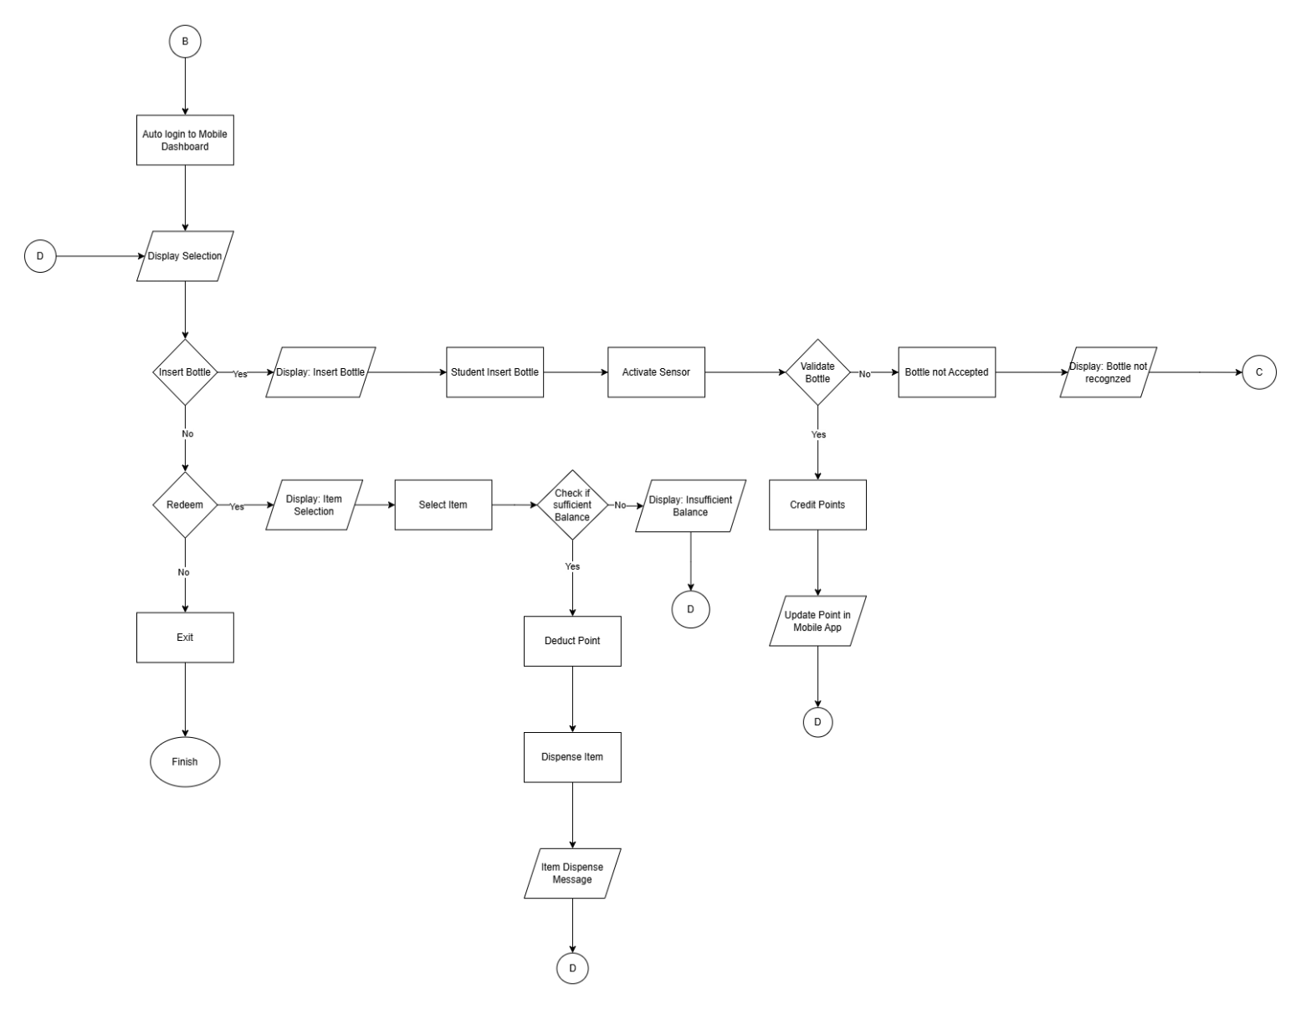
Figure 6: Dashboard Flow Chart

Admin Flow Chart
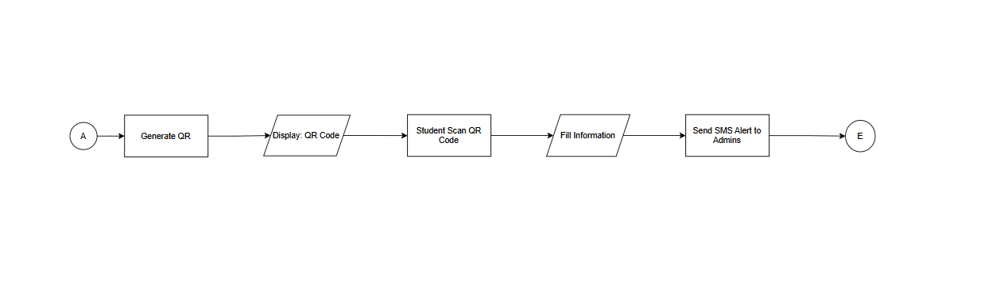
Figure 7: Admin Flow Chart

System Architecture Diagram
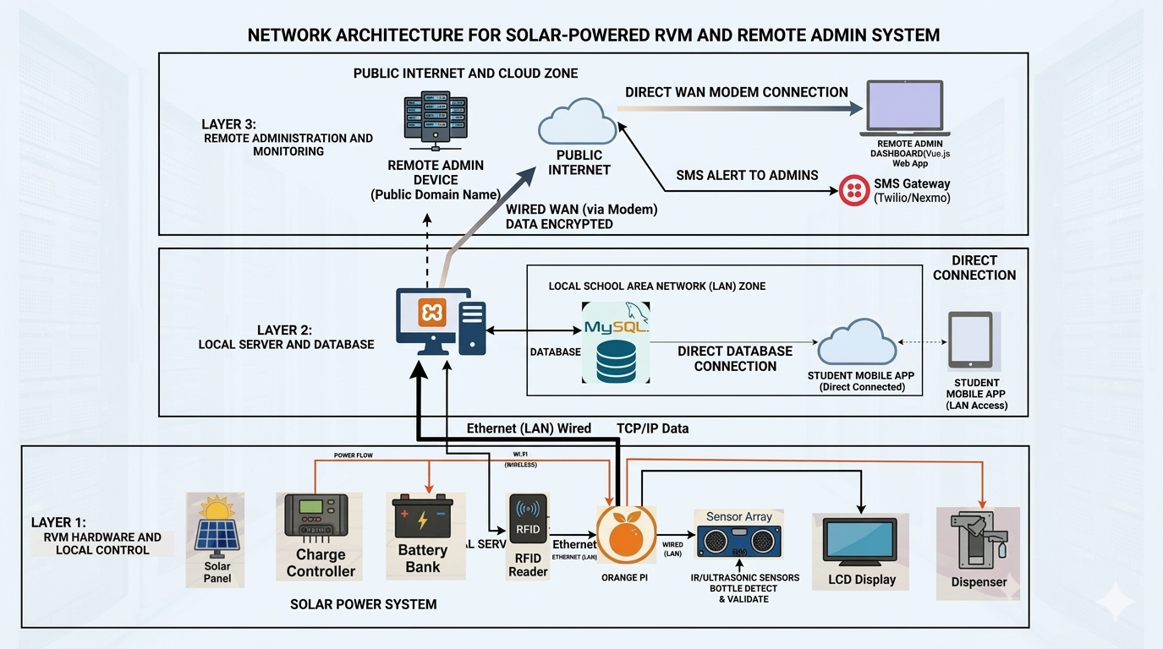

Figure 8: System Architecture Diagram

Network Architecture Diagram

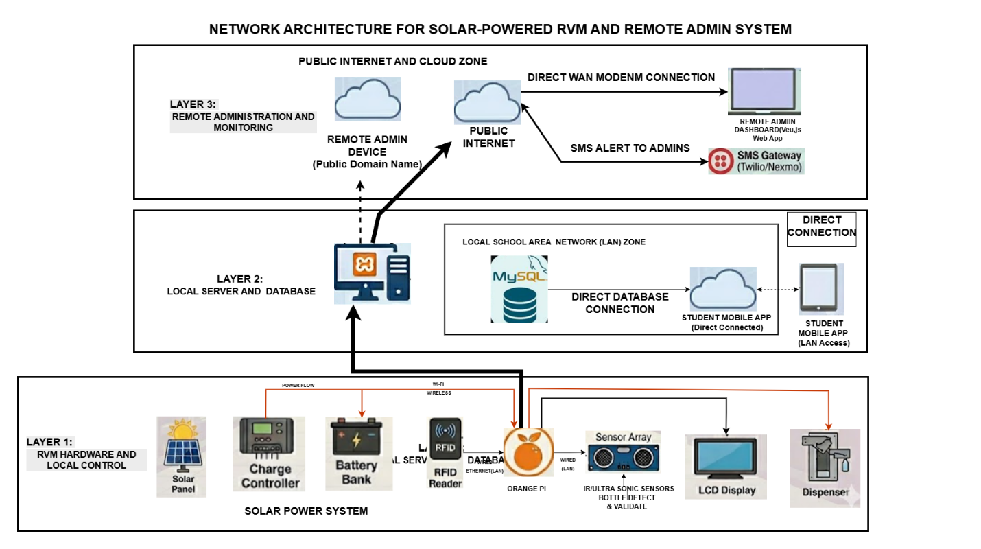

Figure 9: Network Architecture Diagram

Conceptual Framework
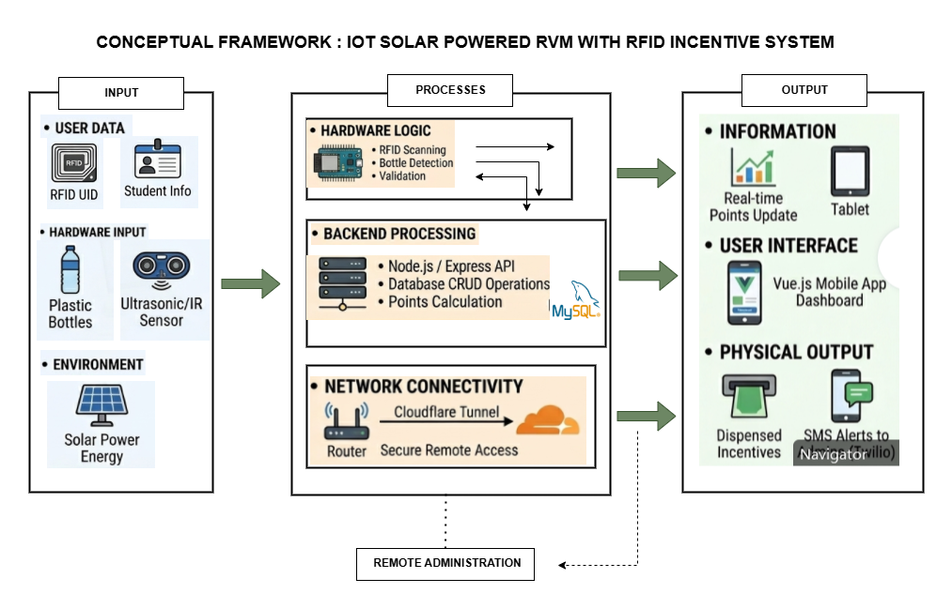

Figure 10: Conceptual Framework

