NAME : KSHITIJ SANGAL ROLLNO : 102203678 SUBGROUP : 2CO15



A Practical activity Report submitted

ELC ASSIGNMENT

Handwritten Digit Recognition

By

**KSHITIJ SANGAL 102203678**



**COMPUTER SCIENCE ENGINEERING DEPARTMENT - CSED**

**THAPAR INSTITUTE OF ENGINEERING AND TECHNOLOGY, (A DEEMED TO BE UNIVERSITY), PATIALA, PUNJAB**

**INDIA**

NAME : KSHITIJ SANGAL ROLLNO : 102203678 SUBGROUP : 2CO15



**EXPERIMENT**

Train your model using K-Nearest Neighbour Algorithm with having values of K as {2,4,5,6,7,10}, over data.csv file provided. The Train and Test split of the data should be in the ratio of 60:40, 70:30, 75:25, 80:20, 90:10, 95:5. Evaluate the performance of the model over test data for all these scenarios (36 cases), and submit the single jupyter notebook, having one of the scenario implemented (and rest in comments), and a single pdf file containing the results of all these scenarios (Accuracy, and Confusion Matrix), also your analysis regarding the dependency of the performance of model over training testing split and k value.

**FOR K = 2**

1. RATIO OF TRAIN AND TEST DATA - 60:40

# ACCURACY – 0.95

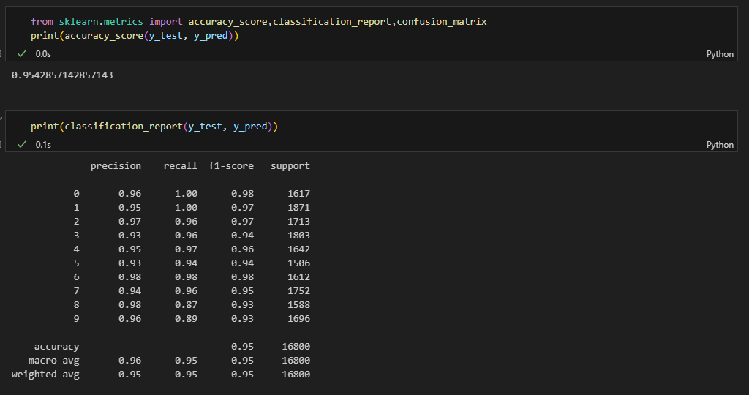

NAME : KSHITIJ SANGAL ROLLNO : 102203678 SUBGROUP : 2CO15



# CONFUSION MATRIX

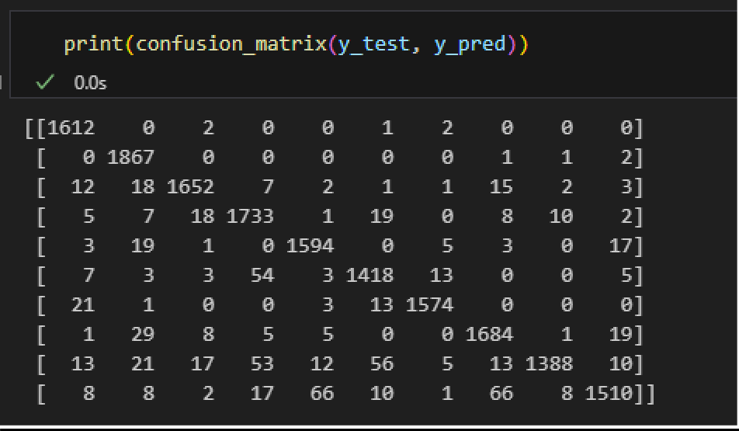

1. RATIO OF TRAIN AND TEST DATA - 70:30

# ACCURACY – 0.95

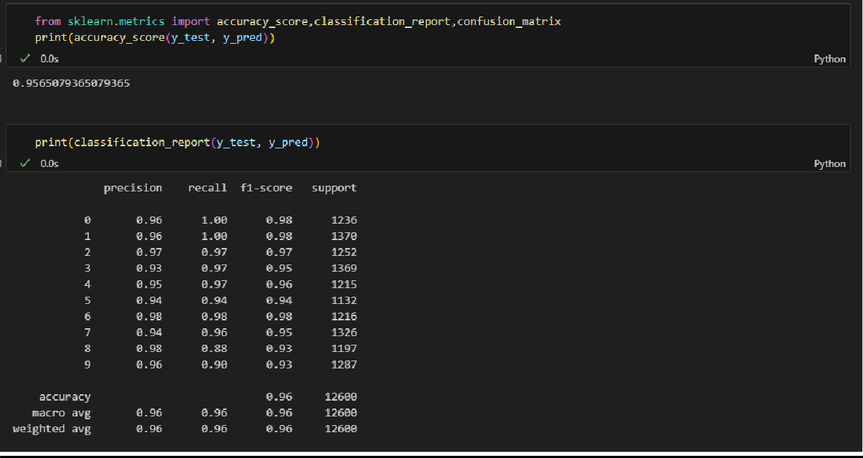

NAME : KSHITIJ SANGAL ROLLNO : 102203678 SUBGROUP : 2CO15



# CONFUSION MATRIX

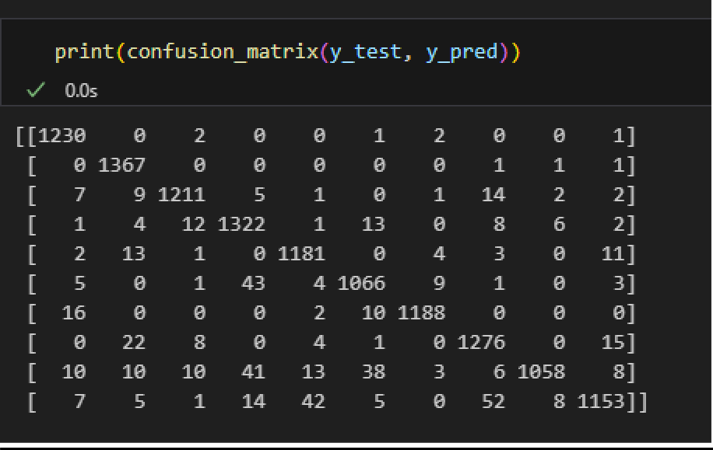

1. RATIO OF TRAIN AND TEST DATA - 75:25

# ACCURACY – 0.95

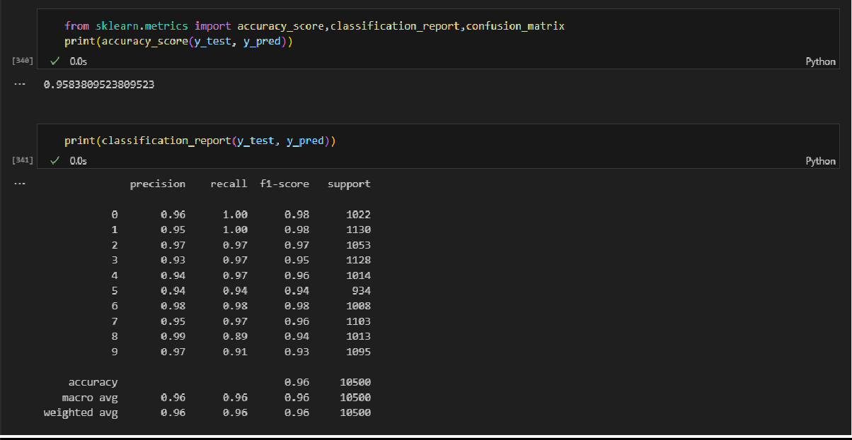

NAME : KSHITIJ SANGAL ROLLNO : 102203678 SUBGROUP : 2CO15



# CONFUSION MATRIX

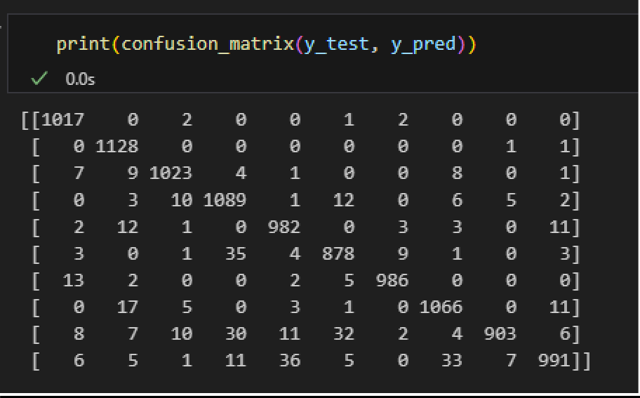

1. RATIO OF TRAIN AND TEST DATA – 80:20

# ACCURACY – 0.95

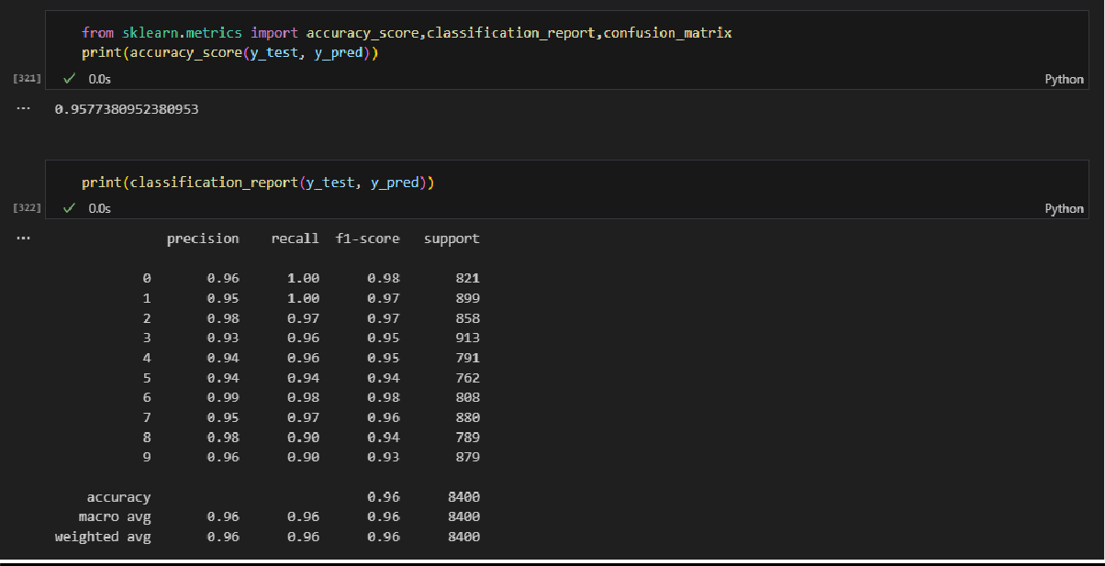

NAME : KSHITIJ SANGAL ROLLNO : 102203678 SUBGROUP : 2CO15



# CONFUSION MATRIX

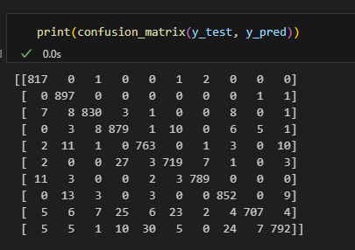

1. RATIO OF TRAIN AND TEST DATA – 90:10

# ACCURACY – 0.96

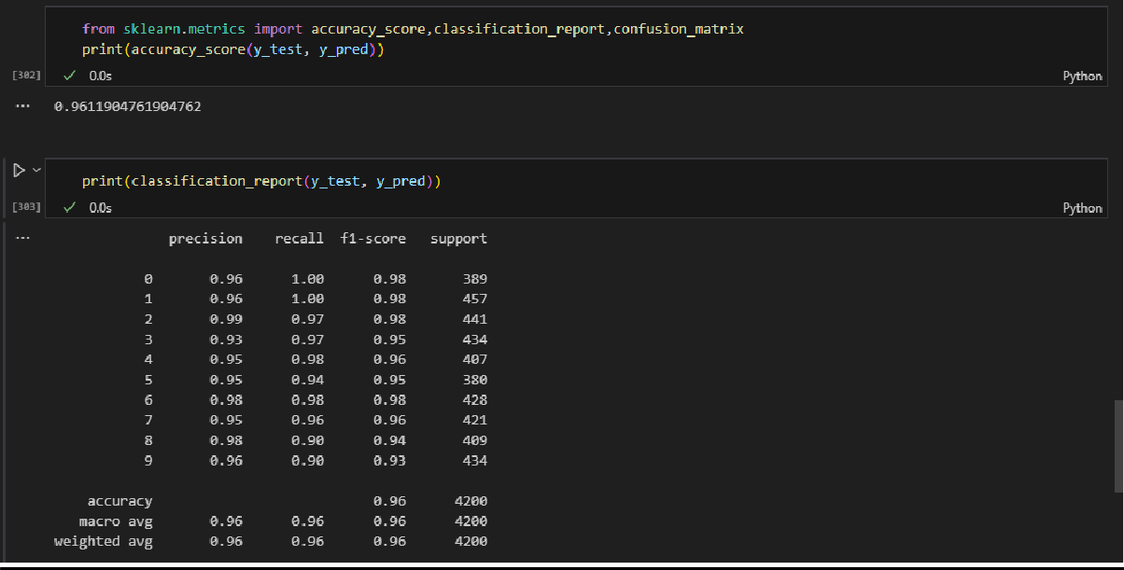

NAME : KSHITIJ SANGAL ROLLNO : 102203678 SUBGROUP : 2CO15



# CONFUSION MATRIX

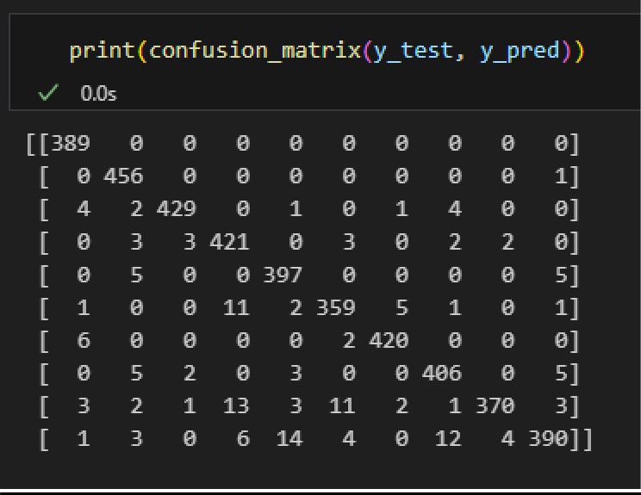

1. RATIO OF TRAIN AND TEST DATA – 95:5

# ACCURACY – 0.95

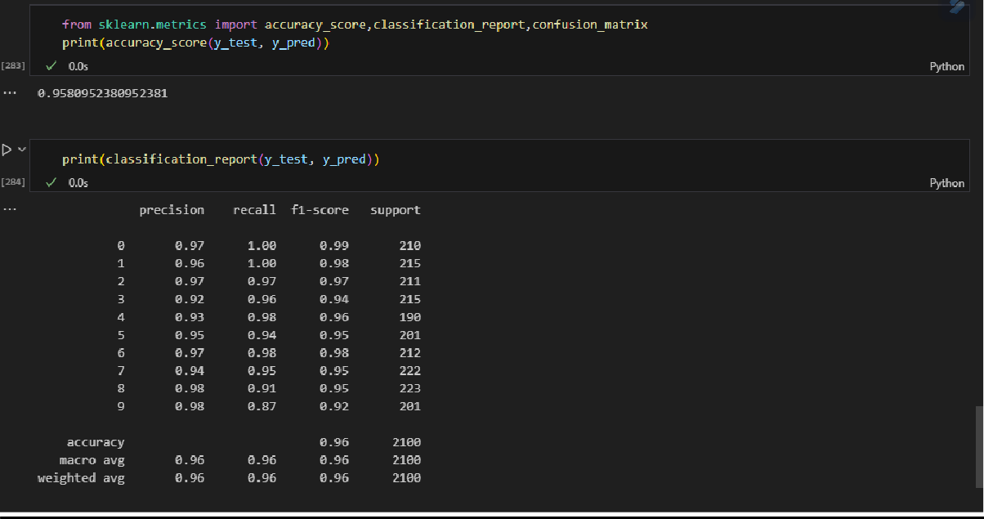

NAME : KSHITIJ SANGAL ROLLNO : 102203678 SUBGROUP : 2CO15



# CONFUSION MATRIX

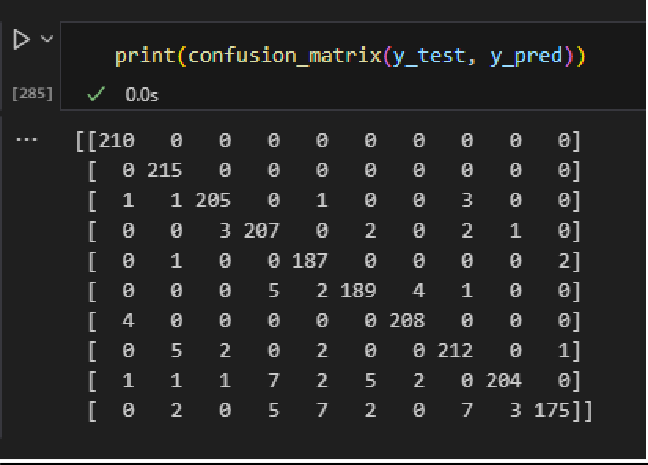

**FOR K = 4**

1. RATIO OF TRAIN AND TEST DATA - 60:40

# ACCURACY – 0.96

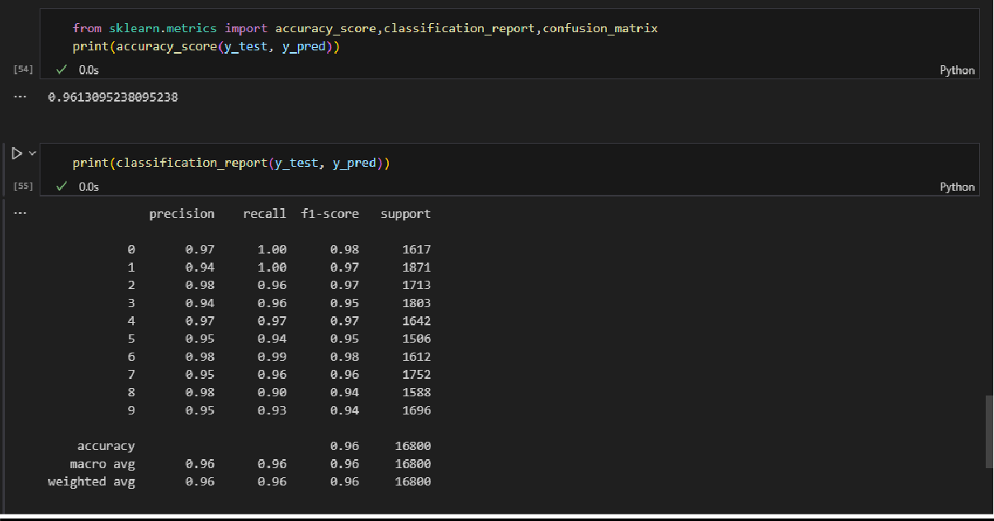

NAME : KSHITIJ SANGAL ROLLNO : 102203678 SUBGROUP : 2CO15



# CONFUSION MATRIX

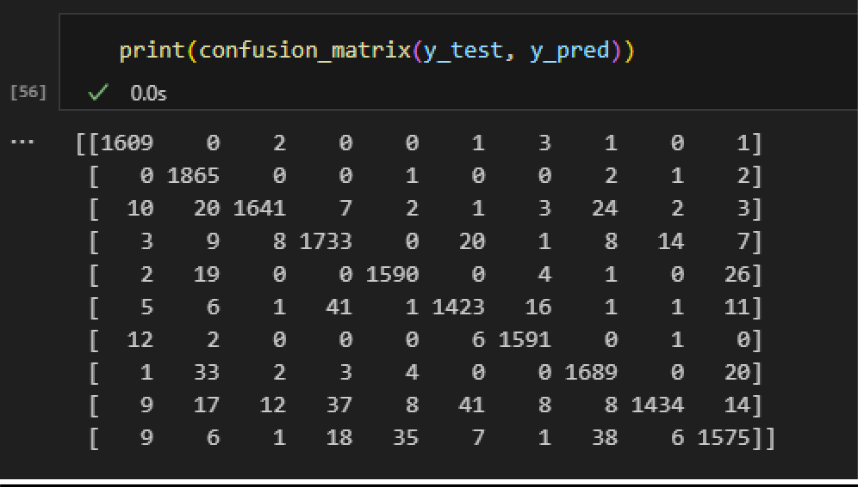

1. RATIO OF TRAIN AND TEST DATA - 70:30

# ACCURACY – 0.96

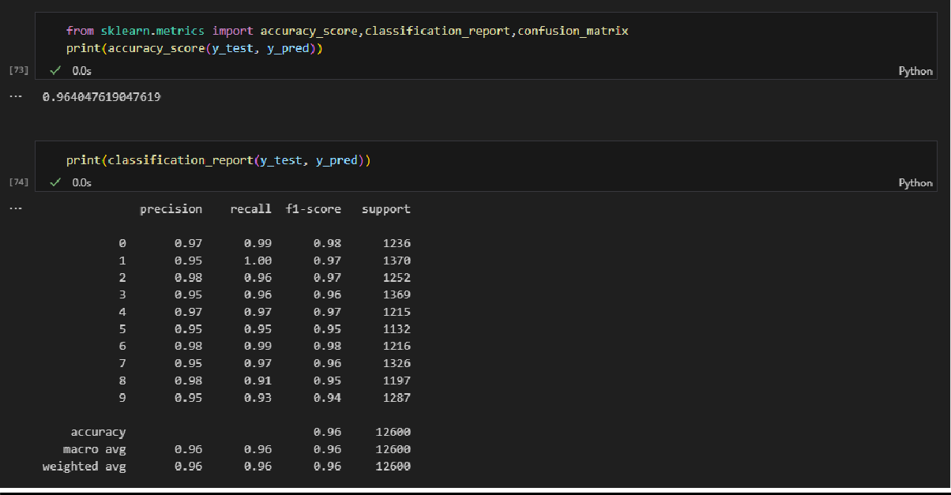

NAME : KSHITIJ SANGAL ROLLNO : 102203678 SUBGROUP : 2CO15



# CONFUSION MATRIX

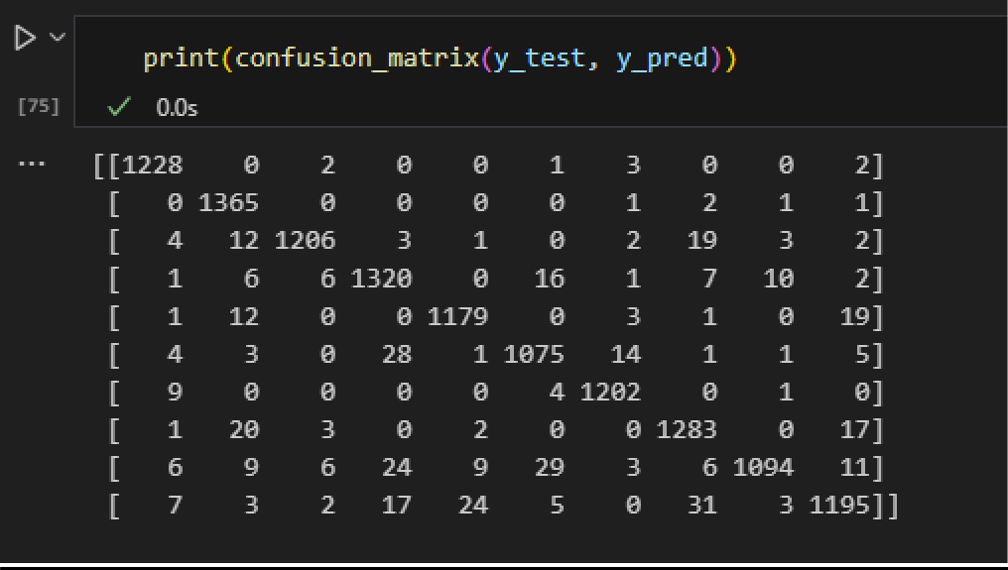

1. RATIO OF TRAIN AND TEST DATA - 75:25

# ACCURACY – 0.96

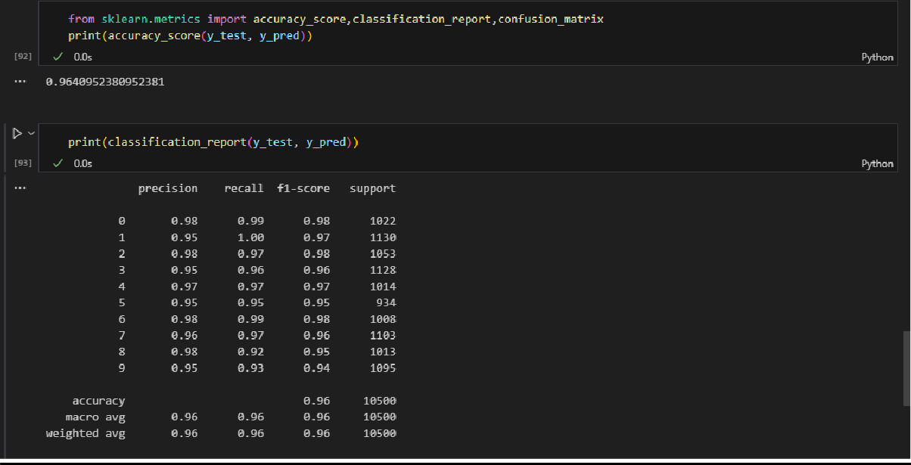

NAME : KSHITIJ SANGAL ROLLNO : 102203678 SUBGROUP : 2CO15



# CONFUSION MATRIX

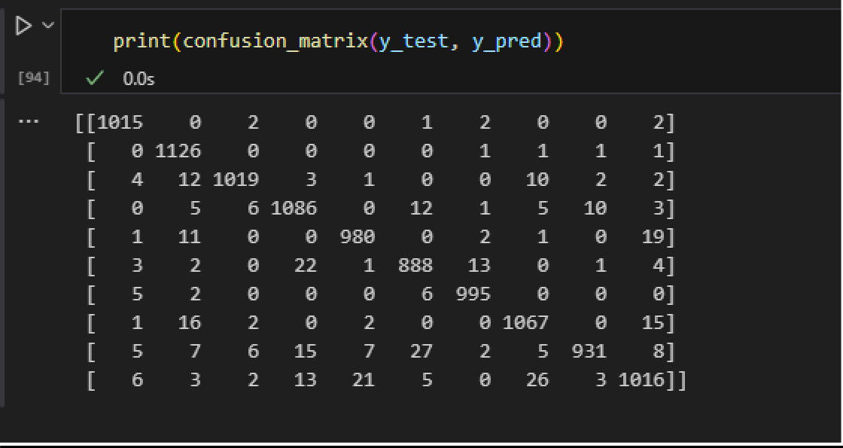

1. RATIO OF TRAIN AND TEST DATA - 80:20

# ACCURACY – 0.96

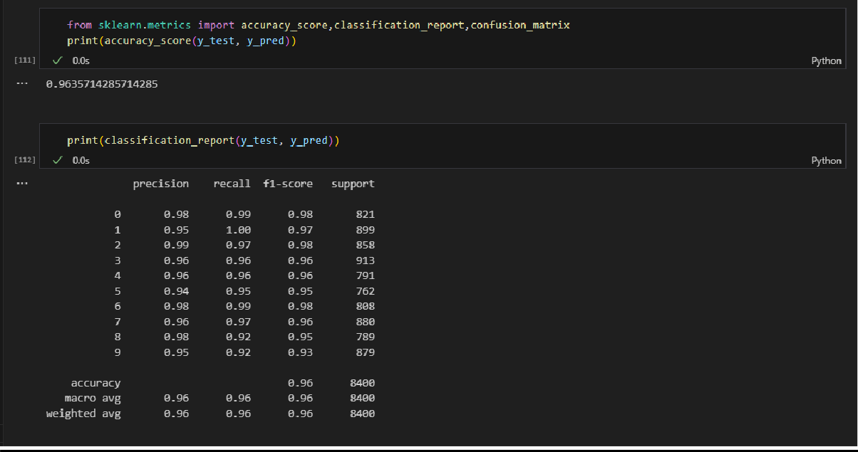

NAME : KSHITIJ SANGAL ROLLNO : 102203678 SUBGROUP : 2CO15



# CONFUSION MATRIX

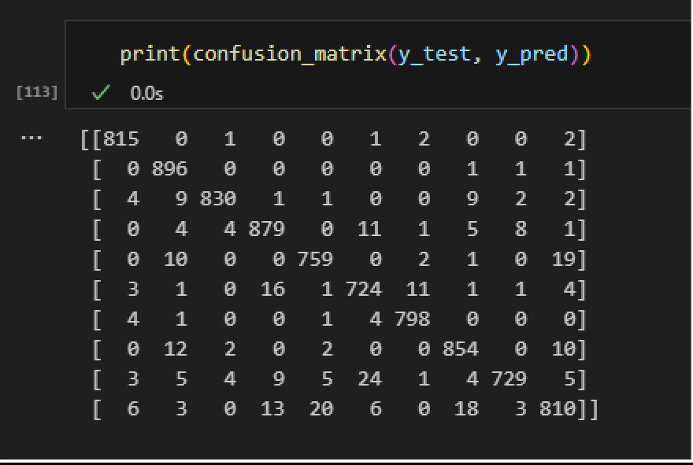

1. RATIO OF TRAIN AND TEST DATA - 90:10

# ACCURACY – 0.96

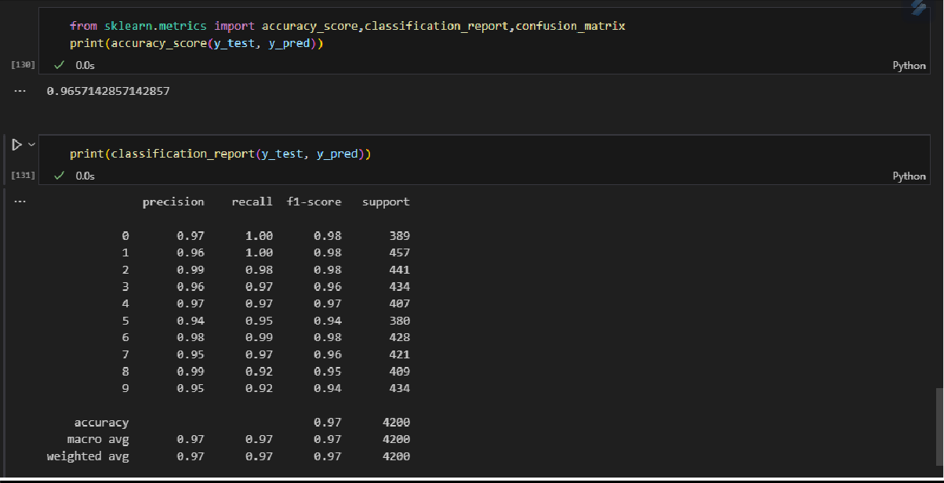

NAME : KSHITIJ SANGAL ROLLNO : 102203678 SUBGROUP : 2CO15



# CONFUSION MATRIX

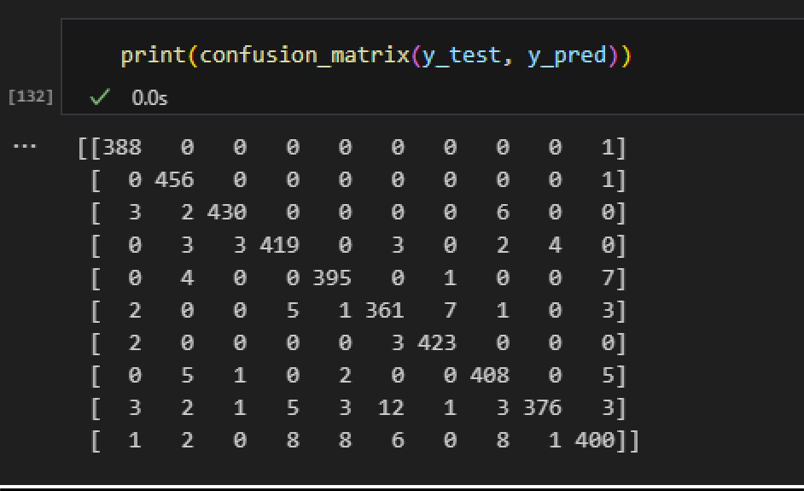

1. RATIO OF TRAIN AND TEST DATA - 95:05

# ACCURACY – 0.96

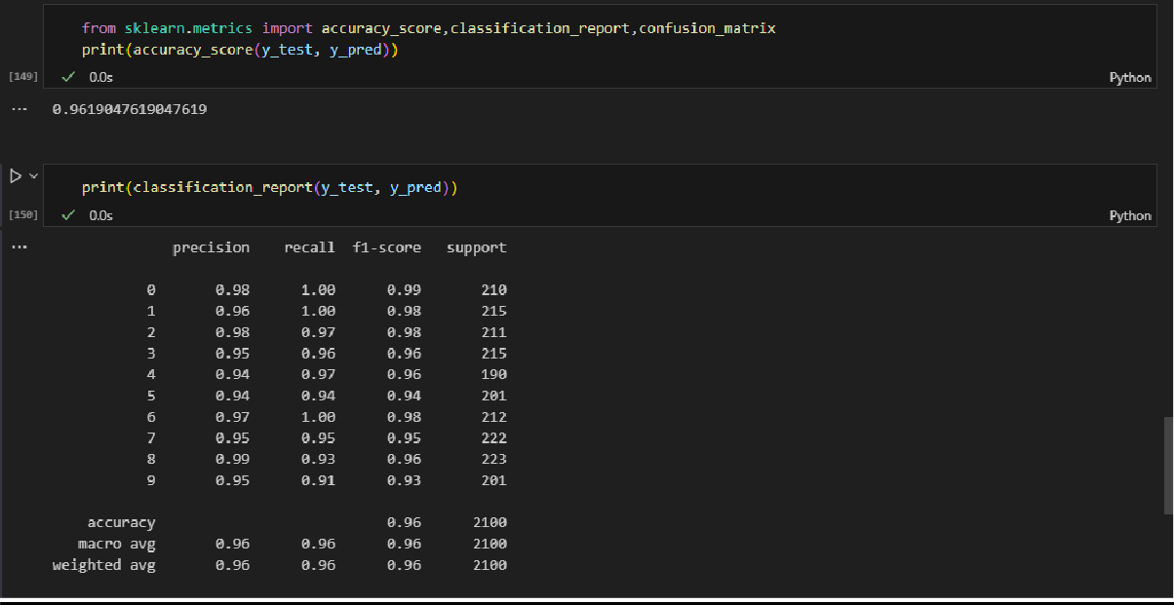

NAME : KSHITIJ SANGAL ROLLNO : 102203678 SUBGROUP : 2CO15



# CONFUSION MATRIX

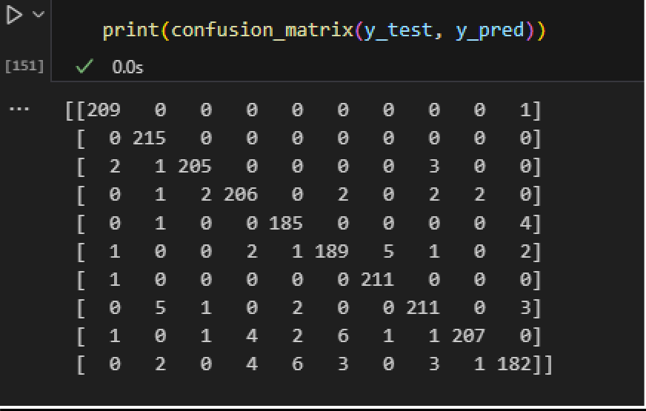

**FOR K = 5**

1. RATIO OF TRAIN AND TEST DATA - 60:40

# ACCURACY – 0.96

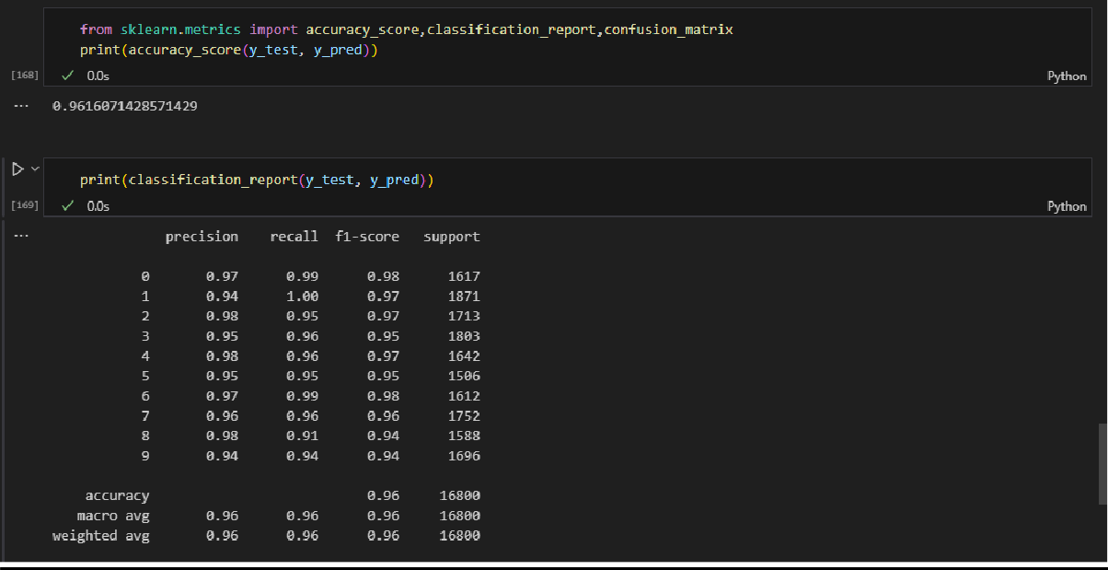

NAME : KSHITIJ SANGAL ROLLNO : 102203678 SUBGROUP : 2CO15



# CONFUSION MATRIX

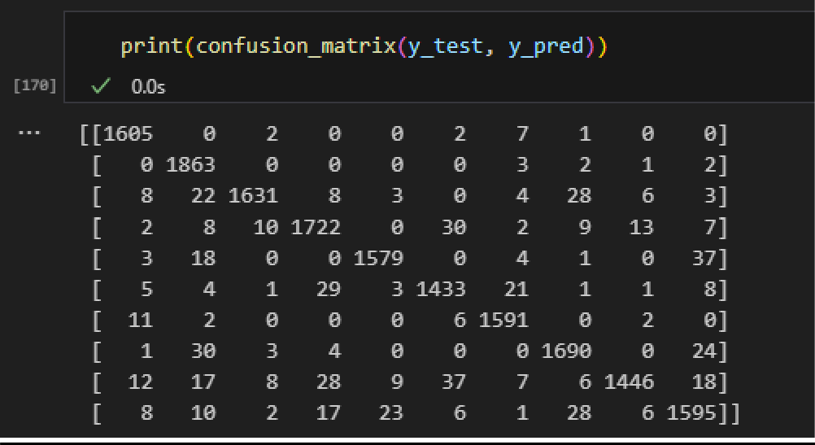

1. RATIO OF TRAIN AND TEST DATA - 70:30

# ACCURACY – 0.96

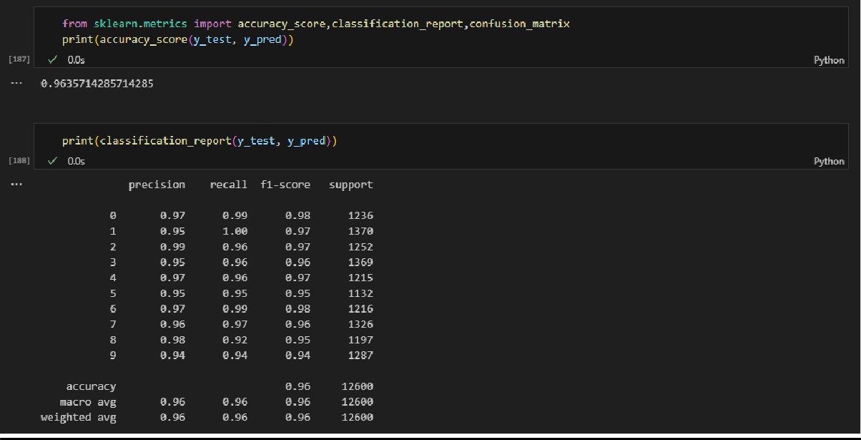

NAME : KSHITIJ SANGAL ROLLNO : 102203678 SUBGROUP : 2CO15



# CONFUSION MATRIX

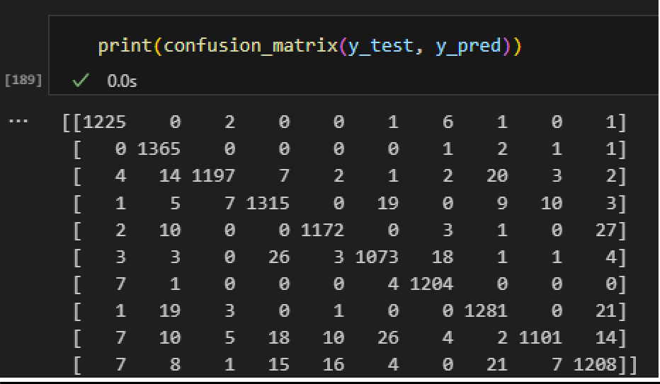

1. RATIO OF TRAIN AND TEST DATA - 75:25

# ACCURACY – 0.96

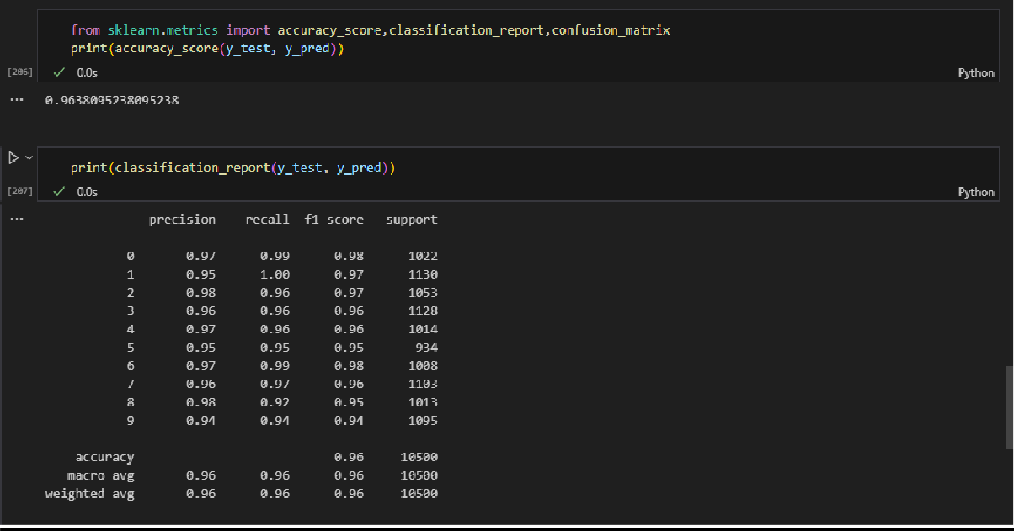

NAME : KSHITIJ SANGAL ROLLNO : 102203678 SUBGROUP : 2CO15



# CONFUSION MATRIX

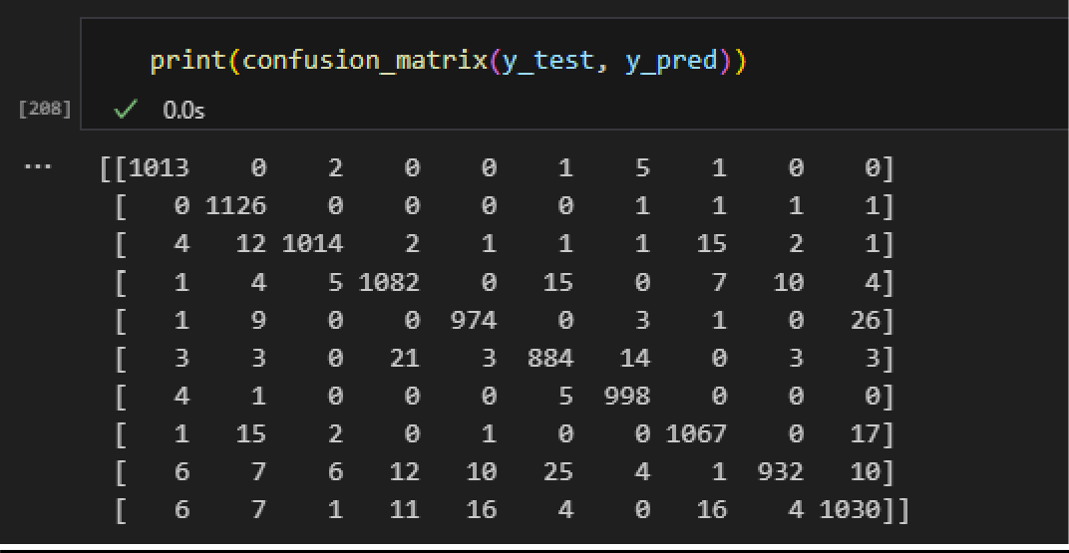

1. RATIO OF TRAIN AND TEST DATA - 80:20

# ACCURACY – 0.96

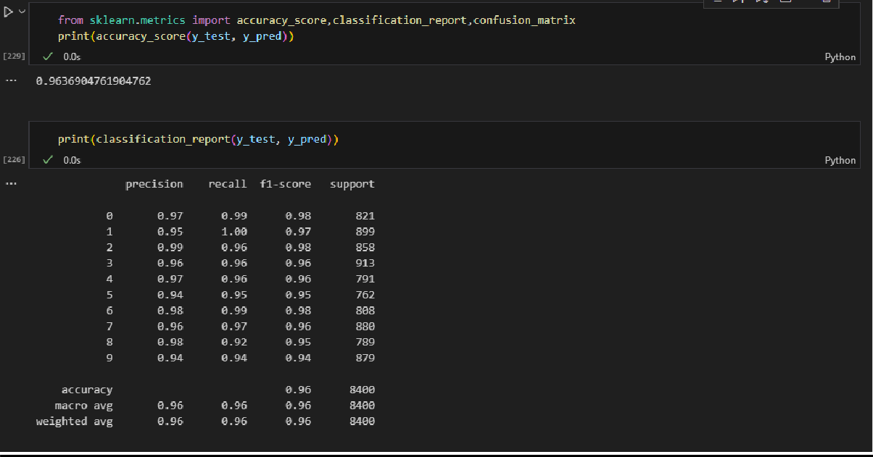

NAME : KSHITIJ SANGAL ROLLNO : 102203678 SUBGROUP : 2CO15



# CONFUSION MATRIX

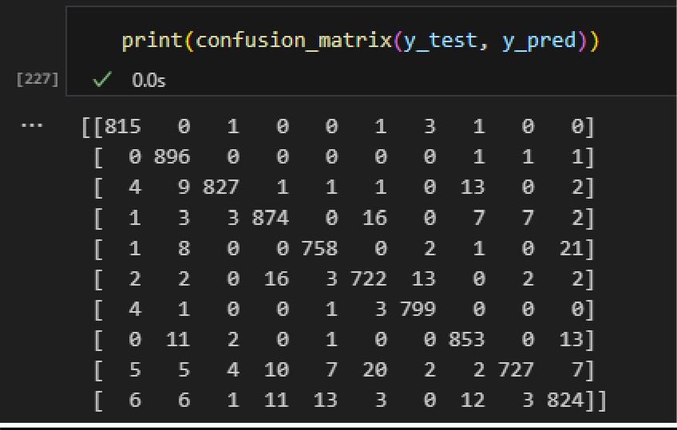

1. RATIO OF TRAIN AND TEST DATA - 90:10

# ACCURACY – 0.96

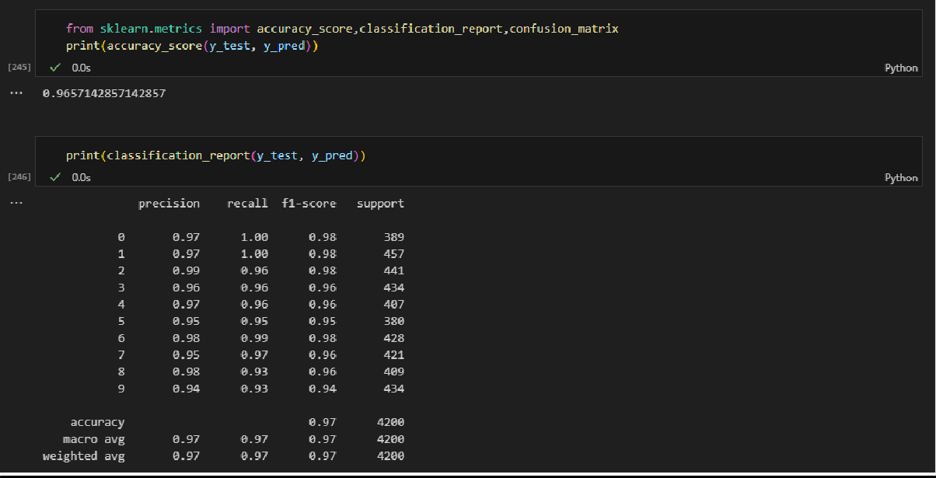

NAME : KSHITIJ SANGAL ROLLNO : 102203678 SUBGROUP : 2CO15



# CONFUSION MATRIX

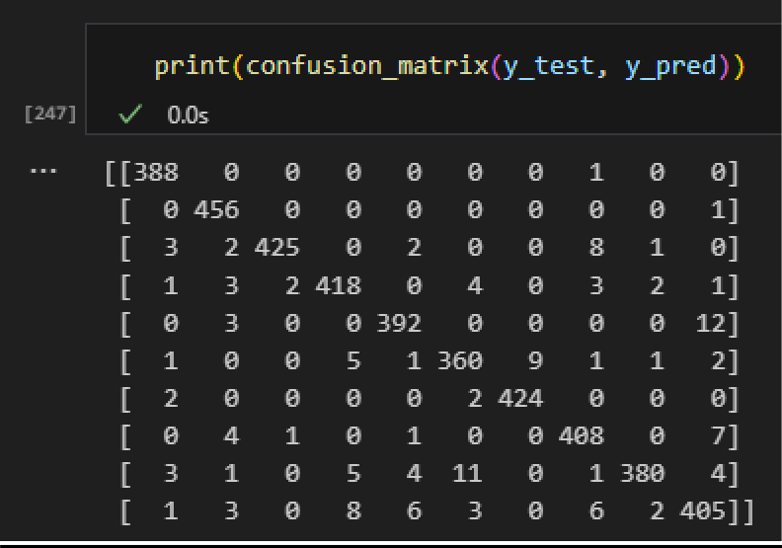

1. RATIO OF TRAIN AND TEST DATA - 95:05

# ACCURACY – 0.96

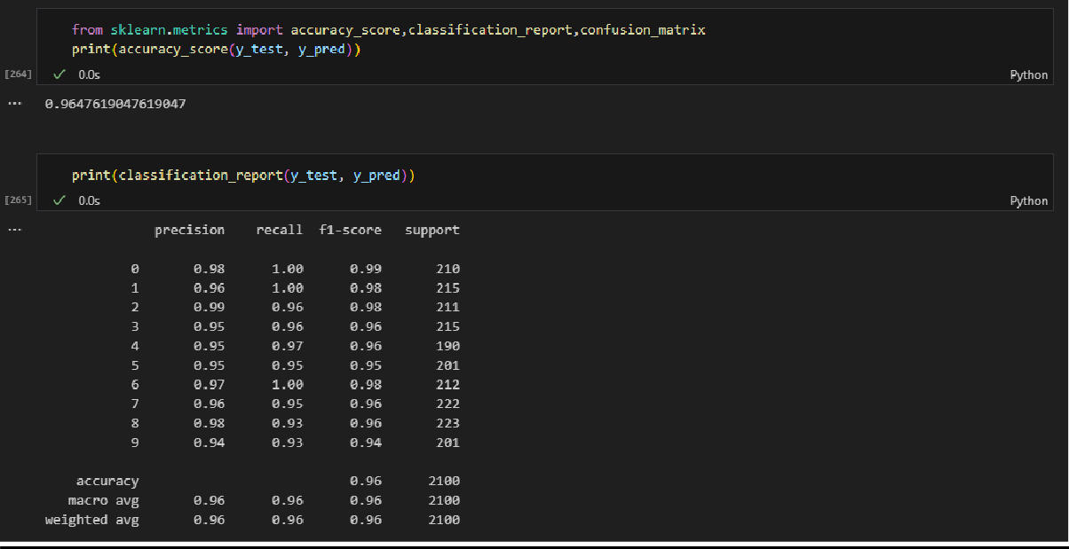

NAME : KSHITIJ SANGAL ROLLNO : 102203678 SUBGROUP : 2CO15



# CONFUSION MATRIX

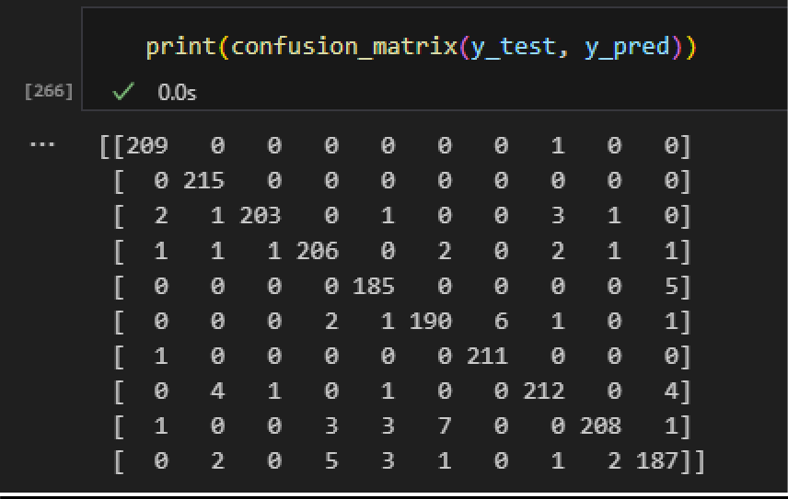

**FOR K = 6**

* 1. RATIO OF TRAIN AND TEST DATA - 70:30

# ACCURACY – 0.96

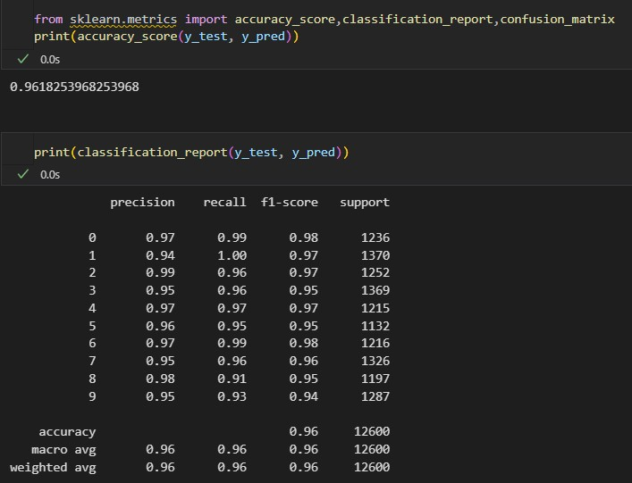

NAME : KSHITIJ SANGAL ROLLNO : 102203678 SUBGROUP : 2CO15



# CONFUSION MATRIX

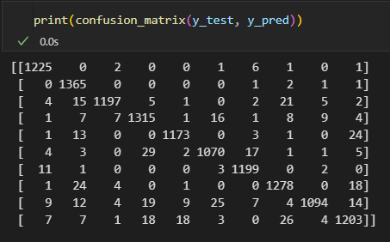

2.) RATIO OF TRAIN AND TEST DATA - 95:05

# ACCURACY – 0.95

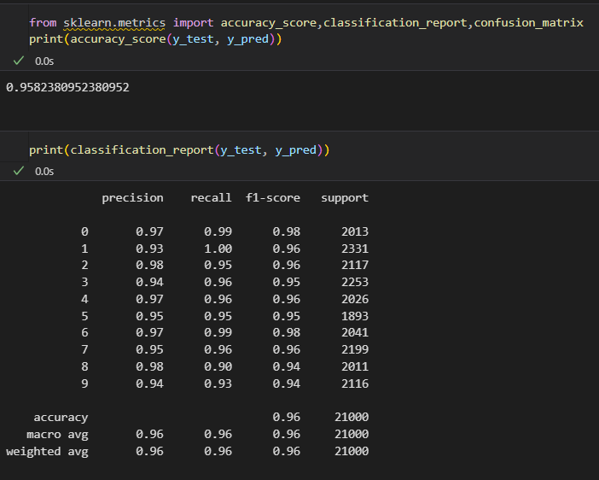

NAME : KSHITIJ SANGAL ROLLNO : 102203678 SUBGROUP : 2CO15



# CONFUSION MATRIX

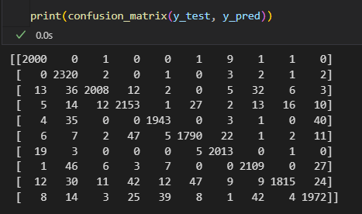

3.) RATIO OF TRAIN AND TEST DATA – 90:10

# ACCURACY – 0.96

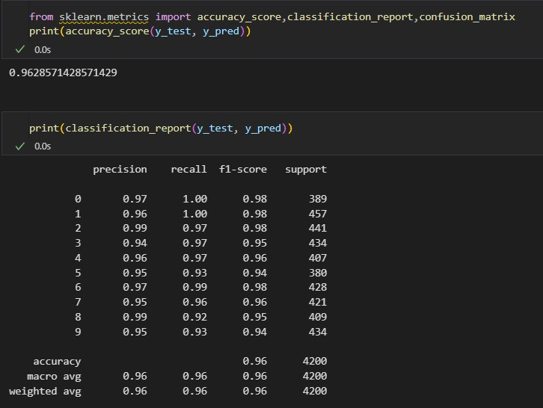

NAME : KSHITIJ SANGAL ROLLNO : 102203678 SUBGROUP : 2CO15



# CONFUSION MATRIX

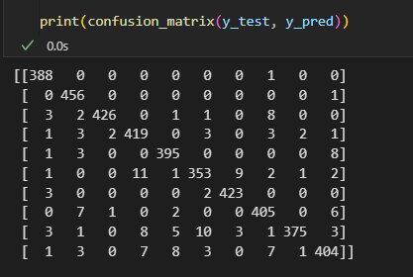

1. RATIO OF TRAIN AND TEST DATA – 80:20

# ACCURACY – 0.96

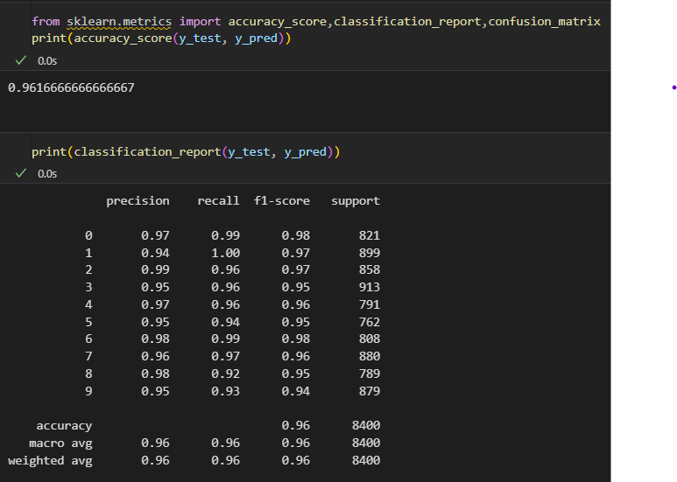

NAME : KSHITIJ SANGAL ROLLNO : 102203678 SUBGROUP : 2CO15



# CONFUSION MATRIX

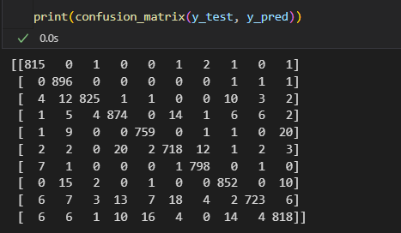

1. RATIO OF TRAIN AND TEST DATA – 75:25

# ACCURACY – 0.96

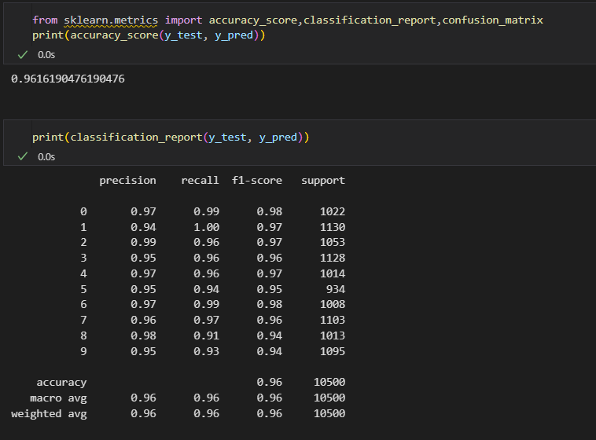

NAME : KSHITIJ SANGAL ROLLNO : 102203678 SUBGROUP : 2CO15



# CONFUSION MATRIX

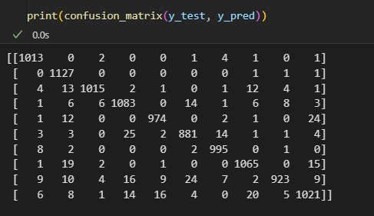

1. RATIO OF TRAIN AND TEST DATA – 60:40

# ACCURACY – 0.96

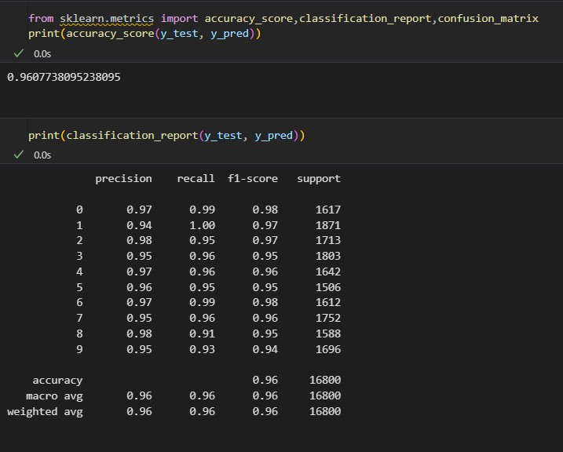

NAME : KSHITIJ SANGAL ROLLNO : 102203678 SUBGROUP : 2CO15



# CONFUSION MATRIX

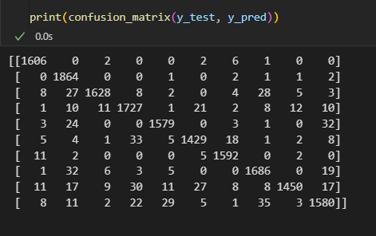

**FOR K = 7**

1.) RATIO OF TRAIN AND TEST DATA - 95:05

# ACCURACY – 0.95

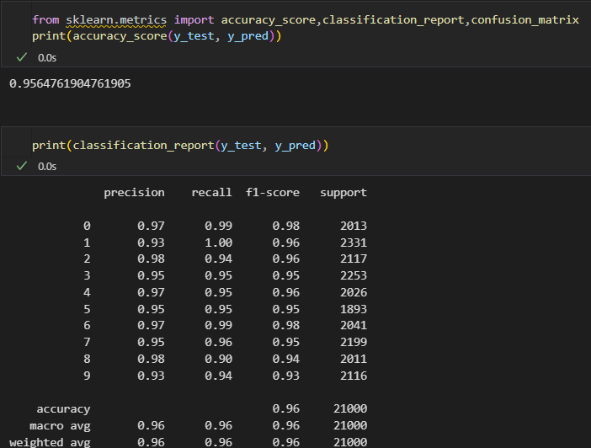

NAME : KSHITIJ SANGAL ROLLNO : 102203678 SUBGROUP : 2CO15



# CONFUSION MATRIX

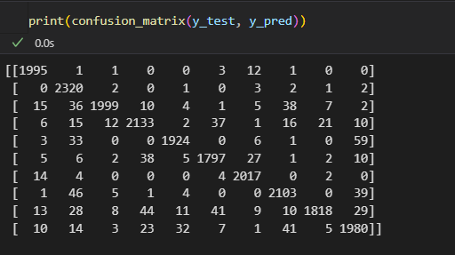

2.) RATIO OF TRAIN AND TEST DATA - 90:10

# ACCURACY – 0.96

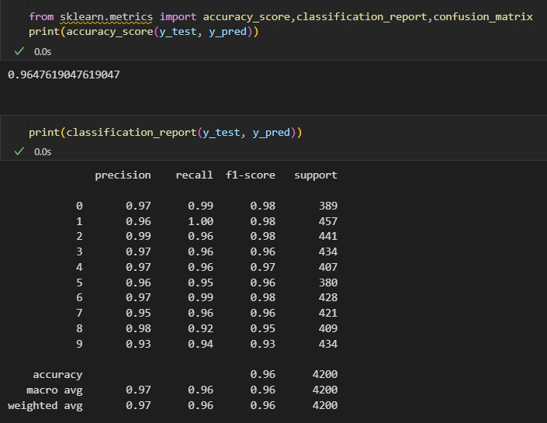

NAME : KSHITIJ SANGAL ROLLNO : 102203678 SUBGROUP : 2CO15



# CONFUSION MATRIX

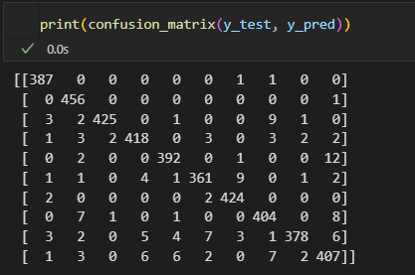

3.) RATIO OF TRAIN AND TEST DATA – 80:20

# ACCURACY – 0.96

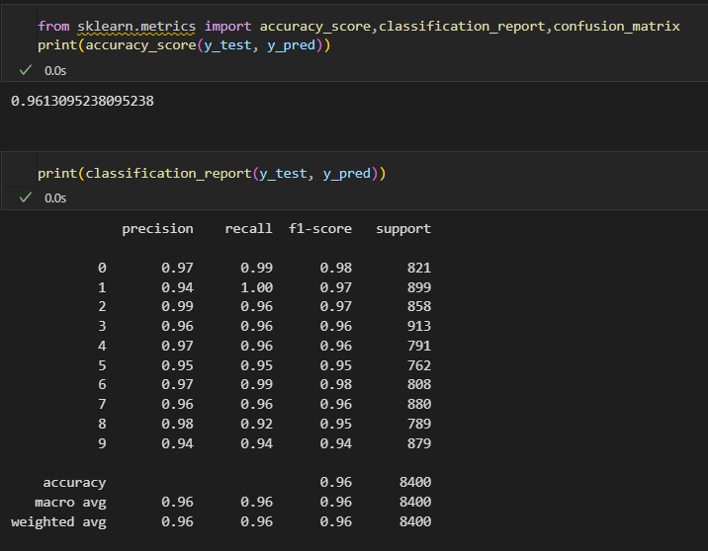

NAME : KSHITIJ SANGAL ROLLNO : 102203678 SUBGROUP : 2CO15



# CONFUSION MATRIX

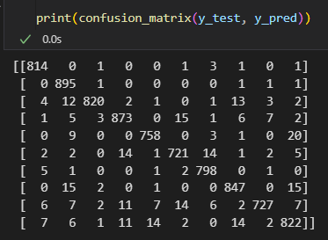

4.) RATIO OF TRAIN AND TEST DATA – 75:25

# ACCURACY – 0.96

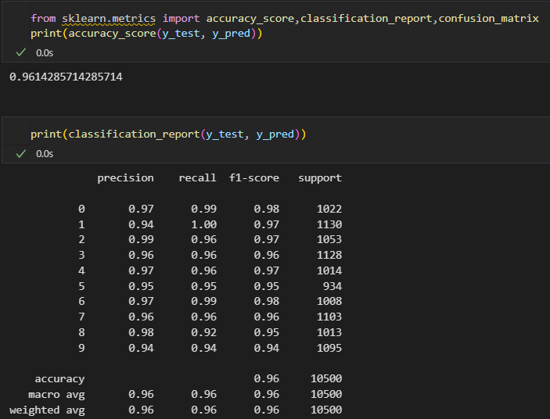

NAME : KSHITIJ SANGAL ROLLNO : 102203678 SUBGROUP : 2CO15



# CONFUSION MATRIX

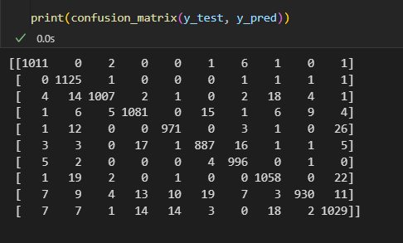

5.) RATIO OF TRAIN AND TEST DATA – 70:30

# ACCURACY – 0.96

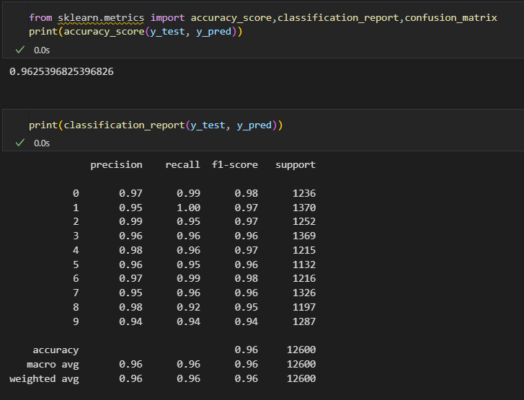

NAME : KSHITIJ SANGAL ROLLNO : 102203678 SUBGROUP : 2CO15



# CONFUSION MATRIX

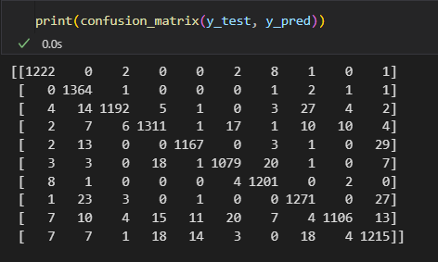

6.) RATIO OF TRAIN AND TEST DATA – 60:40

# ACCURACY – 0.95

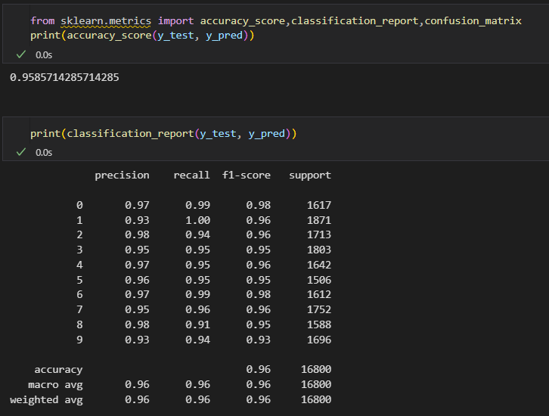

NAME : KSHITIJ SANGAL ROLLNO : 102203678 SUBGROUP : 2CO15



# CONFUSION MATRIX

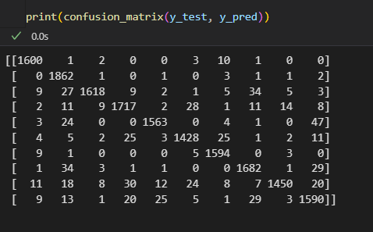

**FOR K = 10**

1.) RATIO OF TRAIN AND TEST DATA - 95:05

# ACCURACY – 0.95

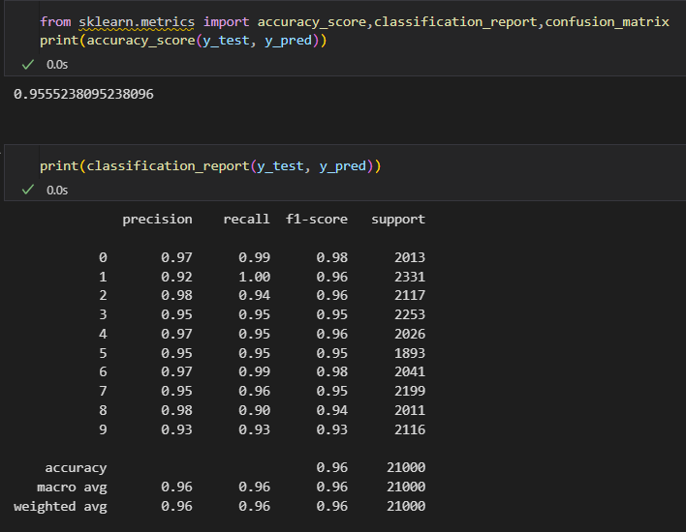

NAME : KSHITIJ SANGAL ROLLNO : 102203678 SUBGROUP : 2CO15



# CONFUSION MATRIX

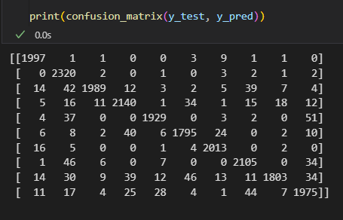

2.) RATIO OF TRAIN AND TEST DATA – 90:10

# ACCURACY – 0.96

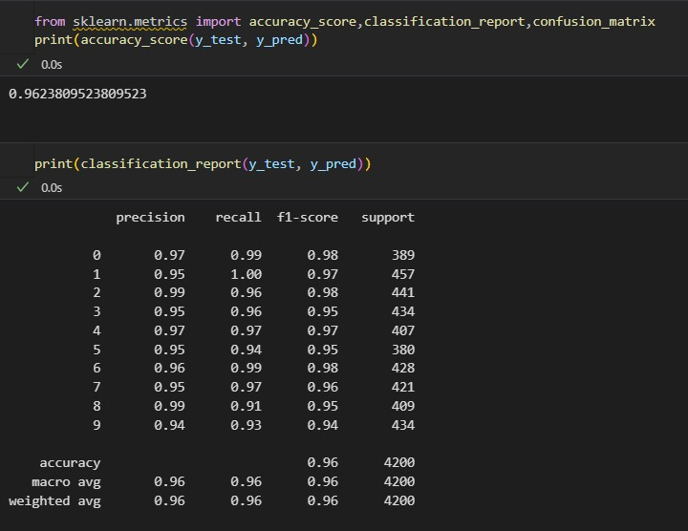

NAME : KSHITIJ SANGAL ROLLNO : 102203678 SUBGROUP : 2CO15



# CONFUSION MATRIX

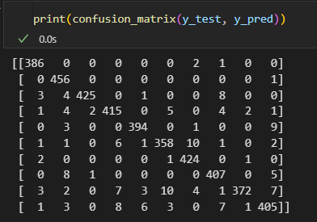

3.) RATIO OF TRAIN AND TEST DATA – 80:20

# ACCURACY – 0.96

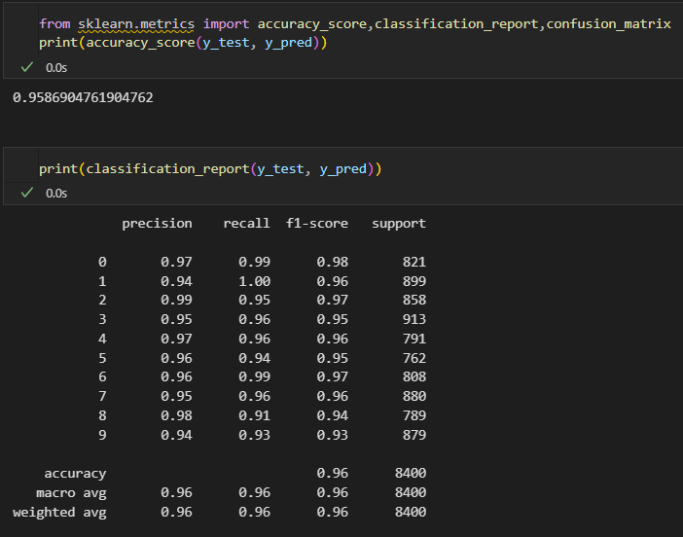

NAME : KSHITIJ SANGAL ROLLNO : 102203678 SUBGROUP : 2CO15



# CONFUSION MATRIX

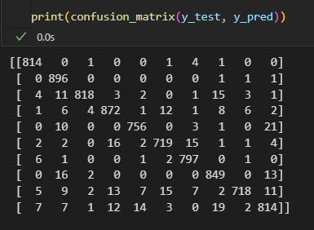

4.) RATIO OF TRAIN AND TEST DATA – 75:25

# ACCURACY – 0.96

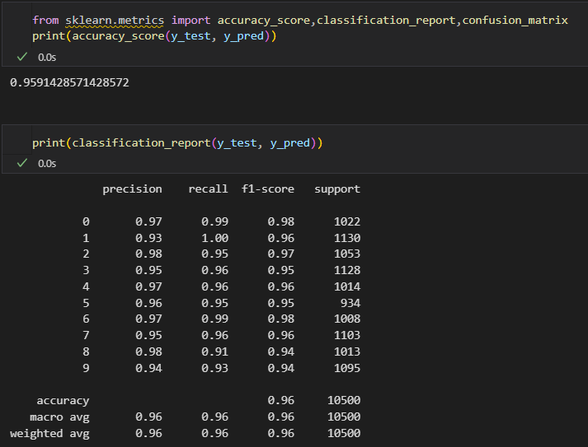

NAME : KSHITIJ SANGAL ROLLNO : 102203678 SUBGROUP : 2CO15



# CONFUSION MATRIX

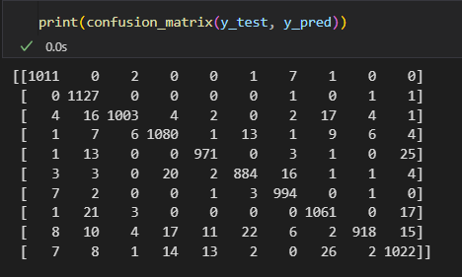

5.) RATIO OF TRAIN AND TEST DATA – 70:30

# ACCURACY – 0.96

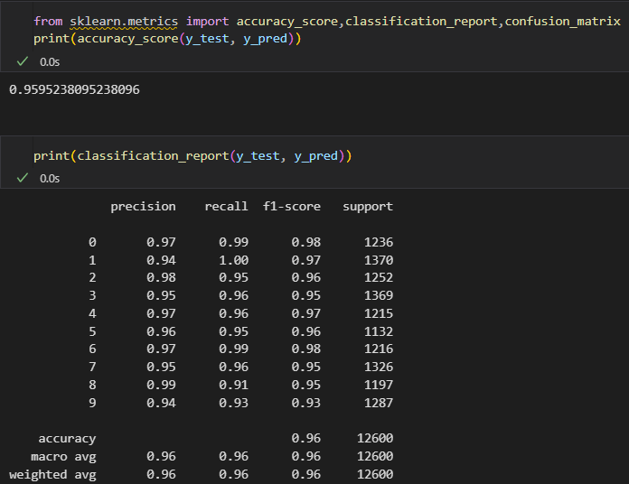

NAME : KSHITIJ SANGAL ROLLNO : 102203678 SUBGROUP : 2CO15



# CONFUSION MATRIX

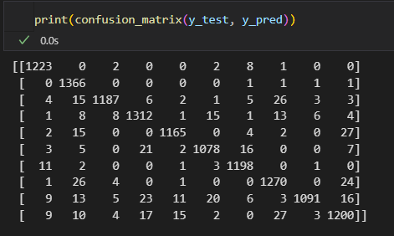

6.) RATIO OF TRAIN AND TEST DATA – 60:40

# ACCURACY – 0.96

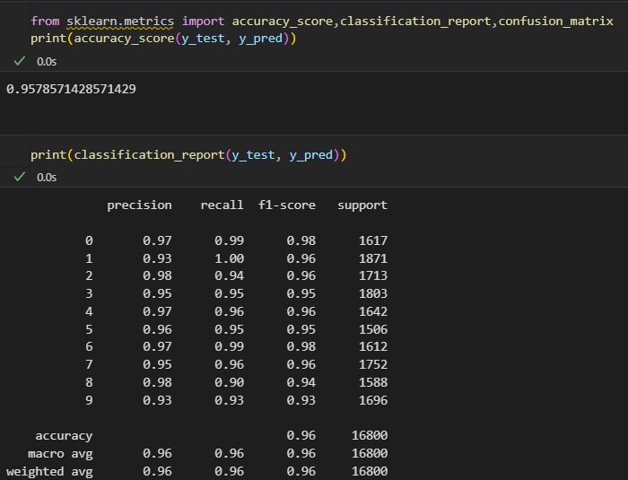

NAME : KSHITIJ SANGAL ROLLNO : 102203678 SUBGROUP : 2CO15



# CONFUSION MATRIX

