**Project development and operation environment**

Tomacat 10.1.10

Jdk/jre 1.7

Mysql 8.0

Eclipse 2023.6

**Functional implementation**

1.Database management together with the Web visualization

2.Design the database and connect it to the website

3.Created the web applications with the following features:

Allows users to register, log in, and link to the robot to display the real-time exploration information of the robot.

4.Visualize robot exploration records, and the import and export of survey data.

5.Link and information import with the real-time survey system through wifi.

**Concrete operations**

1.Connect the robot WiFi to realize the remote database connection.

2.Start the program through the eclipse and jump to the web interface.

3.Conduct user registration and login operations, and jump to the user robot list.

4.Running the robot, the robot information is transmitted to the database in real time.

5.Open the robot activity page, and the data is presented on the page.

**Specific content of the project**

1.Eclipse code testWeb is the project name for dynamic web project.

Java stores the backend code

Resources Store the static files, and store the configuration files

Webapp Store the front-end code

2.In the database sql, the relationship of each table is as follows

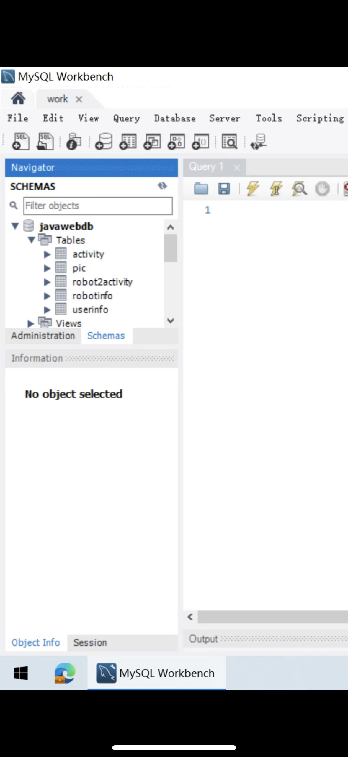

**In addition, if you want to run written source code in the new running environment:**

1.Tomcat version compatibility: Ensure that the Tomcat version you selected is compatible with the Tomcat 10.1.10 you used before

2. JDK version compatibility: If you were using JDK 1.7, you need to ensure that a compatible JDK version is installed in the new environment, install JDK 1.7 or later, and set the JAVA _ HOME environment variable to the new JDK path.

3. Database version compatibility: If you were using MySQL 8.0 before, you need to ensure that a compatible version of MySQL is installed in the new environment. Check the new version of the MySQL document or release notes for its differences and compatibility issues.

4. IDE version compatibility: You need to ensure that Eclipse 2023.6 compatible Eclipse is installed in the new environment.

**The following steps are also required:**

1. Configure the new environment: Install and configure the new versions of Tomcat, JDK, MySQL, and Eclipse so that they can work properly.

2. Import the project: Import the source code into the Eclipse or other applicable IDE in the new environment. Ensure that all required libraries and dependencies are also configured.

3. Modify profiles: According to the requirements of the new environment, some profiles need to be modified, such as the server.xml, web.xml of Tomcat, to adapt to the specific settings of the new environment.

4. Build and Deployment: Build the project using tools in the new environment and deploy the generated WAR files (if a Java Web application) to the Tomcat server.

5. Test and debugging: Start the application in the new environment, and conduct full testing and debugging to ensure that it works properly in the new environment.