1. Introduction

1.1 Purpose

This user operation manual is designed to provide children's bank users with detailed operational guidance to help them manage their accounts, set up task completion tasks, and save and withdraw tasks. Users will be able to easily understand the platform’s features and use it effectively.

1.2 System Overview

Our Kids Bank is an online banking system that allows parent accounts to post tasks, view account balances, and view rankings. Allow children's accounts to accept tasks, save and withdraw cash. The system provides an intuitive user interface and powerful data management tools to meet children's banking needs.

1.3

2. System operating environment

2.1 System hardware environment

You will need a computer with at least 4GB of RAM and enough disk space to store your product information and data.

2.2 System software environment

Our e-commerce platform supports Windows, macOS and Linux operating systems.

3. Children Account

3.1 Registration and login

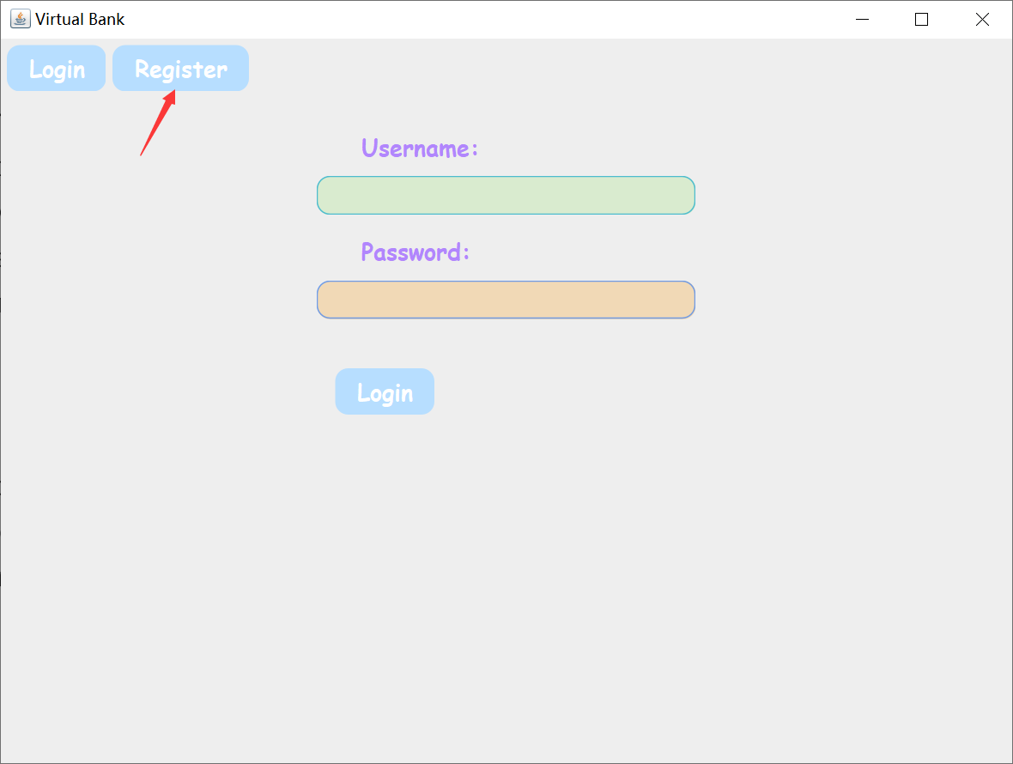 To register a new child account, please visit the system homepage, click the "Register" button, and then fill in the required information, including username and password. After completing the registration, you can log in to the system using your username and password.

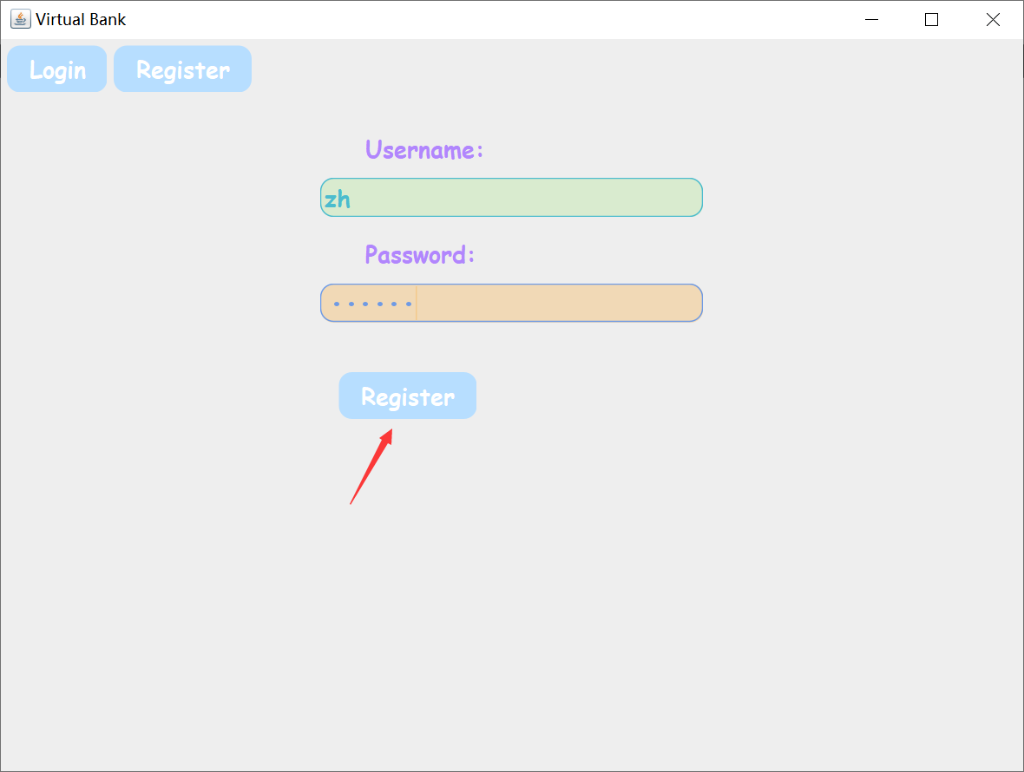

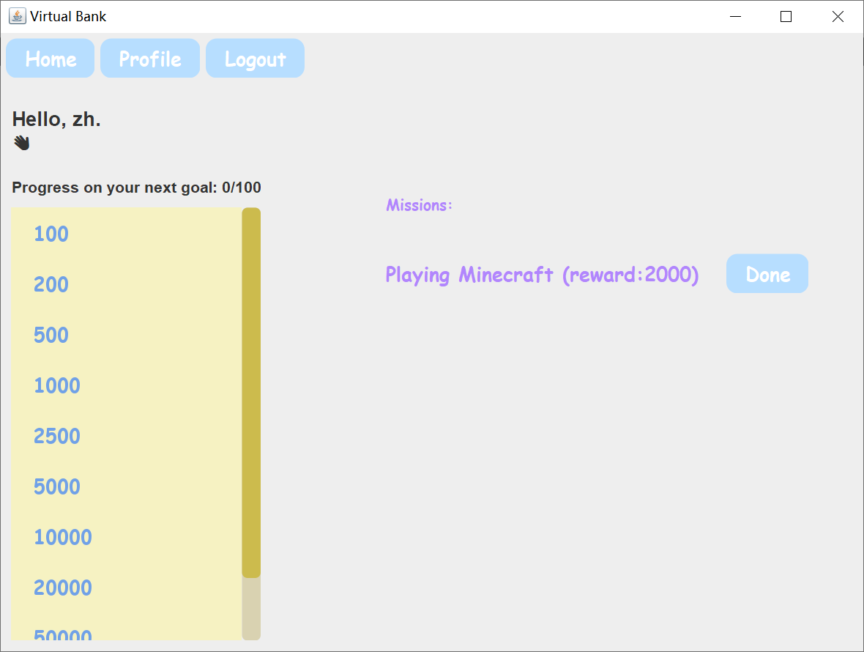

3.2Home interface of children's account

There is a welcome word on the home interface. You can browse the goals by sliding on the left side and check the current deposit progress. On the right side are the tasks to be completed. To complete the task, you can click the "done" button to indicate that it has been completed. After completing the task, the system automatically deposits the reward.

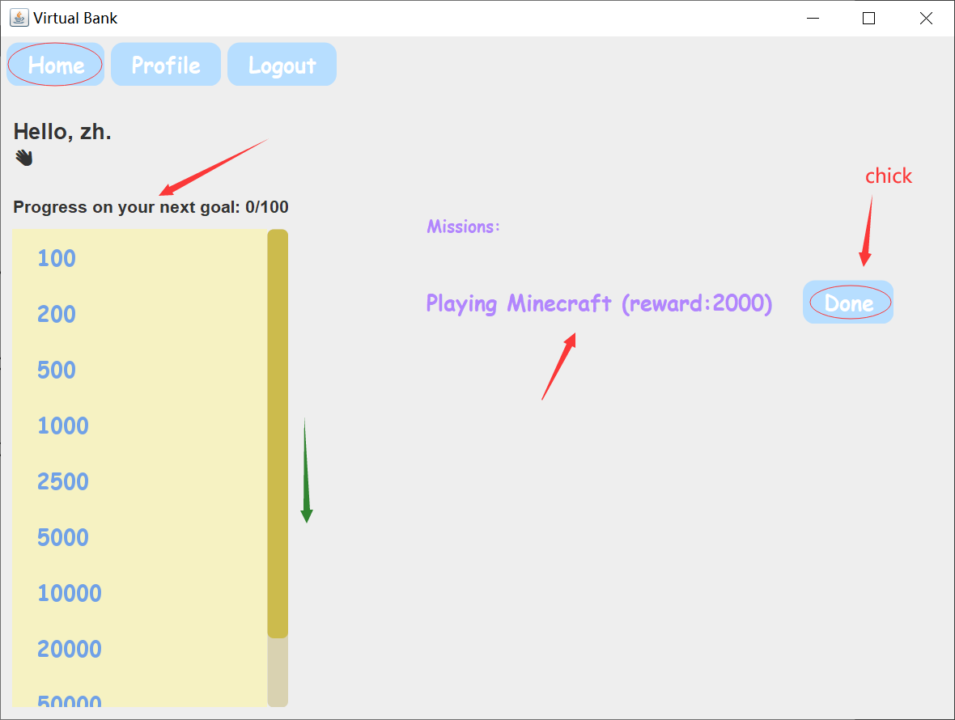

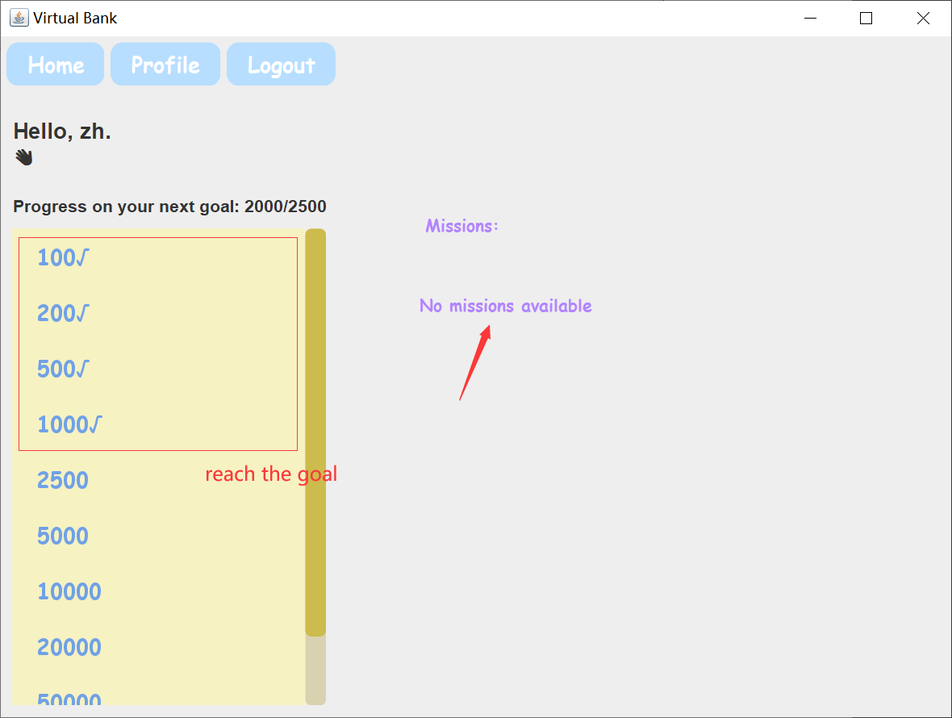

3.3Profile interface for children’s accounts

In the profile interface, all the amounts in the current account can be displayed, as well as the changes in the amounts, and the incoming and outgoing payments can be displayed in detail.

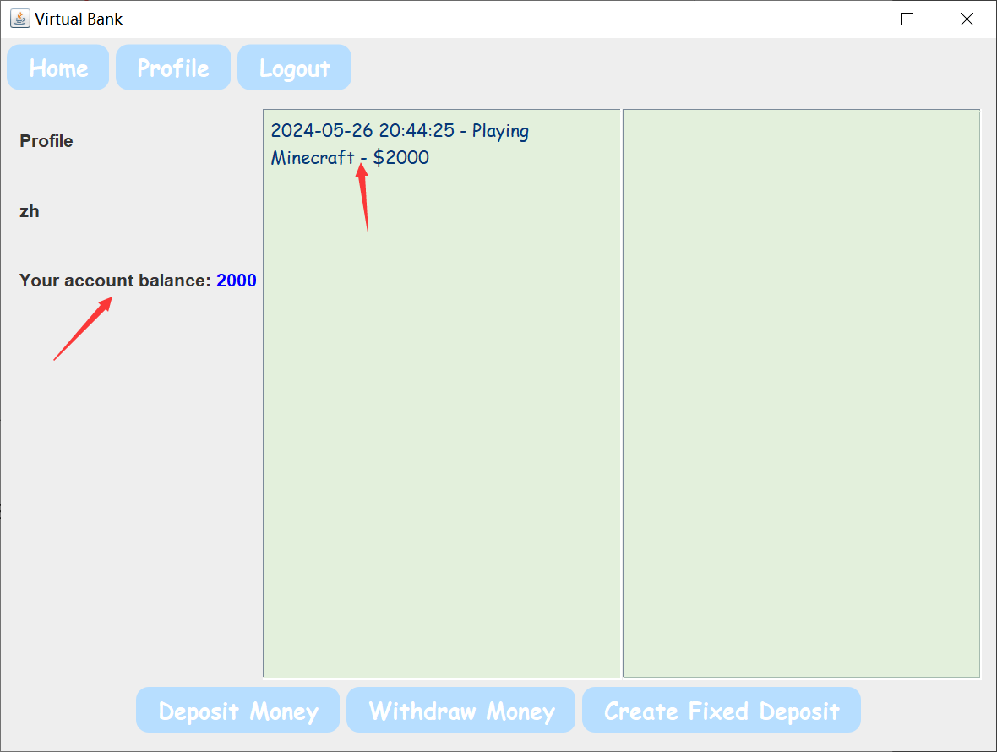

Click "deposit money" to pop up a small window, enter the amount in the input box to complete the current deposit.

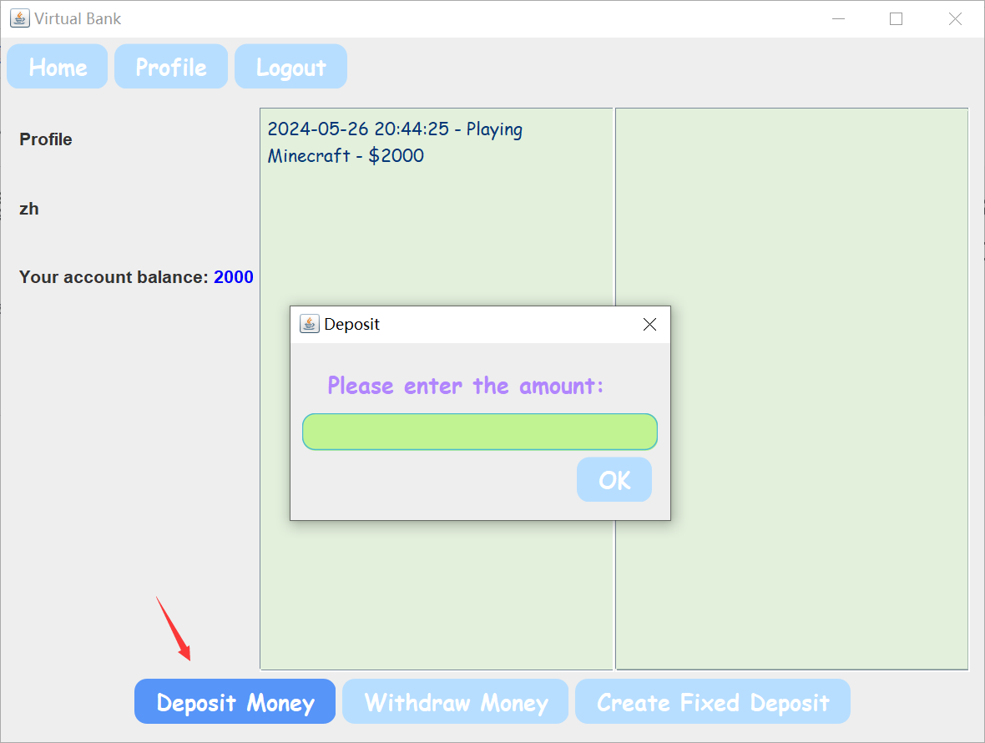

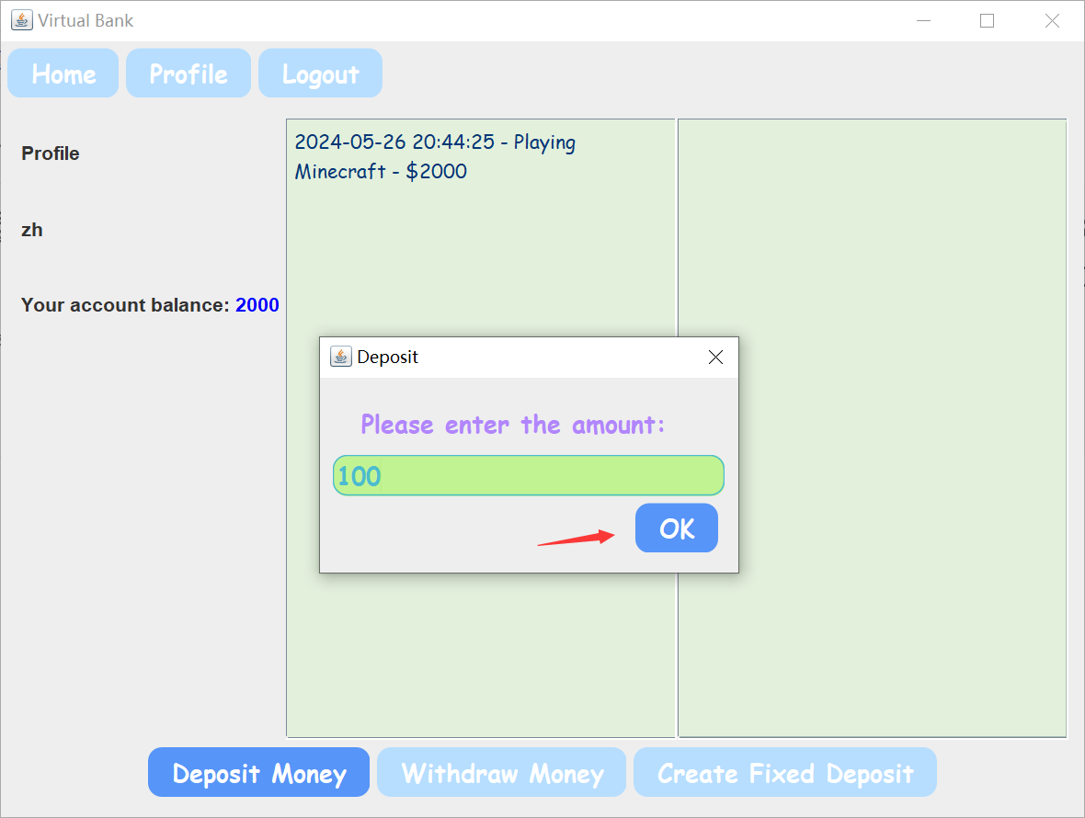

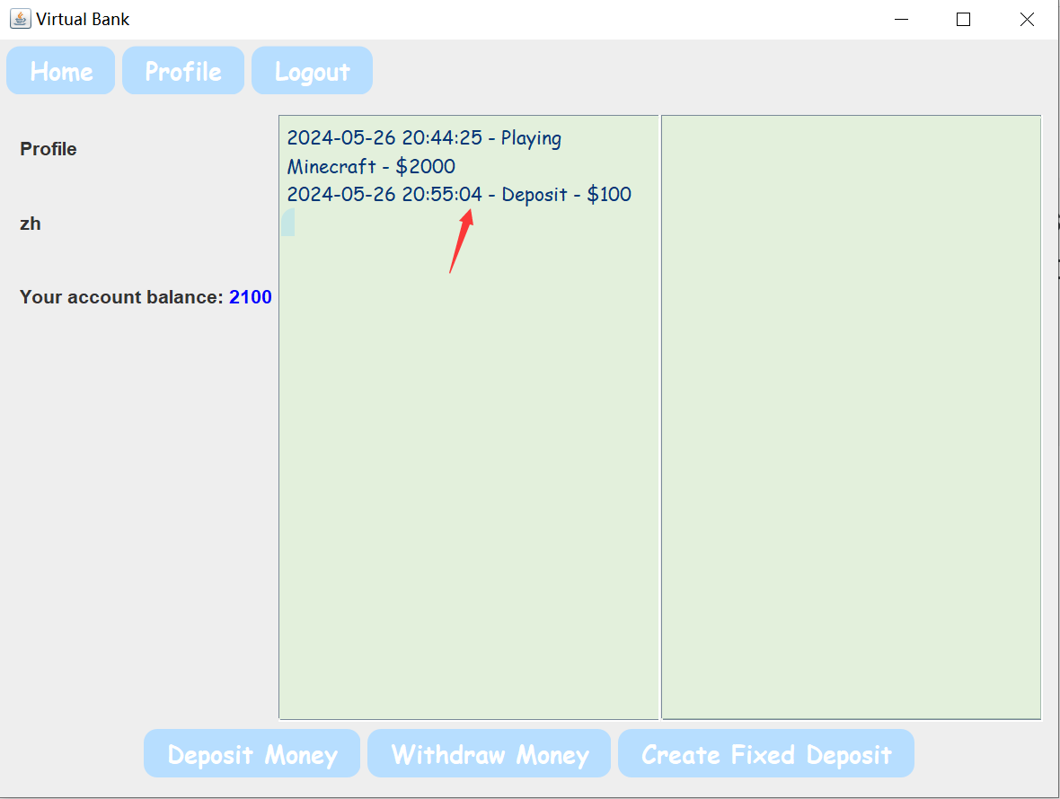

Click "Withdraw Money" to pop up a small window, enter the amount in the input box to complete the withdrawal.

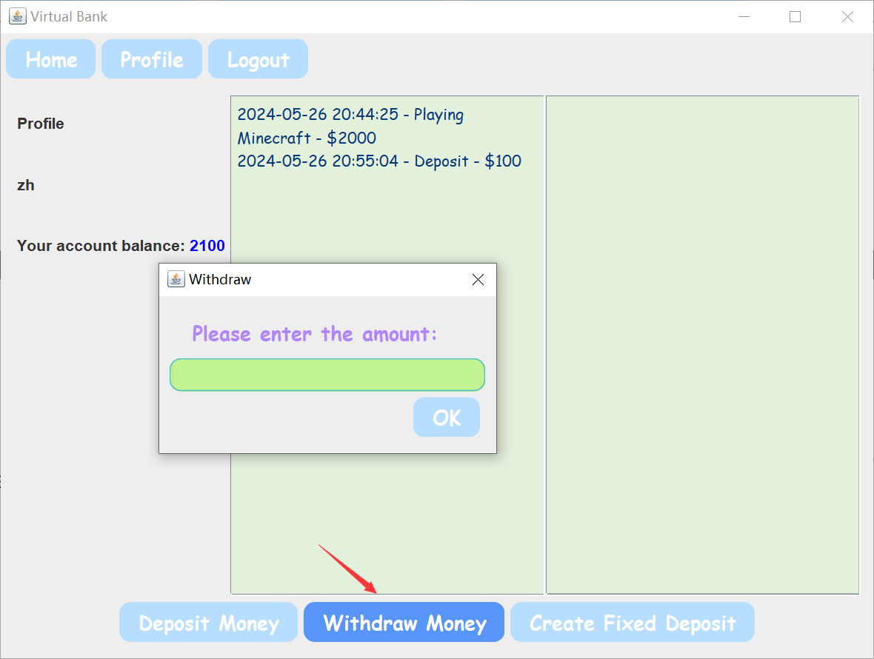

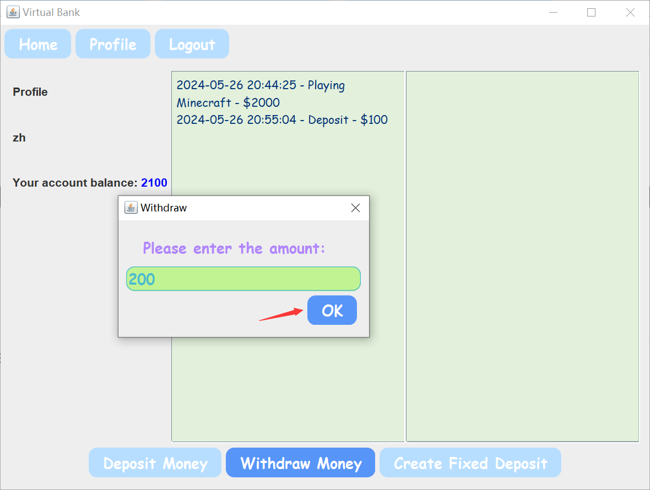

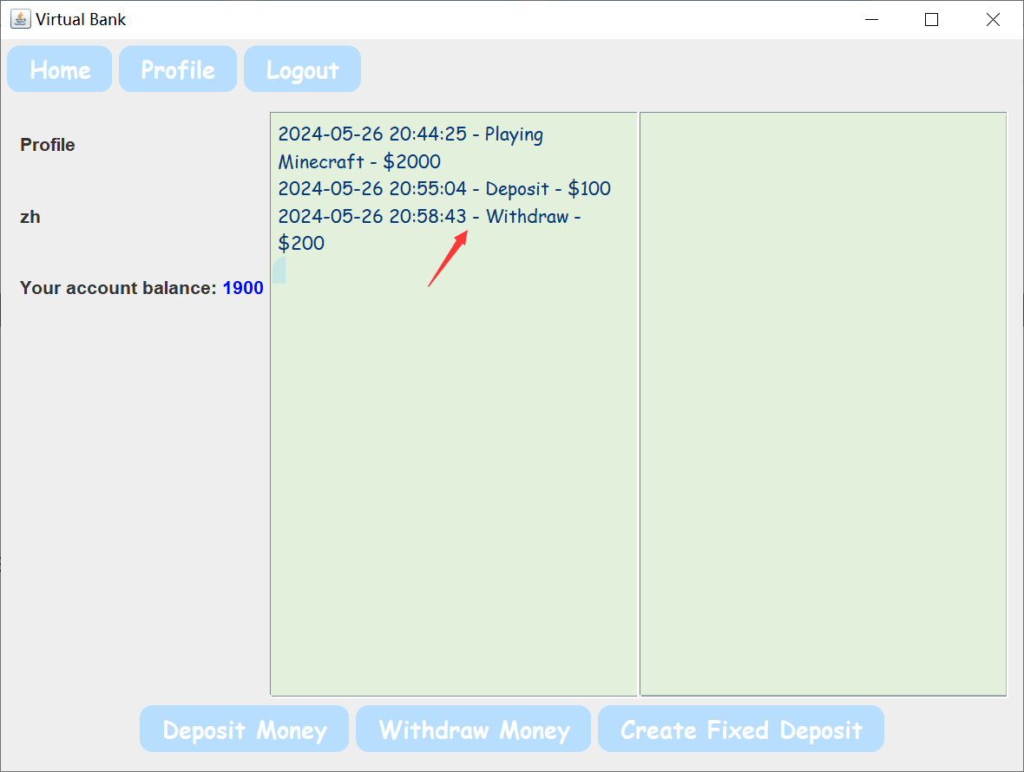

Click "Create Fixed Deposit" and a pop-up window will pop up to enter the demand deposit amount and time as required. After clicking OK, the demand deposit amount, time and interest rate will be displayed on the right side of the interface.

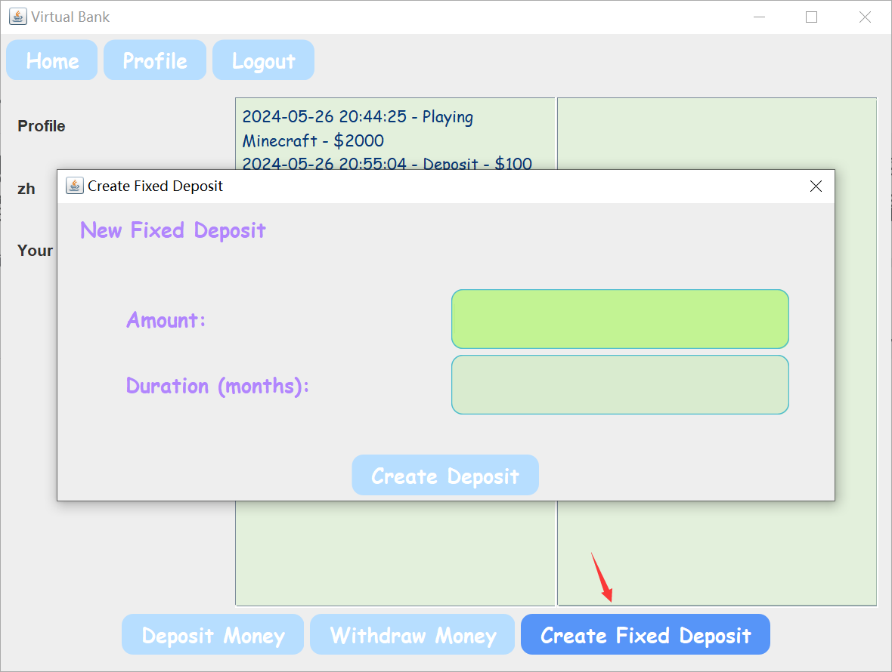

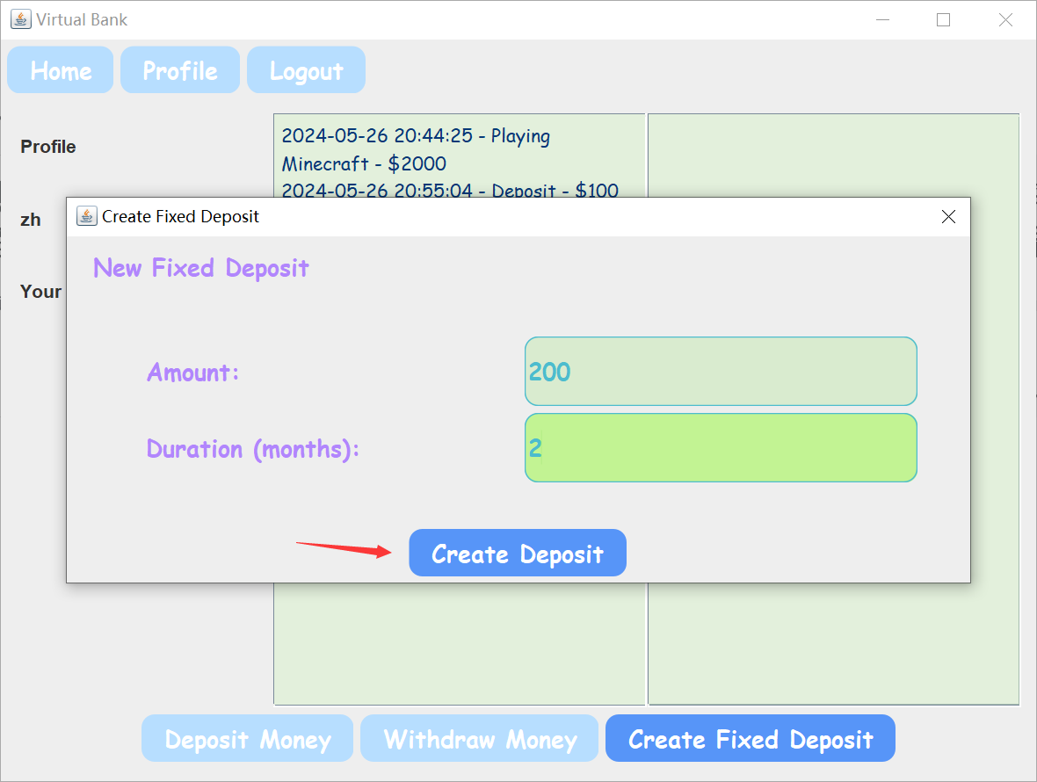

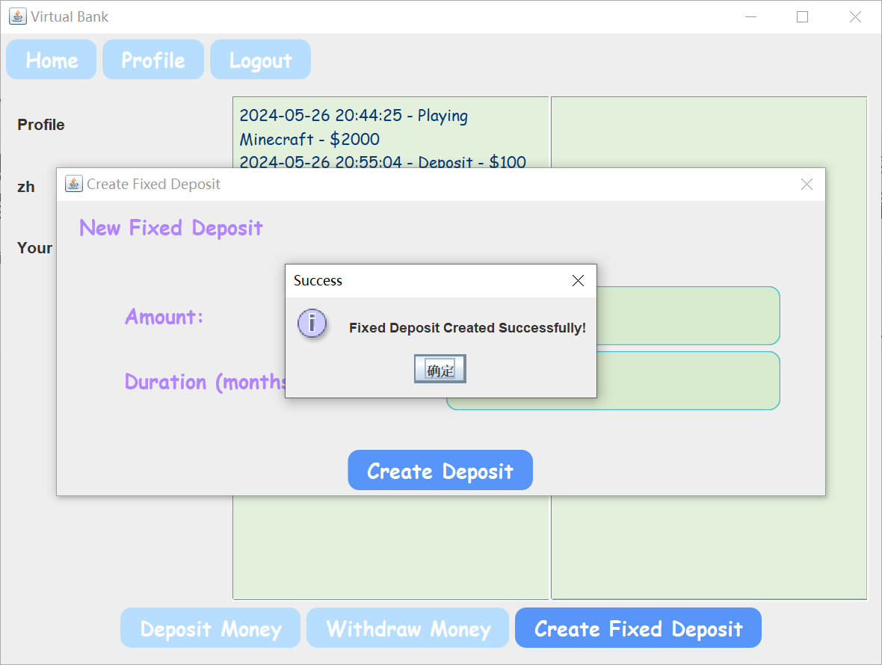

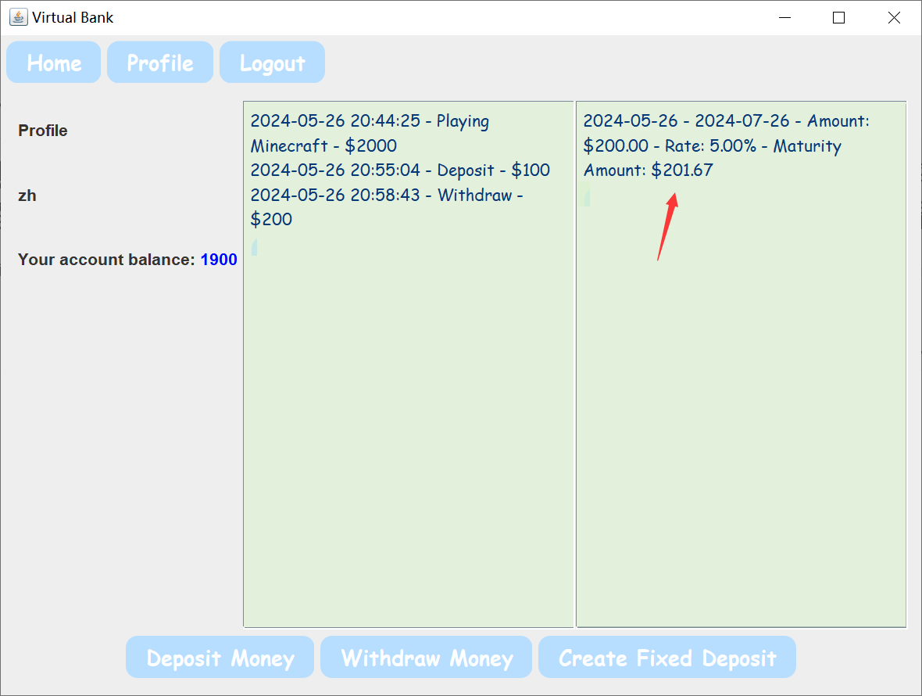

3.4log out

Click the logout button to exit the login

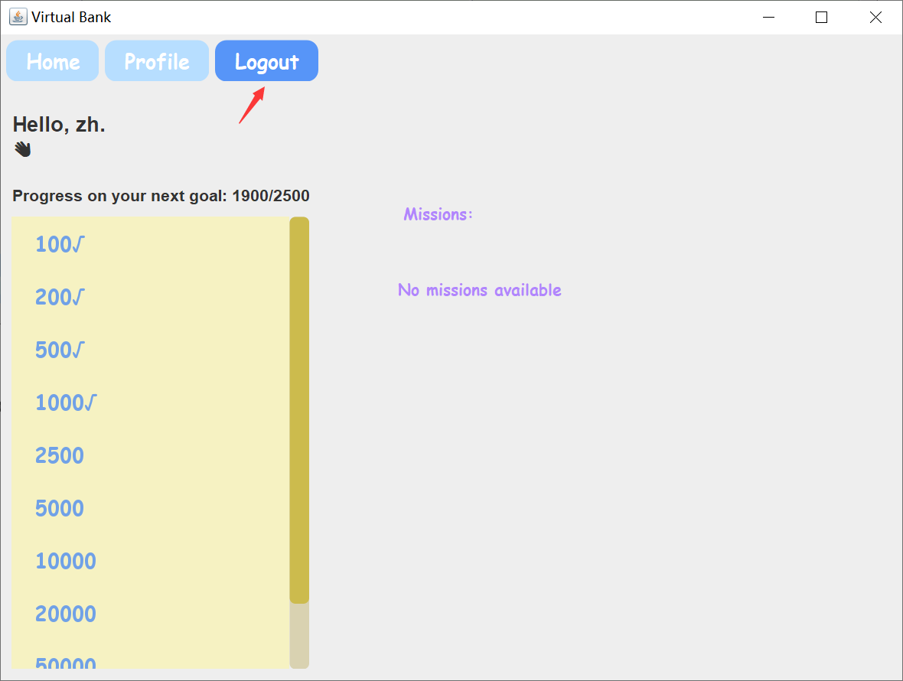

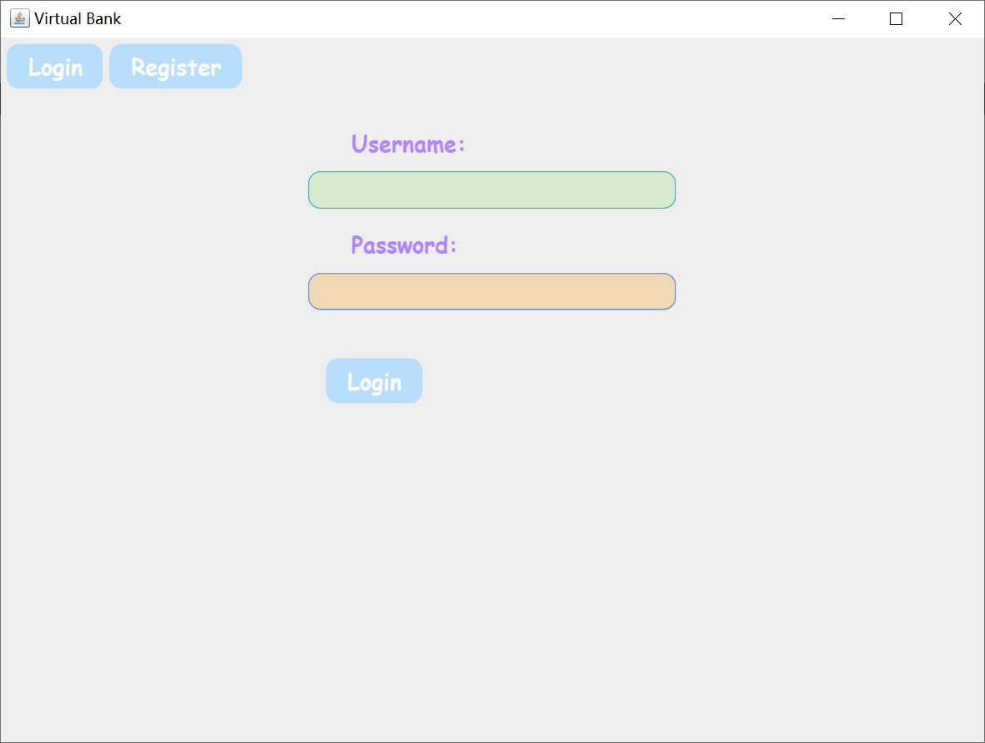

4. Parent Account

4.1Parent account login

The parent account uses the username "admin" and password "123456" to log in to the parent admin interface.

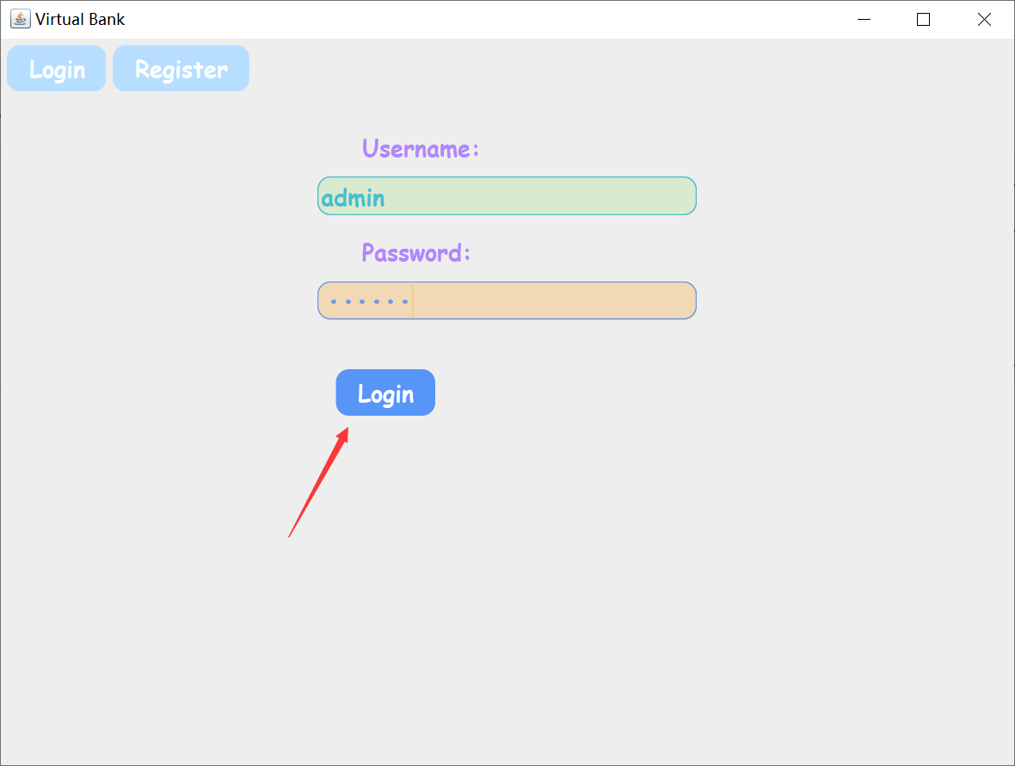

The left side of the interface is the rank list, where you can check the ranking of your child's savings amount.

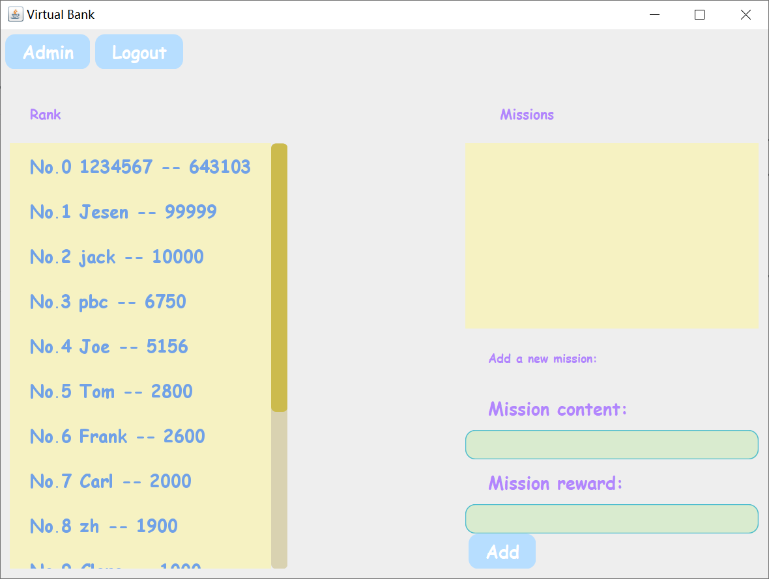

4.2Post a task

Follow the prompts to enter the task content and reward amount, and you can publish

the money saving task. Task information can be synced to children's accounts.

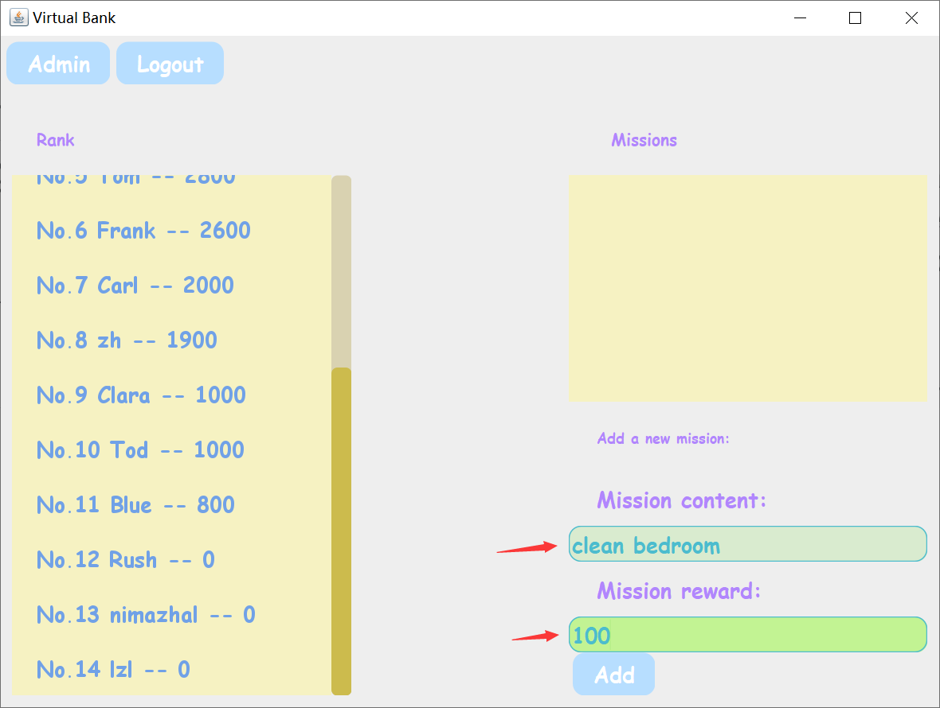

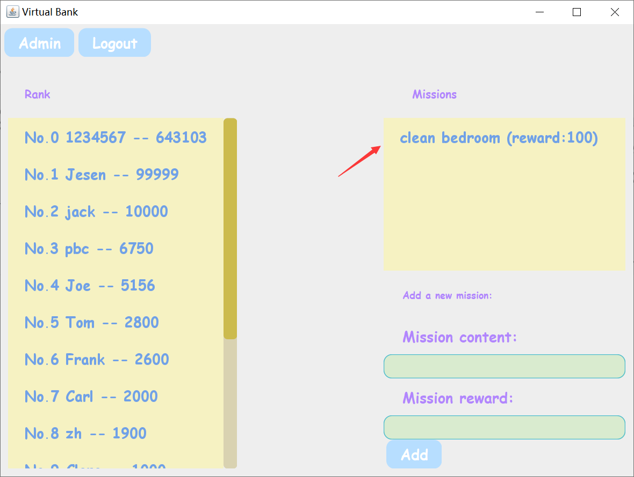

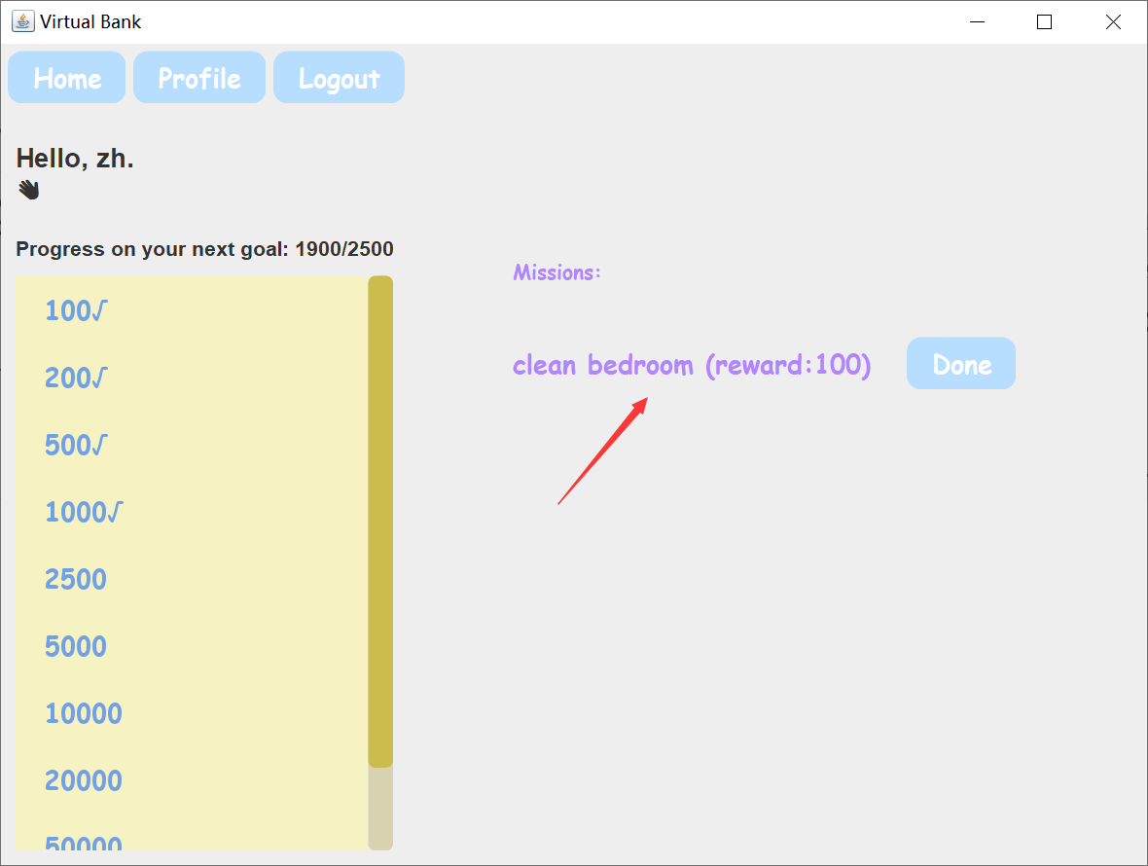

4.3log out

Click the logout button to exit the login

