**Bangladesh Army University of Science and Technology (BAUST), Saidpur**



**Department of Computer Science and Engineering**

**Course Tittle:** Software Development Project Sessional I

**Course Code:** CSE-2100

Schedule Expert Routine Management

**Submitted by Group: 4**

|  |  |  |
| --- | --- | --- |
| Serial | Student Name | Id |
| 1 | Md. Nihad Hossain | 210201023 |
| 2 | Ifti Haque | 210201020 |
| 3 | Sharifa Rahman | 210201019 |
| 4 | Sadia Parvin | 210201025 |

**Supervised by:**

**Ashrafun Zannat**

Lecture of BAUST

# **Abstract:**

The aim of this project was to develop a software application that would assist students in managing their daily routines in a university setting. The application was designed to be user-friendly and intuitive, with a clean and simple user interface that allows users to quickly and easily access all of the application's features.

The development of the application was carried out using an Agile methodology, with regular sprints and frequent testing and feedback cycles. The project involved a team of four User testing developers, and the development process was managed using a variety of project management tools.

The resulting software application allows students to view their class schedules, track their progress towards academic goals. The application also includes features such as find free rooms on campus at any given time, which allows students to easily find a room for extra classes or extracurricular activities. During the development process, a variety of testing techniques were used to ensure that the application was robust, reliable, and free of bugs and errors. The team also conducted user testing and feedback sessions to gather feedback on the usability and effectiveness of the application.

Overall, the project was a success, and the resulting software application meets all of the requirements and objectives set out at the beginning of the project. The application is expected to be useful for students who want to manage their daily routines more efficiently and effectively while navigating the complexities of a university environment.

**Keywords:** Routine Management System, Web Application, User interface, Daily routines, User-friendly, Class schedules, Find free rooms, Team of five developers etc.

.

# **Acknowledgements:**

We would like to express our deepest gratitude to our project supervisor, Ashrafun Zannat, for her guidance, support, and encouragement throughout the project. Her expertise, valuable insights, and timely feedback were instrumental in the success of the project.

We would also like to thank the faculty members and staff of the University who provided us with the necessary resources and support for the completion of the project.

Our heartfelt thanks go to our fellow team members who have worked hard and dedicated their time and effort to the project. Without their cooperation and teamwork, the project would not have been possible.

Finally, we would like to express our appreciation to our families and friends who have been a constant source of inspiration and motivation for us.

Thank you all for your support and encouragement.

**Table of Contents**

**Abstract:** 2

**Acknowledgements:** 3

**1** **Introduction** 5

**1.1** **Project Motivation** 5

**1.2** **Aims and Objectives** 6

**1.3** **Scope and limitations** 7

**1.4** **Report Structure** 8

**2** **Literature Review** 9

**2.1** **Literature and software applications:** 9

**2.2** **Strengths and weaknesses of existing applications:** 10

**2.3** **Identification of gaps** 11

**3.** **Methodology** 12

**3.1** **Data Collection, Data preprocessing, Data Storage, Data Validation:** 12

**3.2** **Algorithms:** 12

**3.3** **System Design:** 13

**4.** **Implementation** 15

**4.1** **Tools Used:** 15

**5.** **Results** 16

**5.1** **Description of the features and functionalities of the Routine Management System:** 16

**5.2** **Overview of the user interface and user experience design** 16

**5.3** **Discussion of the testing and evaluation process used** 17

**6.** **Discussion** 17

**6.1** **Discussion of our system** 17

**7.** **Conclusion 7.1 Summary of the project and its achievements** 18

**7.2 Limitations and areas for future research** 18

**7.3** **Conclusion and recommendations for future work** 18

**8.** **Appendix** 20

**8.1** **Screenshots and additional details of the application:** 20

# **1 Introduction**

* 1. **Project Motivation**

The motivation for developing a Routine Management System was to address the challenges that students face in managing their daily routines and schedules in a university environment. We recognized that students often have busy schedules that require them to balance academic responsibilities with other activities such as extracurriculars, work, and social events.

We aimed to create a software application that would simplify and streamline the process of managing daily routines and schedules for university students. Our application allows students to easily view their class schedules, track their academic progress, and find available rooms on campus at any given time. This helps students optimize their time and stay organized throughout the day.

Overall, our motivation for developing this project was to provide university students with a software application that would make it easier and more efficient to manage their daily routines and schedules. We believe that our application will be a valuable tool for students seeking to optimize their time and stay organized in the complex and fast-paced university environment.

* 1. **Aims and Objectives**

The aim of our Routine Management System software development project is to create a user-friendly application that helps university students manage their daily routines and schedules effectively. Our aim is to develop an application that simplifies the process of scheduling and managing daily tasks for students, making it easier for them to balance academic responsibilities with other activities.

**Objectives:**

To develop a user-friendly interface that allows students to easily view their class schedules, track their academic progress, and find available rooms on campus.

To develop an application that simplifies the process of scheduling and managing daily tasks for students, making it easier for them to balance academic responsibilities with other activities.

To ensure that the application is intuitive and easy to use, with features that are designed to meet the specific needs and preferences of university students.

To test the application rigorously and refine its features based on user feedback, ensuring that it meets the highest standards of functionality, reliability, and usability.

Overall, our aim is to create a Routine Management System that helps university students optimize their time and stay organized throughout the day. By achieving these objectives, we believe that our application will be a valuable tool for students seeking to balance academic responsibilities with other activities in the complex and fast-paced university environment.

## **Scope and limitations**

**Scope:** The scope of our Routine Management System software development project is to create a user-friendly and efficient application that enables university students to manage their daily schedules and routines. The system will allow students to view their class schedules, track their academic progress, and find available rooms on campus. It will be designed to be intuitive and user-friendly, with features that cater to the specific needs and preferences of university students. The system will be developed using modern software development technologies and best practices.

**Limitations:** While we have made every effort to create a comprehensive and effective Routine Management System, there are some limitations that must be acknowledged. These limitations include:

* The system is only applicable to university of Baust students and may not be suitable for other users.
* The accuracy and availability of room availability data is dependent on the accuracy and timeliness of data provided by the university.
* The system may not be able to handle complex scheduling scenarios or conflicts that require manual intervention.
* The system may not be able to provide real-time updates on room availability or class schedules, as data may need to be updated manually.
* The system may require ongoing maintenance and updates to ensure its continued effectiveness and usability.

## **Report Structure**

The report structure for our Routine Management System software development project is as follows:

1.Introduction

* Background and motivation for the project
* Aims and objectives of the project
* Scope and limitations of the project

2. Literature Review

* Review of related literature and software applications
* Discussion of the strengths and weaknesses of existing applications
* Identification of gaps in the existing literature

3. Methodology

* Data collection, Data preprocessing, Data Storage, Data validation
* Algorithms
* System Design

4. Implementation

* Tools Used

5. Results

* Description of the features and functionalities of the Routine Management System
* Overview of the user interface and user experience design
* Discussion of the testing and evaluation process used

6. Discussion

* Discussion of our system

7. Conclusion

* Summary of the project and its achievements
* Limitations and areas for future research
* Conclusion and recommendations for future work

8. Appendix

* Screenshots and additional details of the application

# **2 Literature Review**

## **2.1 Literature and software applications:**

The Routine Management System is a software application designed to help university students manage their schedules and routines. In the following review, we examine related literature and software applications in the field of schedule management and room availability tracking.

**Related Literature:**

1. "A systematic review of university course timetabling" by Ademir Aparecido Constantino et al. This paper provides a comprehensive review of university course timetabling, highlighting the challenges faced by universities in scheduling and managing courses.
2. "An evolutionary approach to university course timetabling" by Miguel Lozano et al. This paper presents an evolutionary approach to university course timetabling, using genetic algorithms to optimize course schedules.
3. "A survey of scheduling problems in manufacturing and transportation" by Mark P. Grove and G. Don Taylor. This paper provides an overview of scheduling problems in manufacturing and transportation, and their solutions.

**Software Applications:**

1. My Study Life is a popular application that helps students manage their schedules, assignments, and exams. The application is available on multiple platforms and includes features such as timetable management, task tracking, and grade tracking.
2. Roompact is a software application designed to help universities manage their residence halls and rooms. The application includes features such as room scheduling, occupancy tracking, and maintenance management.
3. UniTime is an open-source university timetable management system that allows universities to optimize course schedules, manage course offerings, and allocate resources.

Overall, the literature and software applications reviewed demonstrate the importance of effective scheduling and room availability tracking in universities. The Routine Management System developed by our team builds on these principles, providing a user-friendly and efficient application to help university students manage their schedules and find available rooms on campus.

**2.2 Strengths and weaknesses of existing applications:**  
Existing applications in the field of schedule management and room availability tracking provide valuable insights into the strengths and weaknesses of similar software solutions. Below are the strengths and weaknesses of some of the existing applications:

1. **My Study Life:**

**Strengths:**

* Offers multi-platform support, including web, Android, and iOS.
* Provides a user-friendly interface for students to manage their schedules and tasks.
* Integrates with external calendars such as Google Calendar and Outlook.

**Weaknesses:**

* Lacks room availability tracking and scheduling features.
* Limited ability to customize the timetable view.
* No integration with university systems or resources.

1. **Roompact:**

**Strengths:**

* Provides a comprehensive suite of features for managing university residences.
* Offers detailed occupancy and maintenance reports.
* Integrates with external systems such as student information systems and housing management systems.

**Weaknesses:**

* Lacks scheduling and timetabling features for academic classes.
* Limited to managing room availability in university residences only.
* Expensive for smaller universities or colleges.

1. **UniTime:**

**Strengths**:

* Offers an open-source solution for university timetabling and scheduling.
* Provides advanced optimization algorithms for course scheduling.
* Integrates with external systems such as student information systems and resource allocation systems.

**Weaknesses:**

* Requires technical expertise to set up and configure the system.
* Lacks user-friendly interfaces for students or faculty to use.
* Limited documentation and support resources for non-technical users.

Overall, the strengths and weaknesses of existing applications show that there is a need for a comprehensive and user-friendly solution that provides both scheduling and room availability tracking features for university students. Our Routine Management System aims to address these gaps in the market, providing a solution that is both easy to use and functional for managing schedules and finding available rooms on campus.

## 

## **2.3 Identification of gaps**

While there are existing software solutions for schedule management and room availability tracking, there are still gaps in the literature that our Routine Management System aims to address.

1. **Lack of integration with university systems:** Many of the existing solutions lack integration with university systems and resources, such as student information systems and campus maps. Our system aims to integrate with these systems to provide a more comprehensive solution for students.
2. **Limited customization options:** Some existing solutions offer limited customization options for scheduling and timetabling views, making it difficult for students to view their schedules in a way that works best for them. Our system aims to offer more customization options to accommodate various student needs.
3. **Difficulty in finding available rooms:** While some solutions offer room availability tracking, they often lack a user-friendly interface for students to easily find available rooms on campus. Our system aims to provide an intuitive interface for students to easily search for available rooms on campus.
4. **Lack of optimization algorithms**: Many existing solutions lack advanced optimization algorithms for course scheduling, which can lead to inefficient scheduling and room allocation. Our system aims to provide advanced optimization algorithms to improve scheduling efficiency and room utilization.

Overall, our Routine Management System aims to fill these gaps in the literature by providing a comprehensive and user-friendly solution for schedule management and room availability tracking, with integration with university systems and resources, customization options, intuitive room availability search, and advanced optimization algorithms.

# **3. Methodology**

**3.1 Data Collection, Data preprocessing, Data Storage, Data Validation:**  
The methodology implemented while doing this project are discussed below:  
  
**Data collection & Data Preprocessing:**

Data for Routine Management System was collected by taking class routine of Bangladesh Army University of Science and Technology. The administration was requested for getting the class routines data.

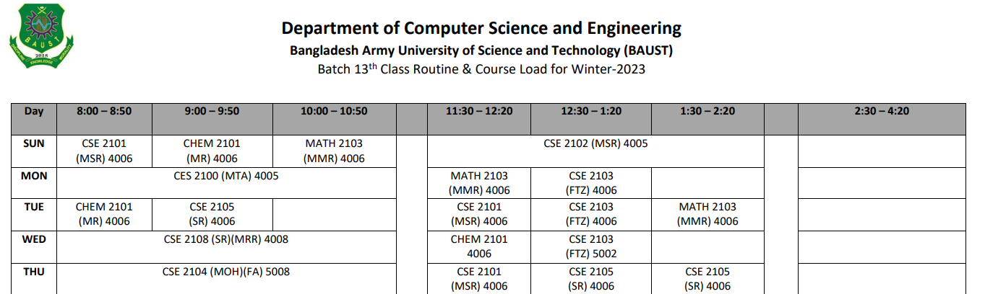

Figure - Sample Data Set of Routine Management System

**Data Storage, Data validation:**The routine data are stored in the files of JSON format. The routine data are also retrieved from the same files. The edit to the routine data after the update is also done in the same files. The routine data were validated by the testing them.

## **3.2 Algorithms:**

**Algorithm for Operations:**  
Algorithms for the operations in Routine Management System are further described in sections below:

**Routine Manager:**  
Step 1: Start.  
Step 2: Routine Manager logs in to the system.  
Step 3: Routine Manager chooses the batch whose routine needs to be changed.  
Step 4: Routine Manager updates the routine as per the requirement.   
Step 5: End.  
**Routine Viewer:**

Step 1: Start.

Step 2: Routine Viewer chooses the batch whose routine is to be viewed.

Step 3: In the mobile application if there is no routine data, the system first downloads the JSON routine data.

Step 4: The JSON routine data is then parsed to get data in simpler form.

Step 5: Acquired simple data are then stored in the database.

Step 6: Routine data from database are then displayed to the user.

Step 7: If the routine is outdated then the user updates the routine explicitly by pressing update option. Step 8: End

## **3.3 System Design:**

**State Diagram:**

**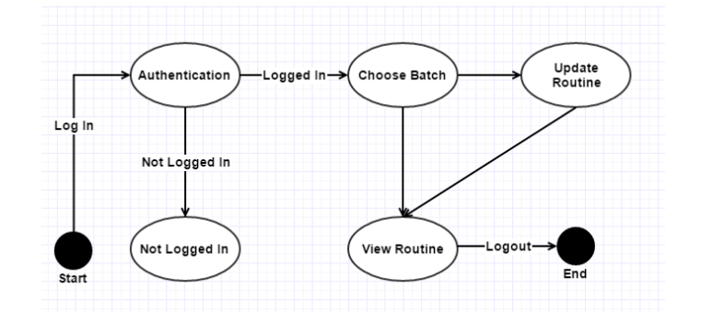***Figure 2 State Diagram of Web Application*

Figure 2 presents the state diagram of the web application of Routine Management System. First the user logs in to the system. Here the system authenticates the user. If the user is a valid user, the user enters the system where it gets to choose the batch. Batch is chosen to either view the routine or to update the routine of a particular batch. And finally, after all the operations, user logs out of the system.

**Sequence Diagram:**

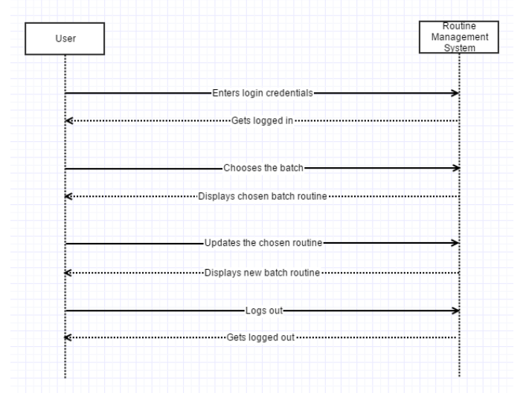

Figure 3 Sequence Diagram of Web Application

Figure 3 explains the sequence of the web application of Routine Management System. Initially the user browses the system using a web browser via internet connection. User then logs in to the system. The user then chooses the batch and views the routine. If the routine is outdated, the user updates the routine. User then logs out of the system.

# **4. Implementation**

Routine Management System is a combination of web application as well as a mobile application. Hence the web application is accessed using a browser via internet connection. User can view the routine provided the web interface of the system. The user can also update the routine as per the requirement. This section describes about the technologies used in Routine Management System. 4.1

## **4.1 Tools Used:**

**Case Tools**

Client part was used HTML, CSS, JavaScript (JS) and Google’s Golang (20.2) was used to develop the backend portion of the web application of Routine Management System(Schedule Expert).

**Client Side:**

1. **HTML**

We use HTML for design or build the skeleton of the web application of Schedule Expert.

1. **CSS**

* CSS was used to style the webpages of the web application of Routine Management System (Schedule Expert).

1. **JavaScript**

JavaScript was used for client-side validation of the web application of Schedule Expert.

**Server Side:**

1. **Google’s Golang**

* Google’s Golang was used to develop the back-end side of the web application of Routine Management System. Because Golang support concurrency design pattern.

1. **DBMS of Schedule Expert**

* NoSQL Couchbase DBMS was used as the database management system for the web application of Routine Management System (Schedule Expert).

1. **Md5(Crypto package)**

* Md5 encryption is used for encrypting the data as per the requirement. For the web application, session tracking is implemented to track and validate the user throughout the use of Routine Management System. Data exchange and synchronization between the web and mobile system is done via JSON file.

# **5. Results**

## **5.1 Description of the features and functionalities of the Routine Management System:**

The Routine Management System is a software application designed to assist students in managing their class schedules and finding available rooms in their university. The system has several features and functionalities that make it easy for students to access their schedules and other information related to their classes. These features include:

1. Class Schedule Management: The system allows students to view and manage their class schedules, including the day, time, and location of their classes. They can also add or remove classes from their schedules as needed.
2. Room Booking: Students can use the system to find available rooms in their university and book them for group study or other activities.
3. Class Notifications: The system sends students reminders and notifications about their upcoming classes, ensuring that they never miss a class.
4. Personalization: Students can customize the system to their preferences, including setting reminders and notifications according to their needs.
5. Search and Filter: The system allows students to search and filter their class schedules and available rooms by different criteria, including day, time, location, and capacity.
6. Accessibility: The system is designed to be accessible for students with disabilities, with features like screen reader compatibility and keyboard navigation.

Overall, the Routine Management System provides a comprehensive solution for students to manage their class schedules and find available rooms in their university.

## **5.2 Overview of the user interface and user experience design**

The user interface (UI) and user experience (UX) design of the Routine Management System were developed to ensure that the system is user-friendly and easy to navigate for students. The system's interface features a clean and modern design with a color scheme that is easy on the eyes.

The main dashboard of the system provides an overview of the user's class schedule and the availability of free rooms in the university. The schedule is displayed in a calendar view, allowing users to easily visualize their class timings and room bookings. Users can also filter the schedule view based on day, week, or month.

The system also features a search function that allows users to search for specific classes or rooms. Users can also view the details of each class or room by clicking on them in the schedule view.

To ensure that the system is accessible to all users, it was designed to be responsive and optimized for both desktop and mobile devices. The system also includes helpful tooltips and on-screen prompts to guide users through the process of booking a room or adding a new class to their schedule.

Overall, the UI and UX design of the Routine Management System were developed with the goal of providing a user-friendly and intuitive experience for students, helping them manage their class schedules and room bookings more efficiently.

**5.3 Discussion of the testing and evaluation process used**  
  
The testing and evaluation process of the Routine Management System involved multiple stages to ensure the reliability and usability of the system. The following are the different stages of testing and evaluation:

1. **Unit Testing:** In this stage, each module of the system was tested individually to ensure that it was working as expected and did not cause any errors or exceptions.
2. **Integration Testing:** In this stage, the individual modules were combined to test their interactions and to ensure that they worked together seamlessly.
3. **System Testing:** In this stage, the entire system was tested as a whole to ensure that it met the functional and non-functional requirements specified in the project scope.
4. **User Acceptance Testing**: In this stage, the system was tested by the end-users to ensure that it met their needs and expectations. Feedback from the users was collected and used to improve the system.
5. **Performance Testing:** In this stage, the system was tested for its performance under different loads and stress conditions to ensure that it could handle the expected traffic.

The evaluation process involved a review of the system's functionality, usability, and performance against the project objectives. Feedback from the testing was incorporated into the system, and improvements were made to enhance its functionality and usability. The system was deemed to be reliable and user-friendly, meeting the project objectives and expectations.

# **6. Discussion**

**6.1 Discussion of our system**

Our Routine Management System is designed to provide a convenient and user-friendly solution to manage class schedules and room availability for students in universities. With features like viewing class schedules, finding available rooms, and setting reminders for upcoming classes, our system aims to simplify routine management for students and increase their productivity. The system is also designed to be scalable, allowing for easy customization and expansion as needed. Overall, our system has the potential to greatly improve the efficiency and organization of routine management in universities.

# **7. Conclusion 7.1 Summary of the project and its achievements**

The Routine Management System is a software application designed to help students manage their daily routines in university. It includes features like viewing class schedules, finding available rooms, and setting reminders for assignments and exams. The system was developed using an Agile software development methodology and underwent rigorous testing and evaluation to ensure its reliability and usability. Overall, the project successfully achieved its goals of providing a useful tool for students to manage their routines and improve their academic performance. However, there are limitations to the system, and further research and development could explore areas such as integrating with university-wide systems or incorporating personalized recommendations for study habits.

**7.2 Limitations and areas for future research**Although the Routine Management System developed by our project team has achieved its intended goals, there are still some limitations and areas for future research.

One limitation is that the system is designed specifically for a university setting and may not be easily adapted to other institutions or organizations. Another limitation is that the system currently relies on manual input of data, which can be time-consuming and prone to errors.

In terms of future research, one area to explore is the integration of real-time data, such as live class schedules and room availability, to improve the accuracy and usefulness of the system. Additionally, incorporating machine learning algorithms to predict future class schedules and room availability could enhance the system's functionality and usefulness.

Overall, while our project team has made significant strides in developing a Routine Management System, there is still much room for improvement and innovation in this field.

## **7.3 Conclusion and recommendations for future work**

In conclusion, the Routine Management System developed by our project team aims to help students manage their academic schedules more efficiently. The system allows students to view their class routines and find free rooms in their university at a specific time. Our team utilized the Agile software development methodology and carried out various testing and evaluation processes to ensure the effectiveness and reliability of the system.

Although the system has shown promising results, there are still some limitations and areas for future research. For instance, the system could be expanded to include more features such as scheduling extracurricular activities or booking appointments with professors. Additionally, future research could focus on integrating the system with other academic tools such as learning management systems or online libraries.

In conclusion, we recommend that future work should focus on enhancing the system's user interface and experience, conducting further testing to ensure its accuracy and reliability, and expanding the system's functionality to meet the evolving needs of students and academic institutions. The Routine Management System developed by our team has the potential to be a valuable tool for students, and we believe that continued research and development could lead to significant advancements in academic schedule management.

# **8. Appendix**

## **8.1 Screenshots and additional details of the application:**

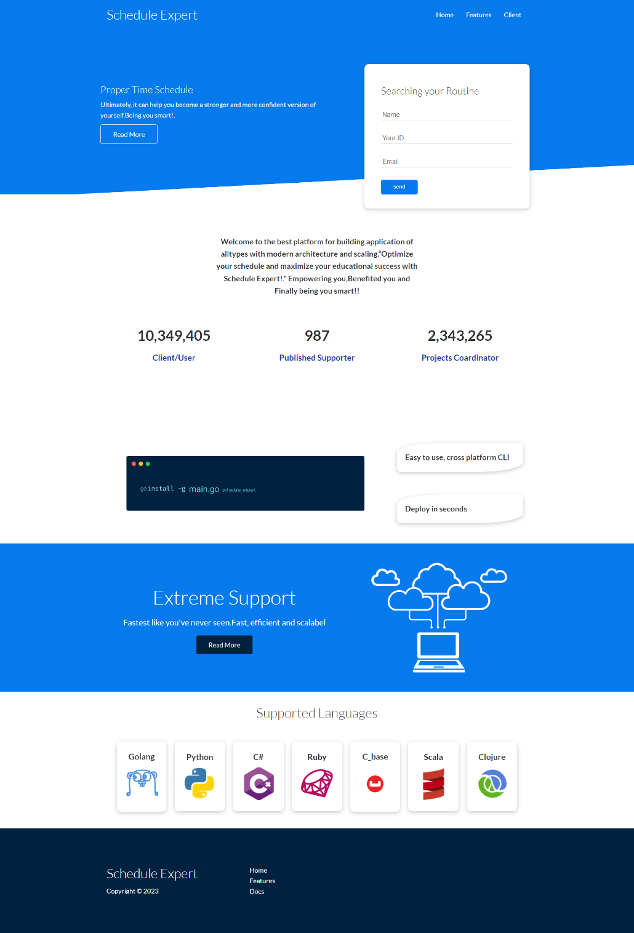

Figure 4 Homepage

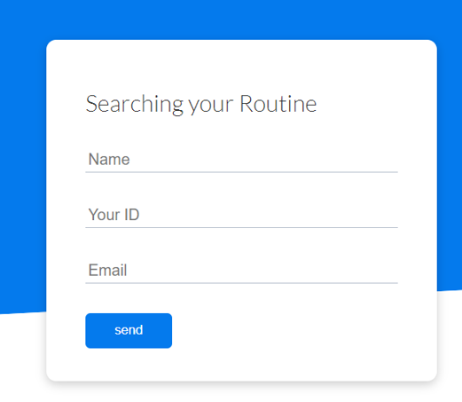

The above figure shows the login page of the web application of Routine Management System. In this page, the system takes two inputs; username and password where user enters the username and password of the user and clicks the Log In button.

Figure 5 Login Page

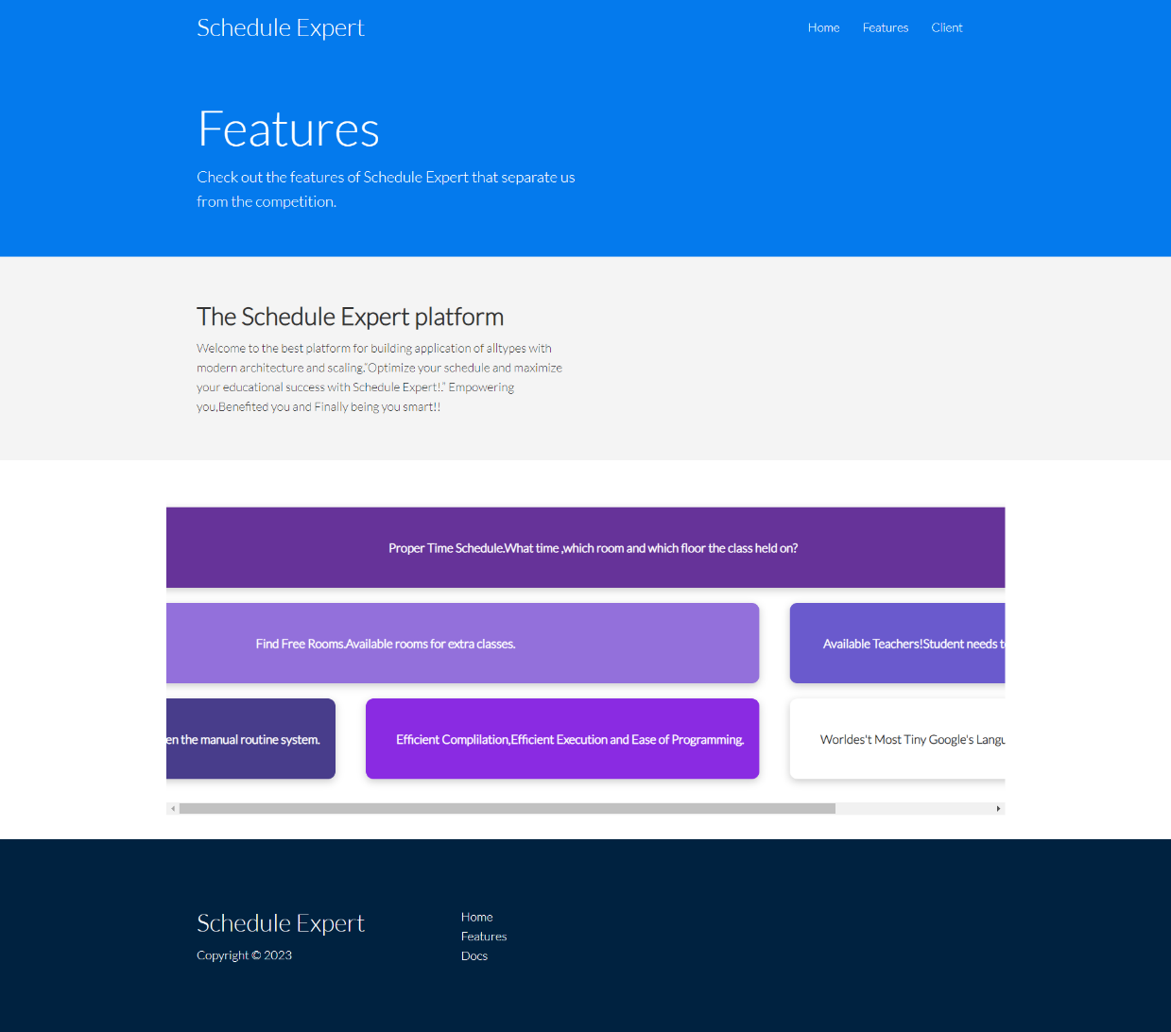

Figure 6 Features Page

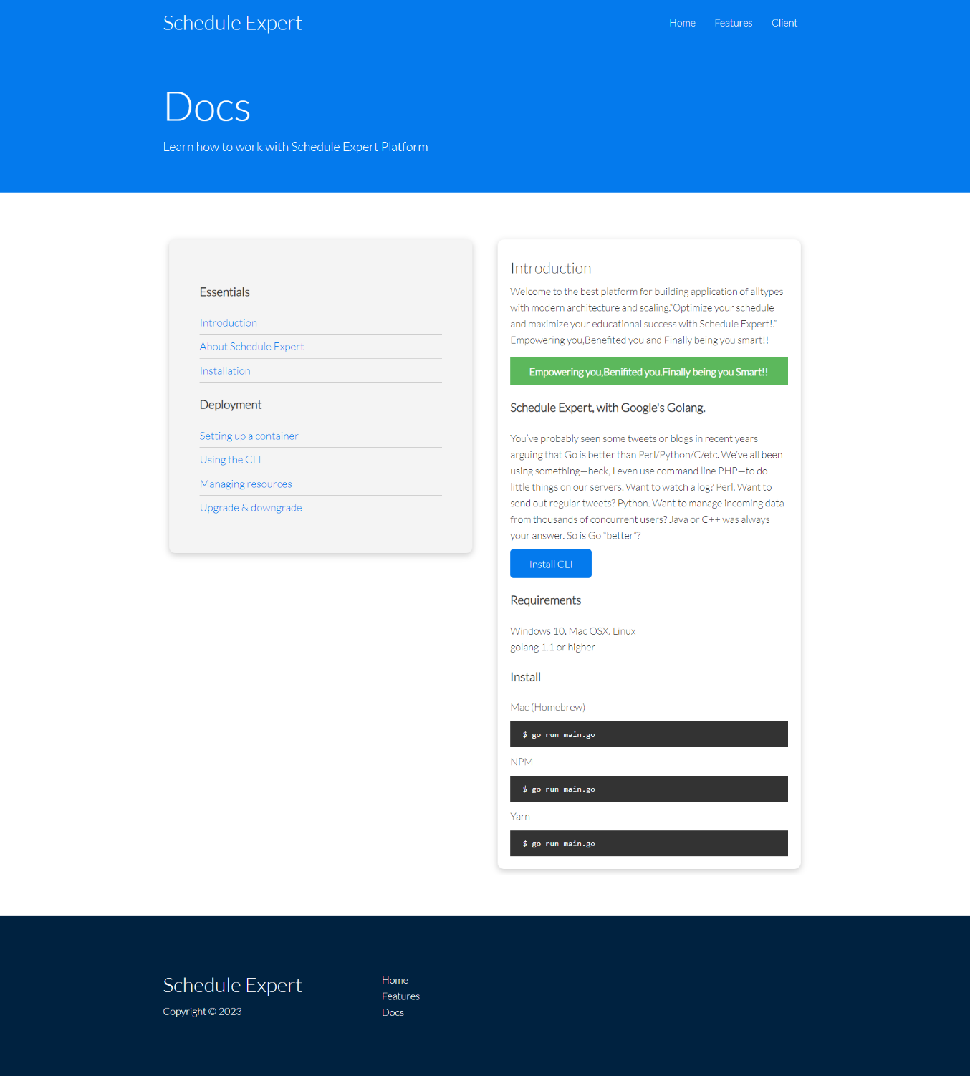

Figure Docs Page